**Assignment**

//Basic Programs

1. Write a program to convert the character into the ASCII value.

a. Without user interaction b. With user interaction

2. Write a program to calculate the area and circumference of a circle.

a. Without user interaction b. With user interaction

3. Write a program to calculate the area and circumference of a square.

a. Without user interaction b. With user interaction

4. Write a program to calculate the area and circumference of a rectangle.

a. Without user interaction b. With user interaction

5. Write a program to calculate the area and circumference of a triangle.

a. Without user interaction b. With user interaction

6. Write a program to ask a person his/her name, address, age, weight etc. and display the information based on the answer.

**//Program**

**import** java.util.Scanner;

**class** BasicProgram {

**static** Scanner *input* = **new** Scanner(System.***in***);

**public** **static** **void** main(String[] args)

{

System.***out***.println("1. Write a program to convert the character into the ASCII value.\r\n" +

"a. Without user interaction\r\n" +

"b. With user interaction\r\n" +

"2. Write a program to calculate the area and circumference of a circle.\r\n" +

"a. Without user interaction\r\n" +

"b. With user interaction\r\n" +

"3. Write a program to calculate the area and circumference of a square.\r\n" +

"a. Without user interaction\r\n" +

"b. With user interaction\r\n" +

"4. Write a program to calculate the area and circumference of a rectangle.\r\n" +

"a. Without user interaction\r\n" +

"b. With user interaction\r\n" +

"5. Write a program to calculate the area and circumference of a triangle.\r\n" +

"a. Without user interaction\r\n" +

"b. With user interaction\r\n" +

"6. Write a program to ask a person his/her name, address, age, weight etc. and display the\r\n" +

"information based on the answer.\r\n" +

"");

**int** ch;

**do**

{

System.***out***.println("Enter your choice:");

ch=*input*.nextInt();

**switch**(ch)

{

**case** 1:

*printAscii*();

**break**;

**case** 2:

*circle*();

**break**;

**case** 3:

*square*();

**break**;

**case** 4:

*rectangle*();

**break**;

**case** 5:

*triangle*();

**break**;

**case** 6:

*info_person*();

**break**;

**case** 7:

System.*exit*(0);

**default**:

System.***out***.println("Input is wrong. ");

}

}**while**(ch<7);

}

**public** **static** **void** printAscii()

{

System.***out***.println("1.User interaction 2. Without user interaction");

**int** num=*input*.nextInt();

**if**(num==1)

{

System.***out***.println("Enter a character: ");

**char** ch = *input*.next().charAt(0);

**int** number=ch;

System.***out***.println("Ascii of "+ ch +" is : " + number);

}

**else**

{

**char** ch;

**for**(ch='A';ch<='Z';ch++)

{

System.***out***.println("Ascii value of "+ch +" is: "+(**byte**)ch);

}

}

}

**public** **static** **void** circle()

{

System.***out***.println(" Input 1. User interaction 2.Without user interaction");

**int** num=*input*.nextInt();

**if**(num==1)

{

System.***out***.print("Enter an radius: ");

**double** radius = *input*.nextDouble();

System.***out***.println("Radius= " + radius);

System.***out***.println("Area of circle="+3.14*radius*radius);

System.***out***.println("Circumference of circle is :" + 2*3.14*radius);

}

**else**

{

**double** radius,area_circle,Circumference;

radius=7.0;

area_circle=3.14*radius*radius;

Circumference=2*3.14*radius;

System.***out***.println("Radius="+radius);

System.***out***.println("Area of circle is "+area_circle);

System.***out***.println("Circumference of circle is "+Circumference);

}

}

**public** **static** **void** square()

{

System.***out***.println(" Input 1. User interaction 2.Without user interaction");

**int** num=*input*.nextInt();

**if**(num==1)

{

System.***out***.print("Enter a side: ");

**double** side = *input*.nextDouble();

System.***out***.println("Area of square is "+ side*side);

System.***out***.println("Perimeter of square is "+ 4*side );

}

**else**

{

**double** side=7.0;

System.***out***.println("Area of square is "+ side*side);

System.***out***.println("Circumference of square is "+ 4*side );

}

}

**public** **static** **void** rectangle()

{

System.***out***.println(" Input 1. User interaction 2.Without user interaction");

**int** num=*input*.nextInt();

**if**(num==1)

{

System.***out***.print("Enter a length and width: ");

**double** length = *input*.nextDouble();

**double** width = *input*.nextDouble();

System.***out***.println("Area of square is "+ length*width);

System.***out***.println("Perimeter of square is "+ 2*(length+width) );

}

**else**

{

**double** length,width;

length=5.5;

width=4.6;

System.***out***.println("Area of square is "+ length*width);

System.***out***.println("Perimeter of square is "+ 2*(length+width) );

}

}

**public** **static** **void** triangle() {

System.***out***.println(" Input 1. User interaction 2.Without user interaction");

**int** num=*input*.nextInt();

**if**(num==1)

{

System.***out***.print("Enter a base and height: ");

**double** base = *input*.nextDouble();

**double** height = *input*.nextDouble();

System.***out***.println("Area of square is "+ 0.5*base*height);

System.***out***.print("Enter three sides of triangle: ");

**double** side1 = *input*.nextDouble();

**double** side2 = *input*.nextDouble();

**double** side3 = *input*.nextDouble();

System.***out***.println("Perimeter of square is "+ side1+side2+side3 );

}

**else**

{

**double** base,height,side1,side2,side3;

base=5.5;

height=4.6;

side1=1.5;

side2=2.8;

side3=3.5;

**double** per= side1+side2+side3;

System.***out***.println("Area of square is "+ 0.5*base*height);

System.***out***.println("Perimeter of triangle is "+ per );

}

}

**public** **static** **void** info_person() {

String name;

String address;

**int** age;

**double** weight;

System.***out***.println("Enter your name address age weight sequentially.");

name=*input*.next();

address=*input*.next();

age=*input*.nextInt();

weight=*input*.nextDouble();

System.***out***.println("Name:"+name);

System.***out***.println("Address:"+address);

System.***out***.println("Age:"+age);

System.***out***.println("Weight:"+weight);

}

}

//OUTPUT

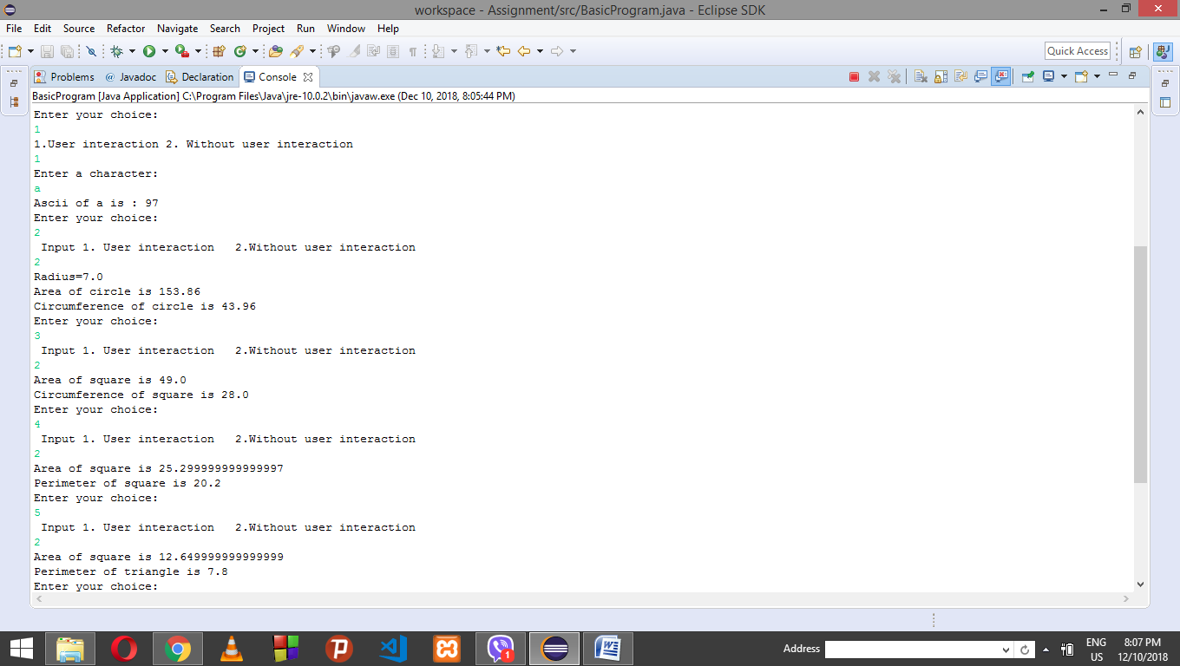

//Data Types

1. Write a program to convert temperature from Fahrenheit to Celsius degree and vice versa.

a. Without user interaction b. With user interaction

2. Write a program that reads a number in inches, converts it to meters.

a. Without user interaction b. With user interaction

3. Write a program that reads an integer between 0 and 1000 and adds all the digits in the integer. Example: Input = 1234 Output =10

a. Without user interaction b. With user interaction

4. Write a program that prints the current time in GMT.

5. Write a Java program to compute body mass index (BMI) and displays the information based on the calculation.

BMI Values:

Underweight : less than 18.5

Normal : between 18.5 and 24.9

Overweight : between 25 and 29.9

Obese : 30 or greater

a. Without user interaction b. With user interaction

6. Write a program to break an integer into a sequence of individual digits.

**import** java.util.Scanner;

**public** **class** dataTypes {

**static** Scanner *input* = **new** Scanner(System.***in***);

**public** **static** **void** main(String[] args) {

System.***out***.println("1. Write a program to convert temperature from Fahrenheit to Celsius degree and vice versa.\r\n" +

"a. Without user interaction\r\n" +

"b. With user interaction\r\n" +

"2. Write a program that reads a number in inches, converts it to meters.\r\n" +

"a. Without user interaction\r\n" +

"b. With user interaction\r\n" +

"3. Write a program that reads an integer between 0 and 1000 and adds all the digits in the\r\n" +

"integer.\r\n" +

"Example:\r\n" +

"Input = 1234\r\n" +

"Output =10\r\n" +

"a. Without user interaction\r\n" +

"b. With user interaction\r\n" +

"4. Write a program that prints the current time in GMT.\r\n" +

"5. Write a Java program to compute body mass index (BMI) and displays the information\r\n" +

"based on the calculation.BMI Values:\r\n" +

"Underweight : less than 18.5\r\n" +

"Normal : between 18.5 and 24.9\r\n" +

"Overweight : between 25 and 29.9\r\n" +

"Obese : 30 or greater\r\n" +

"]\r\n" +

"a. Without user interaction\r\n" +

"b. With user interaction\r\n" +

"6. Write a program to break an integer into a sequence of individual digits. ");

**int** ch;

**do**

{

System.***out***.println("Enter your choice:");

ch=*input*.nextInt();

**switch**(ch)

{

**case** 1:

*changeTemp*();

**break**;

**case** 2:

*inch_to_meter*();

**break**;

**case** 3:

*addDigits*();

**break**;

**case** 4:

*current_time*();

**break**;

**case** 5:

*bmi*();

**break**;

**case** 6:

*break_into_digits*();

**break**;

**case** 7:

System.*exit*(0);

**default**:

System.***out***.println("Input is wrong. ");

}

}**while**(ch<7);

}

**public** **static** **void** changeTemp()

{

System.***out***.println(" Input 1. User interaction 2.Without user interaction");

**int** num=*input*.nextInt();

**if**(num==1)

{

System.***out***.print("Enter the temperature in Fahrenheit: ");

**double** f=*input*.nextDouble();

**double** celseus=(f-32)*5/9;

System.***out***.println("Temperature in Celsius: "+celseus);

System.***out***.print("Enter the temperature in Celsius: ");

**double** celsius=*input*.nextDouble();

**double** fahrenheit=(celsius*9/5)+32;

System.***out***.println("Temperature in Fahrenheit: "+fahrenheit);

}

**else**

{

System.***out***.print("Enter the temperature in Fahrenheit: ");

**double** f=200;

**double** celseus=(f-32)*5/9;

System.***out***.println("Temperature in Celsius: "+celseus);

System.***out***.print("Enter the temperature in Celsius: ");

**double** celsius=200;

**double** fahrenheit=(celsius*9/5)+32;

System.***out***.println("Temperature in Fahrenheit: "+fahrenheit);

}

}

**public** **static** **void** inch_to_meter()

{

System.***out***.println(" Input 1. User interaction 2.Without user interaction");

**int** num=*input*.nextInt();

**if**(num==1)

{

System.***out***.print("Input a value for inch: ");

**double** inch = *input*.nextDouble();

**double** meters = inch * 0.0254;

System.***out***.println(inch + " inch is " + meters + " meters");

}

**else**

{

System.***out***.print("Input a value for inch: ");

**double** inch = 1000;

**double** meters = inch * 0.0254;

System.***out***.println(inch + " inch is " + meters + " meters");

}

}

**public** **static** **void** addDigits()

{

System.***out***.println(" Input 1. User interaction 2.Without user interaction");

**int** num=*input*.nextInt();

**if**(num==1)

{ System.***out***.println("Enter number:");

**int** sum=0;

**int** n=*input*.nextInt();

**int** val=n;

**while** ( n!=0 )

{

sum+=n%10;

n/=10;

}

System.***out***.println("Sum of digits of "+val+" is "+ sum);

}

**else**

{

**int** sum=0;

**int** n=1234;

**int** val=n;

**while** ( n!=0 )

{

sum+=n%10;

n/=10;

}

System.***out***.println("Sum of digits of "+val+" is "+ sum);

}

}

**public** **static** **void** current_time()

{

System.***out***.print("Input the time zone offset to GMT: ");

**long** timeZoneChange = *input*.nextInt();

**long** totalMilliseconds = System.*currentTimeMillis*();

**long** totalSeconds = totalMilliseconds / 1000;

**long** currentSecond = totalSeconds % 60;

**long** totalMinutes = totalSeconds / 60;

**long** currentMinute = totalMinutes % 60;

**long** totalHours = totalMinutes / 60;

**long** currentHour = ((totalHours + timeZoneChange) % 24);

System.***out***.println("Current time is " + currentHour + ":" + currentMinute + ":" + currentSecond);

}

**public** **static** **void** bmi()

{

System.***out***.println(" Input 1. User interaction 2.Without user interaction");

**int** num=*input*.nextInt();

**if**(num==1) {

**double** bmi;

System.***out***.println("Enter weight in kg:");

**int** kg=*input*.nextInt();

System.***out***.println("Height in meters");

**double** height=*input*.nextDouble();

bmi=kg/(height*height);

**if**(bmi<18.5)

{

System.***out***.println("Underweight");

}

**else** **if**( bmi <25)

{

System.***out***.println("Normal");

}

**else** **if**(bmi<30)

{

System.***out***.println("OverWeight");

}

**else**

{

System.***out***.println("Obese");

}

}

**else**

{

**double** bmi;

**int** kg=50;

System.***out***.println("Weights in kg:"+kg);

**double** height=1.7;

System.***out***.println("Height in meters"+height);

bmi=kg/(height*height);

**if**(bmi<18.5)

{

System.***out***.println("Underweight");

}

**else** **if**( bmi <25)

{

System.***out***.println("Normal");

}

**else** **if**(bmi<30)

{

System.***out***.println("OverWeight");

}

**else**

{

System.***out***.println("Obese");

}

}

}

**public** **static** **void** break_into_digits()

{

**int** reminder=0;

System.***out***.println("Enter a number:");

**int** number=*input*.nextInt();

**while**(number!=0) {

reminder=number%10;

System.***out***.println(reminder);

number/=10;

}

}

}

//OUTPUT

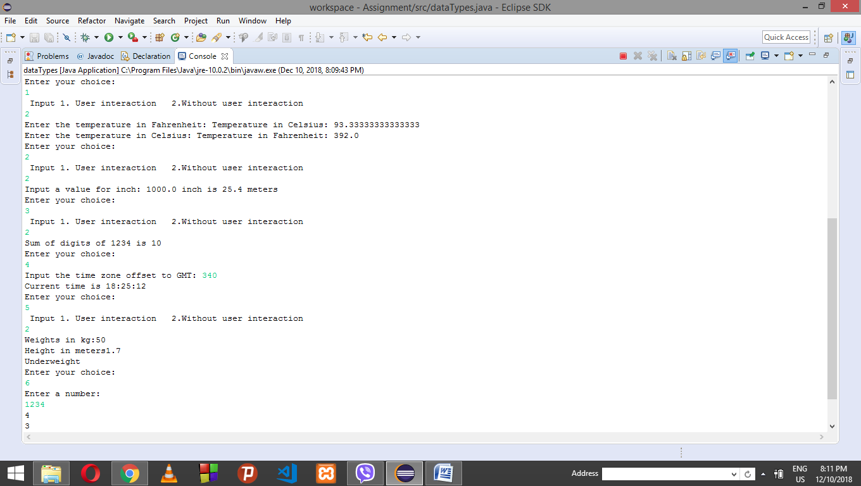

//Variables in Java

1. Write a program in Java to simulate the football match. The program should calculate the total goals of the team, measure the overall team’s performance as well as the performance of individual performance using the methods.

//Program

**public** **class** variables {

//These are the static variables that are shared by the Class instance. (Class)

**static** **int** *fouls* =0;

**static** **int** *corners* =0;

//These are the instance variable shared by every object (players) of the class (Variables)

**int** goal=0;

**int** assists =0;

**int** yellowCard =0;

**int** redCard =0;

**public** **void** stats(){

//These are the local variables that are inside method, the same name has been given as to show the scope.

**int** goal = **this**.goal;

**int** assists = **this**.assists;

**int** yellowCard = **this**.yellowCard;

**int** redCard = **this**.redCard;

**int** fouls= **this**.*fouls*;

System.***out***.println(" Goals: "+ goal);

System.***out***.println(" Assist: "+assists);

System.***out***.println(" Yellow Cards: "+yellowCard);

System.***out***.println(" Red Cards: "+redCard);

System.***out***.println(" fouls:"+fouls);

}

**public** **static** **void** main (String args[]){

variables messi = **new** variables();

variables aguero = **new** variables();

//now messi scores goal;

messi.goal = messi.goal+1;

aguero.*fouls*++;

aguero.goal++;

//team gets corners

*corners*=*corners*+1;

//again messi scores goal;

messi.goal = messi.goal+1;

aguero.*fouls*=*fouls*+1;

messi.goal = messi.goal+1;

aguero.yellowCard=messi.yellowCard+1;

messi.assists = messi.assists+1;

messi.assists = messi.assists+1;

aguero.assists = messi.assists+1;

**int** totalGoals = aguero.goal+messi.goal;

**int** totalYellowCards = messi.yellowCard+aguero.yellowCard;

**int** totalRedCards = messi.redCard+aguero.redCard;

System.***out***.println("\n=============Team Overall Statistics===========");

System.***out***.println("Total Goals: "+totalGoals);

System.***out***.println("Total Fouls: "+*fouls*);

System.***out***.println("Total Corners: "+*corners*);

System.***out***.println("Total Yellow Cards: "+totalYellowCards);

System.***out***.println("Total Red Cards: "+totalRedCards);

System.***out***.println("\n=============Aguero Performance=============");

aguero.stats();

System.***out***.println("==============Messi Performance=============");

messi.stats();

}

}

//OUTPUT

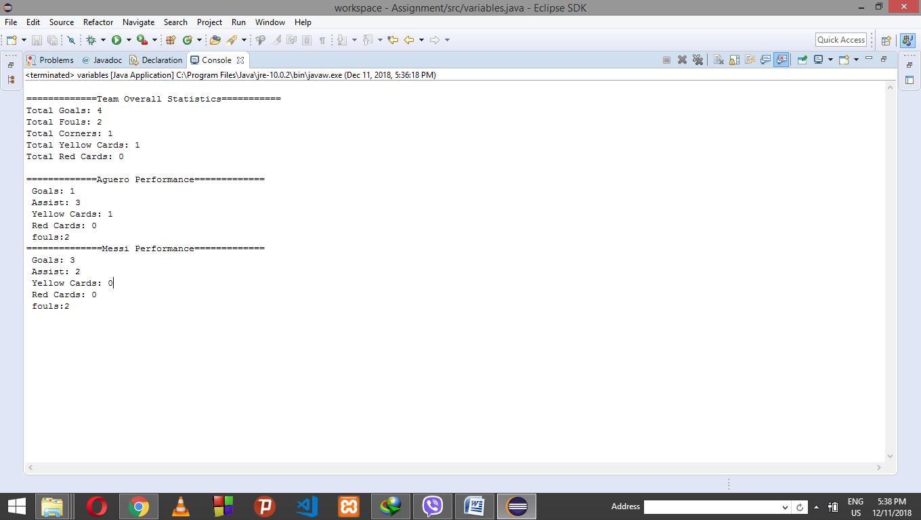

//Operators in Java

1. Write a program to find the smallest among three digits using ternary operator.

a. Without user interaction b. With user interaction

2. Write a program to find the largest among three digits using ternary operator.

a. Without user interaction b. With user interaction

//Program

**import** java.util.Scanner;

**public** **class** CheckLargestSmallest {

**int** a,b,c,result;

**public** **static** Scanner input = **new** Scanner(System.in);

**public** **static** **void** main(String[] args) {

**int** choice;

CheckLargestSmallest C = **new** CheckLargestSmallest();

**do**

{

C.inputThreeNumbers(C.UI());

System.out.println("Enter Your Choice");

System.out.println("Enter 1 to find Smallest among 3 numbers: ");

System.out.println("Enter 2 to find largest among 3 numbers: ");

choice = input.nextInt();

**switch**(choice)

{

**case** 1:

C.checkSmallest();

**break**;

**case** 2:

C.checkLargest();

**break**;

**default**:

System.out.println("Invalid Choice");

}

System.out.println("Enter 1 If you want to continue: ");

choice = input.nextInt();

} **while**(choice == 1);

System.exit(1);

}

**public** **int** UI()

{

System.out.println("Do you want User Interaction: Enter 1");

**int** user = input.nextInt();

**return** user;

}

**public** **void** inputThreeNumbers(**int** u) {

**if**(u == 1)

{

System.out.println("Enter first Number:");

a = input.nextInt();

System.out.println("Enter second Number:");

b = input.nextInt();

System.out.println("Enter third Number:");

c = input.nextInt();

}

**else**

{

a = 1;

b = 2;

c = 3;

}

}

**public** **void** checkSmallest()

{

result = c < (a < b ? a : b) ? c :(a < b ? a : b) ;

System.out.println("smallest: " + result);

}

**public** **void** checkLargest()

{

result = c > (a > b ? a : b) ? c:( a > b ? a : b);

System.out.println("largest: " + result);

}

}

//OUTPUT

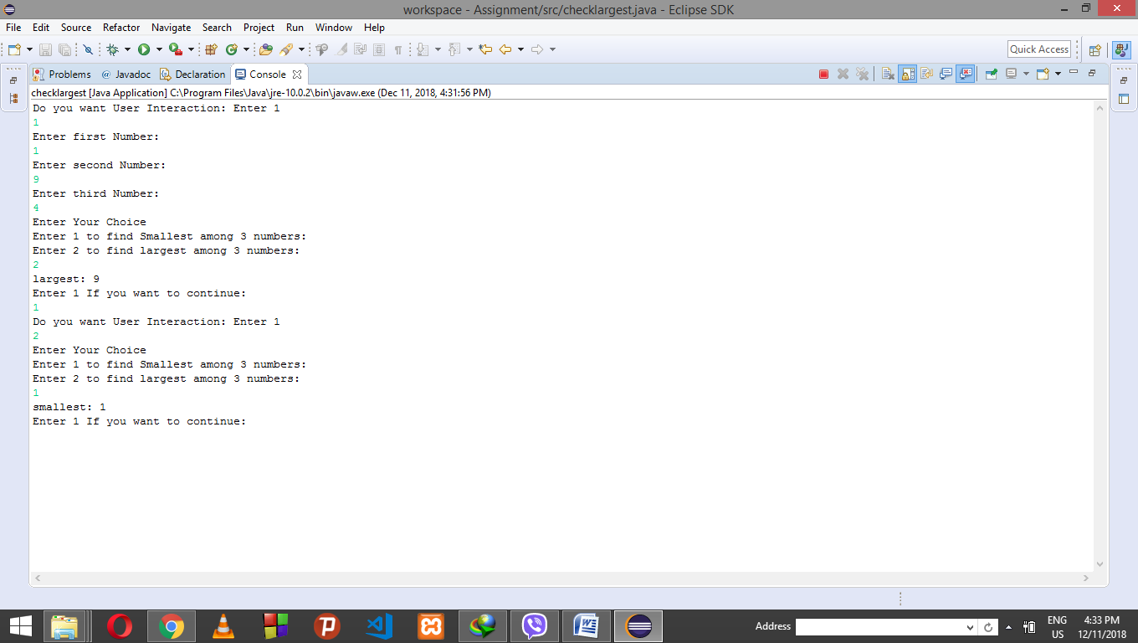

//Control Statements

1. Write a program that takes the user to provide a single character from the alphabet. Print Vowel or Consonant, depending on the user input. If the user input is not a letter (between a and z or A and Z), or is a string of length > 1, print an error message.

2. Write a program in Java to display the multiplication table of a given integer.

a. Without user interaction b. With user interaction

3. Write a program to display the pattern like right angle triangle with a number. Ask user number of rows to print. Example. Rows = 5

1

12

123

1234

12345

4. Write a program to make such a pattern like a pyramid with a number which will repeat the number in the same row.

1

2 2

3 3 3

4 4 4 4

//Program

**import** java.util.Scanner;

**public** **class** ControlStatement {

**static** Scanner *input* = **new** Scanner(System.***in***);

**public** **static** **void** main(String[] args) {

**int** ch;

**do**

{

System.***out***.println("Enter your choice:");

ch=*input*.nextInt();

**switch**(ch)

{

**case** 1:

*alphabet*();

**break**;

**case** 2:

*mul_table*();

**break**;

**case** 3:

*pattern1*();

**break**;

**case** 4:

*pattern2*();

**break**;

**case** 5:

System.*exit*(0);

**default**:

System.***out***.println("Input is wrong. ");

}

}**while**(ch<5);

}

**public** **static** **void** alphabet()

{

System.***out***.print("Input an alphabet: ");

String in = *input*.next().toLowerCase();

**boolean** uppercase = in.charAt(0) >= 65 && in.charAt(0) <= 90;

**boolean** lowercase = in.charAt(0) >= 97 && in.charAt(0) <= 122;

**boolean** vowels =*in*.equals("a") ||*in*.equals("e") ||*in*.equals("i")

|| *in*.equals("o") ||*in*.equals("u");

**if** (in.length() > 1)

{

System.***out***.println("Error. Not a single character.");

}

**else** **if** (!(uppercase || lowercase))

{

System.***out***.println("Error. Not a letter. Enter uppercase or lowercase letter.");

}

**else** **if** (vowels)

{

System.***out***.println("Input letter is Vowel");

}

**else**

{

System.***out***.println("Input letter is Consonant");

System.***out***.println();

}

}

**public** **static** **void** mul_table()

{

**int** i,j;

System.***out***.print("Input the number to calculate table : ");

i = *input*.nextInt();

System.***out***.println ("\n");

**for**(j=0;j<=i;j++)

System.***out***.println(i+" X "+j+" = " +i*j);

}

**public** **static** **void** pattern1()

{ **int** i,j;

System.***out***.println("Enter no. of rows:");

**int** rows=*input*.nextInt();

**for**(i=1;i<=rows;i++)

{

**for**(j=1;j<=i;j++)

{

System.***out***.print(j+" ");

}

System.***out***.println();

}

}

**public** **static** **void** pattern2()

{

**int** i,j,k;

**for**(i=1;i<=4;i++)

{

**for**(k=3;k>=i;k--)

{

System.***out***.print(" ");

}

**for**(j=1;j<=i;j++)

{

System.***out***.print(i+" ");

}

System.***out***.println();

}

}

}

//OUTPUT

