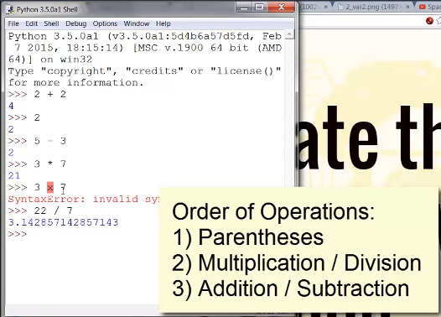

Each line is called an expression… and the order of excution is shown in snippet..

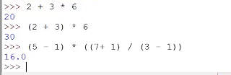

**Data types:**

Integer (-2, 42,3, 4…. Are integers)

Float (42.0, 31.5 ….. are floting values)

String (‘bibhu’ , ‘hello’)

**Variables:**

>>> spam=42

>>> spam

42

>>> spam+2

44

>>> spam='bibhu'

>>> spam+2

Traceback (most recent call last):

File "<pyshell#24>", line 1, in <module>

spam+2

TypeError: can only concatenate str (not "int") to str

>>>



Write you first programme..

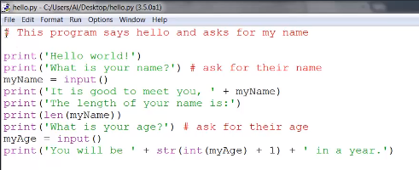

Input() 🡪 this function wait for user to give data

**Typecasting:**

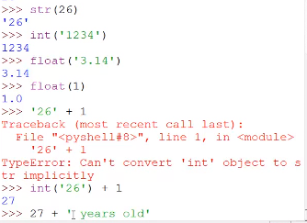

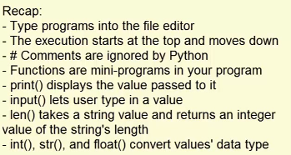

**Operators:**

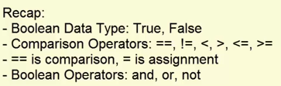

**If, else and elif statements:**

**Example:**

name='Bibhu'

if name=='Bibhu':

print('Hi Bibhu')

print('Done')

o/p- Hi Bibhu

Done

**Note: we can visualize our code with python tutor:** <http://pythontutor.com/visualize.html#mode=display>

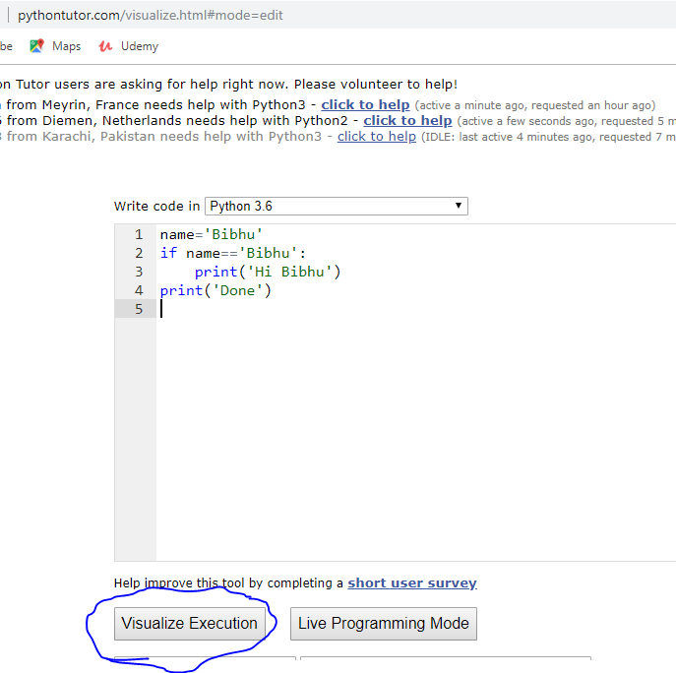

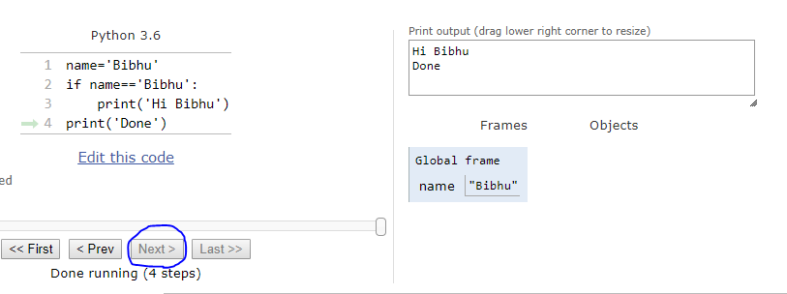

Example:

pwd='abc'

print('enter the pwd')

password=input()

if password==pwd:

print('Access granted:)')

else:

print('Wrong password:(')

O/P-

enter the pwd

abc

Access granted:)

**Example: (if-elif)**

name='raja'

age=28

if name=='Sanu':

print('Hi Sanu')

elif age < 12:

print('You are not raja')

elif age > 25:

print('You are raja')

O/P-

You are raja

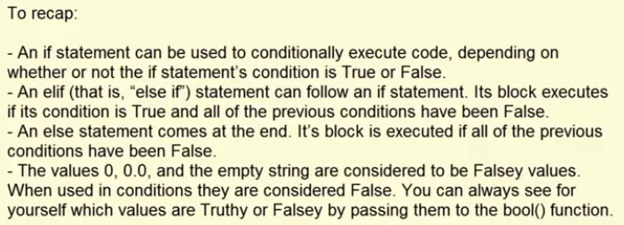

**While loop:**

**Example:**

spam=0

while spam < 5:

print('hello spam={}'.format(spam))

spam=spam+1

O/P-

hello spam=0

hello spam=1

hello spam=2

hello spam=3

hello spam=4

**loop control by ‘break’:**

name=''

while True:

print('Enter your name')

name=input()

if name == 'you name':

break

print('Thank you')

O/P-

Enter your name

bibhu

Enter your name

Ali

Enter your name

raja

Enter your name

you name

Thank you

**Loop control by ‘continue’:**

spam = 0

while spam < 5:

spam = spam + 1

if spam == 3:

continue

print('Spam is '+ str(spam))

o/p-

Spam is 1

Spam is 2

Spam is 4

Spam is 5

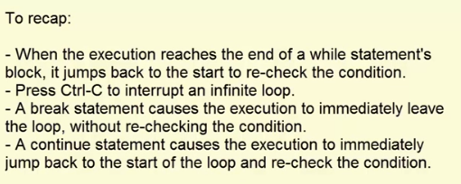

**for loop:**

print('My name is: ')

for i in range(5):

print('hi your name counts: '+ str(i))

o/p-

My name is:

hi your name counts: 0

hi your name counts: 1

hi your name counts: 2

hi your name counts: 3

hi your name counts: 4

**Examples:**

for i in range(5,10):

print('the number is: '+ str(i))

o/p-

the number is: 5

the number is: 6

the number is: 7

the number is: 8

the number is: 9

for i in range(5,10,2):

print('the number is: '+ str(i))

o/p-

the number is: 5

the number is: 7

the number is: 9

for i in range(5,-1,-1):

print('the number is: '+ str(i))

o/p-

the number is: 5

the number is: 4

the number is: 3

the number is: 2

the number is: 1

the number is: 0

**infinite for loop:**

import itertools

for i in itertools.repeat(1):

print('Hi')

