**--------Dictionaries--------**

* **The Dictonary Data Type:**

In dictonary index is called as key & while writing dictonary .. we have to give as key-value pair.

Dictionary will be enclosed in {}

Examples:

|  |
| --- |
| >>> myCat = {'size':'fat','color':'gray','disposition':'loud'}  >>> ## size , color & disposition are the key of this dictonary  >>> ## fat , gray & loud are the value for respective key  >>> myCat['size']  'fat'  >>> myCat['color']  'gray'  >>> myCat['disposition']  'loud'  >>> 'My cat has '+myCat['color']+' fur.'  'My cat has gray fur.'  >>> print('My cat has '+myCat['color']+' fur.')  My cat has gray fur. |

## Dictonaries are unorderd but list are odered.

## Example:

|  |
| --- |
| >>> [1,2,3] == [2,1,3]  False  >>> egg = {'name':'zophie','species':'cat','age':8}  >>> ham = {'species':'cat','age':8,'name':'zophie'}  >>> egg == ham  True |

We can search key in a dictonary using ‘in’ or ‘not in’ operator…

|  |
| --- |
| >>> 'name' in egg  True  >>> 'name' not in egg  False |

We can use 3 methods on dictonary key() , value() and items()

|  |
| --- |
| >>> for k in egg.keys():  print(k)    name  species  age  >>> for v in egg.values():  print(v)    zophie  cat  8  >>> for k, v in egg.items():  print(k , v)    name zophie  species cat  age 8  >>>  >>> for k in egg.keys():  print(egg[k])    zophie  cat  8  >>>  >>> print i in egg.items():    SyntaxError: invalid syntax  >>> for i in egg.items():  print(i)    ('name', 'zophie')  ('species', 'cat')  ('age', 8)  >>>  ## if you are trying to access a key .. and it is not there .. then it could crash your program..  ##so use the following procedure  >>> egg = {'name':'zophie','species':'cat','age':8}  >>> 'cat' in egg.values()  True  >>>  >>> egg['color']  Traceback (most recent call last):  File "<pyshell#4>", line 1, in <module>  egg['color']  KeyError: 'color'  >>> if 'color' in egg:  print(egg['color'])    >>>## But above method is very tedious when you code for realtime project.. so to get rid of this … problem.. use **get()** method..  >>> egg = {'name':'zophie','species':'cat','age':8}  >>> egg  {'name': 'zophie', 'species': 'cat', 'age': 8}  >>> egg.get('color',0) ### if 'color' is not there then return 0  0  >>> egg.get('age',0)  8  >>> |

**Q > How to set a value or add a value to a dictonary?**

|  |
| --- |
| >>> egg  {'name': 'zophie', 'species': 'cat', 'age': 8}  >>> if 'color' not in egg:  egg['color'] = 'black'    >>> egg  {'name': 'zophie', 'species': 'cat', 'age': 8, 'color': 'black'}  >>> **## OR ###**  >>> egg = {'name':'zophie','species':'cat','age':8}  >>> egg  {'name': 'zophie', 'species': 'cat', 'age': 8}  >>> egg.setdefault('color','black') ##it will work if they key is not there  'black'  >>> egg  {'name': 'zophie', 'species': 'cat', 'age': 8, 'color': 'black'}  >>> |

Q> Calculate letter occurance in a string?

|  |
| --- |
| msg='my Name is Bibhu'  count = {}  for ch in msg:  count.setdefault(ch,0)  count[ch]=count[ch]+1  print(count)  o/p-  {'m': 2, 'y': 1, ' ': 3, 'N': 1, 'a': 1, 'e': 1, 'i': 2, 's': 1, 'B': 1, 'b': 1, 'h': 1, 'u': 1} |

Note: As dictonary is un-orderd , so we can use **pprint** module to make it in ordered format.

|  |
| --- |
| Import pprint  msg='my Name is Bibhu'  count = {}  for ch in msg:  count.setdefault(ch,0)  count[ch]=count[ch]+1  pprint.pprint(count)  O/P-  {' ': 3,  'B': 1,  'N': 1,  'a': 1,  'b': 1,  'e': 1,  'h': 1,  'i': 2,  'm': 2,  's': 1,  'u': 1,  'y': 1} |

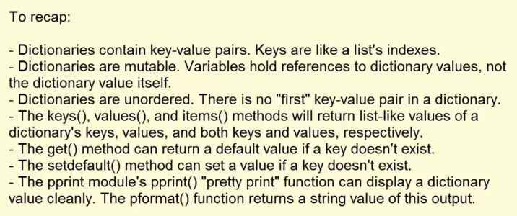

* **DATA Structure:**

We can use dictionary as data structure.

We can use list of dictionary as a data structure.

|  |
| --- |
| >>> cat = {'name':'zophie','age':7,'color':'gray'}  >>> allCats = []  >>> allCats.append({'name':'sipu','age':8,'color':'white'})  >>> allCats.append({'name':'chiku','age':3,'color':'orange'})  >>> print(allCats)  [{'name': 'sipu', 'age': 8, 'color': 'white'}, {'name': 'chiku', 'age': 3, 'color': 'orange'}]  >>> |

**Tic-tac-toe game using data structure:**



  
  
  