If you are doing webscraping or checking a website over and over again. then with help of python we can mail to someone .. if i am looking for some perticular thing.

**Sending Emails:**

-> The protocol which sends emails called SMTP (Simple Mail Transfer Protocol) and python uses a module to implement SMTP is called 'smtplib'

->Enable the below settings.. otherwise will see error while mail login process.

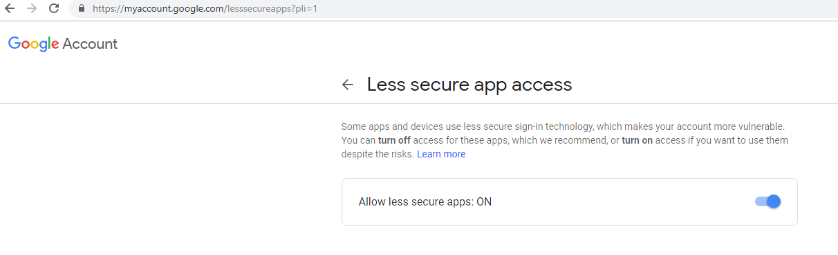

Example:

>>> import smtplib

>>> conn = smtplib.SMTP('smtp.gmail.com', 587)

>>> conn.ehlo() *##just to connect to smtp server*

(250, b'smtp.gmail.com at your service, [103.229.19.19]\nSIZE 35882577\n8BITMIME\nSTARTTLS\nENHANCEDSTATUSCODES\nPIPELINING\nCHUNKING\nSMTPUTF8')

>>> conn.starttls() ## here we start encryption

(220, b'2.0.0 Ready to start TLS')

>>> conn.login('bibhu.prasad.dash01@gmail.com', 'nanabouraja1#')

(235, b'2.7.0 Accepted')

>>>

>>> conn.sendmail('bibhu.prasad.dash01@gmail.com', 'bibhu.prasad.dash01@gmail.com', 'Subject: testing mail with python...\n\nDear bibhu, \nThanks for reading python.\n\n Bibhu Again')

{}

>>> conn.quit()

(221, b'2.0.0 closing connection 63sm15795133pfs.65 - gsmtp')

>>>

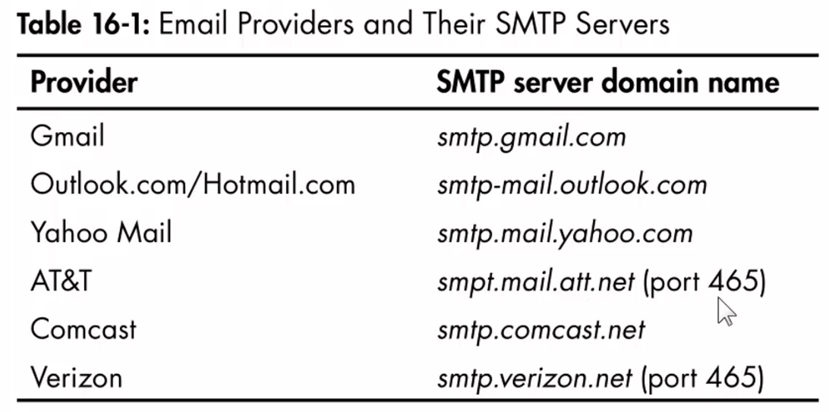

**Checking your Emailinbox:**

* IMAP (Internet Message Access protocol ) helps , how to communicate with the email provider server to retrieve email that is sent my email address.
* IMAP is very complicated and not user friendly (we can do “import imaplib”), but will use two third party module… below mentioned…

*pip install imapclient*

*pip install pyzmail*

Example:

>>> import imapclient

>>> conn = imapclient.IMAPClient('imap.gmail.com', ssl=True)

>>> conn.login('bibhu.prasad.dash01@gmail.com', 'nanabouraja1#')

b'bibhu.prasad.dash01@gmail.com authenticated (Success)'

>>> conn.select_folder('INBOX', readonly= True)

{b'PERMANENTFLAGS': (), b'FLAGS': (b'\\Answered', b'\\Flagged', b'\\Draft', b'\\Deleted', b'\\Seen', b'$NotPhishing', b'$Phishing'), b'UIDVALIDITY': 629967566, b'EXISTS': 21900, b'RECENT': 0, b'UIDNEXT': 39872, b'HIGHESTMODSEQ': 3202119, b'READ-ONLY': [b'']}