Function

**Python Built in function:**

Example: print(), len(), input()

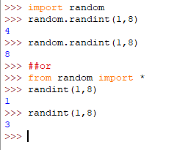

Note:

How to exit from main function…?

Ans- You can use sys.exit() to exit from the middle of the main function.

Example code :

|  |
| --- |
| def main():  type your code  sys.exit()  if __name__ == ‘__main__’:  import sys  import os  import subprocess |

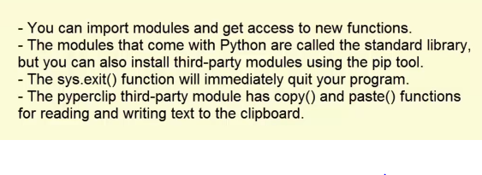

**Write your own function:**

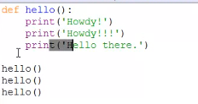

O/P-

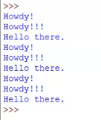

How to pass a value to function and get return value of it?

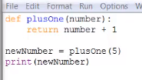

O/P- 6

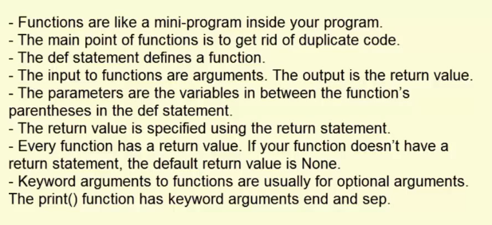

**Global and local scopes:**

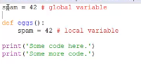

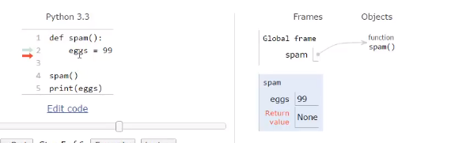

Example:

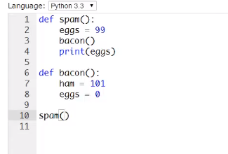

Example:

