**2-For loop with lists, Multiple assignments & Augmenetd assignmet operator:**

* Using range() object as a list:

|  |
| --- |
| >>> import os  >>> for i in range(5):  print(i)  O/P-  0  1  2  3  4 |
| >>> for i in [1,2,3,4]:  print(i)  O/p-  1  2  3  4  >>> |

>>> list(range(5))

[0, 1, 2, 3, 4]

>>>

* Multiple assignment:

|  |
| --- |
| >>> cat = ['fat','orange','loud']  >>> size=cat[0]  >>> color=cat[1]  >>> disposition=cat[2]  >>>  >>> ### Or  >>>  >>> size,color,disposition=cat  >>> size  'fat'  >>> color  'orange'  >>> disposition  'loud'  >>>  >>> size, color, disposition= 'skiny', 'dark', 'quit'  >>>  >>> size  'skiny'  >>> color  'dark'  >>> disposition  'quit' |

* Swaping:

>>> a='hello'

>>> b='world'

>>> a,b =b,a

>>> a

'world'

>>> b

'hello'

>>>

* Augmented operator:

|  |
| --- |
| >>> x=42  >>> x=x+1  >>> x  43  >>> x+=1  >>> x  44  >>> |

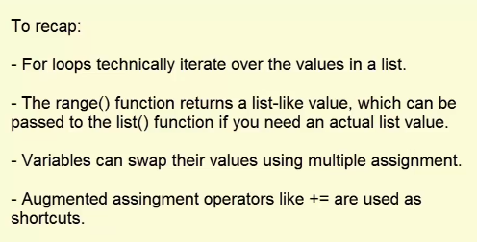

**3-List methods:**

Index() method:

|  |
| --- |
| >>> spam = ['hello','hi','howdy','heyas']  >>> spam.index('hello')  0 |
| >>> spam = ['hello','hi','howdy','hi']  >>> spam.index('hi')  1  >>> |

Append() and insert() methods:

|  |
| --- |
| >>> spam = ['cat','dog','bat']  >>> spam.insert('mouse')  >>> spam.append('mouse')  >>> spam  ['cat', 'dog', 'bat', 'mouse']  >>>  >>> spam.insert(1,'chicken')  >>> spam  ['cat', 'chicken', 'dog', 'bat', 'mouse']  >>> |

Remove() method & del statement:

|  |
| --- |
| ['cat', 'chicken', 'dog', 'bat', 'mouse']  >>>  >>> del spam[0]  >>> spam  ['chicken', 'dog', 'bat', 'mouse']  >>>  >>> spam.remove('bat')  >>> spam  ['chicken', 'dog', 'mouse']  >>> |

Sort() method :

|  |
| --- |
| >>> spam = [2,3,1,7,6]  >>> spam.sort()  >>> spam  [1, 2, 3, 6, 7]  >>> spam =['chicken', 'dog', 'bat', 'mouse']  >>> spam.sort()  >>> spam  ['bat', 'chicken', 'dog', 'mouse']  >>>  >>> spam = ['hi','hello',1]  >>> spam.sort()  Traceback (most recent call last):  File "<pyshell#86>", line 1, in <module>  spam.sort()  TypeError: '<' not supported between instances of 'int' and 'str'  >>> |

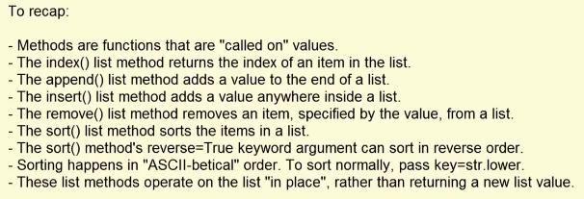

**4-Similarity between List & string:**

In string we can do indexing, looping, slicing . But we we can not assign values like list.

Because List are immutable but string is mutable.

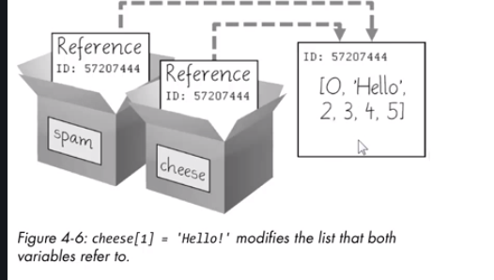

>>> spam = [0,1,2,3,4]

>>> spam

[0, 1, 2, 3, 4]

>>> cheese = spam

>>> cheese[1]='hello'

>>> spam

[0, 'hello', 2, 3, 4]

>>>

