Object oriented programming:

In traditional method of programming (procedure oriented) programming, data and functions are separate or we can say different enity. Will send some data to a function and it will return some value.

But function(procedure) cann’t hold any data, it’s a drawback.

Where as in object oriented programming data & method/function are part of a single entity called class or we can say it is bluprint. So we can create a object/instance of a class and use its members

|  |  |
| --- | --- |
|  |  |

Note:

Data in class called attribute or member variables.

Function in class called method.

Classes and objects in python:

We can Create class using class keyword

Example car.py:

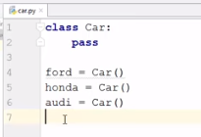

**pass** means empty class, we can create empty function/method as well.

Ford,Honda & audi are object of class Car.

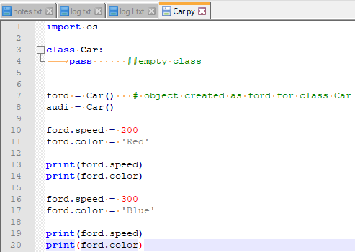

O/p-

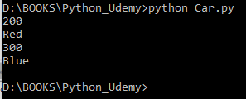

Python __init__ and self in class:

__init__ method is like a constructor and first method to called when any object will be created for the class , where __init__ method present. And self will the first argument for the __init__ method.

Please check the below example:

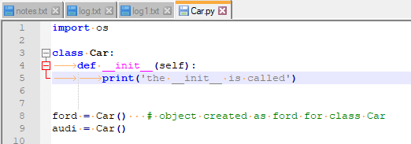

O/p-

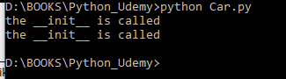 twice called .. when two times object created

Note: We called __init__ as a constructor but it is not a actual constructor but behave like a constructor.

And there is no destructor in python as it has facility of automatic garbage collection.

As __init__ method we can use for initialization, we can use the above programme like below as well:

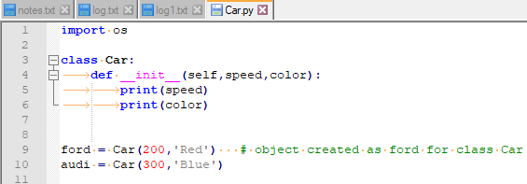

O/P-

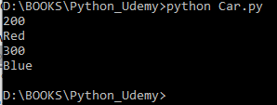

Example:

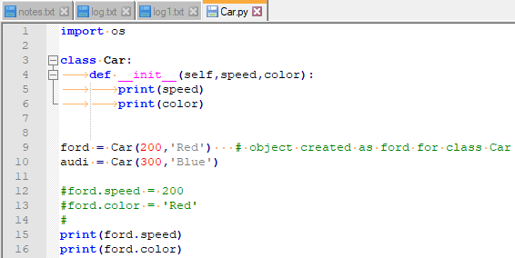

O/P-

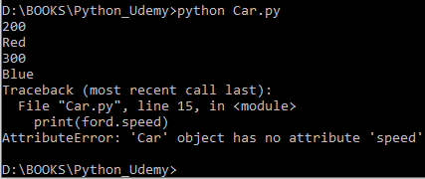

As there is no value provide to speed and color attribute. So we are seeing this error..

Follow below procedure to avoid the error:

Self.speed and self.color

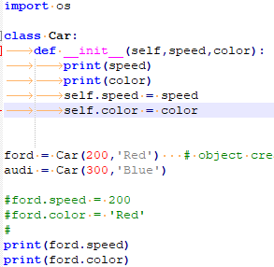

O/P-

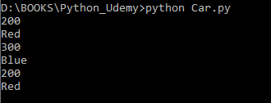

Note:

We use ‘self’ as first argument for every method , but it is not necessary that it will ‘self’ only.

We can give some other name as well.

With out self argument:

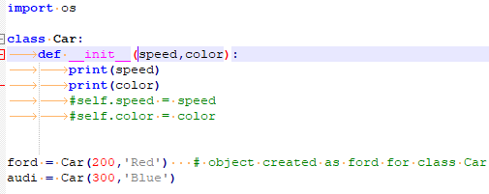

o/p-

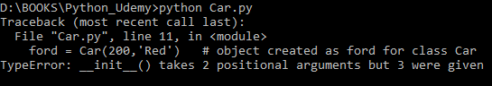

Multiple __init__ method:



Note:

Multiple __init__ method is not possible in a class , but if you give then last __init__ method will be the final one.

How to provide multiple arguments?

Ans> by using *args

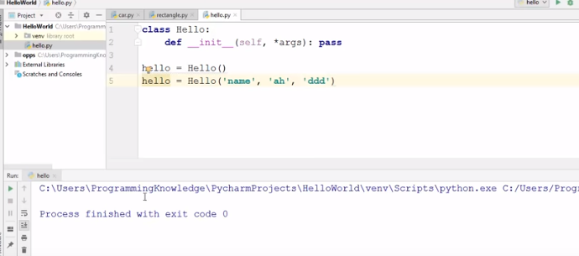

Note:

For dictionary we can provide **kwargs in __init__ method and in object creation we can pass key,value pair like below:  
hello = Hello(name=’bibhu’)

Python Encapsulation:

If for a attribute which takes numeric value .., but if I will give string for that .. then it will work but not a valid one.

So we need to provide security to our data to be modified so easily.

This is called encapsulation , which provides security to our data to be modified.

We can use get_ & set_ methods to secure data from direct modification.

As we know in c++ there is a concept of private,public & protected keywords to protect our data.

But in python there is now such keyword .

In python for private we use double underscore(__) before any attribute.

 Her also we can use ford.set_speed(400) to set the value and ford.get_speed() to get the speed value.

O/P-

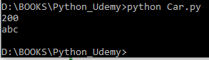

We can see in the above example after using set_ and get_ also our data can be modified.

So now will use underscore(__) before any attribute to make our data private.

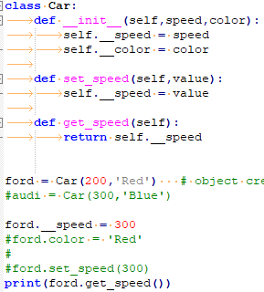

O/P-

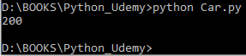ford.__speed() is not working as it is private.

But we can change private value using set_speed() method.

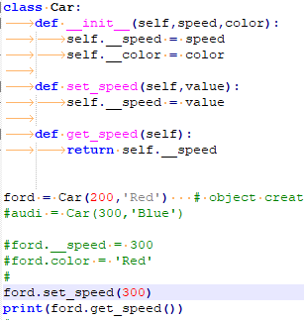

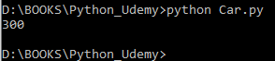

Note:

Private member variables are not accessible outside of class, but accessible in the same class with different member function.

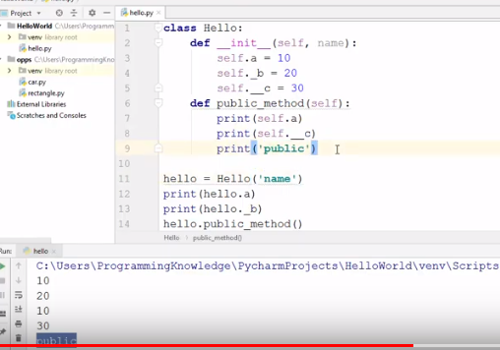

Private Method:



Note:

Private method cann’t called outside class , but can be called outside class.

Inheritance in python:

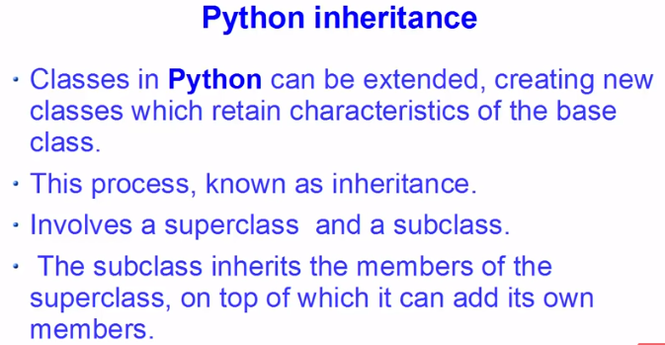

Example:

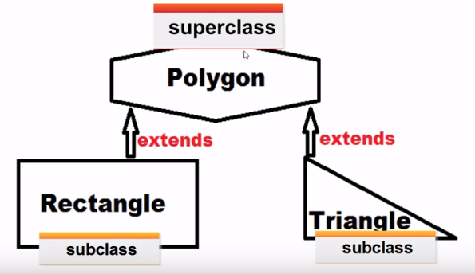

Example:

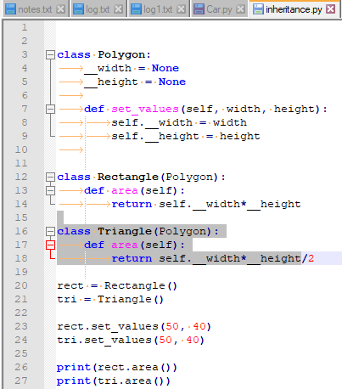

O/P-

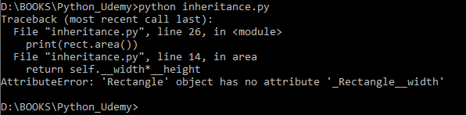

Note:

__width & __height are private members of polygon superclass so it cannot be accessible to subclass.

Solution:

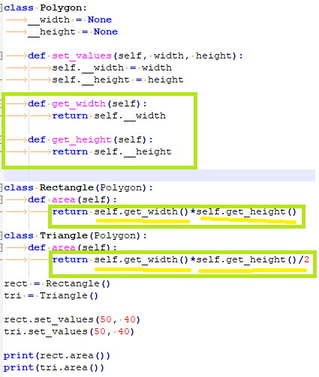

O/P-

