**1-Advanced String Syntax:**

>>> 'bibhu'

'bibhu'

>>> 'this is bibhu's cat'

SyntaxError: invalid syntax

>>>

>>> ###**Using Escape character**

>>>

>>> 'this is bibhu\'s cat'

"this is bibhu's cat"

>>>

>>> ### **Or we can use double quotes as well**

>>>

>>> "this is bibhu's cat"

"this is bibhu's cat"

>>>

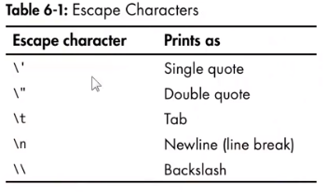

>>> print('Hello there!\nHow are you?\nI\'m fine')

Hello there!

How are you?

I'm fine

>>> ## If you don't want to write so much of escape characters ..then..

>>>

>>> ## **Use Raw string in python**

>>> r'Hello'

'Hello'

>>> print(r'Hello there!')

Hello there!

>>> print(r'This is Carol\'s cat')

This is Carol\'s cat

>>> print(r'This is carol\\'s cat')

SyntaxError: invalid syntax

>>>

>>> ## **How to print multiline string.. (This is very useful if you are taking huge paragraph…)**

>>>

>>> print("""My name is bibhu. I am working in Aricent.""")

My name is bibhu. I am working in Aricent.

>>> print("""My name is bibhu. I am working in Aricent.""")

My name is bibhu. I am working in Aricent.

>>> print("""My name is bibhu. I am working in Aricent. bbbbbbbbbbbbbbbbbbbbbbbbbbbbbbbbbbbbbbbbbbbbbbbbbbbbbbbbbbbbbbbbbbbb """)

My name is bibhu. I am working in Aricent. Bbbbbbbbbbbbbbbbbbbbbbbbbbbbbbbbbbbbbbbbbbbbbbbbbbbbbbbbbbbbbbbbbbbb

>>> spam

'My name is bibhu. I am working in Aricent. bbbbbbbbbbbbbbbbbbbbbbbbbbbbbbbbbbbbbbbbbbbbbbbbbbbbbbbbbbbbbbbbbbbb'

>>> **len(spam)**

111

>>>

>>> spam='hello world'

>>> spam[0]

'h'

>>> spam[1:5]

'ello'

>>> spam[-1]

'd'

>>> 'he' in spam

True

>>> 'He' in spam

False

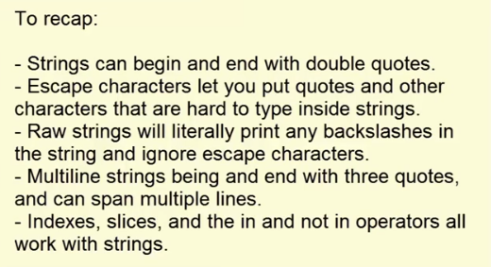

**2-String Methods:**

Strings are mutable, so we cann’t modify the string.

But with string methods we convert it and assign it to other variable.

>>> spam='hello world'

>>> spam.upper()

'HELLO WORLD'

>>> spam

'hello world'

>>> spam=spam.**upper()**

>>> spam

'HELLO WORLD'

>>> spam.**lower()**

'hello world'

>>>

>>> answer=input()

yes

>>> answer

'yes'

>>> answer=input()

YES

>>> answer

'YES'

>>> if answer=='yes':

print('Playing again')

>>> answer == 'yes'

False

>>> answer.lower()=='yes'

True

>>> if answer.lower()=='yes':

print('Playing again')

Playing again

>>>

-----------------------------------------------------------------------

>>> spam='Hello world'

>>> spam.**islower()**

False

>>> spam.lower().islower()

True

>>> spam='HELLO'

>>> spam.**isupper()**

True

>>> spam=''

>>> spam.islower()

False

>>> spam.isupper()

False

>>> '12345'.islower()

False

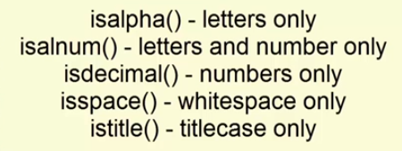

>>> 'Hello world'.**startswith**('Hello')

True

>>> 'Hello world'.startswith('hello')

False

>>> 'Hello world'.**endswith**('world')

True

>>> 'Hello world'.endswith('World')

False

>>>

>>> '.'.**join**(['cat','bat','rat'])

'cat.bat.rat'

>>>

>>>

>>> ','.**join**(['cat','bat','rat'])

'cat,bat,rat'

>>> 'my name is bibhu'.split()

['my', 'name', 'is', 'bibhu']

>>> 'my name is bibhu'.**split**('m')

['', 'y na', 'e is bibhu']

>>>

>>> 'hello'.**rjust**(10)

' hello'

>>> len('hello'.rjust(10))

10

>>> 'hello'.**ljust**(10)

'hello '

>>> 'hello'.ljust(10,'*')

'hello*****'

>>> name='Al'

>>> name.**center**(20,'=')

'=========Al========='

>>> name.**center**(20,'=').strip()

'=========Al========='

>>> name.rjust(20).strip()

'Al'

>>> ' x '.**strip**()

'x'

>>> '==x=='.**strip**()

'==x=='

>>>

>>>

>>> ' x '.**rstrip**() ##to strip white space only

' x'

>>> ' x '.**lstrip**()

'x '

>>>

>>> spam='hello there!'

>>> spam.**replace**('e','xyz')

'hxyzllo thxyzrxyz!'

>>>

**Pyperclip module:**

It can send text to and receive text from computer clipboard…

Pip install pyperclip

>>> import pyperclip

>>>

>>> pyperclip.copy('Hello....')

>>> Hello.... (by doing ctrl+v)

OR

>>> pyperclip.paste()

'Hello....'

>>>

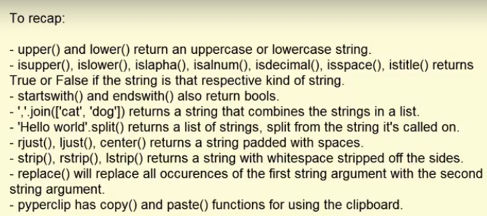

**2-String formatting:**

>>> 'hello'+'world'

'helloworld'

>>>

>>> name='Alice'

>>> place='BBSR'

>>> time='6pm'

>>> food='samosha'

>>> 'Hello'+name+',you are invited to a party at '+place+' at '+time+'. Please bring '+food+'.'

'HelloAlice,you are invited to a party at BBSR at 6pm. Please bring samosha.'

**>>> ##instead of above we can use conversion specifiers for easy code writing.**

**>>> ##Example:**

**>>> ##Note: Here %s are called coversion specifiers..**

>>> 'Hello %s , you are invited to a party at %s at %s. Please bring %s.'%(name,place,time,food)

'Hello Alice , you are invited to a party at BBSR at 6pm. Please bring samosha.'

>>>