**Handling Errors with try/except**

* While running our python program if we are getting any exception, then the entire program is getting crash.
* So the best way is to handle the exception and continue the program to run.
* In below program we are trying to devide 42 by zero so got the exception and program stopped.

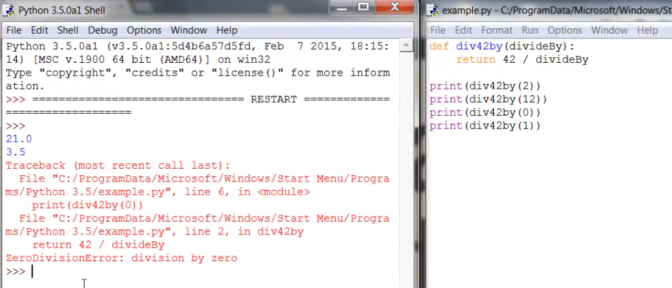

* Solution is to handle the exception using, try/except statement. And program will not stop.

|  |
| --- |
|  |
| O/P-: |

* Let’s try another example:

How many cats I have ? if I will give any number that is fine but if I will give number in letter format , then it will through an exception.

|  |
| --- |
|  |
| O/P:- |

Solution to this problem is as below:

|  |
| --- |
|  |
| O/P: - |

