**Launching Python Programs from Outside IDLE**

It is always inconvenient to open your python program and press F5 to run. So we can create a script like ‘.bat’ which will run our different program sequentillay.. please follow the below procedure…

* The first line of the script should be a “Shebang Line” and for different platform it is different as below:

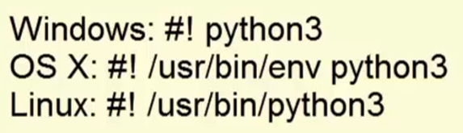

* Let’s take an example:

Create a program as below:

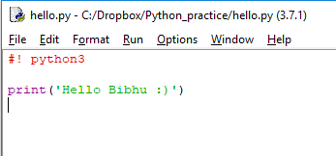

* Now save this program as **hello.py**

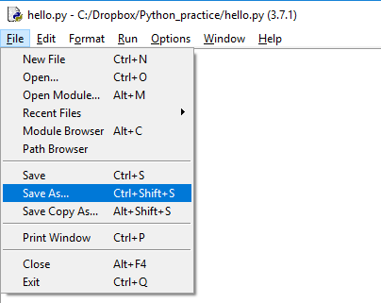

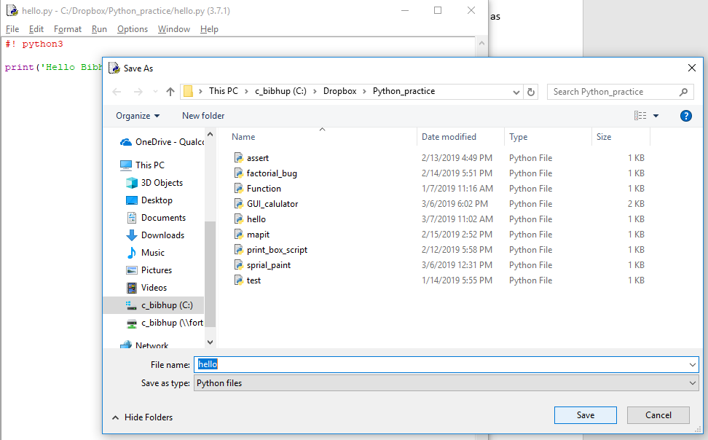

* Now let’s run this program with out Python IDLE

Open a command window and run the hello.py program with full path as below example:

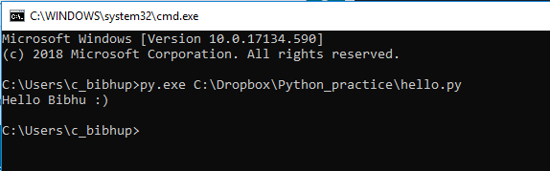

OR

We can run the the same command as above from Run window directly as below:

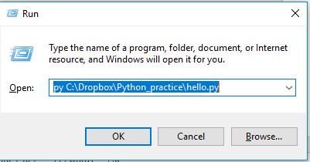

But it will open the window and close instantly after executing the program…

Human eye cannot catch the result.

So, the solution is using the **pause.exe** program which comes by default with windows.

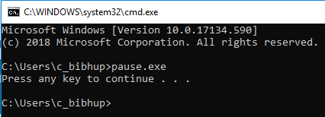

So, it will be better, if we could run our python program and after that we can give a pause. So that the command window will not close instantly.

So now we have to run both (**hello.py** and **pause.exe**) programs , hence the best way is to create a Batch files(these are also called shell scripts in other OS)

And these Batch files basically help us running multiple commands or programs with single file sequentially.

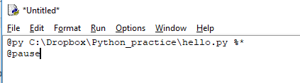

@ symbol indicates:- I don’t want display this line ,but excute the program given

%* indicates:- for accepting any command line arguments if given

Note:

We can use “@pyw” instead of “@py” , if we don’t need any display over command prompt. As below:

@pyw C:\Dropbox\Python_practice\hello.py %*

Now Save as : (hello.bat), with type: (All files) as shown below..

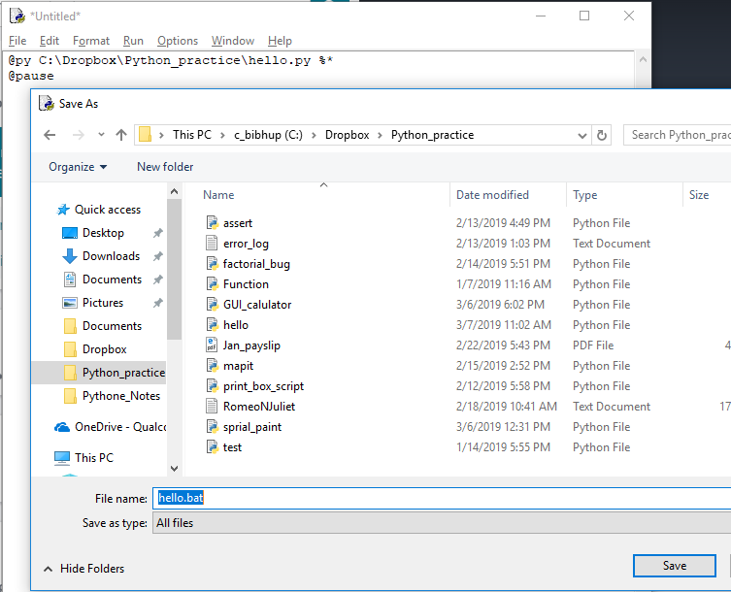

Now we can run the **hello.bat** file from the run window with giving the whole path, as shown below.

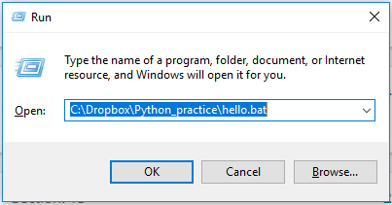

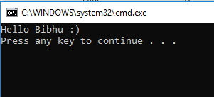

* Still it is very tedious to run our bat script with giving full path.

So, we can add the path (where all python script and bat file) present, to **path** system environment variable.

Follow the below steps-> to set path environment variable.

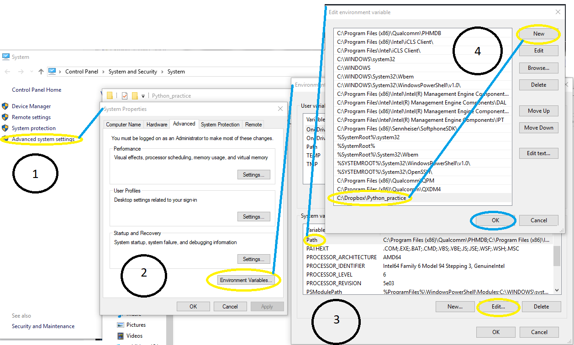

* Now we can hello.bat from run window by only typing “hello” like below 😊

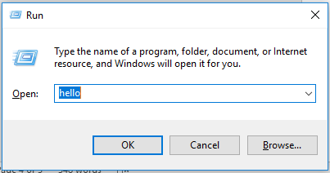

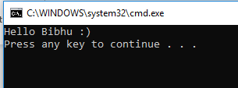

* And for command-line argument please follow the below steps:

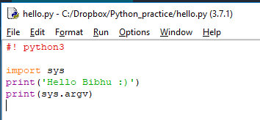

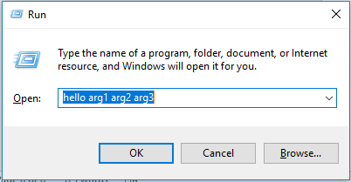

Note:  
sys.argv will return a list of members , given in command line arguments. As shown in below.





