Ideation Phase
Define the Problem Statements

Date | 7 July 2026
Team ID
Project Name
Maximum Marks | 2 Marks

Customer Problem Statement
This template identifies the challenges faced by stock market investors and defines how the Stock Trading Platform addresses them.
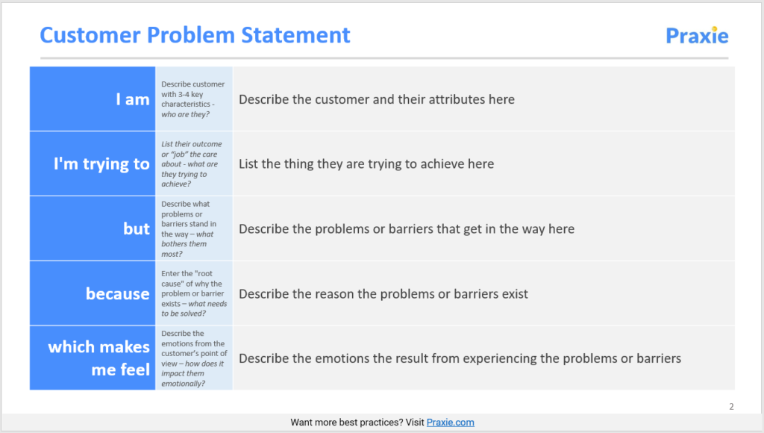
Example:
Problem Statement | I am (Customer) | I'm trying to | But | Because | Which makes me feel
PS-1 | Retail Investor | Trade stocks securely | Market apps are complex | Lack of simple tools | Confused and frustrated

Simple Workflow Diagram

[ User ]
│
▼
[ Login/Register ]
│
▼
[ Dashboard ]
View Live Stocks
Buy/Sell Stocks
Portfolio
Watchlist
Transactions
│
▼
[ Logout ]

