Project Design Phase-II
Technology Stack (Architecture & Stack)

Date | 7 July 2026
Team ID
Project Name
Maximum Marks | 4 Marks

Technical Architecture
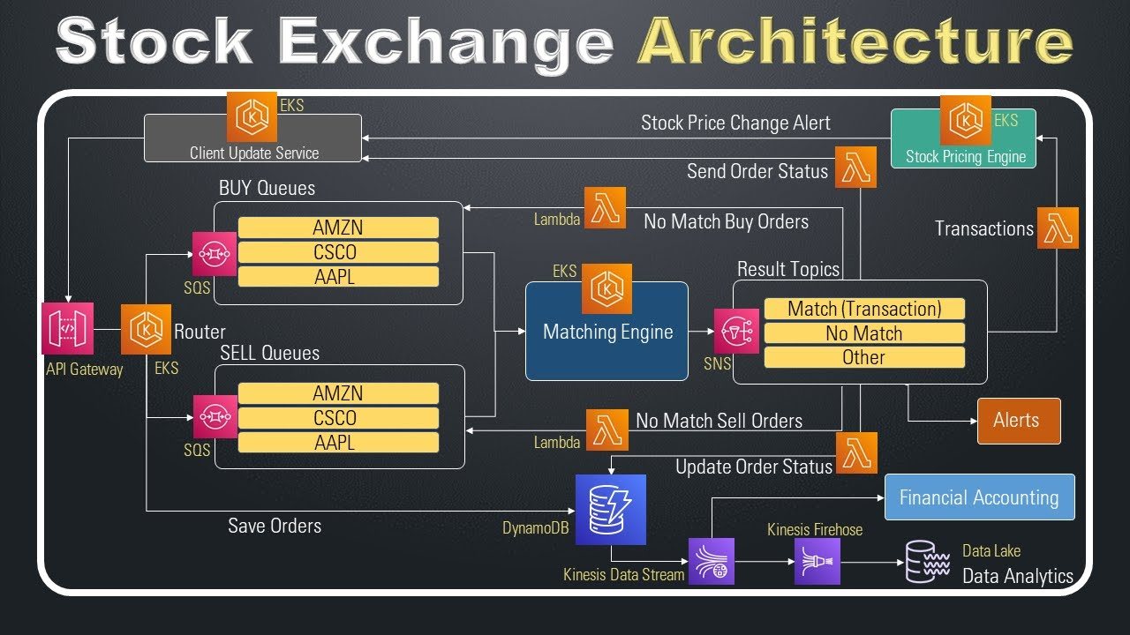
Table-1: Components & Technologies
Component | Description | Technology
UI | Trading Dashboard | React
Backend | Business Logic | Node.js/Express
Database | Store users/stocks | MongoDB
API | Live Market Data | Alpha Vantage/Yahoo Finance
Auth | Secure Login | JWT/Bcrypt
Cloud | Deployment | Render/Vercel

Table-2: Application Characteristics
- Open Source: React, Express
- Security: JWT, Bcrypt
- Scalable: REST API
- Availability: Cloud Deployment
- Performance: Caching & Indexing

