Project Design Phase-II

Data Flow Diagram & User Stories
Project Name: Stock Trading Platform
Date: 31 January 2025
Maximum Marks: 4

DFD Level 0
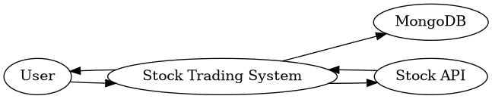

User Stories
User | Epic | USN | Story | Priority | Sprint
Customer | Registration | USN-1 | Register account | High | Sprint-1
Customer | Login | USN-2 | Login securely | High | Sprint-1
Customer | Dashboard | USN-3 | View live stocks | High | Sprint-1
Customer | Trading | USN-4 | Buy/Sell stocks | High | Sprint-2
Customer | Portfolio | USN-5 | Track portfolio | High | Sprint-2
Customer | Watchlist | USN-6 | Manage watchlist | Medium | Sprint-3
Admin | Management | USN-7 | Manage users & stocks | Medium | Sprint-4

