Ideation Phase
Empathize & Discover

Date | 7 July 2026
Team ID
Project Name
Maximum Marks | 4 Marks

Empathy Map Canvas
The empathy map helps understand the needs, behaviors, goals, and challenges of stock trading platform users.

SAYS
I need a secure and easy way to trade stocks.
I want real-time prices.

THINKS
Will this investment be profitable?
Is my money safe?
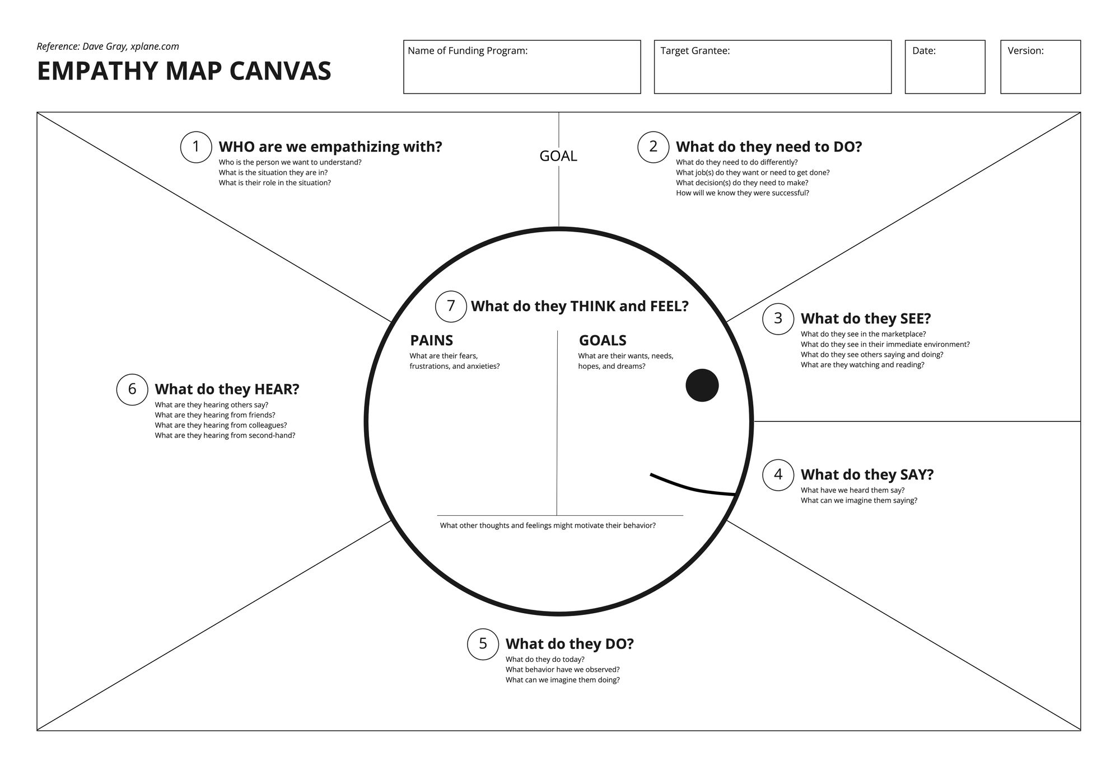

DOES
Searches stocks, buys/sells shares, tracks portfolio, checks watchlist.

FEELS
Excited when markets rise, worried during losses, confident with accurate insights.

PAINS
Complex interfaces, delayed data, security concerns.

GAINS
Simple trading, fast execution, portfolio growth, real-time alerts.

