Project Design Phase
Problem – Solution Fit Template

Date | 7 july 2026
Team ID
Project Name | Stock trading project
Maximum Marks | 2 Marks

Brainstorm & Idea Prioritization
The Stock Trading Platform is a full-stack web application that enables users to securely buy and sell stocks, track portfolios, manage watchlists, and monitor real-time market prices.

Step-1: Team Gathering, Collaboration and Problem Statement
Problem Statement: Build a secure stock trading platform with authentication, portfolio management, watchlists, transactions, and live market data.
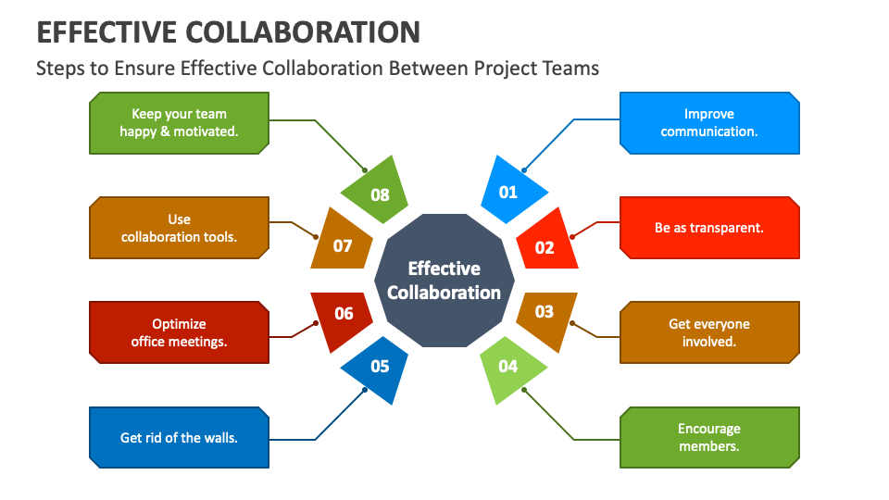

Step-2: Brainstorm, Idea Listing and Grouping
- User Registration/Login
- Live Stock Prices
- Buy & Sell Stocks
- Portfolio Management
- Watchlist
- Transaction History
- Admin Dashboard
- MongoDB Database
- React Frontend
- Node.js Backend
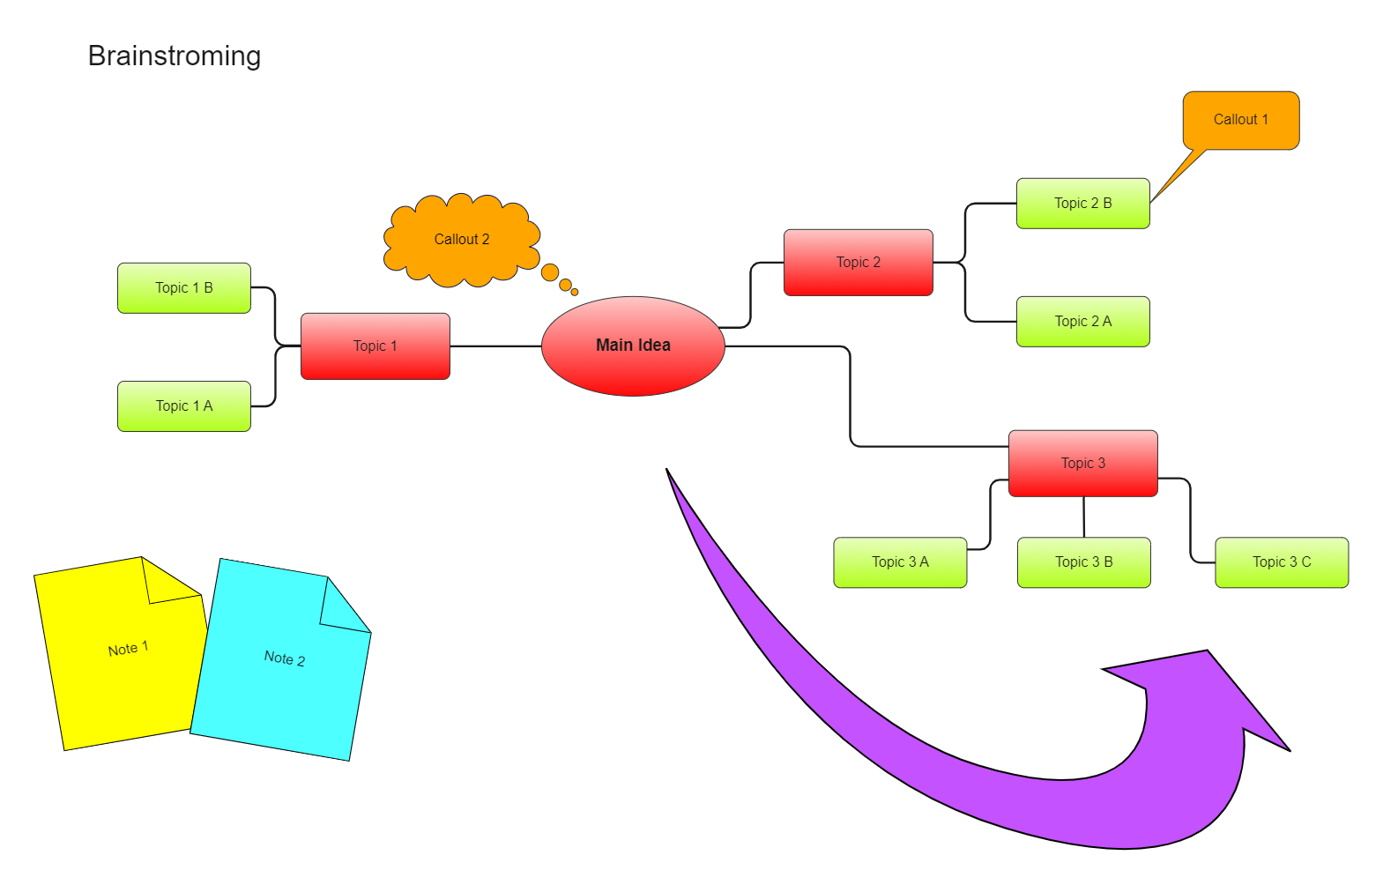

Step-3: Idea Prioritization
Priority | Feature | Status
High | Authentication | Essential
High | Trading | Essential
High | Portfolio | Essential
Medium | Watchlist | Important
Low | AI Recommendations | Future

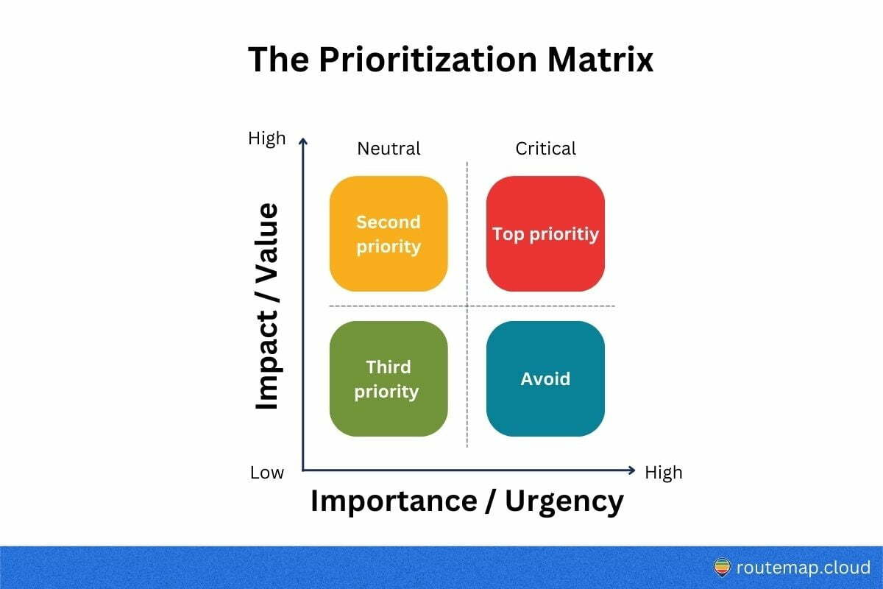

Expected Outcome
A secure, scalable MERN-based stock trading platform with modern UI, REST APIs, JWT authentication, MongoDB integration, and real-time stock data.

