

02. September,2022

**Soccer Crypto**

[SolidProof_io](https://twitter.com/SolidProof_io)



[@solidproof_io](https://t.me/solidproof_io)



Disclaimer 2

Description 5

Project Engagement 5

Logo 5

Contract Link 5

Methodology 7

Used Code from other Frameworks/Smart Contracts (direct imports) 8

Tested Contract Files 9

Source Lines 10

Risk Level 10

Capabilities 11

Inheritance Graph 12

CallGraph 13

Scope of Work/Verify Claims 14

Modifiers and public functions 25

Source Units in Scope 26

Critical issues 27

High issues 27

Medium issues 27

Low issues 27

Informational issues 28

Audit Comments 28

SWC Attacks 29

Disclaimer

[SolidProof.io](http://SolidProof.io) reports are not, nor should be considered, an “endorsement” or “disapproval” of any particular project or team. These reports are not, nor should be considered, an indication of the economics or value of any “product” or “asset” created by any team. SolidProof.io do not cover testing or auditing the integration with external contract or services (such as Unicrypt, Uniswap, PancakeSwap etc’...)

SolidProof.io Audits do not provide any warranty or guarantee regarding the absolute bug- free nature of the technology analyzed, nor do they provide any indication of the technology proprietors. SolidProof Audits should not be used in any way to make decisions around investment or involvement with any particular project. These reports in no way provide investment advice, nor should be leveraged as investment advice of any sort.

SolidProof.io Reports represent an extensive auditing process intending to help our customers increase the quality of their code while reducing the high level of risk presented by cryptographic tokens and blockchain technology. Blockchain technology and cryptographic assets present a high level of ongoing risk. SolidProof’s position is that each company and individual are responsible for their own due diligence and continuous security. SolidProof in no way claims any guarantee of security or functionality of the technology we agree to analyze.

|  |  |  |
| --- | --- | --- |
| Version | Date | Description |
| 1.0 | 01.September,2022 | * Layout project * Automated- /Manual-Security Testing * Summary |

Network

Binance Smart Chain (BSC)

Website

<https://www.soccercrypto.io/>

Telegram

<https://t.me/SoccerCryptoOfficial>

Twitter

<https://twitter.com/SoccerCryptoP2E>

Reddit

<https://www.reddit.com/user/SoccerCrypto>

Discord

<https://discord.gg/5sPYjpNq4h>

Medium

<https://medium.com/@soccercrypto>

Tumblr

https://soccercrypto.tumblr.com/

Description

SoccerCrypto is a combination of passion for football and blockchain technology. We desire to create a platform not just for NFT collection, but also a platform in which users can equip their NFT players with unique designed items, and experience the thrill of fast-paced multiplayer soccer matches!

In SoccerCrypto, players are able to play for free everyday and earn the tickets to participate in exclusive fiery matches to achieve tournaments’ grand prizes worth up to 10.000% ROI.

All SoccerCrypto’s characters have equal strength. Players will rely on skill and luck to collect valuable items. With the more masterful skill set, the more valuable items you can collect in our game and trade them on SoccerCrypto’s marketplace.

Project Engagement

During the 1st of September 2022, **Soccer Crypto** team engaged Solidproof.io to audit the smart contracts that they created. The engagement was technical in nature and focused on identifying the security flaws in the design and implementation of the contracts. They provided Solidproof.io with access to their code repository and whitepaper.

Logo



Contract Links

v1.0

<https://bitbucket.org/playviet/soccercryptosmartconstract>

Commit: **0bcc449**

Vulnerability & Risk Level

Risk represents the probability that a certain source-threat will exploit vulnerability, and the impact of that event on the organization or system. Risk Level is computed based on CVSS version 3.0.

|  |  |  |  |
| --- | --- | --- | --- |
| Level | Value | Vulnerability | Risk (Required Action) |
| **Critical** | 9 - 10 | A vulnerability that can disrupt the contract functioning in a number of scenarios, or creates a risk that the contract may be broken. | Immediate action to reduce risk level. |
| **High** | 7 – 8.9 | A vulnerability that affects the desired outcome when using a contract, or provides the opportunity to use a contract in an unintended way. | Implementation of corrective actions as soon as possible. |
| **Medium** | 4 – 6.9 | A vulnerability that could affect the desired outcome of executing the contract in a specific scenario. | Implementation of corrective actions in a certain period. |
| **Low** | 2 – 3.9 | A vulnerability that does not have a significant impact on possible scenarios for the use of the contract and is probably subjective. | Implementation of certain corrective actions or accepting the risk. |
| **Informational** | 0 – 1.9 | A vulnerability that have informational character but is not effecting any of the code. | An observation that does not determine a level of risk |

Auditing Strategy and Techniques Applied

Throughout the review process, care was taken to evaluate the repository for security-related issues, code quality, and adherence to specification and best practices. To do so, reviewed line-by-line by our team of expert pentesters and smart contract developers, documenting any issues as there were discovered.

Methodology

The auditing process follows a routine series of steps:

1. Code review that includes the following:
   1. Review of the specifications, sources, and instructions provided to SolidProof to make sure we understand the size, scope, and functionality of the smart contract.
   2. Manual review of code, which is the process of reading source code line-by-line in an attempt to identify potential vulnerabilities.
   3. Comparison to specification, which is the process of checking whether the code does what the specifications, sources, and instructions provided to SolidProof describe.
2. Testing and automated analysis that includes the following:
   1. Test coverage analysis, which is the process of determining whether the test cases are actually covering the code and how much code is exercised when we run those test cases.
   2. Symbolic execution, which is analyzing a program to determine what inputs causes each part of a program to execute.
3. Best practices review, which is a review of the smart contracts to improve efficiency, effectiveness, clarify, maintainability, security, and control based on the established industry and academic practices, recommendations, and research.
4. Specific, itemized, actionable recommendations to help you take steps to secure your smart contracts.

Used Code from other Frameworks/Smart Contracts (direct imports)

**Imported packages:**

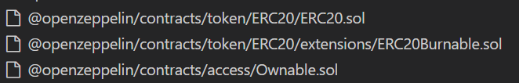

Tested Contract Files

This audit covered the following files listed below with a SHA-1 Hash.

A file with a different Hash has been modified, intentionally or otherwise, after the security review. A different Hash could be (but not necessarily) an indication of a changed condition or potential vulnerability that was not within the scope of this review.

v1.0

| **File Name** | **SHA-1 Hash** |
| --- | --- |
| contracts/SOWToken.sol | 5de2acf8a6828e63a6dde2271d43ffef31fbf733 |
| contracts/Token.sol | 5f31cbe9625e2cfd6a5e6bb79c1fd0635fb3b813 |

Metrics

Source Lines

v1.0

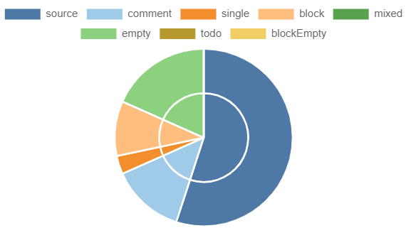

Risk Level

v1.0

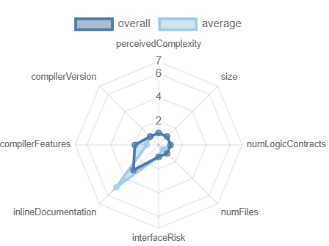

Capabilities

v1.0

**Components**

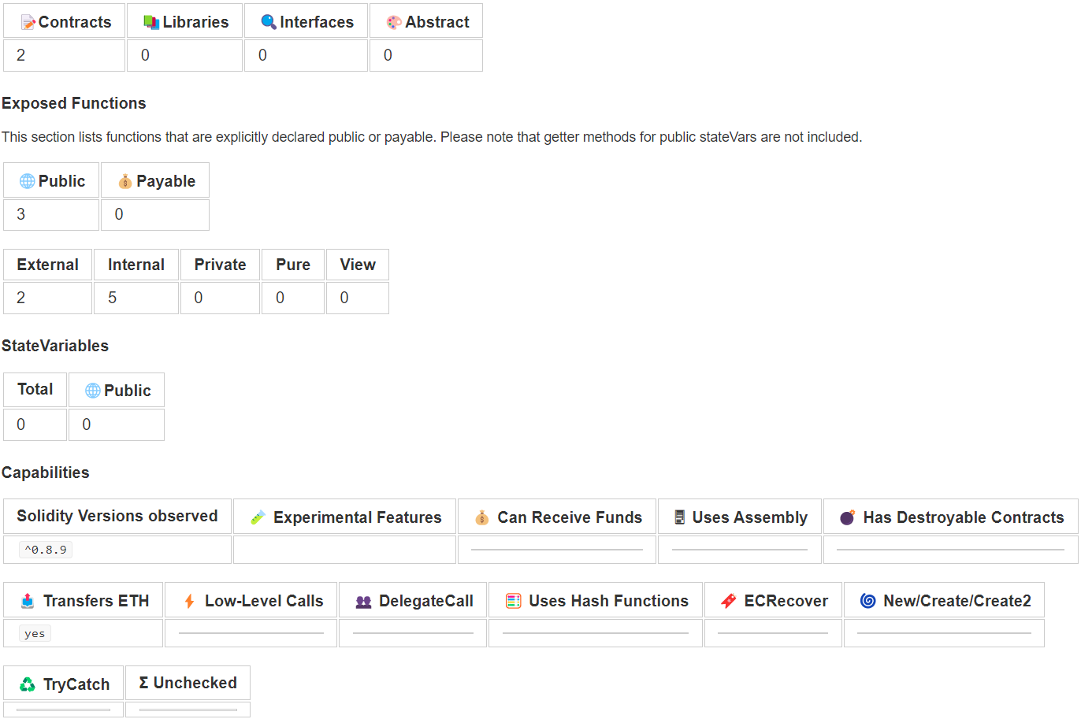

Inheritance Graph

v1.0

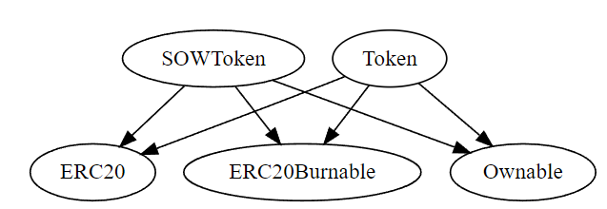

Call Graph

v1.0

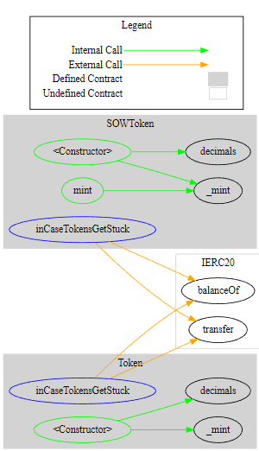

Scope of Work/Verify Claims

The above token Team provided us with the files that needs to be tested (Github, Bscscan, Etherscan, files, etc.). The scope of the audit is the main contract (usual the same name as team appended with .sol).

We will verify the following claims:

* 1. Is contract an upgradeable
  2. Correct implementation of Token standard
  3. Deployer cannot mint any new tokens
  4. Deployer cannot burn or lock user funds
  5. Deployer cannot pause the contract
  6. Deployer can set fees
  7. Deployer can blacklist/antisnipe address
  8. Overall checkup (Smart Contract Security)

Is contract an upgradeable

|  |  |
| --- | --- |
| **Name** | |
| Is contract an upgradeable? | **No** |

Correct implementation of Token standard

|  |  |  |  |  |
| --- | --- | --- | --- | --- |
| **ERC20** | | | | |
| **Function** | **Description** | **Exist** | **Tested** | **Verified** |
| totalSupply | Provides information about the total token supply |  |  |  |
| balanceOf | Provides account balance of the owner's account |  |  |  |
| transfer | Executes transfers of a specified number of tokens to a specified address |  |  |  |
| transferFrom | Executes transfers of a specified number of tokens from a specified address |  |  |  |
| approve | Allow a spender to withdraw a set number of tokens from a specified account |  |  |  |
| allowance | Returns a set number of tokens from a spender to the owner |  |  |  |

Write functions of contracts

v1.0

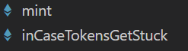

Deployer cannot mint any new tokens

|  |  |  |  |
| --- | --- | --- | --- |
| **Name** | **Exist** | **Tested** | **Status** |
| Deployer cannot mint |  |  |  |
| Max / Total Supply | 1000000000 | | |

**Comments:**

The owner can mint tokens anytime and also more than the total supply. Hence, the Owner can manipulate the price of the SOWToken

Deployer cannot burn or lock user funds

|  |  |  |  |
| --- | --- | --- | --- |
| **Name** | **Exist** | **Tested** | **Status** |
| Deployer cannot lock |  |  |  |
| Deployer cannot burn |  |  |  |

Deployer cannot pause the contract

|  |  |  |  |
| --- | --- | --- | --- |
| **Name** | **Exist** | **Tested** | **Status** |
| Deployer cannot pause |  |  |  |

Deployer can set fees

|  |  |  |  |
| --- | --- | --- | --- |
| **Name** | **Exist** | **Tested** | **Status** |
| Deployer can set fees over 25% |  |  |  |
| Deployer can set fees to nearly 100% or more |  |  |  |

Deployer cannot blacklist/antisnipe addresses

|  |  |  |  |
| --- | --- | --- | --- |
| **Name** | **Exist** | **Tested** | **Status** |
| Deployer can blacklist/antisnipe addresses |  |  |  |

Overall checkup (Smart Contract Security)

|  |  |
| --- | --- |
| **Tested** | **Verified** |
|  |  |

**Legend**

|  |  |
| --- | --- |
| **Attribute** | **Symbol** |
| Verified / Checked |  |
| Partly Verified |  |
| Unverified / Not checked |  |
| Not available |  |

Modifiers and public functions

v1.0

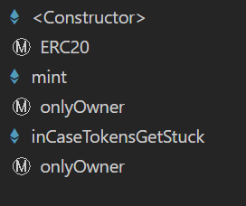 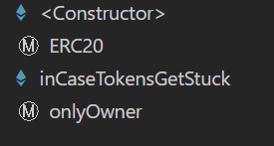

Comments:

* The owner can mint tokens
* The owner can drain the tokens from the contract by calling the InCaseGetStuck function.

Source Units in Scope

v1.0

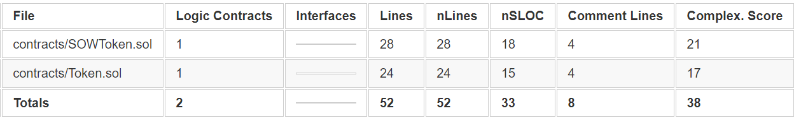

**Legend**

|  |  |
| --- | --- |
| Attribute | Description |
| Lines | total lines of the source unit |
| nLines | normalized lines of the source unit (e.g. normalizes functions spanning multiple lines) |
| nSLOC | normalized source lines of code (only source-code lines; no comments, no blank lines) |
| Comment Lines | lines containing single or block comments |
| Complexity Score | a custom complexity score derived from code statements that are known to introduce code complexity (branches, loops, calls, external interfaces, ...) |

Audit Results

AUDIT PASSED

Critical issues

No critical issues

High issues

No high issues

Medium issues

No medium issues

Low issues

|  |  |  |  |  |
| --- | --- | --- | --- | --- |
| Issue | File | Type | Line | Description |
| #1 | SOWToken/Token.sol | Owner can Drain Tokens | 21/18 | The owner can call this function and pass the address of the contract itself and drain all the tokens |
| #2 | SOWToken/Token.sol | Floating Pragma | - | The current pragma Solidity directive is “^0.8.9”. |

Informational issues

|  |  |  |  |  |
| --- | --- | --- | --- | --- |
| Issue | File | Type | Line | Description |
| #1 | Main | NatSpec documentation missing | - | If you started to comment your code, also comment all other functions, variables etc. |

Audit Comments

We recommend you to use the special form of comments (NatSpec Format, Follow link for more information <https://docs.soliditylang.org/en/v0.5.10/natspec-format.html>) for your contracts to provide rich documentation for functions, return variables and more. This helps investors to make clear what that variables, functions etc. do.

02. September, 2022:

* There is still an owner (Owner still has not renounced ownership)
* Please invest after doing your own research because the owner will have the ability to mint as much tokens as they please without any maximum limit until the ownership has been renounced
* Read the whole report and modifiers section for more information.

SWC Attacks

|  |  |  |  |
| --- | --- | --- | --- |
| ID | Title | Relationships | Status |
| [SWC-136](https://swcregistry.io/docs/SWC-136) | Unencrypted Private Data On-Chain | [CWE-767: Access to Critical Private Variable via Public Method](https://cwe.mitre.org/data/definitions/767.html) | **PASSED** |
| [SWC-135](https://swcregistry.io/docs/SWC-135) | Code With No Effects | [CWE-1164: Irrelevant Code](https://cwe.mitre.org/data/definitions/1164.html) | **PASSED** |
| [SWC-134](https://swcregistry.io/docs/SWC-134) | Message call with hardcoded gas amount | [CWE-655: Improper Initialization](https://cwe.mitre.org/data/definitions/665.html) | **PASSED** |
| [SWC-133](https://swcregistry.io/docs/SWC-133) | Hash Collisions With Multiple Variable Length Arguments | [CWE-294: Authentication Bypass by Capture-replay](https://cwe.mitre.org/data/definitions/294.html) | **PASSED** |
| [SWC-132](https://swcregistry.io/docs/SWC-132) | Unexpected Ether balance | [CWE-667: Improper Locking](https://cwe.mitre.org/data/definitions/667.html) | **PASSED** |
| [SWC-131](https://smartcontractsecurity.github.io/SWC-registry/docs/SWC-131) | Presence of unused variables | [CWE-1164: Irrelevant Code](https://cwe.mitre.org/data/definitions/1164.html) | **PASSED** |
| [SWC-130](https://smartcontractsecurity.github.io/SWC-registry/docs/SWC-130) | Right-To-Left-Override control character (U+202E) | [CWE-451: User Interface (UI) Misrepresentation of Critical Information](http://cwe.mitre.org/data/definitions/451.html) | **PASSED** |
| [SWC-129](https://smartcontractsecurity.github.io/SWC-registry/docs/SWC-129) | Typographical Error | [CWE-480: Use of Incorrect Operator](https://cwe.mitre.org/data/definitions/480.html) | **PASSED** |
| [SWC-128](https://smartcontractsecurity.github.io/SWC-registry/docs/SWC-128) | DoS With Block Gas Limit | [CWE-400: Uncontrolled Resource Consumption](https://cwe.mitre.org/data/definitions/400.html) | **PASSED** |
| [SWC-127](https://smartcontractsecurity.github.io/SWC-registry/docs/SWC-127) | Arbitrary Jump with Function Type Variable | [CWE-695: Use of Low-Level Functionality](https://cwe.mitre.org/data/definitions/695.html) | **PASSED** |
| [SWC-125](https://smartcontractsecurity.github.io/SWC-registry/docs/SWC-125) | Incorrect Inheritance Order | [CWE-696: Incorrect Behavior Order](https://cwe.mitre.org/data/definitions/696.html) | **PASSED** |
| [SWC-124](https://smartcontractsecurity.github.io/SWC-registry/docs/SWC-124) | Write to Arbitrary Storage Location | [CWE-123: Write-what-where Condition](https://cwe.mitre.org/data/definitions/123.html) | **PASSED** |
| [SWC-123](https://smartcontractsecurity.github.io/SWC-registry/docs/SWC-123) | Requirement Violation | [CWE-573: Improper Following of Specification by Caller](https://cwe.mitre.org/data/definitions/573.html) | **PASSED** |
| [SWC-122](https://smartcontractsecurity.github.io/SWC-registry/docs/SWC-122) | Lack of Proper Signature Verification | [CWE-345: Insufficient Verification of Data Authenticity](https://cwe.mitre.org/data/definitions/345.html) | **PASSED** |
| [SWC-121](https://smartcontractsecurity.github.io/SWC-registry/docs/SWC-121) | Missing Protection against Signature Replay Attacks | [CWE-347: Improper Verification of Cryptographic Signature](https://cwe.mitre.org/data/definitions/347.html) | **PASSED** |
| [SWC-120](https://smartcontractsecurity.github.io/SWC-registry/docs/SWC-120) | Weak Sources of Randomness from Chain Attributes | [CWE-330: Use of Insufficiently Random Values](https://cwe.mitre.org/data/definitions/330.html) | **PASSED** |
| [SWC-119](https://smartcontractsecurity.github.io/SWC-registry/docs/SWC-119) | Shadowing State Variables | [CWE-710: Improper Adherence to Coding Standards](http://cwe.mitre.org/data/definitions/710.html) | **PASSED** |
| [SWC-118](https://smartcontractsecurity.github.io/SWC-registry/docs/SWC-118) | Incorrect Constructor Name | [CWE-665: Improper Initialization](http://cwe.mitre.org/data/definitions/665.html) | **PASSED** |
| [SWC-117](https://smartcontractsecurity.github.io/SWC-registry/docs/SWC-117) | Signature Malleability | [CWE-347: Improper Verification of Cryptographic Signature](https://cwe.mitre.org/data/definitions/347.html) | **PASSED** |
| [SWC-116](https://smartcontractsecurity.github.io/SWC-registry/docs/SWC-116) | Timestamp Dependence | [CWE-829: Inclusion of Functionality from Untrusted Control Sphere](https://cwe.mitre.org/data/definitions/829.html) | **PASSED** |
| [SWC-115](https://smartcontractsecurity.github.io/SWC-registry/docs/SWC-115) | Authorization through tx.origin | [CWE-477: Use of Obsolete Function](https://cwe.mitre.org/data/definitions/477.html) | **PASSED** |
| [SWC-114](https://smartcontractsecurity.github.io/SWC-registry/docs/SWC-114) | Transaction Order Dependence | [CWE-362: Concurrent Execution using Shared Resource with Improper Synchronization ('Race Condition')](https://cwe.mitre.org/data/definitions/362.html) | **PASSED** |
| [SWC-113](https://smartcontractsecurity.github.io/SWC-registry/docs/SWC-113) | DoS with Failed Call | [CWE-703: Improper Check or Handling of Exceptional Conditions](https://cwe.mitre.org/data/definitions/703.html) | PASSED |
| [SWC-112](https://smartcontractsecurity.github.io/SWC-registry/docs/SWC-112) | Delegatecall to Untrusted Callee | [CWE-829: Inclusion of Functionality from Untrusted Control Sphere](https://cwe.mitre.org/data/definitions/829.html) | **PASSED** |
| [SWC-111](https://smartcontractsecurity.github.io/SWC-registry/docs/SWC-111) | Use of Deprecated Solidity Functions | [CWE-477: Use of Obsolete Function](https://cwe.mitre.org/data/definitions/477.html) | **PASSED** |
| [SWC-110](https://smartcontractsecurity.github.io/SWC-registry/docs/SWC-110) | Assert Violation | [CWE-670: Always-Incorrect Control Flow Implementation](https://cwe.mitre.org/data/definitions/670.html) | **PASSED** |
| [SWC-109](https://smartcontractsecurity.github.io/SWC-registry/docs/SWC-109) | Uninitialized Storage Pointer | [CWE-824: Access of Uninitialized Pointer](https://cwe.mitre.org/data/definitions/824.html) | **PASSED** |
| [SWC-108](https://smartcontractsecurity.github.io/SWC-registry/docs/SWC-108) | State Variable Default Visibility | [CWE-710: Improper Adherence to Coding Standards](https://cwe.mitre.org/data/definitions/710.html) | **PASSED** |
| [SWC-107](https://smartcontractsecurity.github.io/SWC-registry/docs/SWC-107) | Reentrancy | [CWE-841: Improper Enforcement of Behavioral Workflow](https://cwe.mitre.org/data/definitions/841.html) | **PASSED** |
| [SWC-106](https://smartcontractsecurity.github.io/SWC-registry/docs/SWC-106) | Unprotected SELFDESTRUCT Instruction | [CWE-284: Improper Access Control](https://cwe.mitre.org/data/definitions/284.html) | **PASSED** |
| [SWC-105](https://smartcontractsecurity.github.io/SWC-registry/docs/SWC-105) | Unprotected Ether Withdrawal | [CWE-284: Improper Access Control](https://cwe.mitre.org/data/definitions/284.html) | **PASSED** |
| [SWC-104](https://smartcontractsecurity.github.io/SWC-registry/docs/SWC-104) | Unchecked Call Return Value | [CWE-252: Unchecked Return Value](https://cwe.mitre.org/data/definitions/252.html) | **PASSED** |
| [SWC-103](https://smartcontractsecurity.github.io/SWC-registry/docs/SWC-103) | Floating Pragma | [CWE-664: Improper Control of a Resource Through its Lifetime](https://cwe.mitre.org/data/definitions/664.html) | **NOT**  **PASSED** |
| [SWC-102](https://smartcontractsecurity.github.io/SWC-registry/docs/SWC-102) | Outdated Compiler Version | [CWE-937: Using Components with Known Vulnerabilities](http://cwe.mitre.org/data/definitions/937.html) | **PASSED** |
| [SWC-101](https://smartcontractsecurity.github.io/SWC-registry/docs/SWC-101) | Integer Overflow and Underflow | [CWE-682: Incorrect Calculation](https://cwe.mitre.org/data/definitions/682.html) | **PASSED** |
| [SWC-100](https://smartcontractsecurity.github.io/SWC-registry/docs/SWC-100) | Function Default Visibility | [CWE-710: Improper Adherence to Coding Standards](https://cwe.mitre.org/data/definitions/710.html) | **PASSED** |

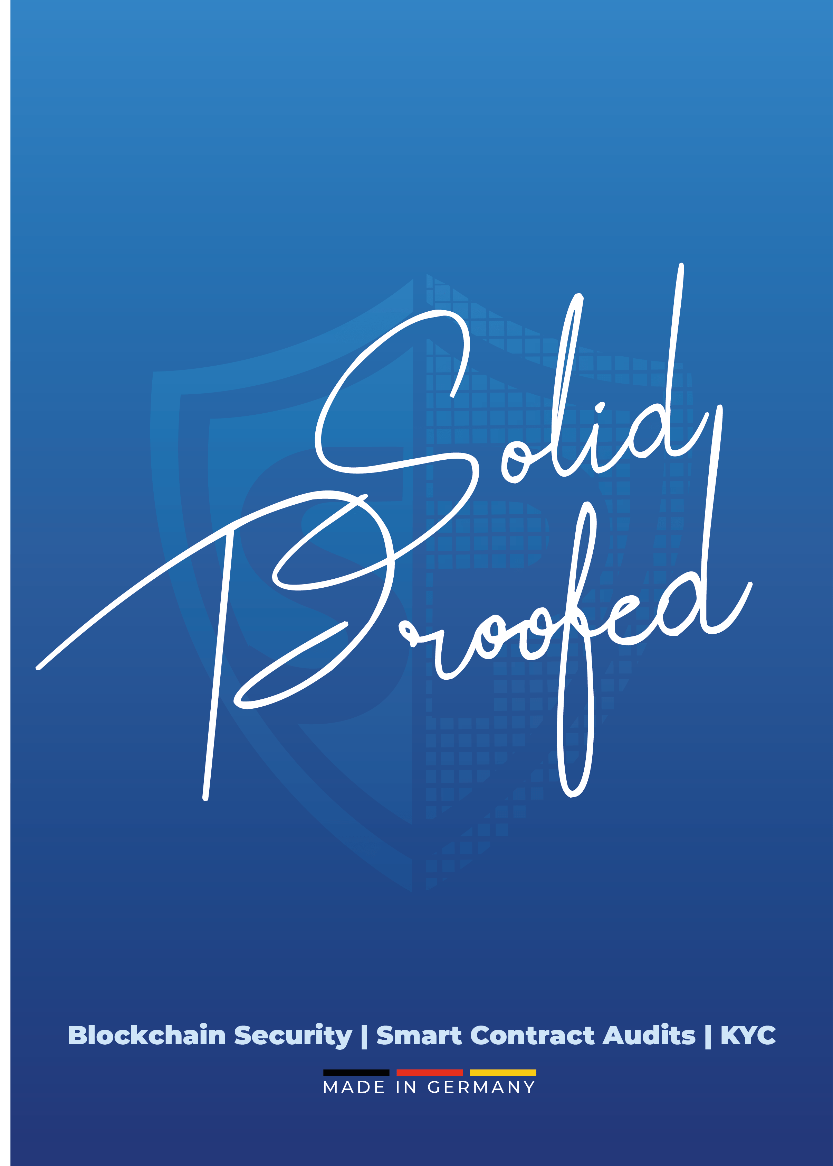

[SolidProof_io](https://twitter.com/SolidProof_io)



[@solidproof_io](https://t.me/solidproof_io)

