9. Create a function that calculates the sum of an arbitrary number of sinusoidal terms. Call this function from the MATLAB command line or in a MATLAB script (.m)

function Y = SUM()

Y = 10 \* sin (20)+ 30 \* sin (40)+ 50 \* sin (60);

end

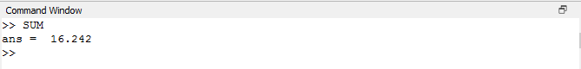

7. Write a script that calculates the mean of five samples of data from a vector of random data. Calculate the overall mean. Use a for loop to perform the calculations. For each iteration of the loop print out the intermediate results. Use an if..else control block to display the results depending on whether the mean of the samples is less than, greater than or equal to the overall mean.

function values = vector()

A = [1 100]

M = mean(A)

for i= randi([1 100],3)

Y = randi([1 100],1,5)

B= mean (Y)

disp(B)

if( B>M)

disp(" The mean is graeter than the overall mean")

elseif( B<M)

disp(" The mean is less than the overall mean")

else

disp(" The means are equal")

end

end

end

