# Cucumber

BDD is based on TDD

Cucumber is one of the BDD supported tools (it is used for BDD)

## Gherkin

It is the format for Cucumber specification

It is the format for most BDD supported tools

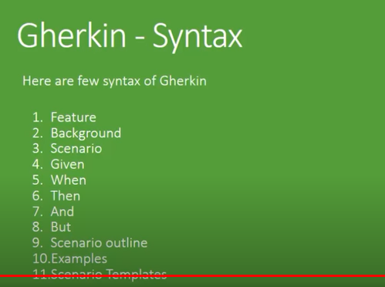

BDD v/s traditional

JARs Needed

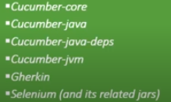

Feature file