
SmartSwine™
Standard Operating Procedures & How-To Guide
Comprehensive Field Manual, Step-by-Step Production Protocols & Visual Reference Guide for Commercial & Smallholder Swine Producers
Application & System: | SmartSwine / The Pig Farmer (Android & Web)
Document Version: | Version 2.0 (Editable Master for Content & Image Updates)
Target Audience: | Farm Owners, Herd Managers, Veterinary Officers, Swine Attendants
Organization: | BibiniiTech Solutions & SmartSwine Engineering
Date Generated: | September 23, 2026

💡 PRO TIP: HOW TO USE THIS WORD DOCUMENT: You can modify any text, headings, or tips directly in Microsoft Word. To update any screenshot or pictorial reference, simply right-click the mockup placeholder image and choose "Change Picture" -> "From This Device...". Word will automatically replace it with your newly captured screenshot while keeping all document layouts and margins intact.

1. Guide Maintenance & Editorial Instructions
This document serves as the master editable copy of the SmartSwine How-To Guide. It contains all 8 operational modules used in the mobile app and web dashboard, including exact screen routes, visual indications, procedural steps, and farming pro tips.

1.1 How to Edit Text & Procedures
• Modify any text, step descriptions, or pro-tips directly in Microsoft Word just like any standard document.
• Each module includes an "Editorial Notes & Pending Updates" table at the bottom where you can record your revisions, author names, and sign-offs.
• To reflect your revised text in the SmartSwine software codebase, consult the Appendix at the end of this guide, which lists the exact translation keys in app/src/main/assets/locales/en.json and HowToGuideData.kt.

1.2 How to Update & Replace Screenshots
Every module in this document contains a pre-scaled pictorial mockup placeholder frame with built-in guidelines and workflow hotspots.
To replace any placeholder image with your live app screenshot:
1. Right-click the image frame in Microsoft Word.
2. Select "Change Picture" from the pop-up context menu, then choose "From This Device..." (or "From a File...").
3. Select your newly captured screenshot from your computer and click "Insert".
4. Word will immediately replace the placeholder with your image while maintaining crisp layout alignment and correct margins.

1.3 Recommended Image Specifications
• File Formats: High-resolution PNG or JPG.
• Mobile Screenshots: 1080 x 1920 px (or 1080 x 2400 px) 9:16 portrait orientation.
• Web Dashboard Screenshots: 1920 x 1080 px 16:9 landscape orientation.
• Annotation Callouts: When annotating your images, use circular red or blue numbered badges (1, 2, 3) that correspond with the Hotspot Legends provided in each module.

2. Master Module Directory & Quick Index
The SmartSwine platform organizes farm operations into 8 core functional modules. Use the directory below to locate specific workflows:
Mod # | Module Title | Category | Core Workflows Covered
1 | Adding & Managing Pigs | HERD MANAGEMENT | Register animals, manage ear tags, assign pens, and track lineage.
2 | Formulating & Balancing Feed | FEED & NUTRITION | Design cost-effective, nutritionally complete diets for every production stage.
3 | Breeding Cycles & Farrowing | BREEDING & REPRODUCTION | Track sow heat cycles, serve dates, 114-day gestation, and farrowing litters.
4 | Financials & Unit Economics | FINANCIALS & ECONOMICS | Track expenses, sales revenue, and calculate cost of production per kg.
5 | Disease Finder & Biosecurity | HEALTH & BIOSECURITY | Identify symptoms, follow treatment protocols, and maintain strict biosecurity.
6 | Weight Checker & ADG | TOOLS & GROWTH INTELLIGENCE | Estimate pig weights, track growth velocity, and forecast slaughter dates.
7 | Staff & Farm Operations | STAFF & FARM OPERATIONS | Manage workers, assign daily tasks, track attendance, and log payroll.
8 | Offline-First Syncing | OFFLINE & CLOUD SYNC | Work seamlessly without internet in remote pens; sync automatically when reconnected.

Module 1: Adding & Managing Pigs
Category: HERD MANAGEMENT | Operational Focus: Register animals, manage ear tags, assign pens, and track lineage.
📱 In-App Navigation: SmartSwine Mobile > Drawer / Bottom Nav > Herd Data > '+' FAB Button
🌐 Web App Route: /dashboard/herd?action=add
⚡ Direct Action Button: Open Herd Data

Visual Reference & Workflow Hotspots
The pictorial reference below illustrates the screen layout and key user action zones. Right-click this placeholder in Word to replace it with an updated screenshot.
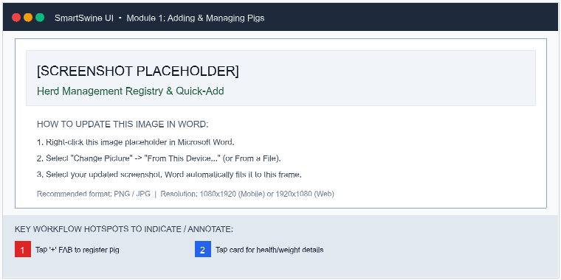
Figure 1.1: Herd Management Registry & Quick-Add Screen [SCREENSHOT-HERD-01]
Key Workflow Hotspots Identified in Screenshot:
Hotspot # | Workflow Indication | Target Action & Purpose
Badge [1] | Tap '+' to register pig | Pulsing '+' Floating Action Button at bottom right to quickly open the animal registration dialog.
Badge [2] | Tap card for health/weight | Tap any animal row card to open full lineage, weight charts, and medication histories.

Standard Operating Procedures (SOP)
Step 1: Navigate to Herd Management
Access 'Herd Data' from the main dashboard or drawer menu to view your entire herd registry.
💡 PRO TIP: You can filter herd records by status (Active, Sold, Cull) using the status tabs.

Step 2: Register a New Animal
Tap the '+' floating button. Fill in essential information: Tag ID, Breed, Sex, Birth Date, and Pen location.
💡 PRO TIP: Assign clear, standardized tag IDs (e.g., SOW-001, BOAR-01) for easier farm-wide tracking.

Step 3: Record Weights & Health Updates
Open any animal's profile card to log regular scale weights, vaccinations, deworming, or medical treatments.
💡 PRO TIP: Regular weighing helps calculate precise Average Daily Gain (ADG) and detect illness early.

Step 4: Assign Pens & Batches
Group growing pigs into designated pens or batch groups to accurately monitor pen density and feed consumption.
💡 PRO TIP: Avoid overcrowded pens to prevent biting behaviors and ensure uniform animal growth.

Editorial Notes & Pending Updates
Use this table to document revisions, image status, or additional localized instructions for this module:
Review Item | Editor Notes & Changes for Adding & Managing Pigs | Status / Sign-off
Text & Instructions | [Type your content modifications, extra steps, or corrections here] | ☐ Pending ☐ Done
Screenshot / Image | [Right-click mockup above -> "Change Picture" -> insert new screenshot] | ☐ Pending ☐ Done

Module 2: Formulating & Balancing Feed
Category: FEED & NUTRITION | Operational Focus: Design cost-effective, nutritionally complete diets for every production stage.
📱 In-App Navigation: SmartSwine Mobile > Feed > Feed Formulation
🌐 Web App Route: /dashboard/feed/mix
⚡ Direct Action Button: Open Feed Formulator

Visual Reference & Workflow Hotspots
The pictorial reference below illustrates the screen layout and key user action zones. Right-click this placeholder in Word to replace it with an updated screenshot.
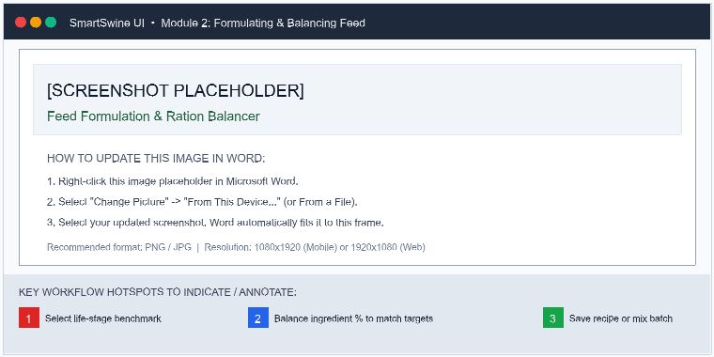
Figure 2.1: Feed Formulation & Ration Balancer Screen [SCREENSHOT-FEED-01]
Key Workflow Hotspots Identified in Screenshot:
Hotspot # | Workflow Indication | Target Action & Purpose
Badge [1] | Select life-stage benchmark | Target stage dropdown: Creep, Starter, Grower, Finisher, Gestating Sow, Lactating Sow.
Badge [2] | Balance ingredient % to match targets | Real-time nutrient indicators for Crude Protein, Ca:P balance, and metabolizable energy.
Badge [3] | Save recipe or mix batch | Save recipe button to store the mix or log a batch directly into farm feed inventory.

Standard Operating Procedures (SOP)
Step 1: Launch the Feed Formulator
Go to 'Feed' and open the 'Feed Formulation' tool to create or adjust custom feeding rations.
💡 PRO TIP: Check ingredient market prices beforehand to identify the most cost-effective local protein and energy sources.

Step 2: Select Life Stage Benchmark
Choose the target pig stage (Creep, Starter, Grower, Finisher, Gestating Sow, Lactating Sow) to load standard nutrient requirements.
💡 PRO TIP: Grower pigs require higher crude protein (16-18%) than gestating sows (12-14%).

Step 3: Adjust Ingredient Inclusions
Add ingredients such as Maize, Soya Meal, Wheat Bran, Fishmeal, and Premix. Balance percentages until nutrient bars turn green.
💡 PRO TIP: Ensure the Calcium to Phosphorus (Ca:P) ratio stays between 1.2:1 and 1.6:1 for healthy bone development.

Step 4: Save Recipe & Mix Batch
Save your balanced recipe for quick access, or log a mixed batch to automatically update feed inventory.
💡 PRO TIP: Mix feed in uniform batches and store in dry, elevated pallets to prevent aflatoxin and spoilage.

Editorial Notes & Pending Updates
Use this table to document revisions, image status, or additional localized instructions for this module:
Review Item | Editor Notes & Changes for Formulating & Balancing Feed | Status / Sign-off
Text & Instructions | [Type your content modifications, extra steps, or corrections here] | ☐ Pending ☐ Done
Screenshot / Image | [Right-click mockup above -> "Change Picture" -> insert new screenshot] | ☐ Pending ☐ Done

Module 3: Breeding Cycles & Farrowing
Category: BREEDING & REPRODUCTION | Operational Focus: Track sow heat cycles, serve dates, 114-day gestation, and farrowing litters.
📱 In-App Navigation: SmartSwine Mobile > Production Activities > Breeding & Mating
🌐 Web App Route: /dashboard/activities
⚡ Direct Action Button: Open Breeding & Activities

Visual Reference & Workflow Hotspots
The pictorial reference below illustrates the screen layout and key user action zones. Right-click this placeholder in Word to replace it with an updated screenshot.
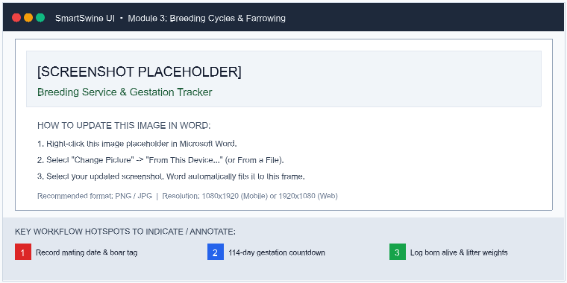
Figure 3.1: Breeding Service, Gestation Timeline & Farrowing Logger [SCREENSHOT-BREEDING-01]
Key Workflow Hotspots Identified in Screenshot:
Hotspot # | Workflow Indication | Target Action & Purpose
Badge [1] | Record mating date & boar tag | Mating service record with boar tag ID, AI batch number, and service technique.
Badge [2] | 114-day gestation countdown | Automated 114-day countdown with return-to-heat checks (Day 21) and farrowing crate prep alerts (Day 110).
Badge [3] | Log born alive & litter weights | Litter outcome log tracking Born Alive, Stillborns, Mummies, and average piglet birth weights.

Standard Operating Procedures (SOP)
Step 1: Detect Heat & Record Mating
Look for standing reflex, swollen vulva, and vocalizations. Record natural service or AI with boar tag details.
💡 PRO TIP: Best practice is to serve the sow twice: 12 hours apart during peak standing heat.

Step 2: Monitor Gestation (114 Days)
SmartSwine automatically schedules repeat heat checks at 18-24 days and farrowing alerts around 110-114 days.
💡 PRO TIP: Check for return to heat around Day 21. If sow shows standing heat, re-service immediately.

Step 3: Prepare Farrowing Pen
Disinfect farrowing crates and move pregnant sows 4 to 5 days before expected due date. Prepare heat lamps for piglets.
💡 PRO TIP: Keep the piglet creep area warm (30-32°C) to prevent hypothermia in newborns.

Step 4: Record Litter Delivery
Log Born Alive, Stillborns, Mummies, and Total Litter Birth Weight to evaluate sow maternal performance.
💡 PRO TIP: Administer iron injections and clip needle teeth within 24-48 hours of farrowing.

Editorial Notes & Pending Updates
Use this table to document revisions, image status, or additional localized instructions for this module:
Review Item | Editor Notes & Changes for Breeding Cycles & Farrowing | Status / Sign-off
Text & Instructions | [Type your content modifications, extra steps, or corrections here] | ☐ Pending ☐ Done
Screenshot / Image | [Right-click mockup above -> "Change Picture" -> insert new screenshot] | ☐ Pending ☐ Done

Module 4: Financials & Unit Economics
Category: FINANCIALS & ECONOMICS | Operational Focus: Track expenses, sales revenue, and calculate cost of production per kg.
📱 In-App Navigation: SmartSwine Mobile > Financials > Add Transaction
🌐 Web App Route: /dashboard/financials?action=add
⚡ Direct Action Button: Open Financials

Visual Reference & Workflow Hotspots
The pictorial reference below illustrates the screen layout and key user action zones. Right-click this placeholder in Word to replace it with an updated screenshot.
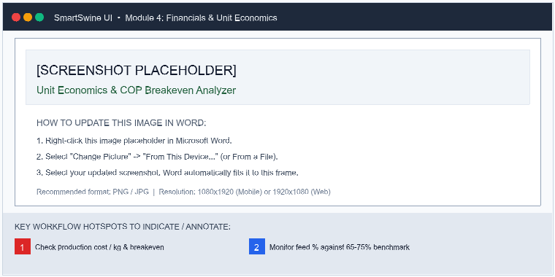
Figure 4.1: Financial Performance, Unit Economics & COP Breakeven [SCREENSHOT-FINANCES-01]
Key Workflow Hotspots Identified in Screenshot:
Hotspot # | Workflow Indication | Target Action & Purpose
Badge [1] | Check production cost / kg & breakeven | Real-time Cost of Production (COP) per kg and minimum finisher sale price to ensure profitability.
Badge [2] | Monitor feed % against 65-75% benchmark | Expense breakdown gauge monitoring feed cost ratio against the standard 65-75% commercial benchmark.

Standard Operating Procedures (SOP)
Step 1: Record Farm Expenses
Log all farm expenditures categorized by Feed, Veterinary, Labor, Utilities, and Maintenance.
💡 PRO TIP: Log expenses as soon as purchases occur so cost analytics stay up to date.

Step 2: Log Pig & Product Sales
Record income from live animal sales, slaughtered carcasses, breeding stock, or organic manure.
💡 PRO TIP: Record both live weight and final price per kg to track realized market margins.

Step 3: Analyze Cost of Production (COP)
Review COP per kg and Finisher Breakeven price to ensure each transaction generates healthy profit.
💡 PRO TIP: Feed should ideally represent 65-75% of your total production cost. Minimize feed wastage.

Editorial Notes & Pending Updates
Use this table to document revisions, image status, or additional localized instructions for this module:
Review Item | Editor Notes & Changes for Financials & Unit Economics | Status / Sign-off
Text & Instructions | [Type your content modifications, extra steps, or corrections here] | ☐ Pending ☐ Done
Screenshot / Image | [Right-click mockup above -> "Change Picture" -> insert new screenshot] | ☐ Pending ☐ Done

Module 5: Disease Finder & Biosecurity
Category: HEALTH & BIOSECURITY | Operational Focus: Identify symptoms, follow treatment protocols, and maintain strict biosecurity.
📱 In-App Navigation: SmartSwine Mobile > Disease Finder > Symptom Diagnostics
🌐 Web App Route: /dashboard?section=symptoms
⚡ Direct Action Button: Open Disease Finder

Visual Reference & Workflow Hotspots
The pictorial reference below illustrates the screen layout and key user action zones. Right-click this placeholder in Word to replace it with an updated screenshot.
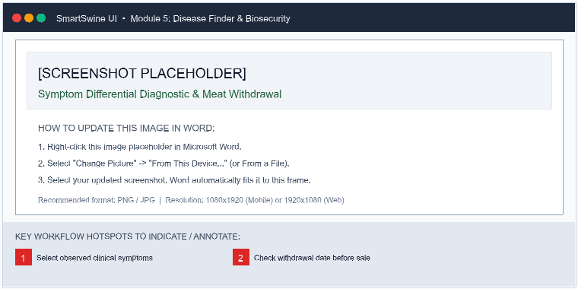
Figure 5.1: Symptom Differential Diagnosis & Meat Withdrawal Warning [SCREENSHOT-HEALTH-01]
Key Workflow Hotspots Identified in Screenshot:
Hotspot # | Workflow Indication | Target Action & Purpose
Badge [1] | Select observed symptoms | Interactive symptom filter chips (coughing, lesions, diarrhea, fever, loss of appetite).
Badge [2] | Check withdrawal date before sale | Critical meat withdrawal banner calculating slaughter withholding date after administering medications.

Standard Operating Procedures (SOP)
Step 1: Symptom Diagnosis
Use the Disease Finder tool to match observed clinical signs (coughing, diarrhea, lesions) with common swine conditions.
💡 PRO TIP: Isolate sick animals immediately into quarantine pens before beginning treatment.

Step 2: Administer Treatments & Log Withdrawal
Record antibiotic or antiparasitic treatments and strictly note meat withdrawal days.
💡 PRO TIP: Never market or slaughter an animal before the full meat withdrawal window expires.

Step 3: Enforce Farm Biosecurity
Maintain footbaths with disinfectant, control farm visitors, sanitize vehicles, and quarantine new stock for 30 days.
💡 PRO TIP: Biosecurity is 10 times cheaper than treating a disease outbreak.

Editorial Notes & Pending Updates
Use this table to document revisions, image status, or additional localized instructions for this module:
Review Item | Editor Notes & Changes for Disease Finder & Biosecurity | Status / Sign-off
Text & Instructions | [Type your content modifications, extra steps, or corrections here] | ☐ Pending ☐ Done
Screenshot / Image | [Right-click mockup above -> "Change Picture" -> insert new screenshot] | ☐ Pending ☐ Done

Module 6: Weight Checker & ADG
Category: TOOLS & GROWTH INTELLIGENCE | Operational Focus: Estimate pig weights, track growth velocity, and forecast slaughter dates.
📱 In-App Navigation: SmartSwine Mobile > Tools > Weight Checker
🌐 Web App Route: /dashboard?section=weight&subOption=tape
⚡ Direct Action Button: Open Weight Checker

Visual Reference & Workflow Hotspots
The pictorial reference below illustrates the screen layout and key user action zones. Right-click this placeholder in Word to replace it with an updated screenshot.
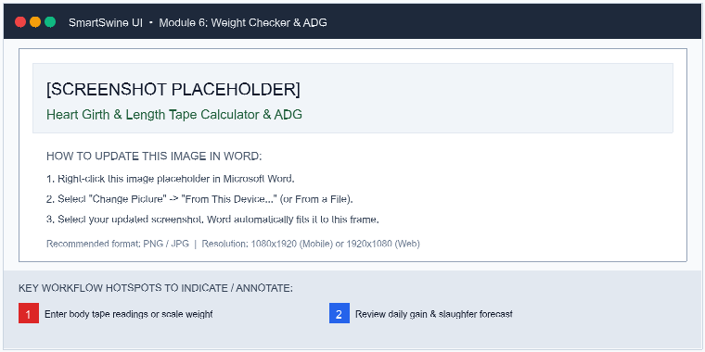
Figure 6.1: Tape Weight Estimation & Average Daily Gain (ADG) Forecaster [SCREENSHOT-WEIGHT-01]

Heart Girth & Length Measurement Reference Diagram
Use the anatomical reference diagram below to guide farm workers when taking tape measurements: Heart Girth (Dimension B, immediately behind front legs) and Body Length (Dimension A, from ear poll to tail base).
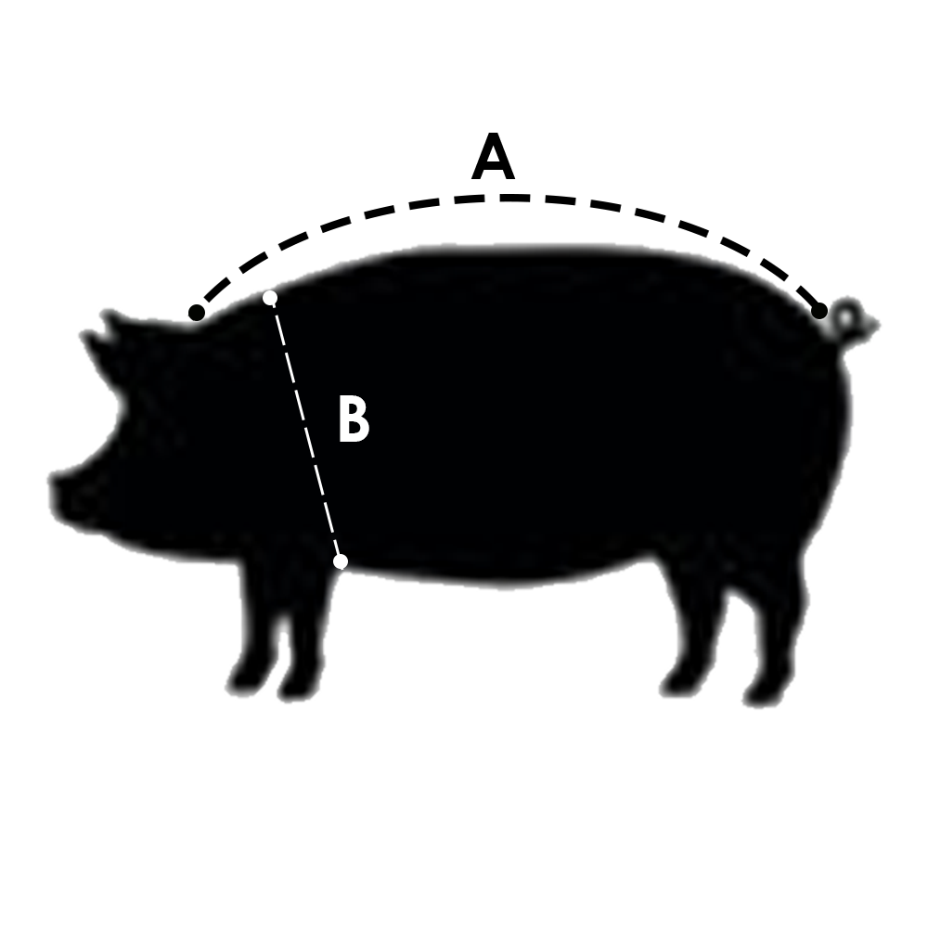
Figure 6.2: Body Tape Anatomical Measurement Guide — Length (A) and Heart Girth (B) [DIAGRAM-SCALE-01]
Key Workflow Hotspots Identified in Screenshot:
Hotspot # | Workflow Indication | Target Action & Purpose
Badge [1] | Enter body tape readings or scale weight | Enter body tape measurements: Heart Girth (circumference behind front legs) and Body Length.
Badge [2] | Review daily gain & market slaughter date | Automated Average Daily Gain (ADG) calculation and projected market slaughter date for 90-100 kg targets.

Standard Operating Procedures (SOP)
Step 1: Measure Heart Girth & Length
When a scale is unavailable, measure heart girth behind the front legs and length from ears to tail base.
💡 PRO TIP: Keep the measuring tape snug against the pig's skin without compressing the flesh.

Step 2: Calculate ADG (Average Daily Gain)
SmartSwine computes ADG between weighings to monitor growth trajectory against standard benchmarks.
💡 PRO TIP: Target ADG for commercial growers is 650g - 850g/day under good nutrition.

Step 3: Forecast Market-Ready Date
View projected market slaughter date (target 90-100kg) to plan feed budgets and advance buyer sales.
💡 PRO TIP: Plan your finisher sales in advance to lock in favorable buyer agreements.

Editorial Notes & Pending Updates
Use this table to document revisions, image status, or additional localized instructions for this module:
Review Item | Editor Notes & Changes for Weight Checker & ADG | Status / Sign-off
Text & Instructions | [Type your content modifications, extra steps, or corrections here] | ☐ Pending ☐ Done
Screenshot / Image | [Right-click mockup above -> "Change Picture" -> insert new screenshot] | ☐ Pending ☐ Done

Module 7: Staff & Farm Operations
Category: STAFF & FARM OPERATIONS | Operational Focus: Manage workers, assign daily tasks, track attendance, and log payroll.
📱 In-App Navigation: SmartSwine Mobile > Dashboard > Human Resources
🌐 Web App Route: /dashboard?section=hr&action=add
⚡ Direct Action Button: Open Staff & HR

Visual Reference & Workflow Hotspots
The pictorial reference below illustrates the screen layout and key user action zones. Right-click this placeholder in Word to replace it with an updated screenshot.
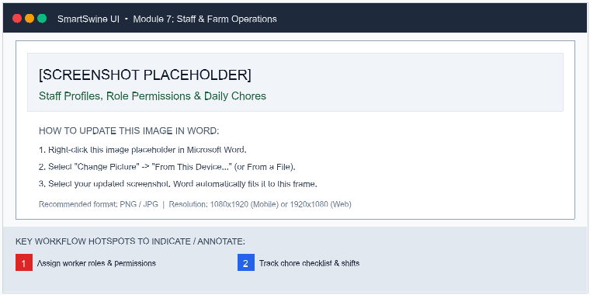
Figure 7.1: Worker Permissions, Shift Rosters & Chore Checklists [SCREENSHOT-HR-01]
Key Workflow Hotspots Identified in Screenshot:
Hotspot # | Workflow Indication | Target Action & Purpose
Badge [1] | Assign worker roles & permissions | Assign granular access roles: Administrator, Farm Supervisor, Technician, General Farmhand.
Badge [2] | Track chore checklist & shifts | Daily chore checklist tracking morning/evening feedings, pen disinfection, and farrowing shifts.

Standard Operating Procedures (SOP)
Step 1: Add Team Members & Assign Roles
Register workers, farm managers, and consulting vets with role-specific access permissions.
💡 PRO TIP: Restricting financial access to Admins and Managers keeps sensitive records safe.

Step 2: Assign Daily Chores & Schedules
Delegate daily routines such as pen feeding, waterer cleaning, farrowing watches, and heat detection.
💡 PRO TIP: Clear task checklists prevent missed feedings or delayed medication rounds.

Step 3: Track Payroll & Payouts
Log salary payments, bonuses, and deductions to maintain a transparent, organized payroll history.
💡 PRO TIP: Always include notes on performance bonuses or salary advances for audit clarity.

Editorial Notes & Pending Updates
Use this table to document revisions, image status, or additional localized instructions for this module:
Review Item | Editor Notes & Changes for Staff & Farm Operations | Status / Sign-off
Text & Instructions | [Type your content modifications, extra steps, or corrections here] | ☐ Pending ☐ Done
Screenshot / Image | [Right-click mockup above -> "Change Picture" -> insert new screenshot] | ☐ Pending ☐ Done

Module 8: Offline-First Syncing
Category: OFFLINE & CLOUD SYNC | Operational Focus: Work seamlessly without internet in remote pens; sync automatically when reconnected.
📱 In-App Navigation: SmartSwine Mobile > Top Status Banner
🌐 Web App Route: /dashboard
⚡ Direct Action Button: Open Dashboard

Visual Reference & Workflow Hotspots
The pictorial reference below illustrates the screen layout and key user action zones. Right-click this placeholder in Word to replace it with an updated screenshot.
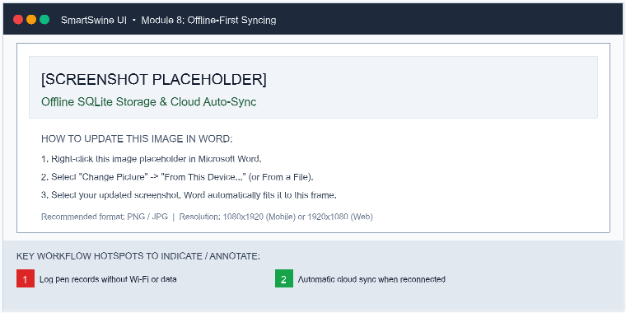
Figure 8.1: Offline SQLite Local Logging & Automatic Cloud Sync [SCREENSHOT-OFFLINE-01]
Key Workflow Hotspots Identified in Screenshot:
Hotspot # | Workflow Indication | Target Action & Purpose
Badge [1] | Log pen records without Wi-Fi or data | Offline banner indicating all pen data, mating records, and weights are safely cached locally in SQLite.
Badge [2] | Automatic cloud sync when reconnected | Automatic two-way cloud sync triggers silently as soon as Wi-Fi or cellular data reconnects.

Standard Operating Procedures (SOP)
Step 1: Work Freely Anywhere
Record animal additions, feed logs, breeding services, and treatments even without Wi-Fi or cellular signal.
💡 PRO TIP: All changes are saved locally to your device's secure offline database.

Step 2: Automatic Cloud Synchronization
When internet connectivity is restored, all offline updates automatically synchronize with the cloud database.
💡 PRO TIP: Check the offline banner at the top of the screen to verify your current connection status.

Editorial Notes & Pending Updates
Use this table to document revisions, image status, or additional localized instructions for this module:
Review Item | Editor Notes & Changes for Offline-First Syncing | Status / Sign-off
Text & Instructions | [Type your content modifications, extra steps, or corrections here] | ☐ Pending ☐ Done
Screenshot / Image | [Right-click mockup above -> "Change Picture" -> insert new screenshot] | ☐ Pending ☐ Done

3. Appendix: Localization String Keys & Code Reference
To update the text in the SmartSwine Android or Web application after completing your edits in Word, locate the corresponding translation key in the JSON locale files and Kotlin source files listed below:
String Resource Key | English Translation (en.json) | Source Code Location
guide_intro_title | Master Your Piggery with SmartSwine | HowToGuideScreen.kt / page.tsx
guide_intro_desc | Step-by-step interactive workflows to streamline herd health, feed formulation, breeding cycles, financials, and staff management. | HowToGuideScreen.kt / page.tsx
guide_search_placeholder | Search topics, tasks, or workflows... | HowToGuideScreen.kt / page.tsx
pictorial_reference | Pictorial Reference | GuidePictorialReferences.kt
indication_visual_guide | Visual Guide | GuidePictorialReferences.kt
guide_herd_title | Adding & Managing Pigs | HowToGuideData.kt
guide_herd_subtitle | Register animals, manage ear tags, assign pens, and track lineage. | HowToGuideData.kt
indication_1 | Tap '+' to register pig | GuidePictorialReferences.kt
indication_2 | Tap card for health/weight | GuidePictorialReferences.kt
Step 1: Navigate to Herd Management | Access 'Herd Data' from the main dashboard or drawer menu to... | HowToGuideData.kt
Step 2: Register a New Animal | Tap the '+' floating button. Fill in essential information: ... | HowToGuideData.kt
Step 3: Record Weights & Health Updates | Open any animal's profile card to log regular scale weights,... | HowToGuideData.kt
Step 4: Assign Pens & Batches | Group growing pigs into designated pens or batch groups to a... | HowToGuideData.kt
guide_feed_title | Formulating & Balancing Feed | HowToGuideData.kt
guide_feed_subtitle | Design cost-effective, nutritionally complete diets for every production stage. | HowToGuideData.kt
indication_3 | Save recipe or mix batch | GuidePictorialReferences.kt
Step 1: Launch the Feed Formulator | Go to 'Feed' and open the 'Feed Formulation' tool to create ... | HowToGuideData.kt
Step 2: Select Life Stage Benchmark | Choose the target pig stage (Creep, Starter, Grower, Finishe... | HowToGuideData.kt
Step 3: Adjust Ingredient Inclusions | Add ingredients such as Maize, Soya Meal, Wheat Bran, Fishme... | HowToGuideData.kt
Step 4: Save Recipe & Mix Batch | Save your balanced recipe for quick access, or log a mixed b... | HowToGuideData.kt
guide_breeding_title | Breeding Cycles & Farrowing | HowToGuideData.kt
guide_breeding_subtitle | Track sow heat cycles, serve dates, 114-day gestation, and farrowing litters. | HowToGuideData.kt
Step 1: Detect Heat & Record Mating | Look for standing reflex, swollen vulva, and vocalizations. ... | HowToGuideData.kt
Step 2: Monitor Gestation (114 Days) | SmartSwine automatically schedules repeat heat checks at 18-... | HowToGuideData.kt
Step 3: Prepare Farrowing Pen | Disinfect farrowing crates and move pregnant sows 4 to 5 day... | HowToGuideData.kt
Step 4: Record Litter Delivery | Log Born Alive, Stillborns, Mummies, and Total Litter Birth ... | HowToGuideData.kt
guide_financials_title | Financials & Unit Economics | HowToGuideData.kt
guide_financials_subtitle | Track expenses, sales revenue, and calculate cost of production per kg. | HowToGuideData.kt
Step 1: Record Farm Expenses | Log all farm expenditures categorized by Feed, Veterinary, L... | HowToGuideData.kt
Step 2: Log Pig & Product Sales | Record income from live animal sales, slaughtered carcasses,... | HowToGuideData.kt
Step 3: Analyze Cost of Production (COP) | Review COP per kg and Finisher Breakeven price to ensure eac... | HowToGuideData.kt
guide_disease_finder_title | Disease Finder & Biosecurity | HowToGuideData.kt
guide_disease_finder_subtitle | Identify symptoms, follow treatment protocols, and maintain strict biosecurity. | HowToGuideData.kt
Step 1: Symptom Diagnosis | Use the Disease Finder tool to match observed clinical signs... | HowToGuideData.kt
Step 2: Administer Treatments & Log Withdrawal | Record antibiotic or antiparasitic treatments and strictly n... | HowToGuideData.kt

— End of SmartSwine How-To Guide Export —

