Resource: Familiarization, Internalization, Articulation (Fia) Images
Familiarization, Internalization, Articulation (FIA) Images © 2023 SRV Partners Released under CC BY-SA 4.0 license. Familiarization, Internalization, Articulation (FIA) Images has been adapted in the following languages Tok Pisin, عربي, Français, हिंदी, Bahasa Indonesia, Português, Русский, Español, Kiswahili, 简体中文 from Familiarization, Internalization, Articulation (FIA) © 2023 SRV Partners. Released under CC BY-SA 4.0 license by Mission Mutual

Familiarization, Internalization, Articulation (Fia) Images

I

Idol

Image Content

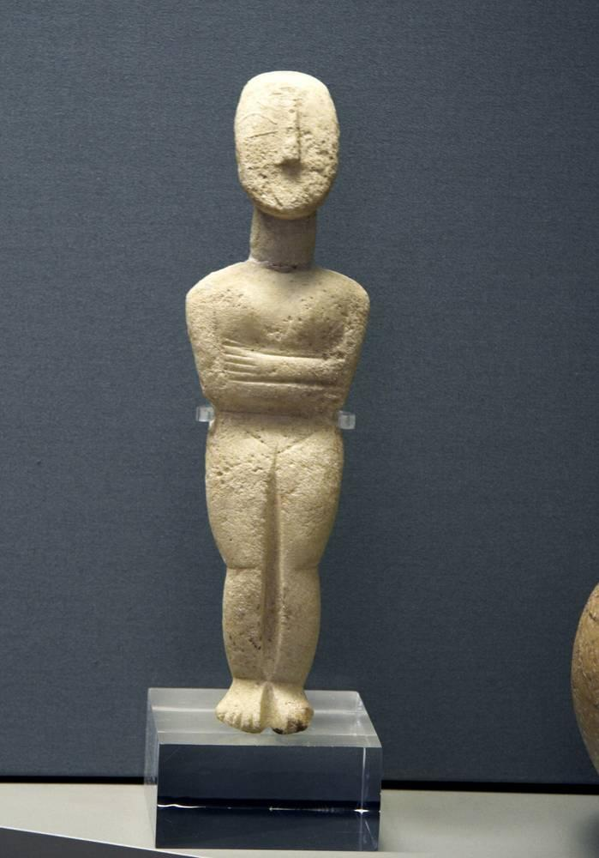
link

Idol

Image Content

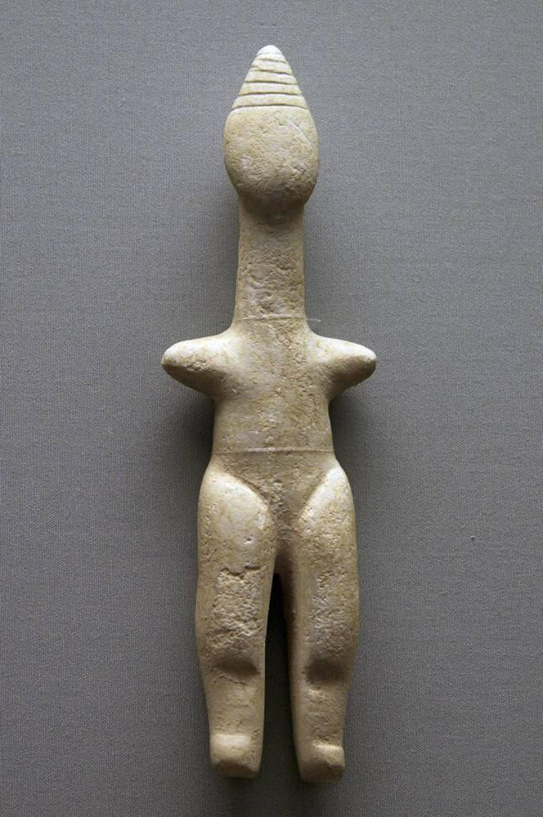
link

Incense Altar

Image Content

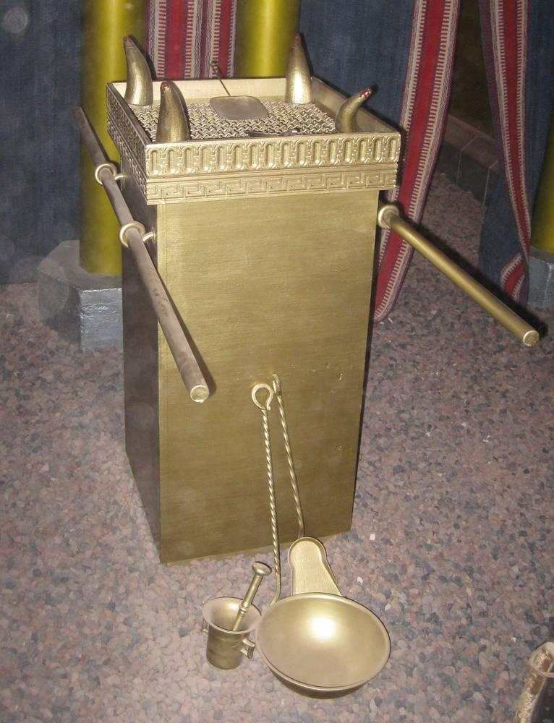
link

Incense Altar

Image Content

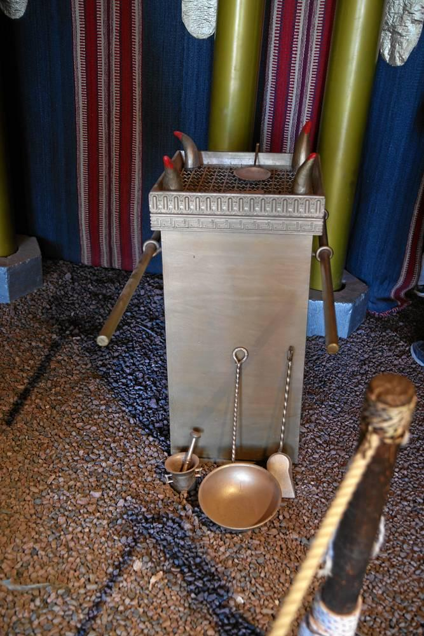
link

Inner Room

Image Content

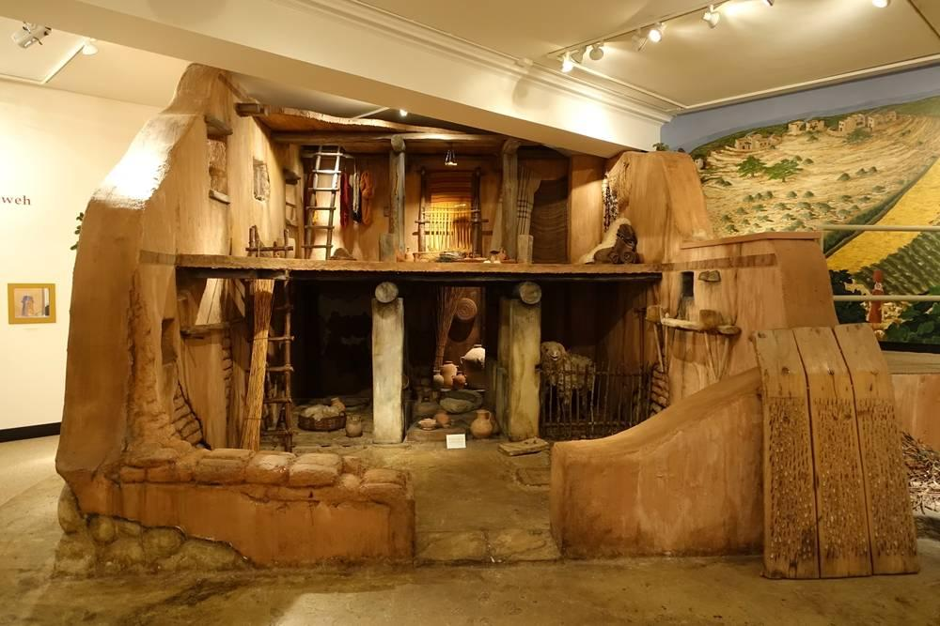
link

Inside of the Tabernacle

Image Content

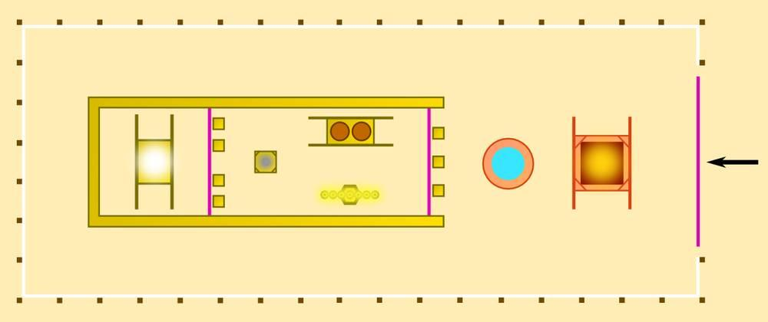
link

Intestinal Worm

Image Content

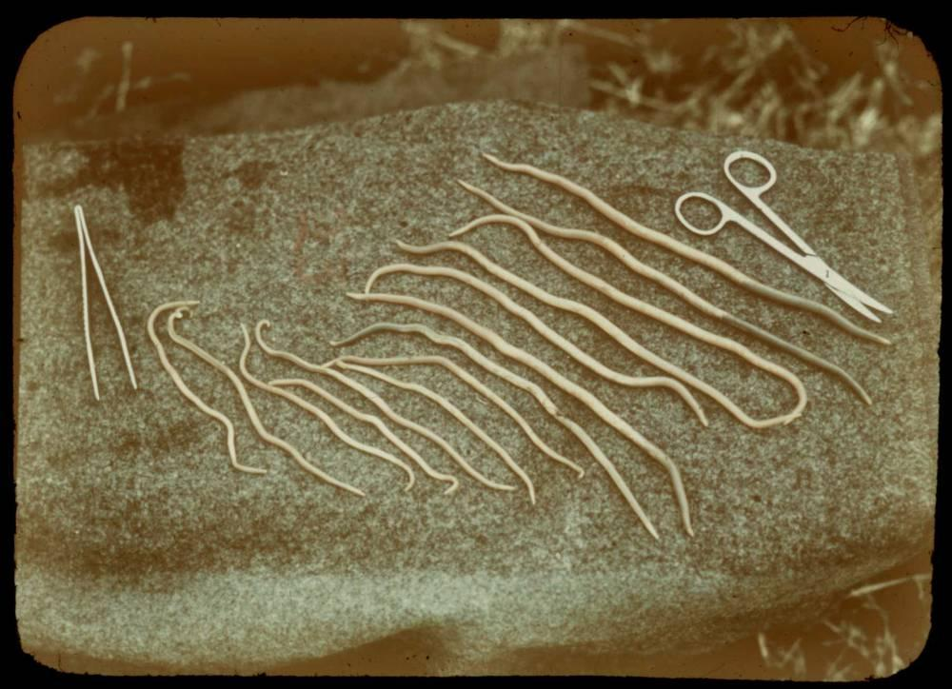
link

Iron

Image Content

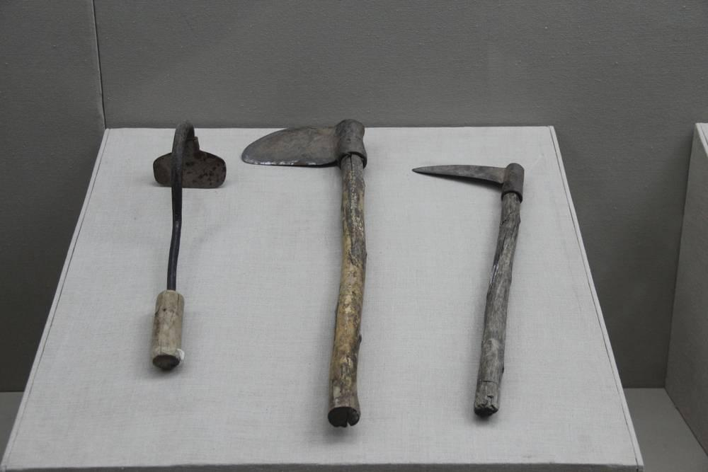
link

Iron

Image Content

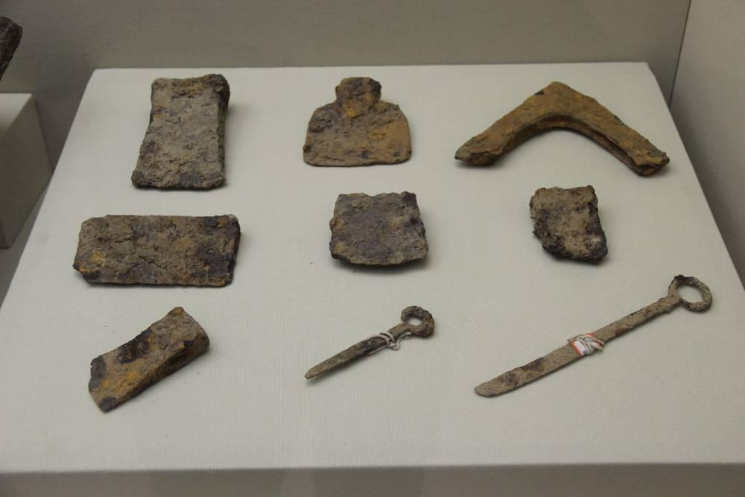
link

Iron

Image Content

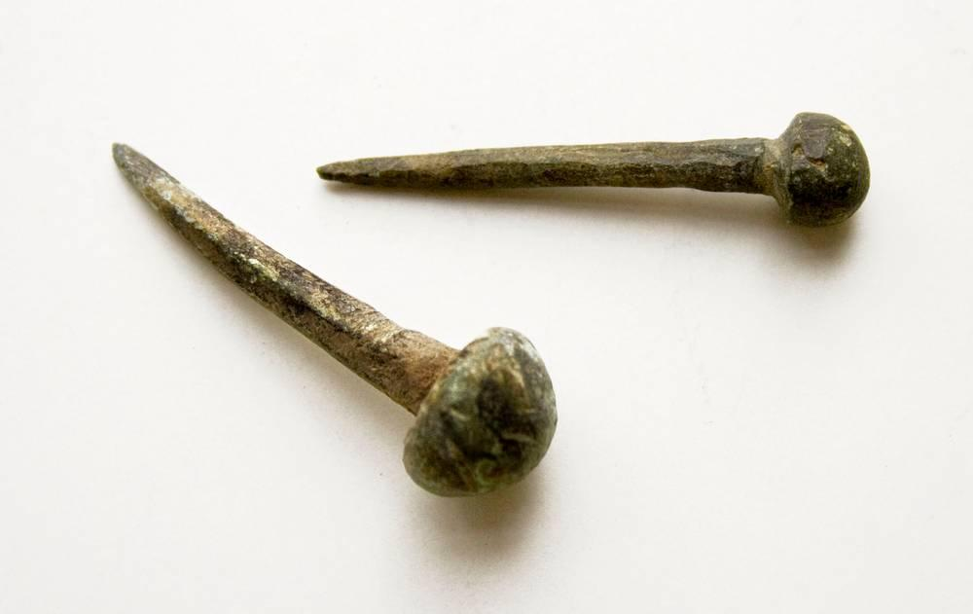
link

Iron

Image Content

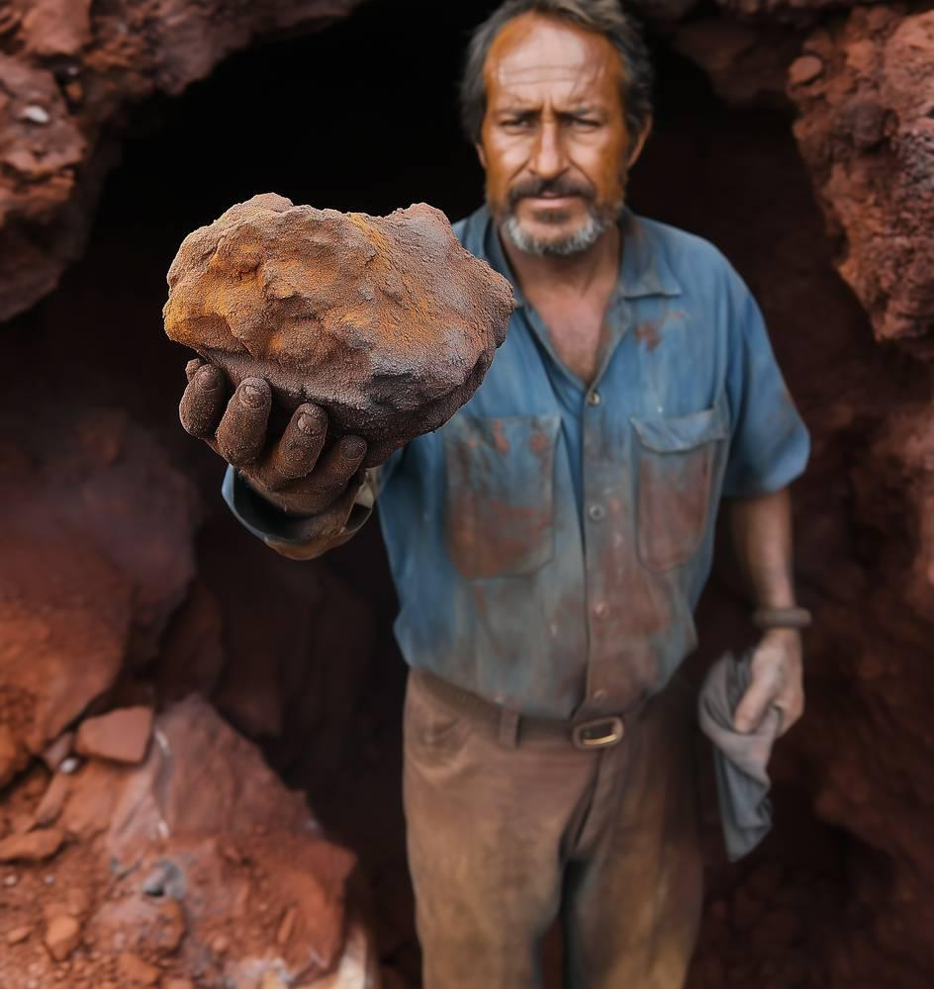
link

Iron Gate

Image Content

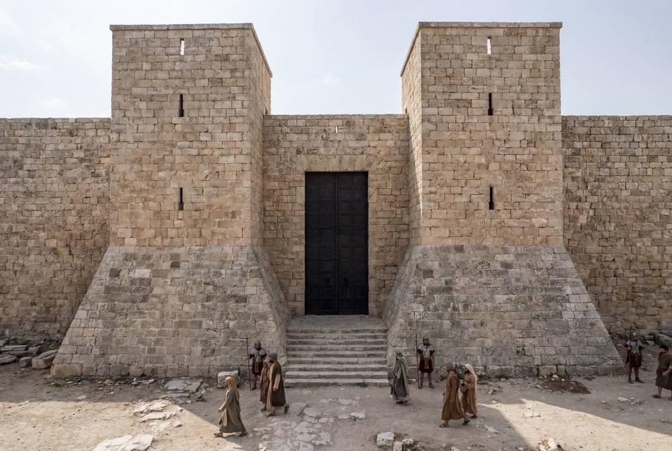
link

Iron Gate

Image Content

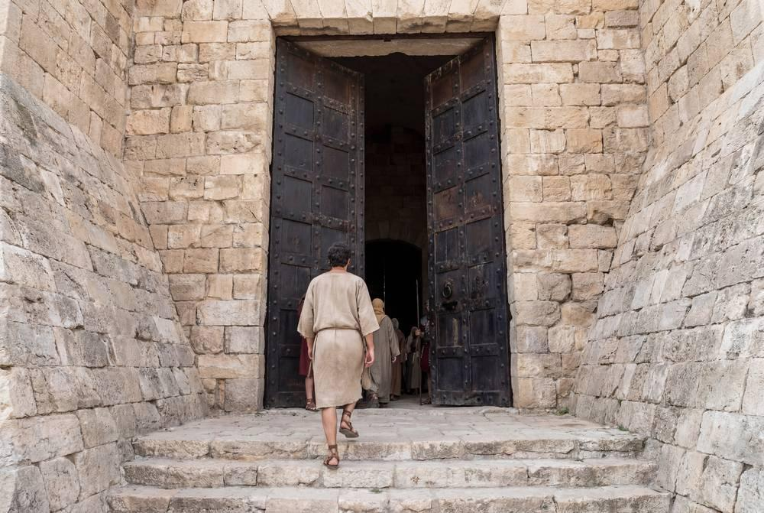
link

Iron Gate

Image Content

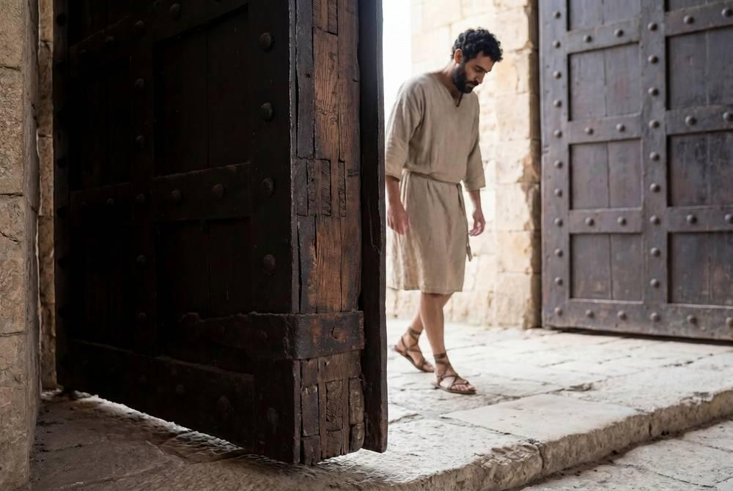
link

Israelite Soldier Wearing a Sword

Image Content


link

Israelite Soldier Wearing a Sword

Image Content


link

Israelite Soldier Wearing a Sword

Image Content

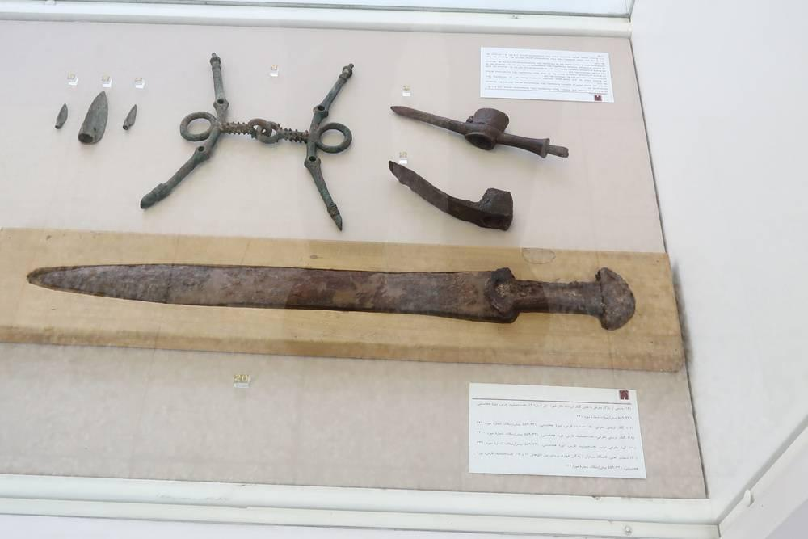
link

Israelites Camping Around Tabernacle

Image Content

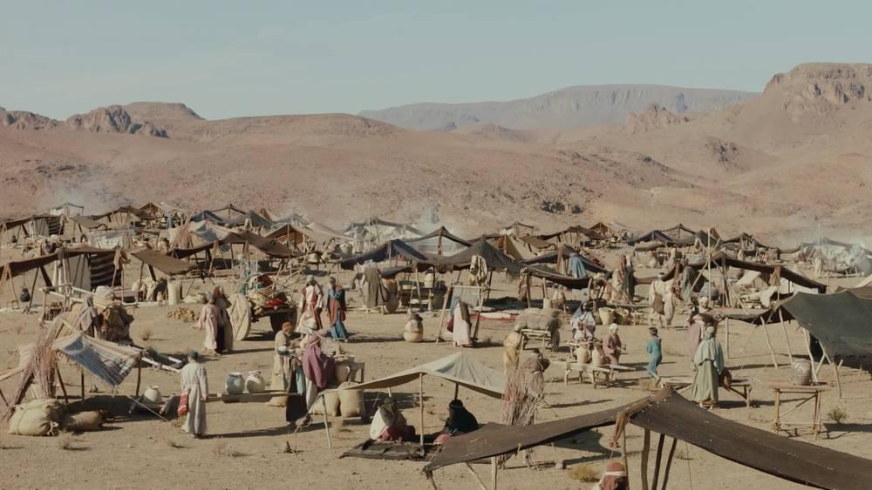
link

Items of Gold, Silver and Bronze

Image Content

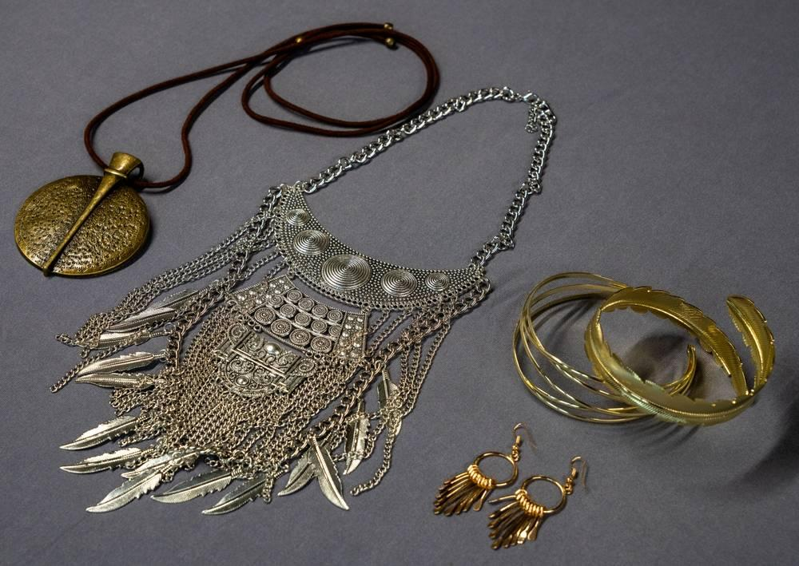
link

Items of Gold, Silver and Bronze

Image Content

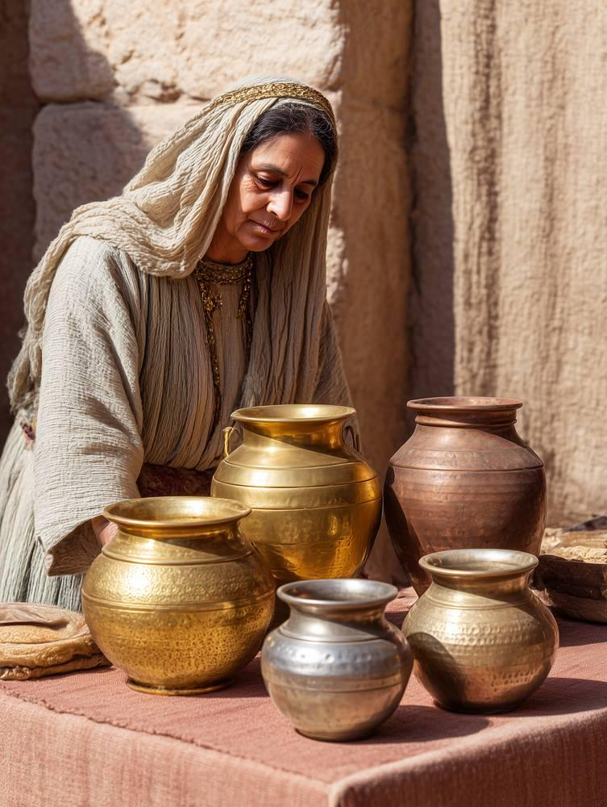
link

Items of Gold, Silver and Bronze

Image Content

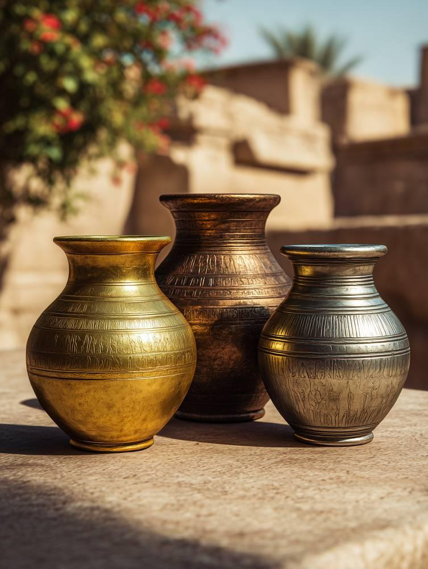
link

