Resource: Familiarization, Internalization, Articulation (Fia) Images
Familiarization, Internalization, Articulation (FIA) Images © 2023 SRV Partners Released under CC BY-SA 4.0 license. Familiarization, Internalization, Articulation (FIA) Images has been adapted in the following languages Tok Pisin, عربي, Français, हिंदी, Bahasa Indonesia, Português, Русский, Español, Kiswahili, 简体中文 from Familiarization, Internalization, Articulation (FIA) © 2023 SRV Partners. Released under CC BY-SA 4.0 license by Mission Mutual

Familiarization, Internalization, Articulation (Fia) Images

V

Veau engraissé

Image Content

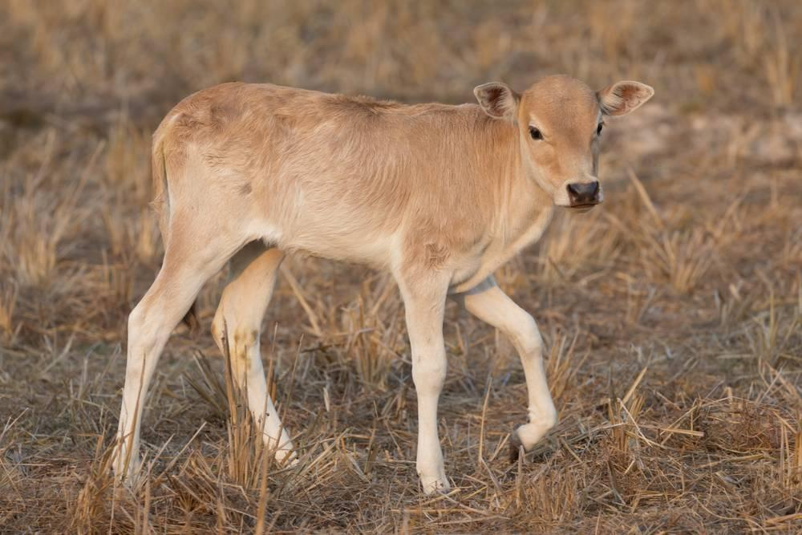
link

Veau engraissé

Image Content

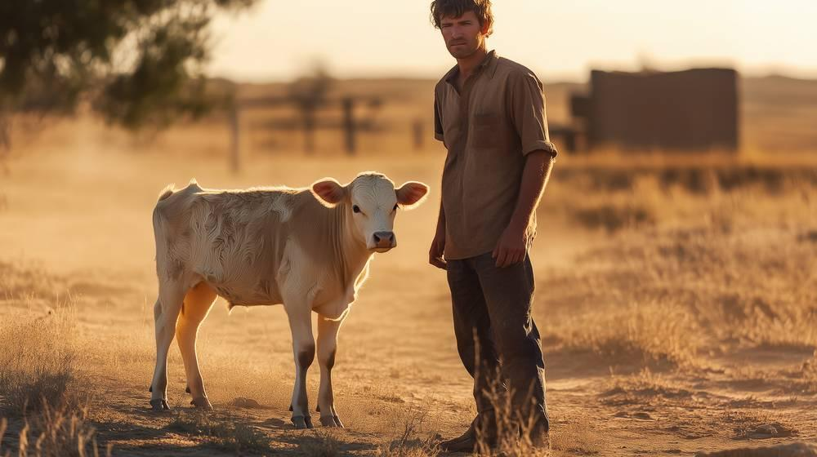
link

Vidéo accélérée d'une semence qui pousse

Image Content


link

Vidéo accélérée d'une semence qui pousse

Image Content

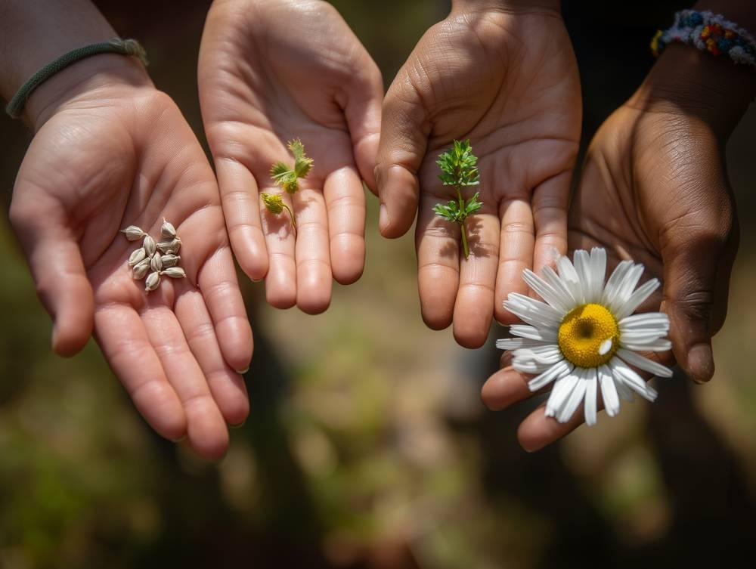
link

Vidéo accélérée d'une semence qui pousse

Image Content


link

Vigne

Image Content

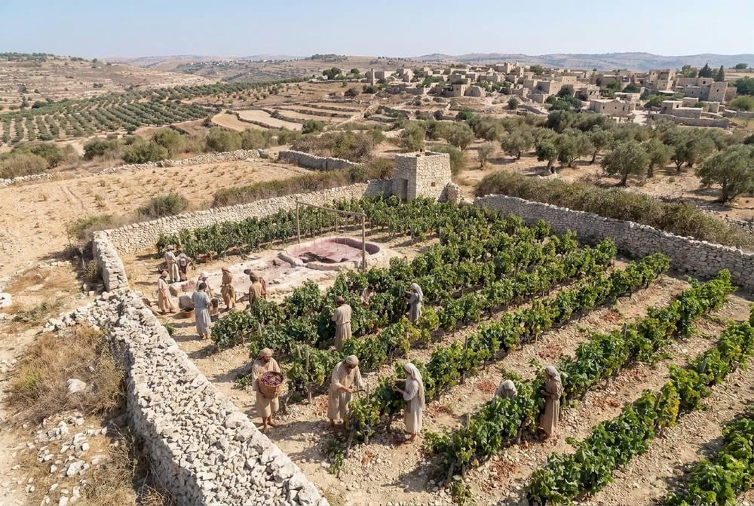
link

Vigne

Image Content

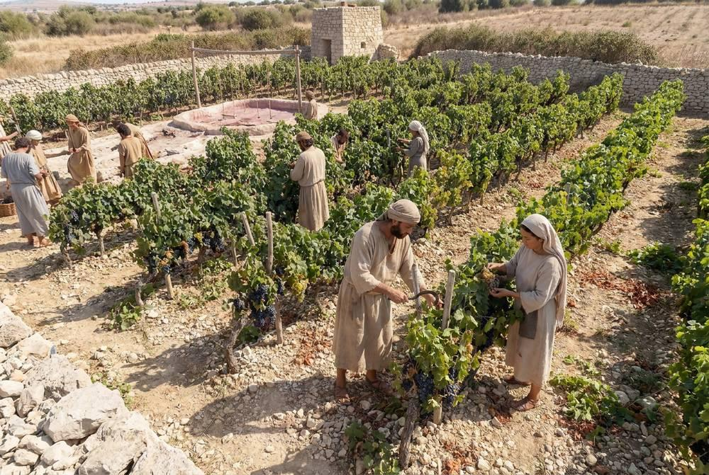
link

Vigne

Image Content

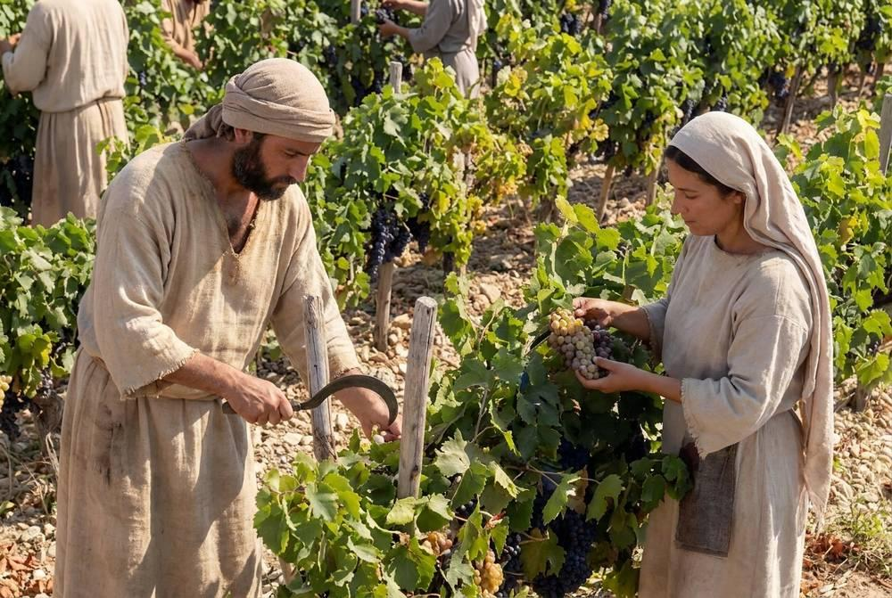
link

Vin

Image Content

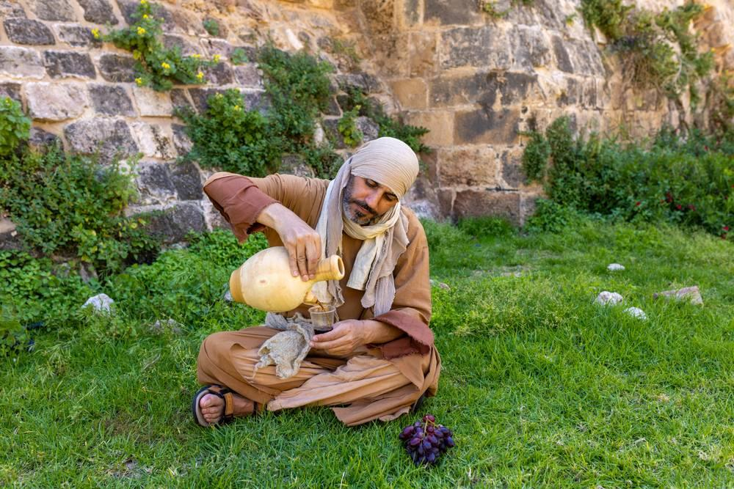
link

