Resource: Familiarization, Internalization, Articulation (Fia) Images
Familiarization, Internalization, Articulation (FIA) Images © 2023 SRV Partners Released under CC BY-SA 4.0 license. Familiarization, Internalization, Articulation (FIA) Images has been adapted in the following languages Tok Pisin, عربي, Français, हिंदी, Bahasa Indonesia, Português, Русский, Español, Kiswahili, 简体中文 from Familiarization, Internalization, Articulation (FIA) © 2023 SRV Partners. Released under CC BY-SA 4.0 license by Mission Mutual

Familiarization, Internalization, Articulation (Fia) Images

N

Nard Plant

Image Content

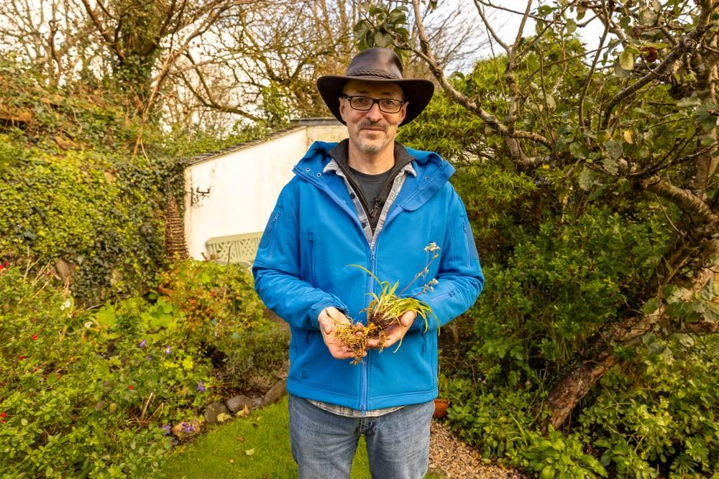
link

Nard Plant

Image Content

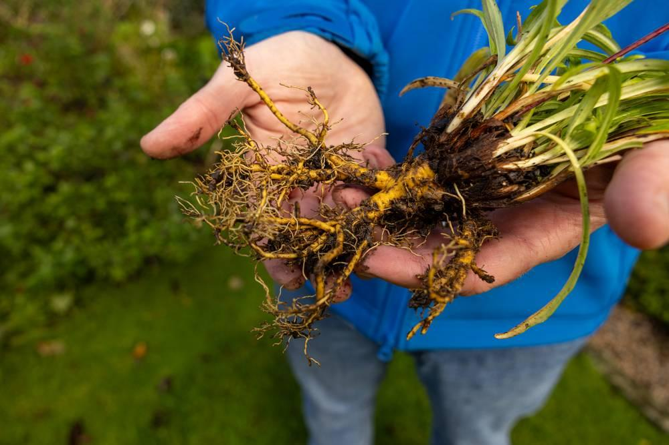
link

Narrow Street

Image Content

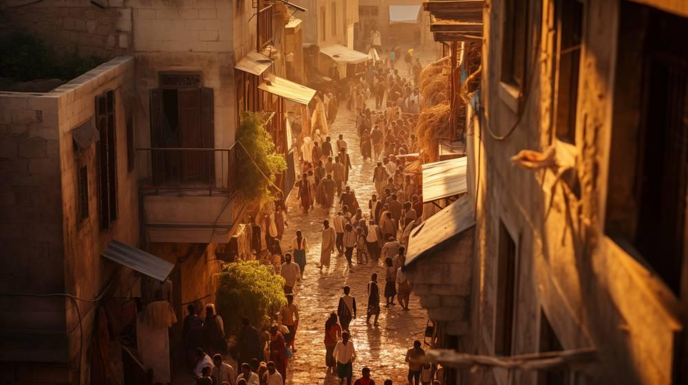
link

Narrow Street

Image Content

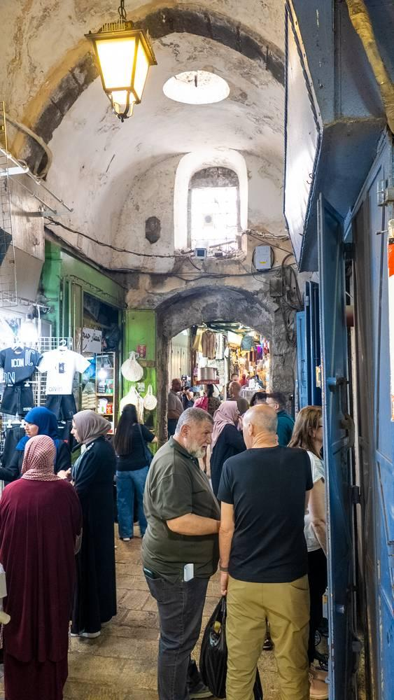
link

Negev Desert

Image Content

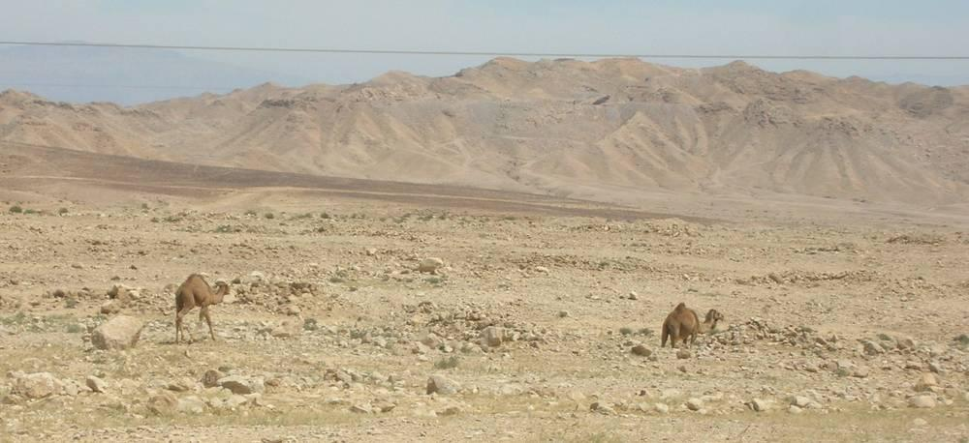
link

Negev Desert

Image Content

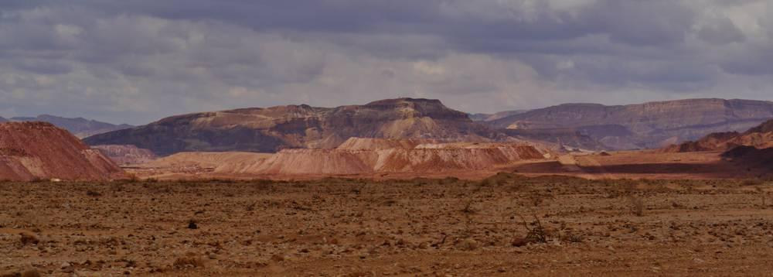
link

Nests Inside Noah's Ark

Image Content

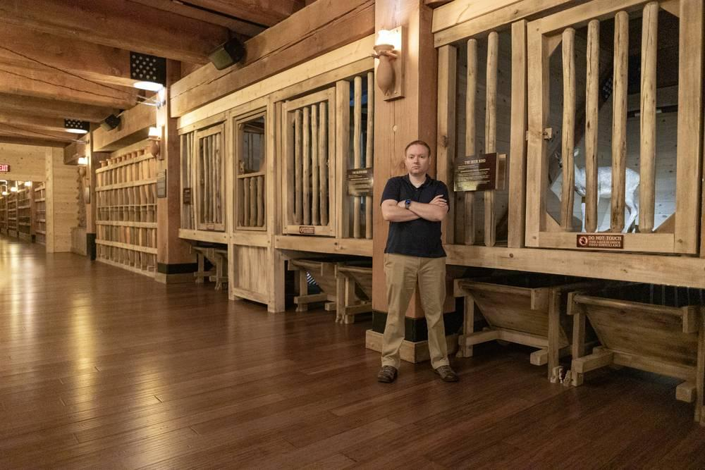
link

Nests Inside Noah's Ark

Image Content

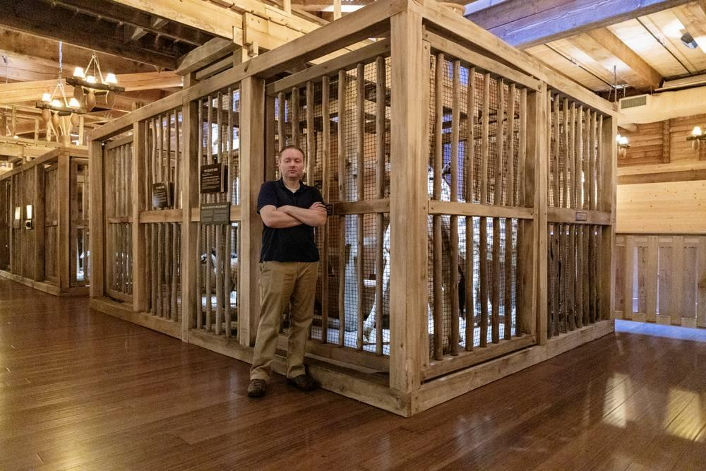
link

Nests Inside Noah's Ark

Image Content

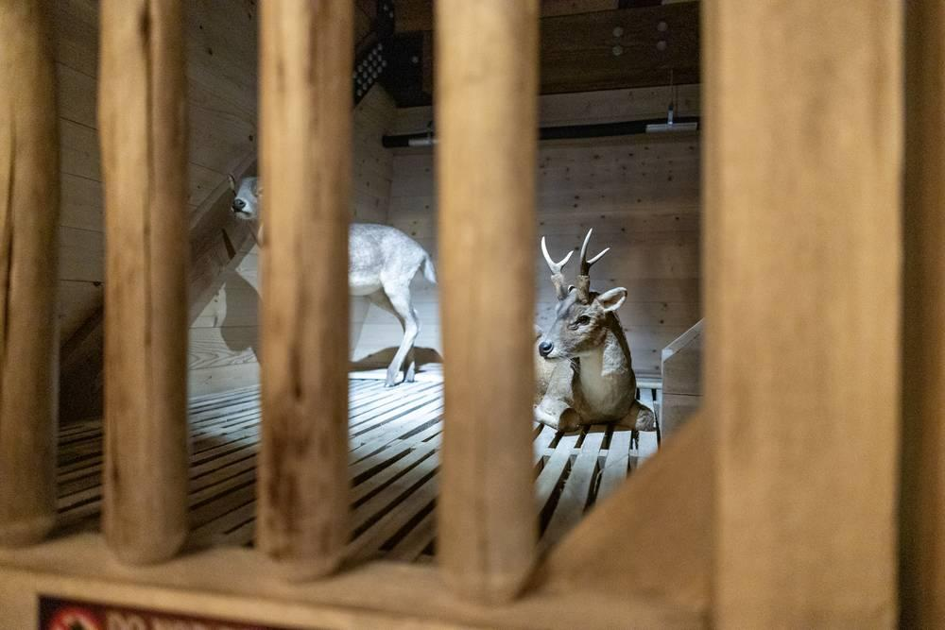
link

Night Sky Filled with Stars

Image Content


link

Night Sky Filled with Stars

Image Content

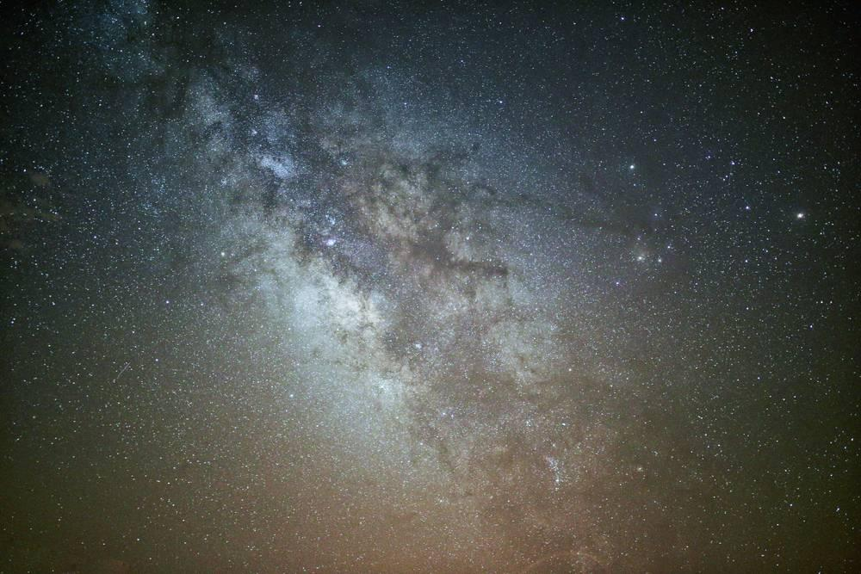
link

Night Sky Filled with Stars

Image Content


link

Nile River

Image Content

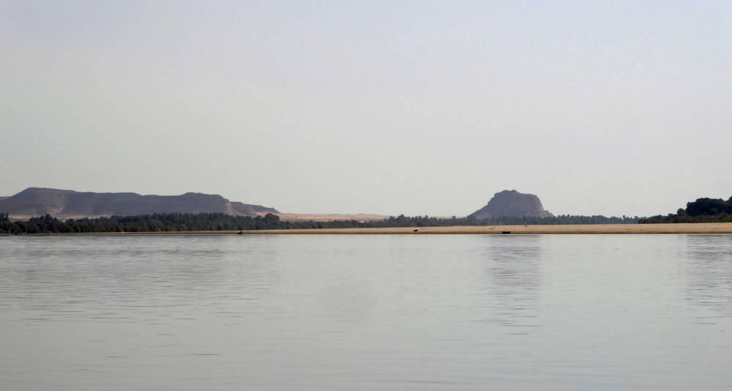
link

Nile River

Image Content

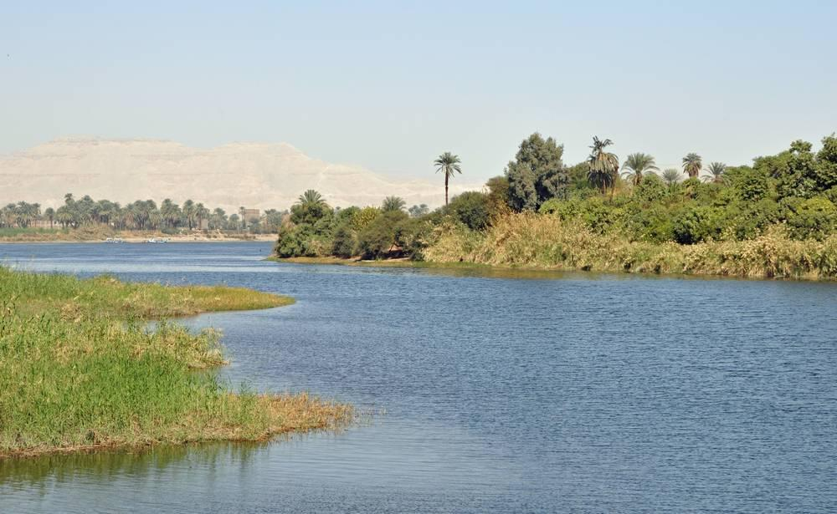
link

Noah's Ark

Image Content

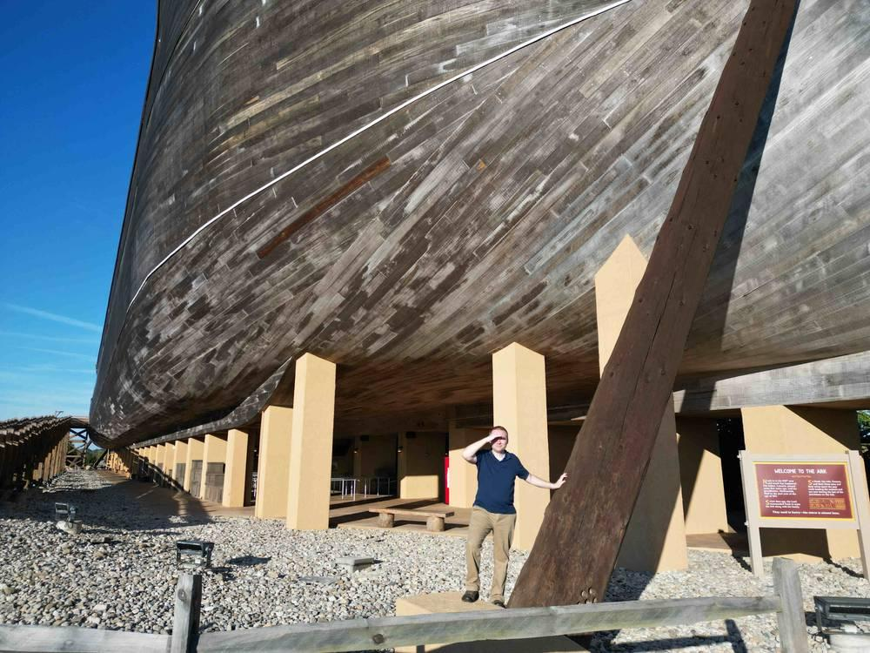
link

Noah's Ark

Image Content

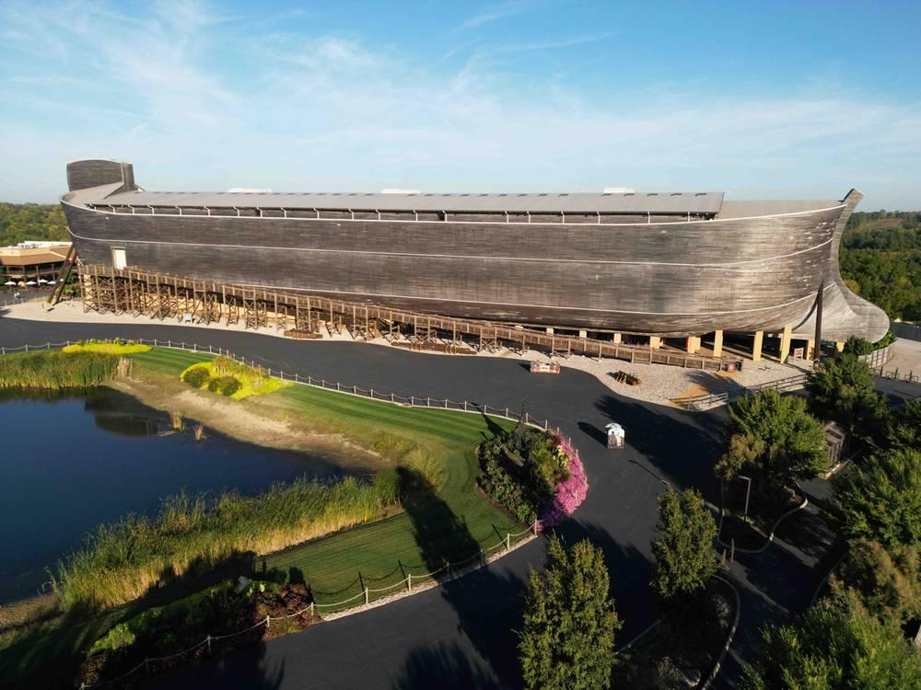
link

Noah's Ark

Image Content

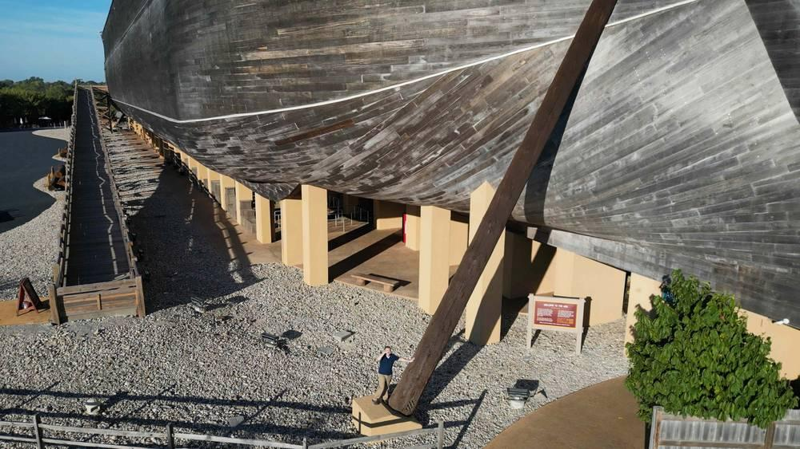
link

