Resource: Familiarization, Internalization, Articulation (Fia) Images
Familiarization, Internalization, Articulation (FIA) Images © 2023 SRV Partners Released under CC BY-SA 4.0 license. Familiarization, Internalization, Articulation (FIA) Images has been adapted in the following languages Tok Pisin, عربي, Français, हिंदी, Bahasa Indonesia, Português, Русский, Español, Kiswahili, 简体中文 from Familiarization, Internalization, Articulation (FIA) © 2023 SRV Partners. Released under CC BY-SA 4.0 license by Mission Mutual

Familiarization, Internalization, Articulation (Fia) Images

U

Unfortified Ancient City

Image Content

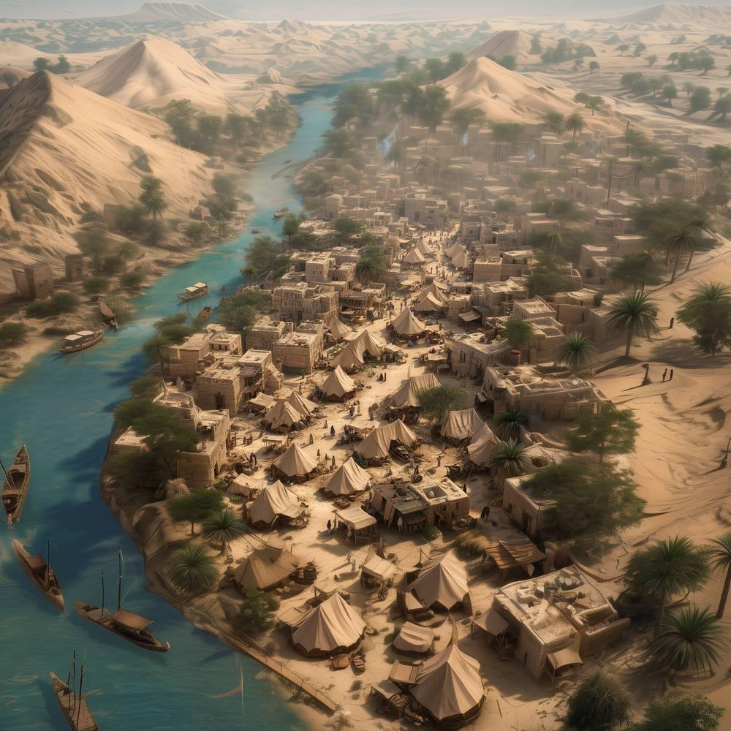
link

Unfortified Ancient City

Image Content


link

Unleavened Bread

Image Content

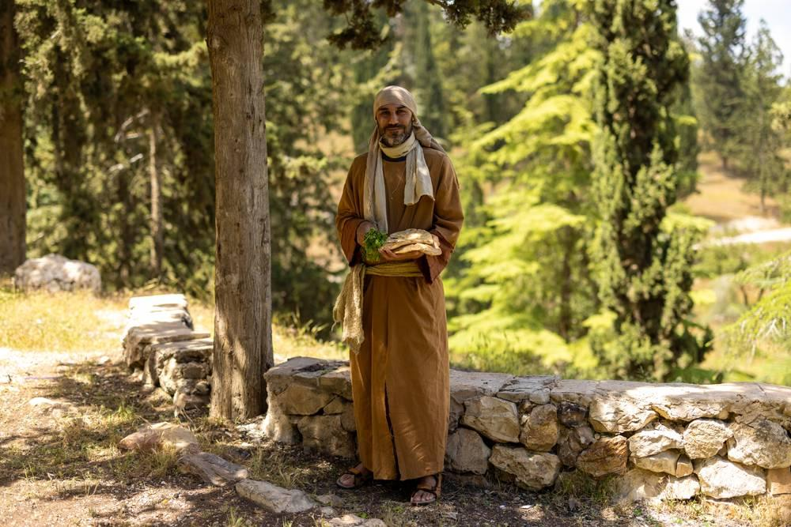
link

Unleavened Bread

Image Content

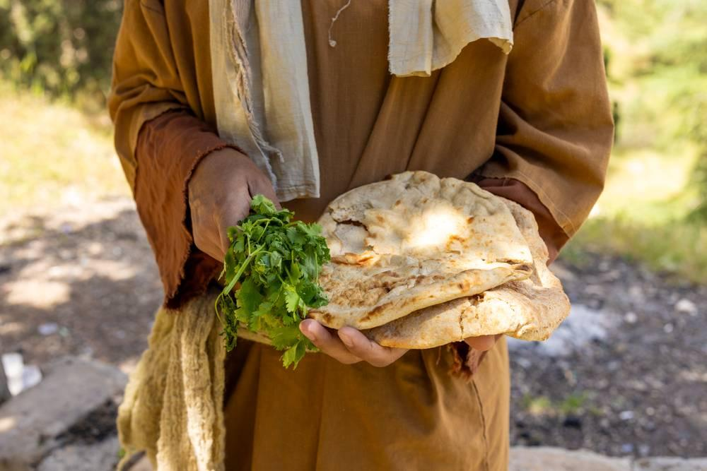
link

Unleavened Bread

Image Content

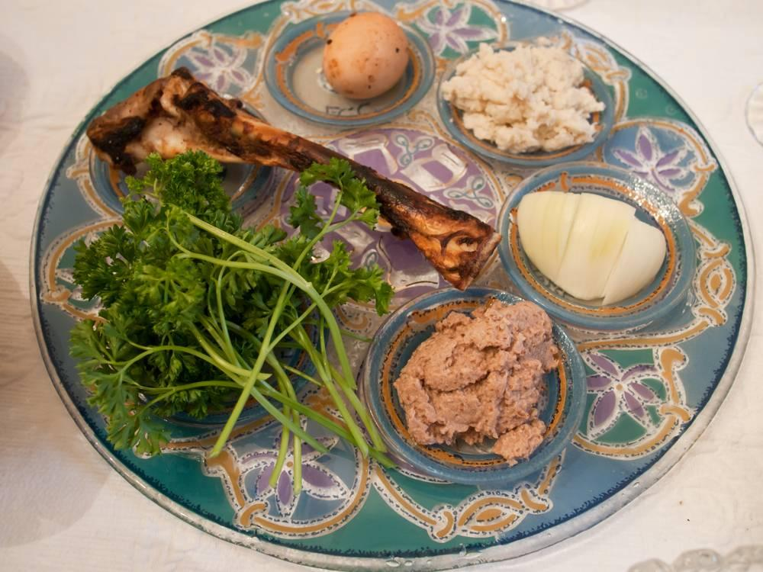
link

Unleavened Bread Cake

Image Content

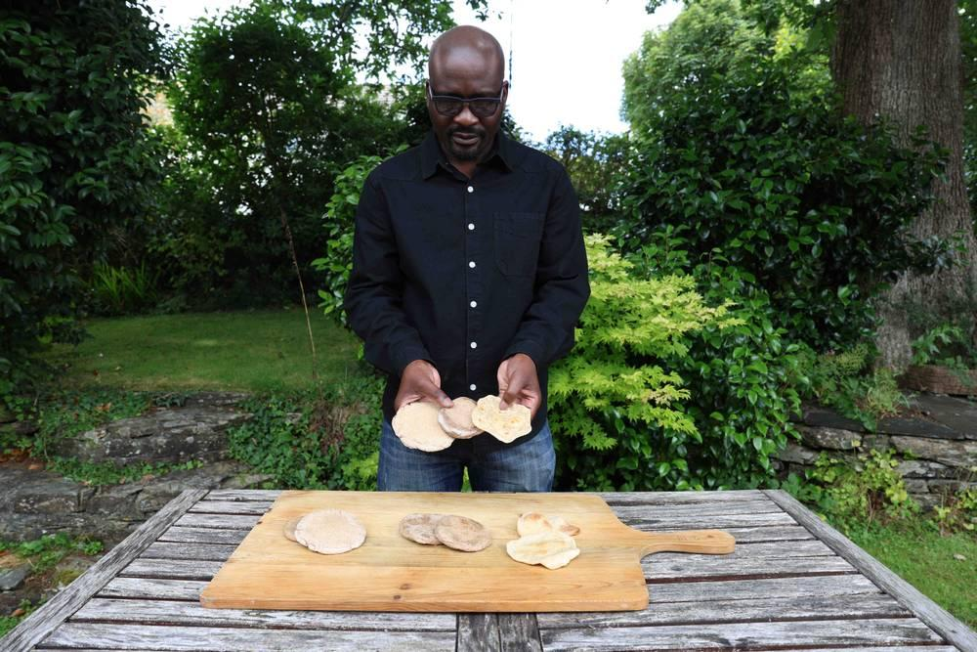
link

Unleavened Bread Cake

Image Content

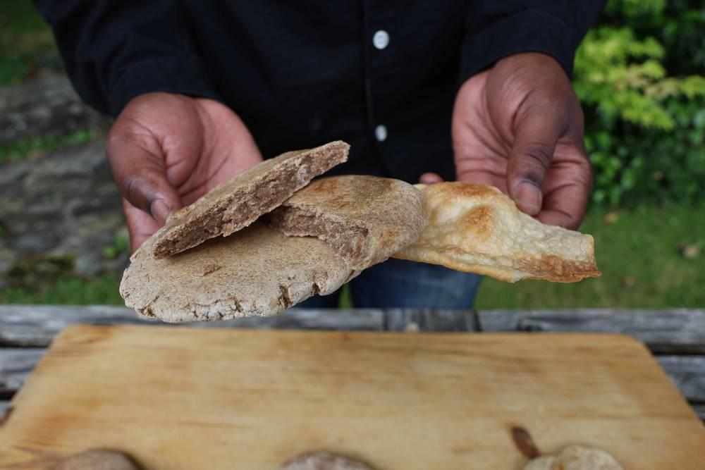
link

Upper Room

Image Content

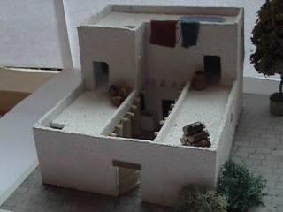
link

Upper Room

Image Content

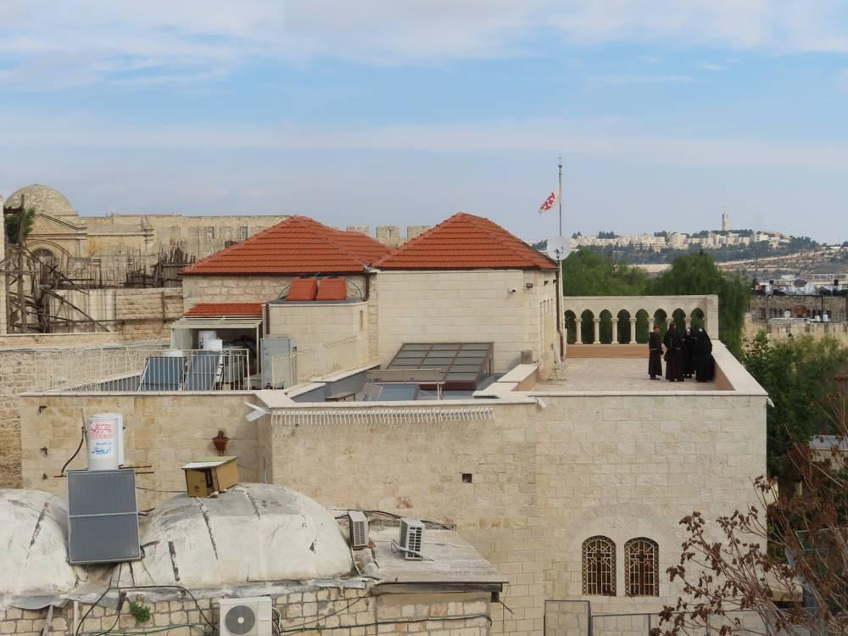
link

Upper Room

Image Content

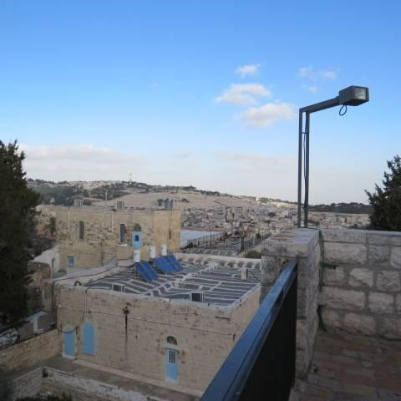
link

