Resource: Familiarization, Internalization, Articulation (Fia) Images
Familiarization, Internalization, Articulation (FIA) Images © 2023 SRV Partners Released under CC BY-SA 4.0 license. Familiarization, Internalization, Articulation (FIA) Images has been adapted in the following languages Tok Pisin, عربي, Français, हिंदी, Bahasa Indonesia, Português, Русский, Español, Kiswahili, 简体中文 from Familiarization, Internalization, Articulation (FIA) © 2023 SRV Partners. Released under CC BY-SA 4.0 license by Mission Mutual

Familiarization, Internalization, Articulation (Fia) Images

Y

Yogurt

Image Content

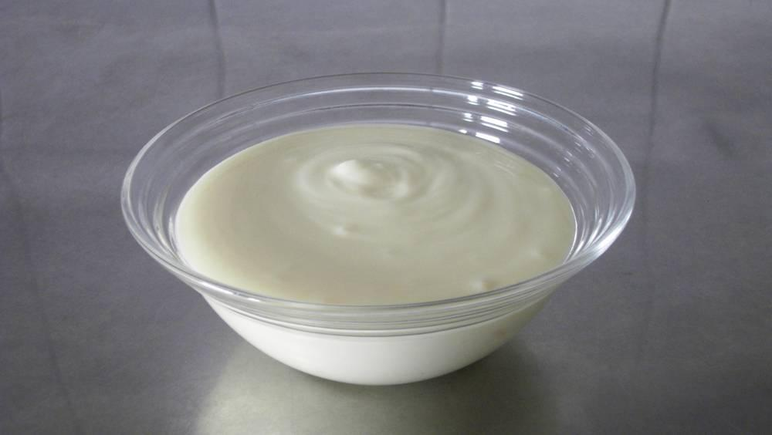
link

Yogurt

Image Content

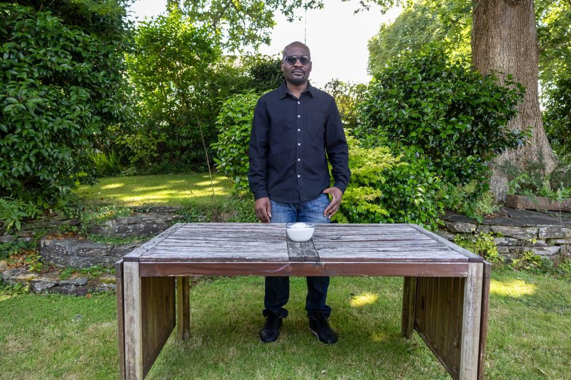
link

Yogurt

Image Content

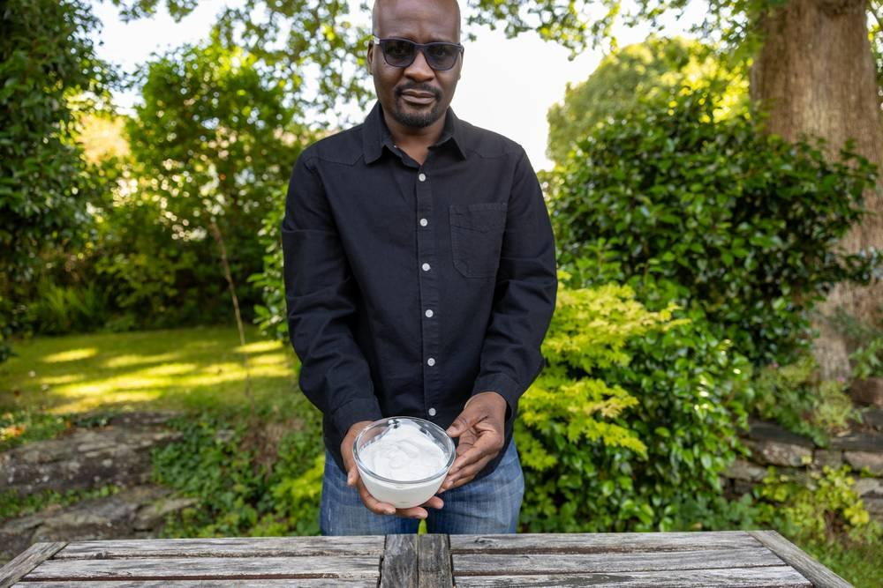
link

Yogurt

Image Content

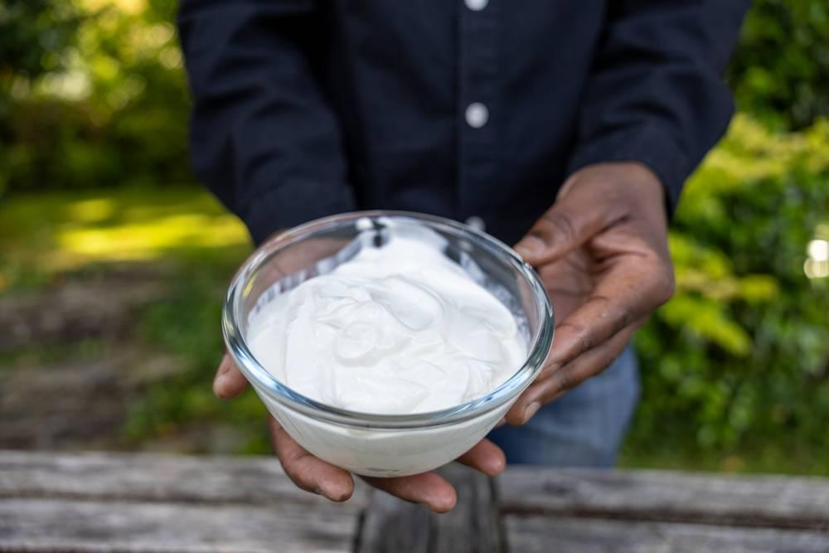
link

Yoke

Image Content

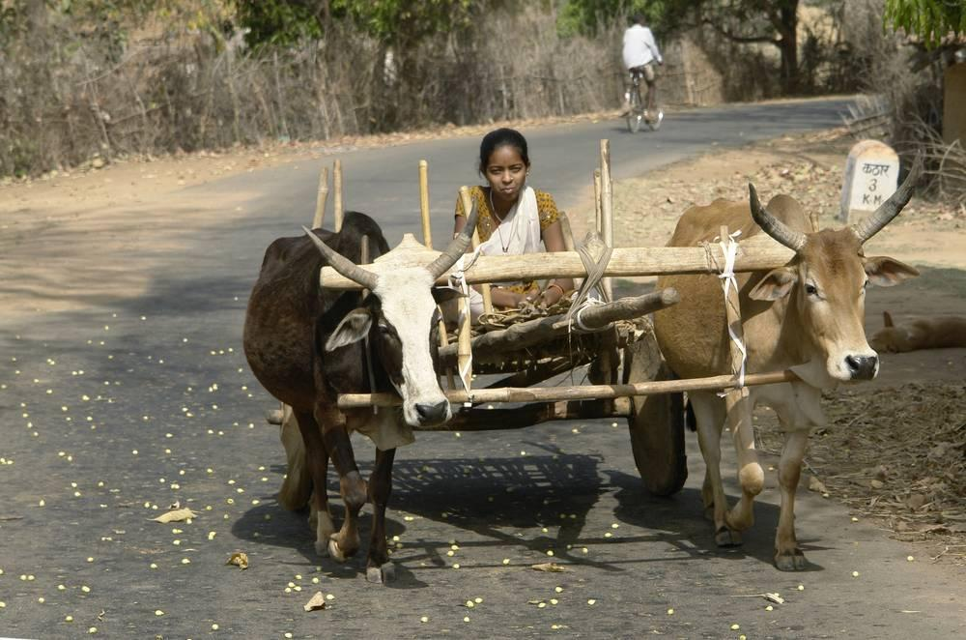
link

Yoke

Image Content

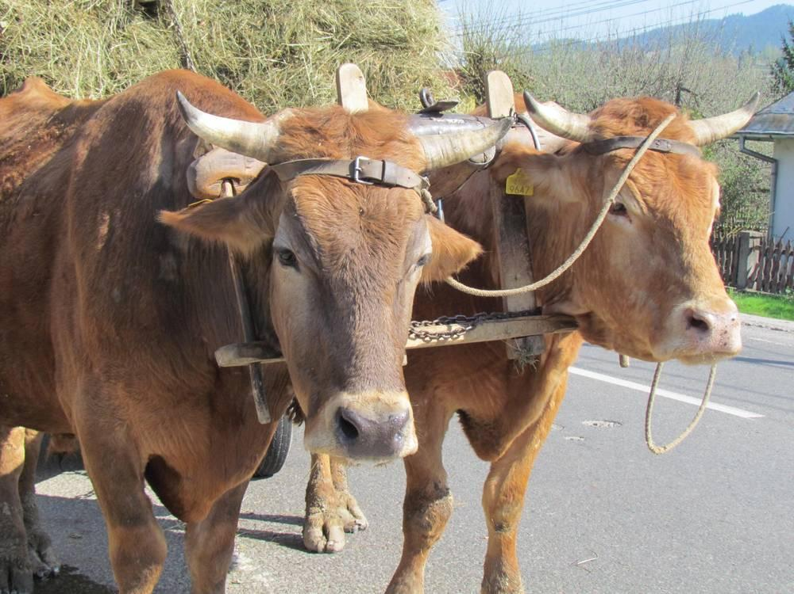
link

Young Donkey

Image Content

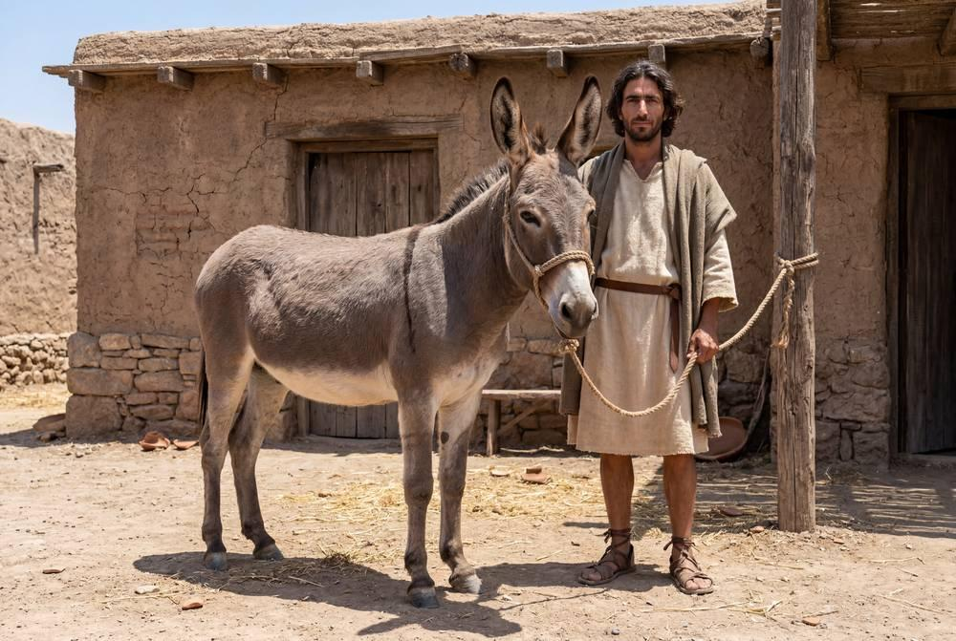
link

Young Donkey

Image Content

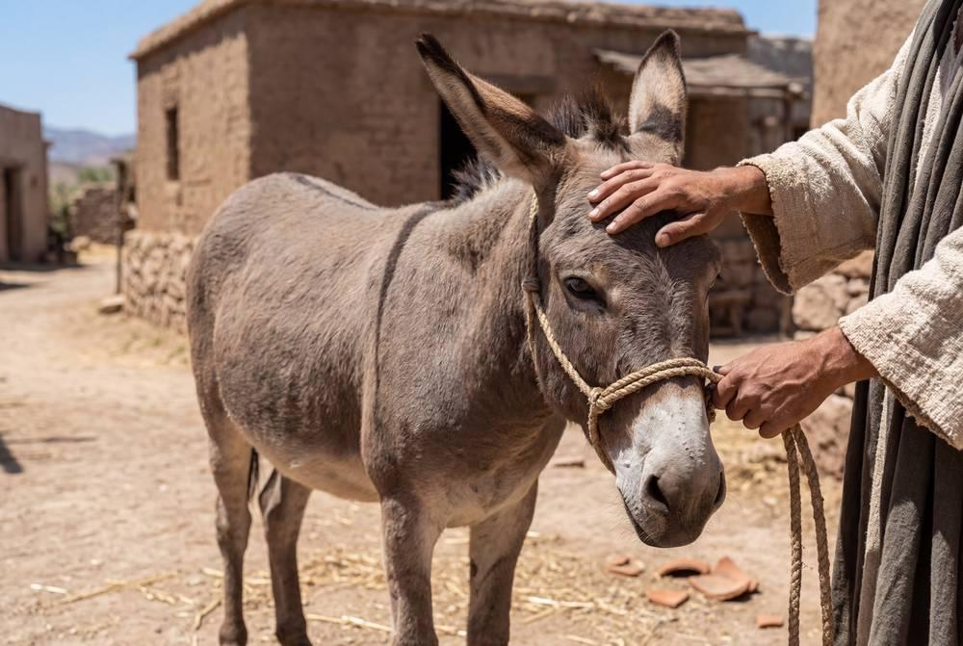
link

Young Donkey

Image Content

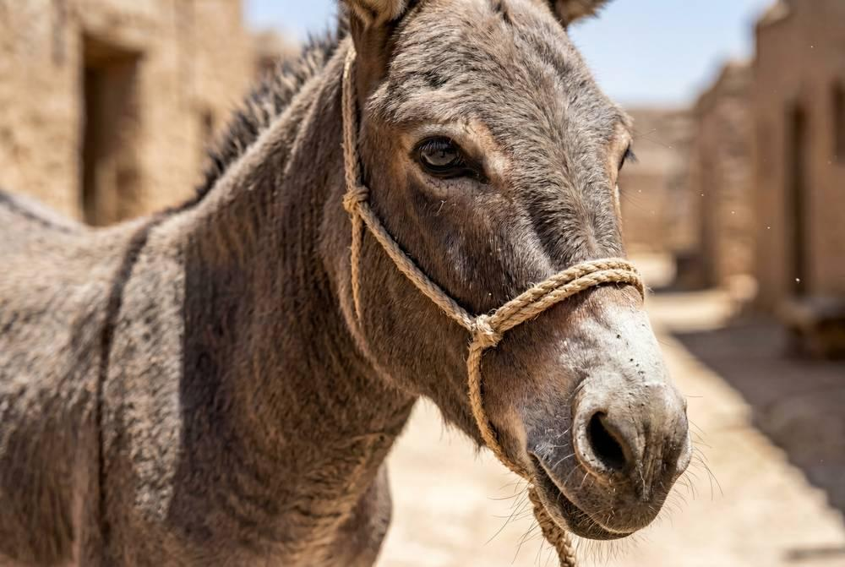
link

Young Lion

Image Content

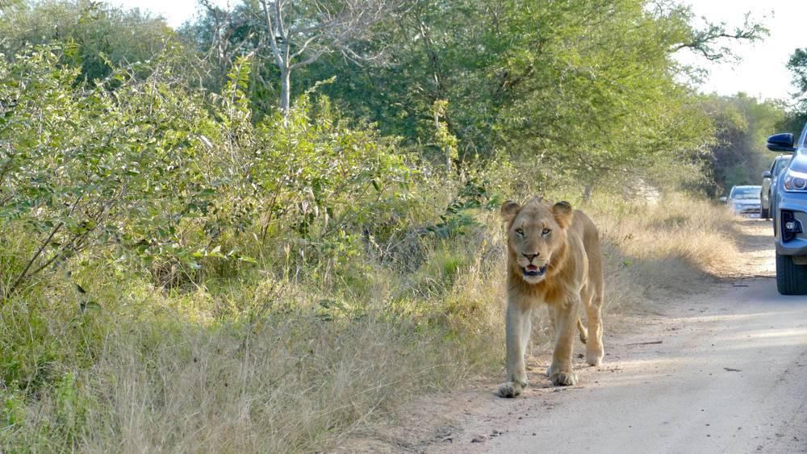
link

Young Lion

Image Content

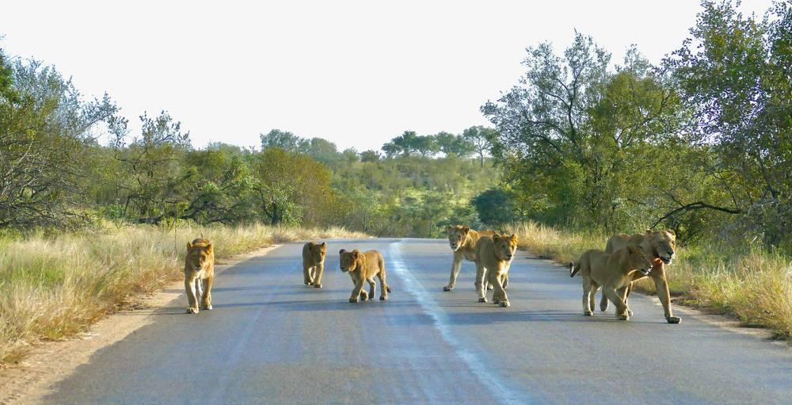
link

Young Lion

Image Content

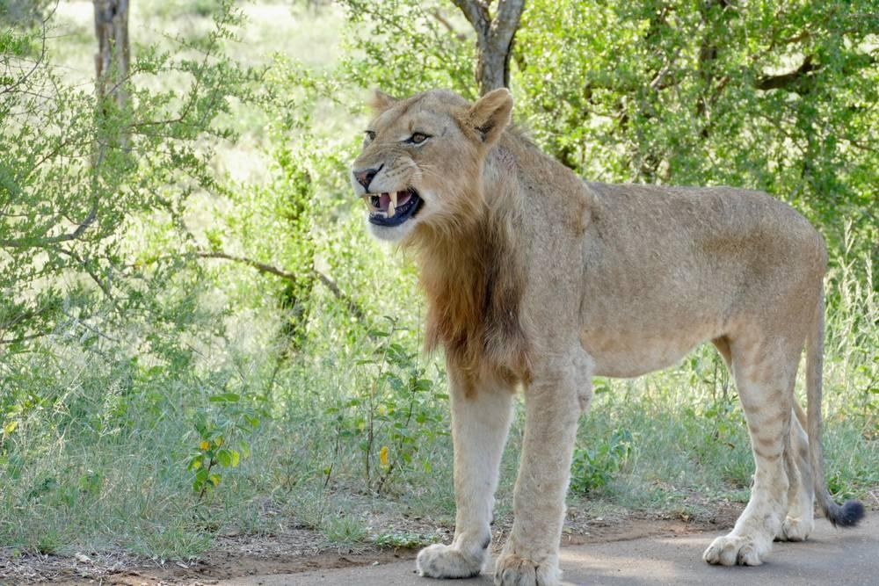
link

Young Lion

Image Content

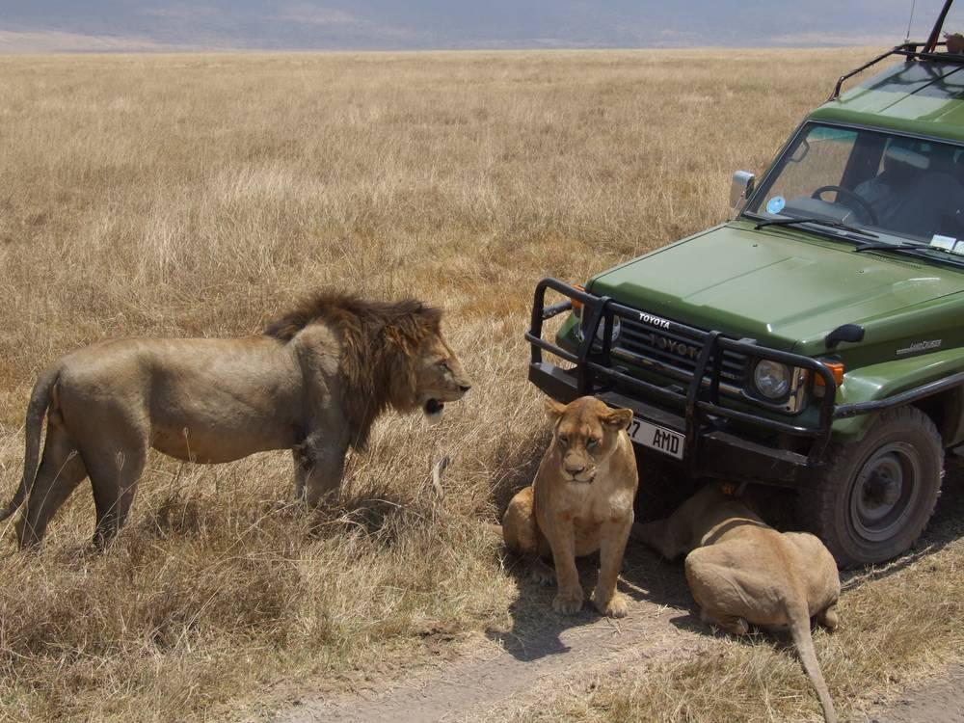
link

Young Spelt Plants

Image Content

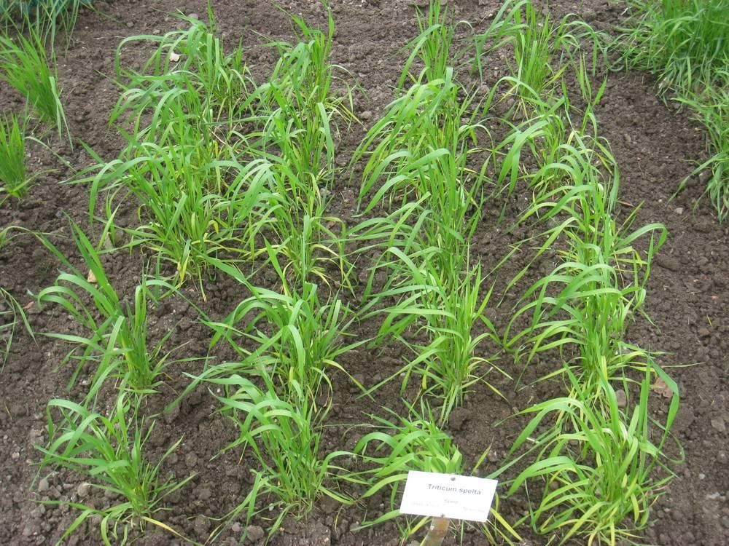
link

Young Wheat Plants

Image Content

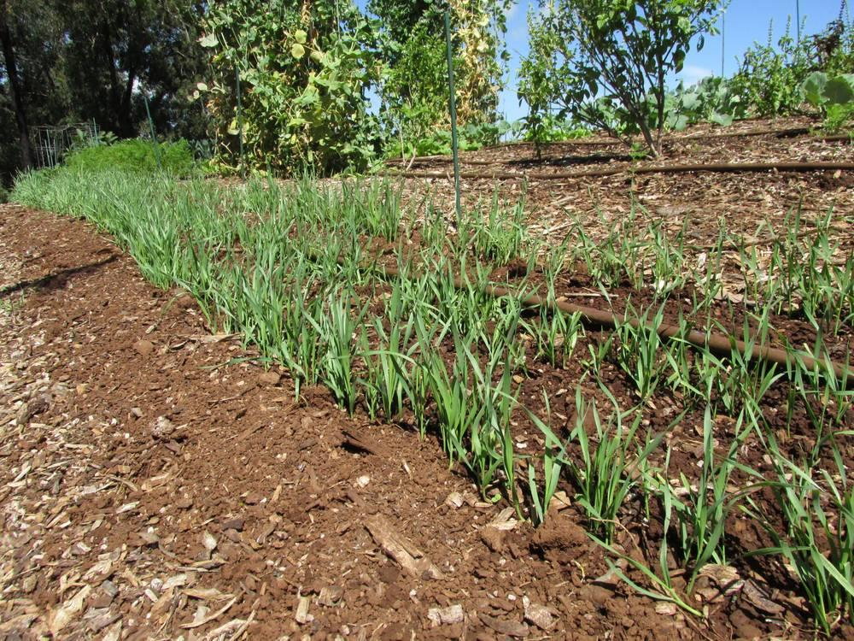
link

Young Wheat Plants

Image Content

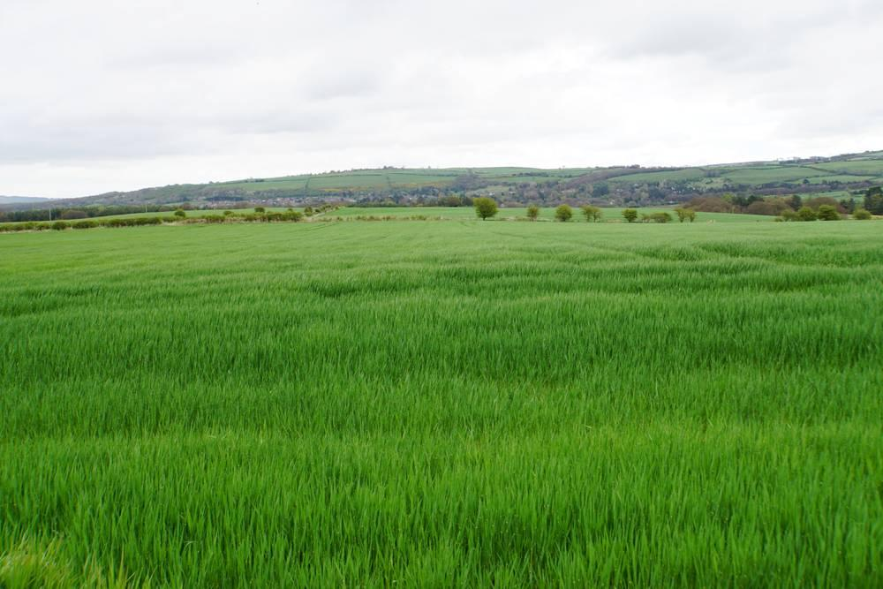
link

Young Wheat Plants

Image Content

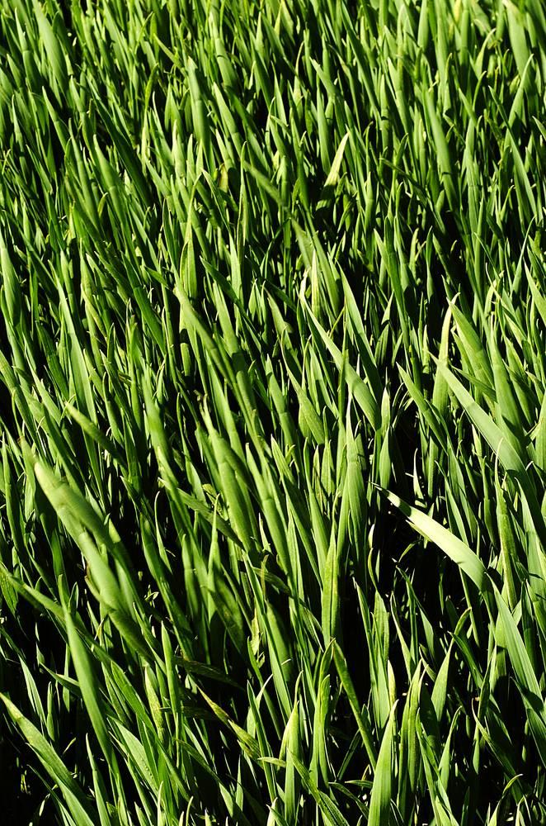
link

