Resource: Familiarization, Internalization, Articulation (Fia) Images
Familiarization, Internalization, Articulation (FIA) Images © 2023 SRV Partners Released under CC BY-SA 4.0 license. Familiarization, Internalization, Articulation (FIA) Images has been adapted in the following languages Tok Pisin, عربي, Français, हिंदी, Bahasa Indonesia, Português, Русский, Español, Kiswahili, 简体中文 from Familiarization, Internalization, Articulation (FIA) © 2023 SRV Partners. Released under CC BY-SA 4.0 license by Mission Mutual

Familiarization, Internalization, Articulation (Fia) Images

J

Jacinth and Turquoise

Image Content

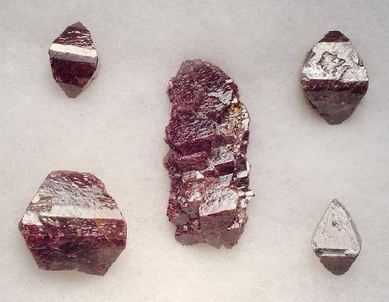
link

Jacinth and Turquoise

Image Content

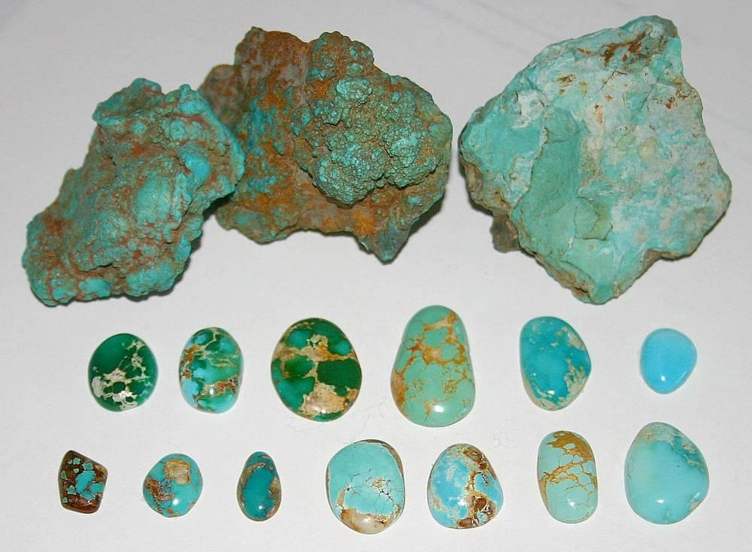
link

Jacinth and Turquoise

Image Content

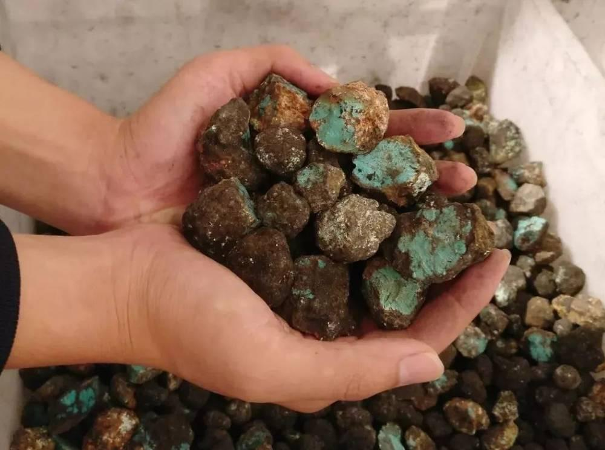
link

Jacob's Geneaology

Image Content

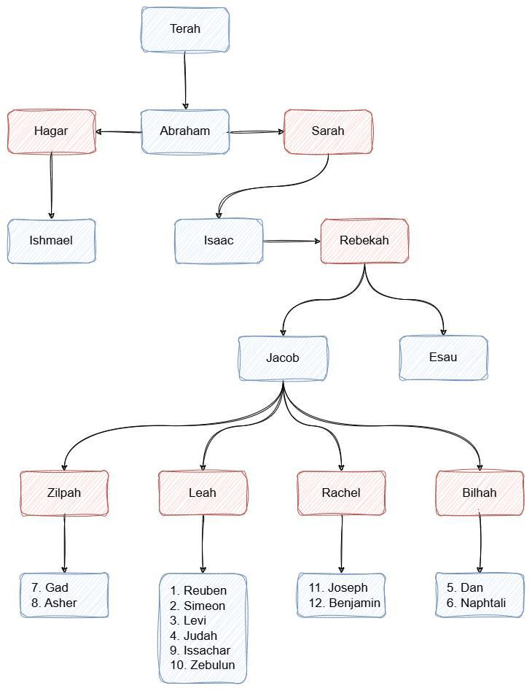
link

Jar of Olive Oil

Image Content

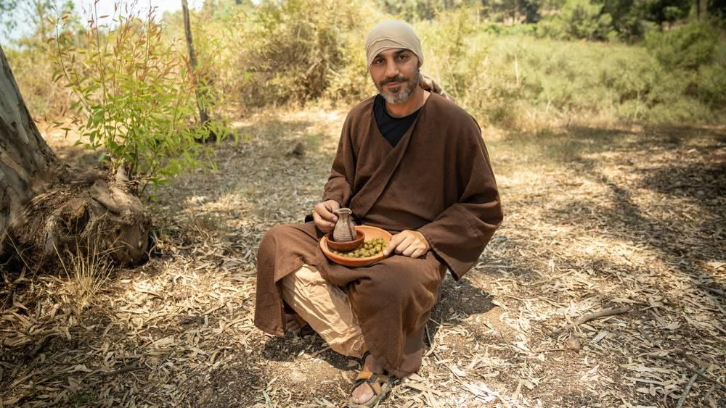
link

Jar of Olive Oil

Image Content

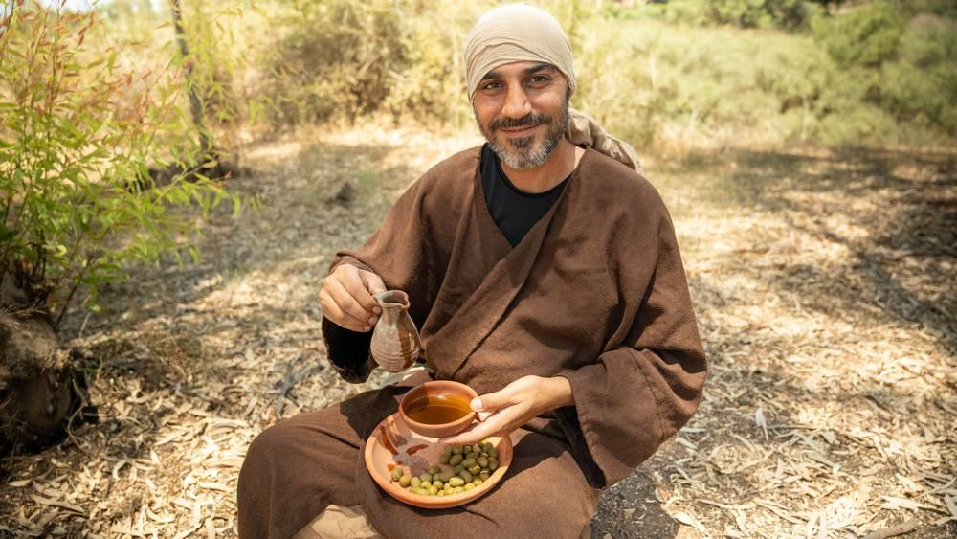
link

Jar of Olive Oil

Image Content

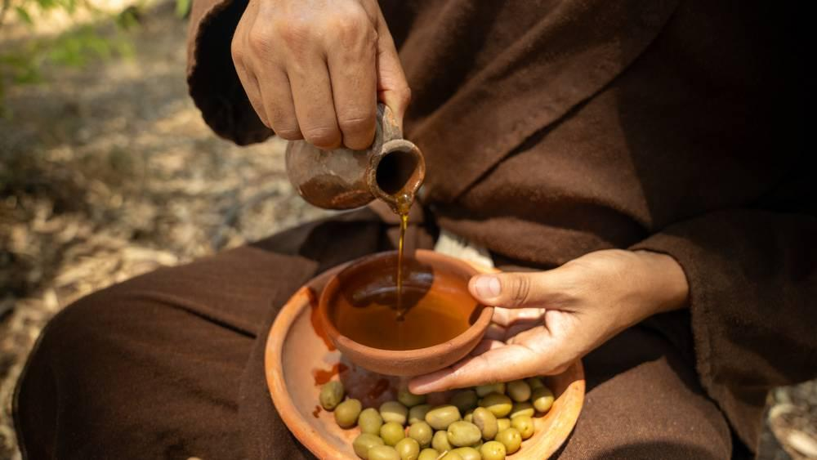
link

Jericho Road

Image Content

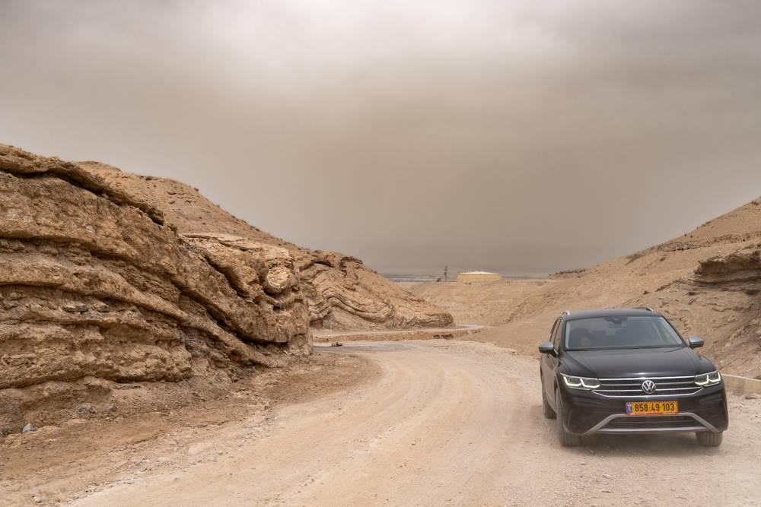
link

Jerusalem Landscape

Image Content

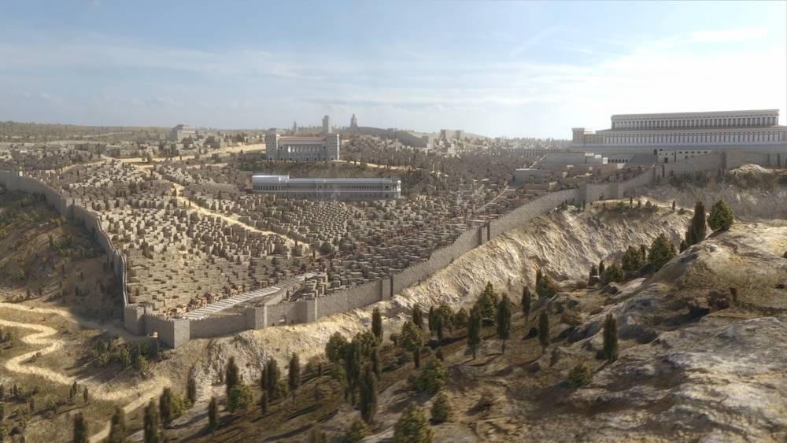
link

Jerusalem Wall Tower

Image Content

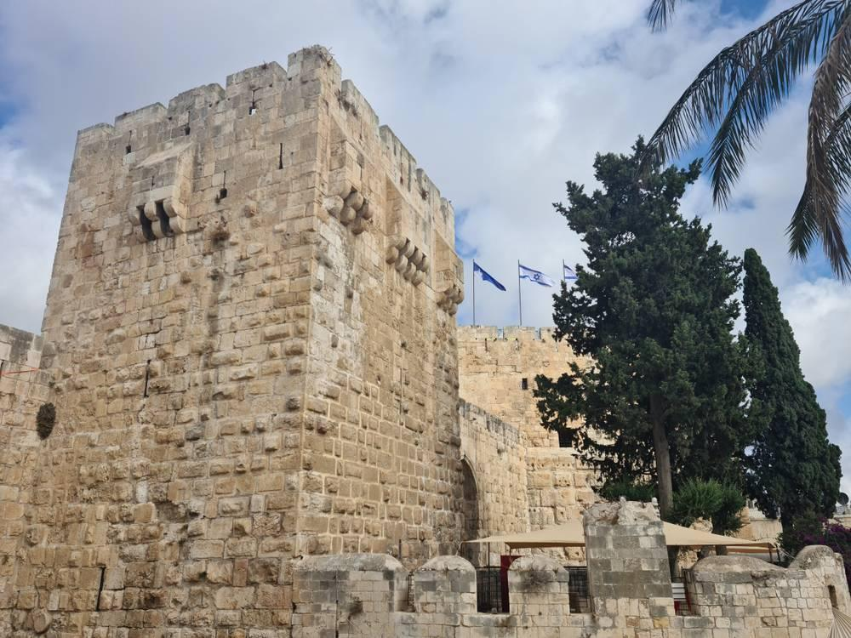
link

Jesus and Disciples in a Boat

Image Content


link

Jesus and Disciples in a Boat

Image Content

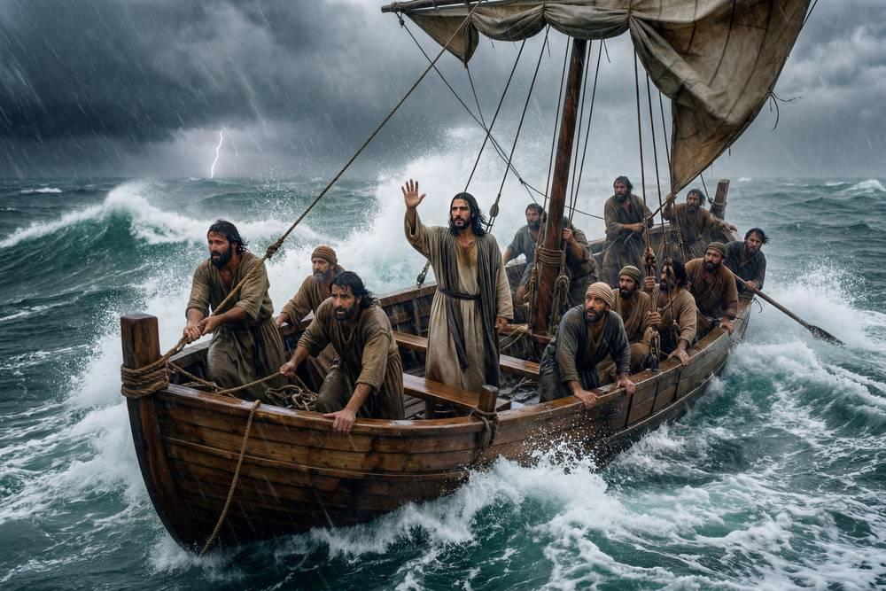
link

Jesus and Disciples in a Boat

Image Content

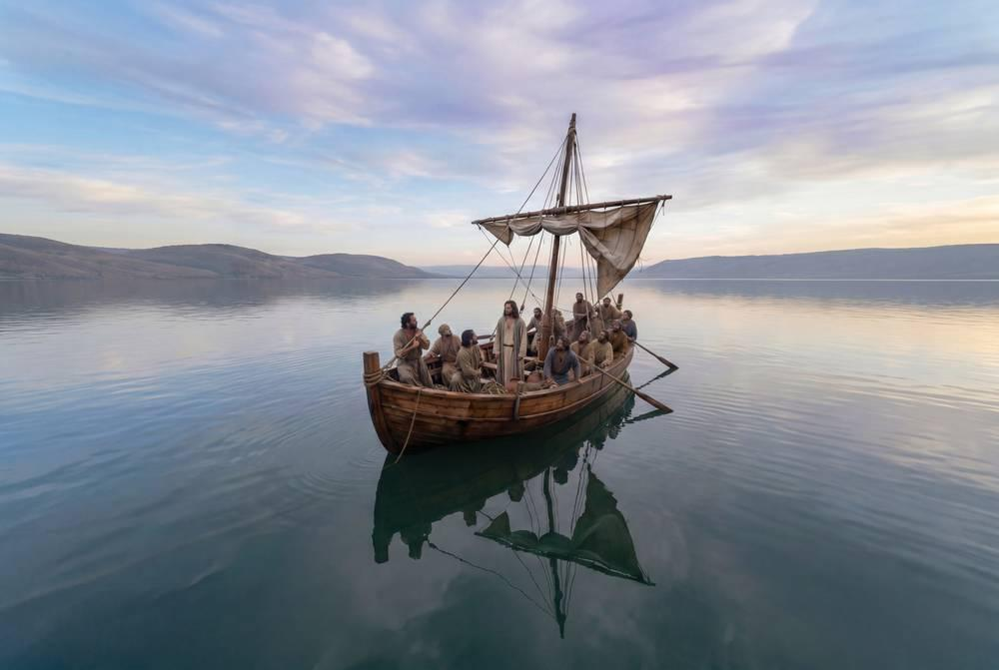
link

Jesus Tried by the High Priest

Image Content

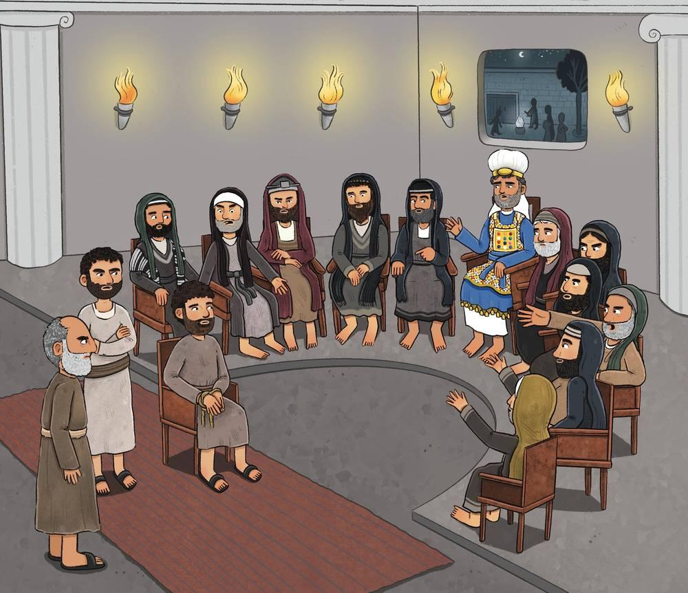
link

Jewel with Engraving

Image Content

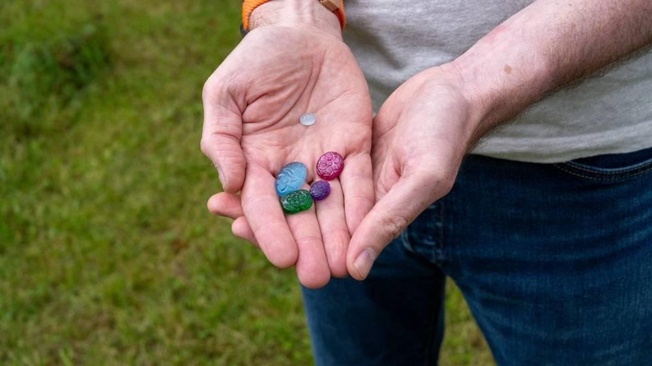
link

Jewel with Engraving

Image Content

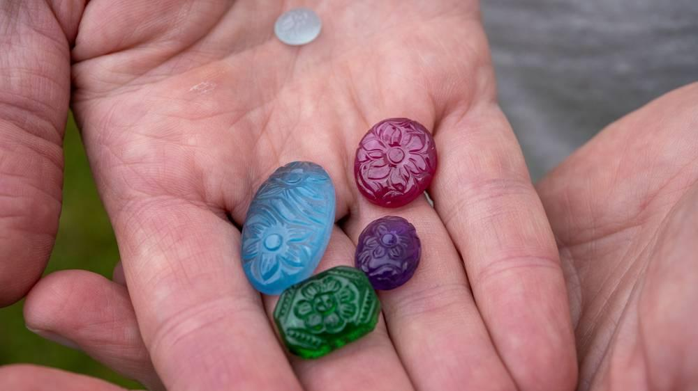
link

Jewelry

Image Content

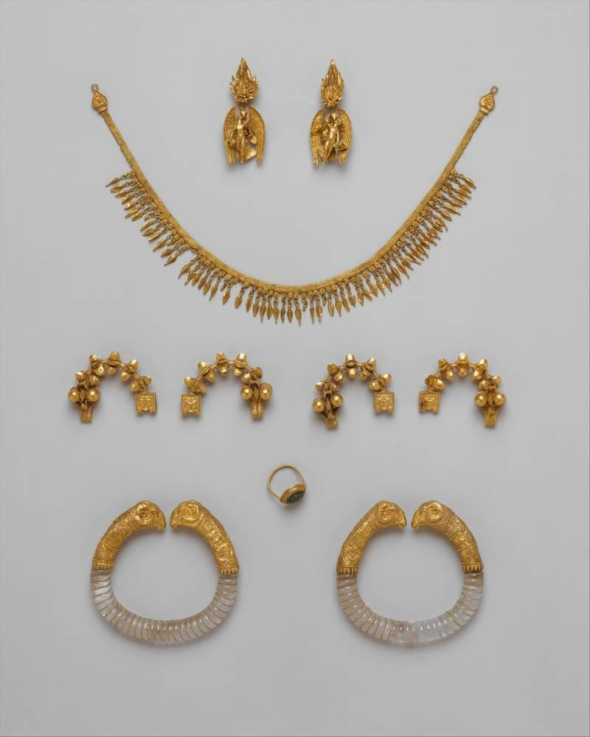
link

Jewelry

Image Content

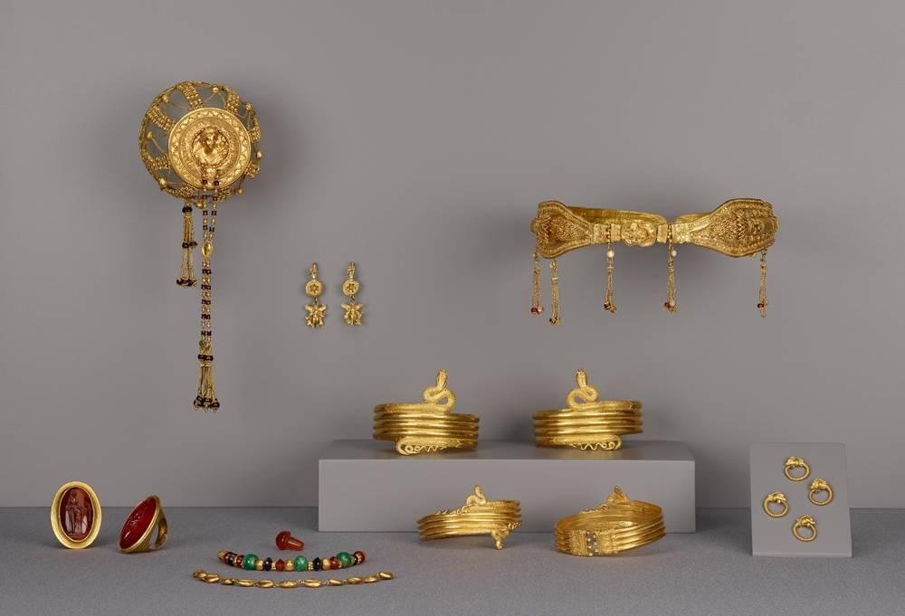
link

Jewelry

Image Content

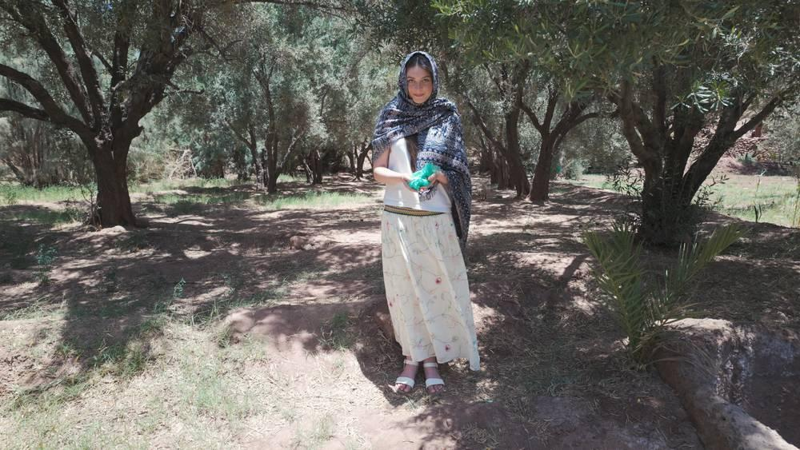
link

Jewelry

Image Content

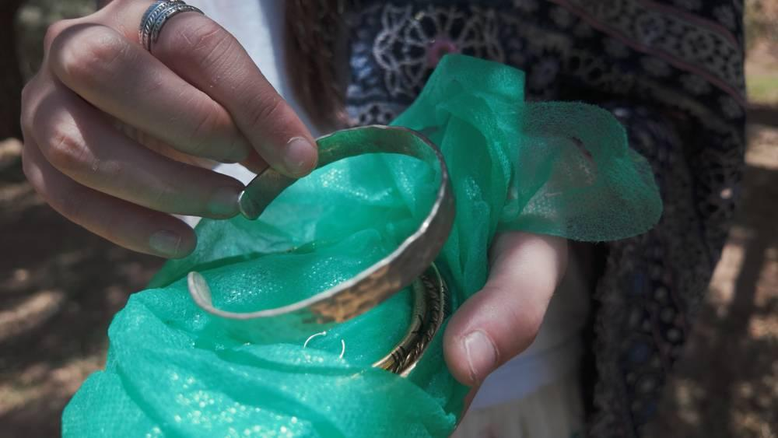
link

Jewelry

Image Content

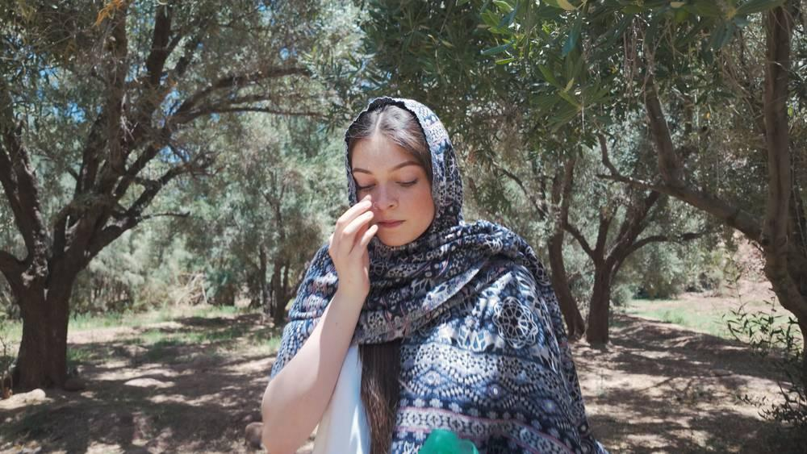
link

Jewelry

Image Content

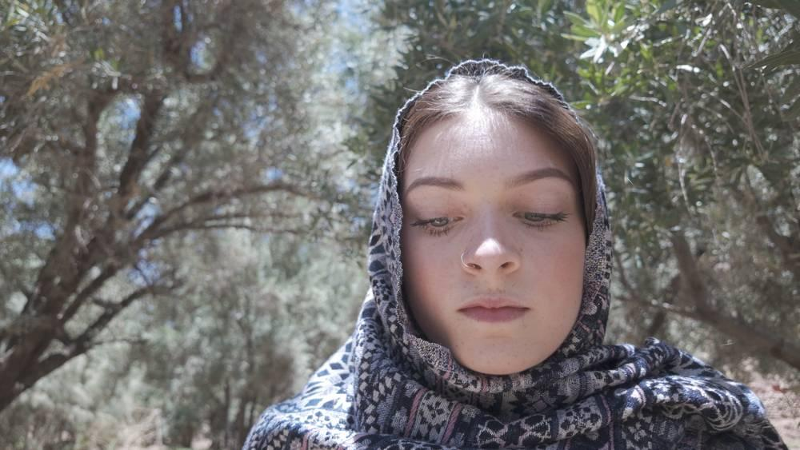
link

Jewelry

Image Content

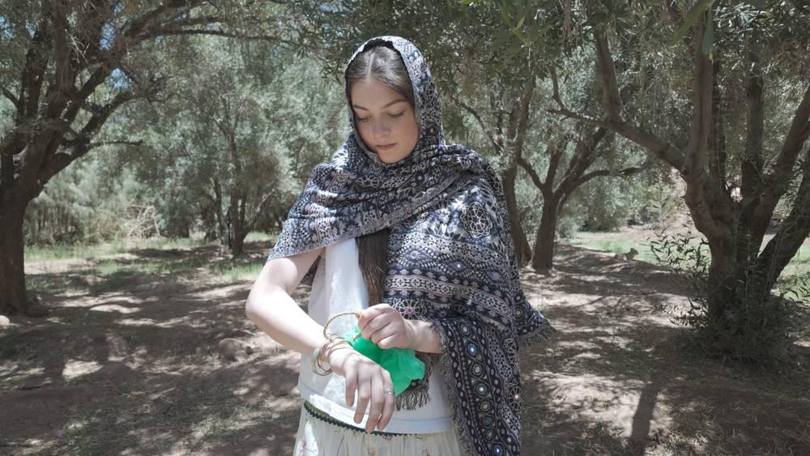
link

Jewelry

Image Content

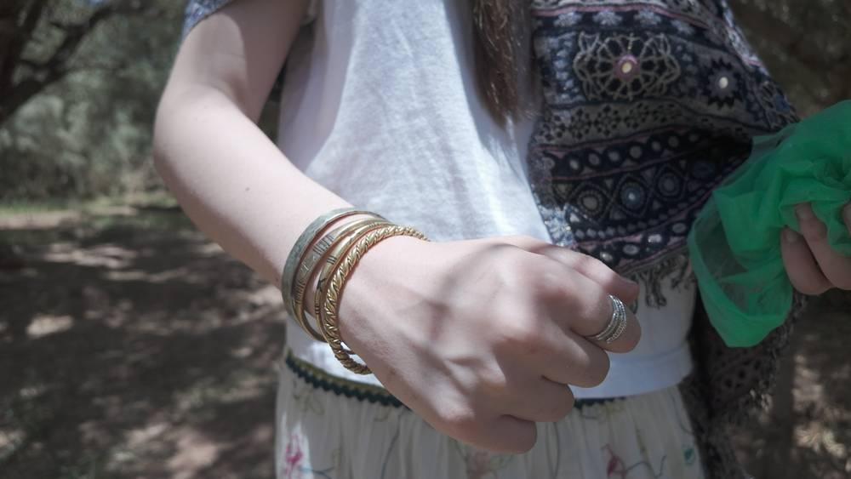
link

Jewish Lecture Hall

Image Content

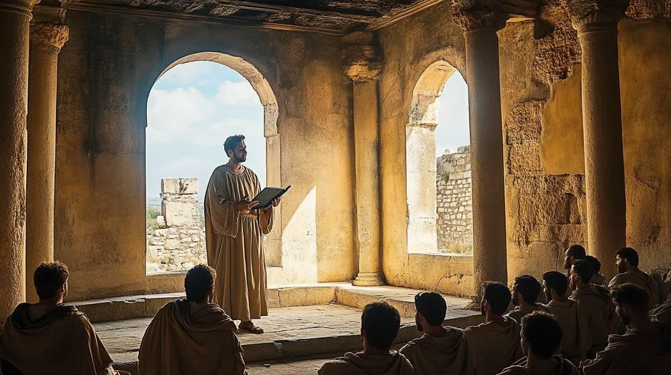
link

Jewish Lecture Hall

Image Content

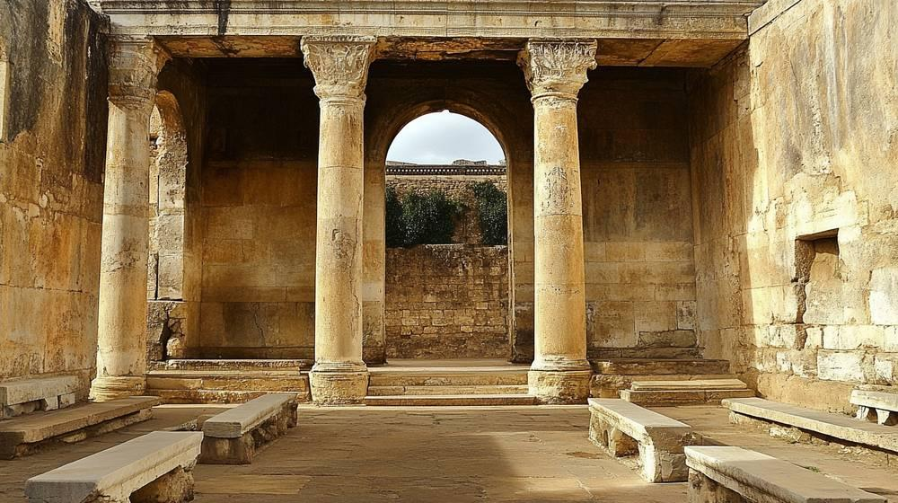
link

Jewish Lecture Hall

Image Content

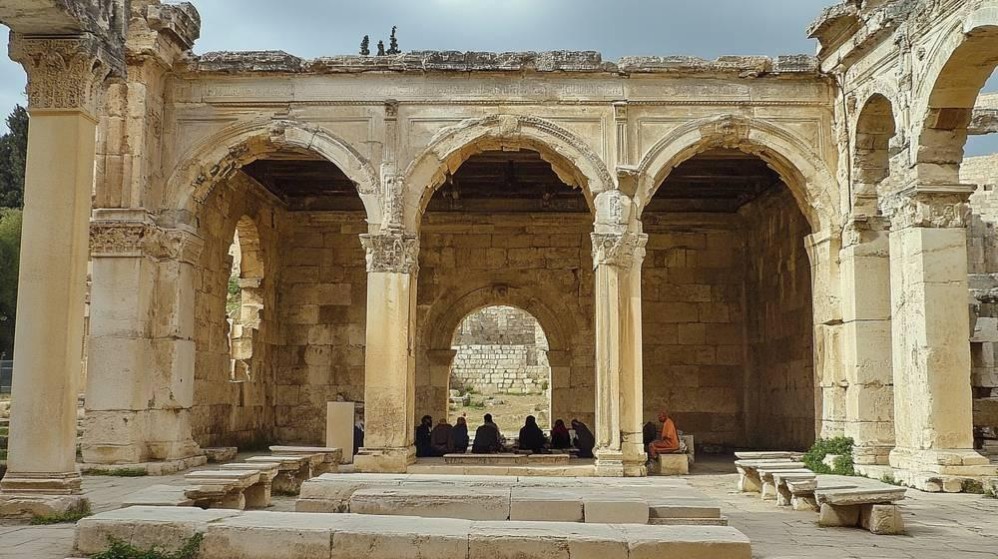
link

Jezreel Valley

Image Content

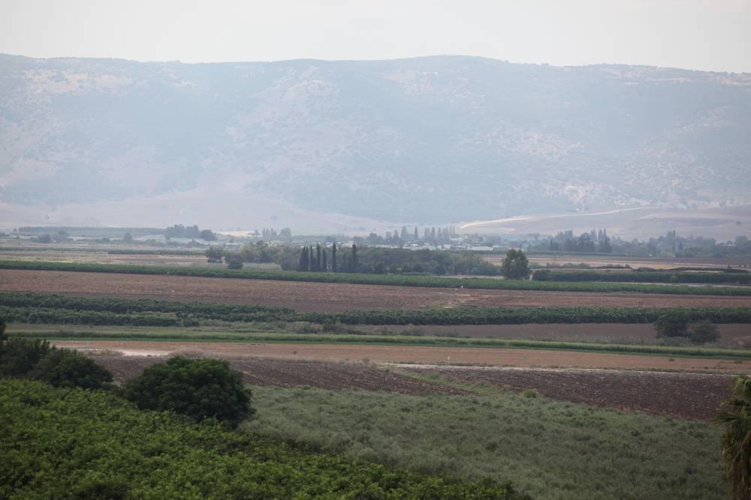
link

Jezreel Valley

Image Content

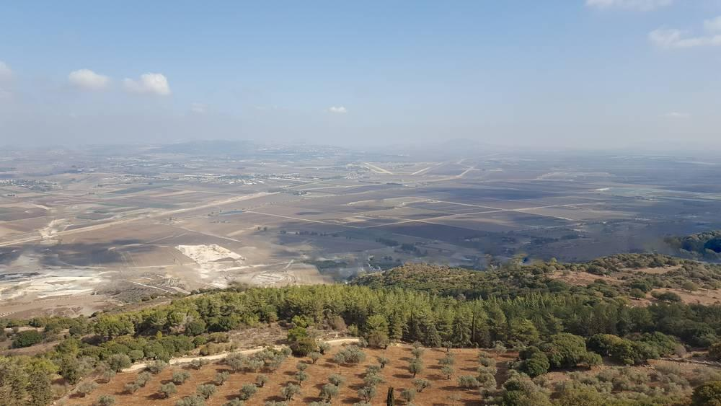
link

Jezreel Valley

Image Content

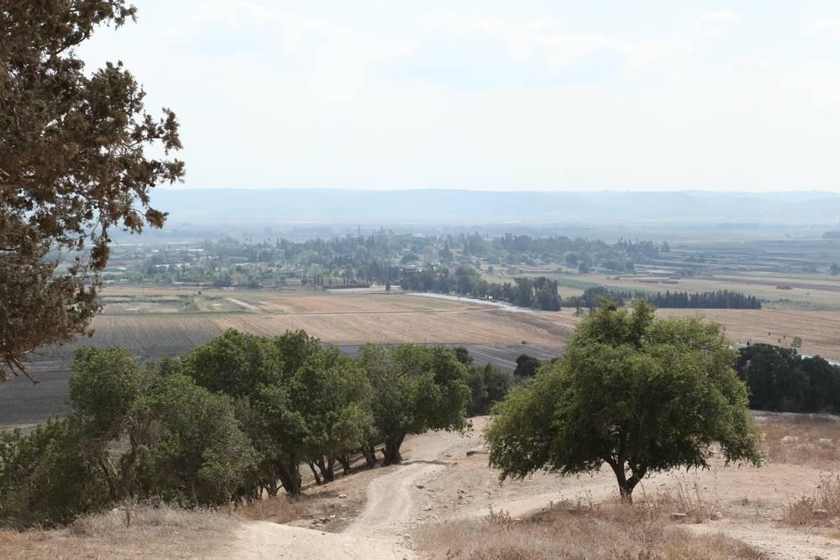
link

Jordan River

Image Content

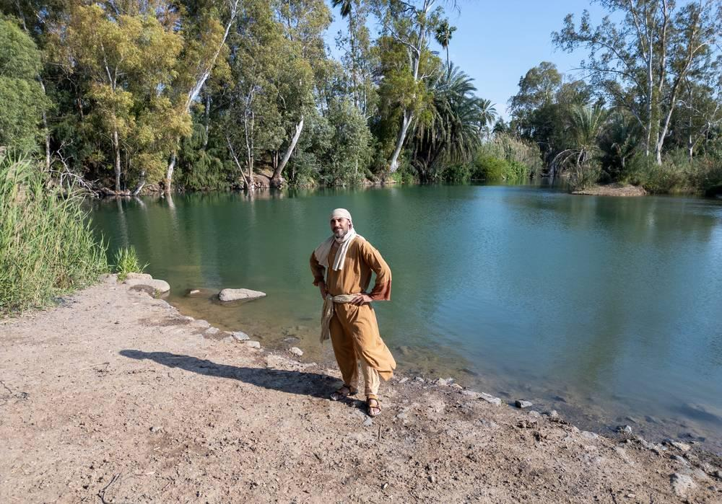
link

Joseph's Coat

Image Content

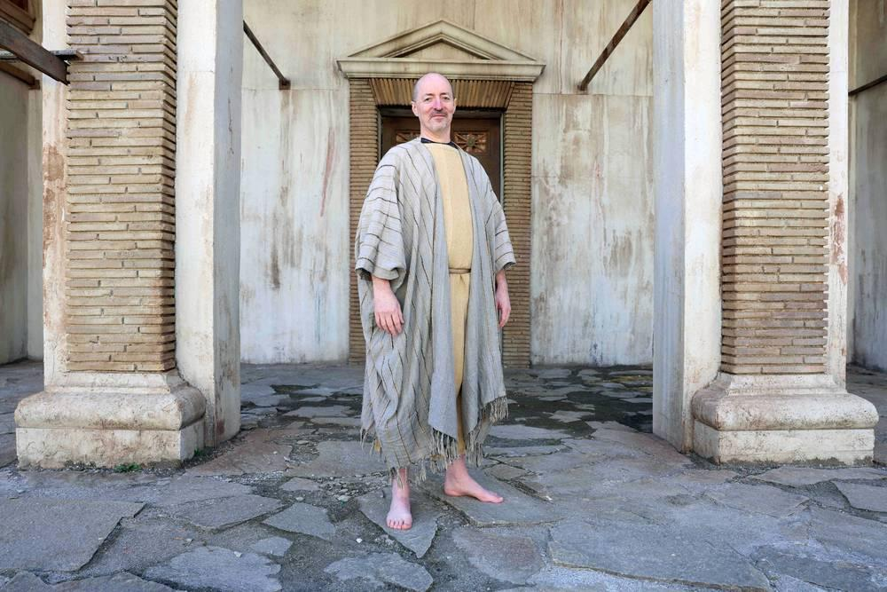
link

Joseph's Coat

Image Content

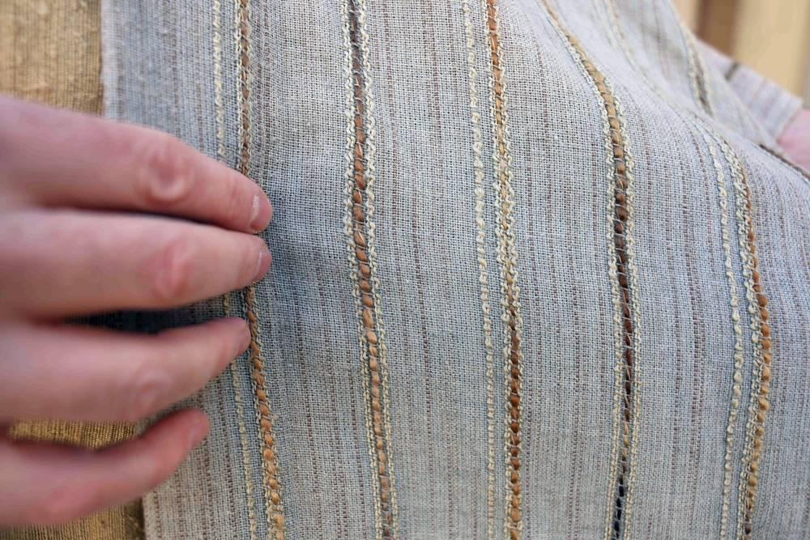
link

Joseph's Coat

Image Content

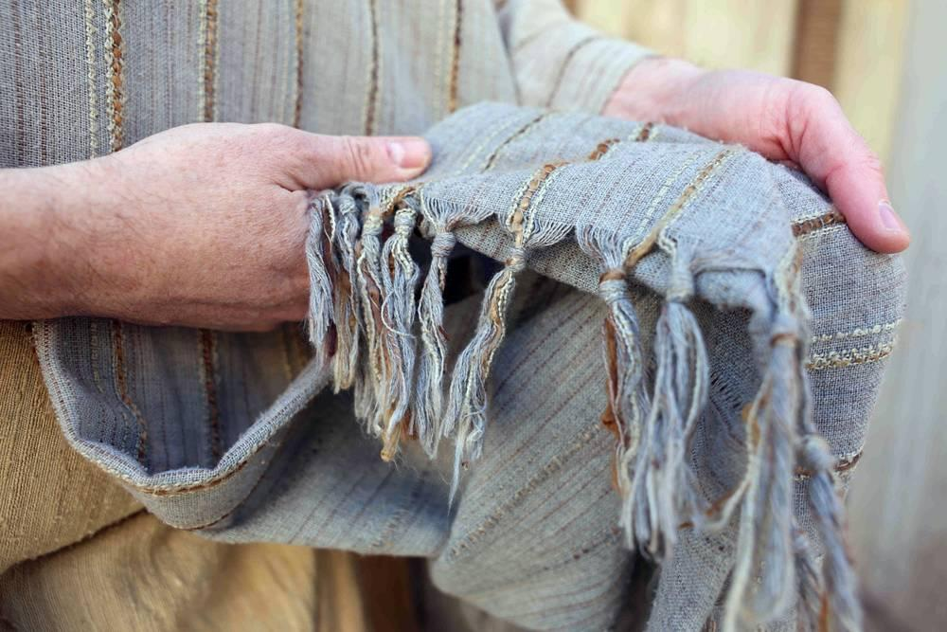
link

