Resource: Familiarization, Internalization, Articulation (Fia) Images
Familiarization, Internalization, Articulation (FIA) Images © 2023 SRV Partners Released under CC BY-SA 4.0 license. Familiarization, Internalization, Articulation (FIA) Images has been adapted in the following languages Tok Pisin, عربي, Français, हिंदी, Bahasa Indonesia, Português, Русский, Español, Kiswahili, 简体中文 from Familiarization, Internalization, Articulation (FIA) © 2023 SRV Partners. Released under CC BY-SA 4.0 license by Mission Mutual

Familiarization, Internalization, Articulation (Fia) Images

Q

Quail

Image Content

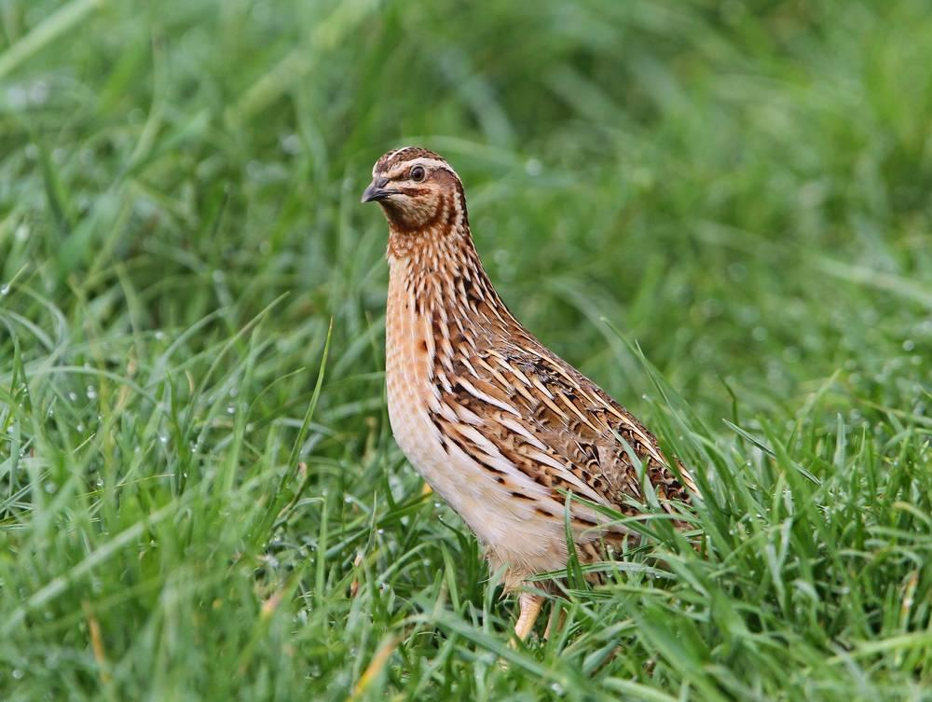
link

Quail

Image Content

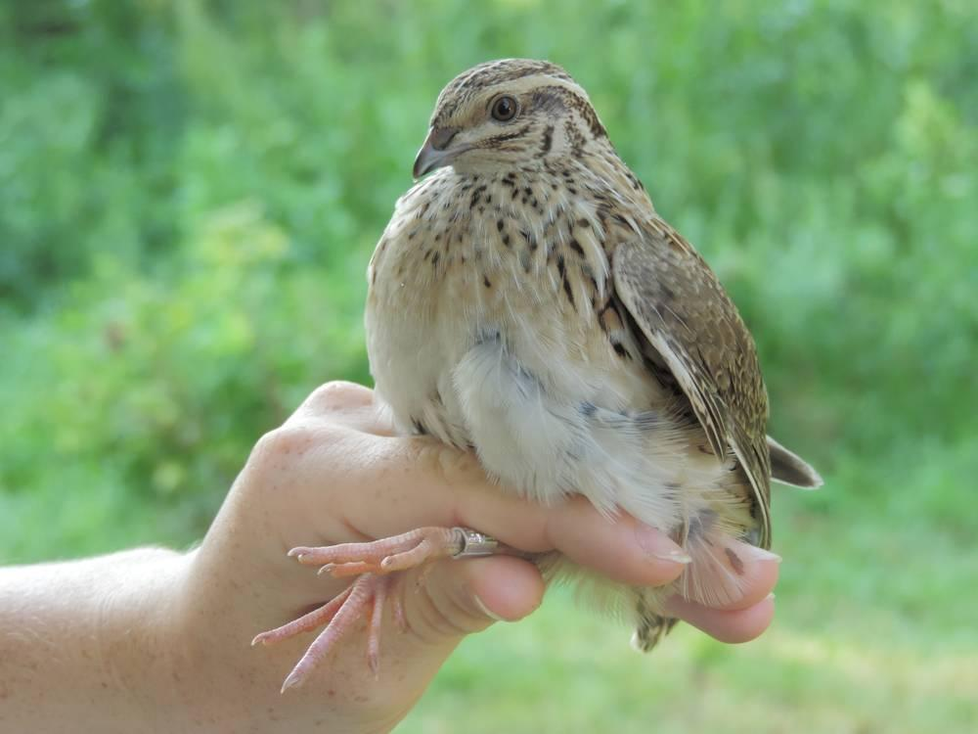
link

