Resource: Familiarization, Internalization, Articulation (Fia) Images
Familiarization, Internalization, Articulation (FIA) Images © 2023 SRV Partners Released under CC BY-SA 4.0 license. Familiarization, Internalization, Articulation (FIA) Images has been adapted in the following languages Tok Pisin, عربي, Français, हिंदी, Bahasa Indonesia, Português, Русский, Español, Kiswahili, 简体中文 from Familiarization, Internalization, Articulation (FIA) © 2023 SRV Partners. Released under CC BY-SA 4.0 license by Mission Mutual

Familiarization, Internalization, Articulation (Fia) Images

B

Banc à manger

Image Content

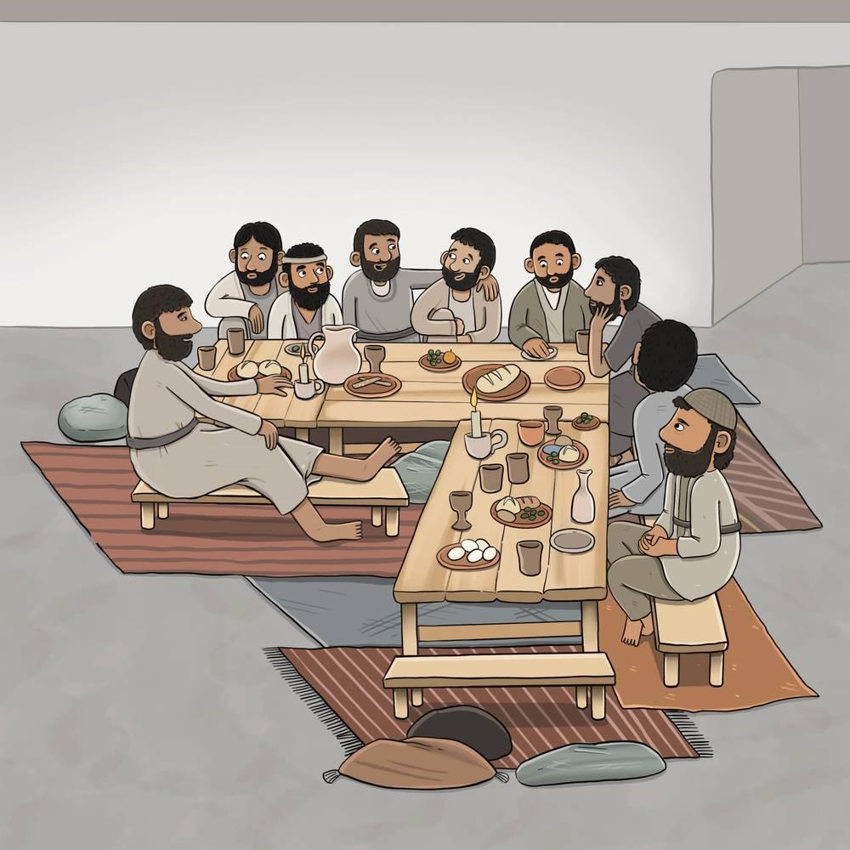
link

Banc à manger

Image Content

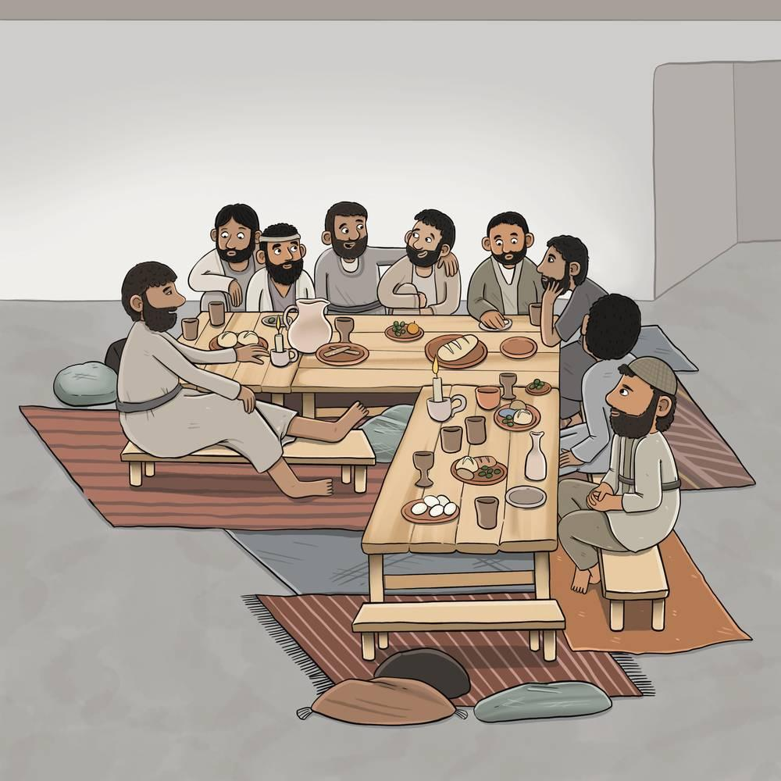
link

bateau

Image Content

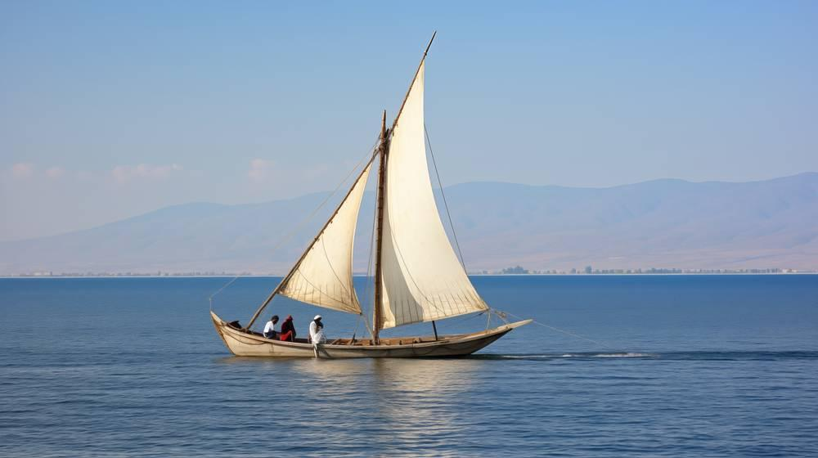
link

bâton

Image Content

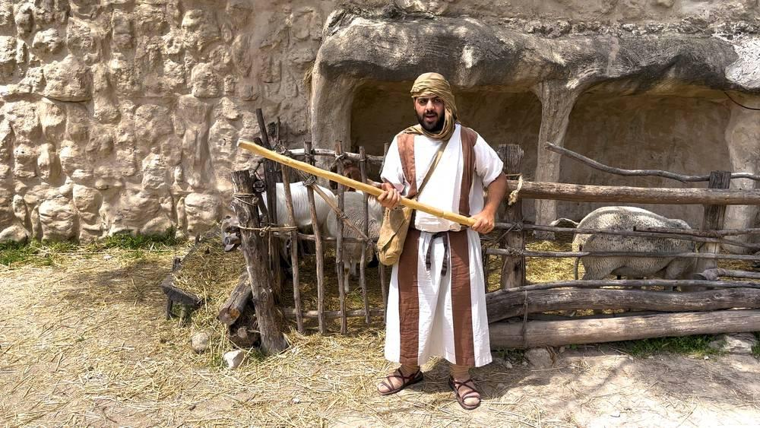
link

Bergers

Image Content

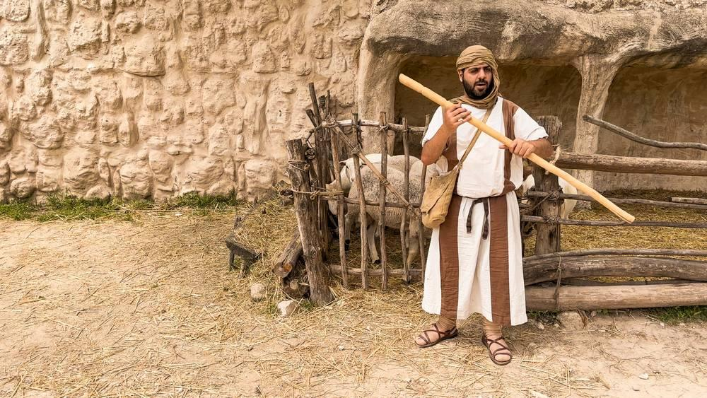
link

Bergers

Image Content

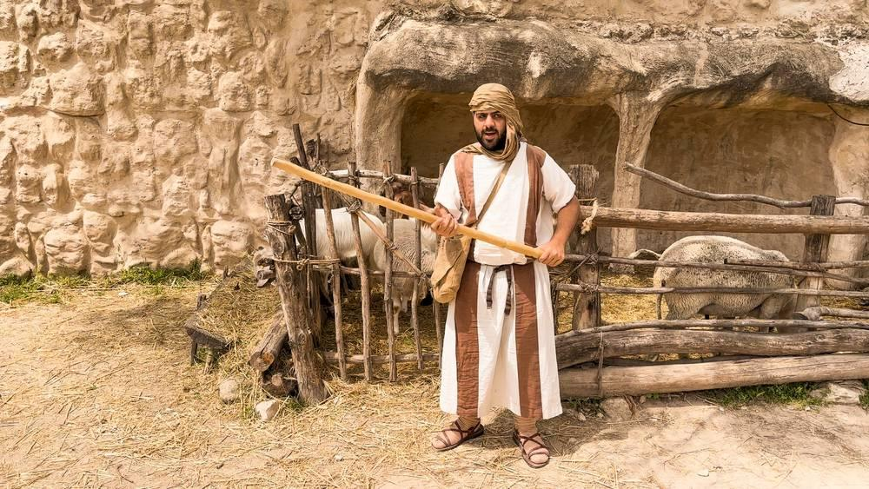
link

Bergers

Image Content

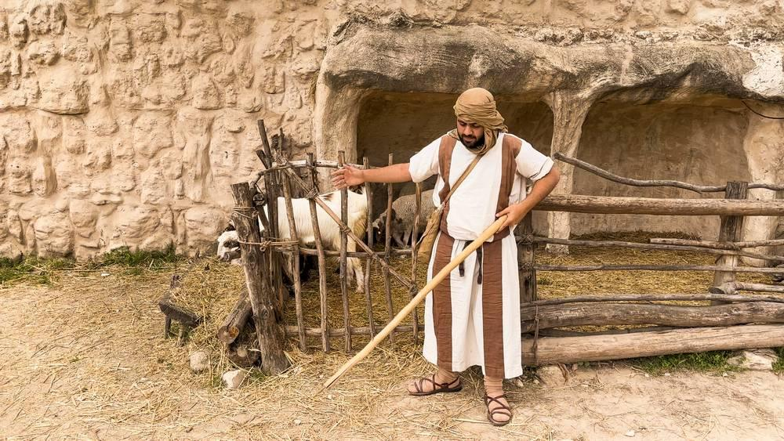
link

Blé avec des têtes de grain

Image Content

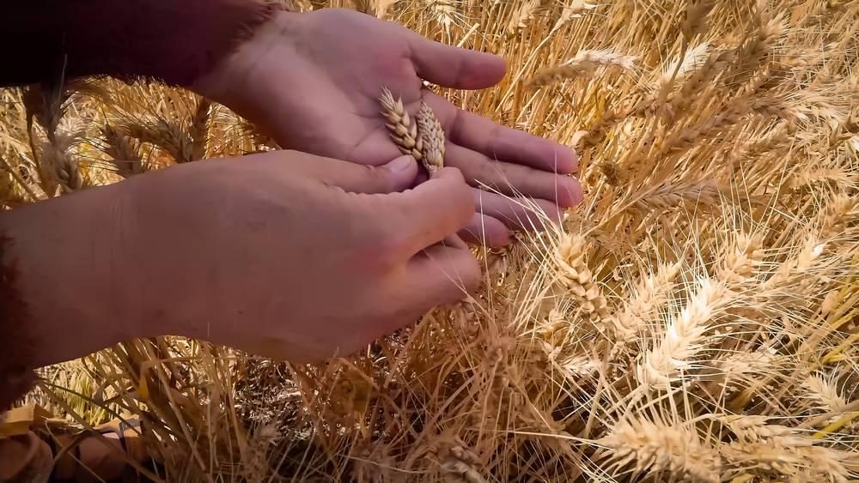
link

Blé avec des têtes de grain

Image Content

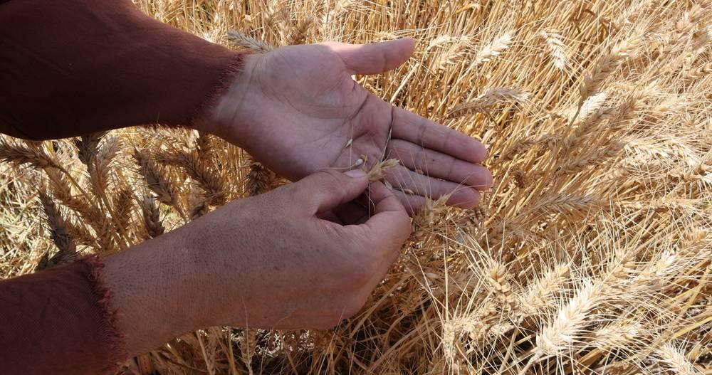
link

Blé Prêt Pour La Récolte

Image Content

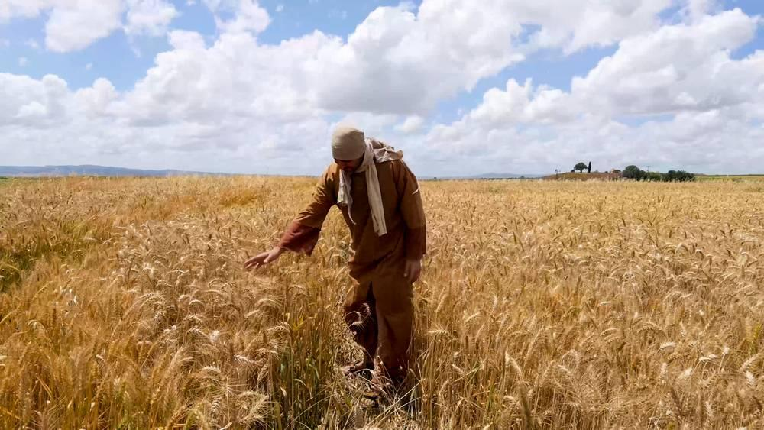
link

Branches d'olivier et de palmier

Image Content

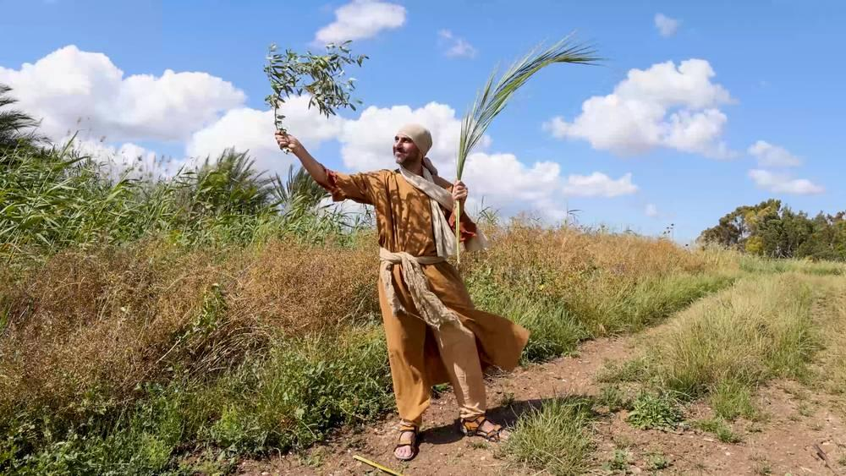
link

Branches d'olivier et de palmier

Image Content

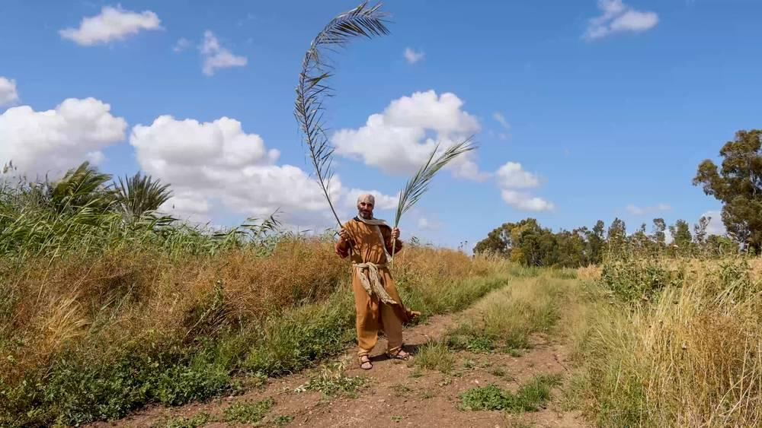
link

