Resource: Familiarization, Internalization, Articulation (Fia) Images
Familiarization, Internalization, Articulation (FIA) Images © 2023 SRV Partners Released under CC BY-SA 4.0 license. Familiarization, Internalization, Articulation (FIA) Images has been adapted in the following languages Tok Pisin, عربي, Français, हिंदी, Bahasa Indonesia, Português, Русский, Español, Kiswahili, 简体中文 from Familiarization, Internalization, Articulation (FIA) © 2023 SRV Partners. Released under CC BY-SA 4.0 license by Mission Mutual

Familiarization, Internalization, Articulation (Fia) Images

C

Chameau

Image Content

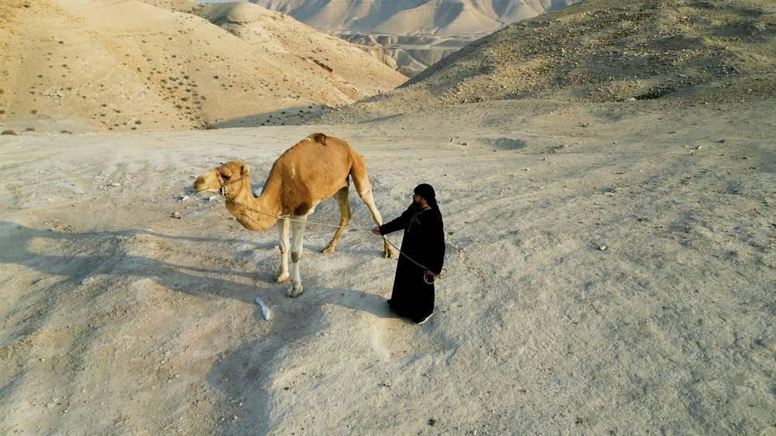
link

chandelier

Image Content


link

chandelier

Image Content

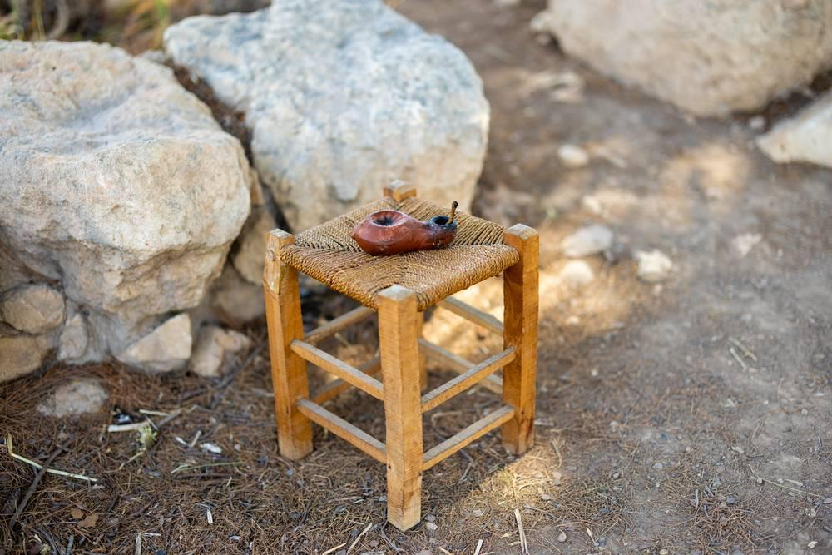
link

Club

Image Content

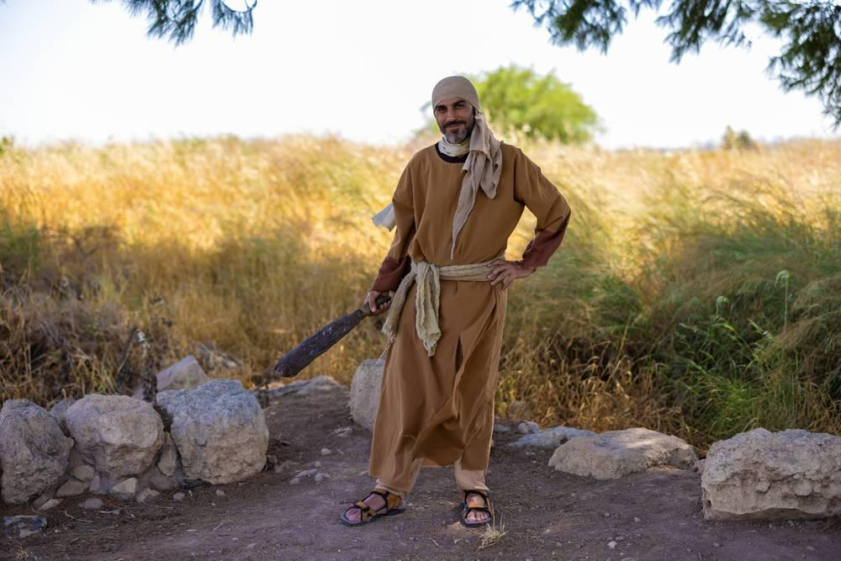
link

Club

Image Content

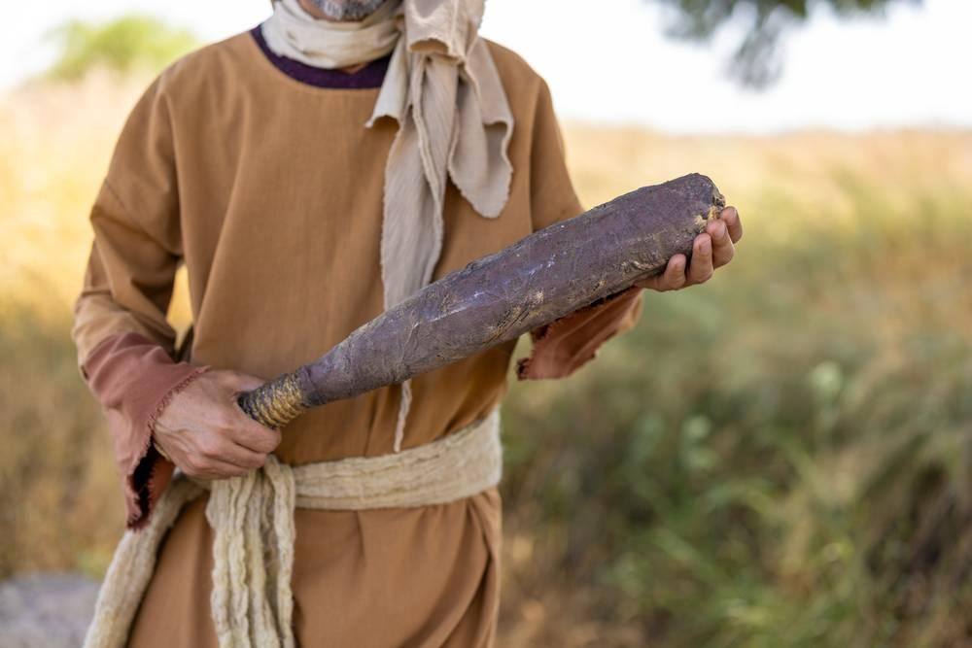
link

Coq

Image Content


link

Coq

Image Content

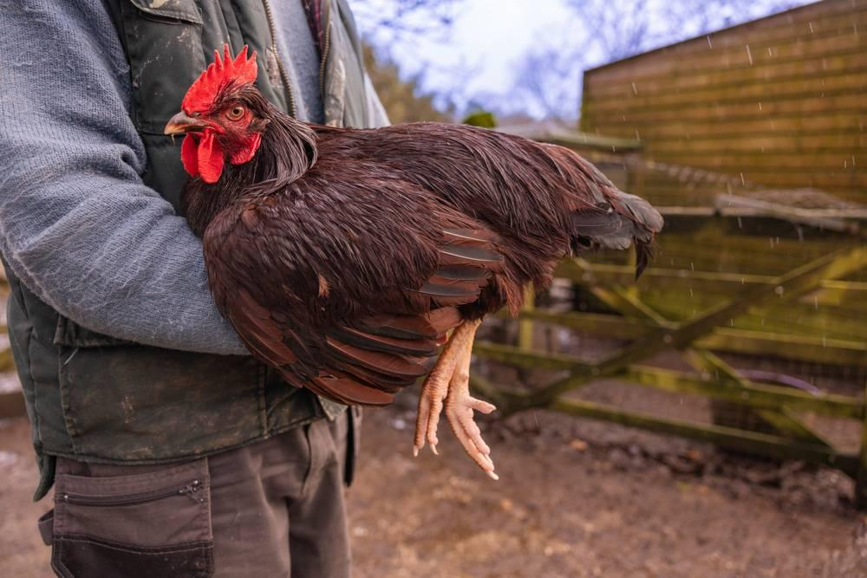
link

Coq

Image Content

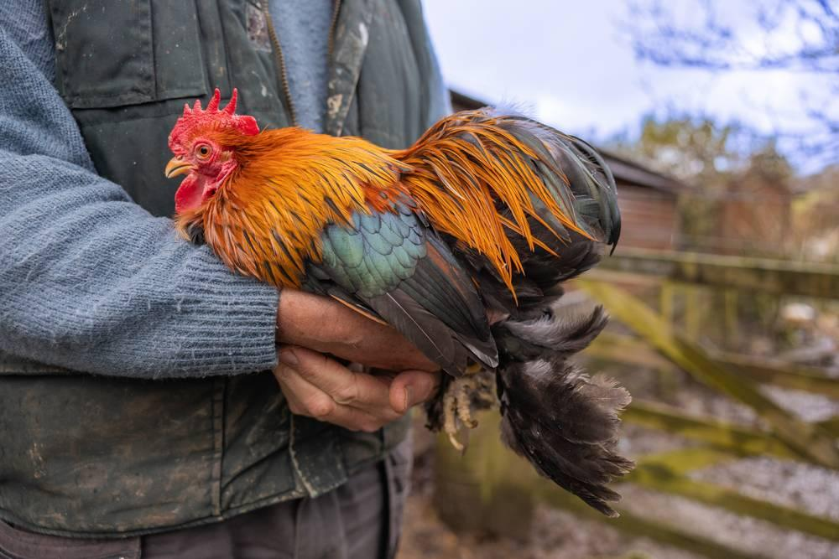
link

Cultiver un champ

Image Content

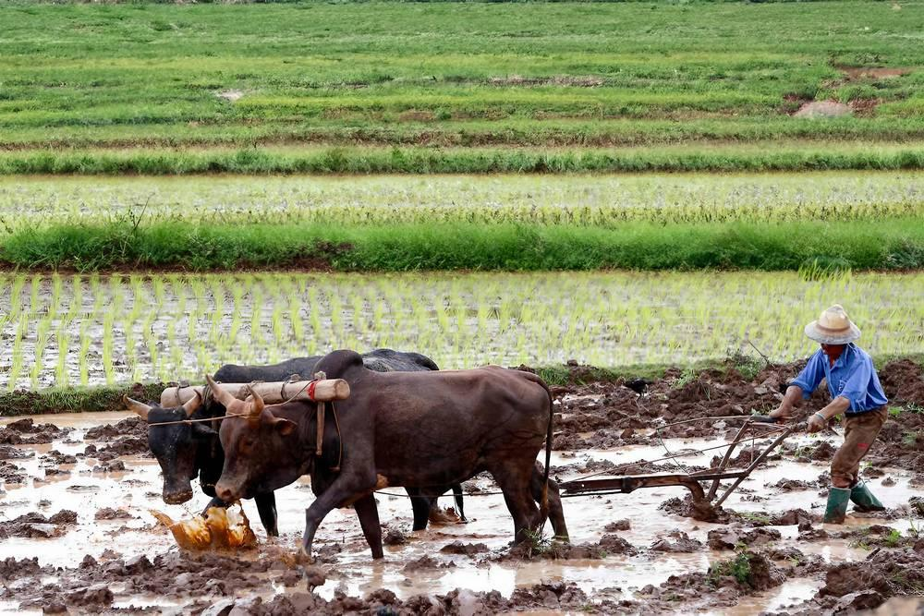
link

