Resource: Familiarization, Internalization, Articulation (Fia) Images
Familiarization, Internalization, Articulation (FIA) Images © 2023 SRV Partners Released under CC BY-SA 4.0 license. Familiarization, Internalization, Articulation (FIA) Images has been adapted in the following languages Tok Pisin, عربي, Français, हिंदी, Bahasa Indonesia, Português, Русский, Español, Kiswahili, 简体中文 from Familiarization, Internalization, Articulation (FIA) © 2023 SRV Partners. Released under CC BY-SA 4.0 license by Mission Mutual

Familiarization, Internalization, Articulation (Fia) Images

E

Épée

Image Content

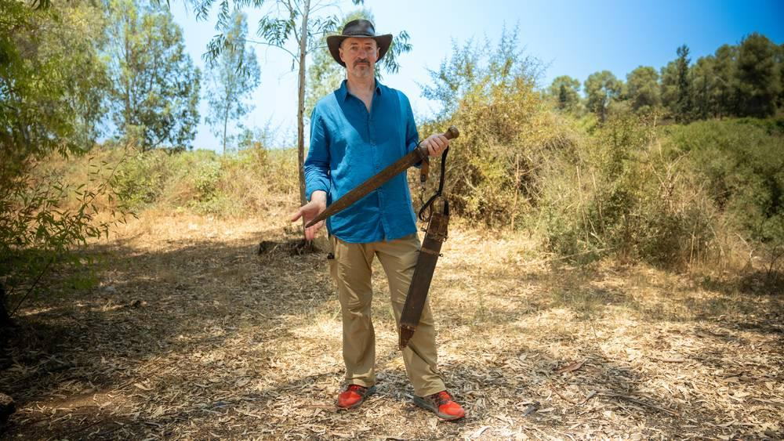
link

Épée

Image Content

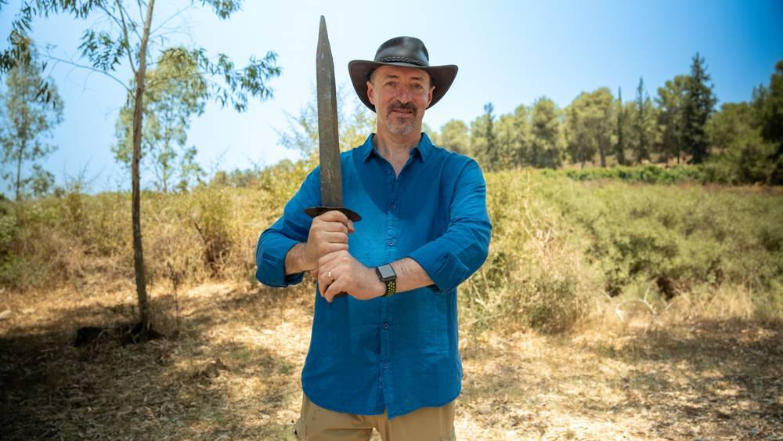
link

Épée

Image Content

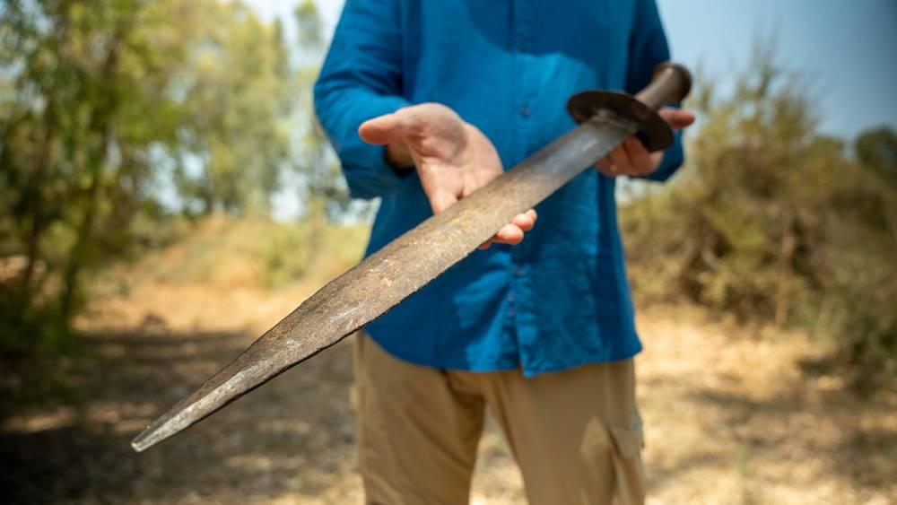
link

Épée

Image Content


link

Épée

Image Content

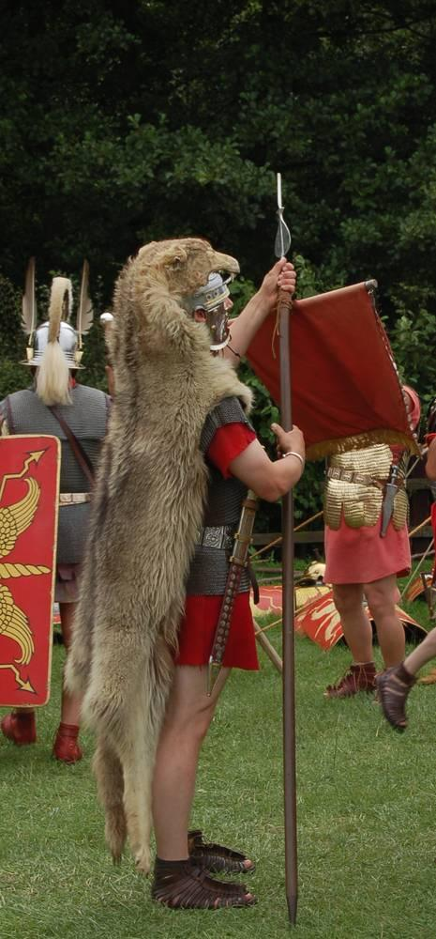
link

Éponge avec du vin sur un bâton

Image Content

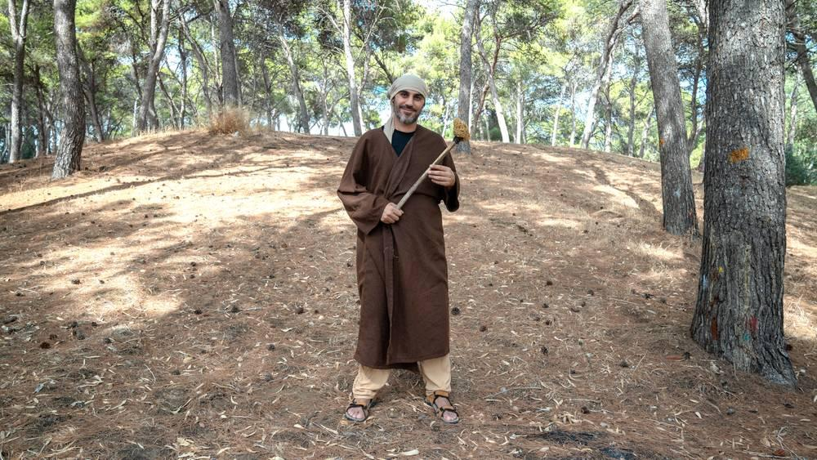
link

Éponge avec du vin sur un bâton

Image Content

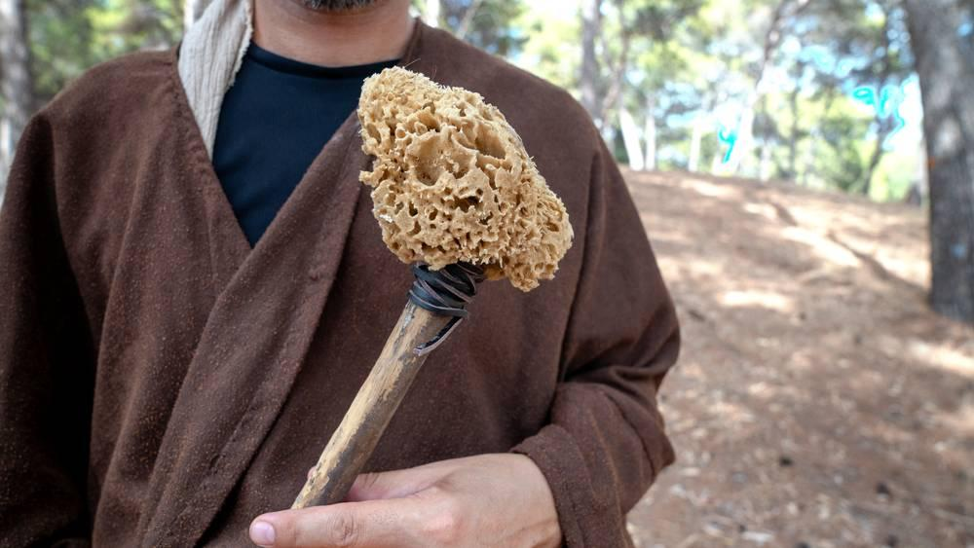
link

Étapes de la croissance du blé

Image Content

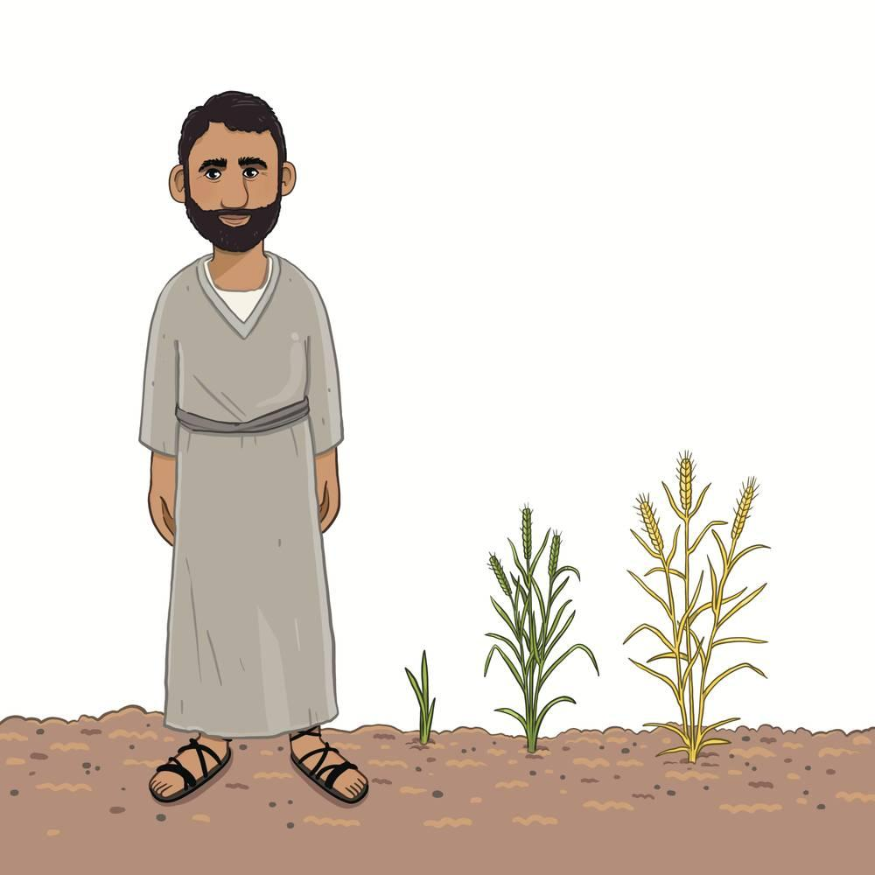
link

