Resource: Familiarization, Internalization, Articulation (Fia) Images
Familiarization, Internalization, Articulation (FIA) Images © 2023 SRV Partners Released under CC BY-SA 4.0 license. Familiarization, Internalization, Articulation (FIA) Images has been adapted in the following languages Tok Pisin, عربي, Français, हिंदी, Bahasa Indonesia, Português, Русский, Español, Kiswahili, 简体中文 from Familiarization, Internalization, Articulation (FIA) © 2023 SRV Partners. Released under CC BY-SA 4.0 license by Mission Mutual

Familiarization, Internalization, Articulation (Fia) Images

F

Falaises

Image Content

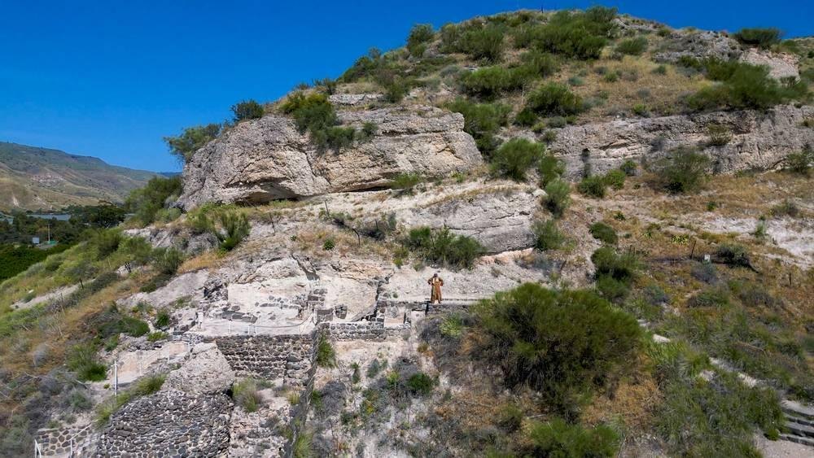
link

Falaises

Image Content

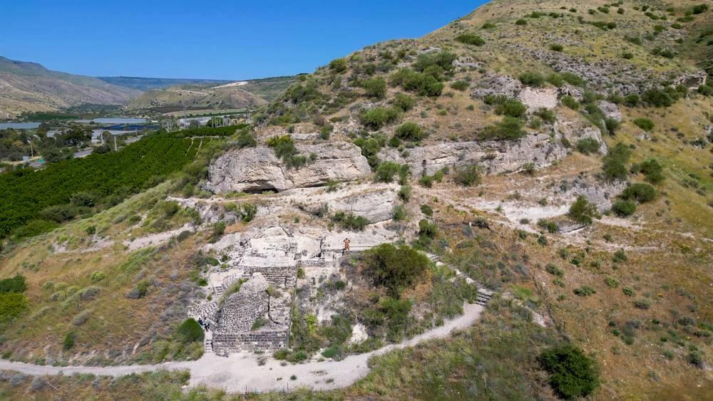
link

Faucille

Image Content

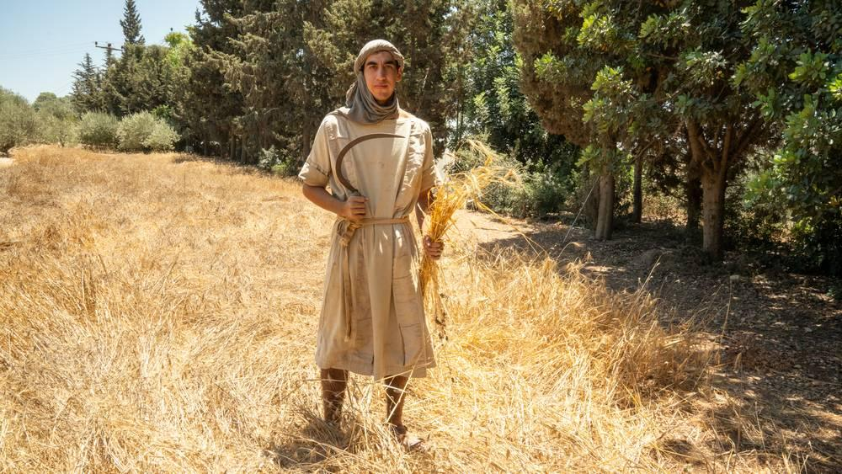
link

Faucille

Image Content

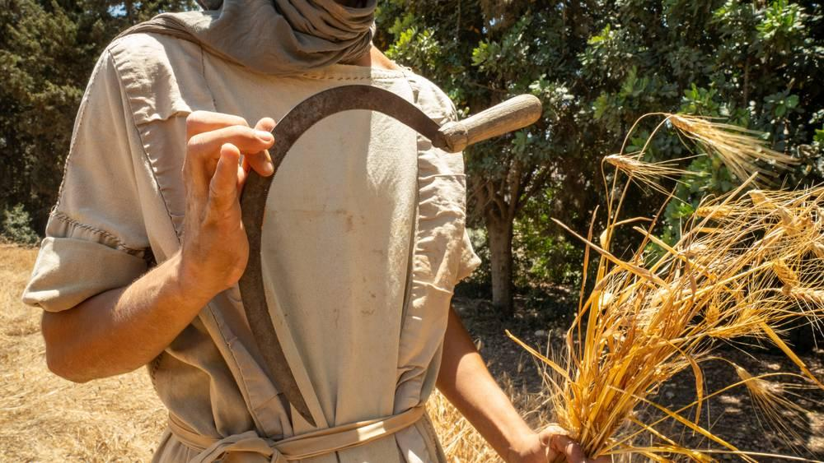
link

Faucille

Image Content

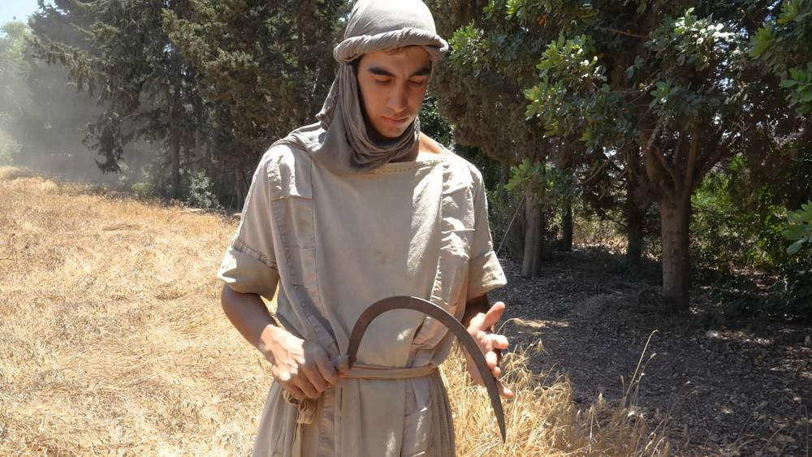
link

Faucille

Image Content

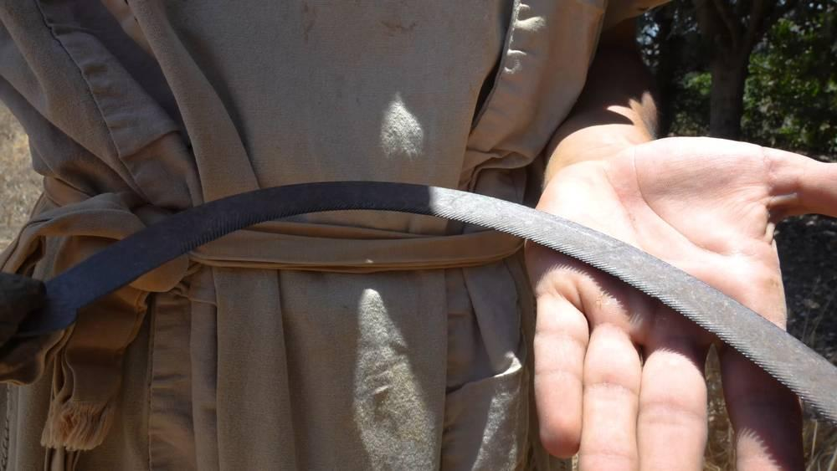
link

Figuier

Image Content

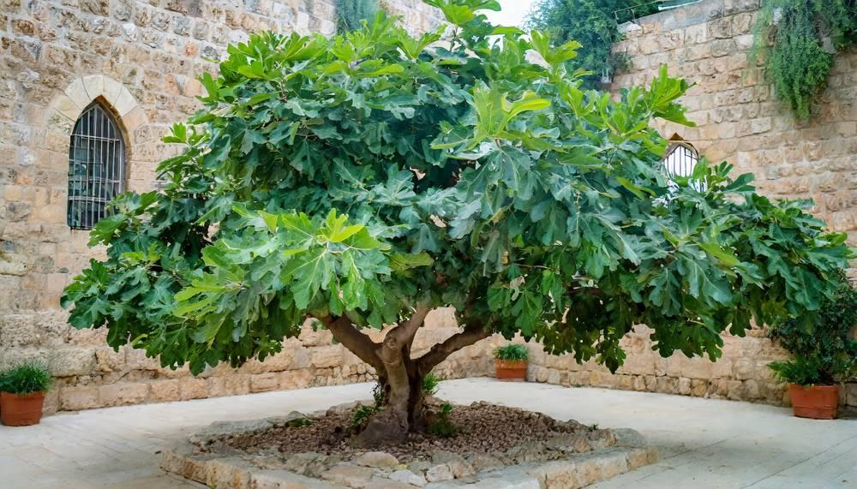
link

Figuier

Image Content

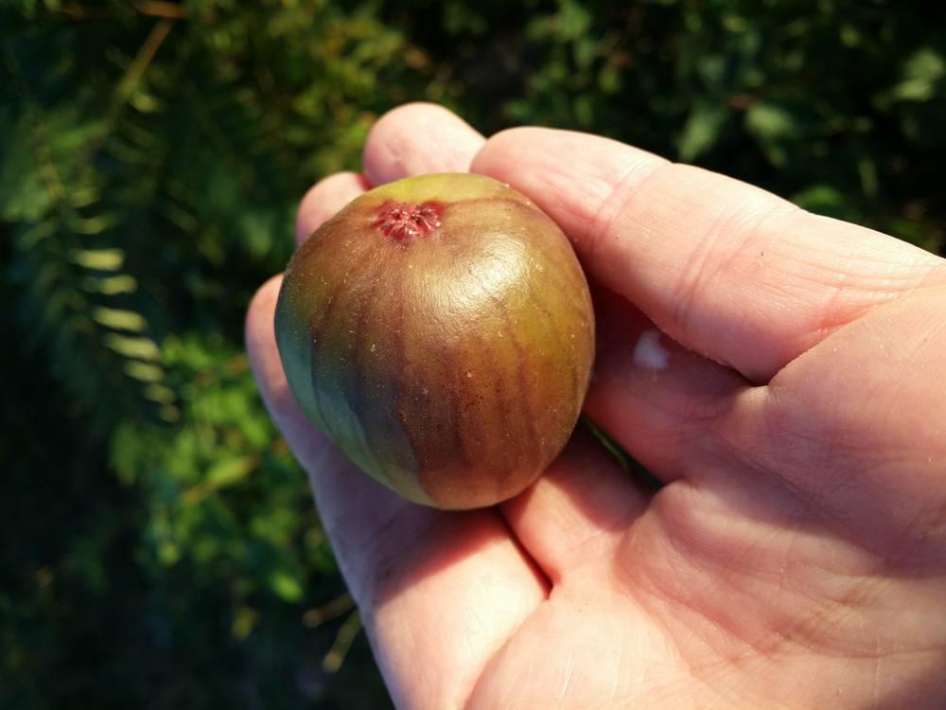
link

Filet de pêche

Image Content

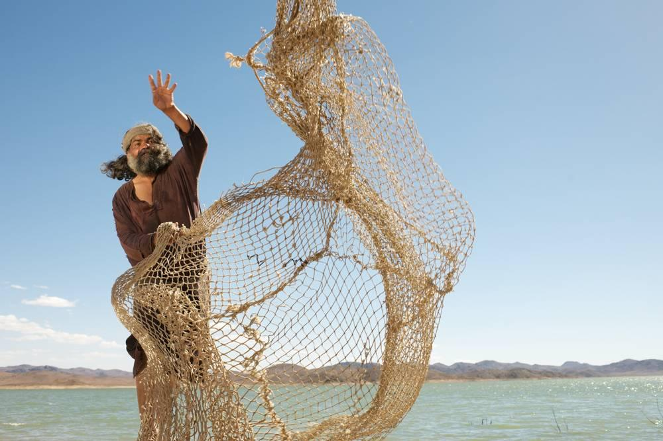
link

Filet de pêche

Image Content

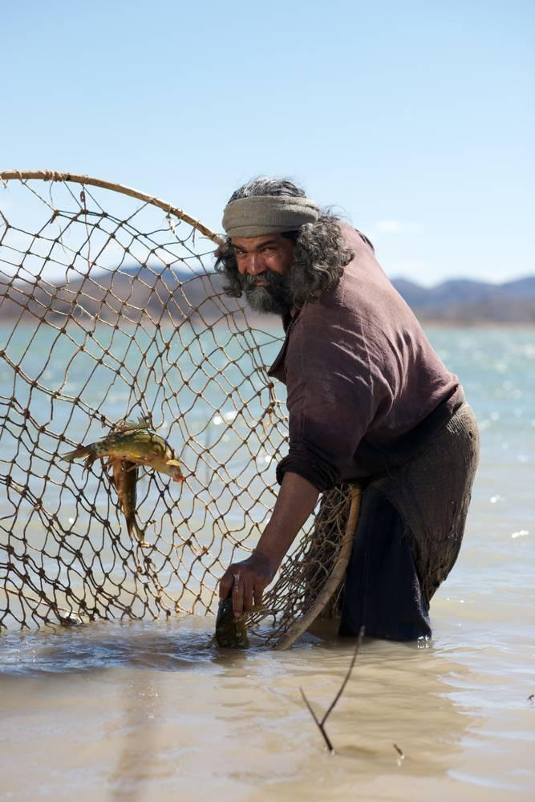
link

Filet de pêche

Image Content

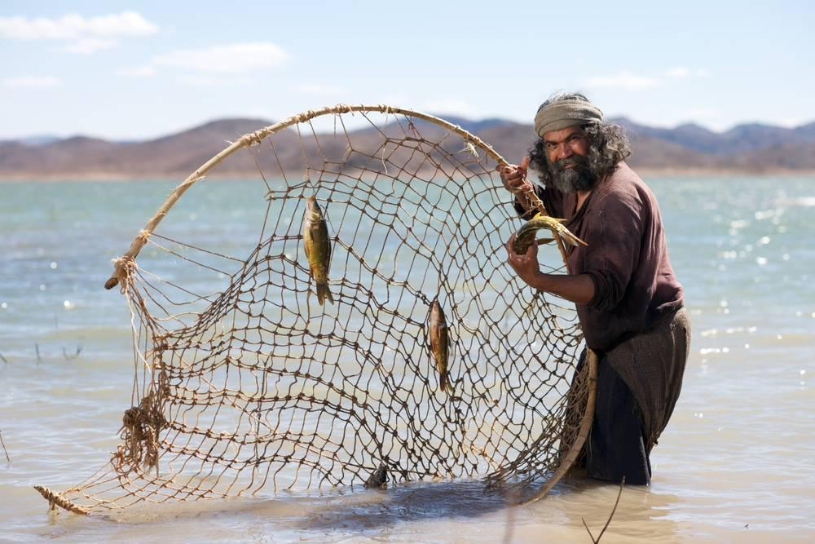
link

Filet de pêche

Image Content

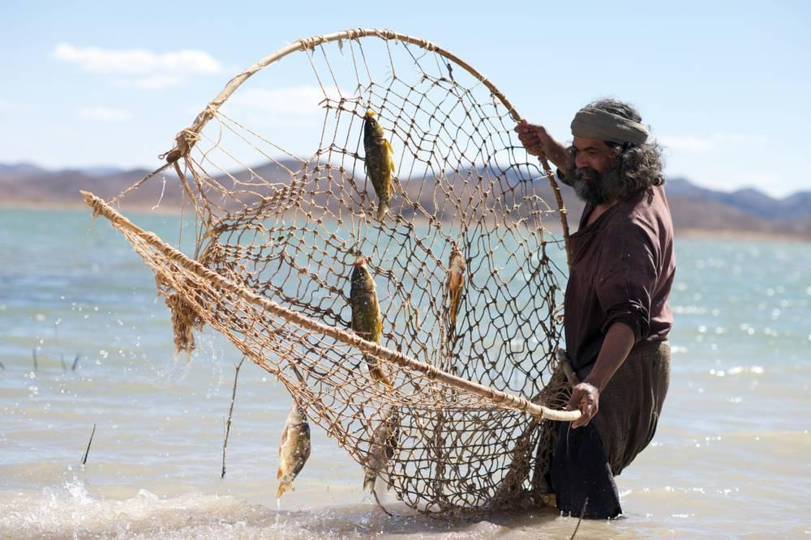
link

Filet de pêche

Image Content

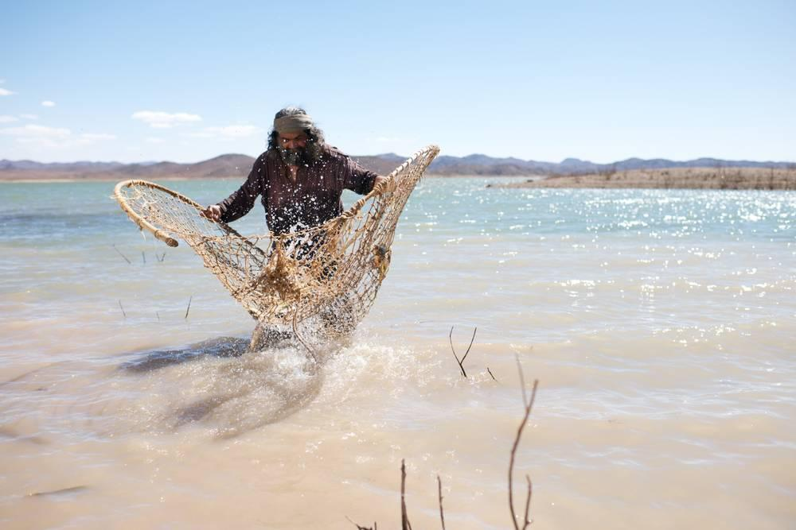
link

fleuve Jourdain

Image Content

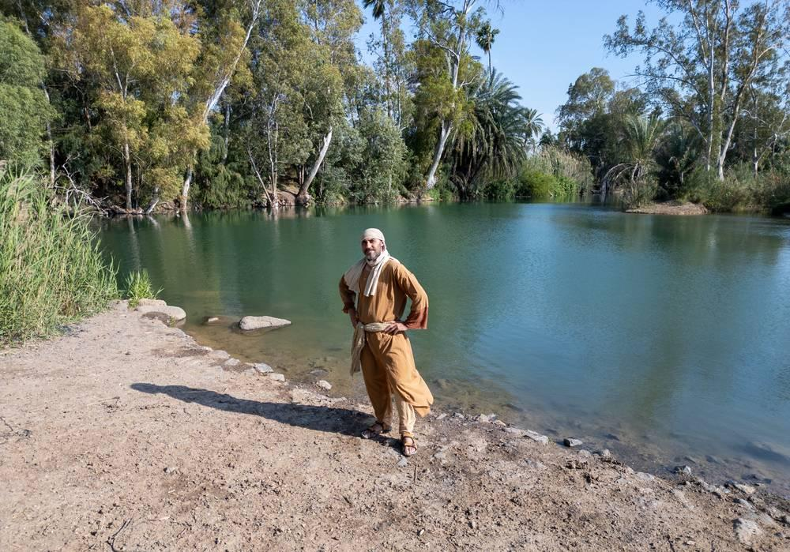
link

Fouet avec la pointe

Image Content

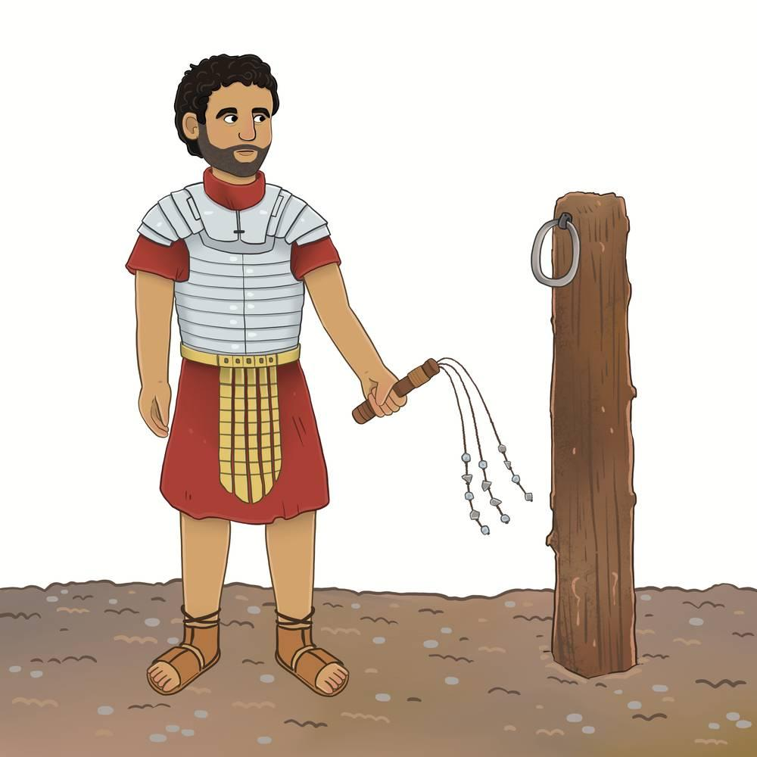
link

Fouet avec la pointe

Image Content

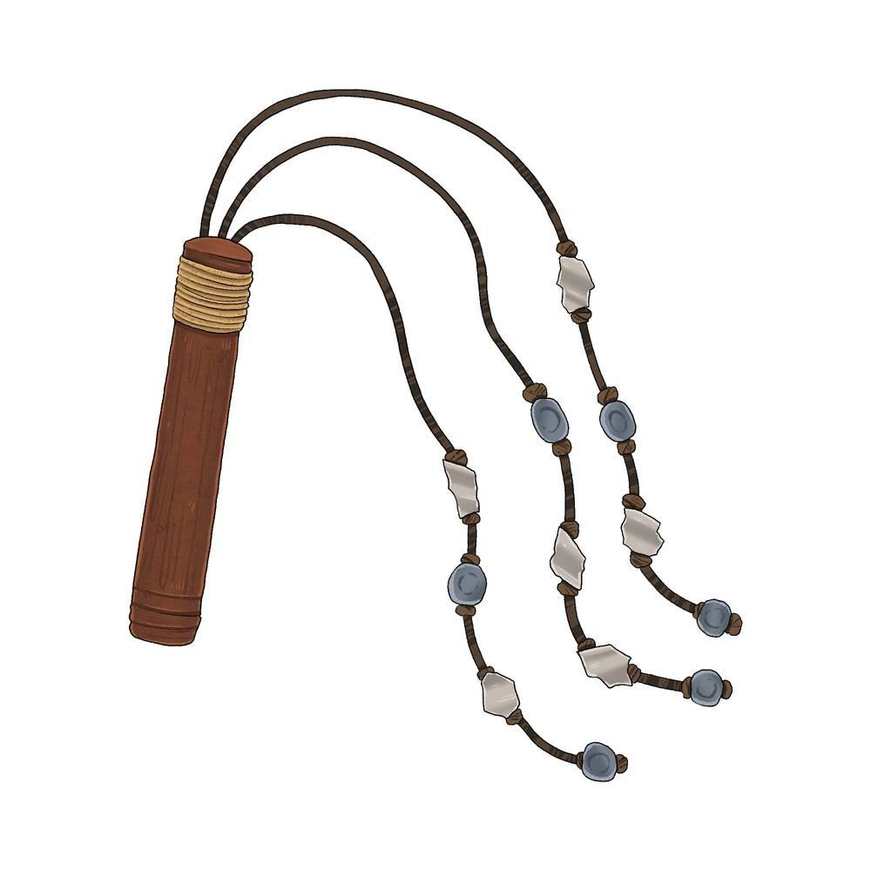
link

