Resource: Familiarization, Internalization, Articulation (Fia) Images
Familiarization, Internalization, Articulation (FIA) Images © 2023 SRV Partners Released under CC BY-SA 4.0 license. Familiarization, Internalization, Articulation (FIA) Images has been adapted in the following languages Tok Pisin, عربي, Français, हिंदी, Bahasa Indonesia, Português, Русский, Español, Kiswahili, 简体中文 from Familiarization, Internalization, Articulation (FIA) © 2023 SRV Partners. Released under CC BY-SA 4.0 license by Mission Mutual

Familiarization, Internalization, Articulation (Fia) Images

M

Maison à l'époque de Jésus

Image Content

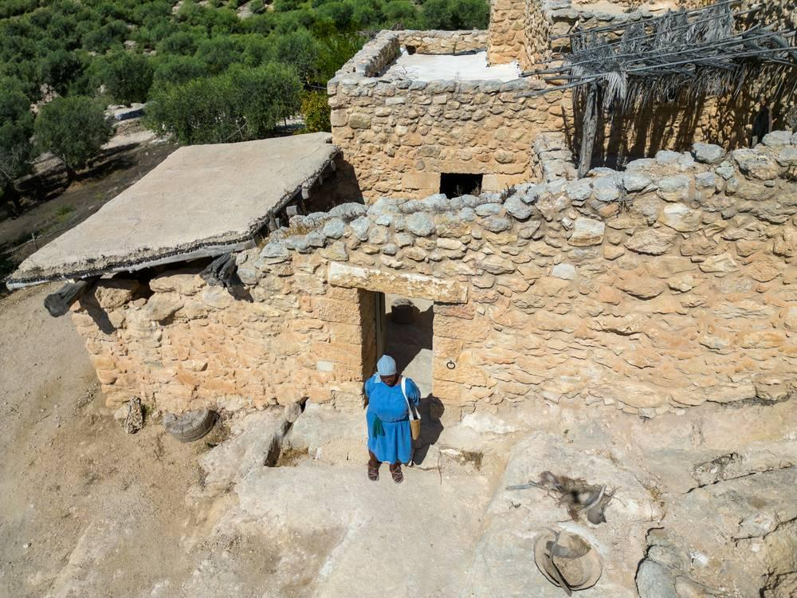
link

Maison à l'époque de Jésus

Image Content

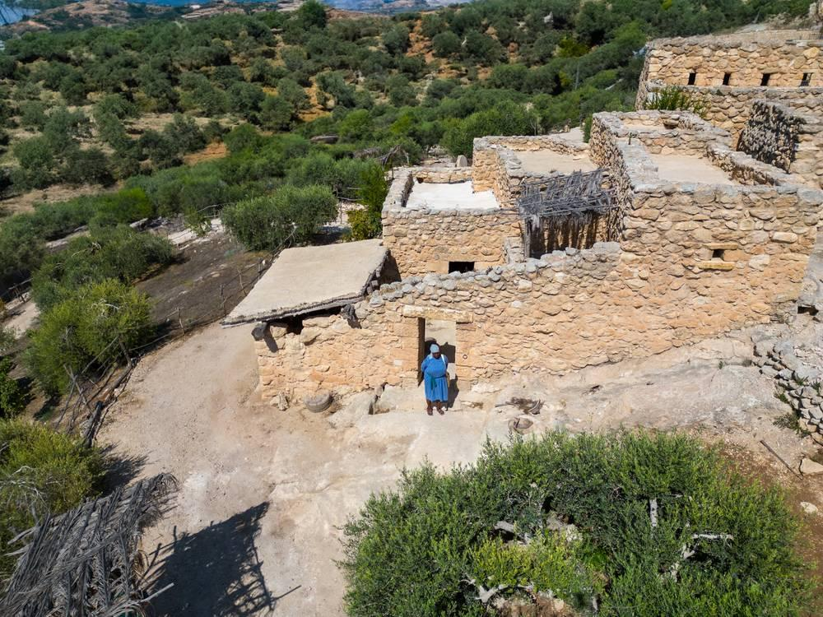
link

Maison à l'époque de Jésus

Image Content

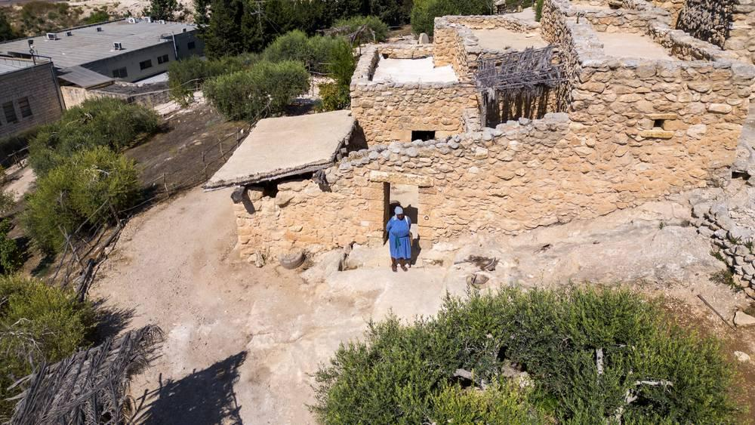
link

Maison à l'époque de Jésus

Image Content

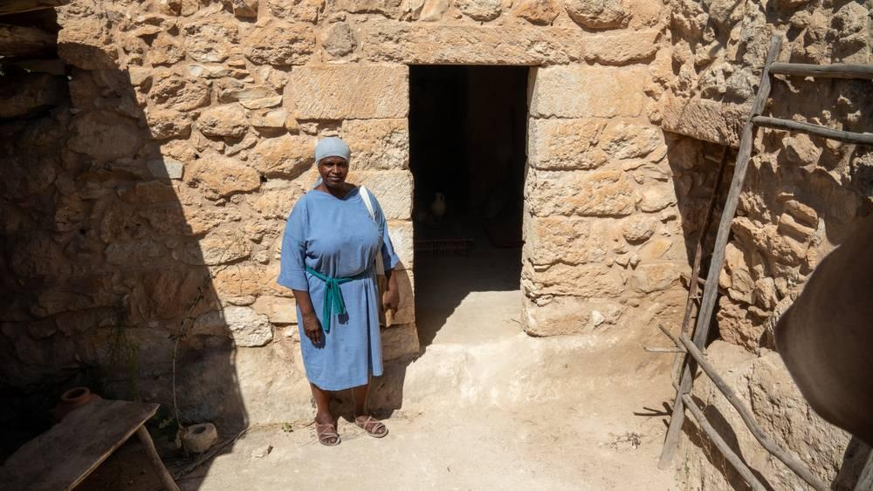
link

Manteau

Image Content

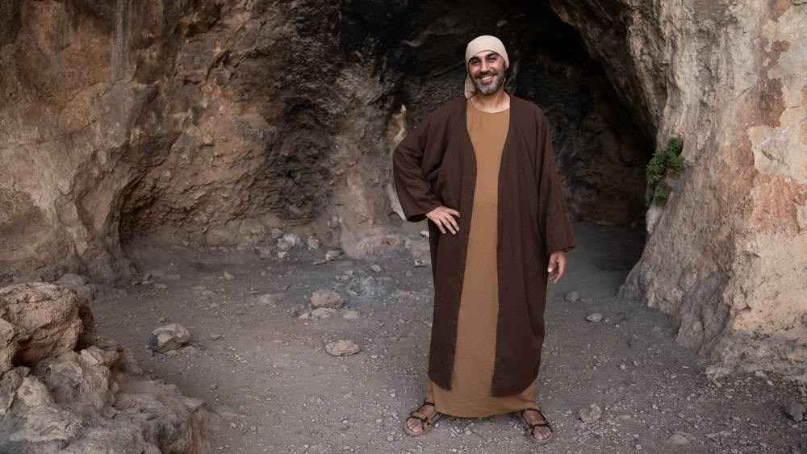
link

Mer de Galilée

Image Content

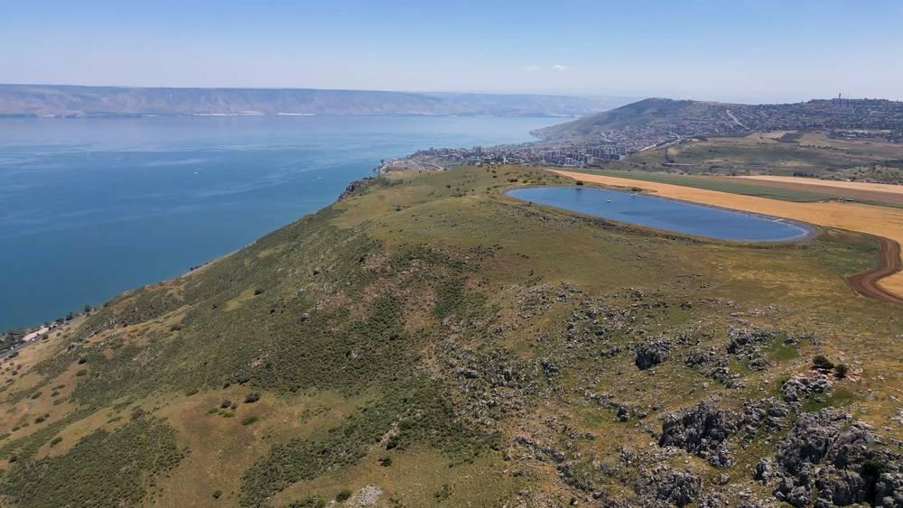
link

Mer de Galilée

Image Content

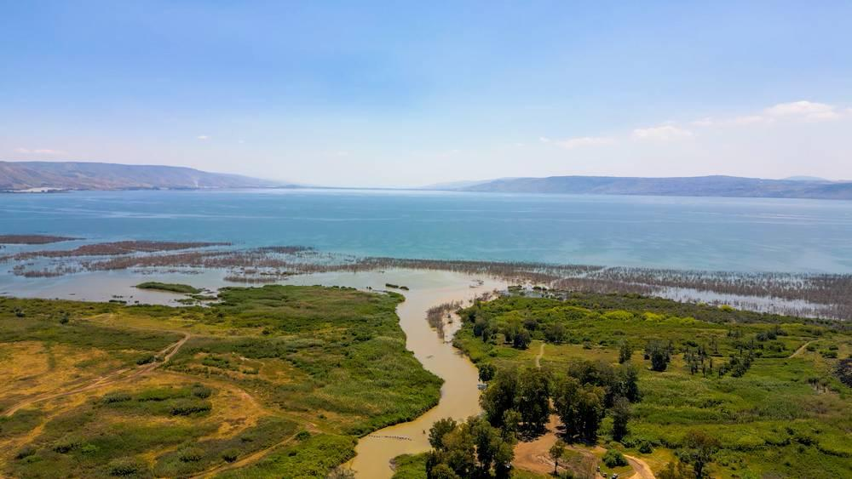
link

Mer de Galilée

Image Content

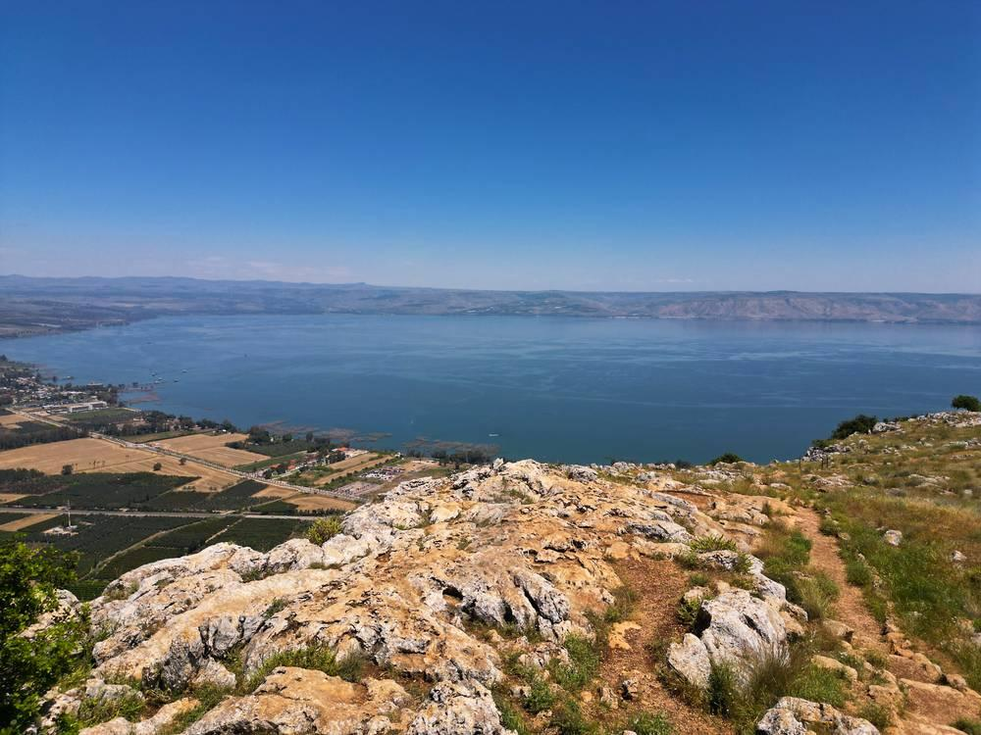
link

Mer de Galilée

Image Content

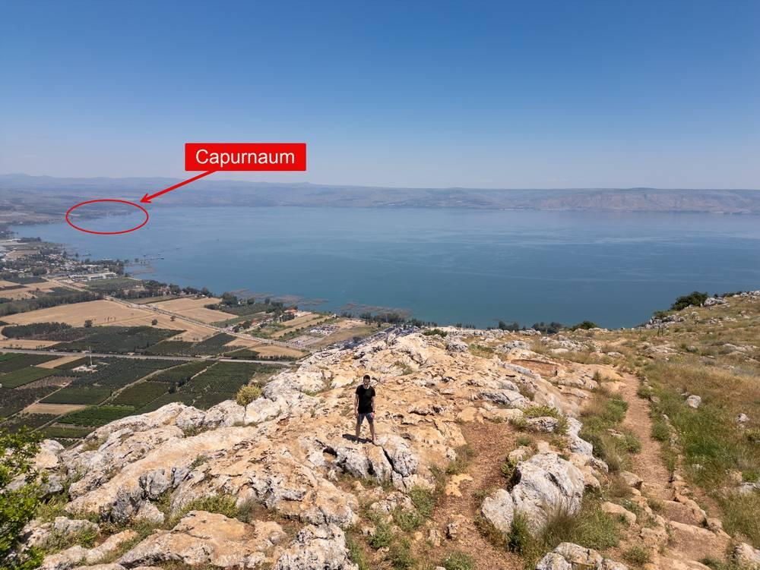
link

Mer de Galilée

Image Content

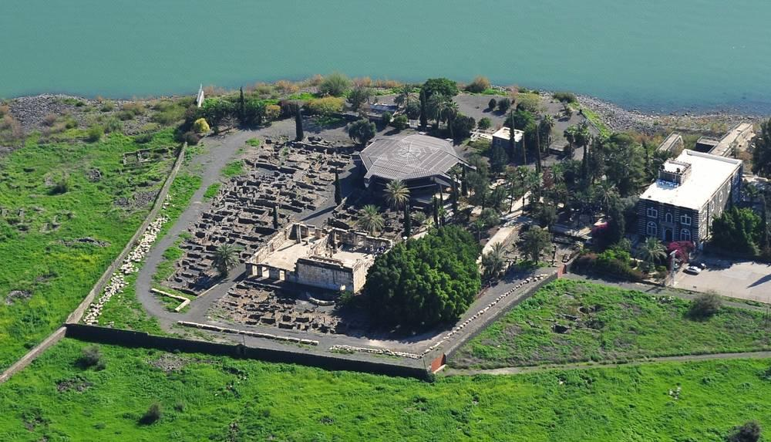
link

Mont des Oliviers

Image Content

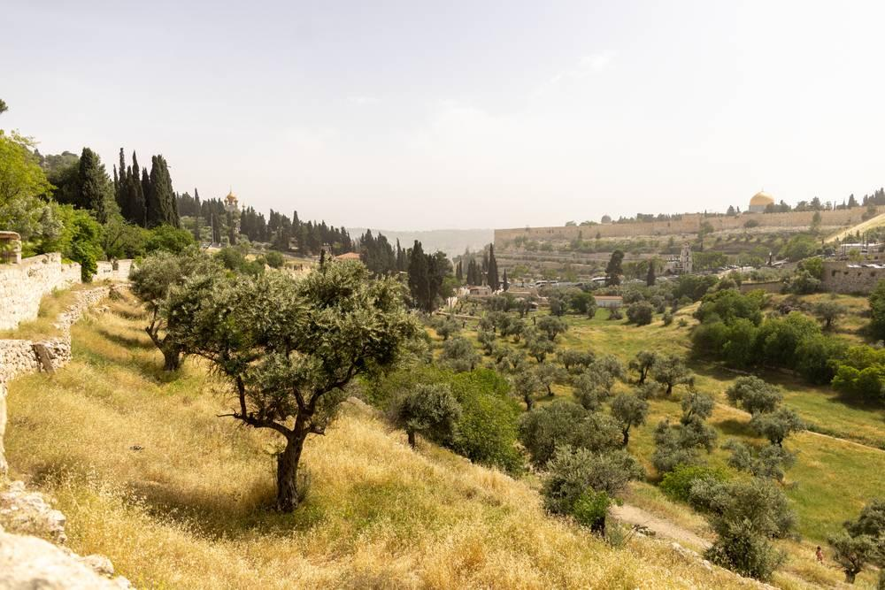
link

Moutarde

Image Content

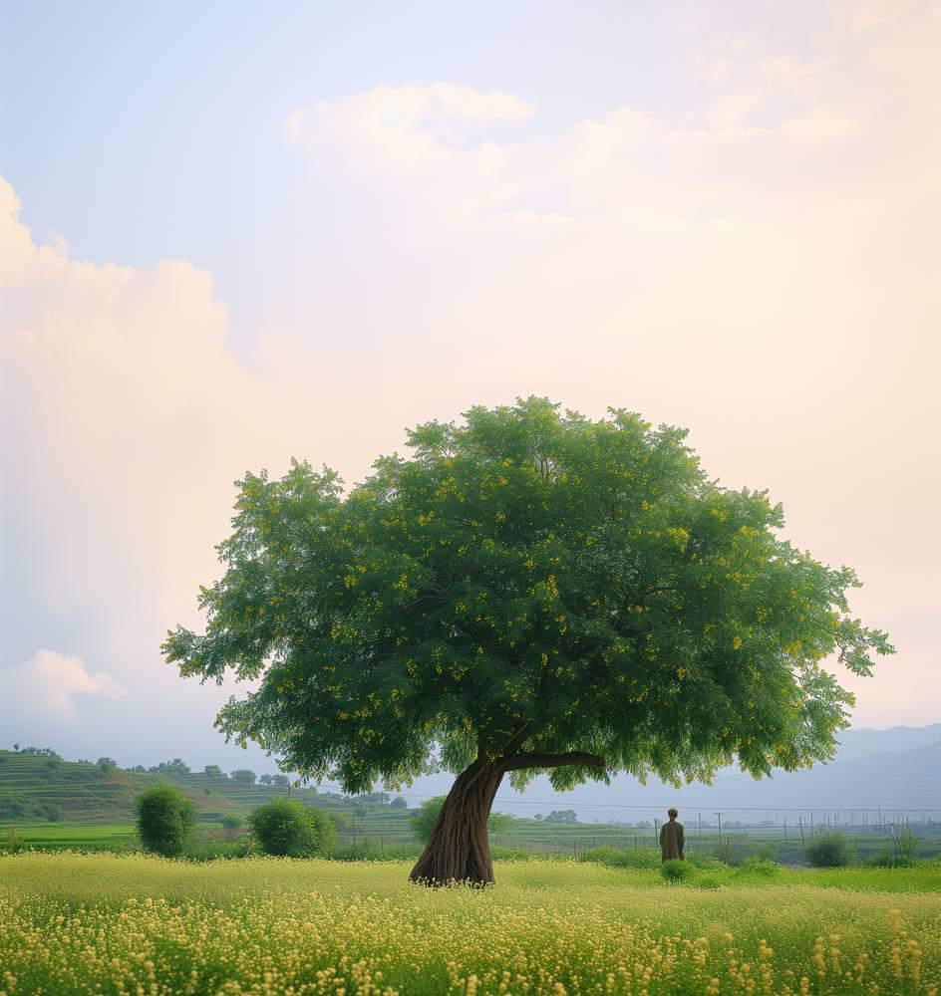
link

Mur de pierre autour d'une vigne

Image Content

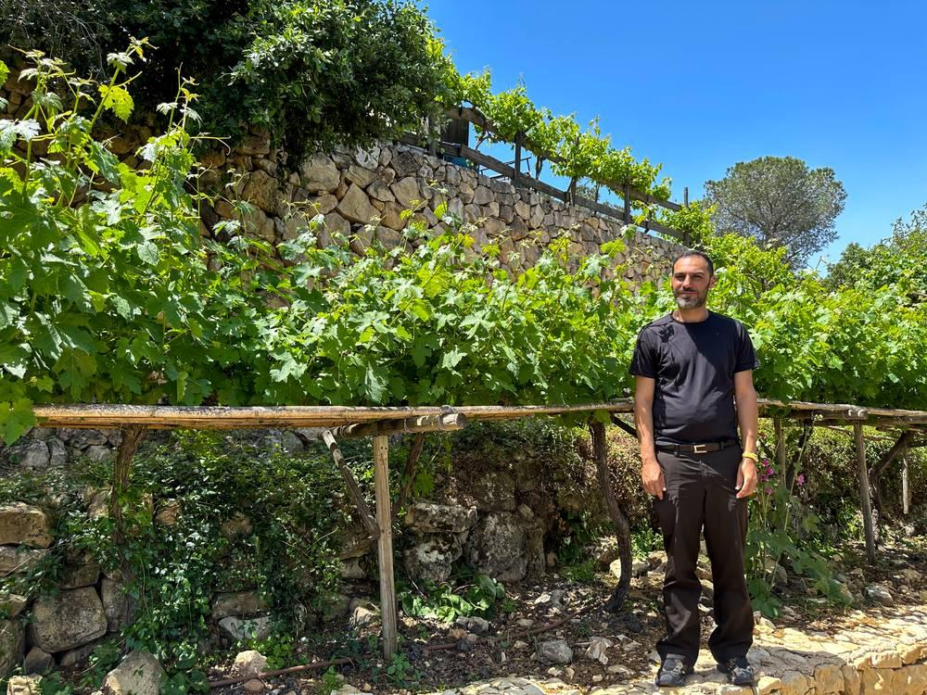
link

