Resource: Familiarization, Internalization, Articulation (Fia) Images
Familiarization, Internalization, Articulation (FIA) Images © 2023 SRV Partners Released under CC BY-SA 4.0 license. Familiarization, Internalization, Articulation (FIA) Images has been adapted in the following languages Tok Pisin, عربي, Français, हिंदी, Bahasa Indonesia, Português, Русский, Español, Kiswahili, 简体中文 from Familiarization, Internalization, Articulation (FIA) © 2023 SRV Partners. Released under CC BY-SA 4.0 license by Mission Mutual

Familiarization, Internalization, Articulation (Fia) Images

P

Pain

Image Content


link

Pain

Image Content

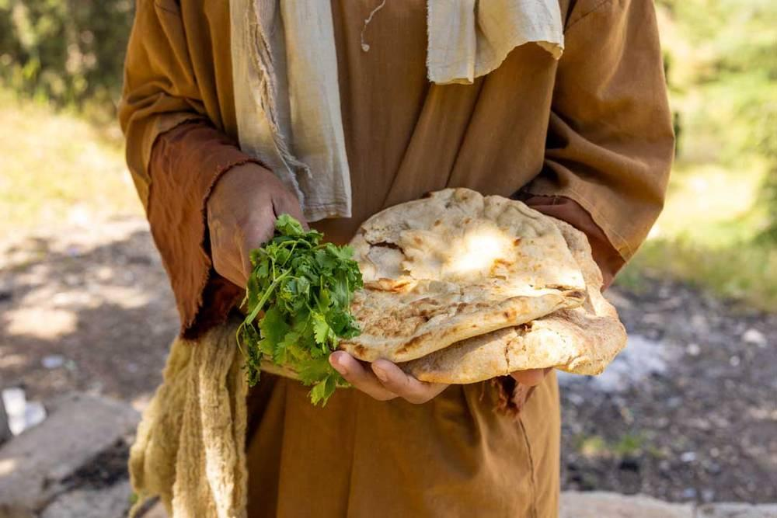
link

Panier de provisions

Image Content

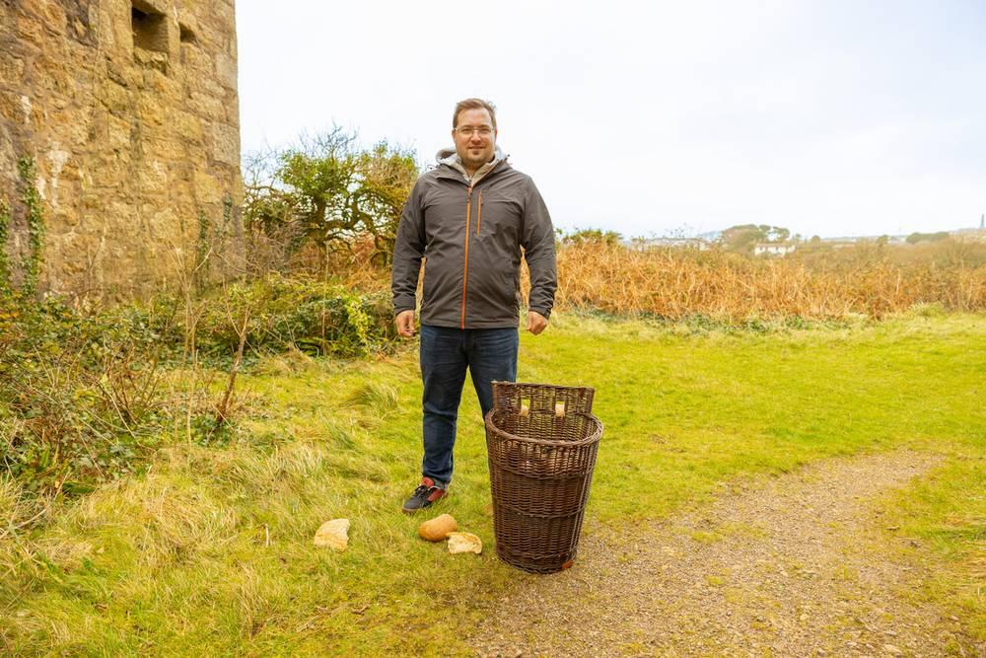
link

Panier de provisions

Image Content

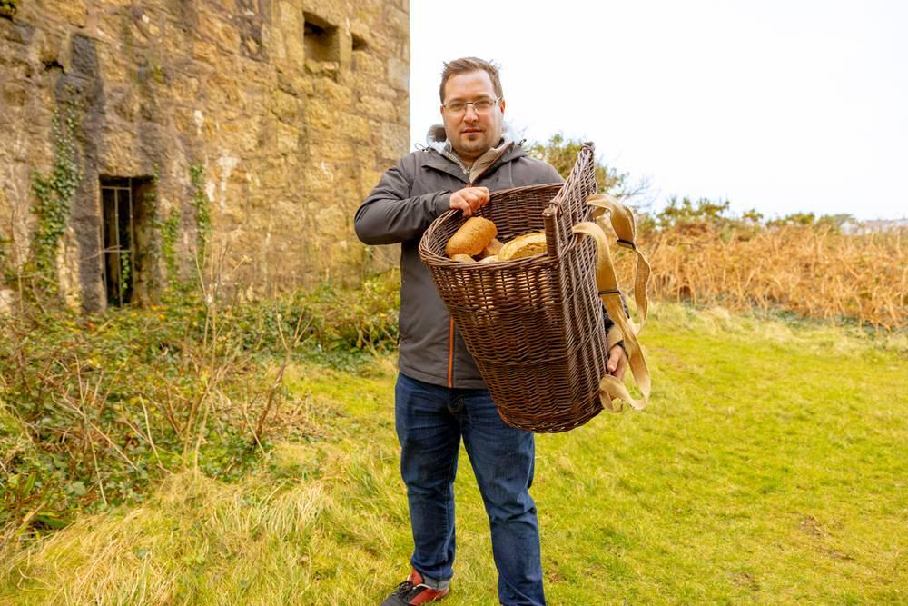
link

Panier de provisions

Image Content

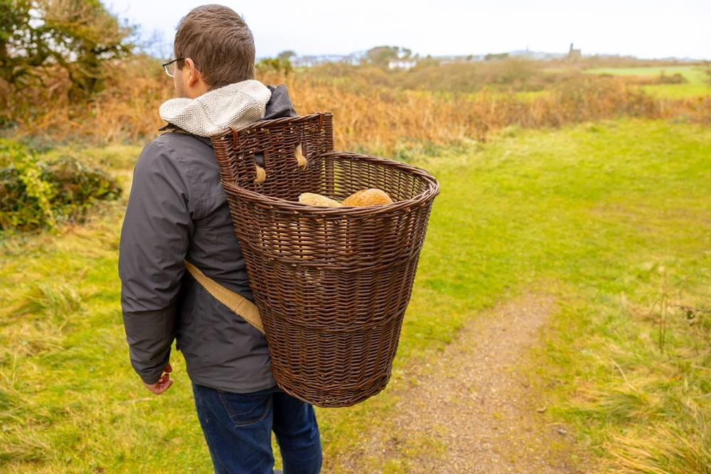
link

Panier en tant boisseau

Image Content

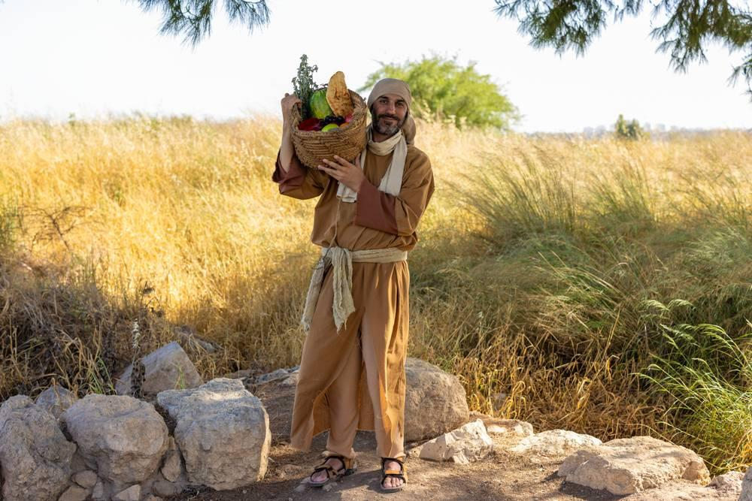
link

Panier en tant boisseau

Image Content

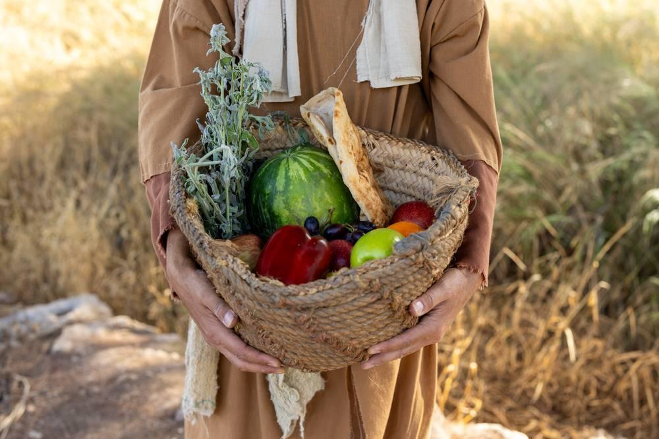
link

Pièces

Image Content

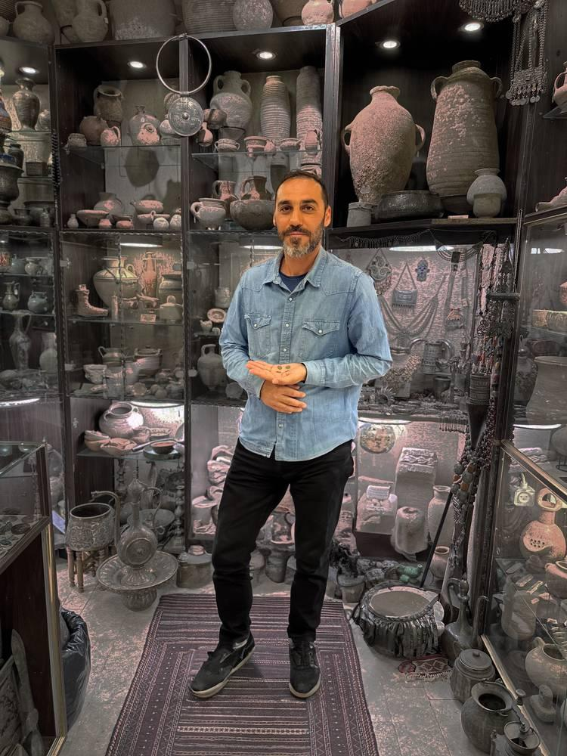
link

Pièces

Image Content

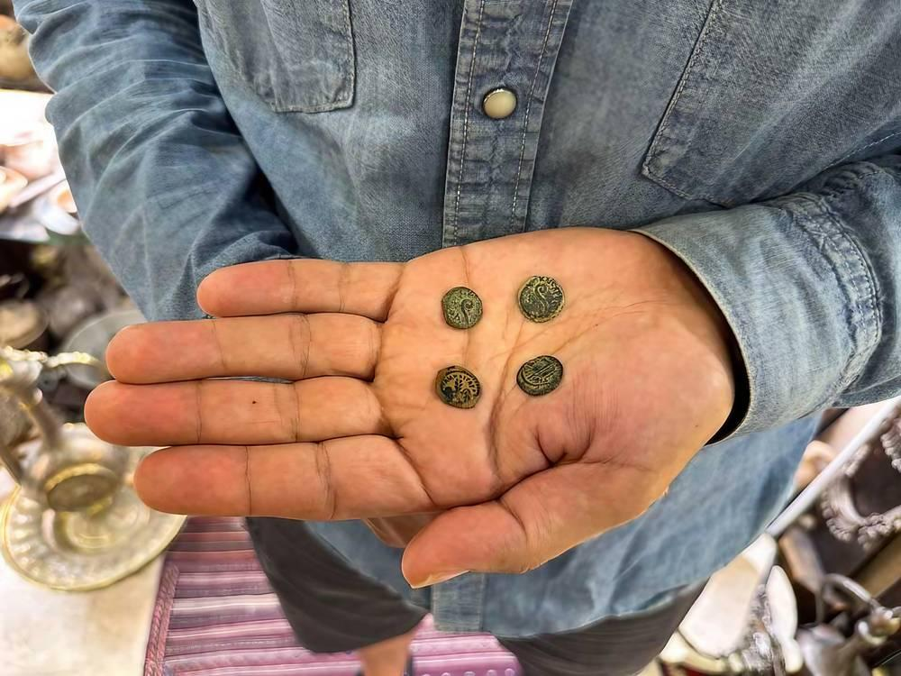
link

Pièces de cuivre

Image Content

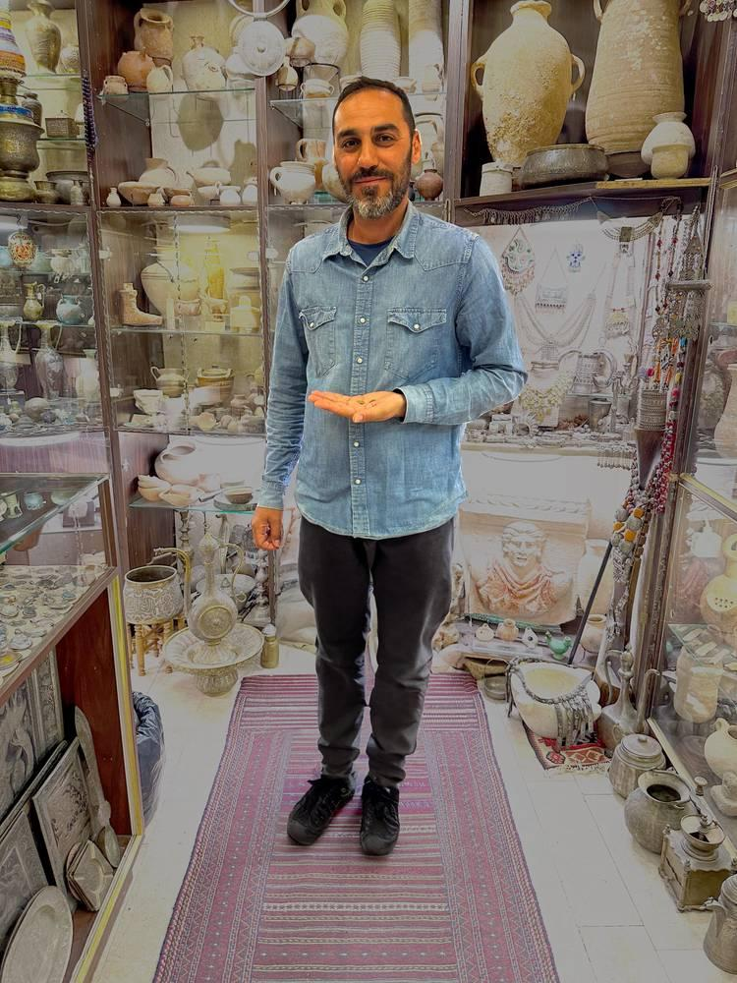
link

Pièces de cuivre

Image Content

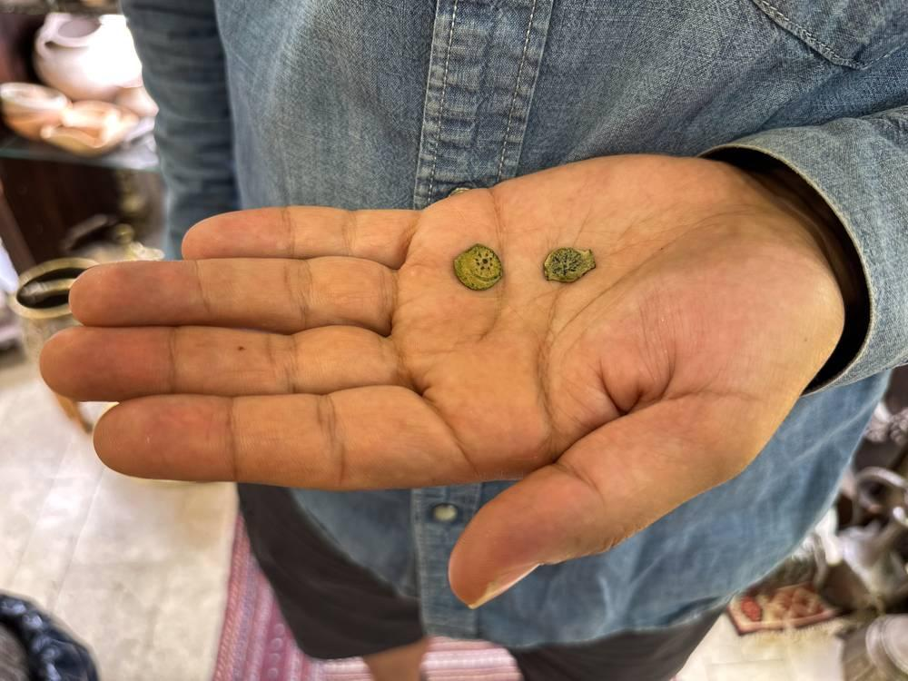
link

Pierre à moudre

Image Content

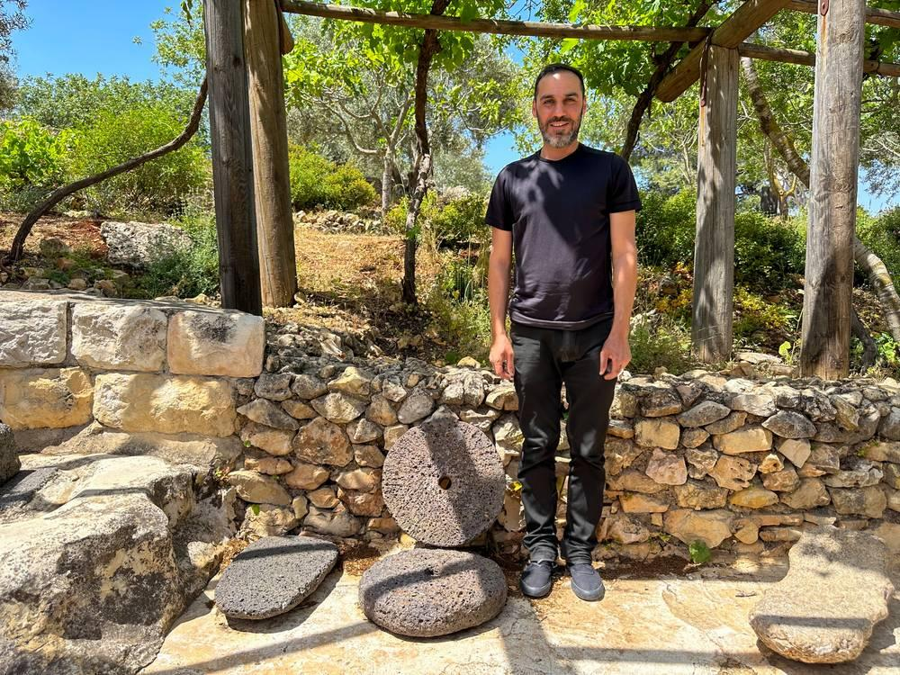
link

Pierre à moudre

Image Content

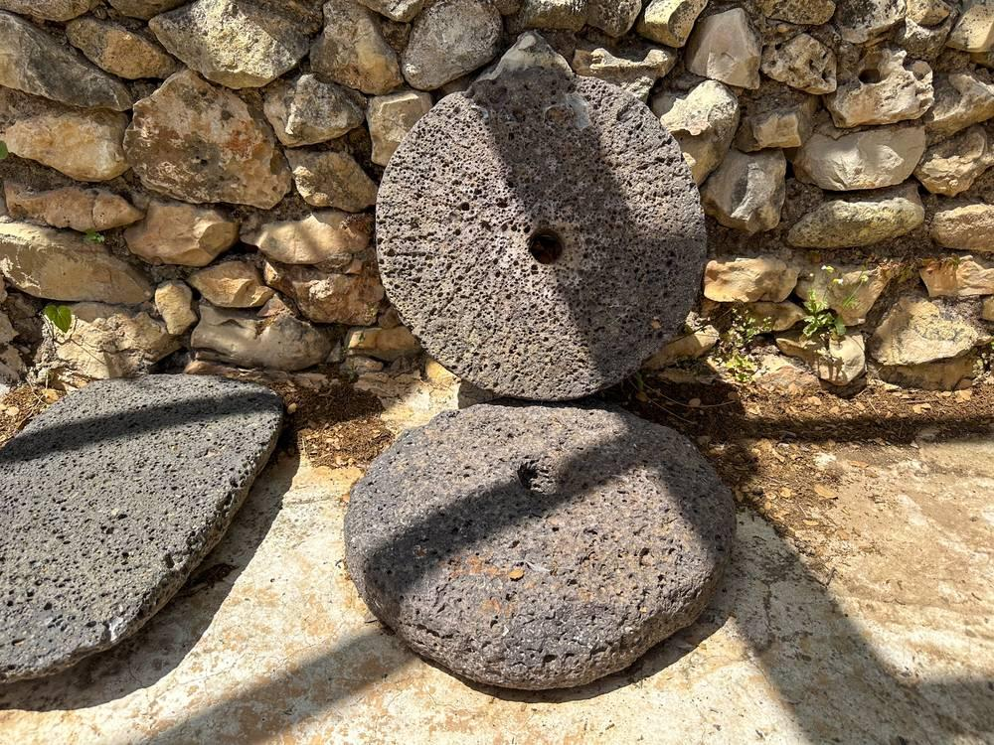
link

Pierre à moudre

Image Content

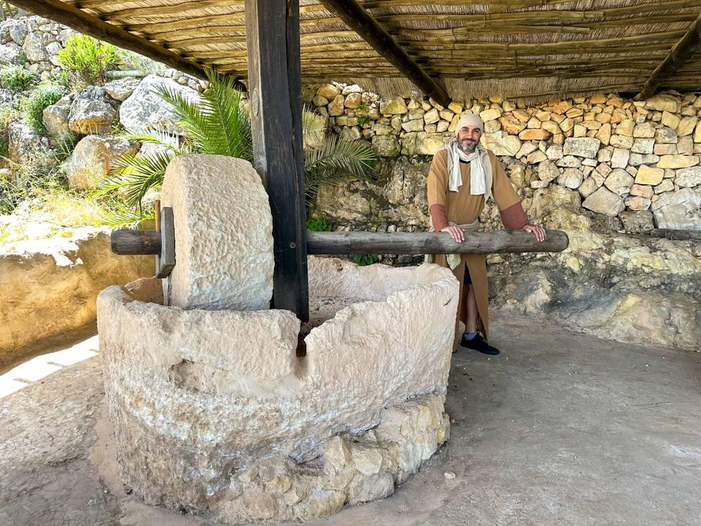
link

Pierre d'angle

Image Content

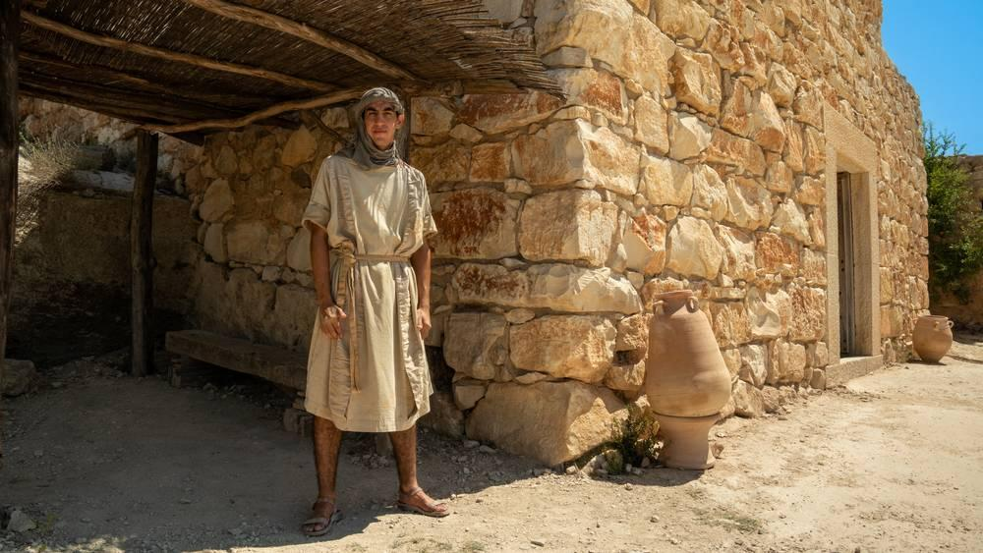
link

Pierre d'angle

Image Content

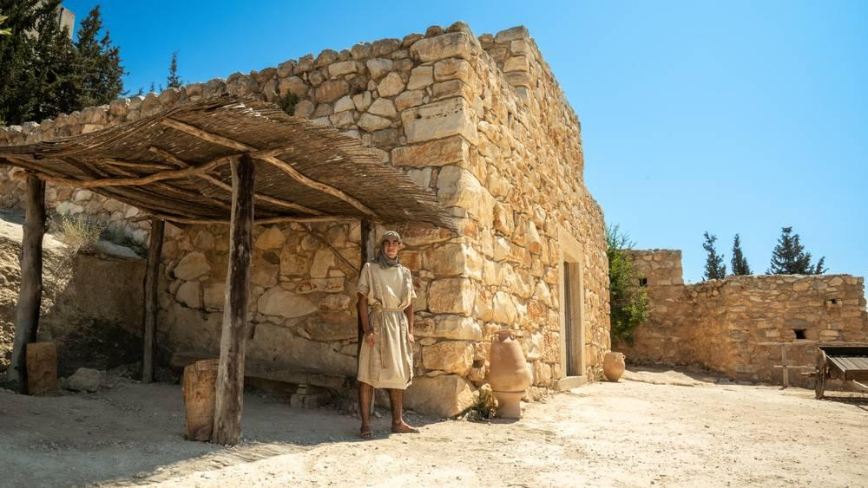
link

Pierre d'angle

Image Content

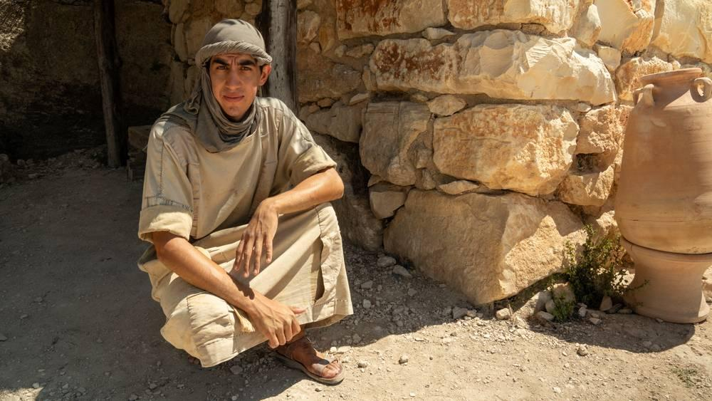
link

Pigeon

Image Content

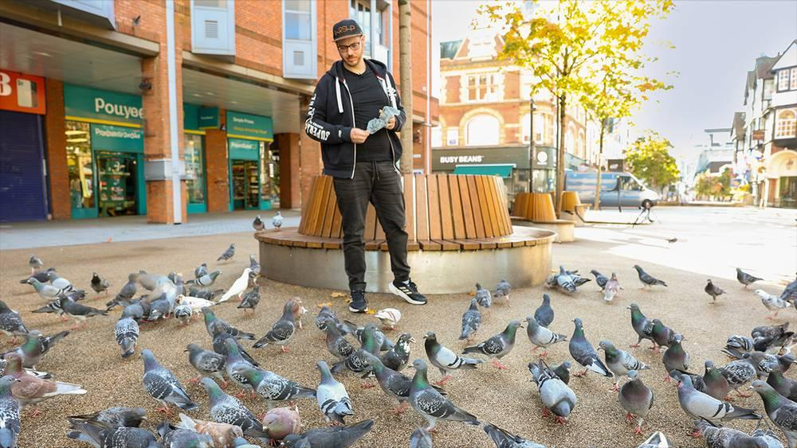
link

Pigeon

Image Content

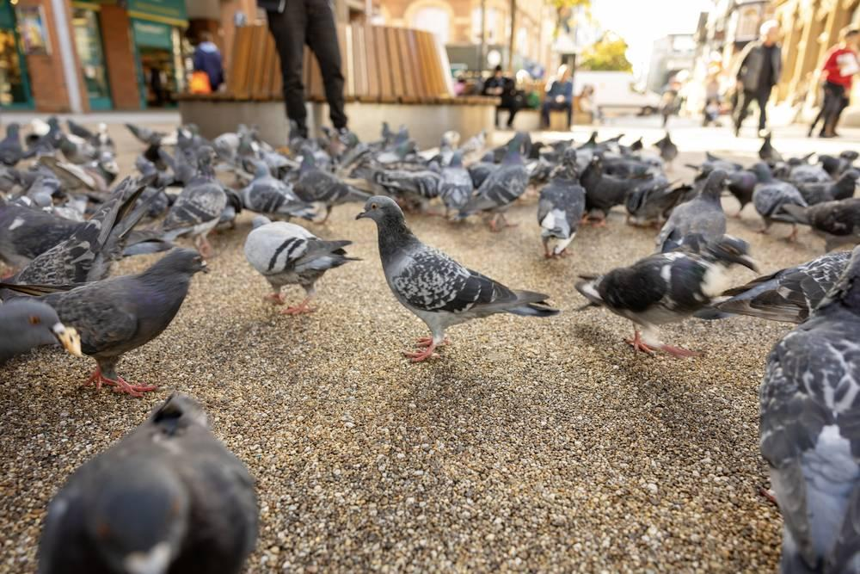
link

Plante de nard

Image Content

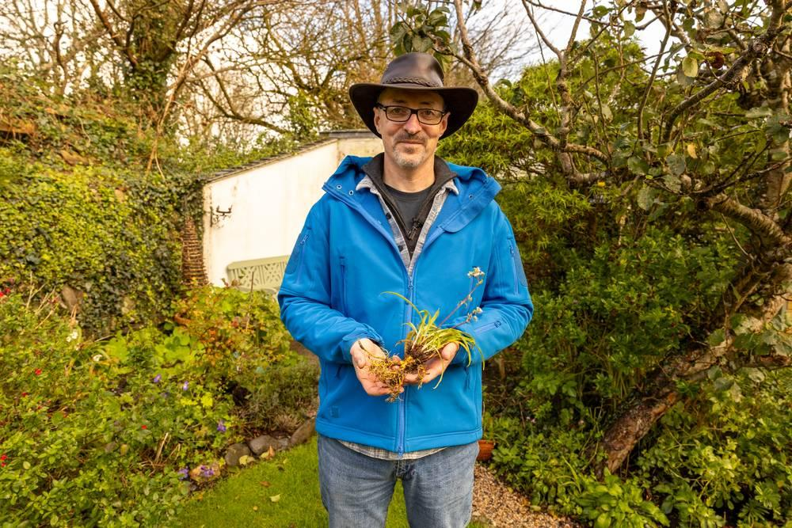
link

Plante de nard

Image Content

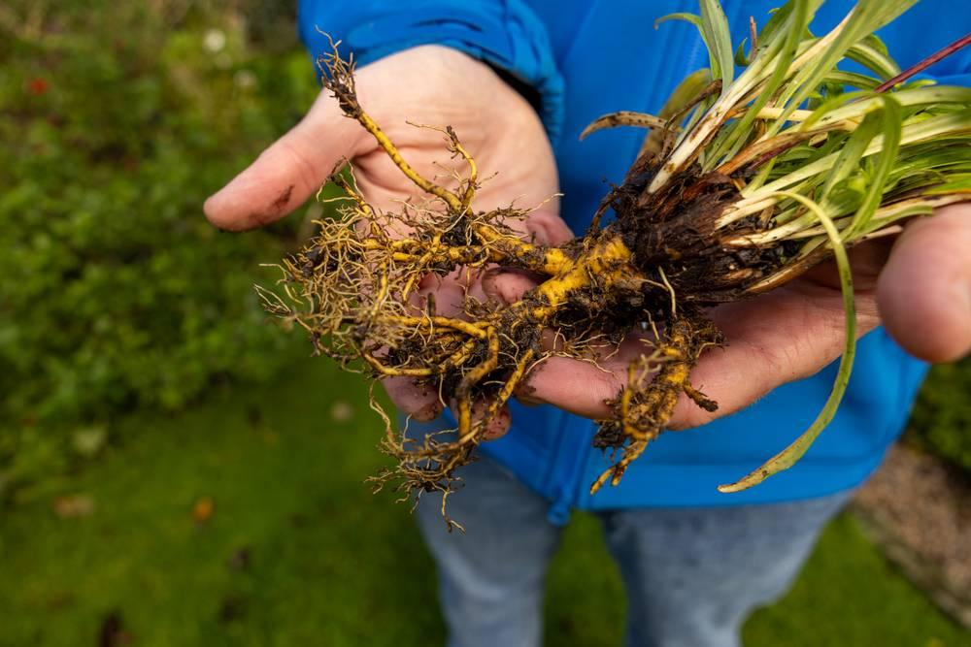
link

Plat

Image Content

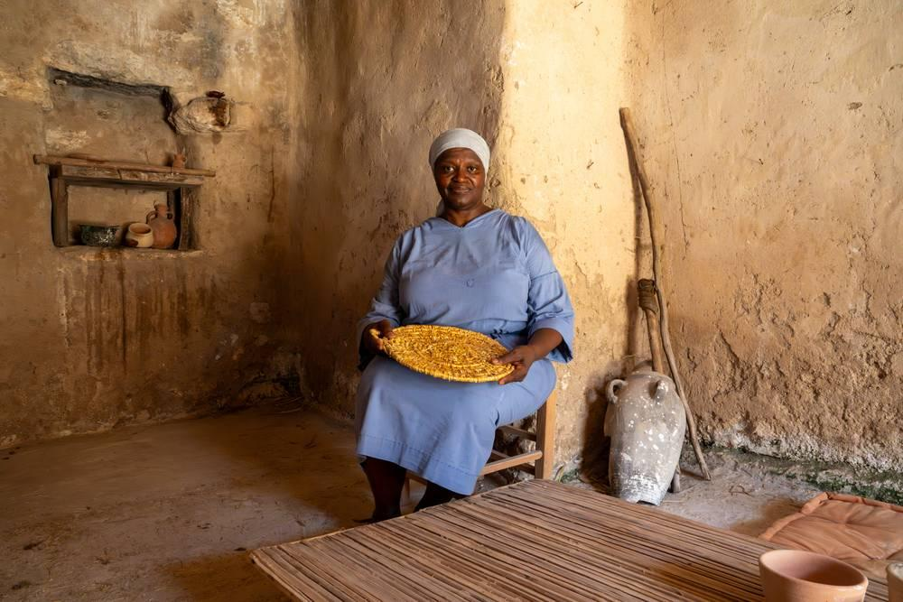
link

Plat

Image Content

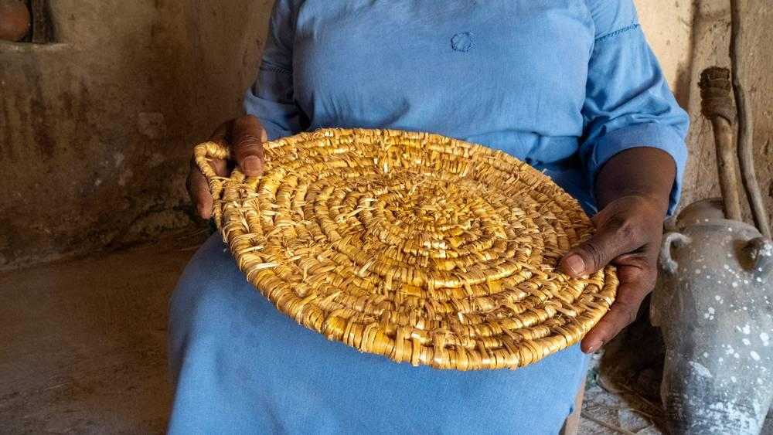
link

Poisson cuit

Image Content

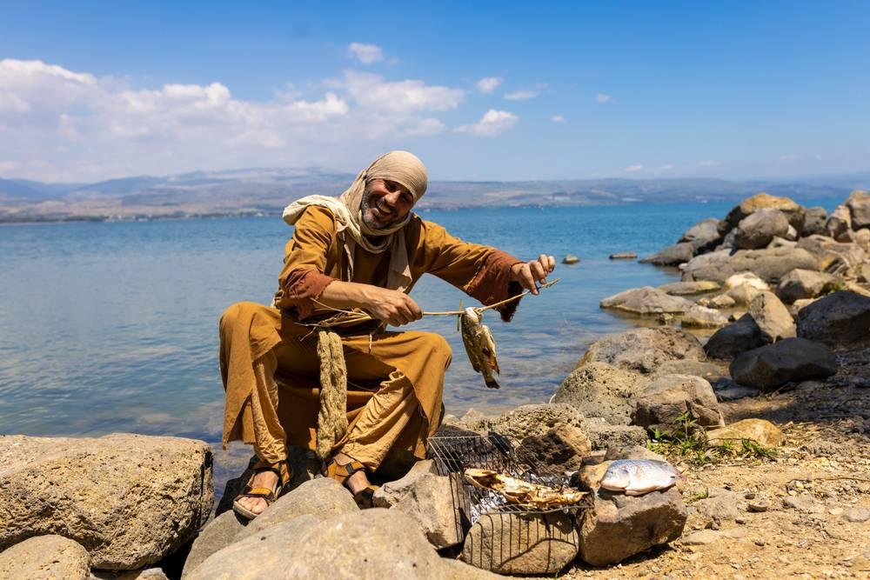
link

Pot d'eau

Image Content

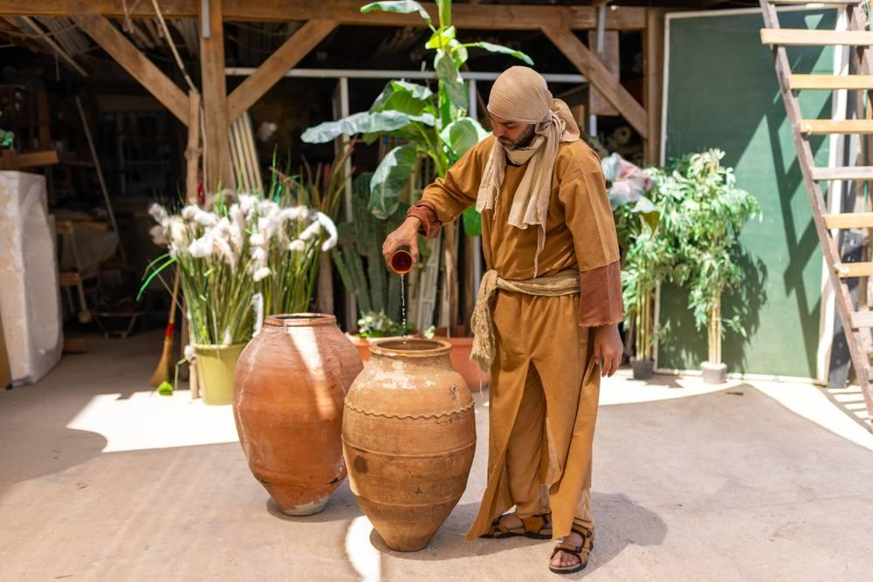
link

Pot d'eau

Image Content


link

Pot d'eau

Image Content

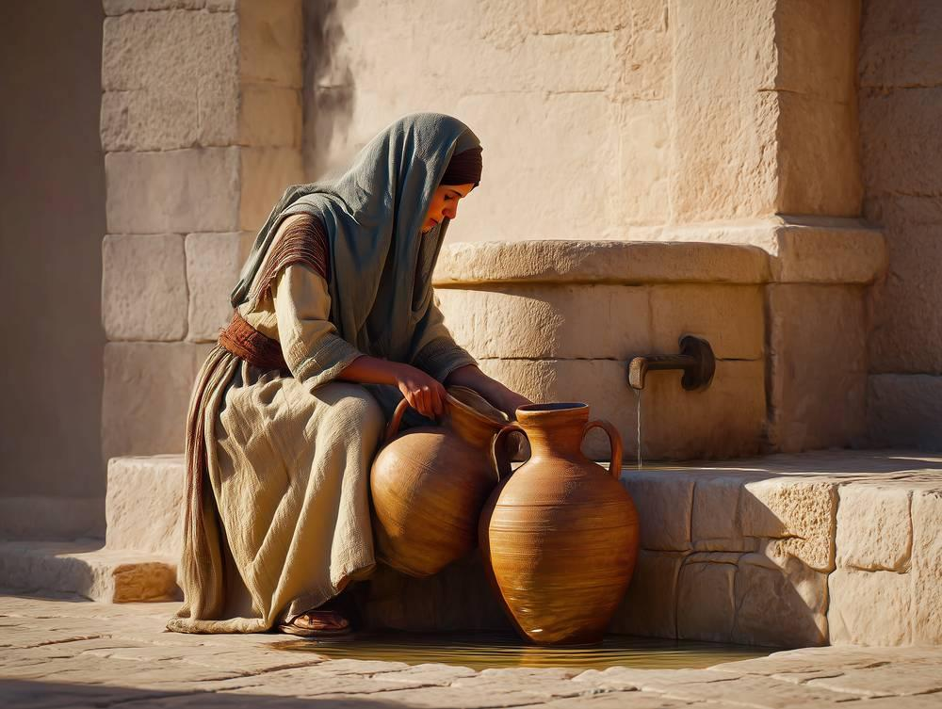
link

Pot d'eau

Image Content

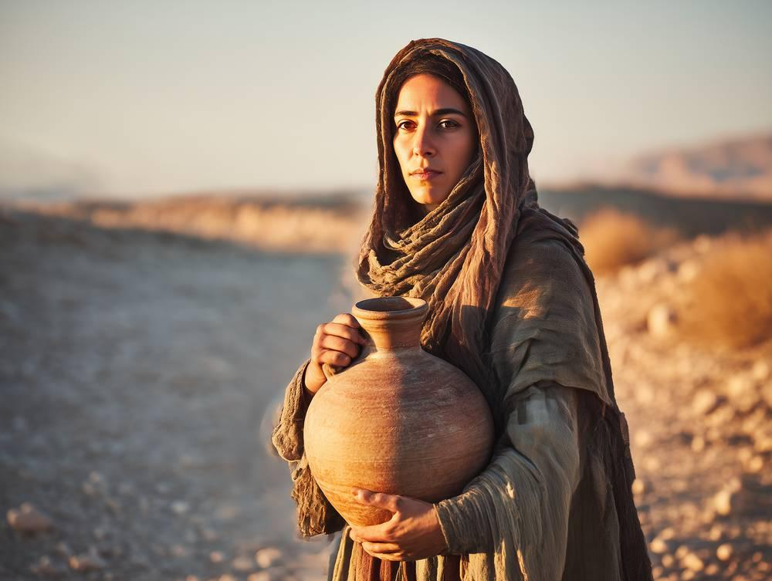
link

Pot en albâtre

Image Content

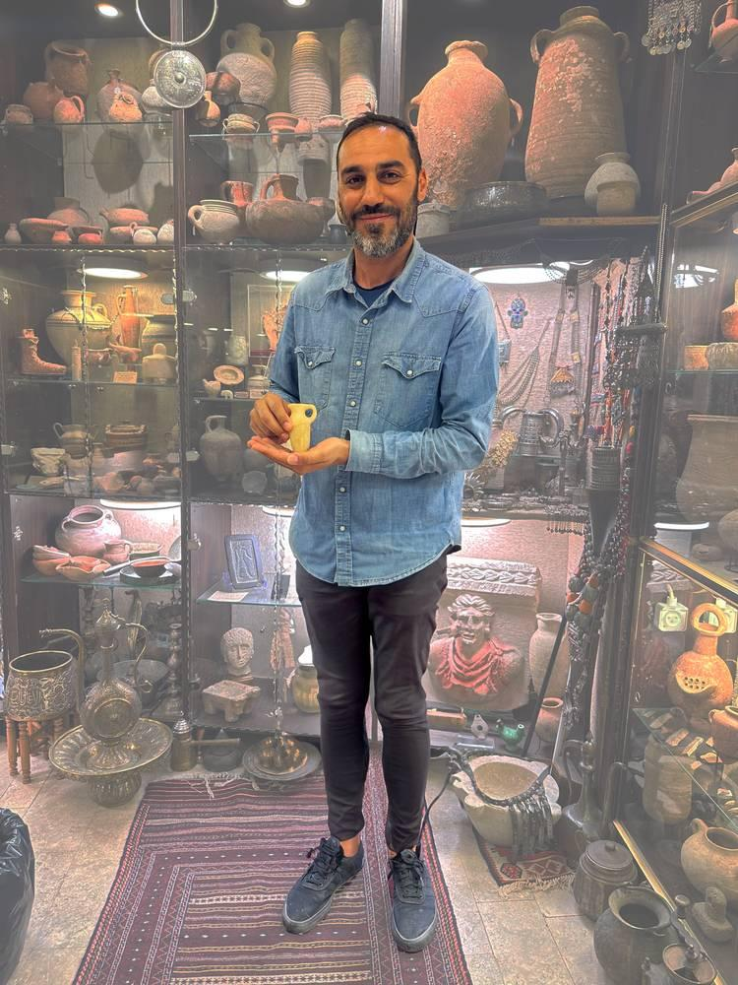
link

Pot en albâtre

Image Content

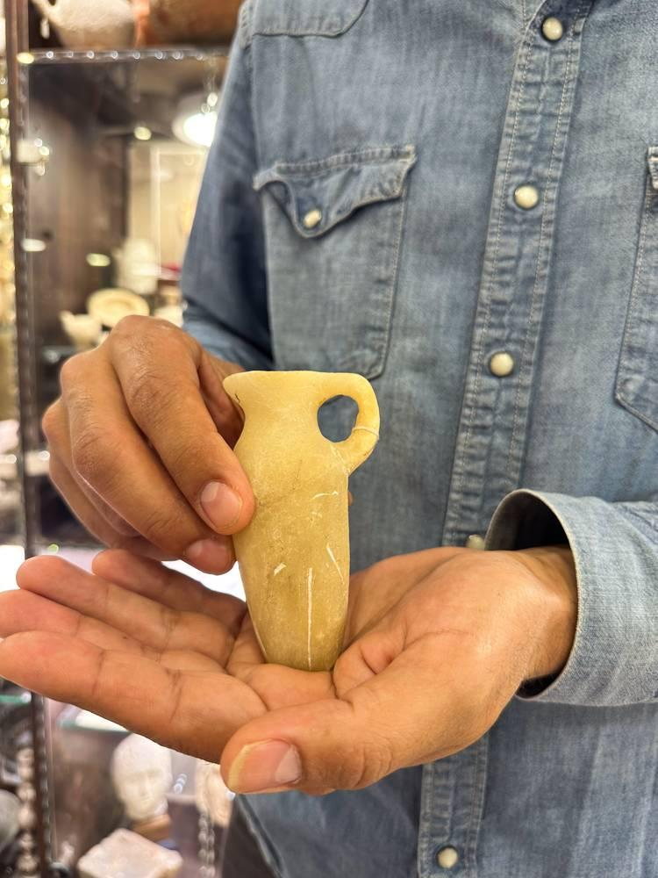
link

Pot en albâtre

Image Content

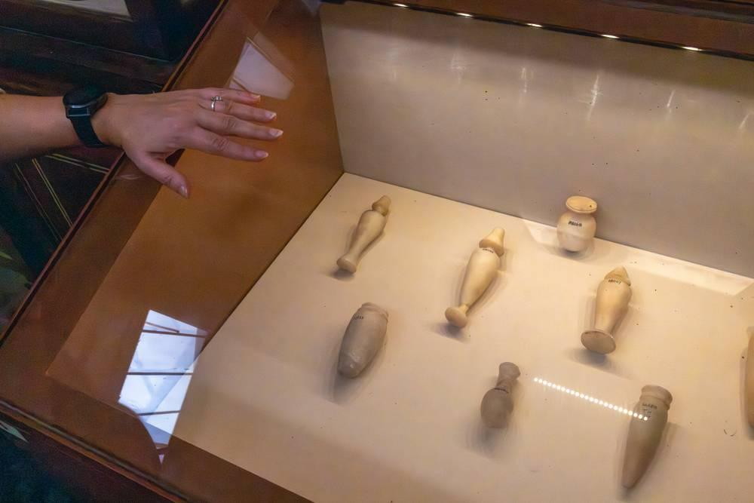
link

Pot en albâtre

Image Content

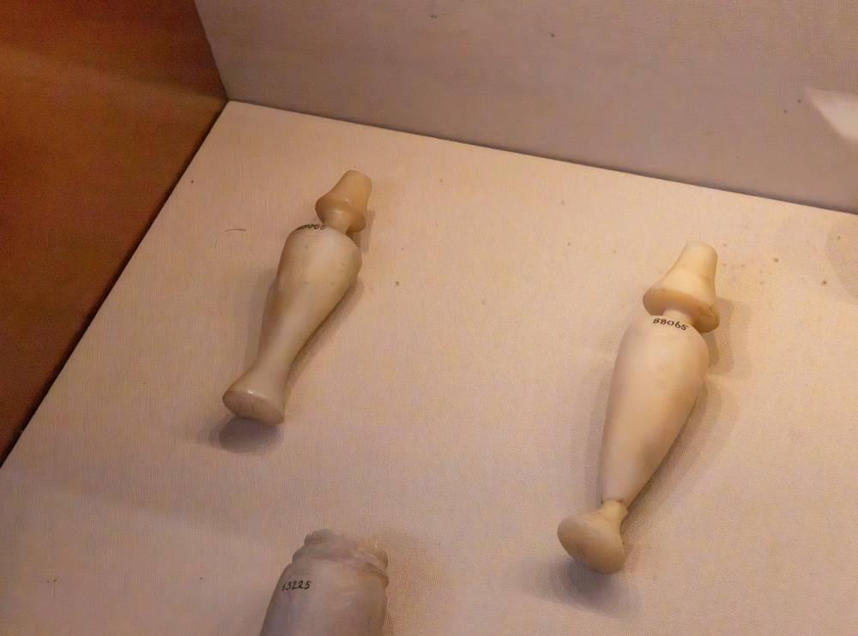
link

Pressoir à vin

Image Content

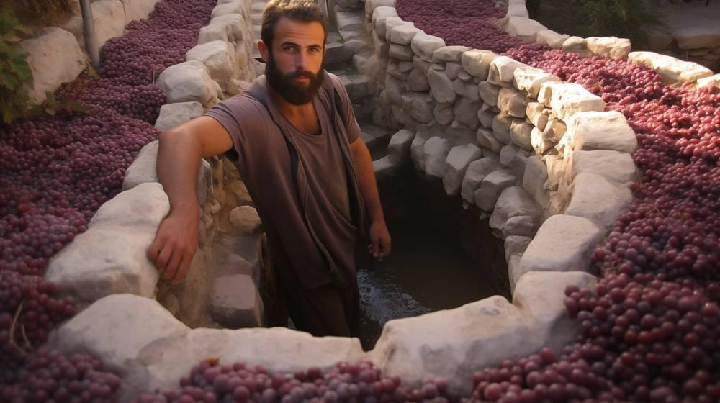
link

