Resource: Familiarization, Internalization, Articulation (Fia) Images
Familiarization, Internalization, Articulation (FIA) Images © 2023 SRV Partners Released under CC BY-SA 4.0 license. Familiarization, Internalization, Articulation (FIA) Images has been adapted in the following languages Tok Pisin, عربي, Français, हिंदी, Bahasa Indonesia, Português, Русский, Español, Kiswahili, 简体中文 from Familiarization, Internalization, Articulation (FIA) © 2023 SRV Partners. Released under CC BY-SA 4.0 license by Mission Mutual

Familiarization, Internalization, Articulation (Fia) Images

T

Tapis de couchage

Image Content

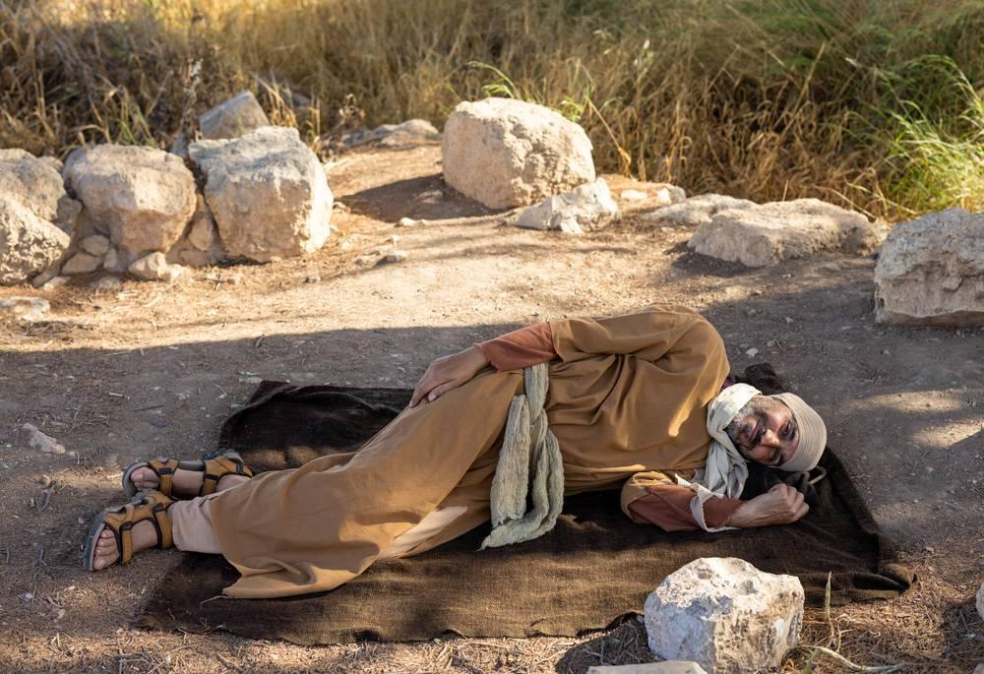
link

Tapis de couchage

Image Content

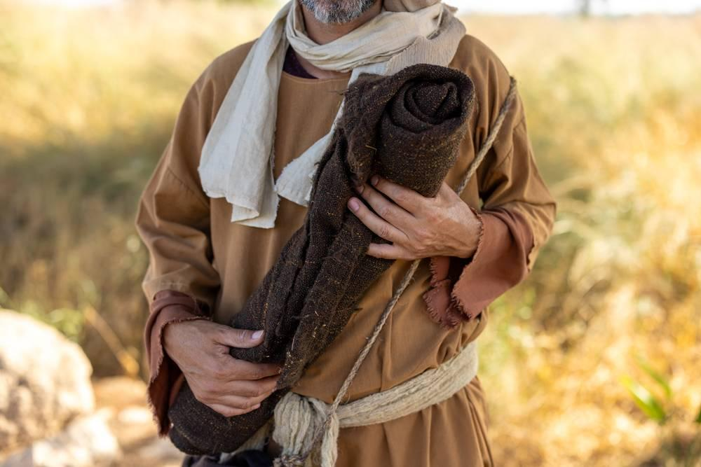
link

Tempête sur la mer de Galilée

Image Content

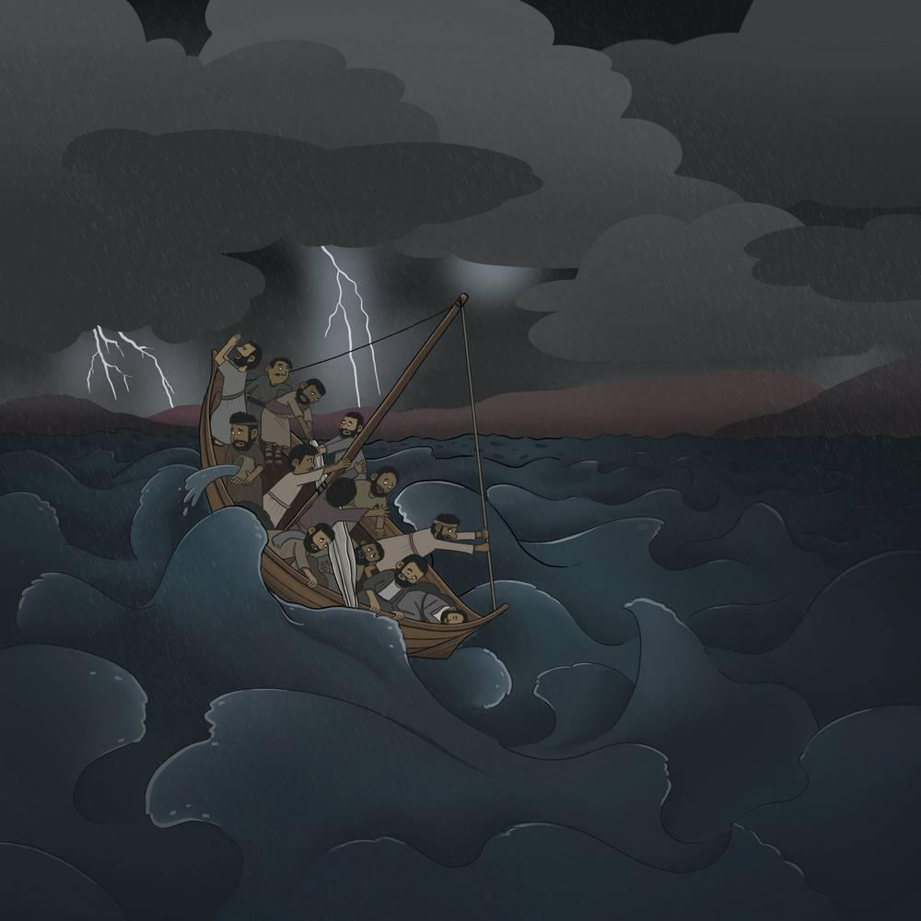
link

Temple d'Hérode

Image Content

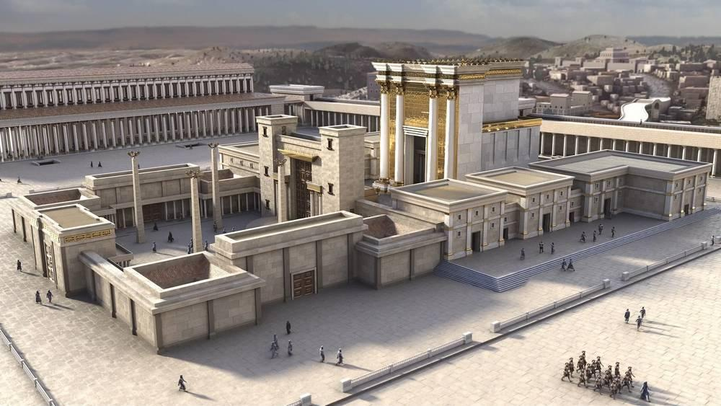
link

Tombeau de jardin

Image Content

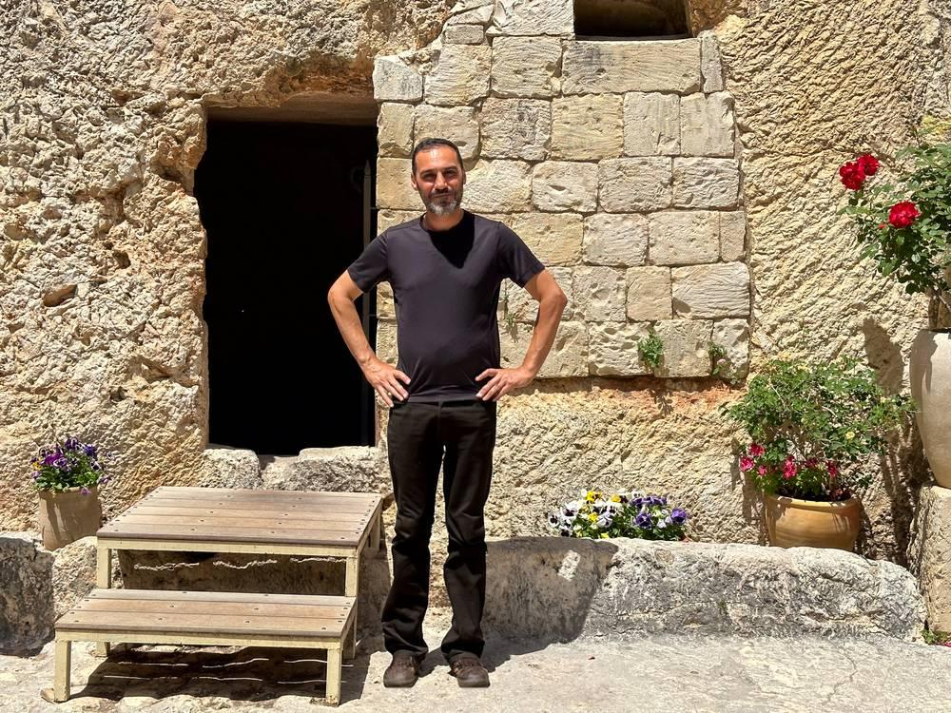
link

Tombeaux

Image Content

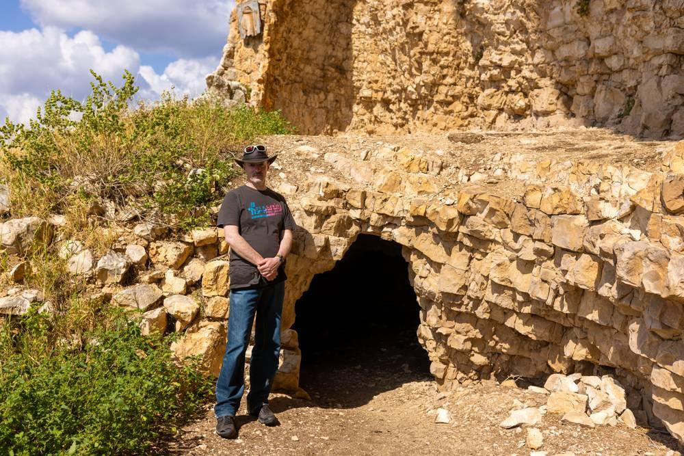
link

Tombeaux

Image Content

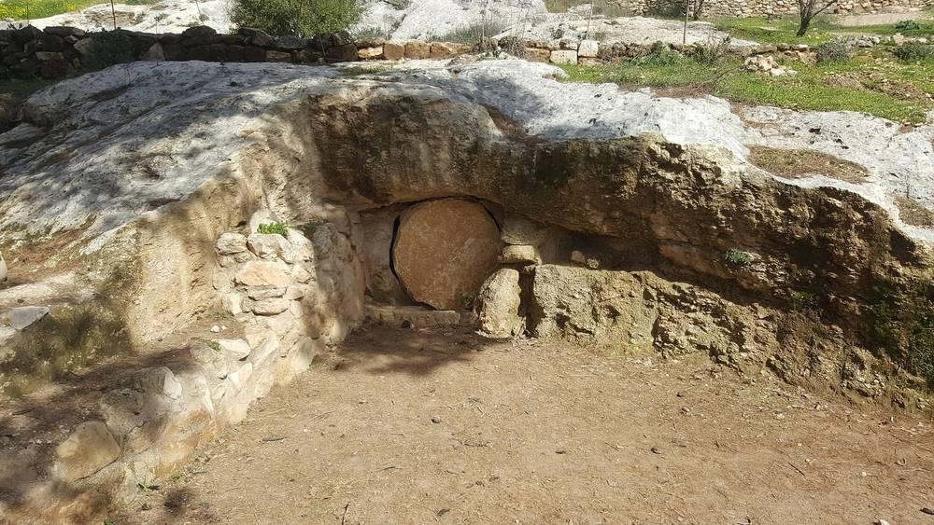
link

Tour de guet d'une vigne

Image Content

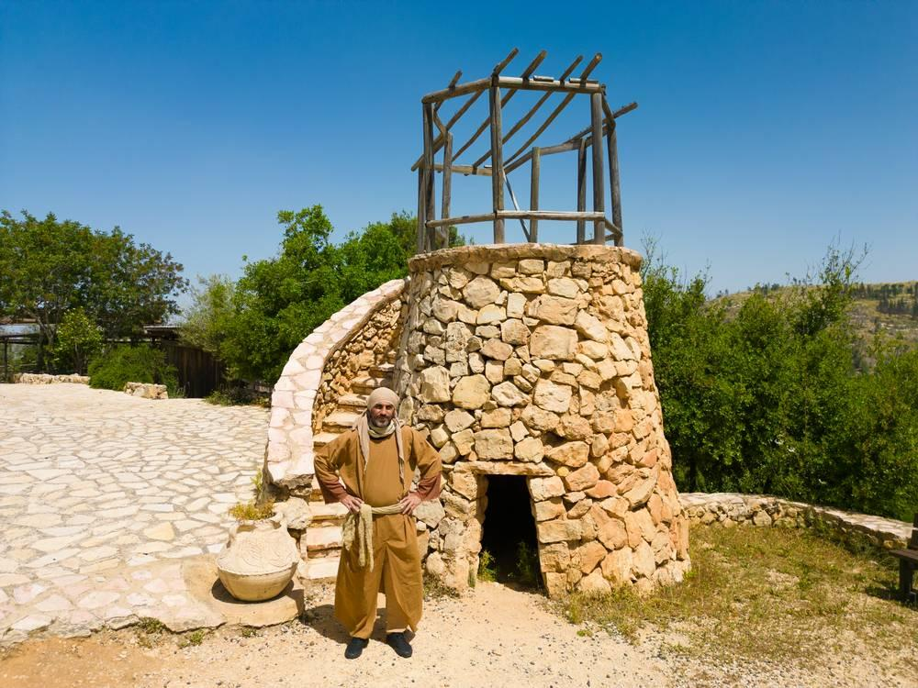
link

Tour de guet d'une vigne

Image Content

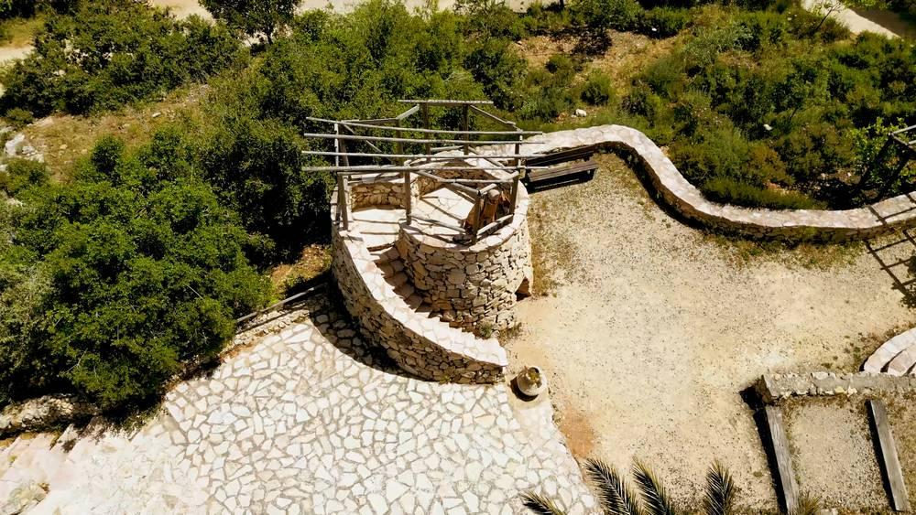
link

Tunique

Image Content

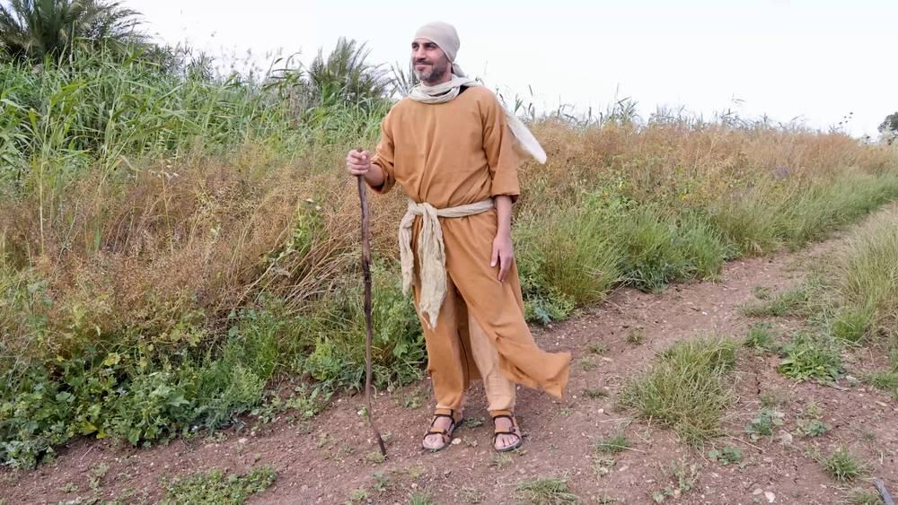
link

Tunique

Image Content

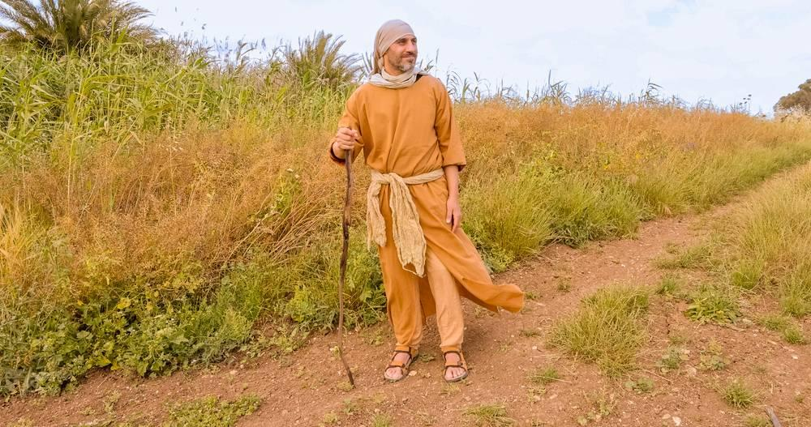
link

