Resource: Familiarization, Internalization, Articulation (Fia) Images
Familiarization, Internalization, Articulation (FIA) Images © 2023 SRV Partners Released under CC BY-SA 4.0 license. Familiarization, Internalization, Articulation (FIA) Images has been adapted in the following languages Tok Pisin, عربي, Français, हिंदी, Bahasa Indonesia, Português, Русский, Español, Kiswahili, 简体中文 from Familiarization, Internalization, Articulation (FIA) © 2023 SRV Partners. Released under CC BY-SA 4.0 license by Mission Mutual

Familiarization, Internalization, Articulation (Fia) Images

छ

छंटाई और बिना छंटाई वाली अंगूर के बेलें

Image Content

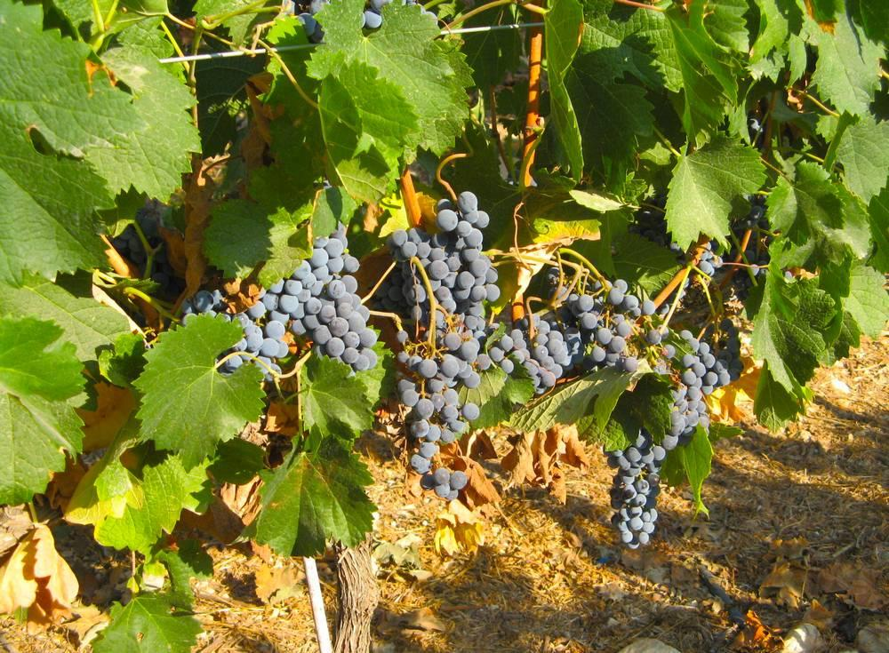
link

छंटाई और बिना छंटाई वाली अंगूर के बेलें

Image Content

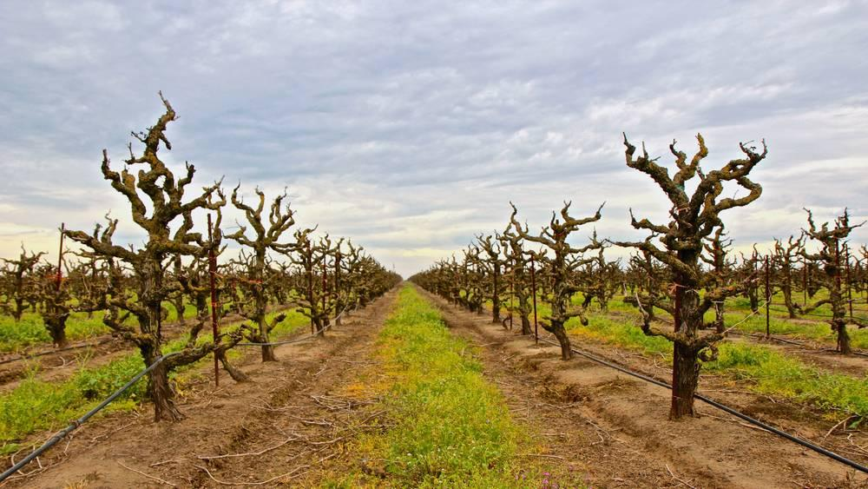
link

छंटाई और बिना छंटाई वाली अंगूर के बेलें

Image Content

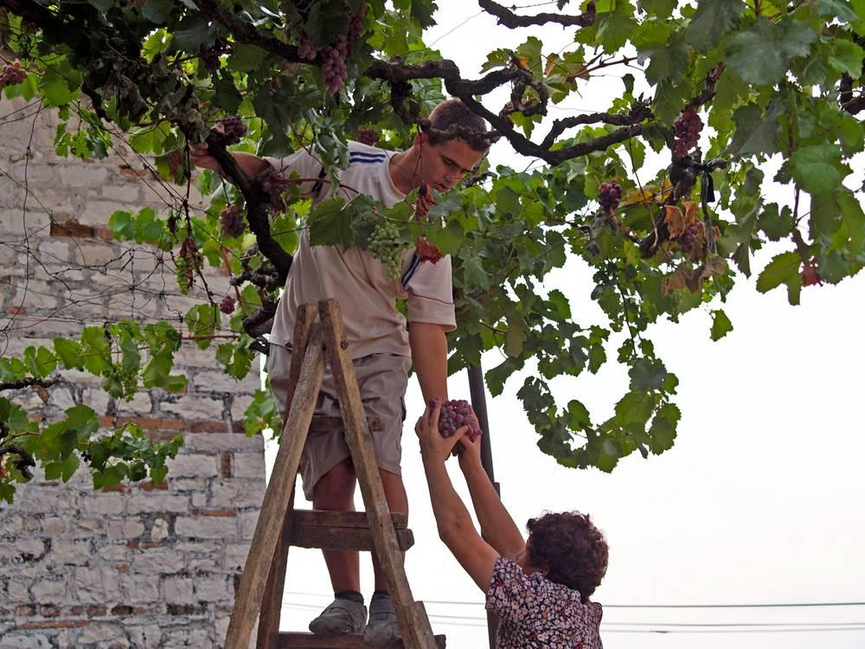
link

छोटी बाढ़

Image Content

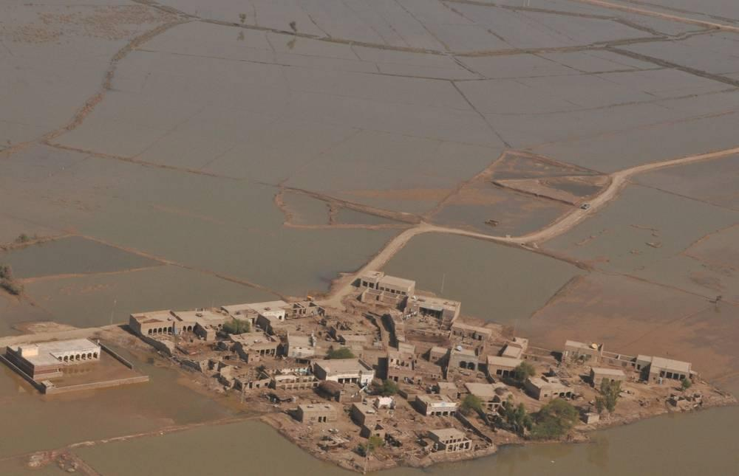
link

