Resource: Familiarization, Internalization, Articulation (Fia) Images
Familiarization, Internalization, Articulation (FIA) Images © 2023 SRV Partners Released under CC BY-SA 4.0 license. Familiarization, Internalization, Articulation (FIA) Images has been adapted in the following languages Tok Pisin, عربي, Français, हिंदी, Bahasa Indonesia, Português, Русский, Español, Kiswahili, 简体中文 from Familiarization, Internalization, Articulation (FIA) © 2023 SRV Partners. Released under CC BY-SA 4.0 license by Mission Mutual

Familiarization, Internalization, Articulation (Fia) Images

B

Baía

Image Content


link

Baía

Image Content

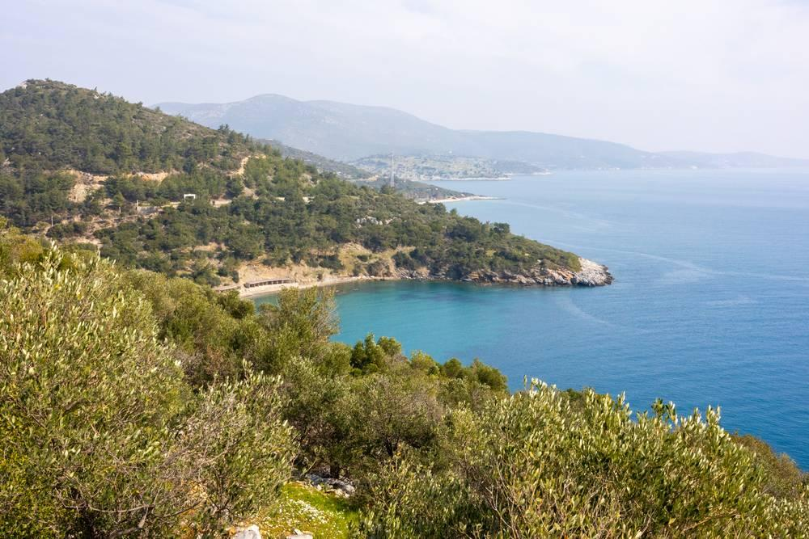
link

Banco de jantar

Image Content

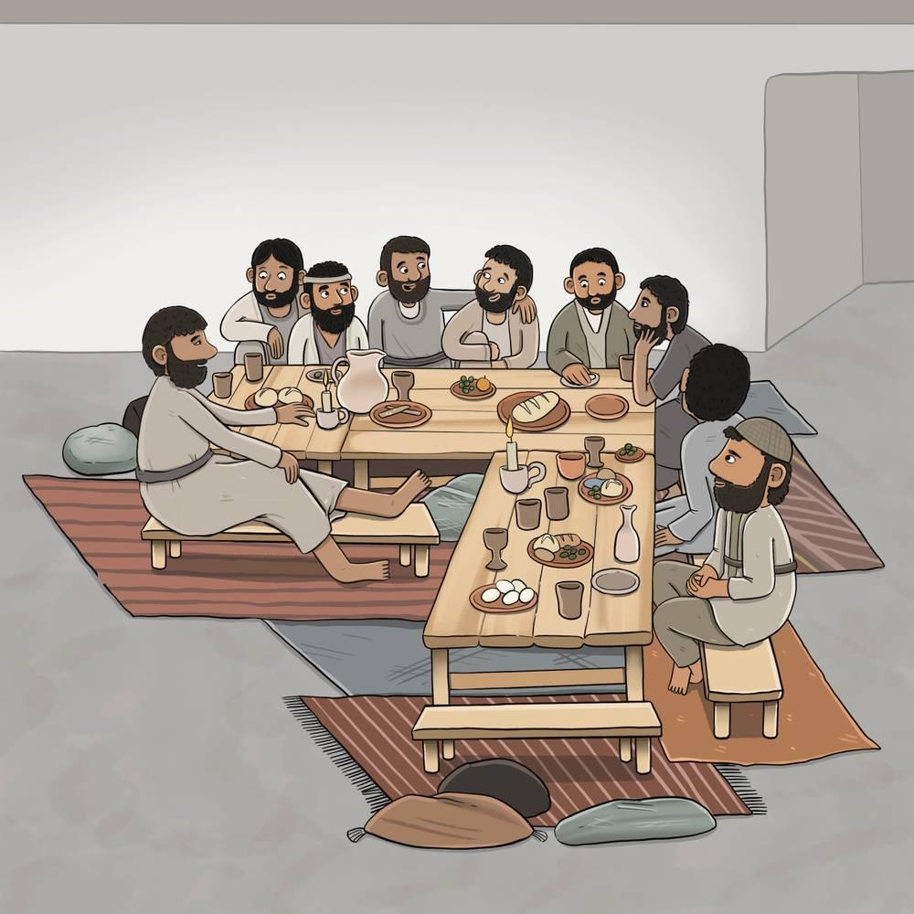
link

Banco de jantar

Image Content

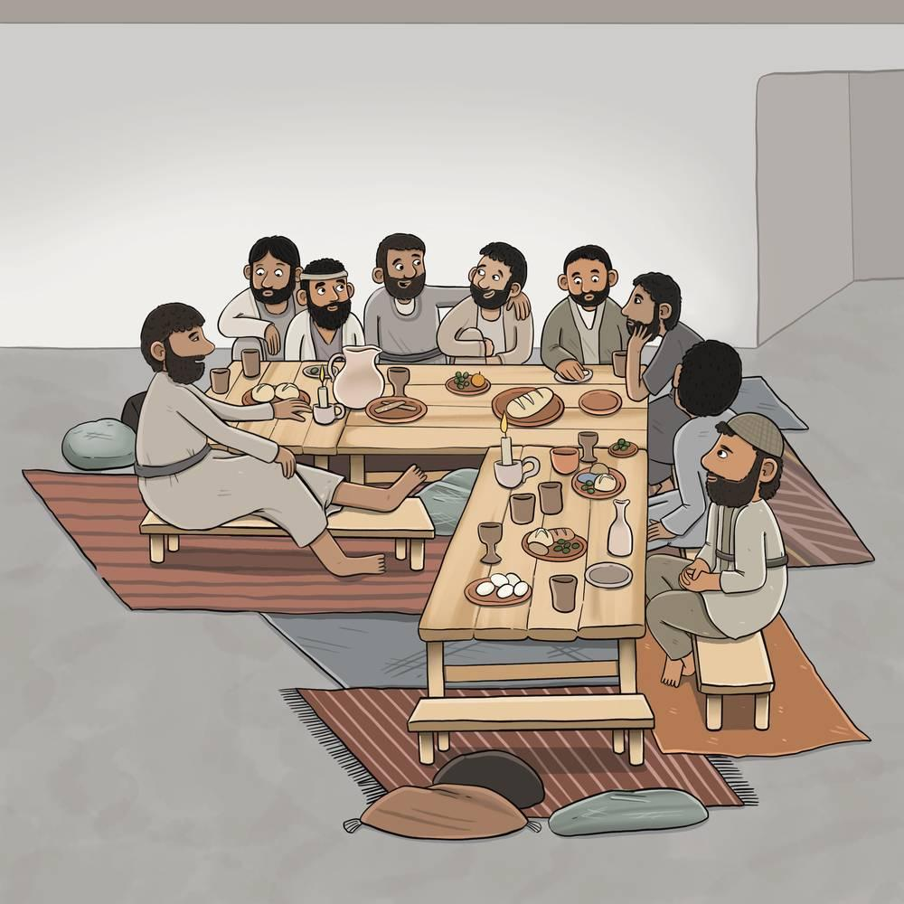
link

Bandeja

Image Content

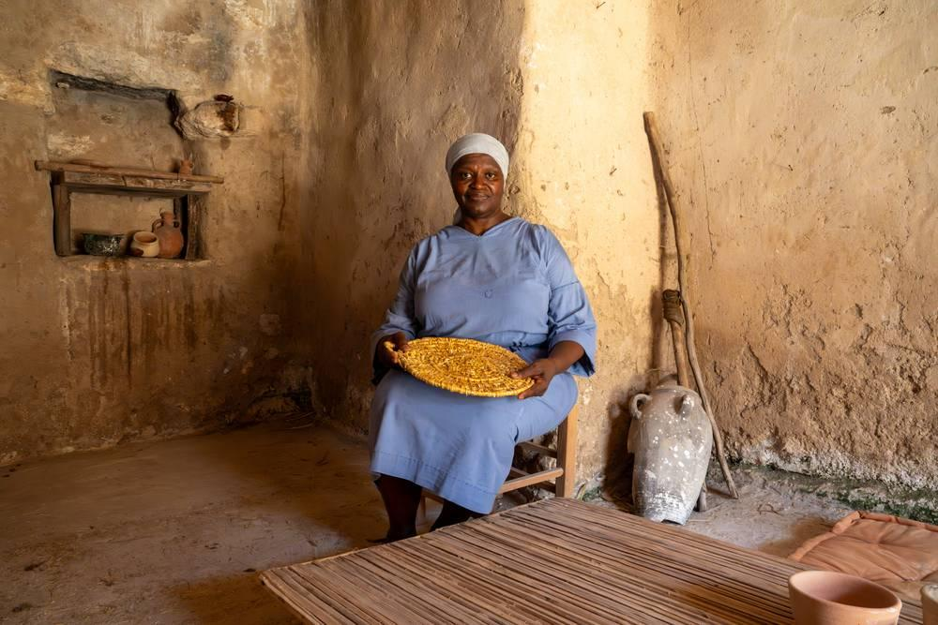
link

Bandeja

Image Content

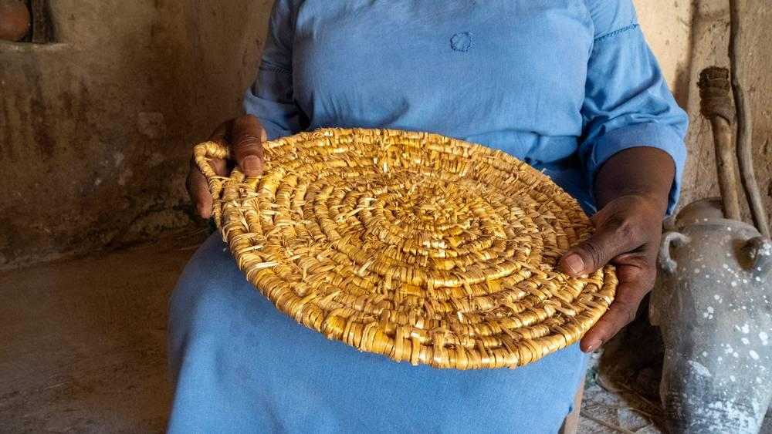
link

Barco

Image Content

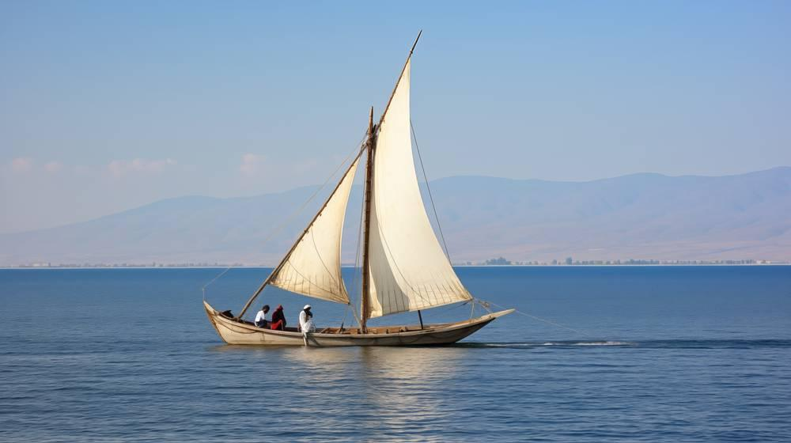
link

Bezerro cevado

Image Content

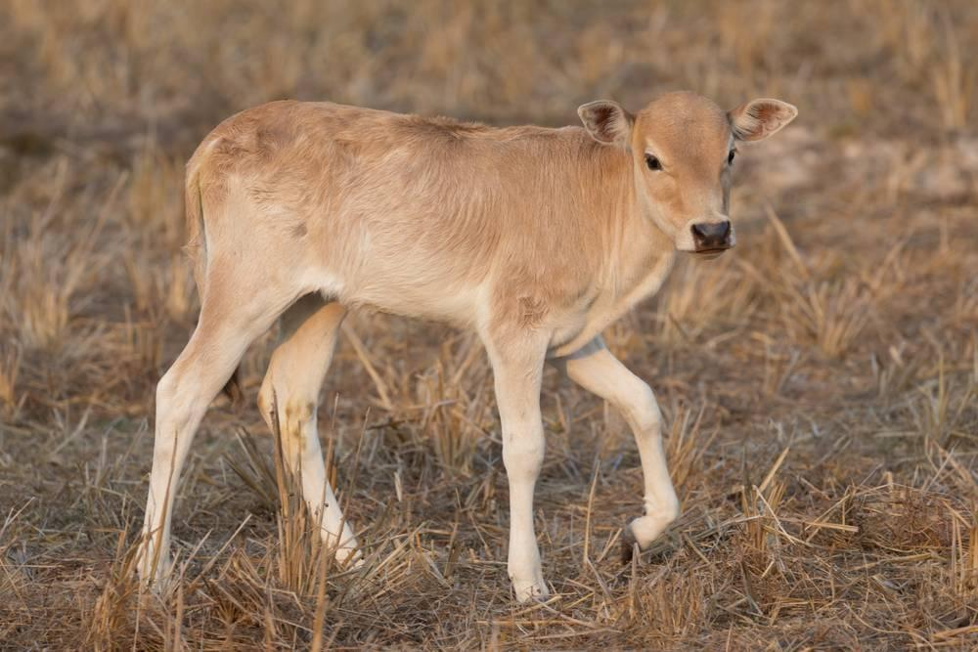
link

Bezerro cevado

Image Content

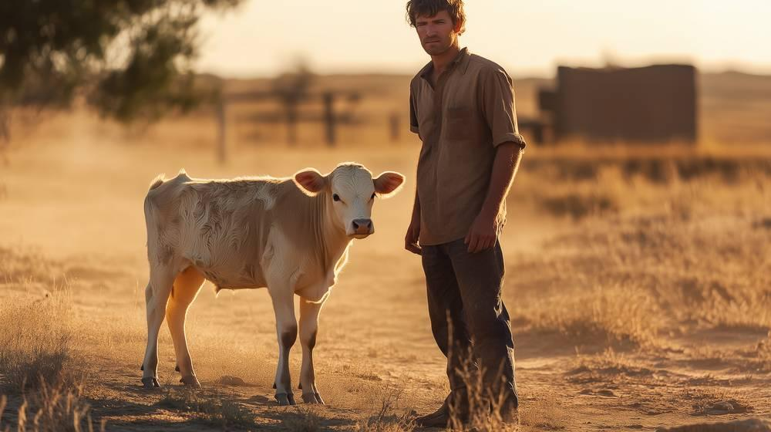
link

Bezerro de ouro

Image Content

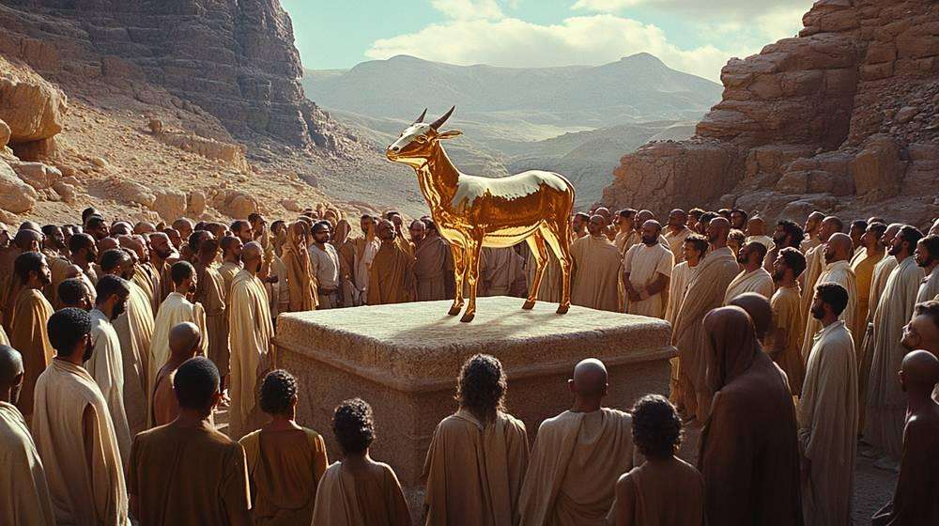
link

Bezerro de ouro

Image Content

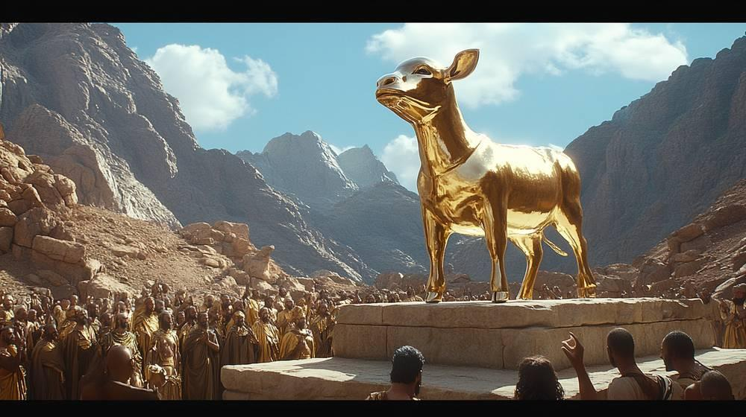
link

Boi sacrificiais

Image Content

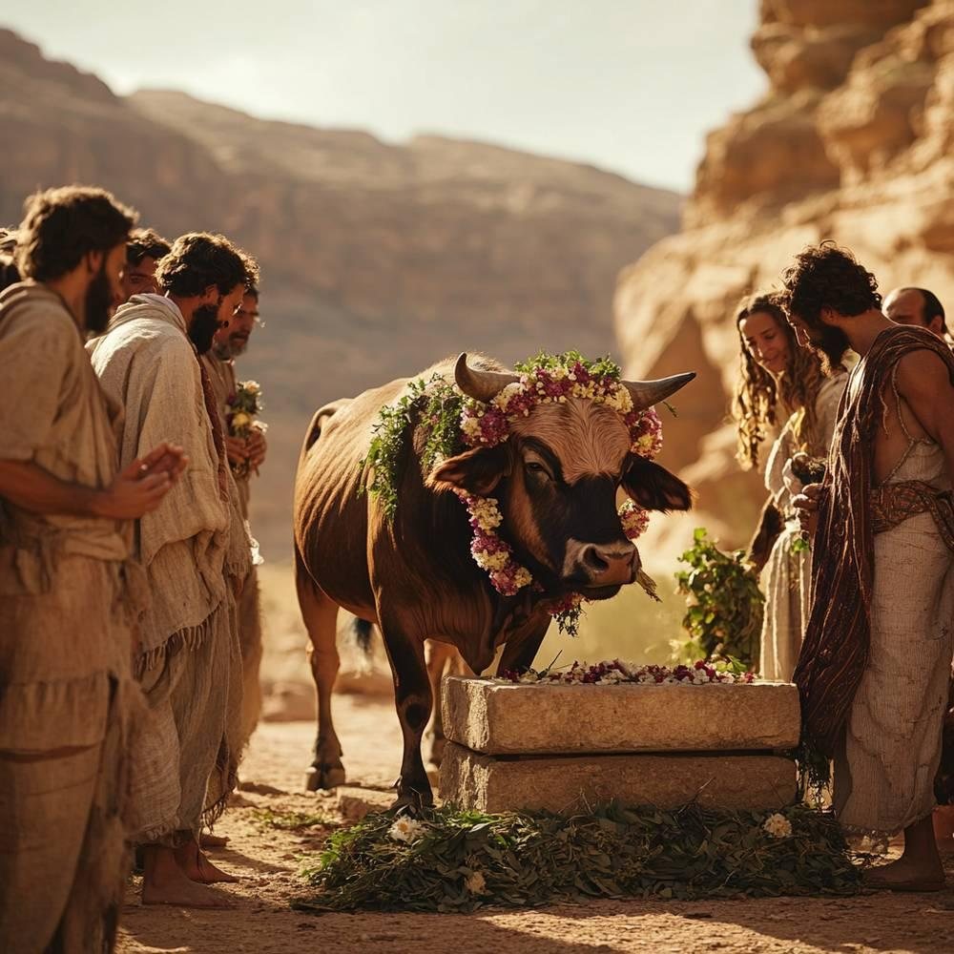
link

Boi sacrificiais

Image Content

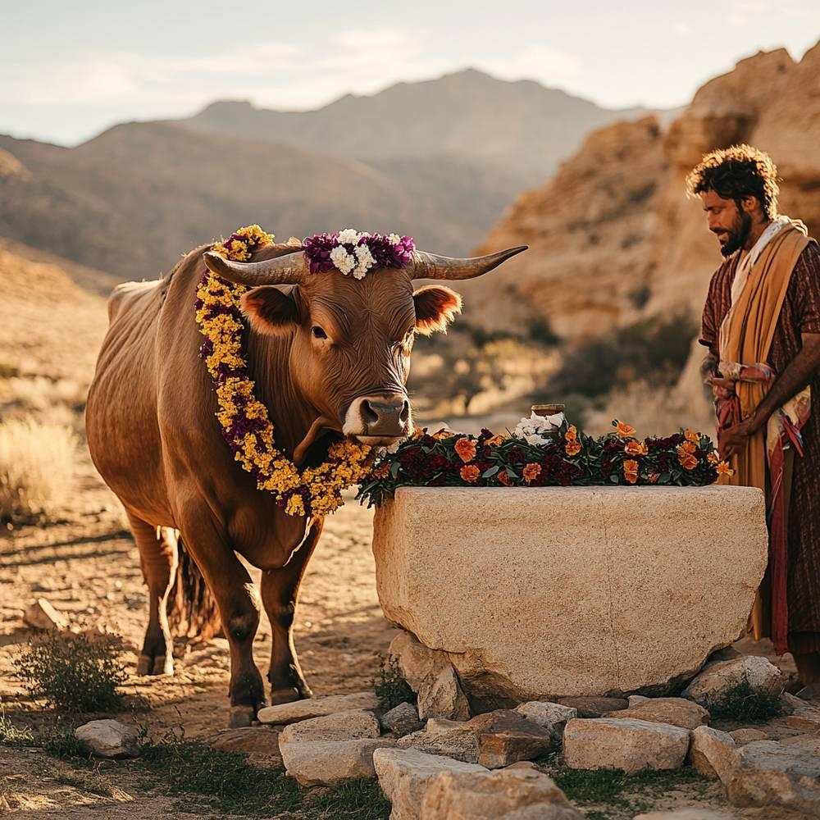
link

Bolsa

Image Content

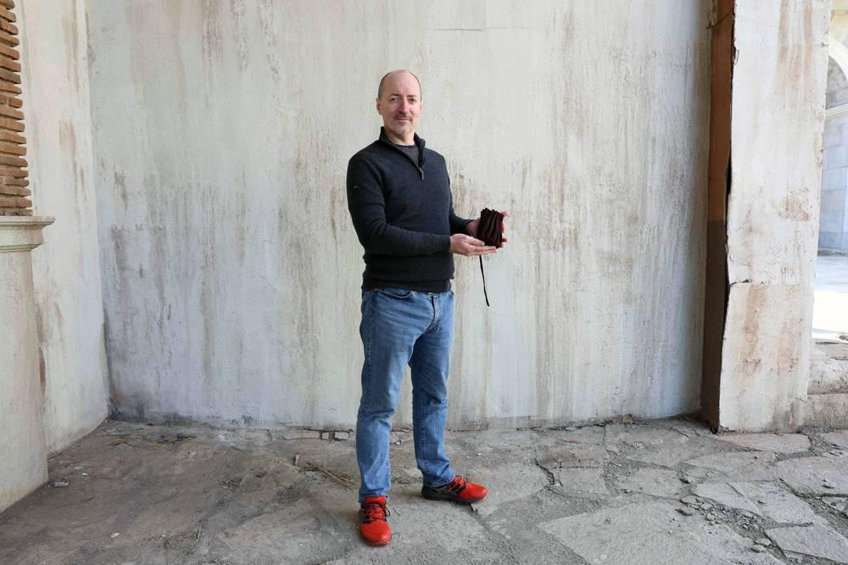
link

Bolsa

Image Content

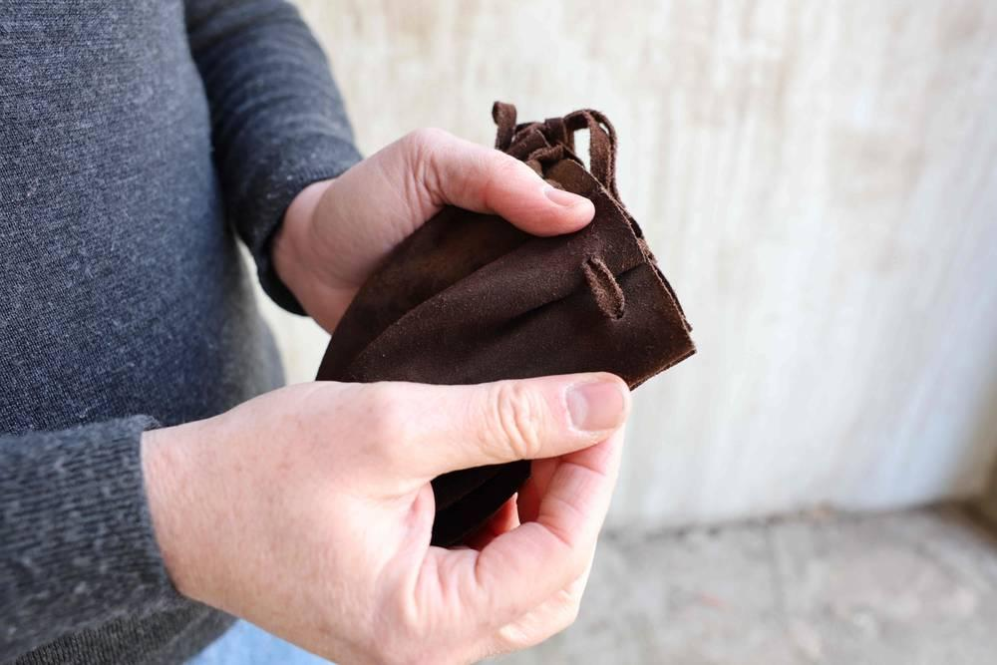
link

Bolsa

Image Content

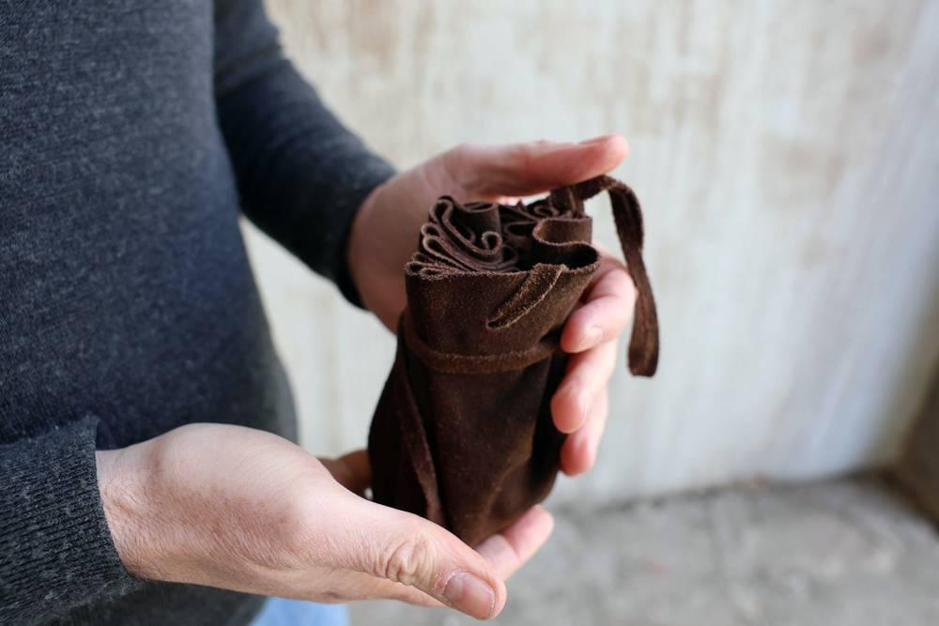
link

Bolsa

Image Content

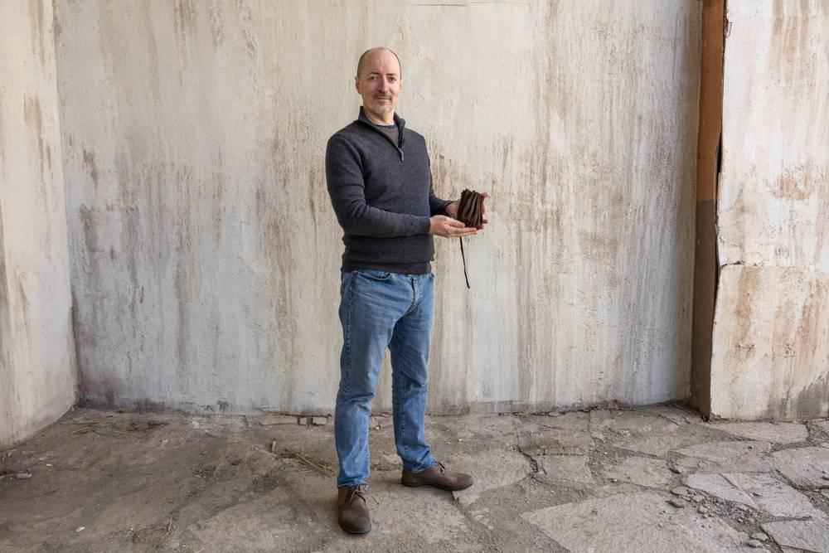
link

Bolsa

Image Content

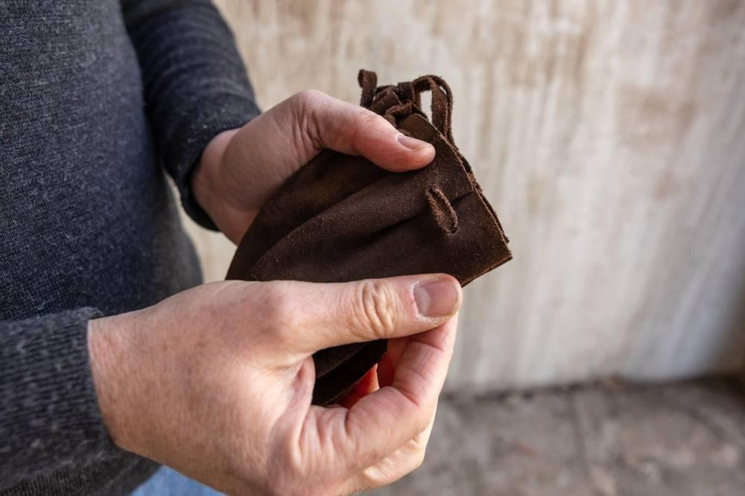
link

Bolsa

Image Content

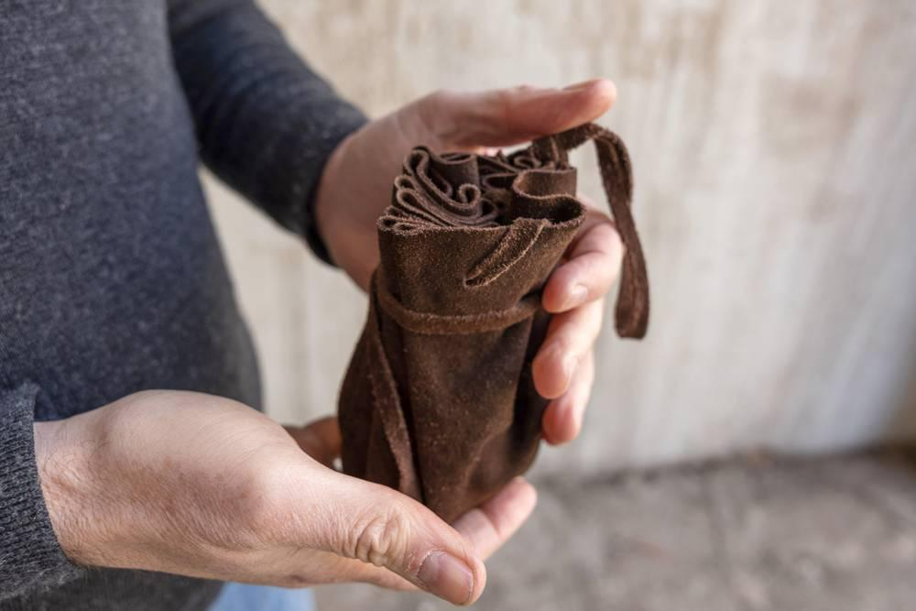
link

Bolsa de sementes do semeador

Image Content

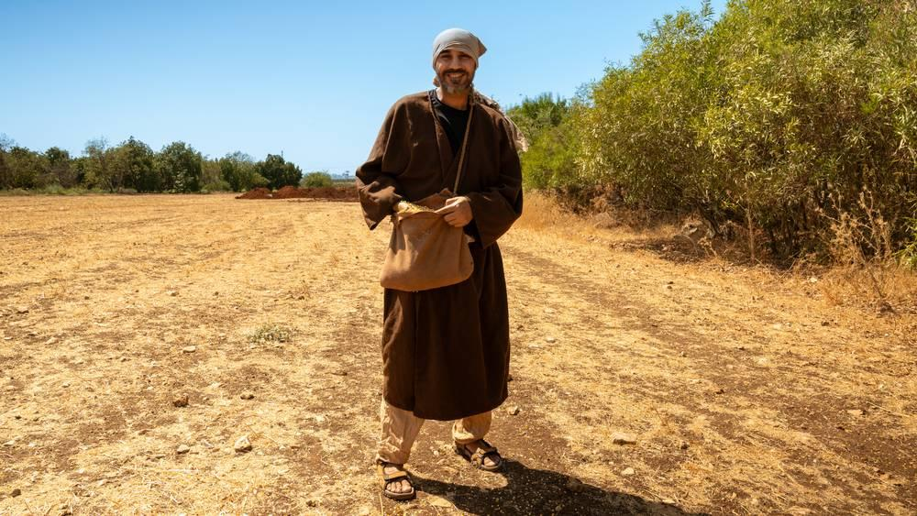
link

Bolsa de sementes do semeador

Image Content

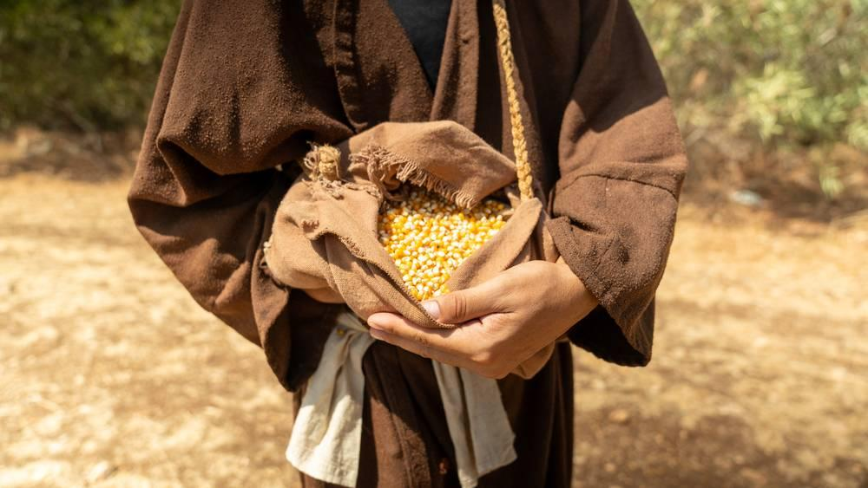
link

Bolsa de viajante

Image Content

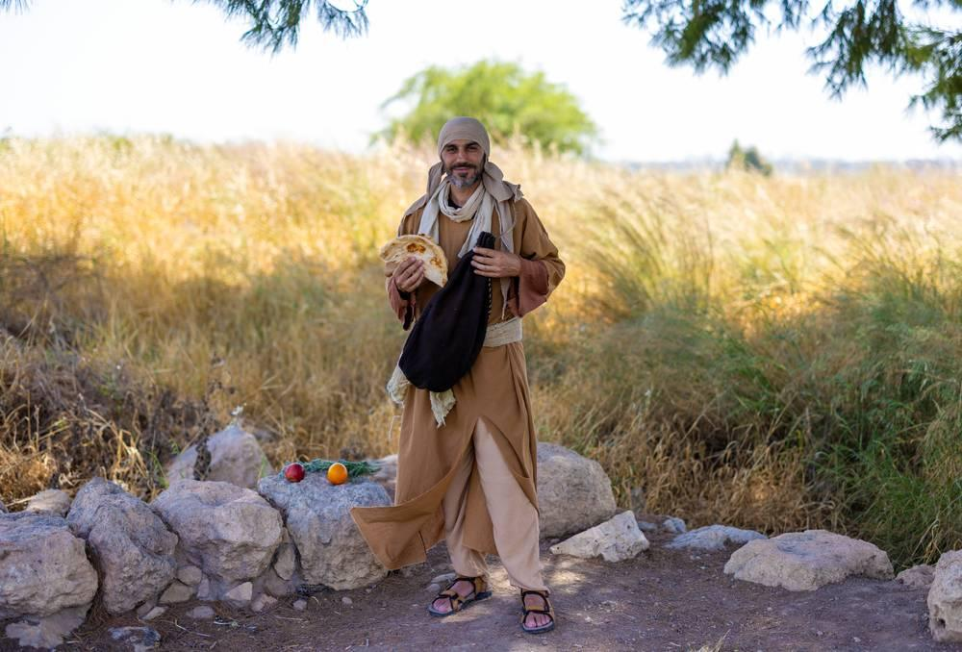
link

Bolsa de viajante

Image Content

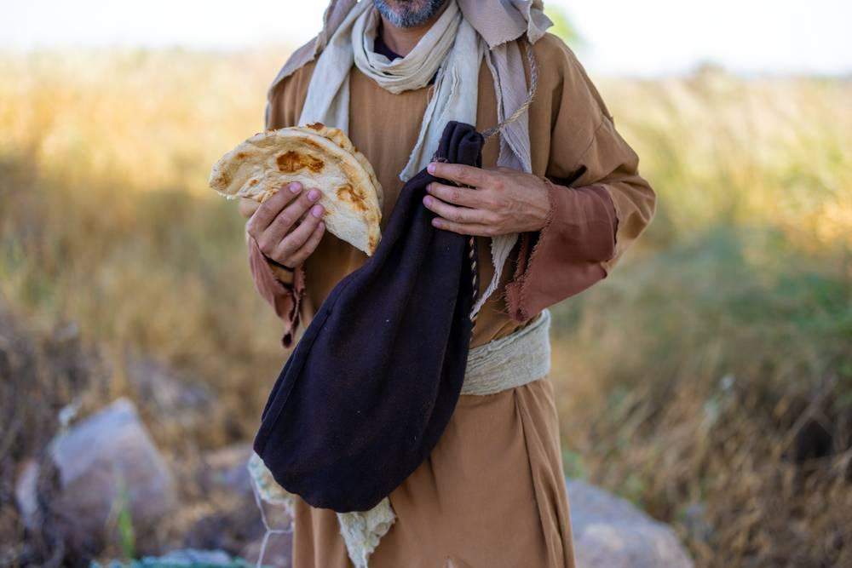
link

Borda da capa com borlas

Image Content


link

Buraco de sepultamento

Image Content

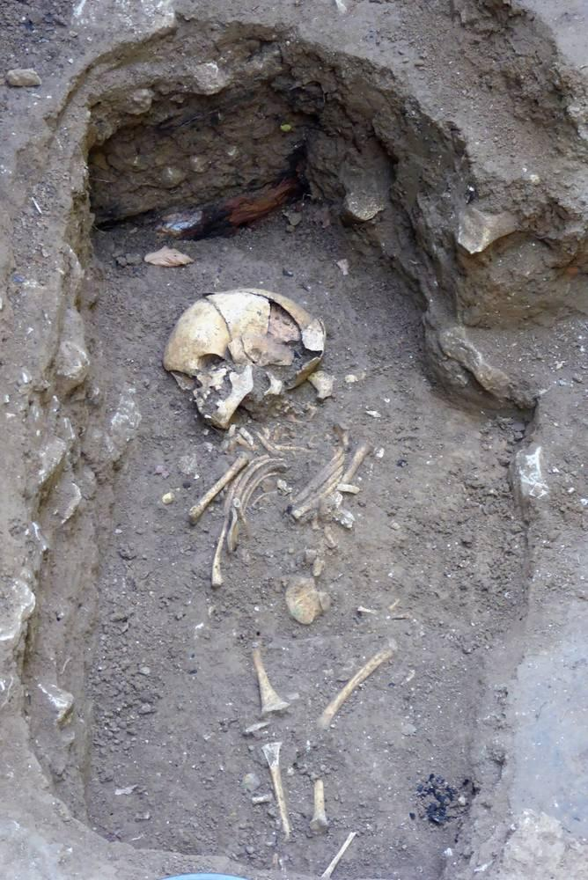
link

Burro de carga

Image Content

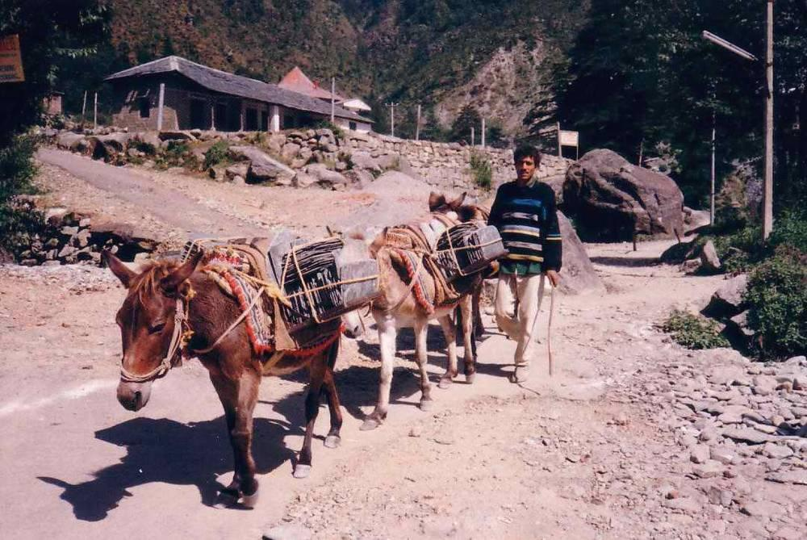
link

Burro de carga

Image Content

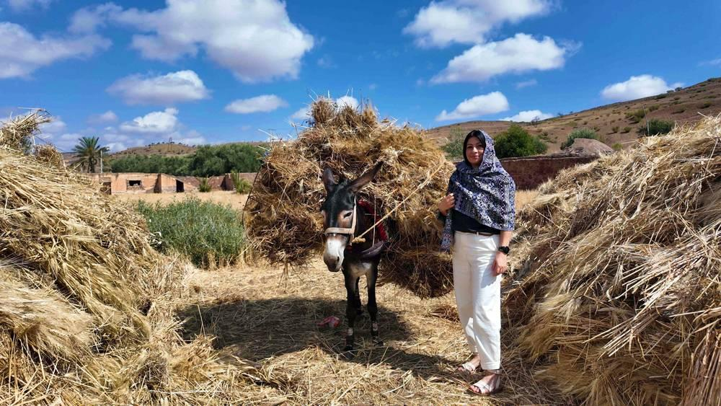
link

Burro de carga

Image Content

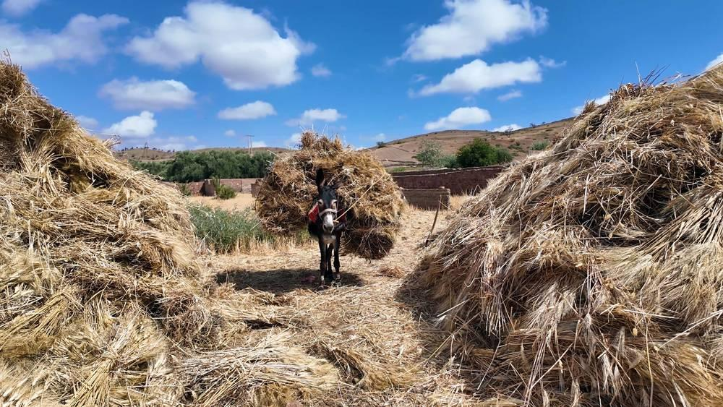
link

