Resource: Familiarization, Internalization, Articulation (Fia) Images
Familiarization, Internalization, Articulation (FIA) Images © 2023 SRV Partners Released under CC BY-SA 4.0 license. Familiarization, Internalization, Articulation (FIA) Images has been adapted in the following languages Tok Pisin, عربي, Français, हिंदी, Bahasa Indonesia, Português, Русский, Español, Kiswahili, 简体中文 from Familiarization, Internalization, Articulation (FIA) © 2023 SRV Partners. Released under CC BY-SA 4.0 license by Mission Mutual

Familiarization, Internalization, Articulation (Fia) Images

E

Endro

Image Content

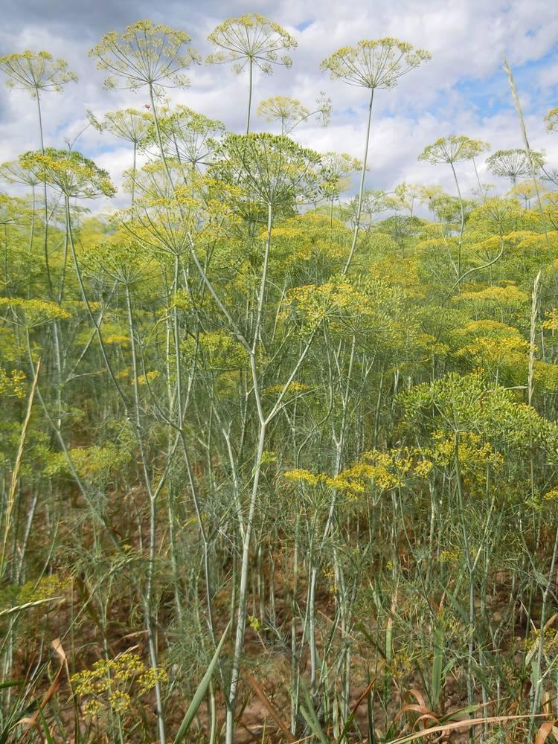
link

Endro

Image Content

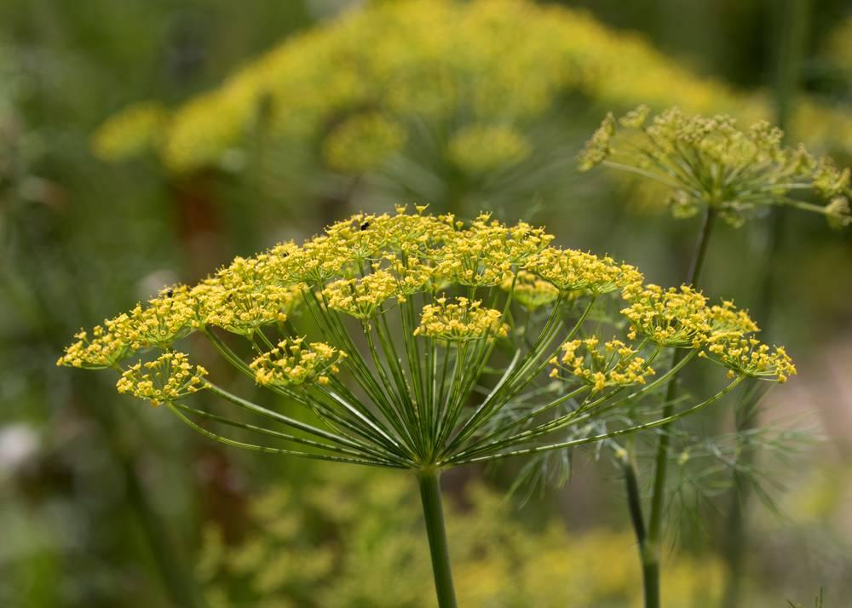
link

Endro

Image Content

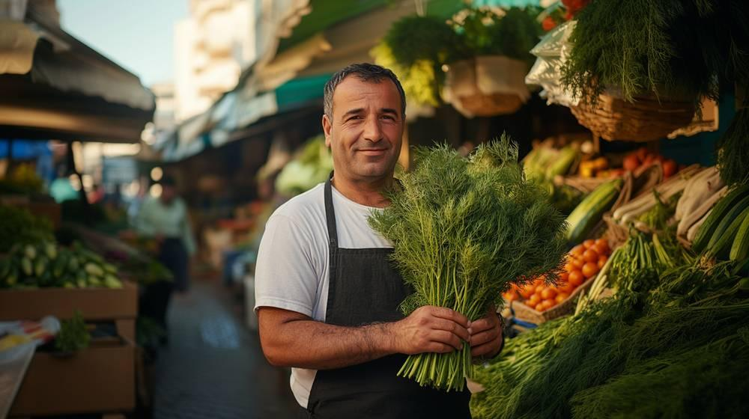
link

Entrada de uma casa judaica

Image Content

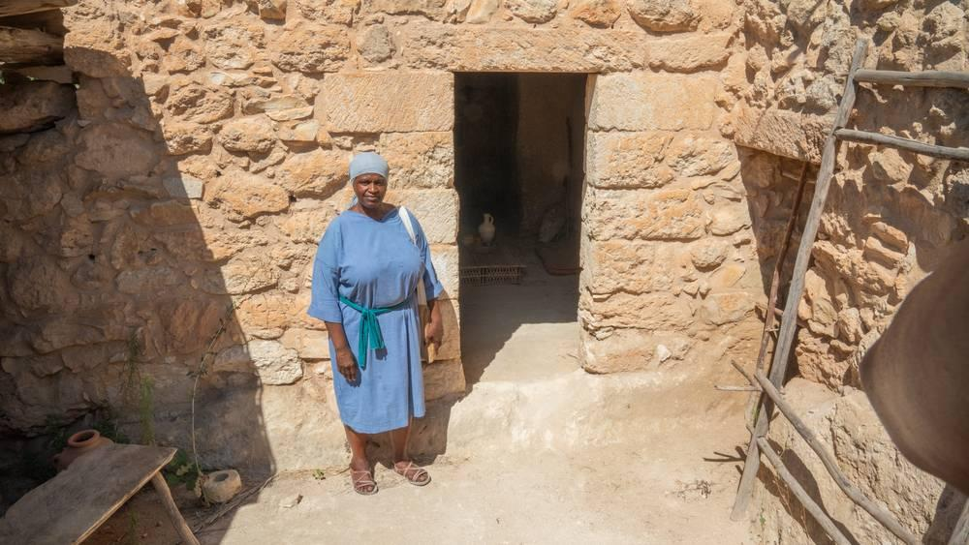
link

Ermo ou deserto

Image Content

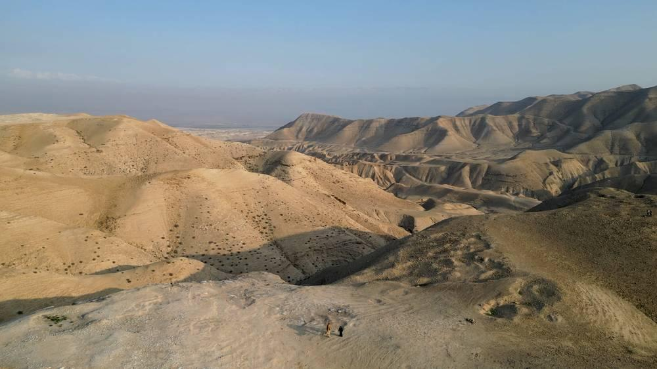
link

Ervas amargas

Image Content

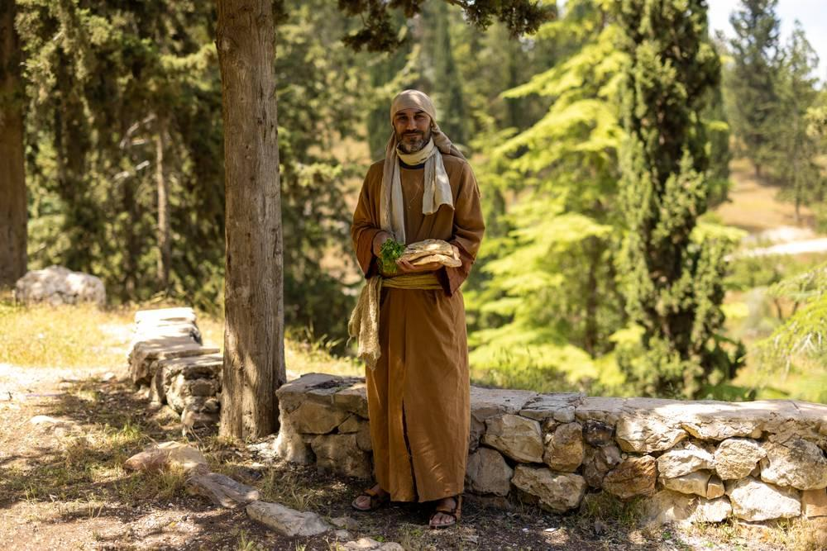
link

Ervas amargas

Image Content

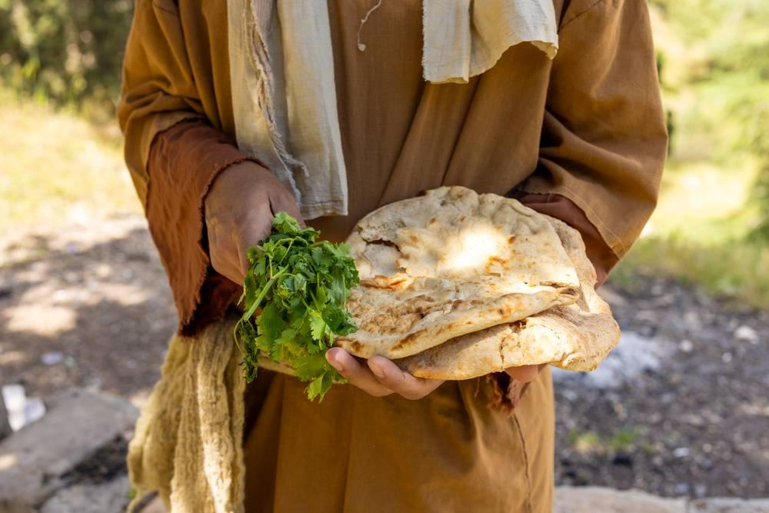
link

Escabelo

Image Content

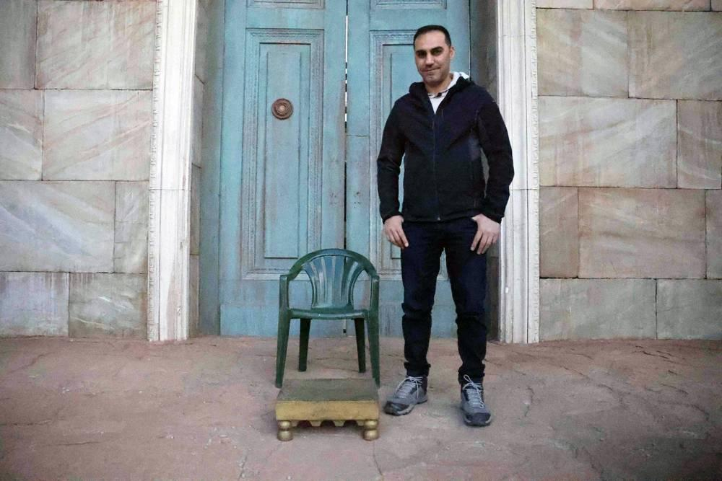
link

Escabelo

Image Content

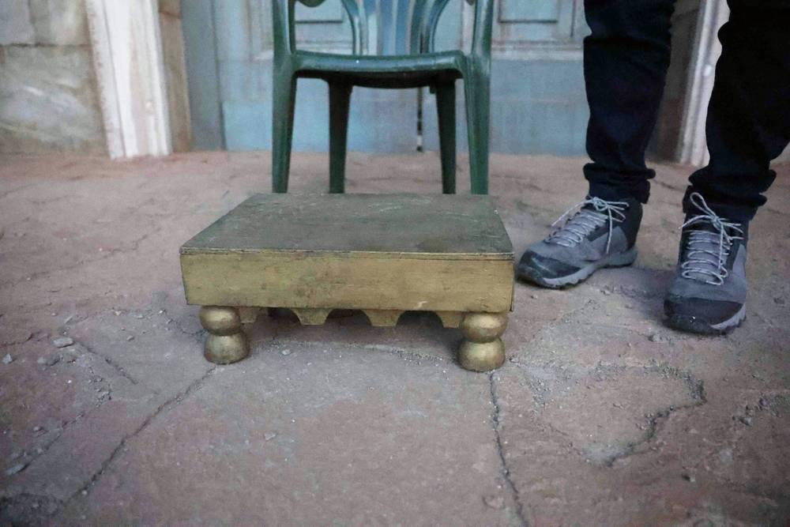
link

Escabelo

Image Content

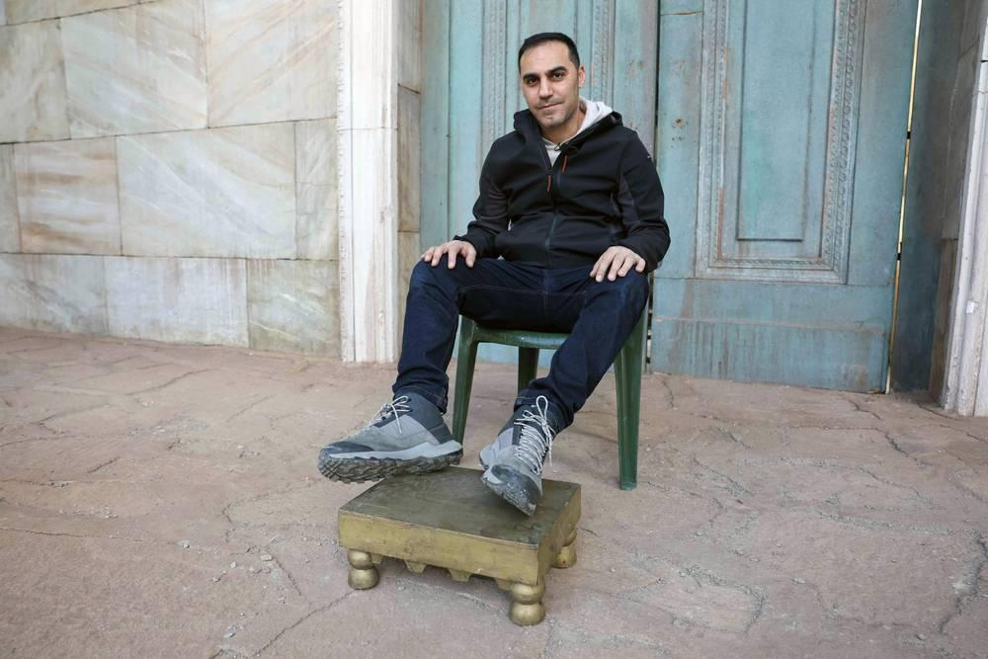
link

Escamas de peixe

Image Content

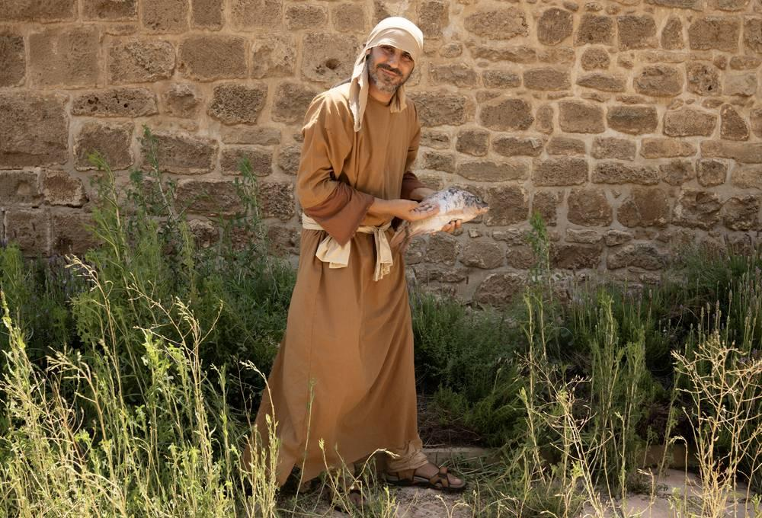
link

Escamas de peixe

Image Content

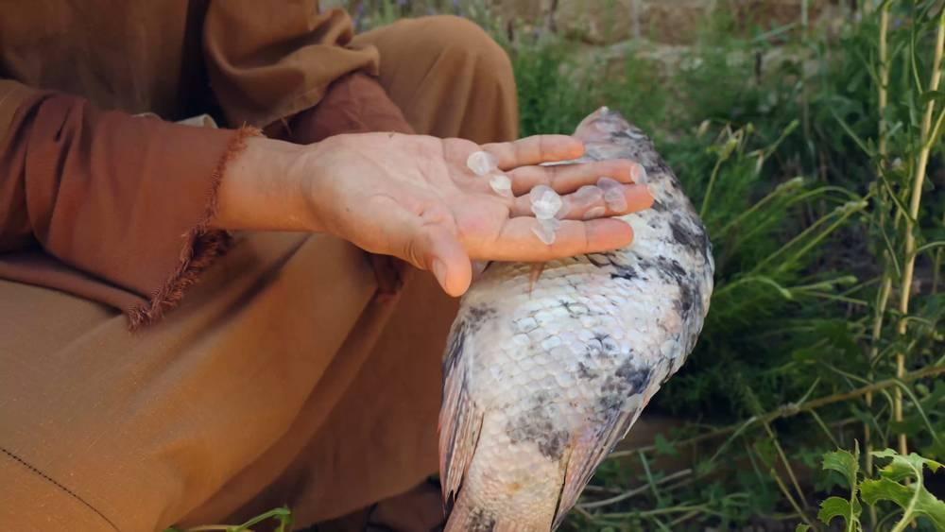
link

Escorpião

Image Content

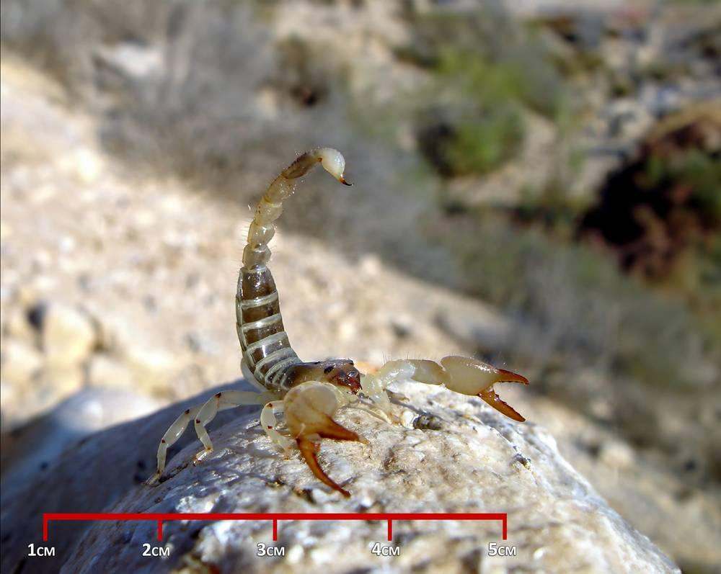
link

Escorpião

Image Content

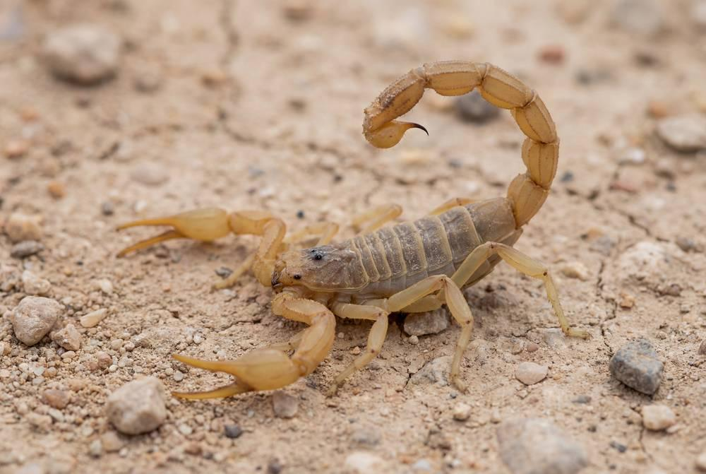
link

Escorpião

Image Content

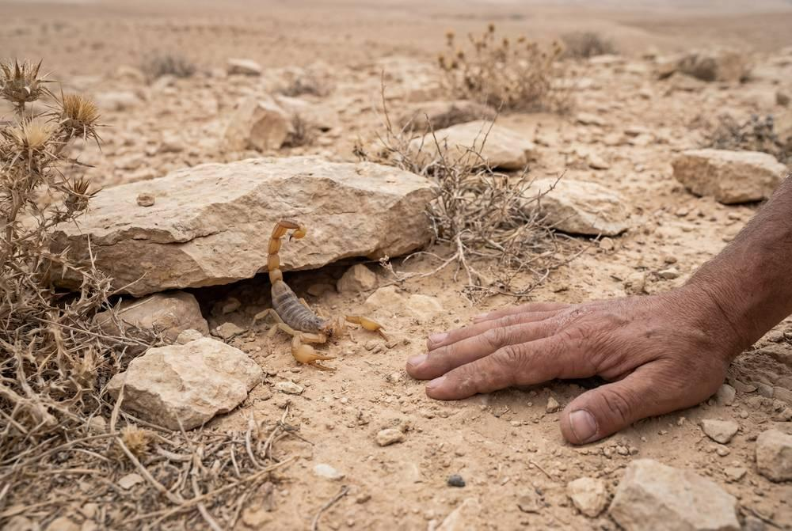
link

Escorpião

Image Content

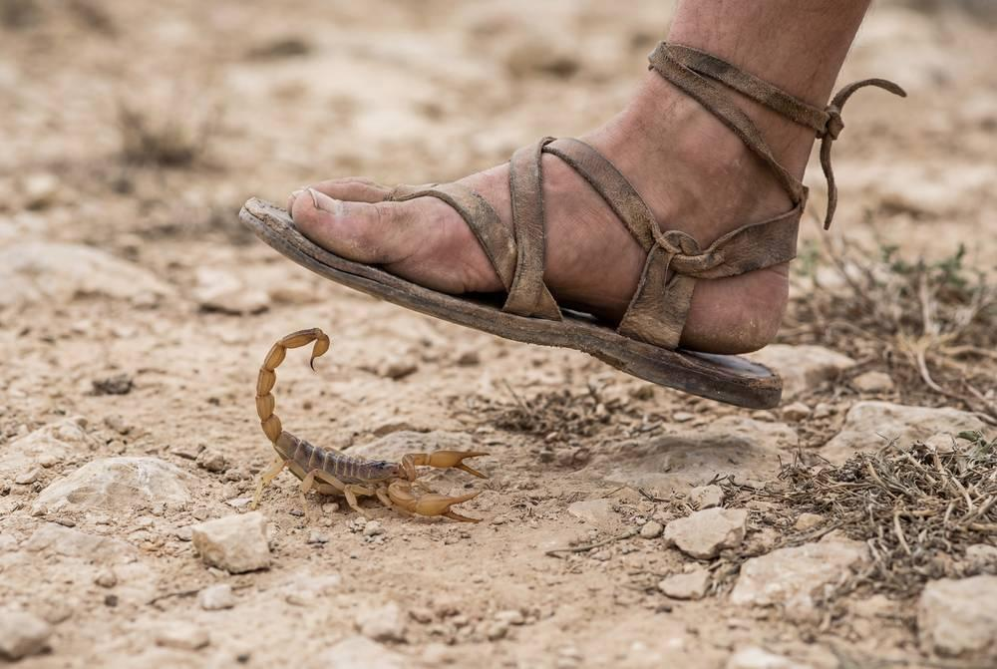
link

Espada

Image Content

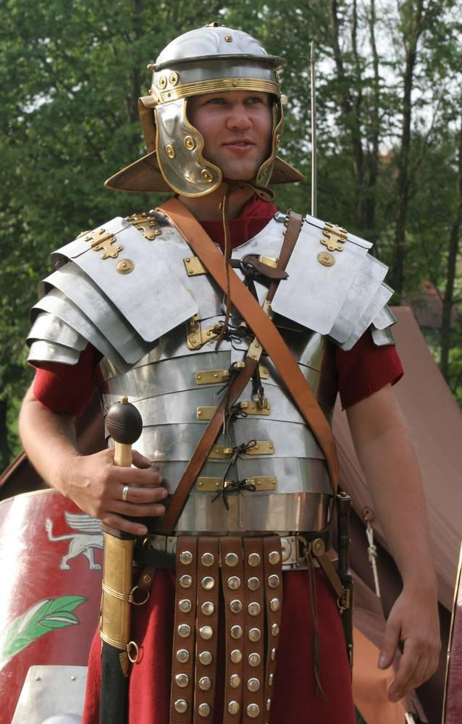
link

Espada

Image Content

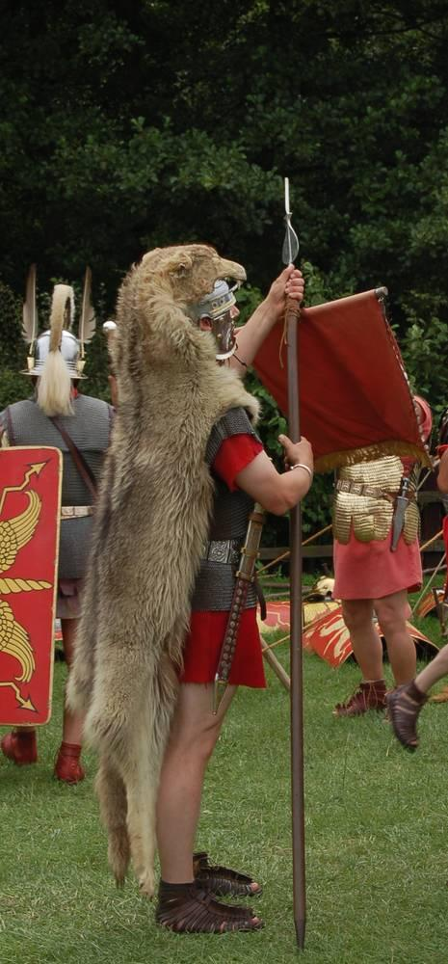
link

Especiarias

Image Content

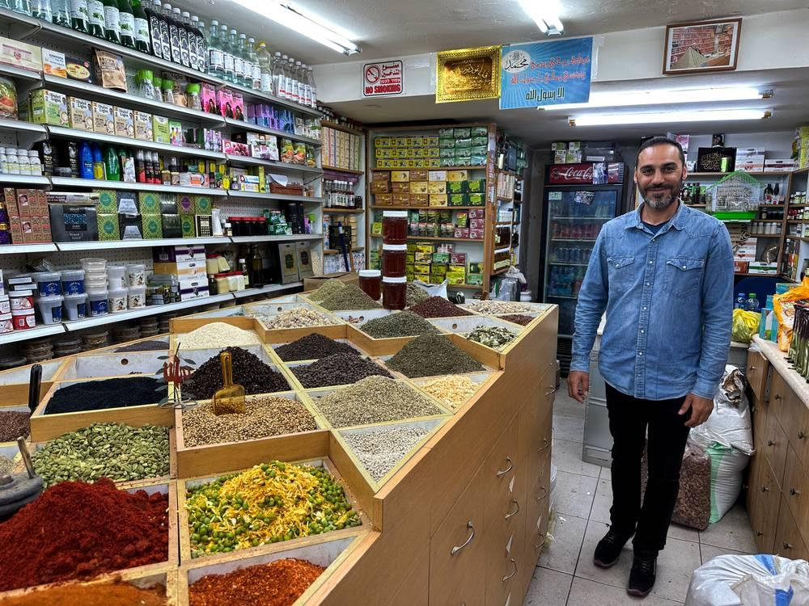
link

Especiarias

Image Content

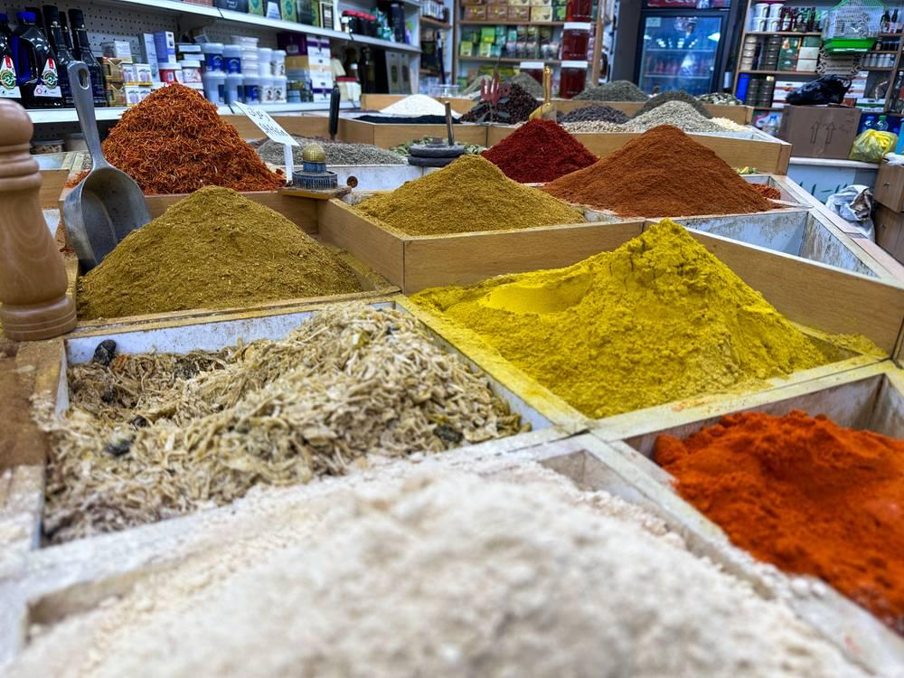
link

Especiarias

Image Content

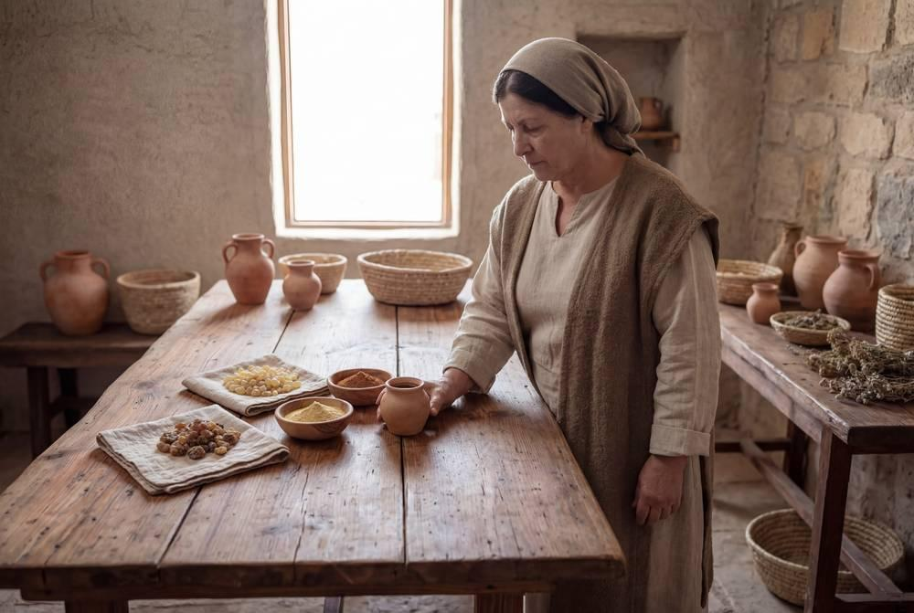
link

Especiarias

Image Content

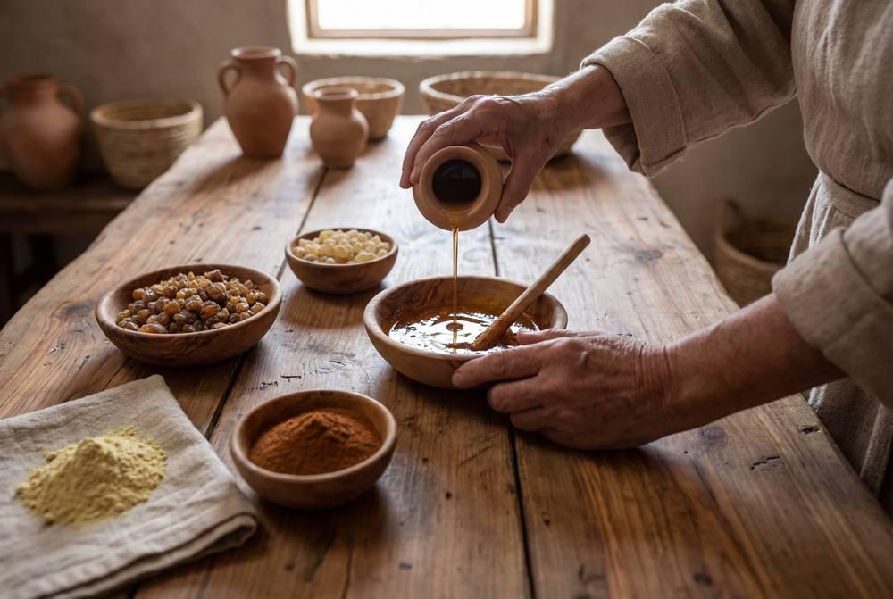
link

Especiarias

Image Content

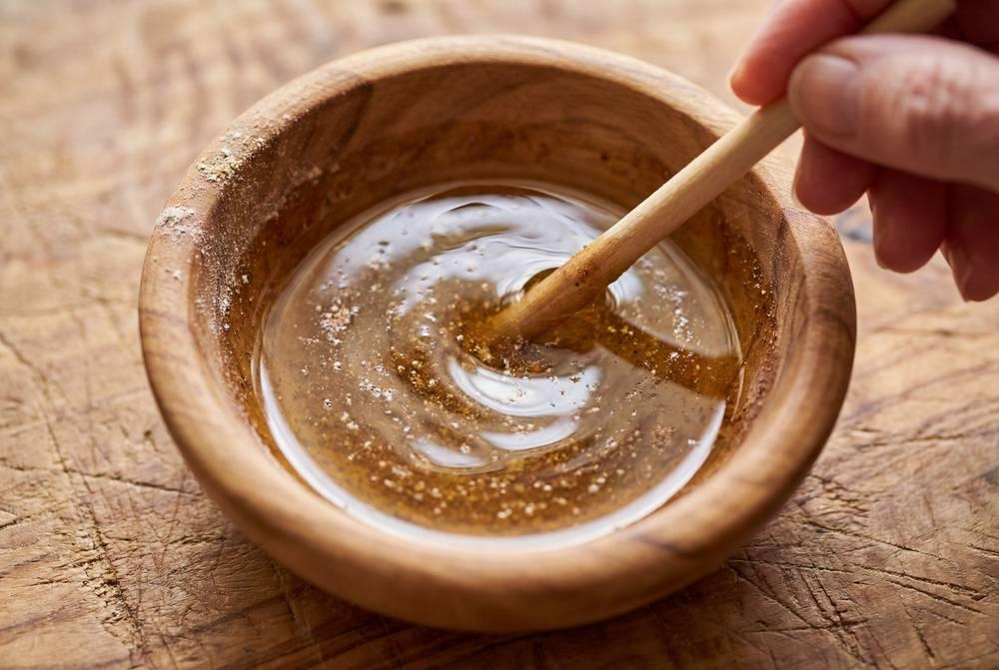
link

Esponja com vinho em uma vara

Image Content

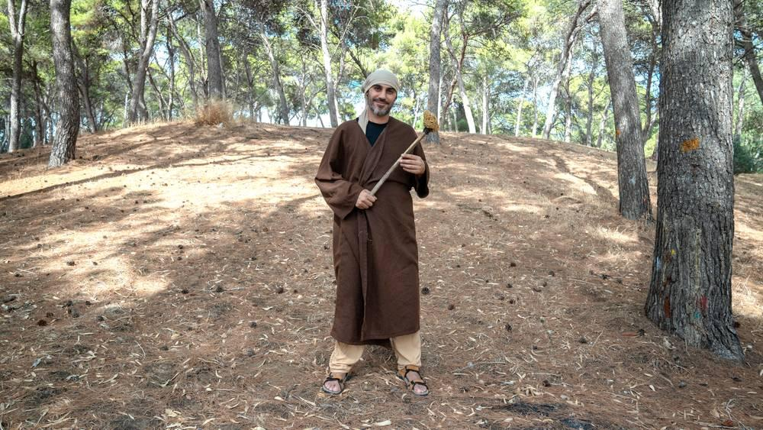
link

Esponja com vinho em uma vara

Image Content

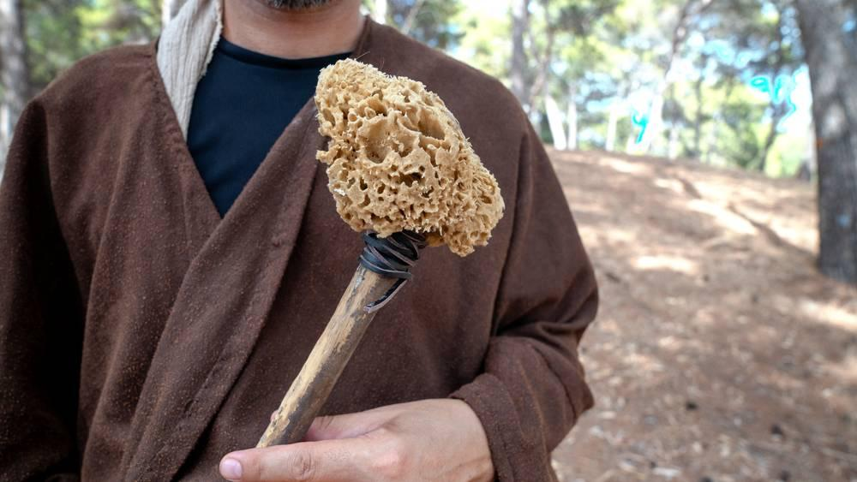
link

Esquife

Image Content

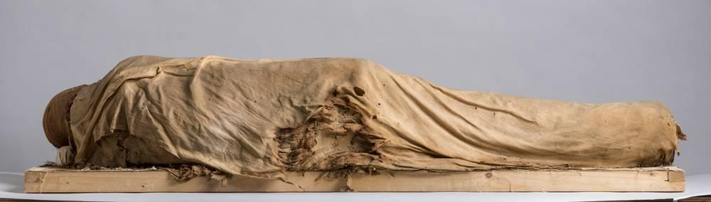
link

Estágios do crescimento do trigo

Image Content

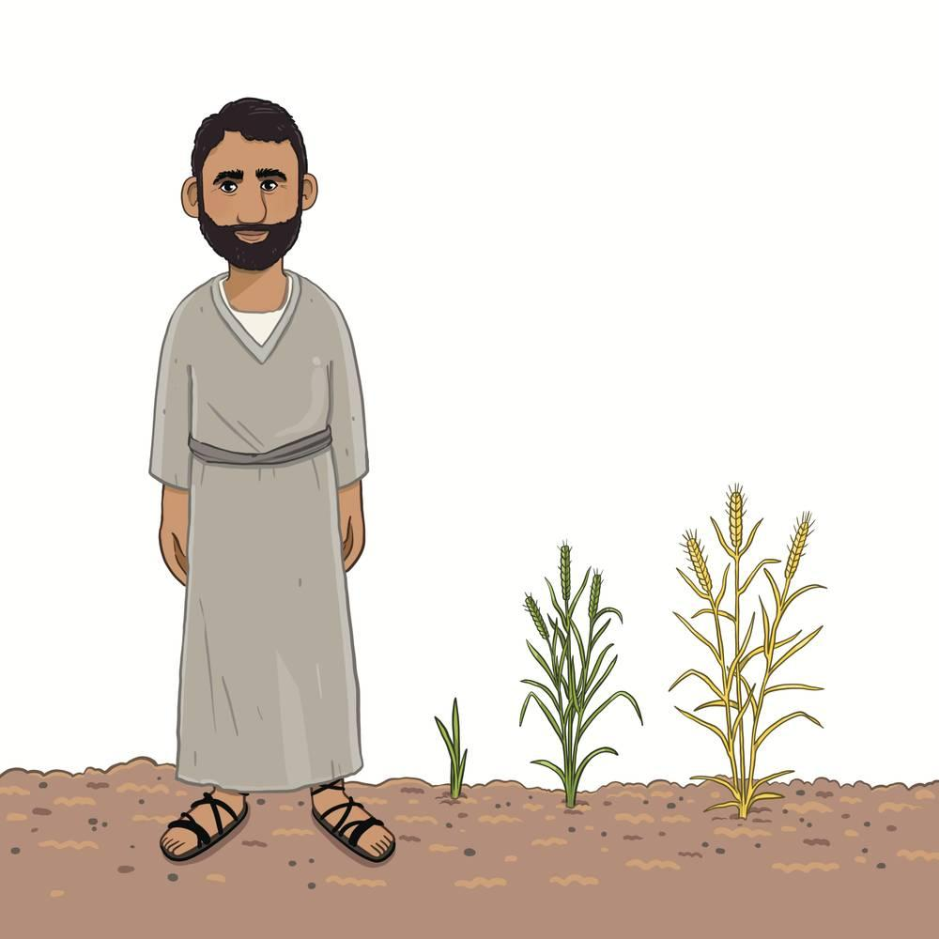
link

Esteira de dormir

Image Content

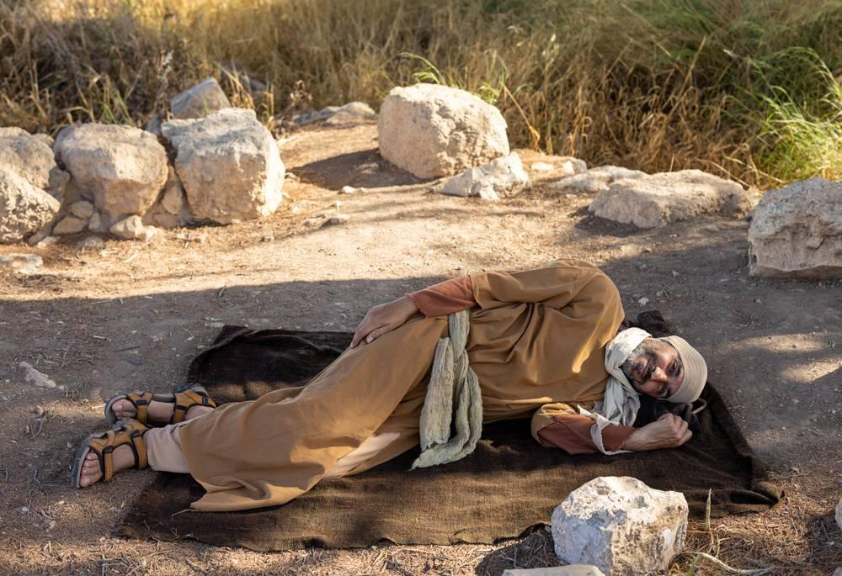
link

Esteira de dormir

Image Content

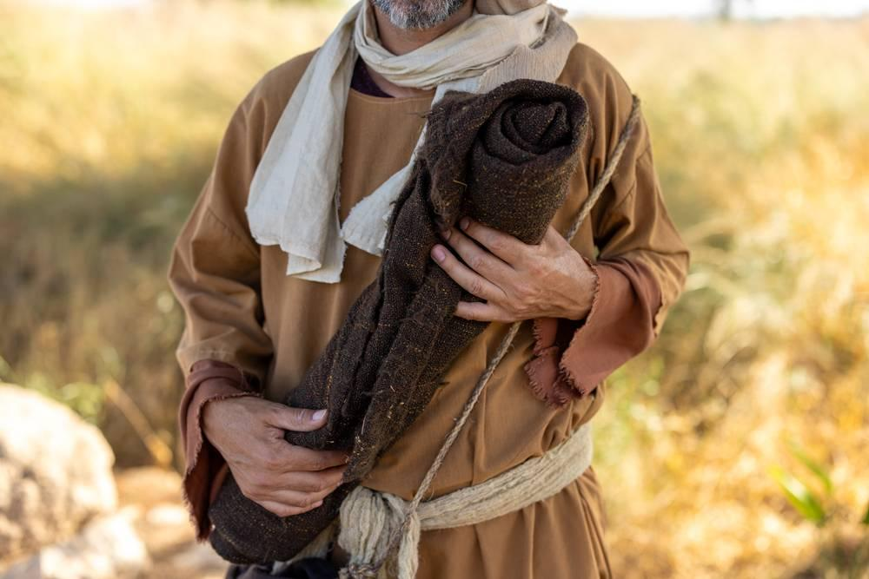
link

Estrada de Jericó

Image Content

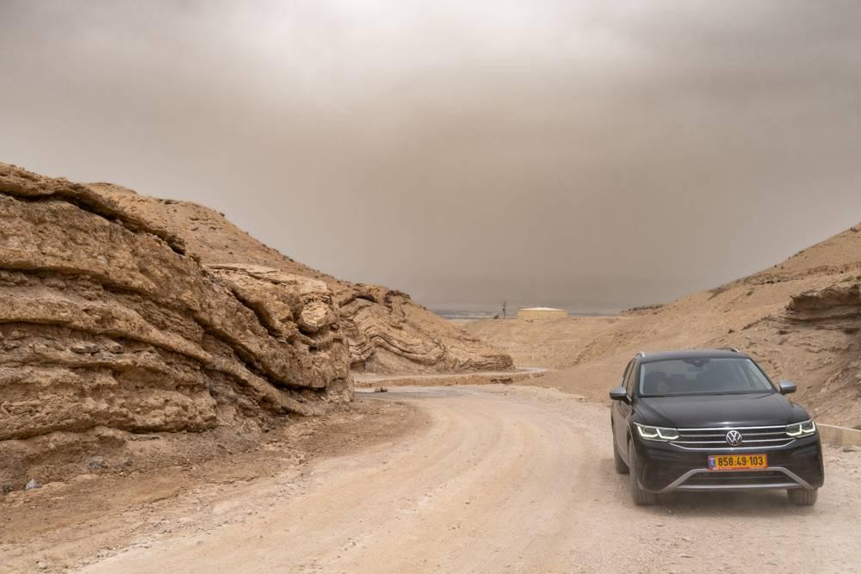
link

Estrutura de cama de madeira

Image Content

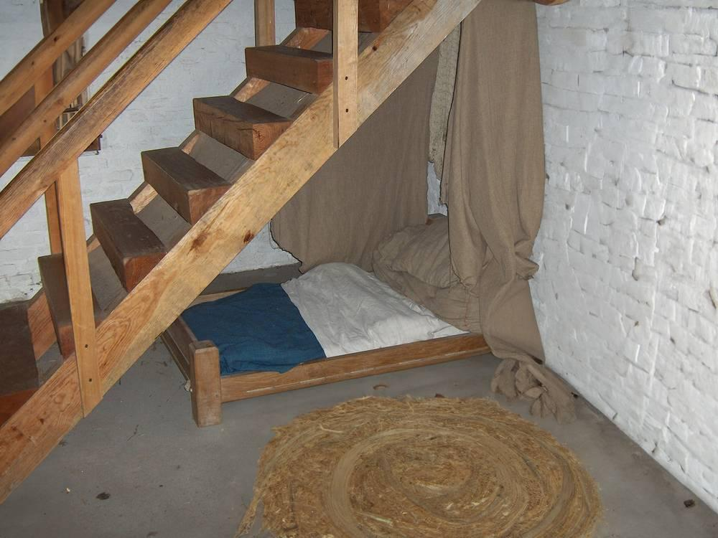
link

Exército romano

Image Content

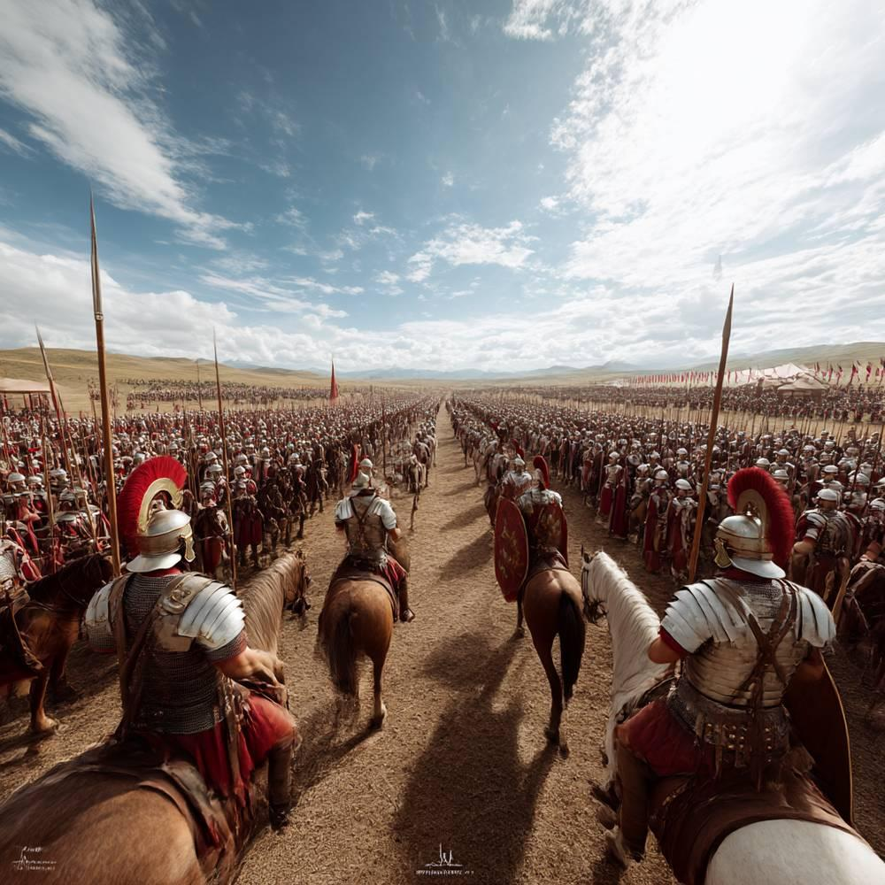
link

Exército romano

Image Content

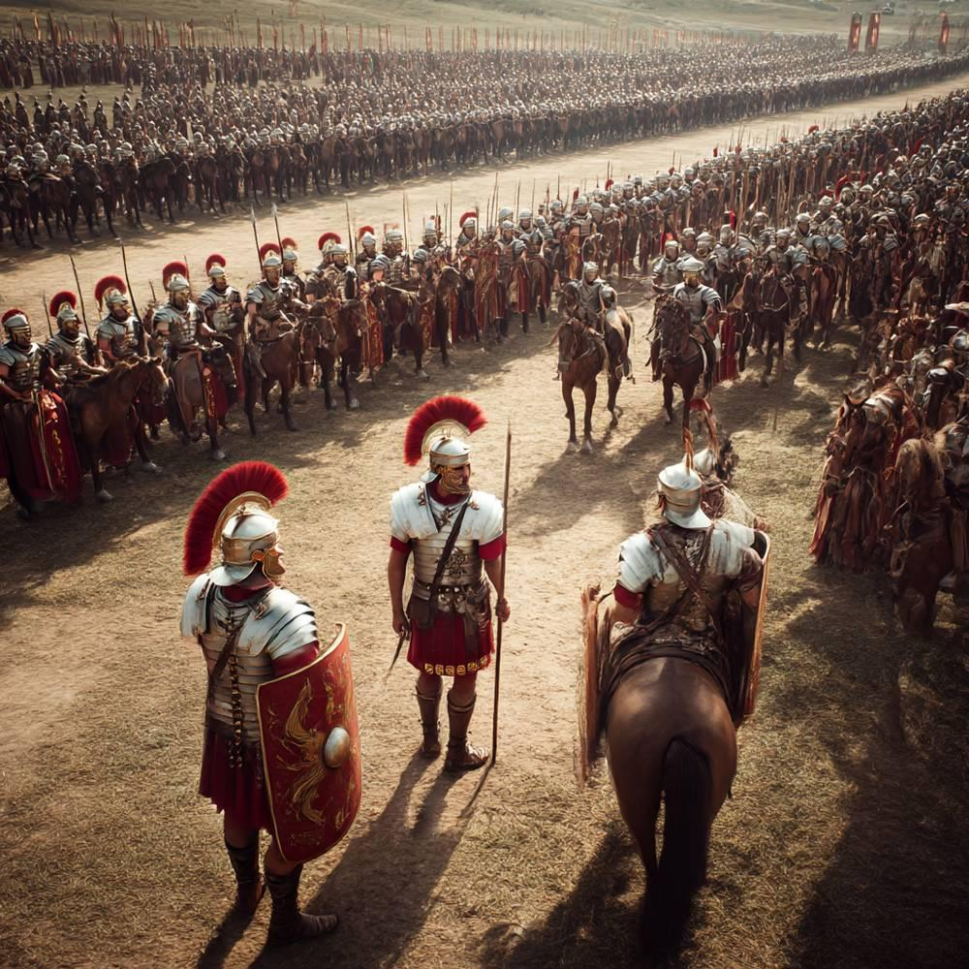
link

Exército romano

Image Content

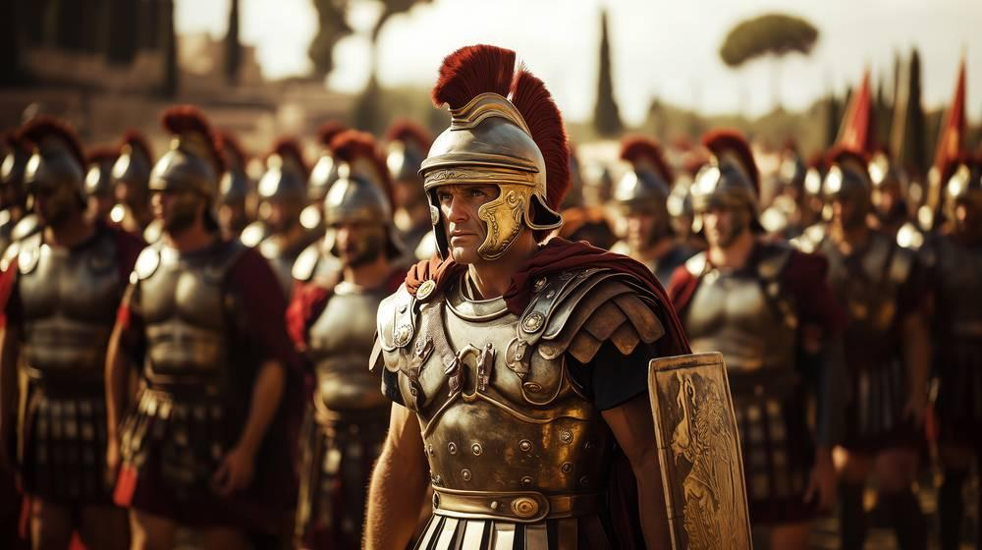
link

Exército romano

Image Content

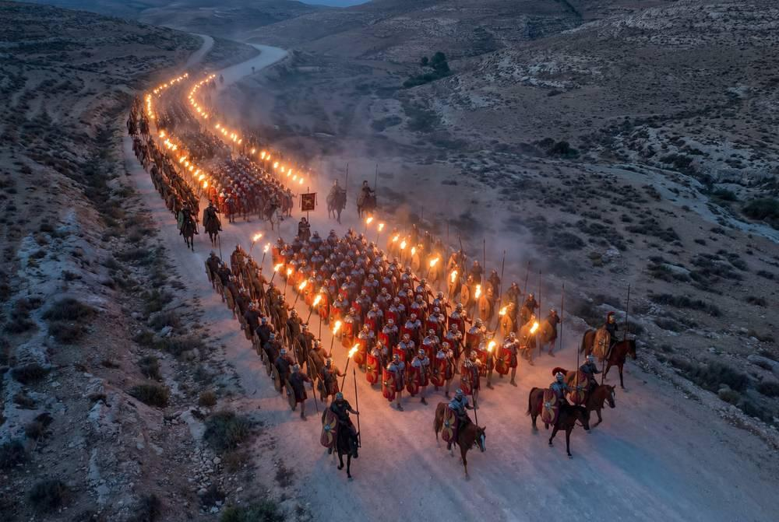
link

Exército romano

Image Content

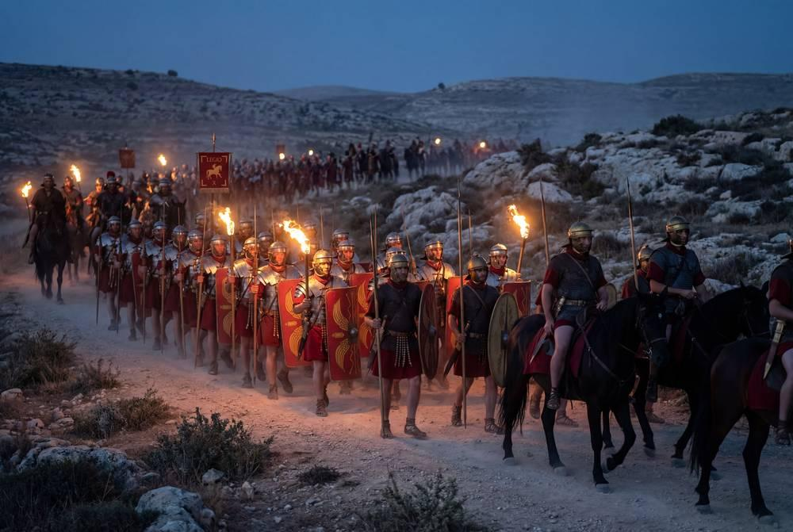
link

Exército romano

Image Content


link

Exterior do Templo de Herodes

Image Content

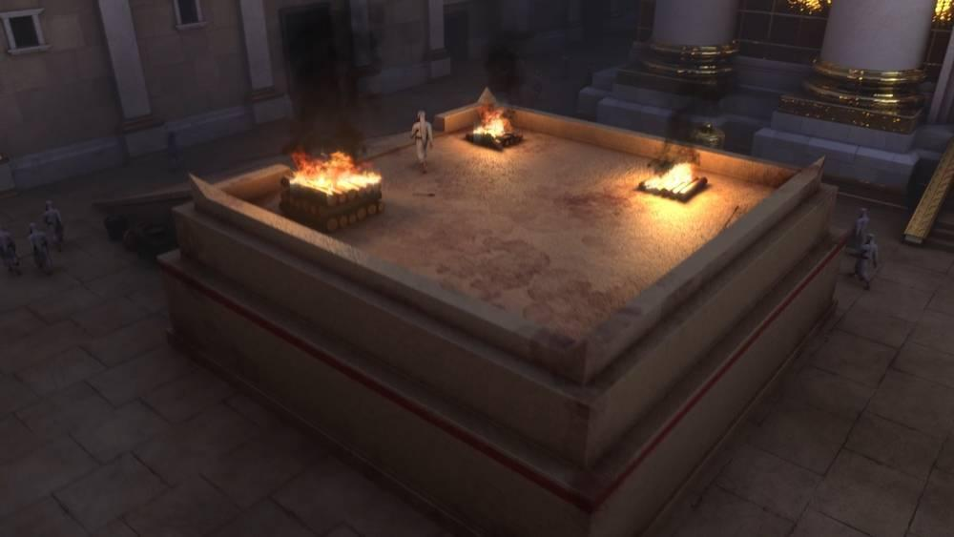
link

