Resource: Familiarization, Internalization, Articulation (Fia) Images
Familiarization, Internalization, Articulation (FIA) Images © 2023 SRV Partners Released under CC BY-SA 4.0 license. Familiarization, Internalization, Articulation (FIA) Images has been adapted in the following languages Tok Pisin, عربي, Français, हिंदी, Bahasa Indonesia, Português, Русский, Español, Kiswahili, 简体中文 from Familiarization, Internalization, Articulation (FIA) © 2023 SRV Partners. Released under CC BY-SA 4.0 license by Mission Mutual

Familiarization, Internalization, Articulation (Fia) Images

F

Fermento natural

Image Content

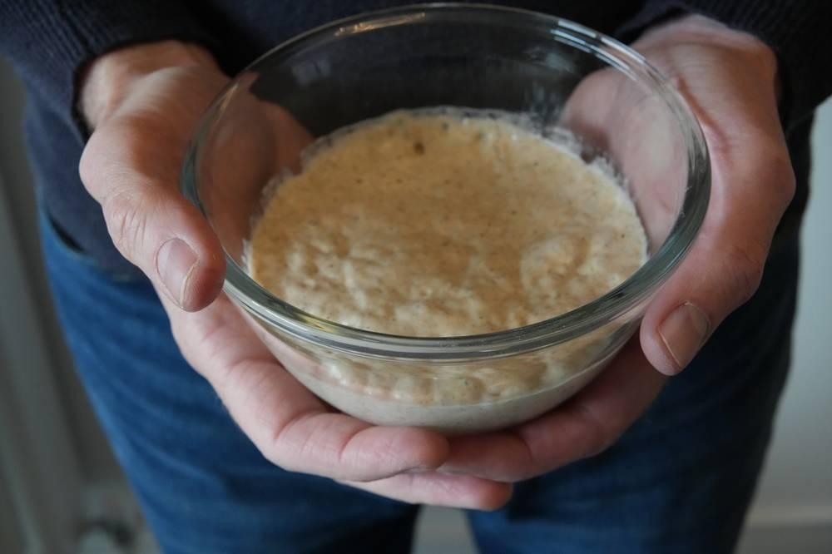
link

Fermento natural

Image Content

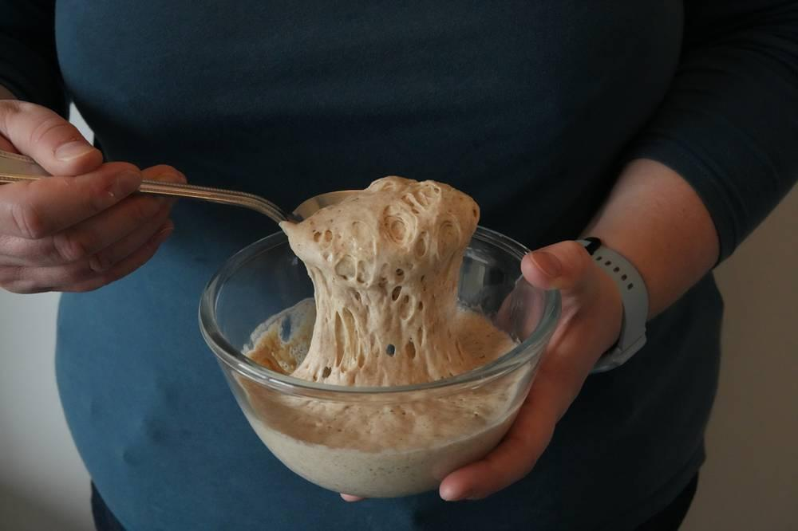
link

Figueira

Image Content

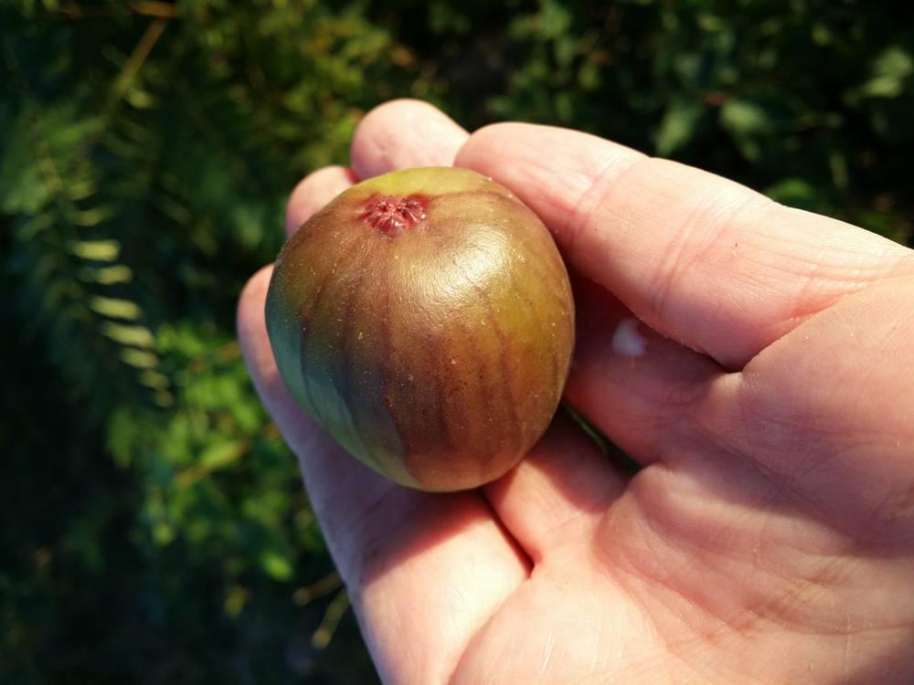
link

Figueira com folhas

Image Content

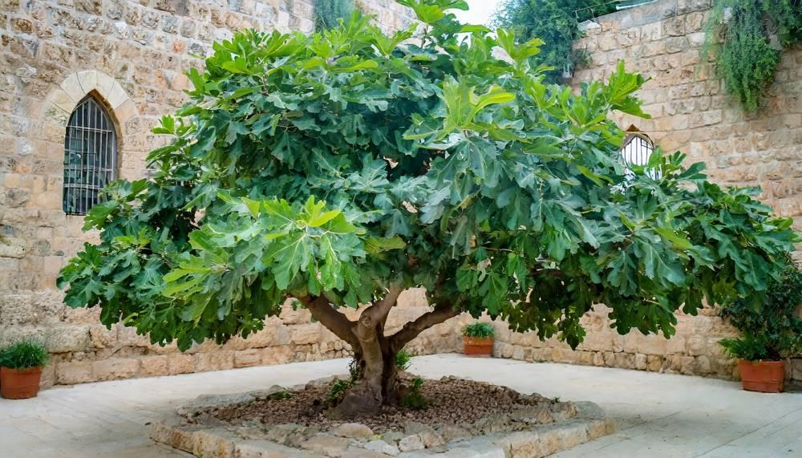
link

Figura de proa de um navio

Image Content

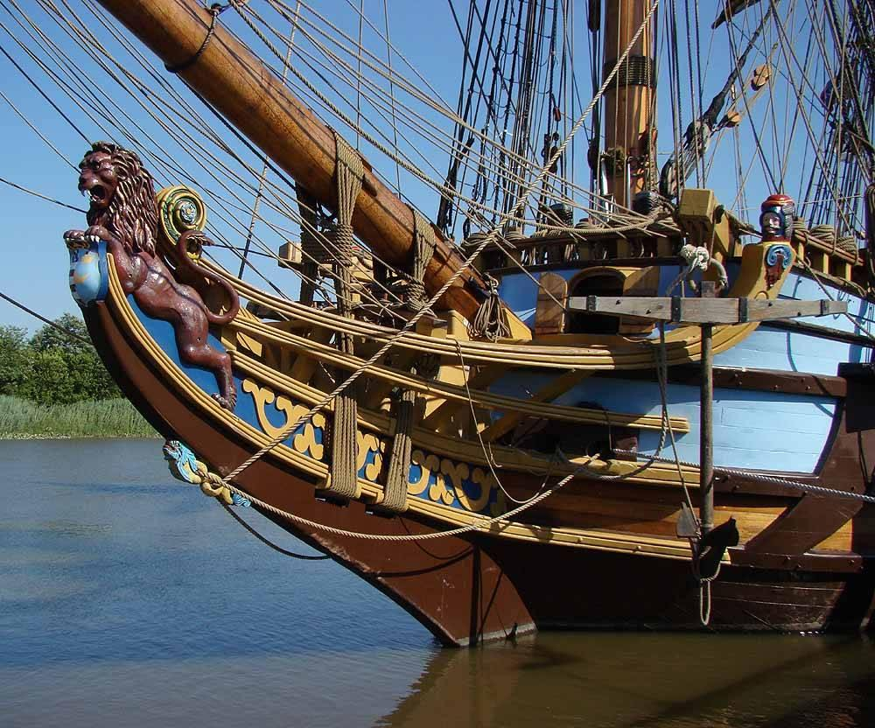
link

Figura de proa de um navio

Image Content

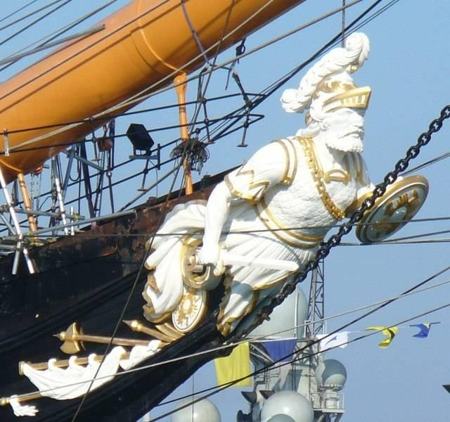
link

Flauta

Image Content

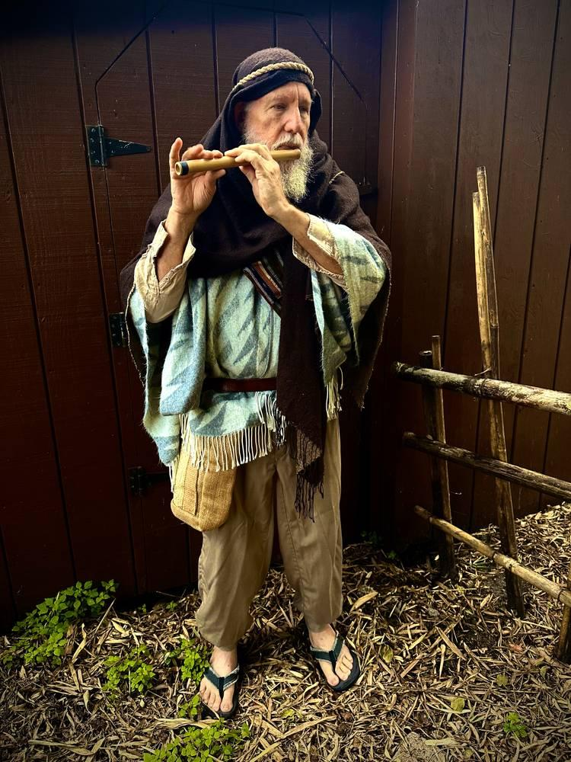
link

Flauta

Image Content

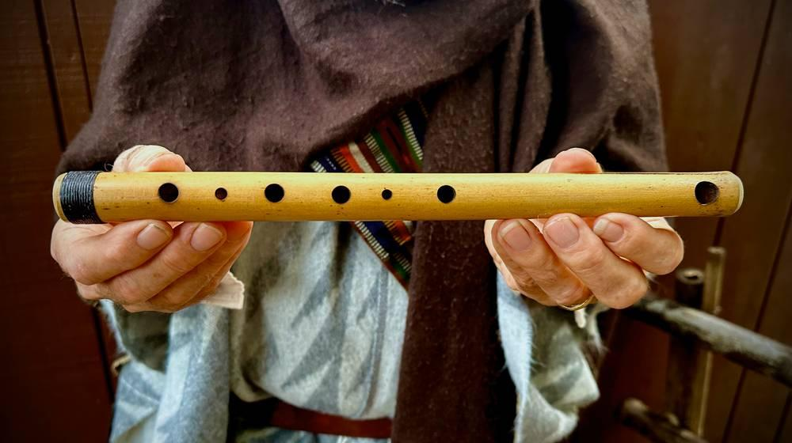
link

Flauta

Image Content

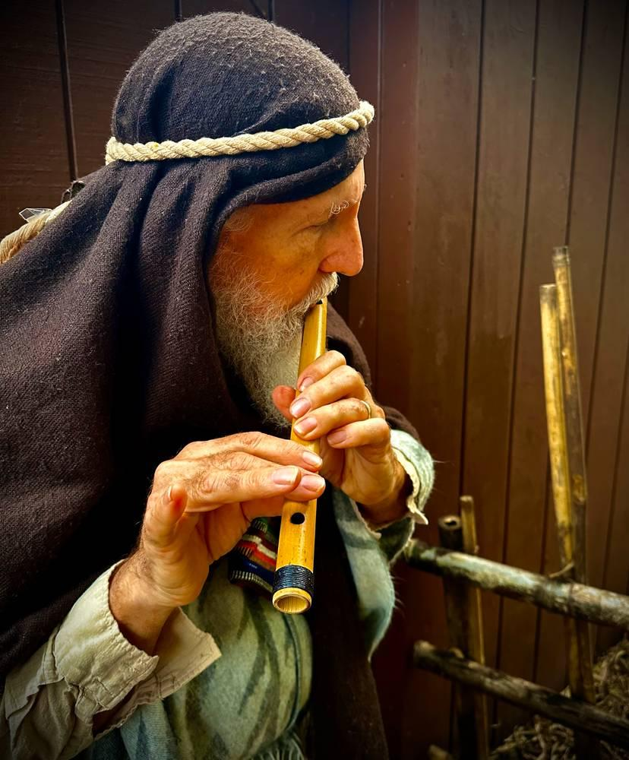
link

Foice

Image Content

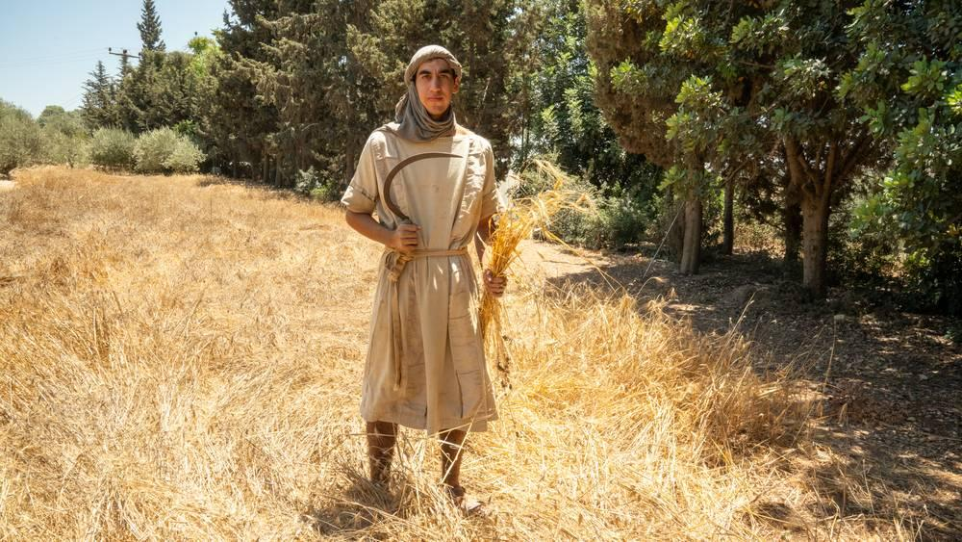
link

Foice

Image Content

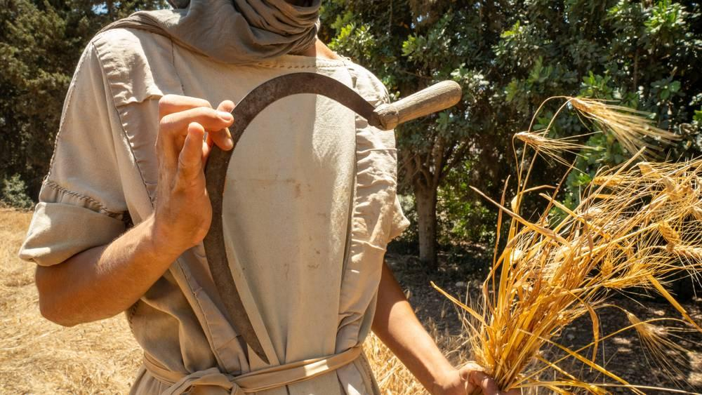
link

Foice

Image Content

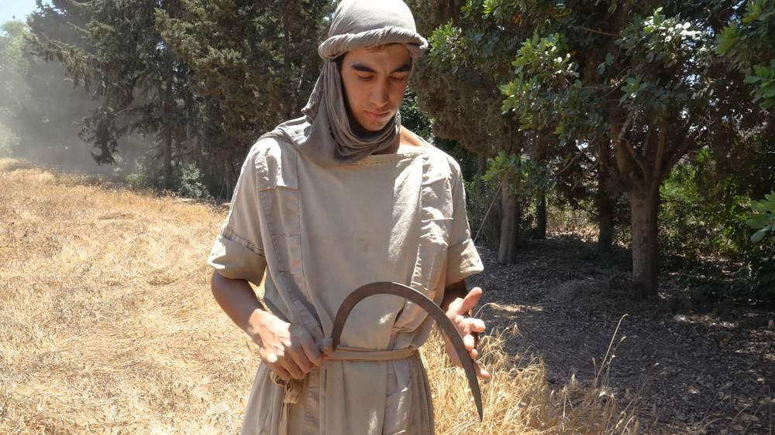
link

Foice

Image Content

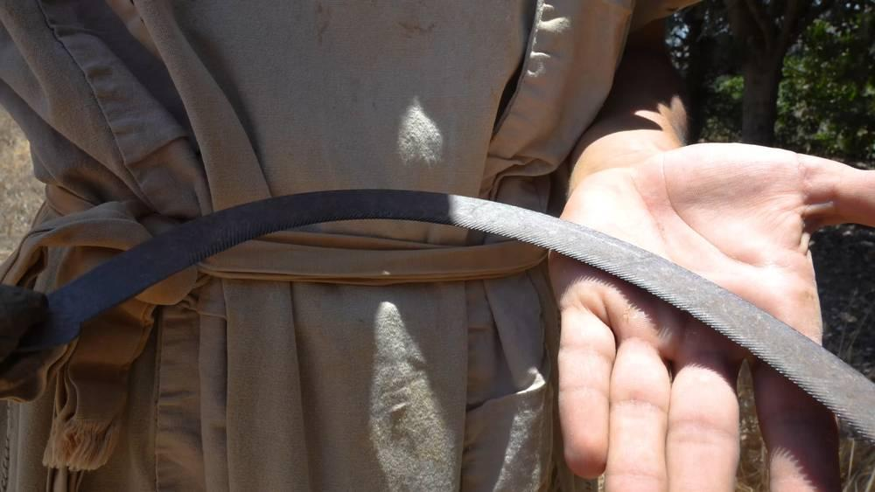
link

Folhas de pergaminho

Image Content

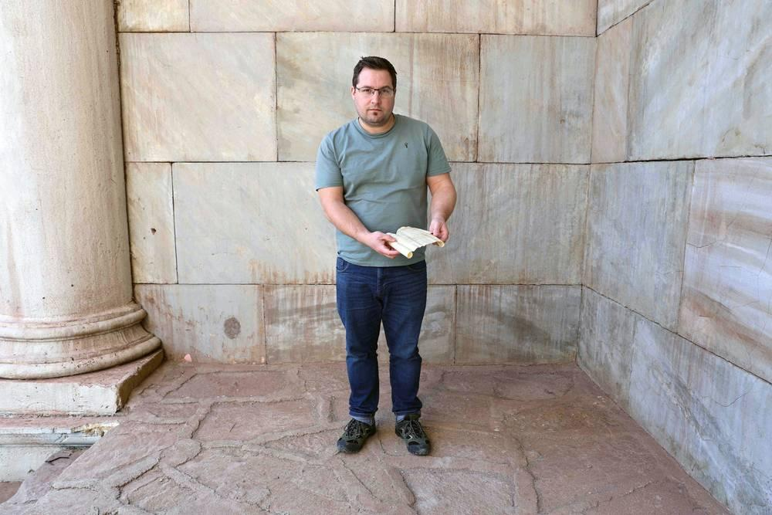
link

Folhas de pergaminho

Image Content

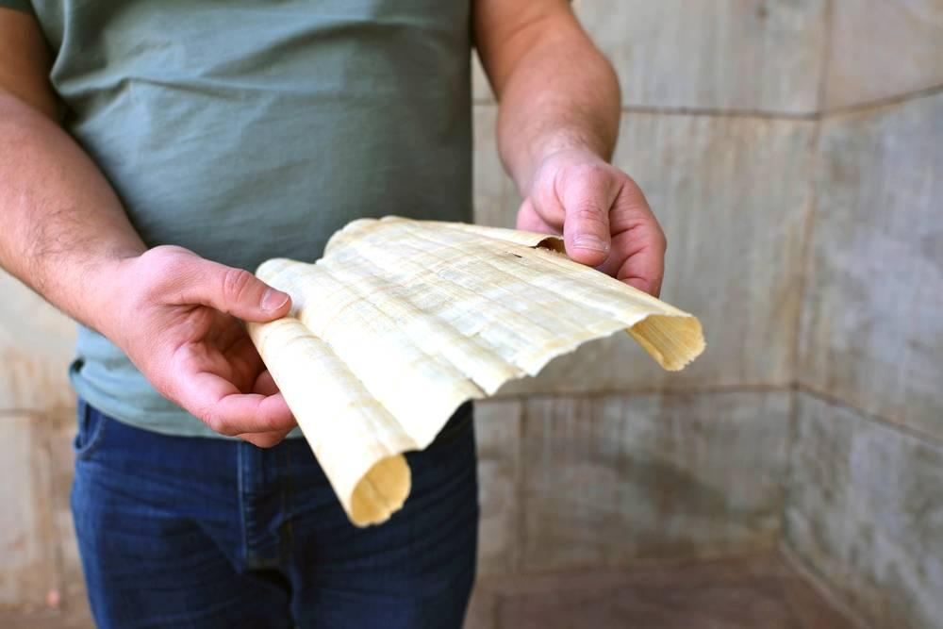
link

Folhas de pergaminho

Image Content

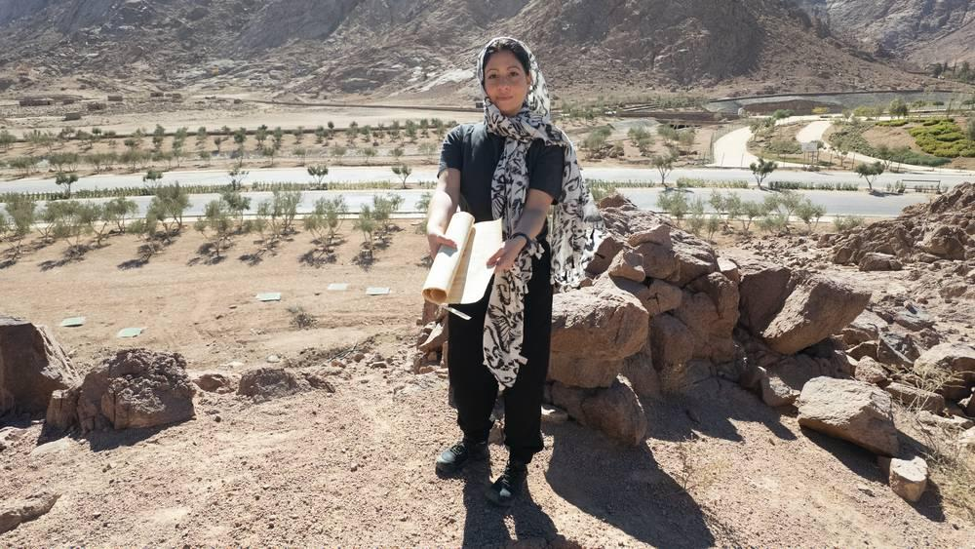
link

Folhas de pergaminho

Image Content

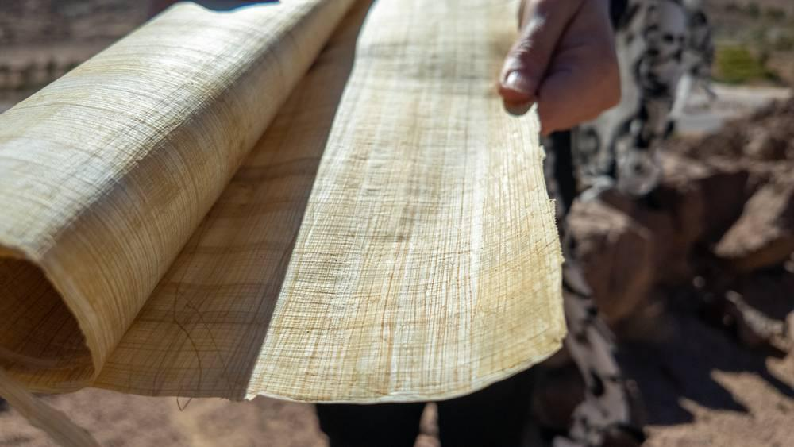
link

Folhas de pergaminho

Image Content

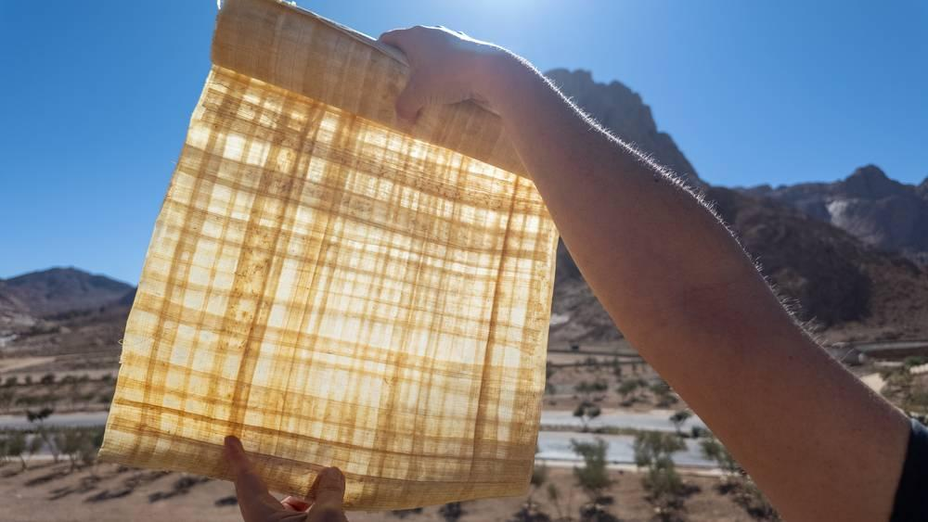
link

Fortaleza Antônia

Image Content

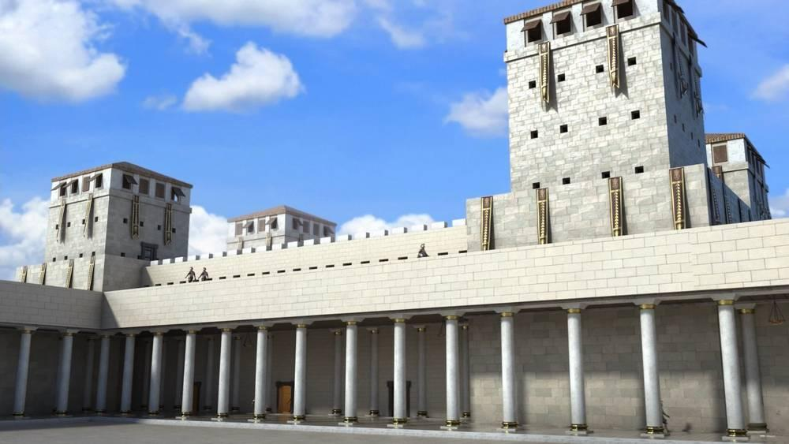
link

Fortaleza Antônia

Image Content

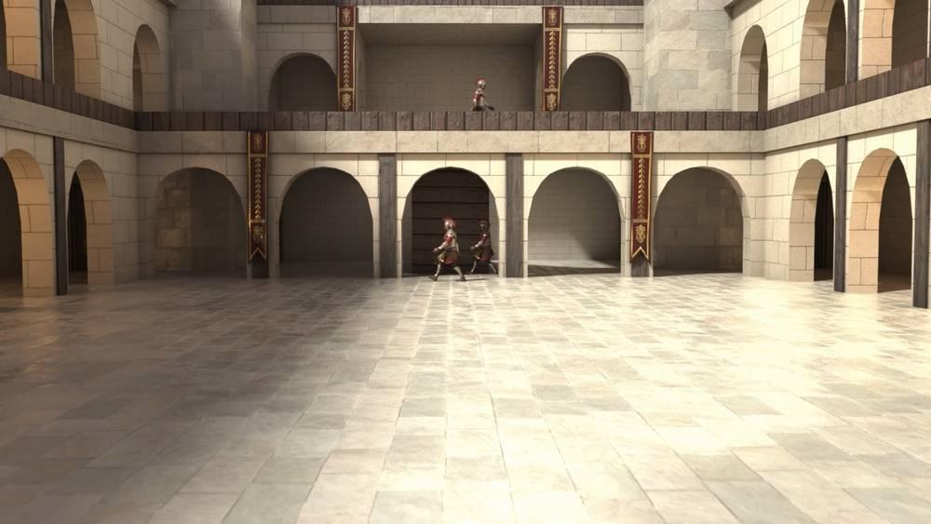
link

Fortaleza Antônia

Image Content

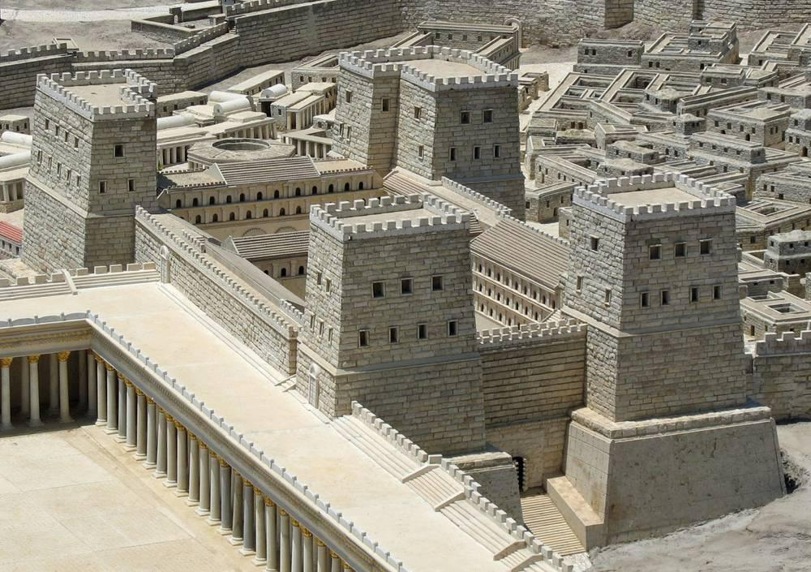
link

Frasco de alabastro

Image Content

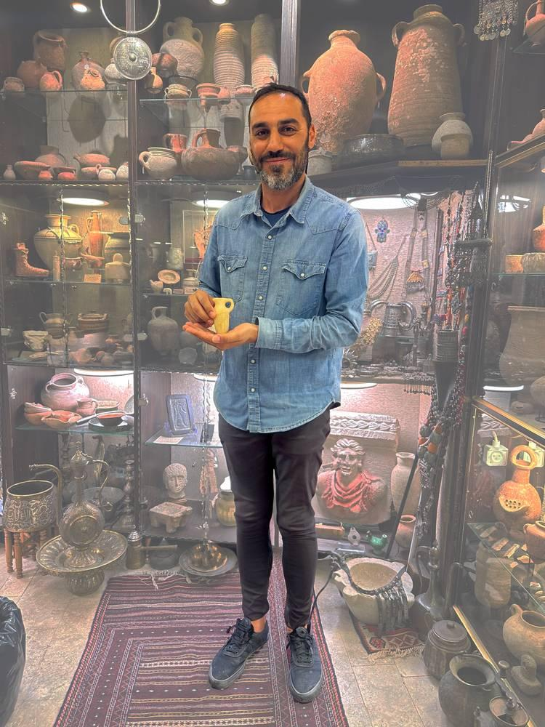
link

Frasco de alabastro

Image Content

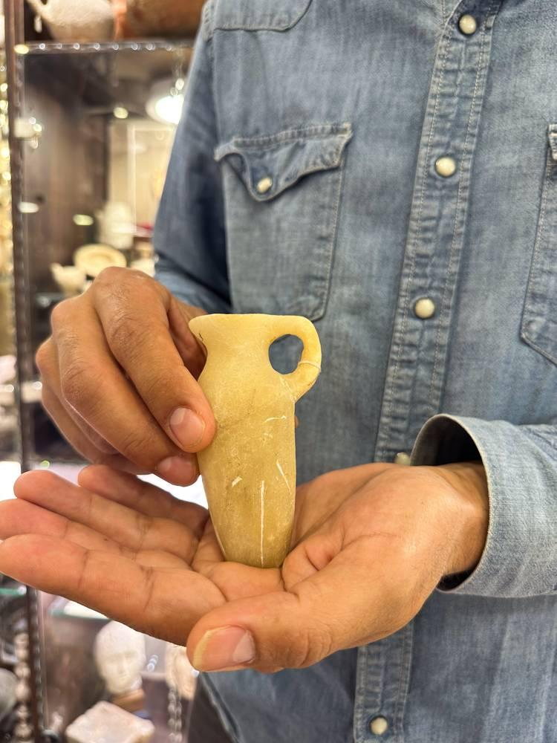
link

Frasco de alabastro

Image Content

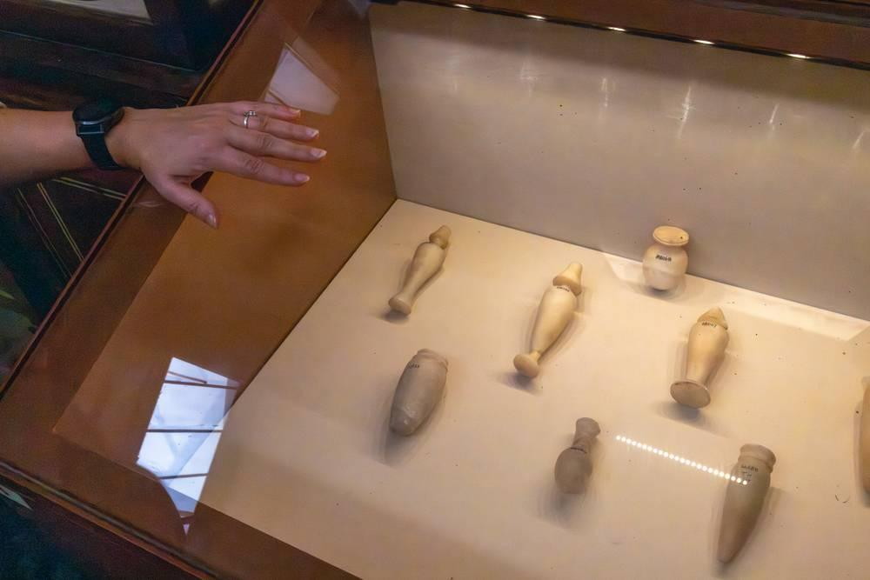
link

Frasco de alabastro

Image Content

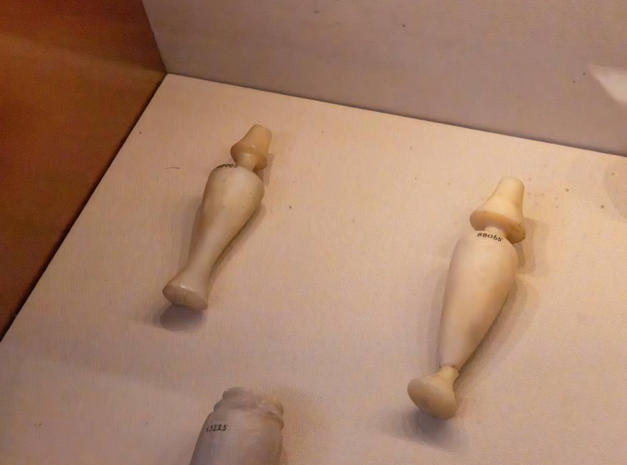
link

