Resource: Familiarization, Internalization, Articulation (Fia) Images
Familiarization, Internalization, Articulation (FIA) Images © 2023 SRV Partners Released under CC BY-SA 4.0 license. Familiarization, Internalization, Articulation (FIA) Images has been adapted in the following languages Tok Pisin, عربي, Français, हिंदी, Bahasa Indonesia, Português, Русский, Español, Kiswahili, 简体中文 from Familiarization, Internalization, Articulation (FIA) © 2023 SRV Partners. Released under CC BY-SA 4.0 license by Mission Mutual

Familiarization, Internalization, Articulation (Fia) Images

G

Gafanhotos

Image Content

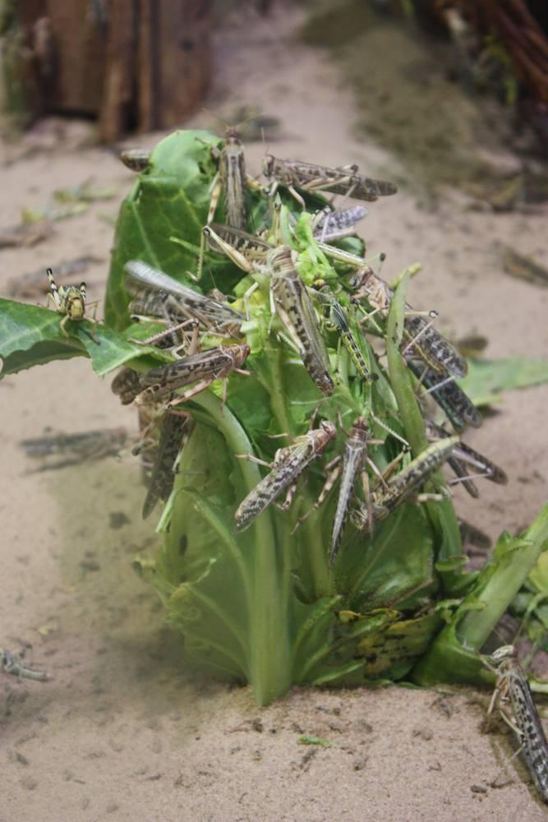
link

Gafanhotos

Image Content

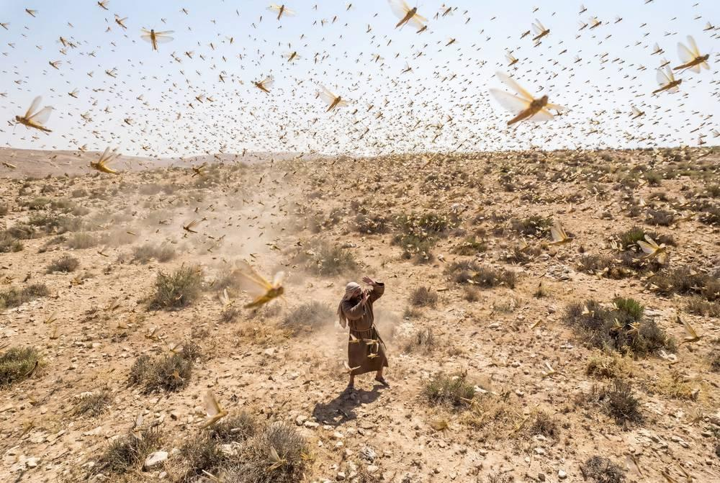
link

Gafanhotos

Image Content

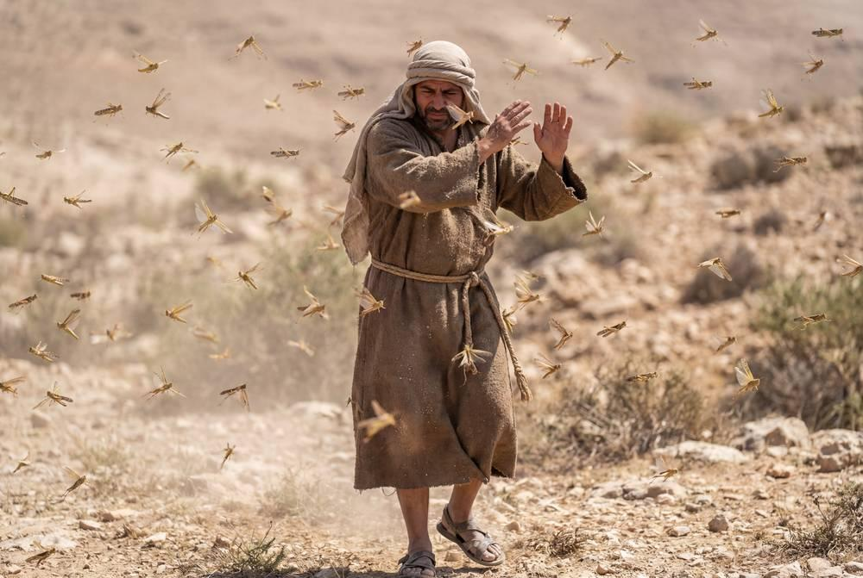
link

Gafanhotos

Image Content

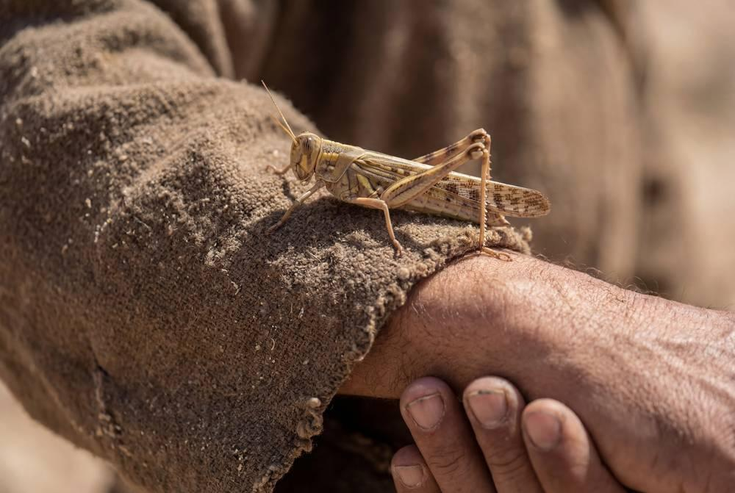
link

Galinha

Image Content

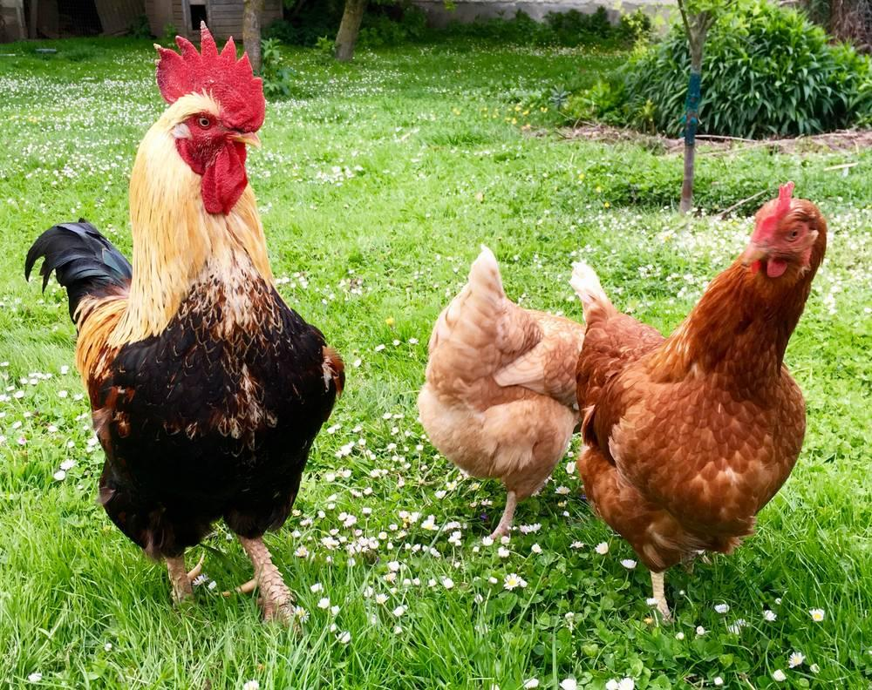
link

Galinha

Image Content

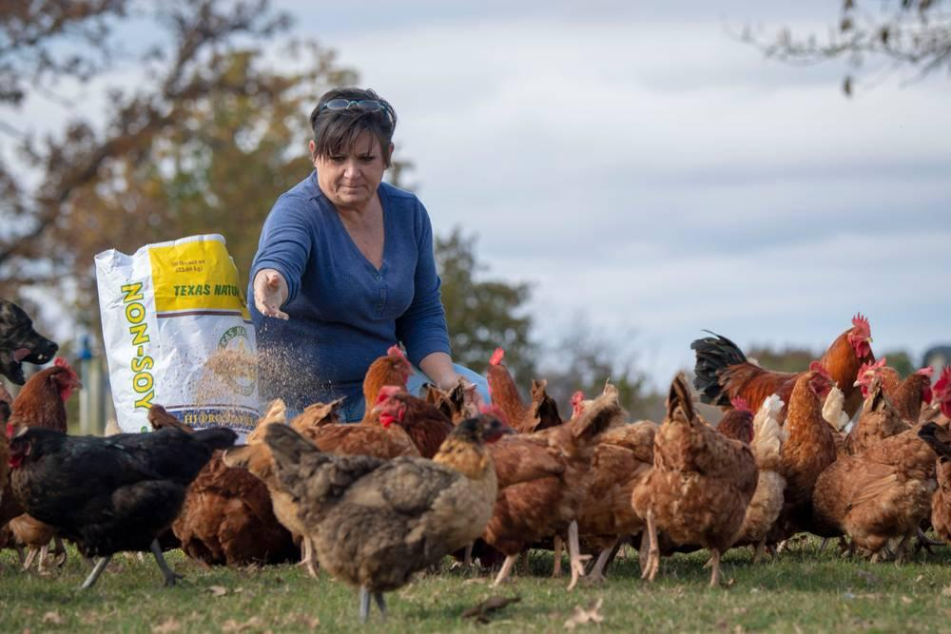
link

Galinha

Image Content

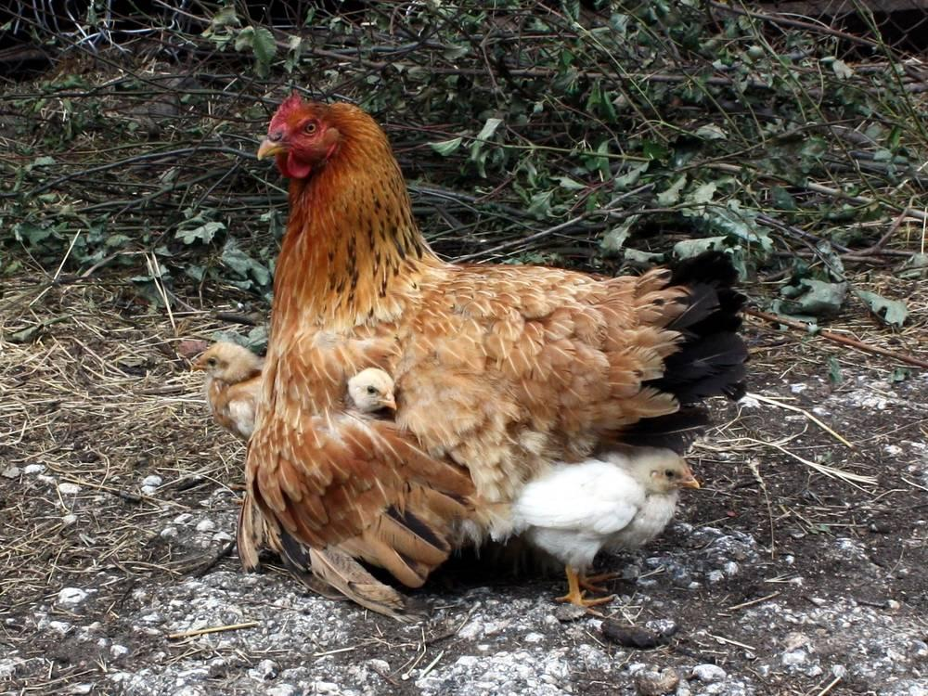
link

Galinha

Image Content

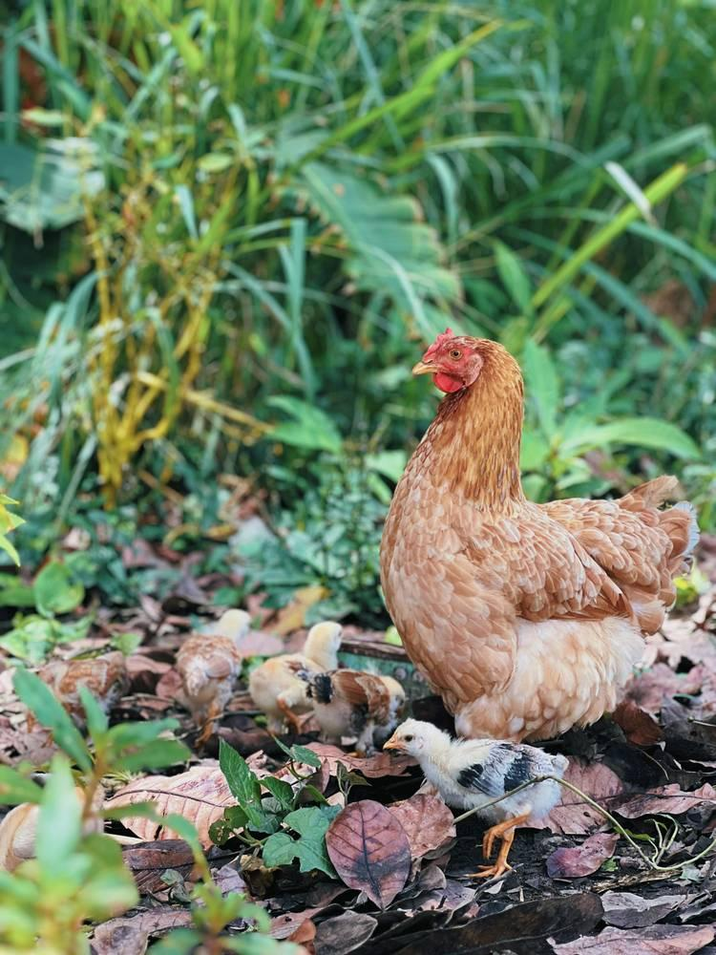
link

Galinha

Image Content

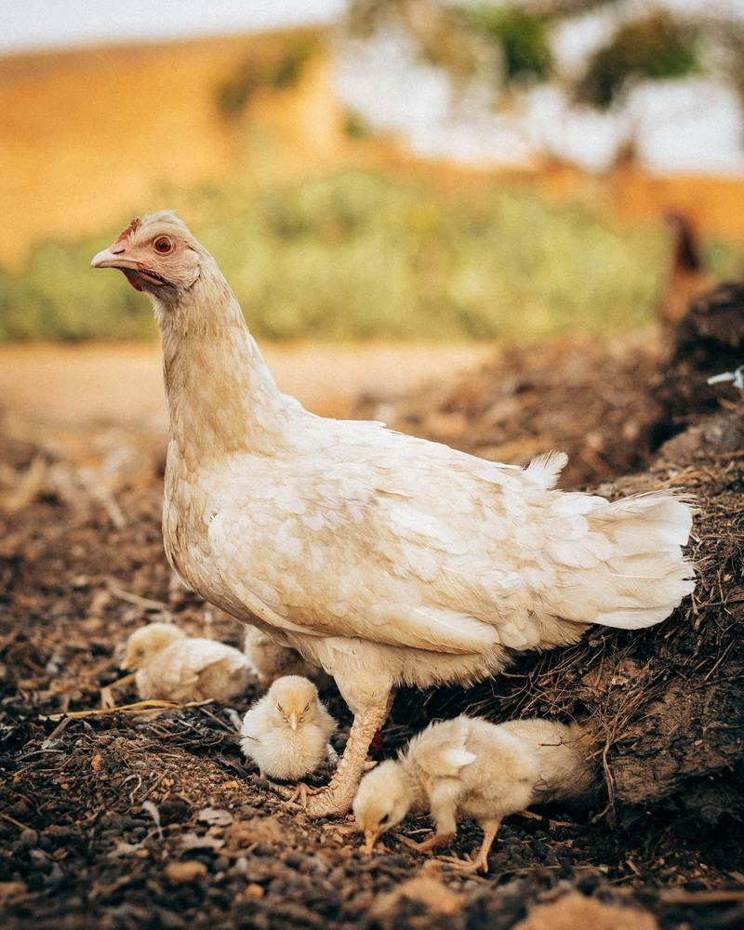
link

Galo

Image Content

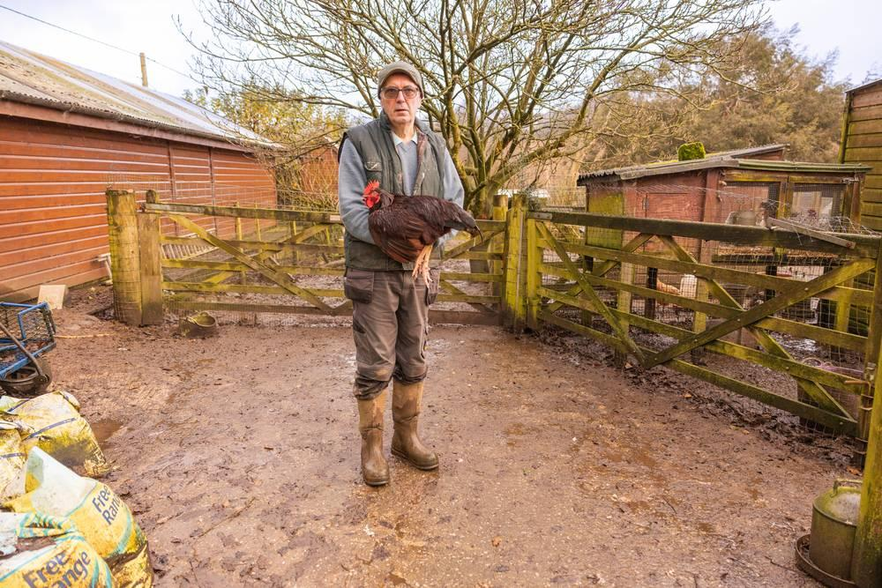
link

Galo

Image Content

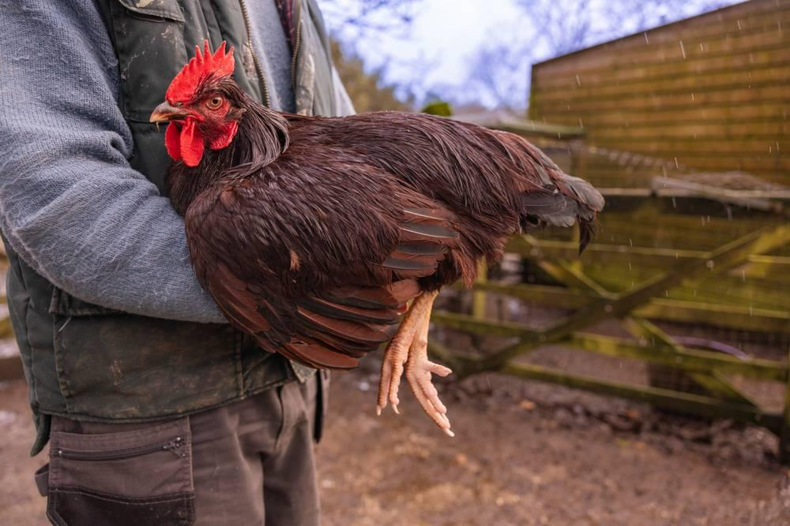
link

Galo

Image Content

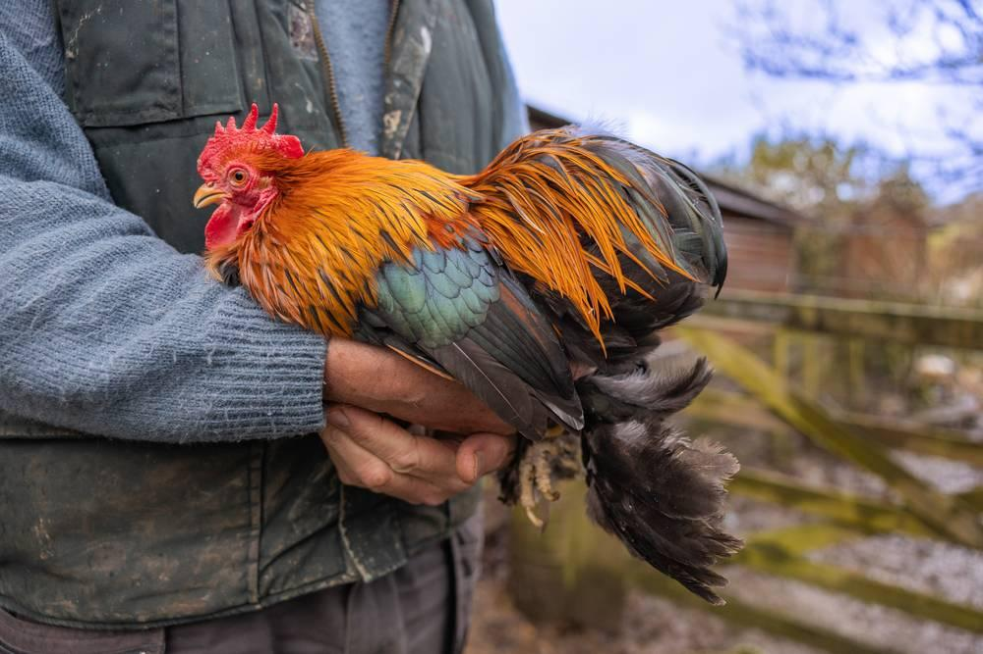
link

Gazela

Image Content

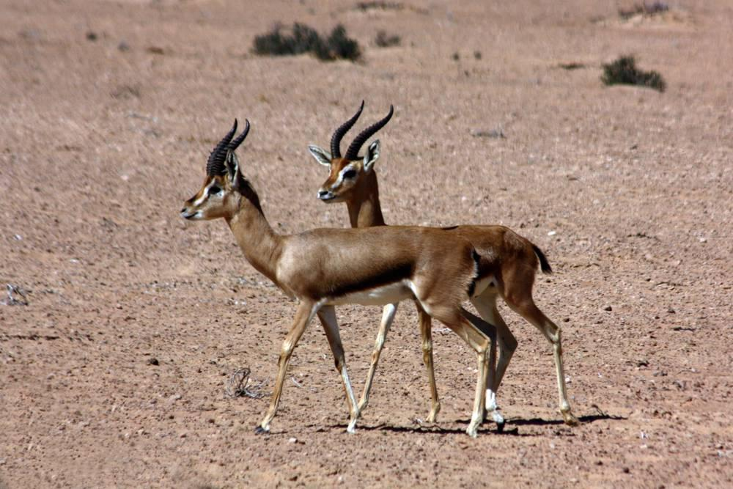
link

Gazela

Image Content

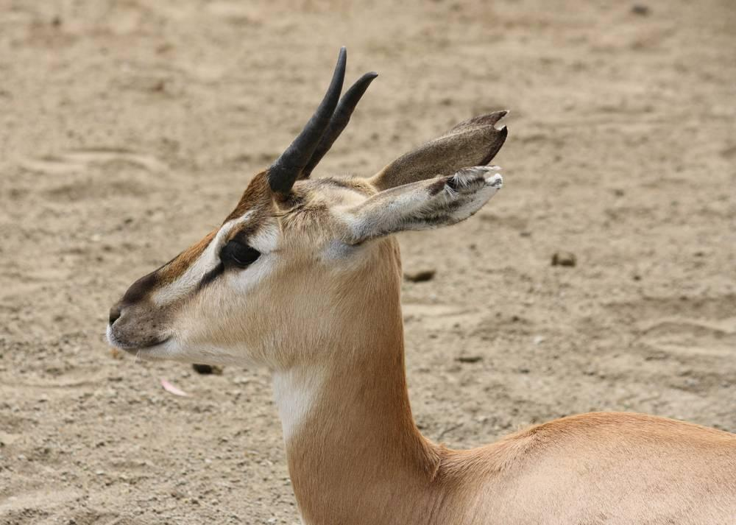
link

Grande multidão de 10 mil

Image Content


link

Grande multidão de 10 mil

Image Content

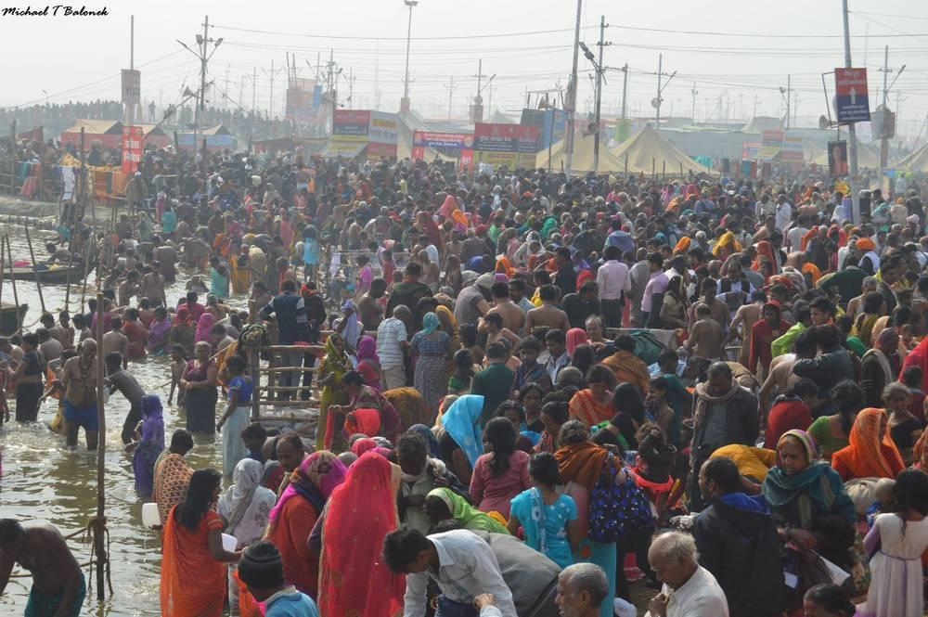
link

Grande multidão de 10 mil

Image Content

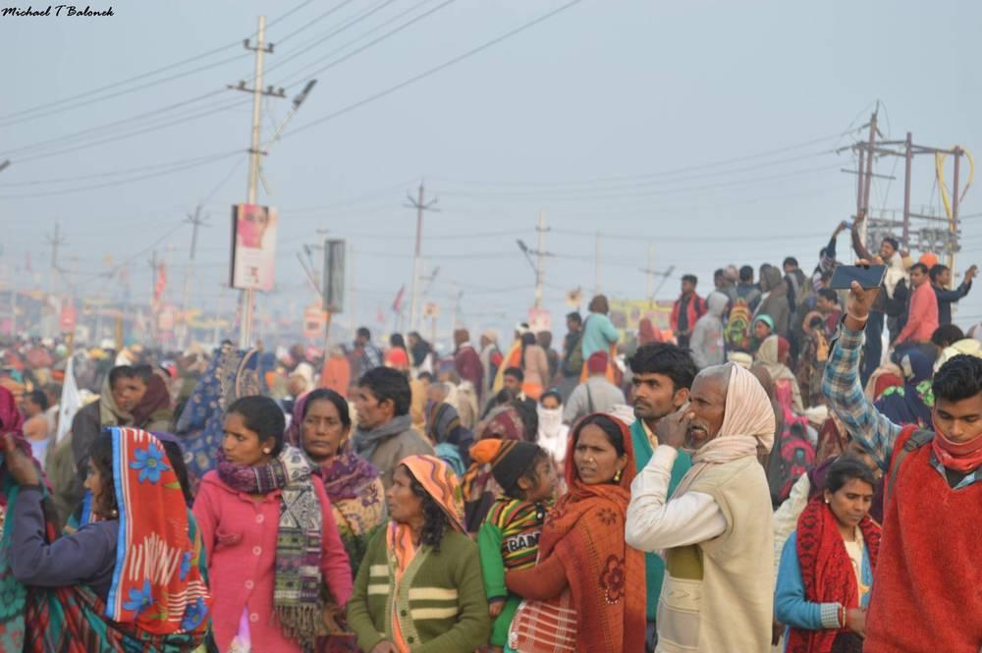
link

