Resource: Familiarization, Internalization, Articulation (Fia) Images
Familiarization, Internalization, Articulation (FIA) Images © 2023 SRV Partners Released under CC BY-SA 4.0 license. Familiarization, Internalization, Articulation (FIA) Images has been adapted in the following languages Tok Pisin, عربي, Français, हिंदी, Bahasa Indonesia, Português, Русский, Español, Kiswahili, 简体中文 from Familiarization, Internalization, Articulation (FIA) © 2023 SRV Partners. Released under CC BY-SA 4.0 license by Mission Mutual

Familiarization, Internalization, Articulation (Fia) Images

J

Jardim do Getsêmani

Image Content

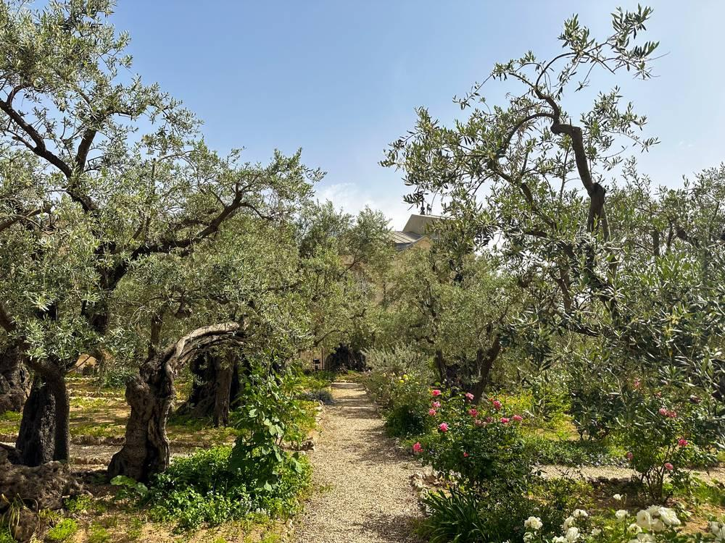
link

Jardim do Getsêmani

Image Content

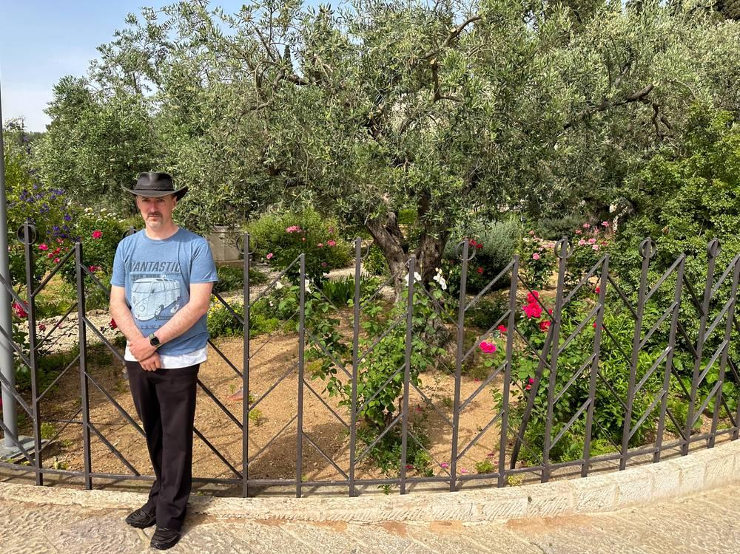
link

Jarro de água

Image Content

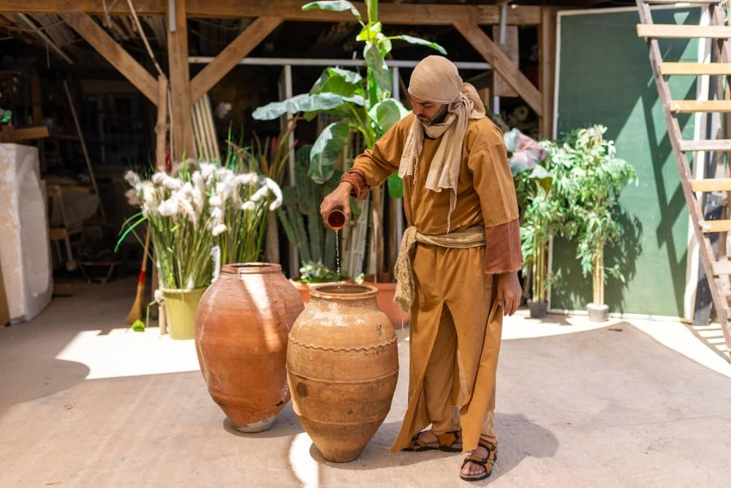
link

Jarro de água

Image Content

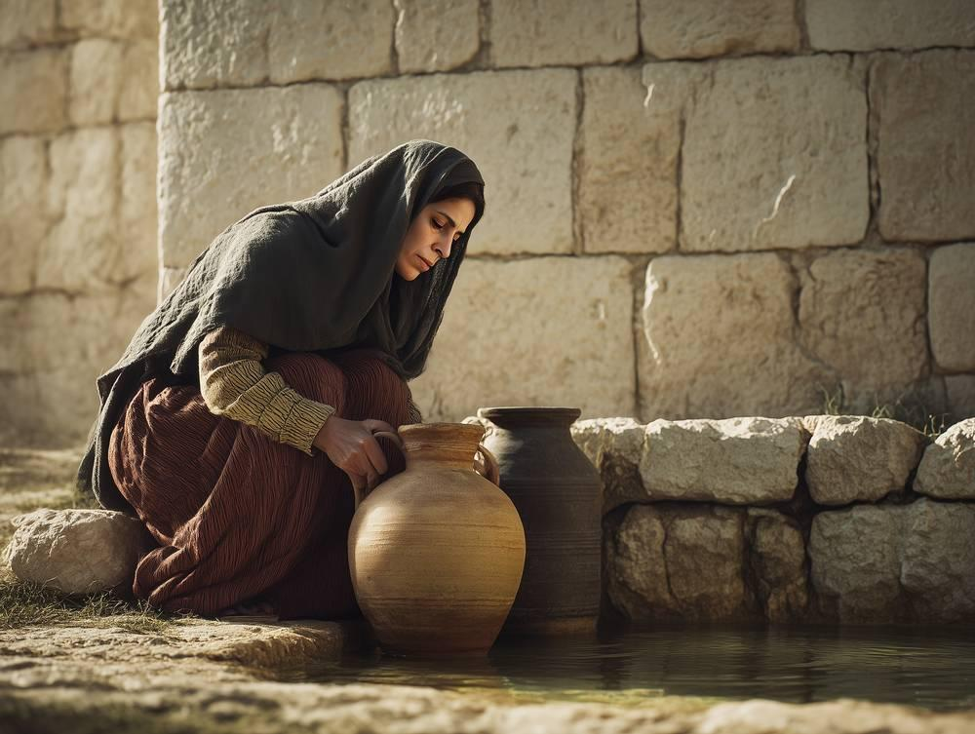
link

Jarro de água

Image Content

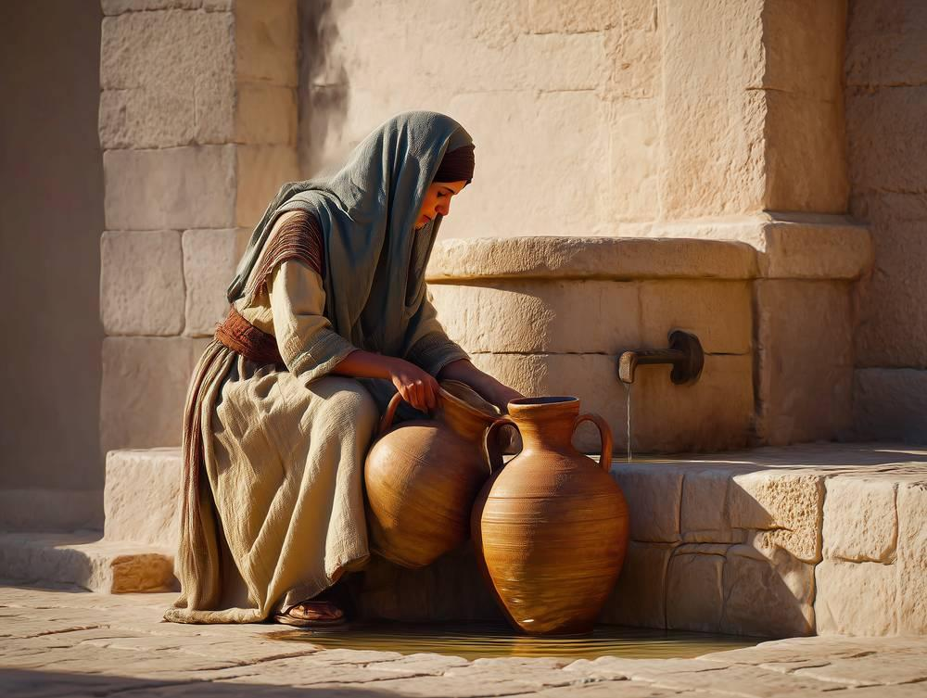
link

Jarro de água

Image Content

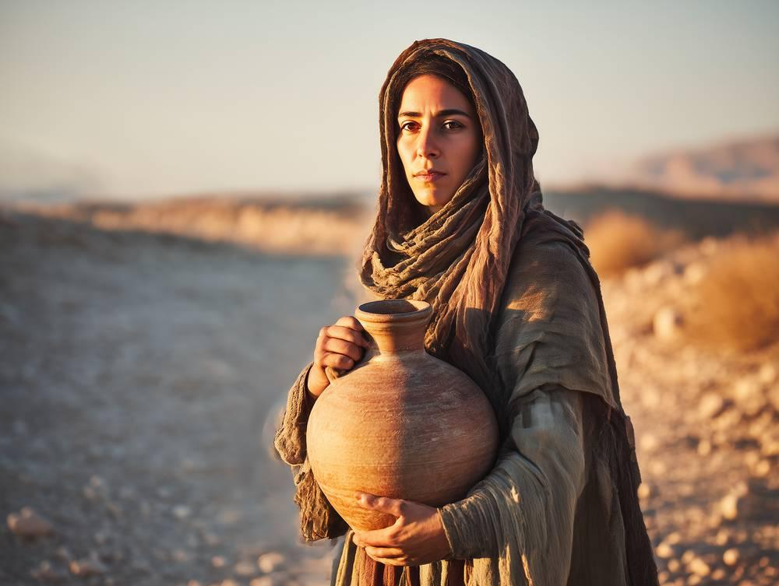
link

Jarro de água carregado no ombro

Image Content

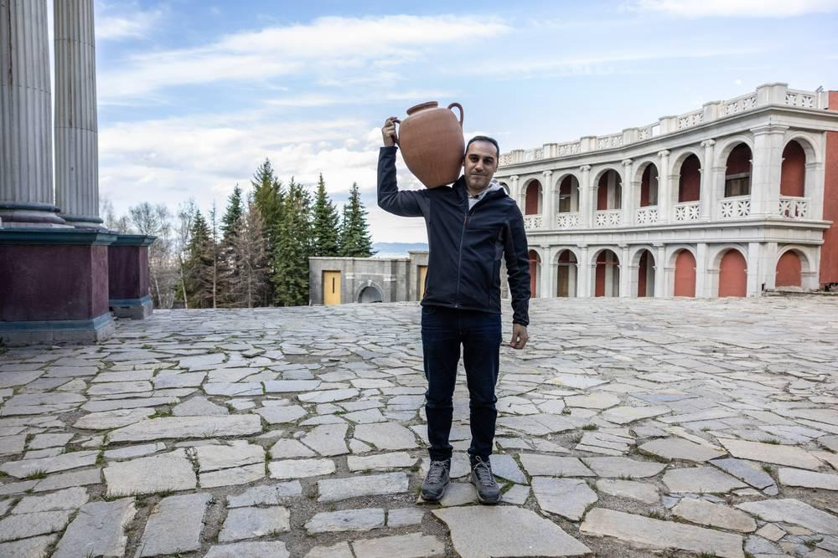
link

Jesus e os discípulos em um barco

Image Content


link

Jesus e os discípulos em um barco

Image Content

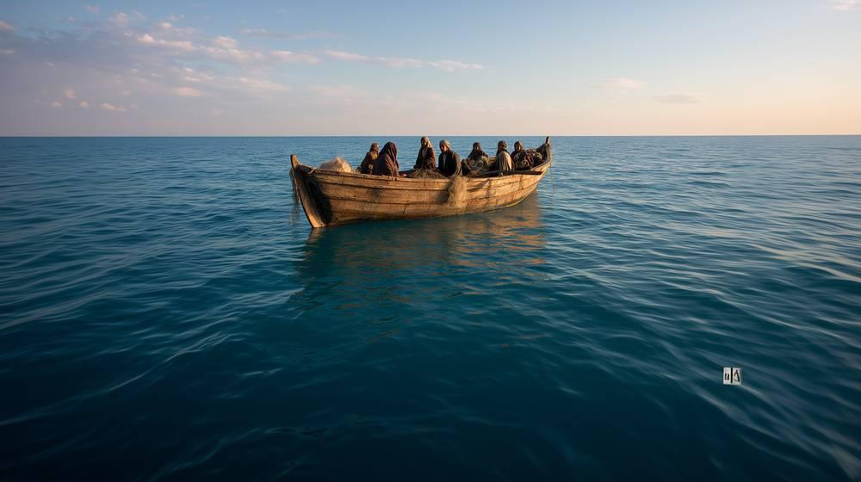
link

Jesus e os discípulos em um barco

Image Content

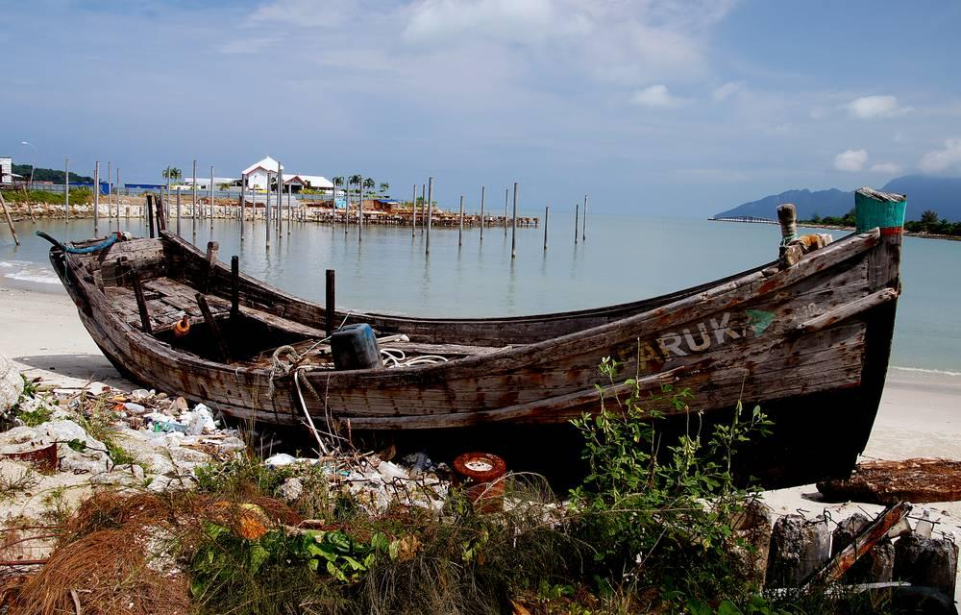
link

Julgamento de Jesus pelo sumo sacerdote

Image Content

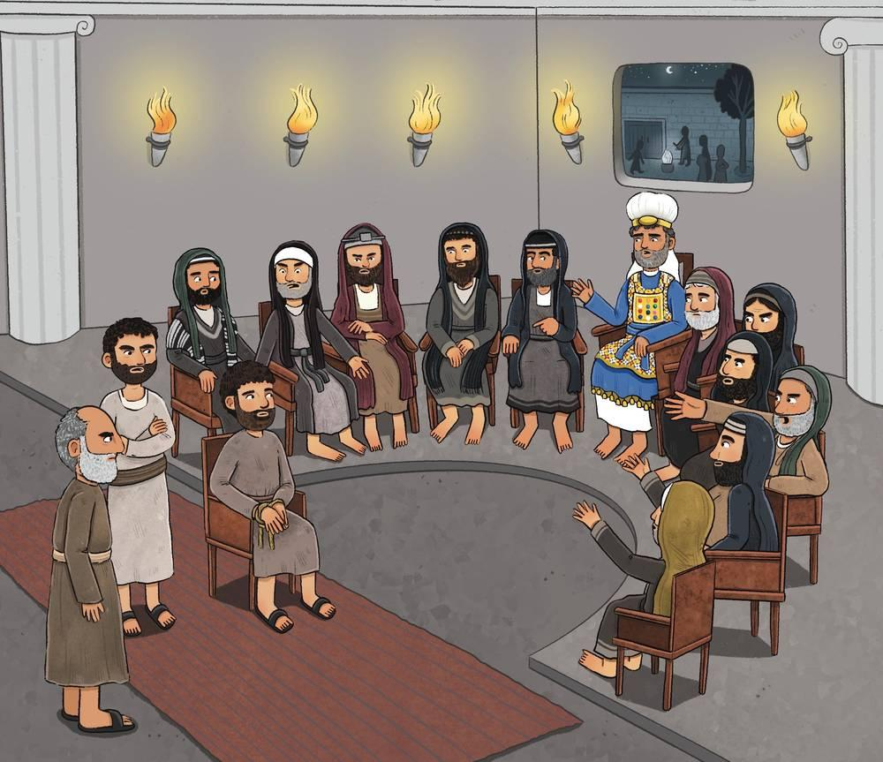
link

Jumentinho

Image Content

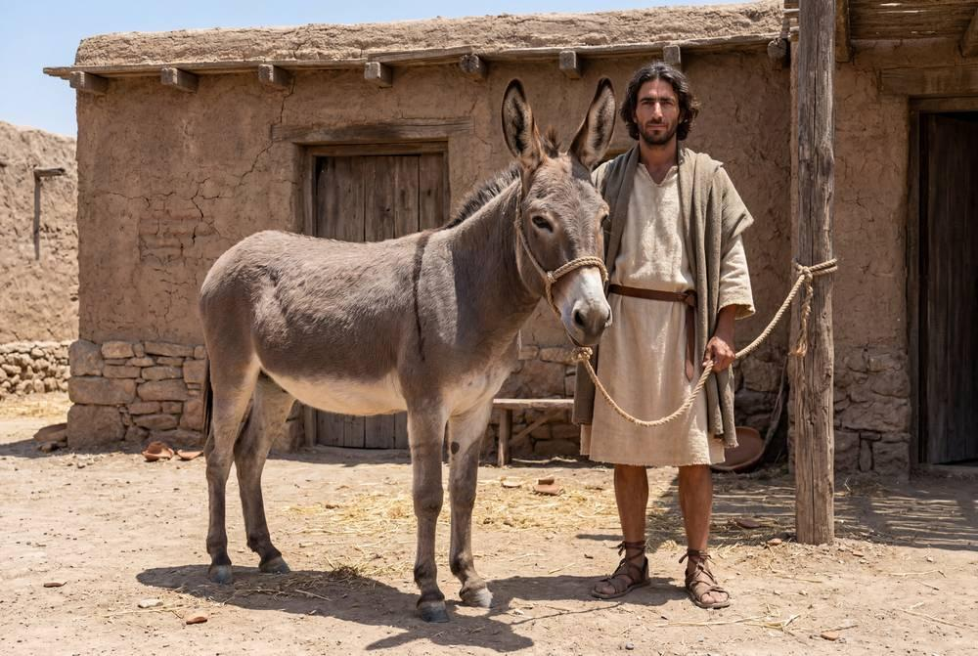
link

Jumentinho

Image Content

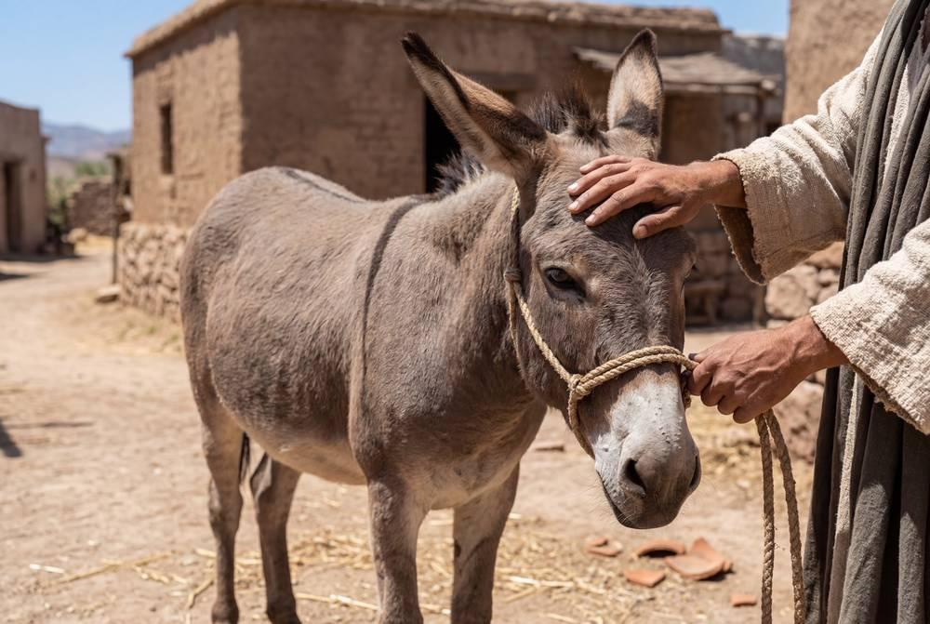
link

Jumentinho

Image Content

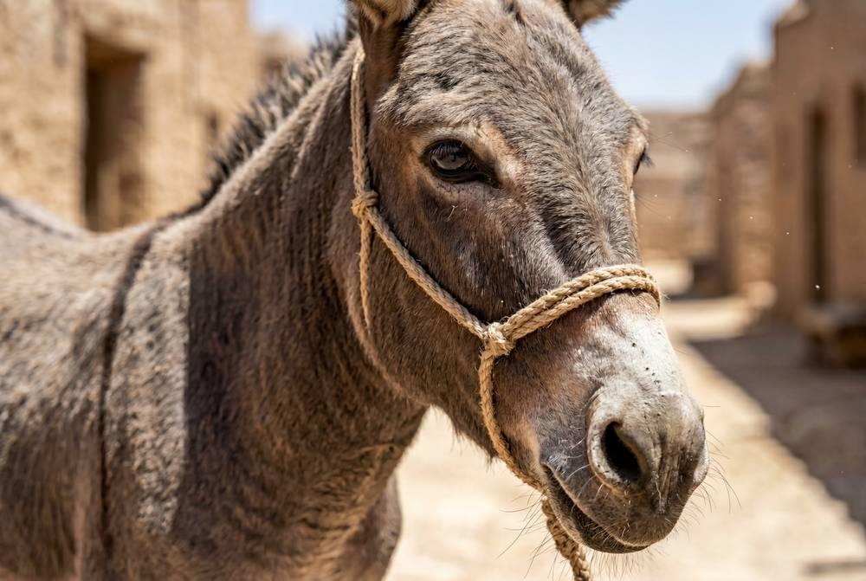
link

Jumento adulto

Image Content

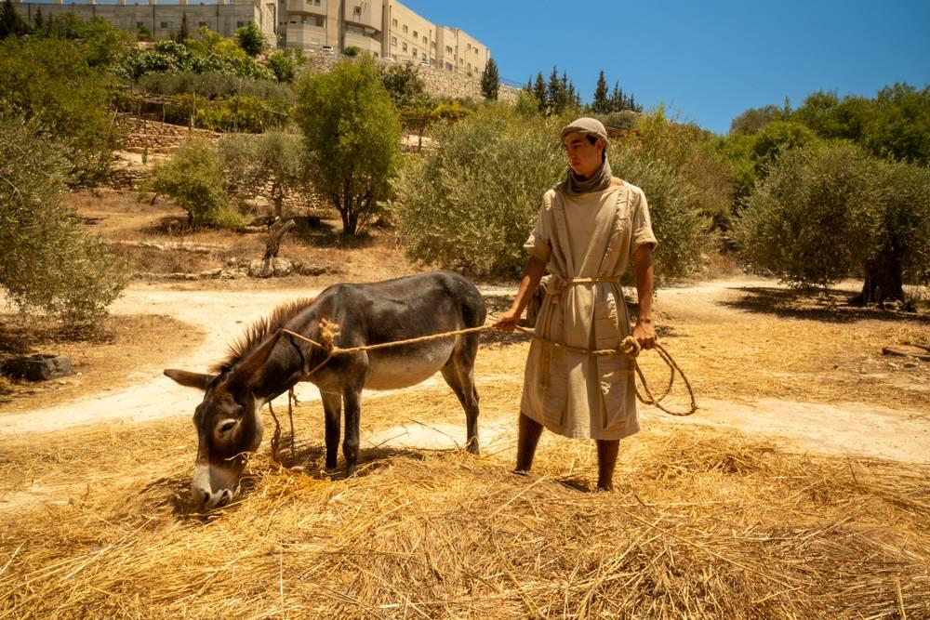
link

Jumento adulto

Image Content

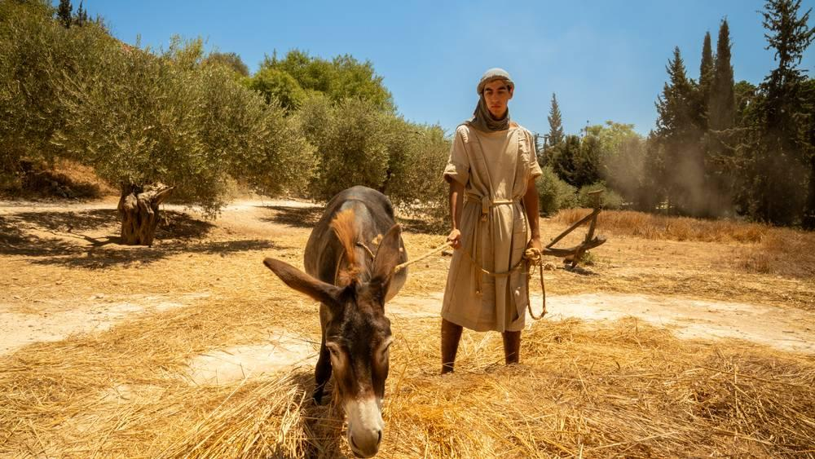
link

