Resource: Familiarization, Internalization, Articulation (Fia) Images
Familiarization, Internalization, Articulation (FIA) Images © 2023 SRV Partners Released under CC BY-SA 4.0 license. Familiarization, Internalization, Articulation (FIA) Images has been adapted in the following languages Tok Pisin, عربي, Français, हिंदी, Bahasa Indonesia, Português, Русский, Español, Kiswahili, 简体中文 from Familiarization, Internalization, Articulation (FIA) © 2023 SRV Partners. Released under CC BY-SA 4.0 license by Mission Mutual

Familiarization, Internalization, Articulation (Fia) Images

L

Lagar

Image Content

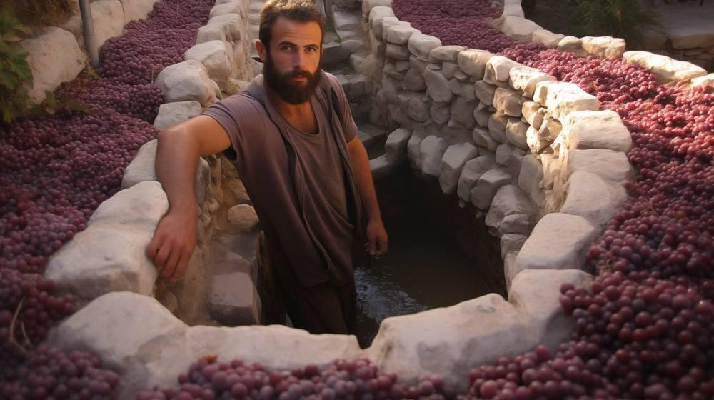
link

Lamparina

Image Content

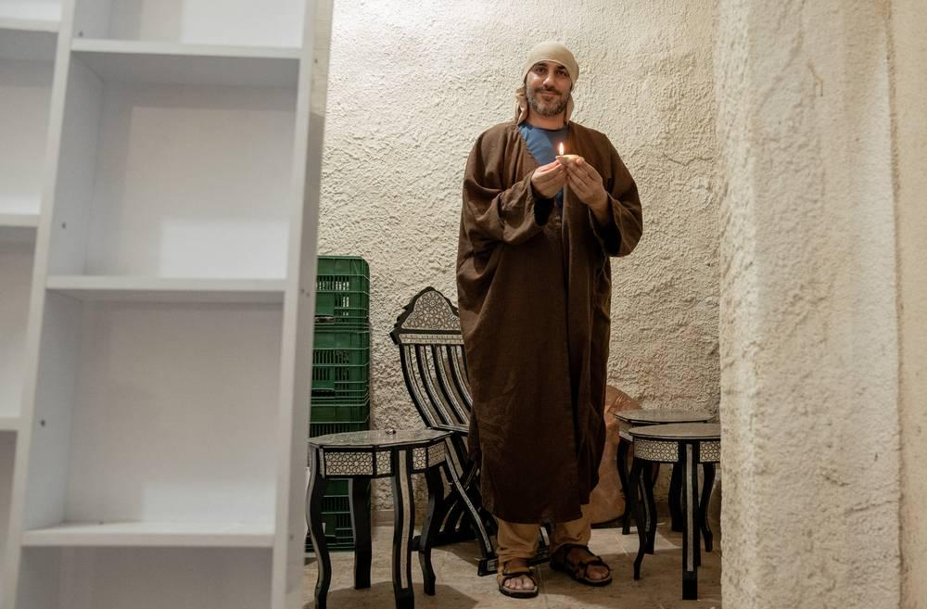
link

Lamparina

Image Content

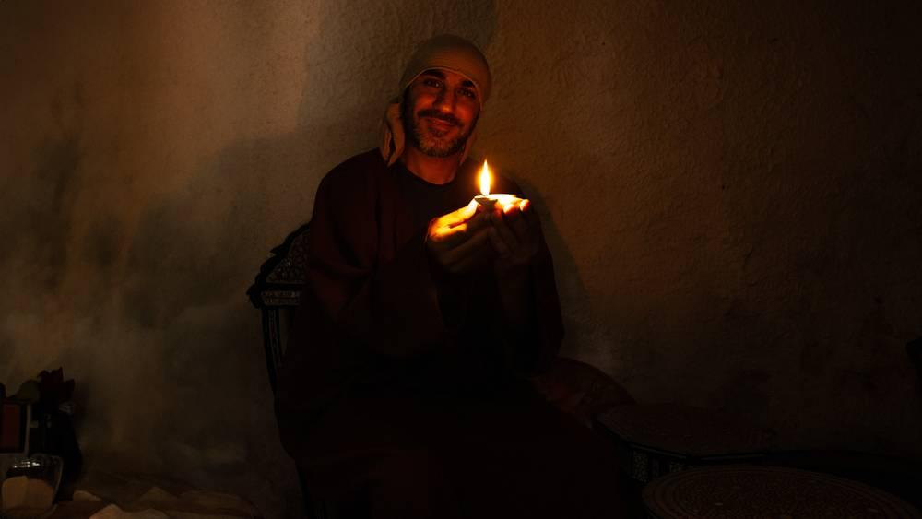
link

Lençol com animais

Image Content

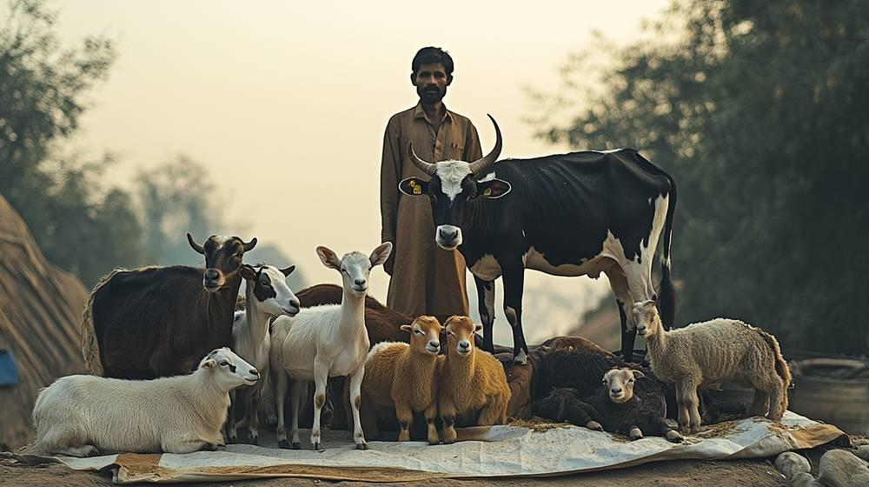
link

Lençol com animais

Image Content

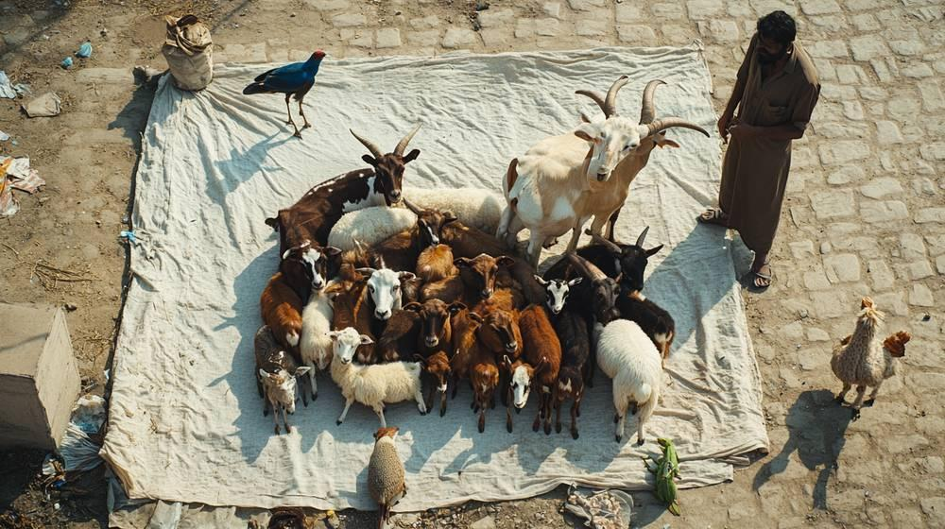
link

Lençol com animais

Image Content

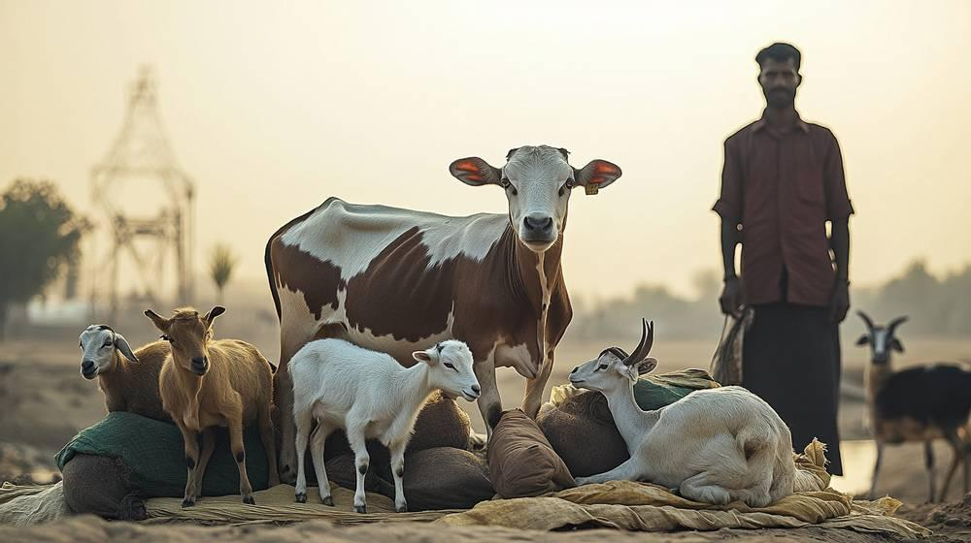
link

Linha de pesca e anzol

Image Content

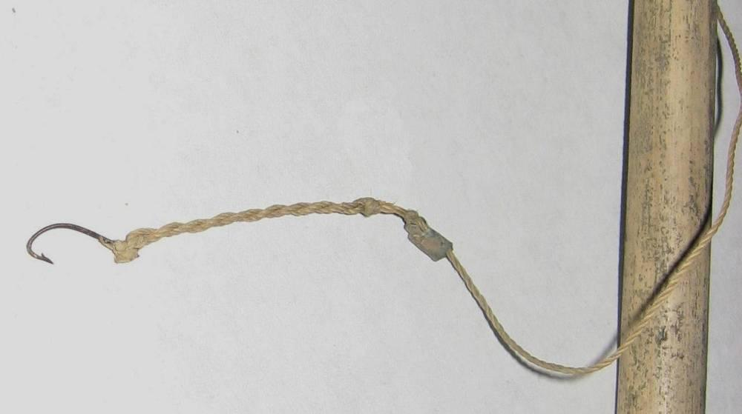
link

Linha de pesca e anzol

Image Content

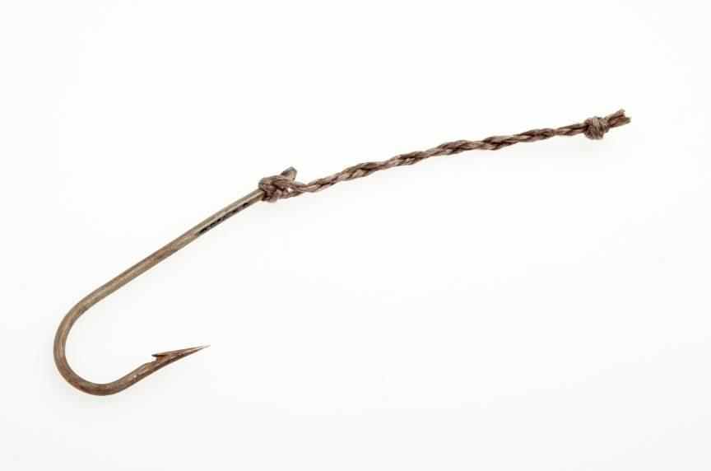
link

Linha de pesca e anzol

Image Content

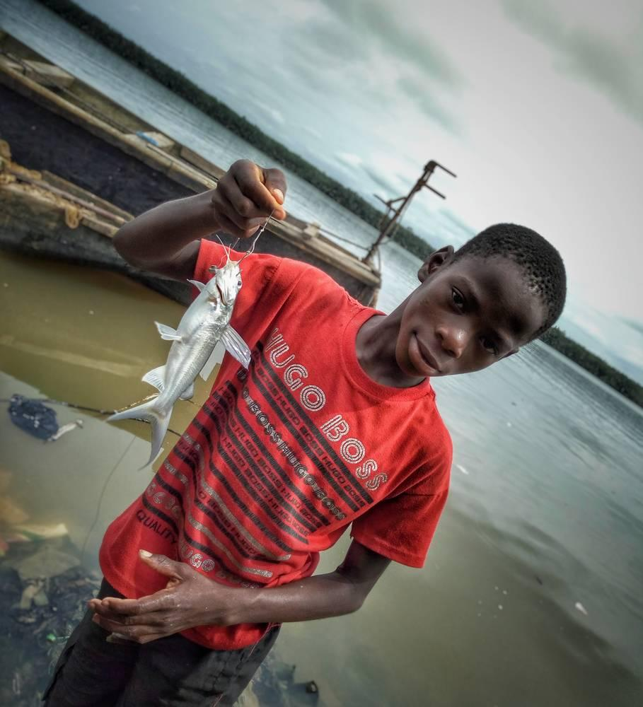
link

Lírios

Image Content

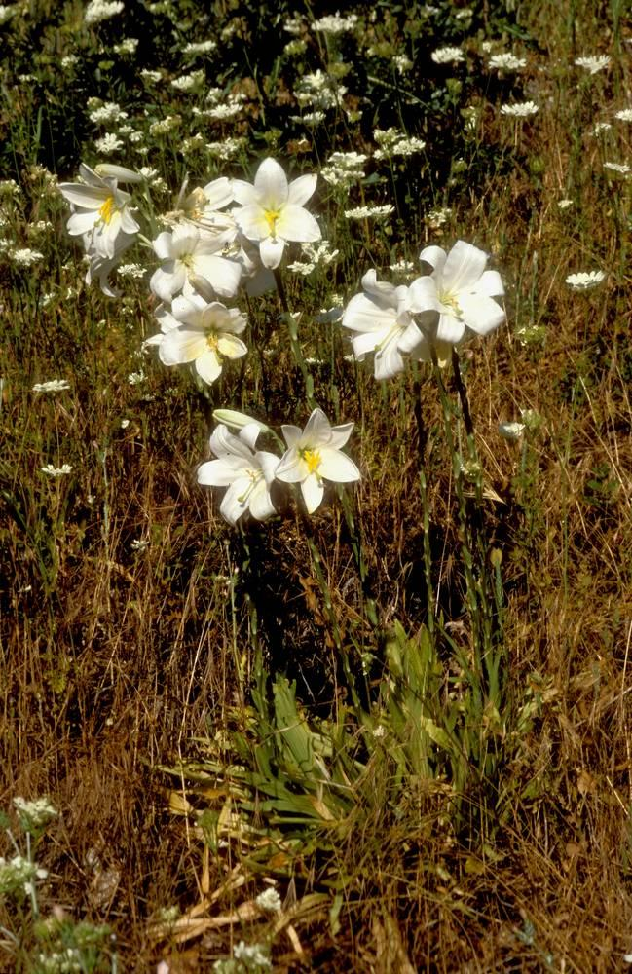
link

Lírios

Image Content

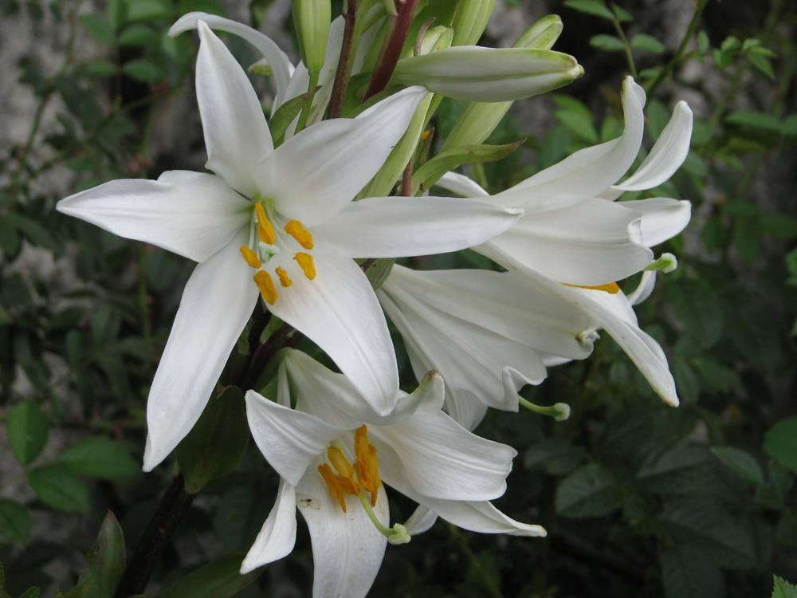
link

Lobo

Image Content

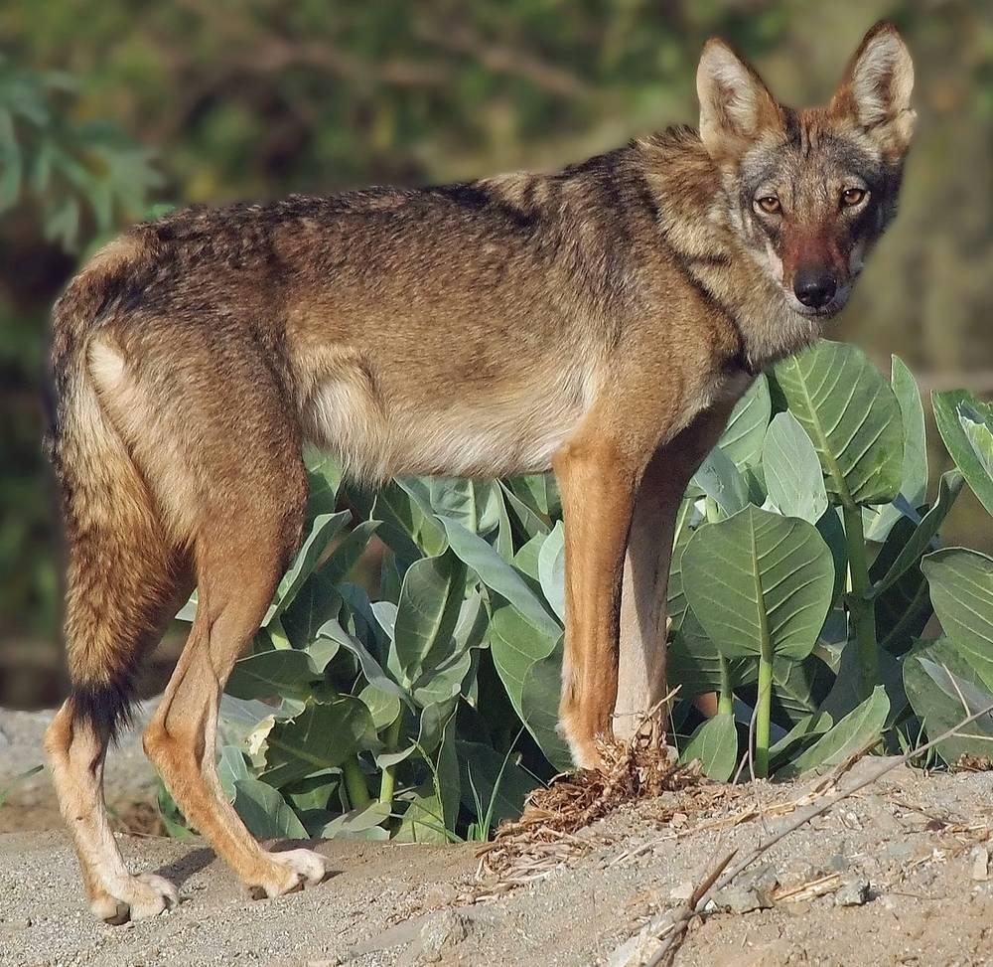
link

Lugar alto

Image Content

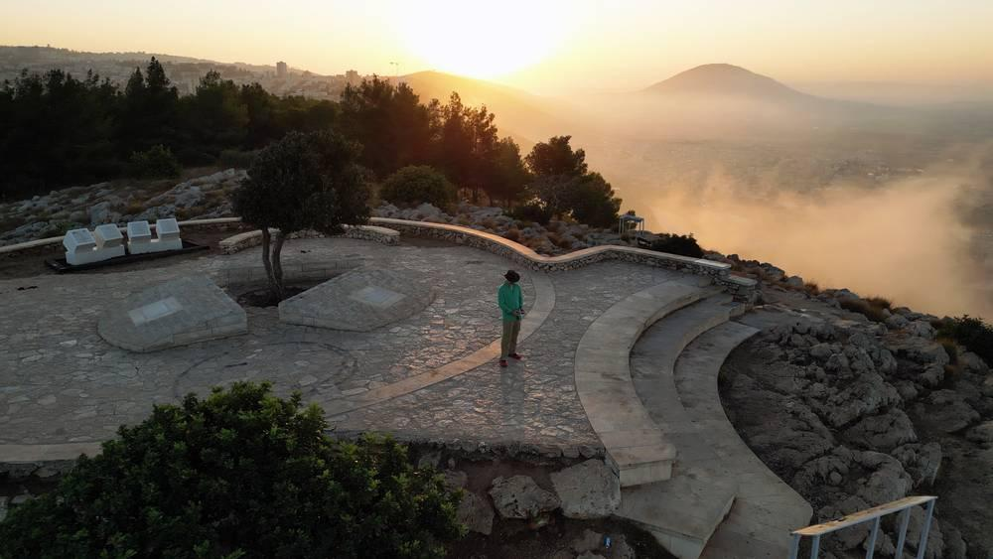
link

Lugar alto

Image Content

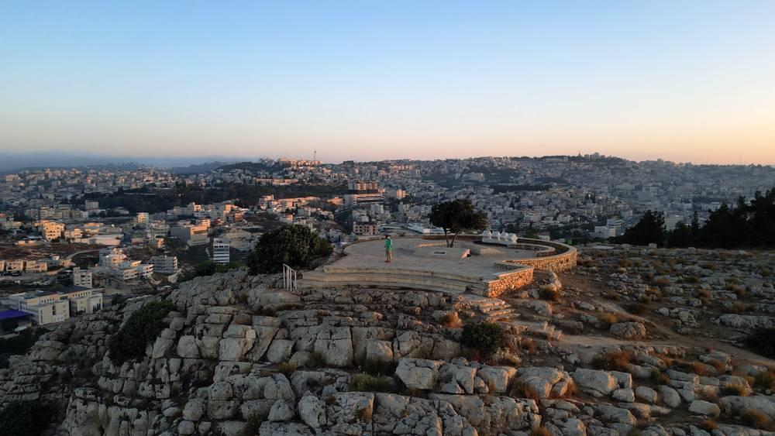
link

