Resource: Familiarization, Internalization, Articulation (Fia) Images
Familiarization, Internalization, Articulation (FIA) Images © 2023 SRV Partners Released under CC BY-SA 4.0 license. Familiarization, Internalization, Articulation (FIA) Images has been adapted in the following languages Tok Pisin, عربي, Français, हिंदी, Bahasa Indonesia, Português, Русский, Español, Kiswahili, 简体中文 from Familiarization, Internalization, Articulation (FIA) © 2023 SRV Partners. Released under CC BY-SA 4.0 license by Mission Mutual

Familiarization, Internalization, Articulation (Fia) Images

N

Navio

Image Content

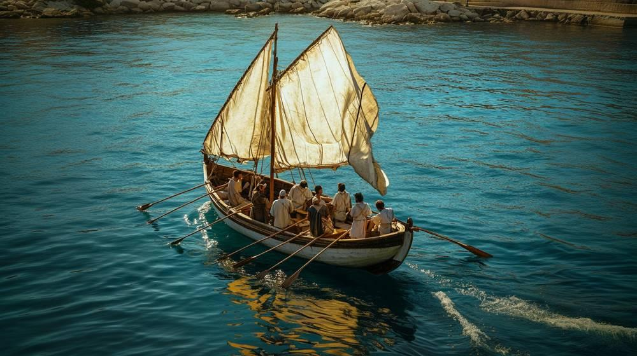
link

Navio de carga do Mediterrâneo

Image Content


link

Navio de carga do Mediterrâneo

Image Content

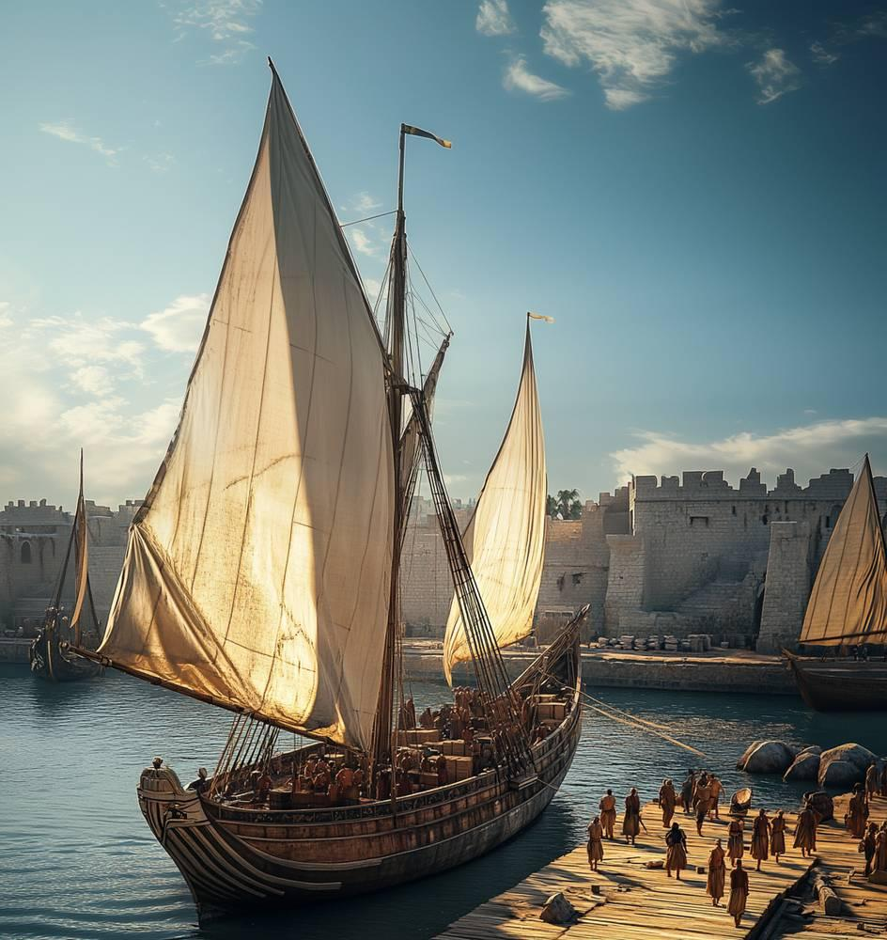
link

Neve

Image Content

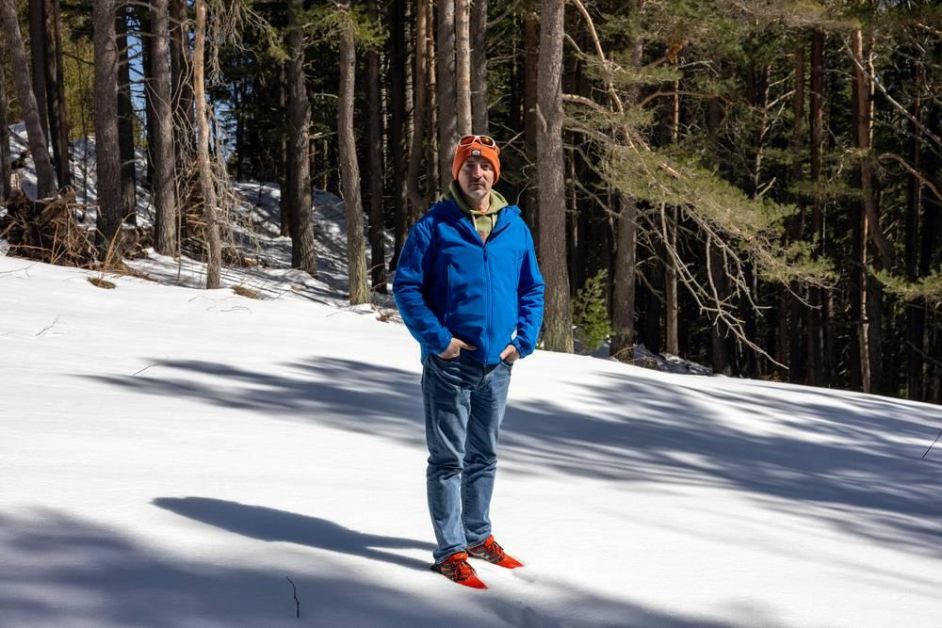
link

Neve

Image Content

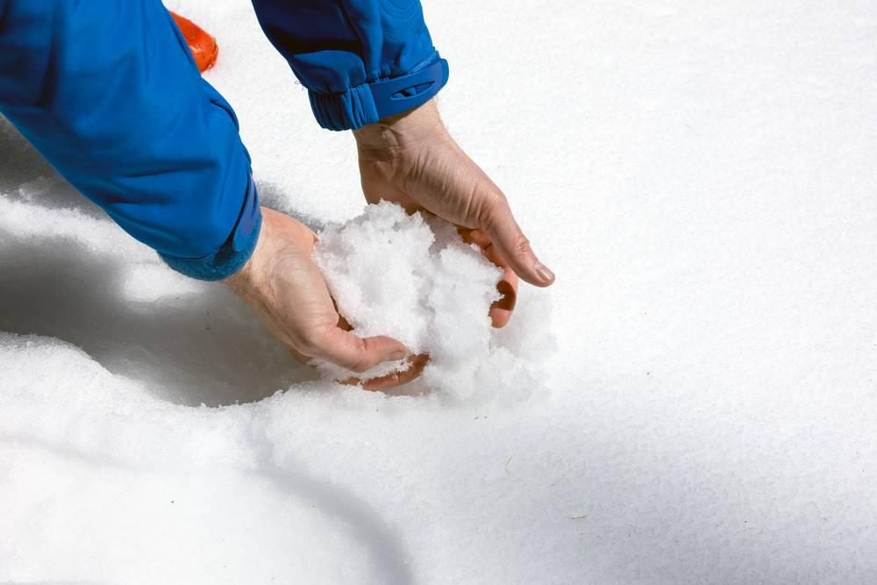
link

Ninho de pássaro

Image Content


link

Ninho de pássaro

Image Content

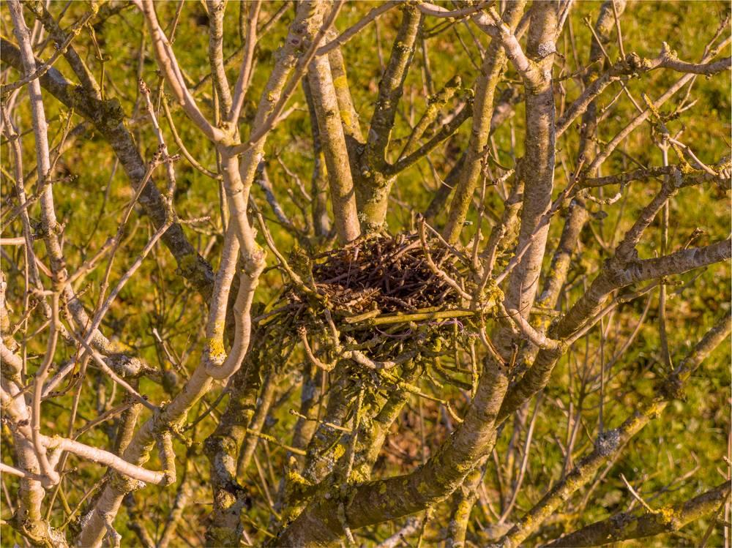
link

