Resource: Familiarization, Internalization, Articulation (Fia) Images
Familiarization, Internalization, Articulation (FIA) Images © 2023 SRV Partners Released under CC BY-SA 4.0 license. Familiarization, Internalization, Articulation (FIA) Images has been adapted in the following languages Tok Pisin, عربي, Français, हिंदी, Bahasa Indonesia, Português, Русский, Español, Kiswahili, 简体中文 from Familiarization, Internalization, Articulation (FIA) © 2023 SRV Partners. Released under CC BY-SA 4.0 license by Mission Mutual

Familiarization, Internalization, Articulation (Fia) Images

O

Odres

Image Content

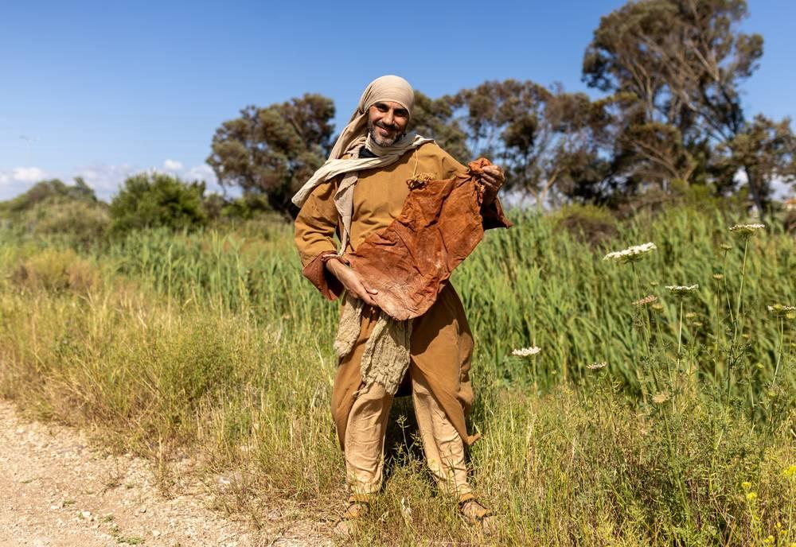
link

Oficiais da tribuna romana

Image Content


link

Oficiais da tribuna romana

Image Content

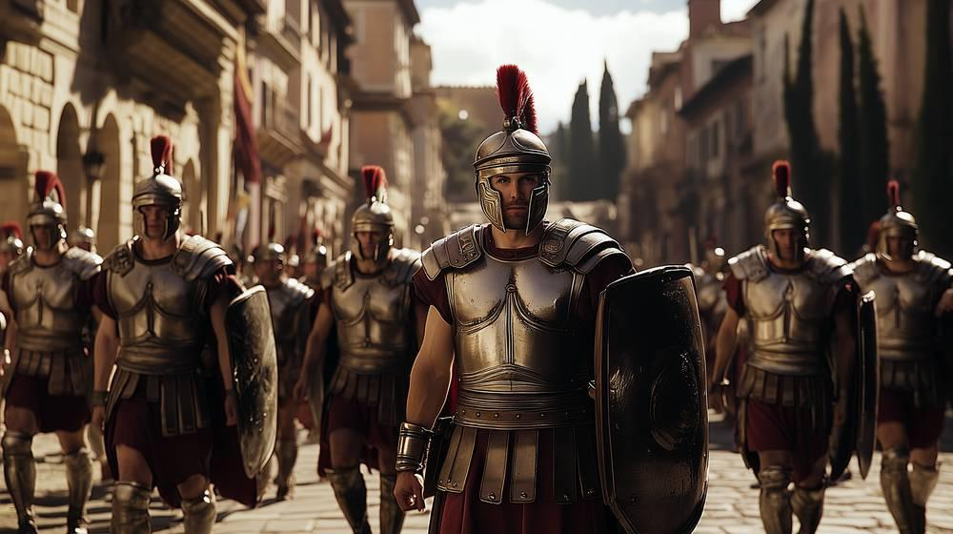
link

Oficiais da tribuna romana

Image Content


link

Olho de uma agulha

Image Content

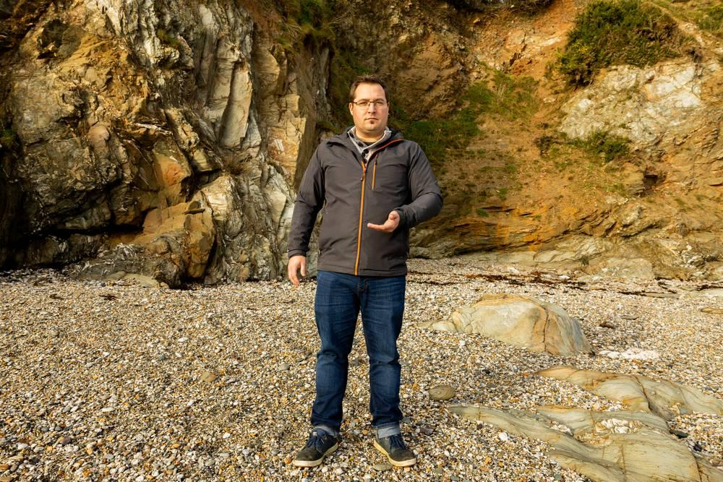
link

Olho de uma agulha

Image Content

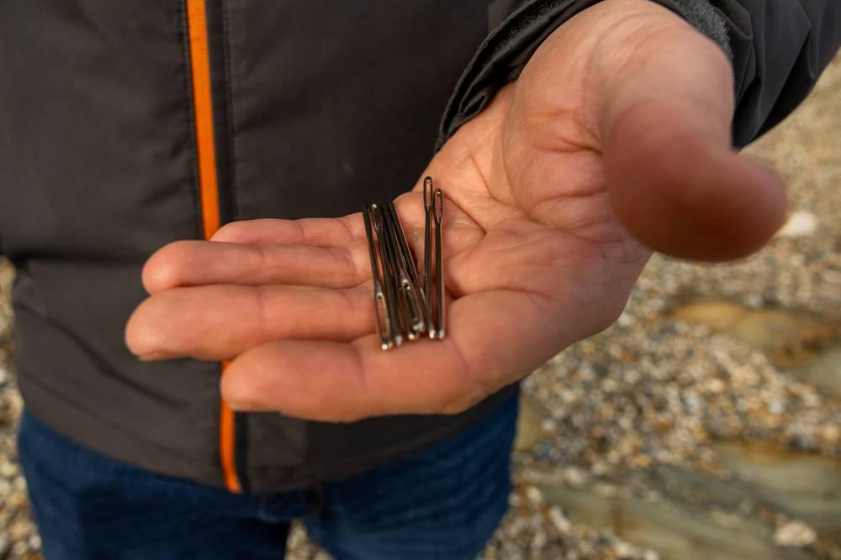
link

Olho de uma agulha

Image Content

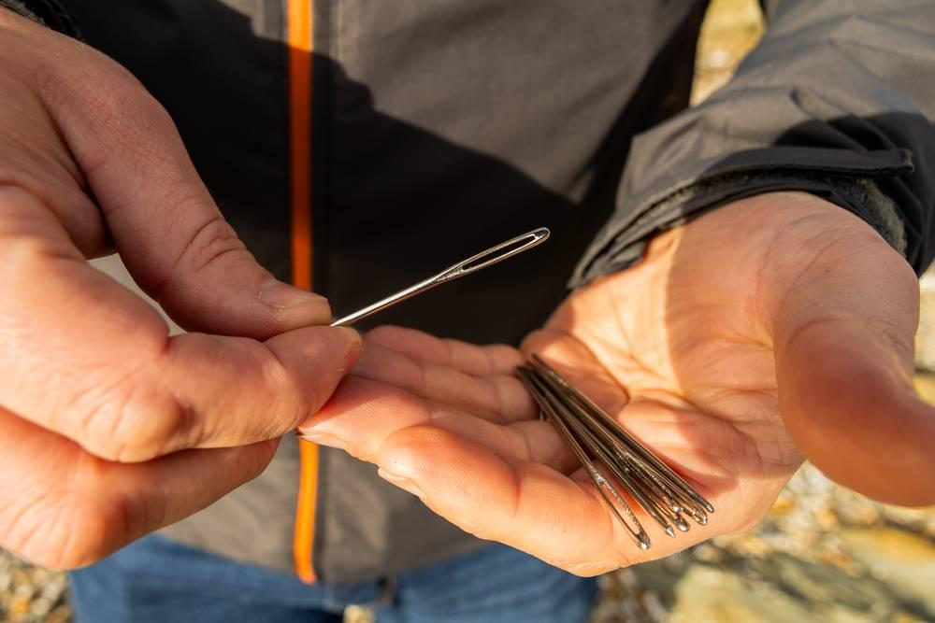
link

Olíbano

Image Content

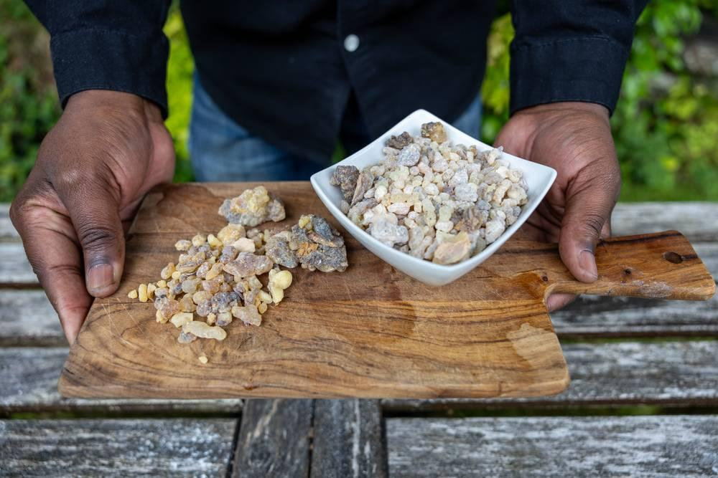
link

Oliveira

Image Content

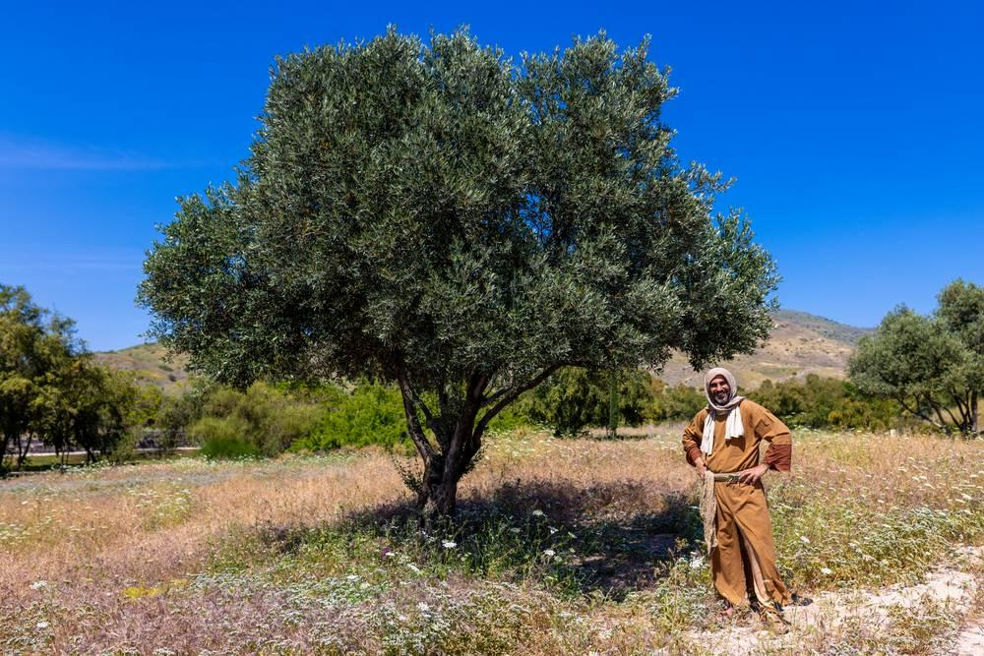
link

Oliveira

Image Content

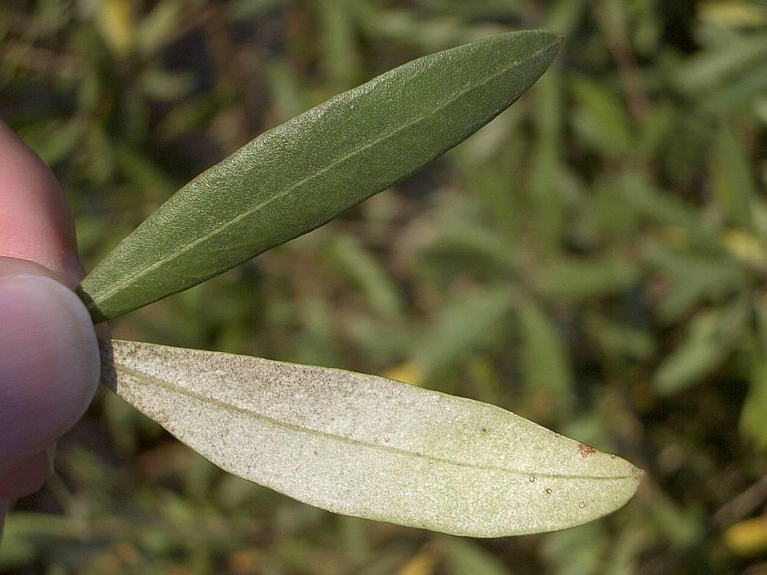
link

Ovelha e cordeiro

Image Content

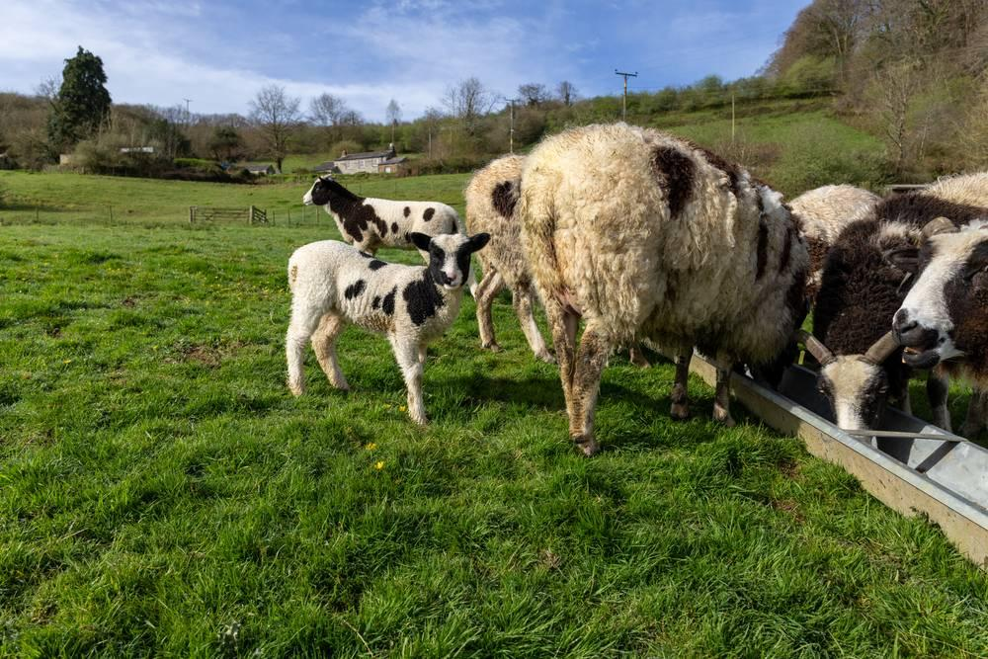
link

Ovelha e cordeiro

Image Content

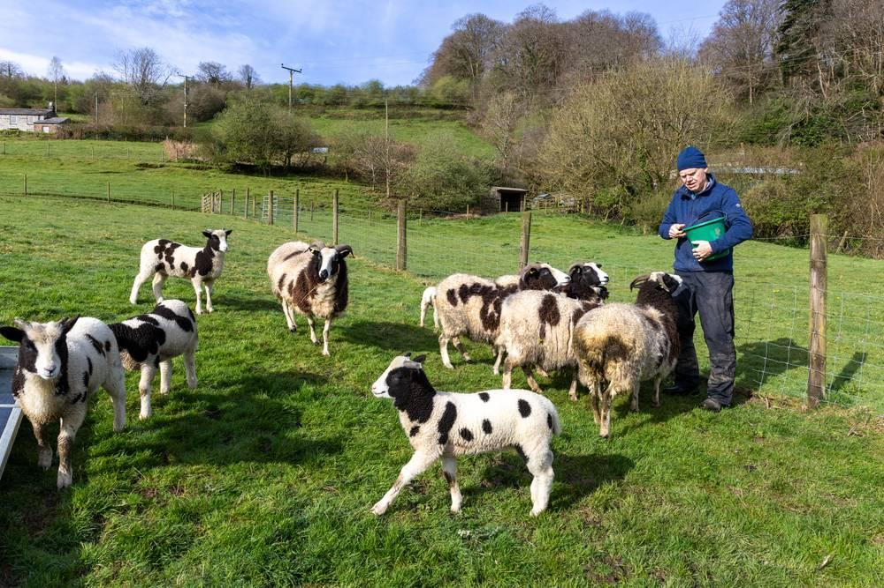
link

Ovelha e cordeiro

Image Content

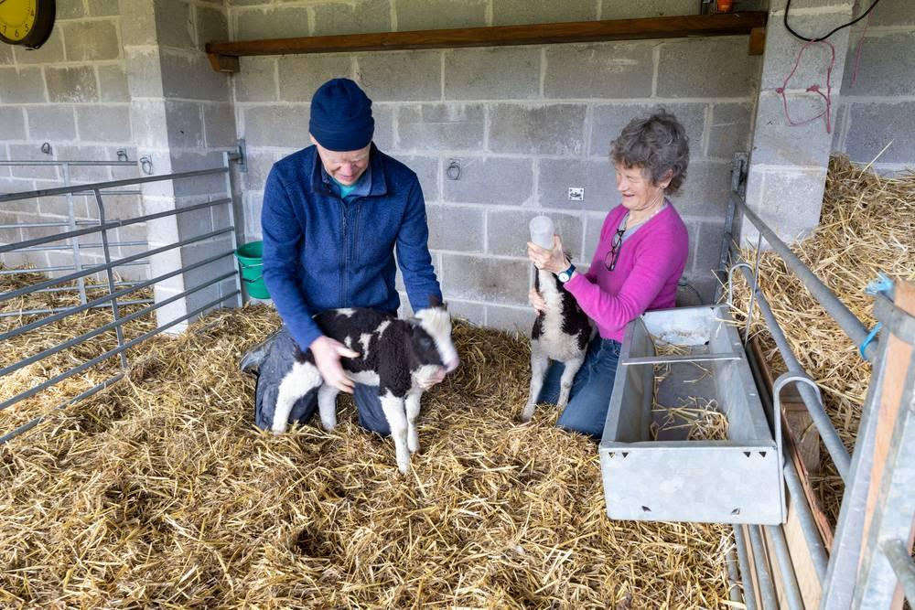
link

Ovelha e lobo

Image Content

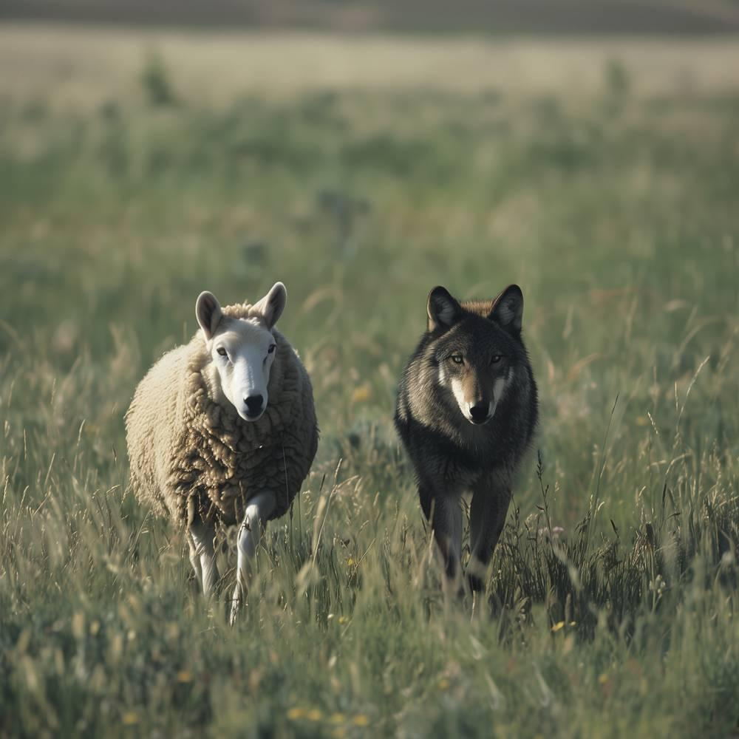
link

Ovelha e lobo

Image Content

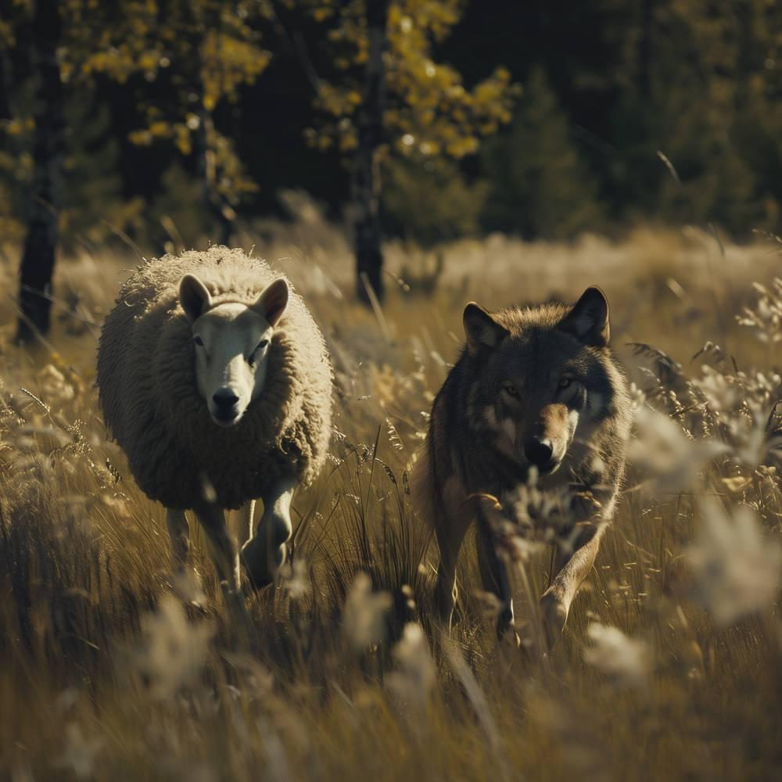
link

Ovelha e lobo

Image Content

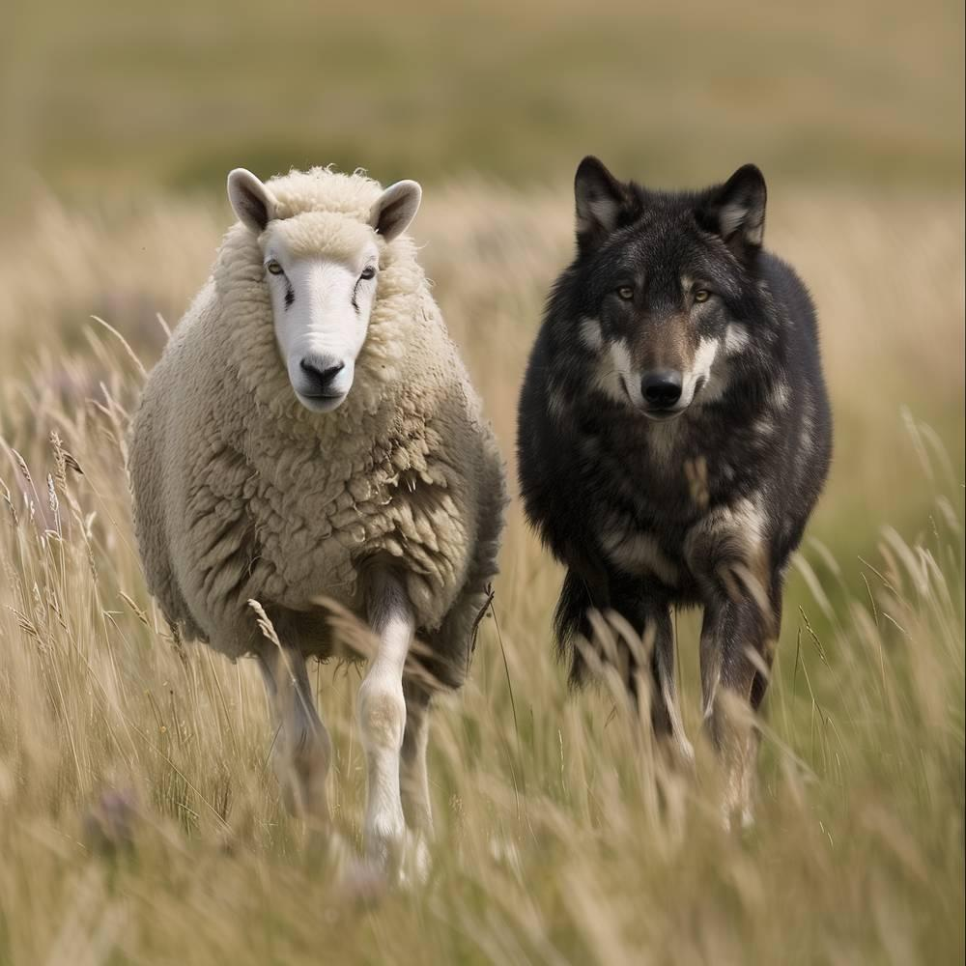
link

Ovelhas

Image Content

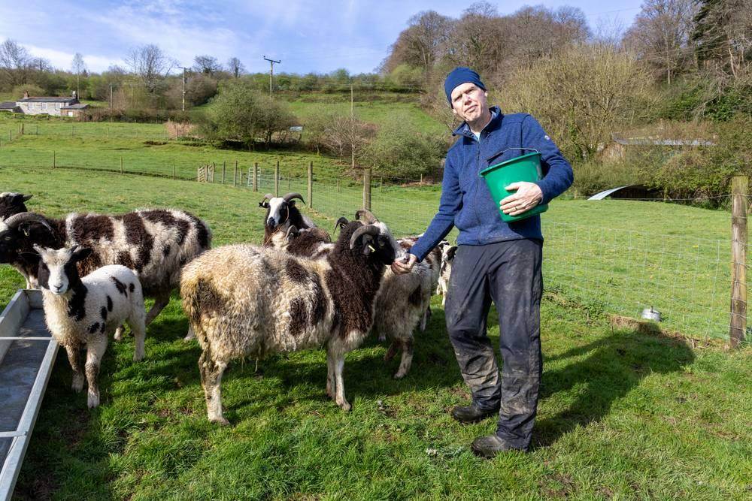
link

Ovelhas

Image Content

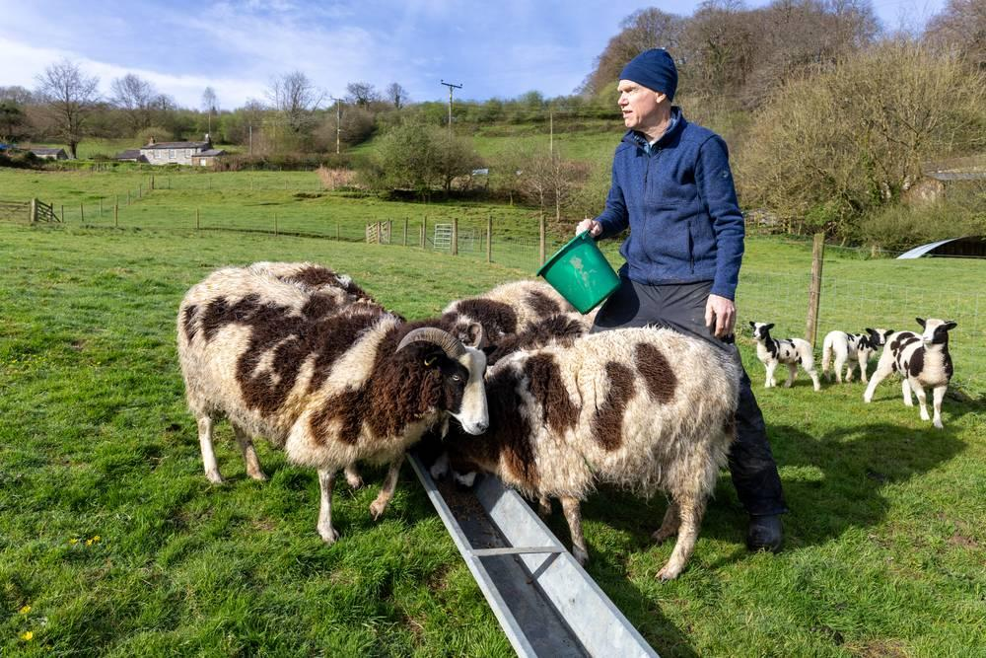
link

Ovelhas

Image Content

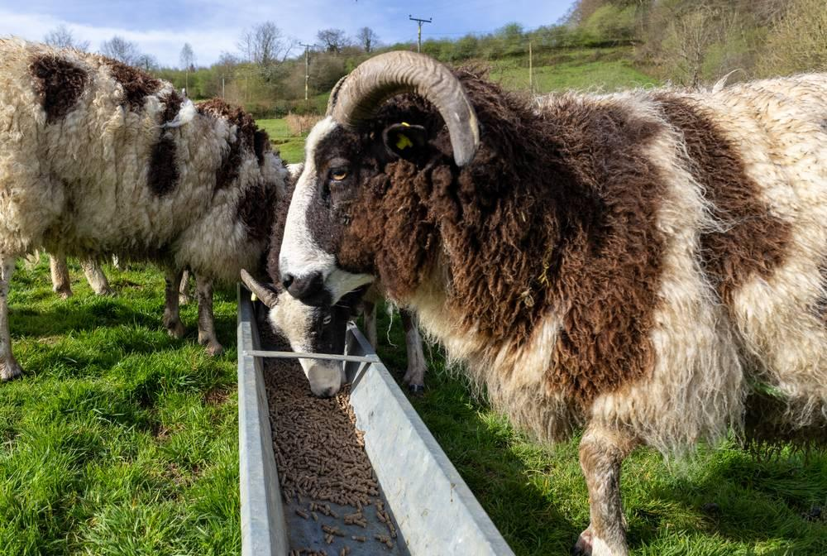
link

Ovelhas e cabras

Image Content

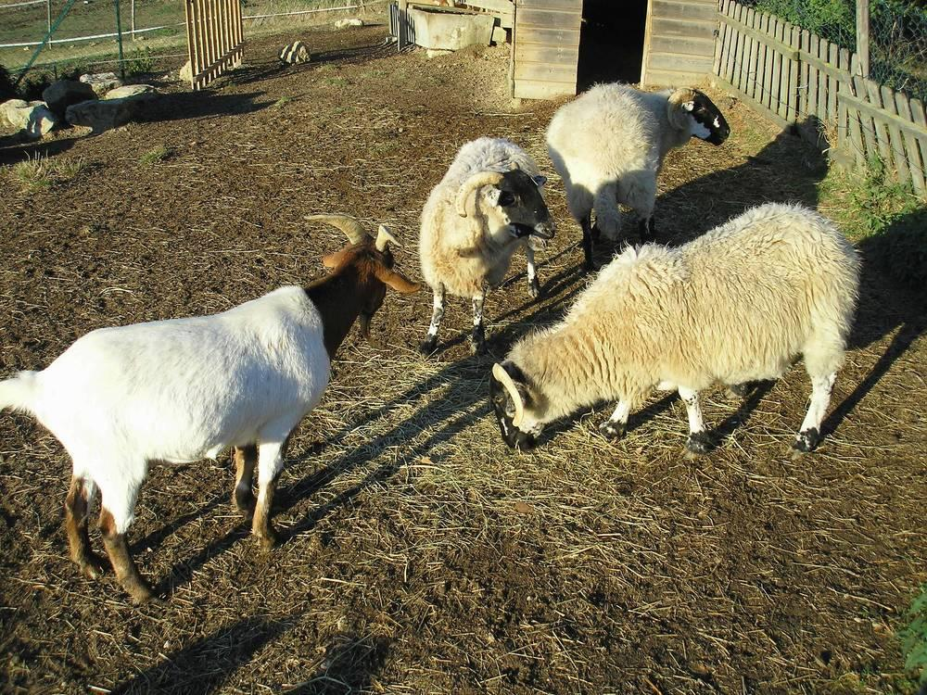
link

Ovelhas e cabras

Image Content

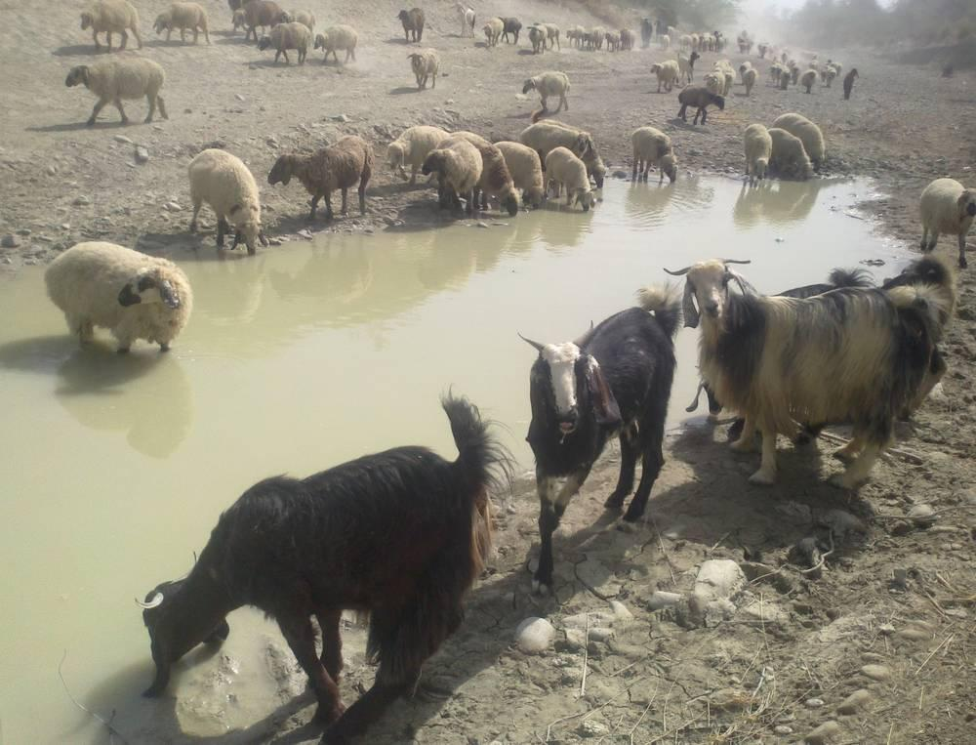
link

