Resource: Familiarization, Internalization, Articulation (Fia) Images
Familiarization, Internalization, Articulation (FIA) Images © 2023 SRV Partners Released under CC BY-SA 4.0 license. Familiarization, Internalization, Articulation (FIA) Images has been adapted in the following languages Tok Pisin, عربي, Français, हिंदी, Bahasa Indonesia, Português, Русский, Español, Kiswahili, 简体中文 from Familiarization, Internalization, Articulation (FIA) © 2023 SRV Partners. Released under CC BY-SA 4.0 license by Mission Mutual

Familiarization, Internalization, Articulation (Fia) Images

R

Ramos de oliveira e palmeira

Image Content

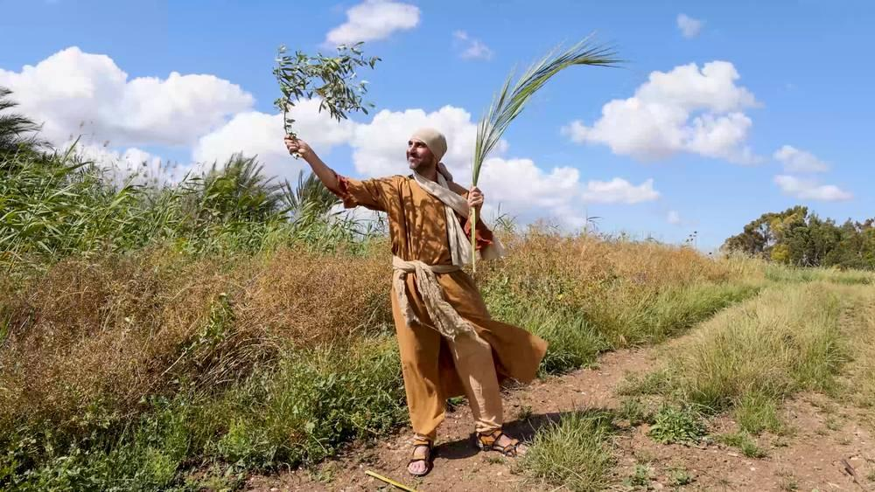
link

Ramos de oliveira e palmeira

Image Content

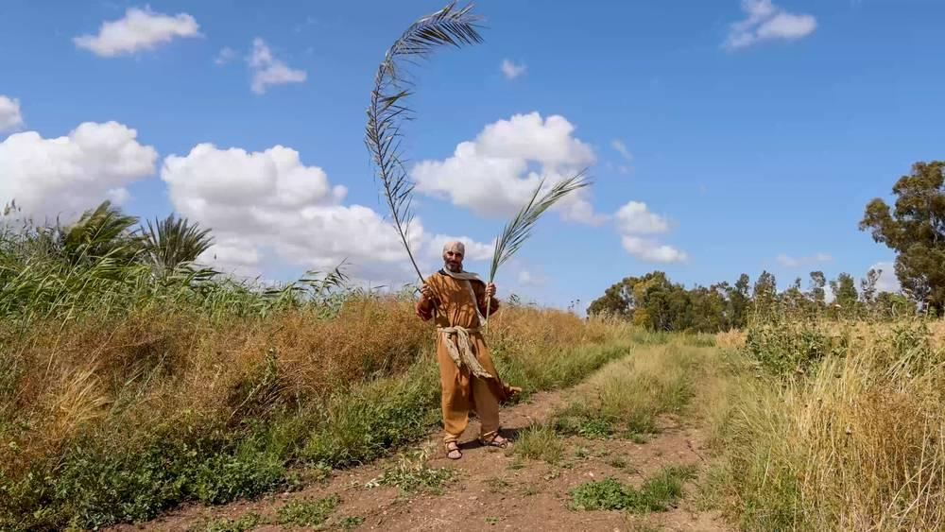
link

Raposa

Image Content

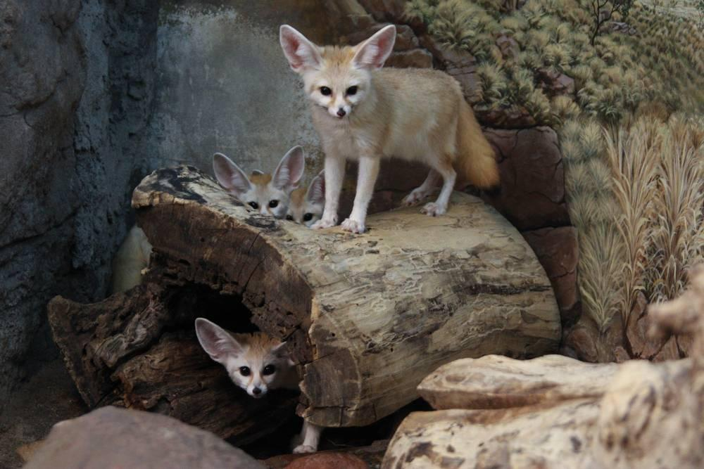
link

Raposa

Image Content

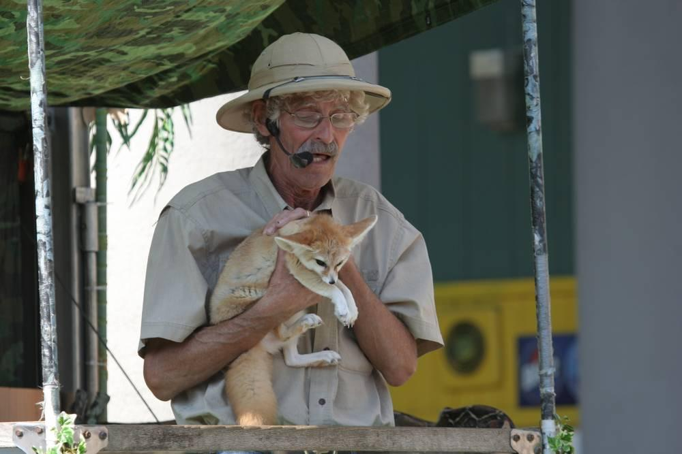
link

Raposa

Image Content

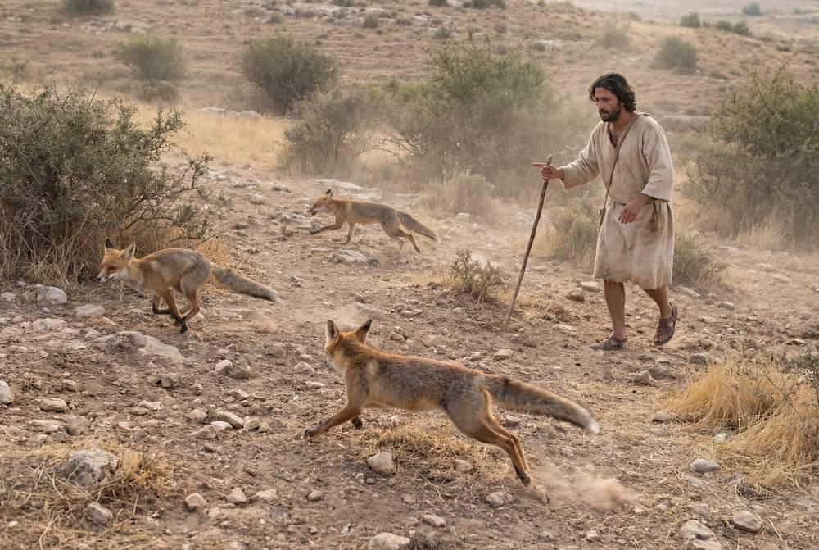
link

Raposa

Image Content

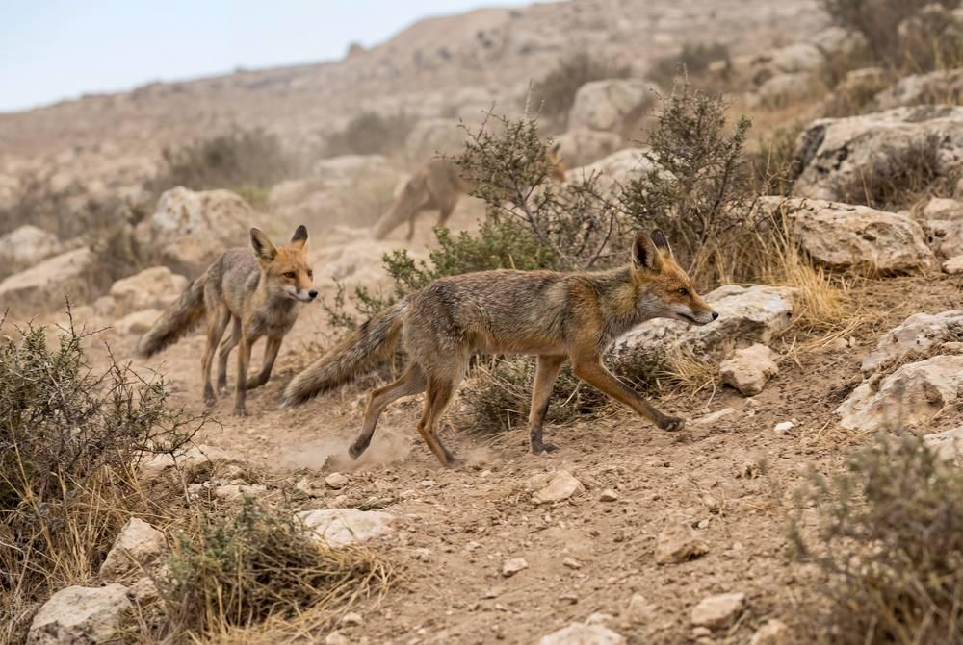
link

Raposa

Image Content

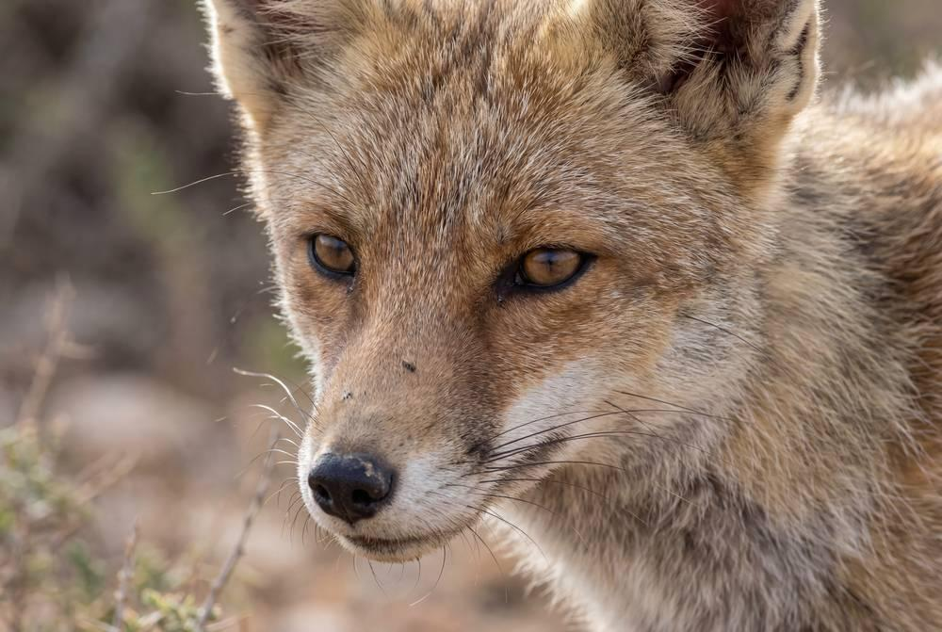
link

Rede de pesca

Image Content

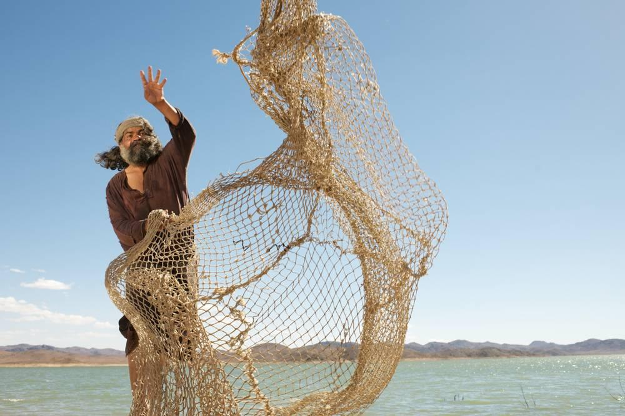
link

Rede de pesca

Image Content

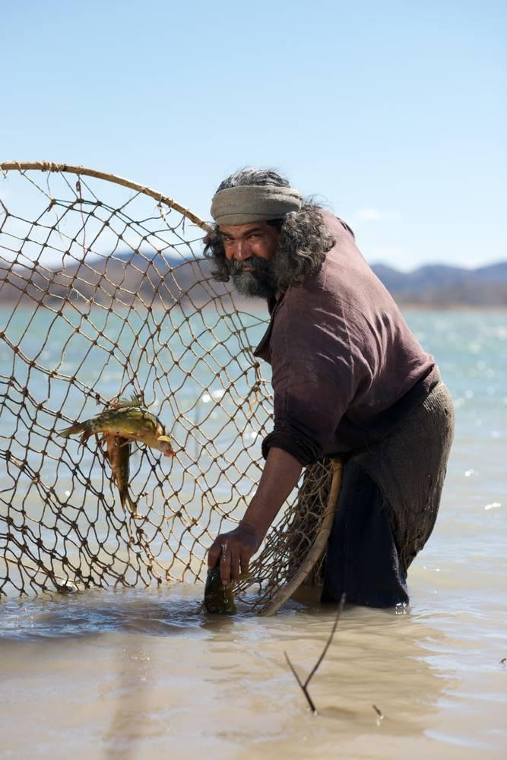
link

Rede de pesca

Image Content

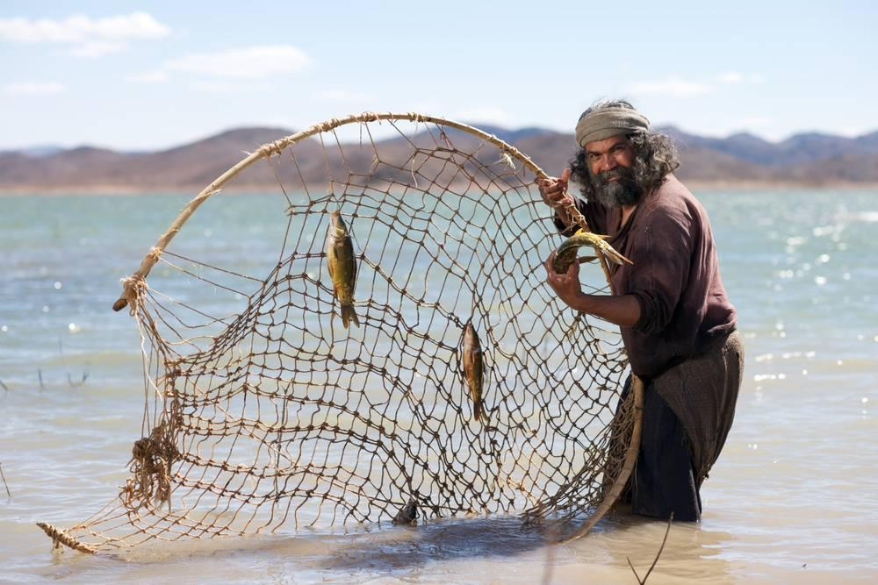
link

Rede de pesca

Image Content

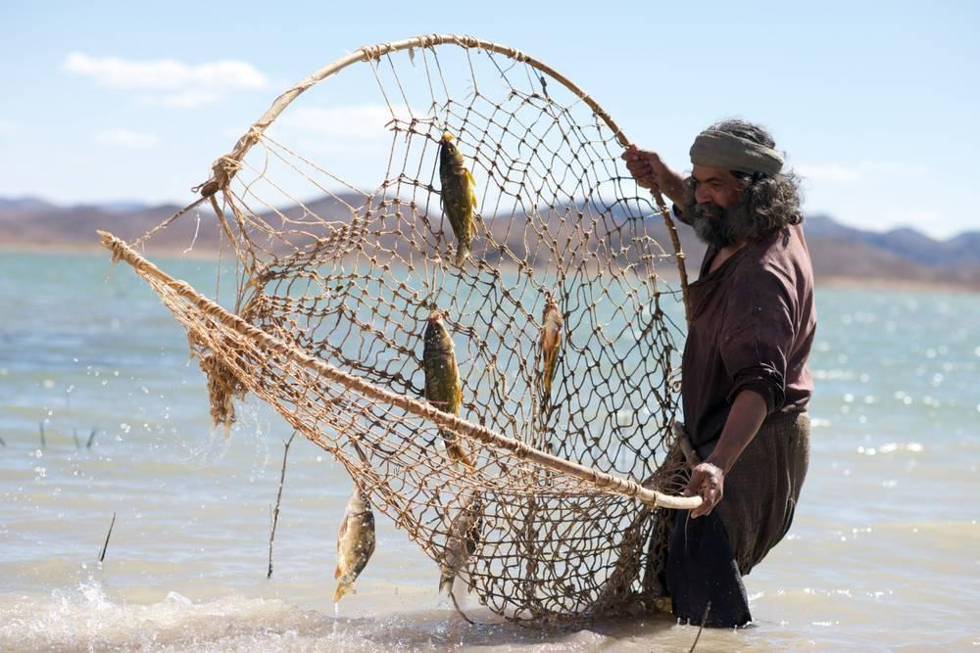
link

Rede de pesca

Image Content

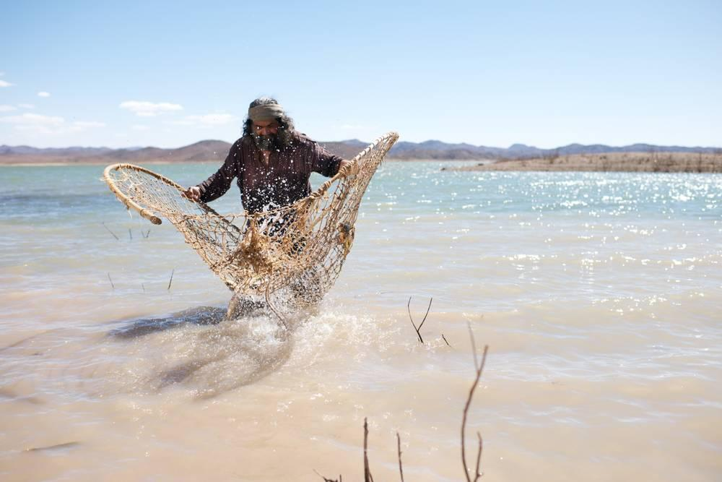
link

Relâmpago

Image Content

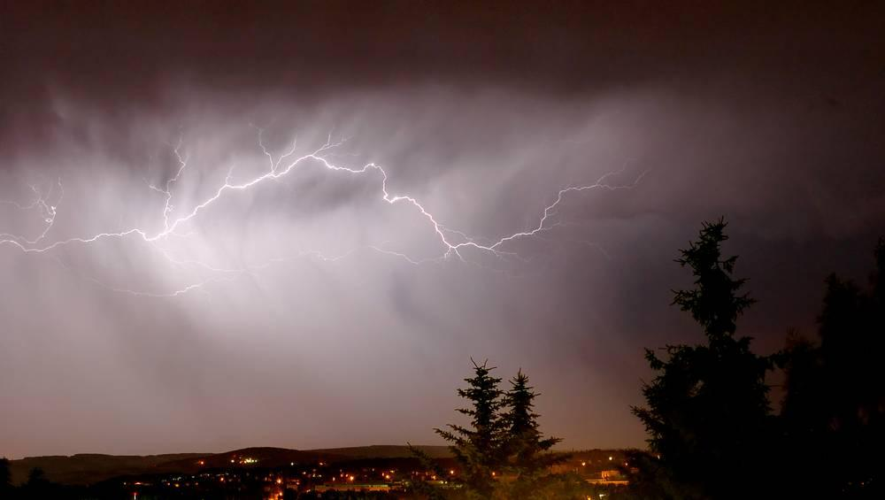
link

Relâmpago

Image Content

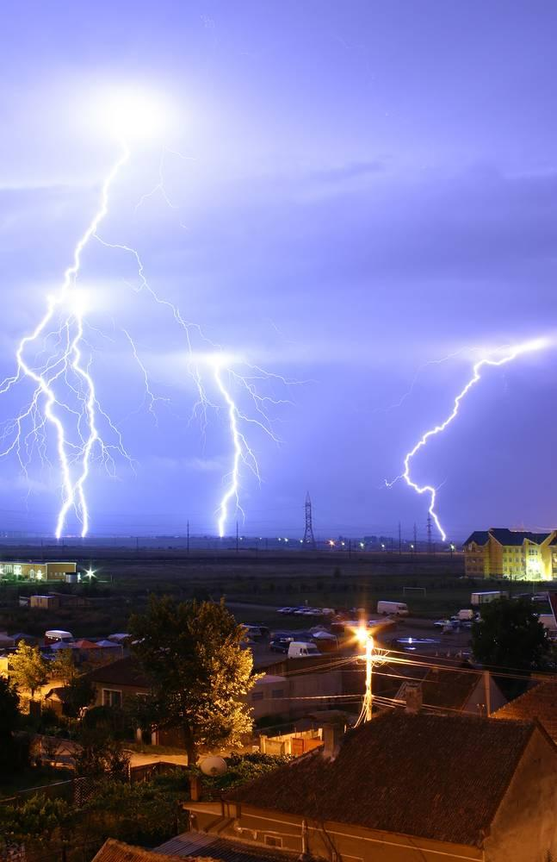
link

Relâmpago

Image Content


link

Relâmpago

Image Content

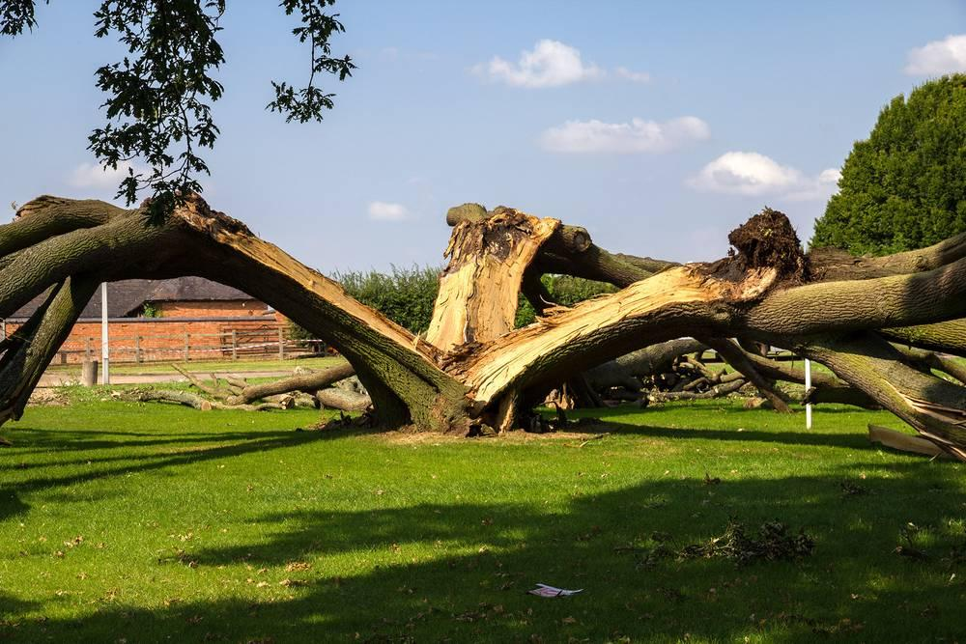
link

Rio Jordão

Image Content

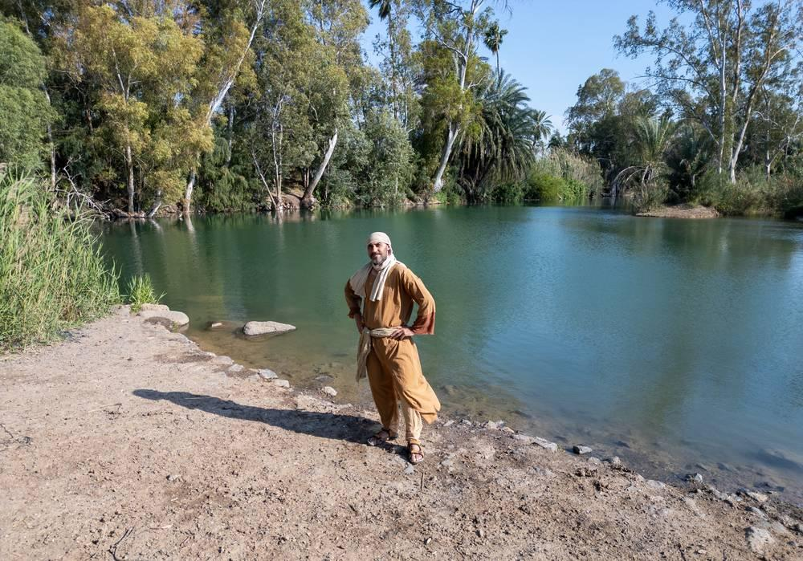
link

Rocha de lava

Image Content

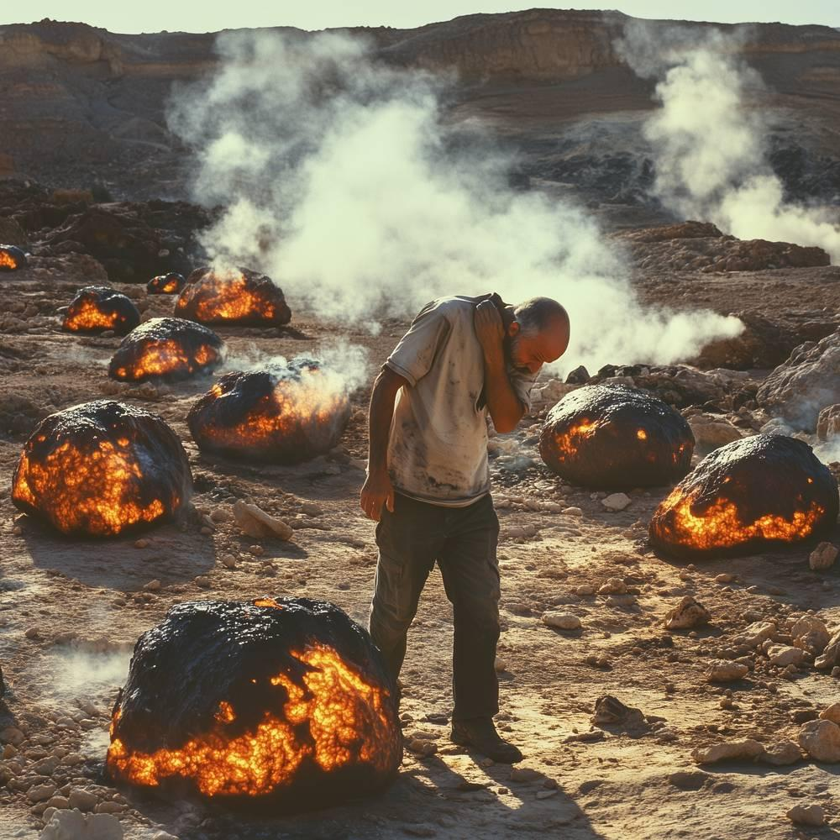
link

Rocha para construir

Image Content

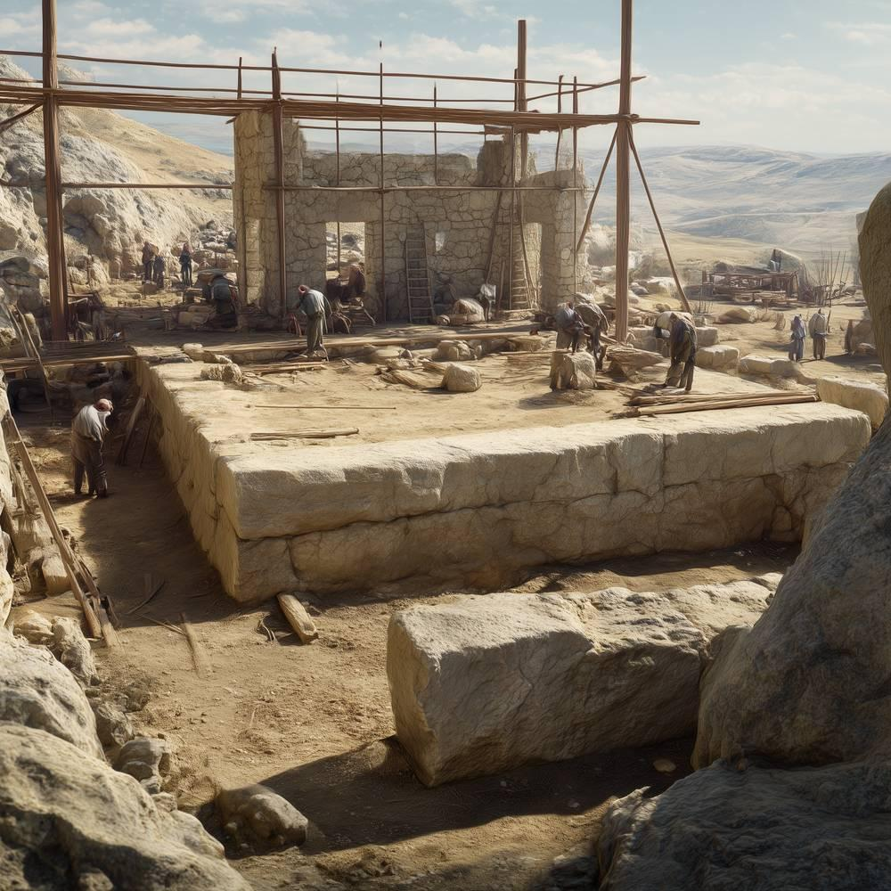
link

Rocha para construir

Image Content

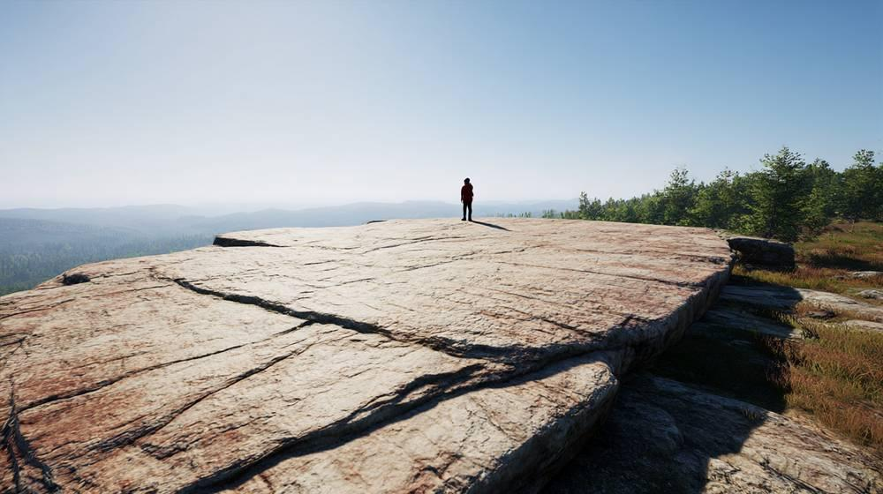
link

Rocha para construir

Image Content

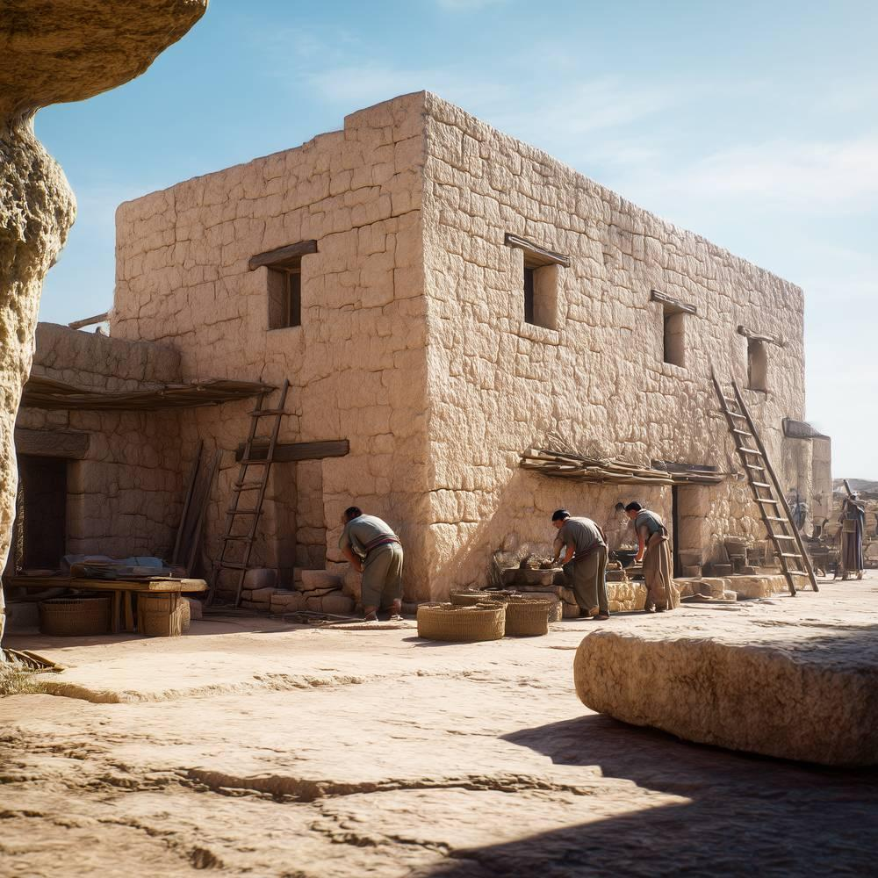
link

Rolo (livro)

Image Content

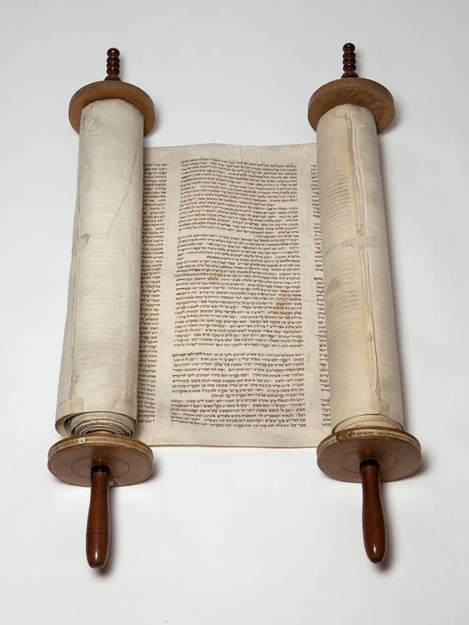
link

Rolos de pergaminho

Image Content

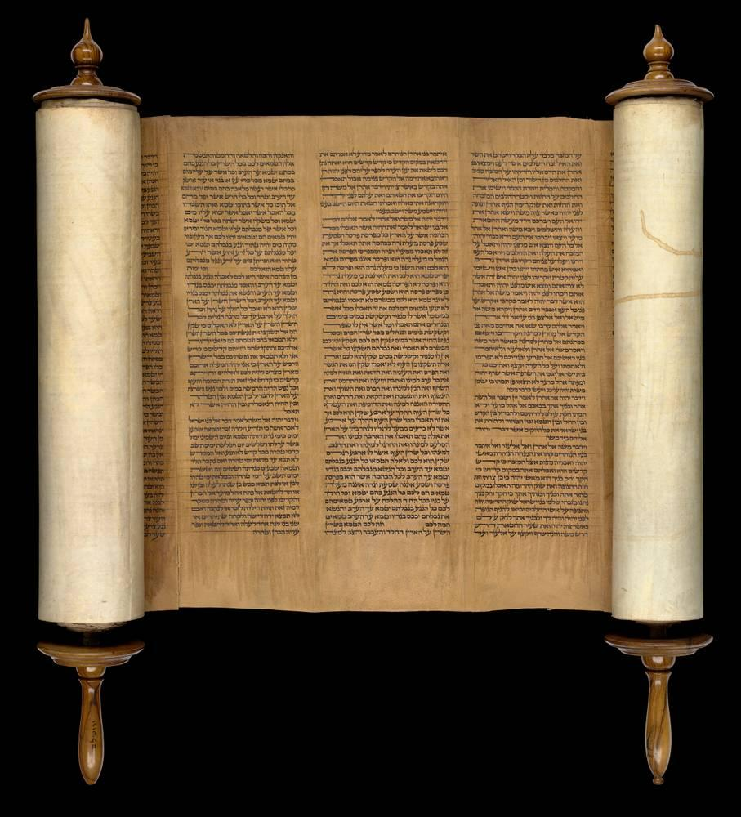
link

Rolos de pergaminho

Image Content

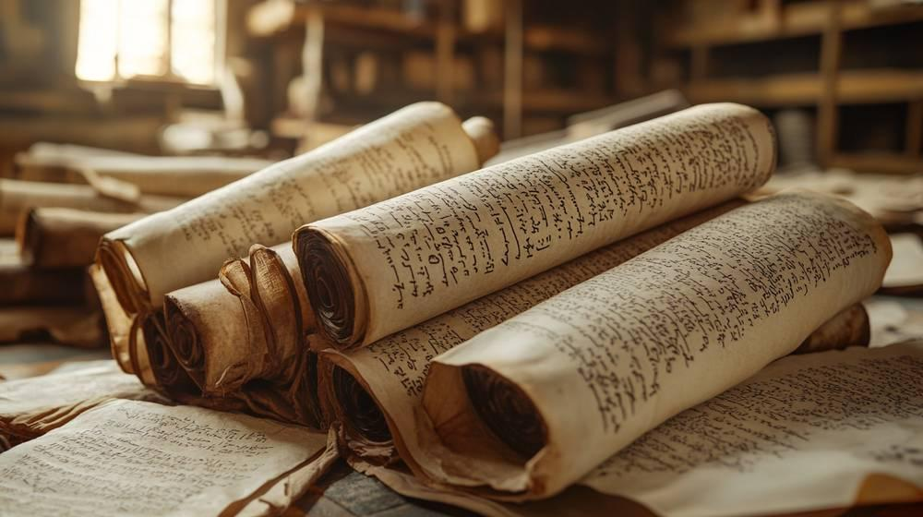
link

Rolos de pergaminho

Image Content

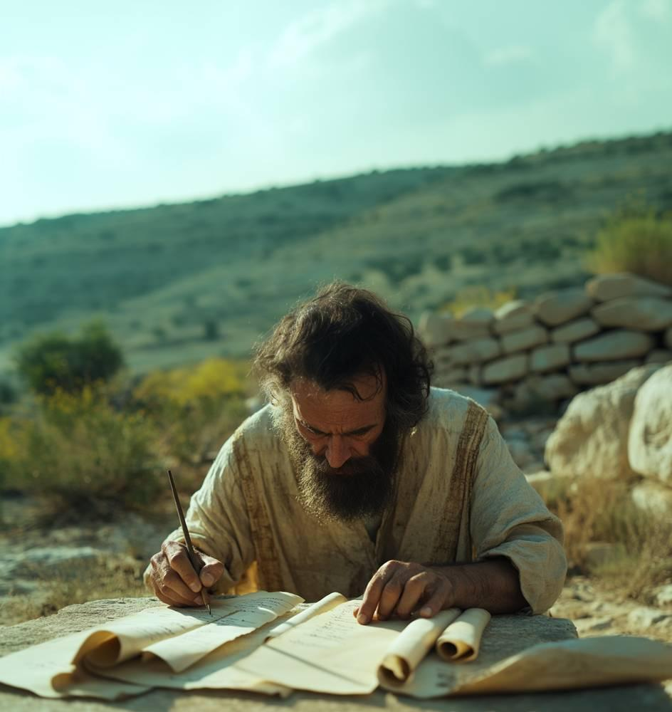
link

Ruínas da Antioquia antiga

Image Content

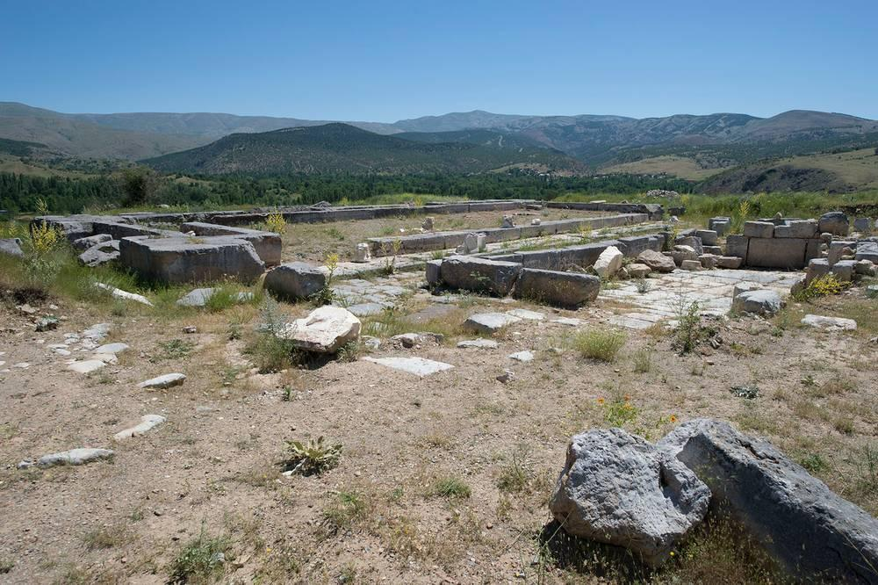
link

Ruínas da Antioquia antiga

Image Content

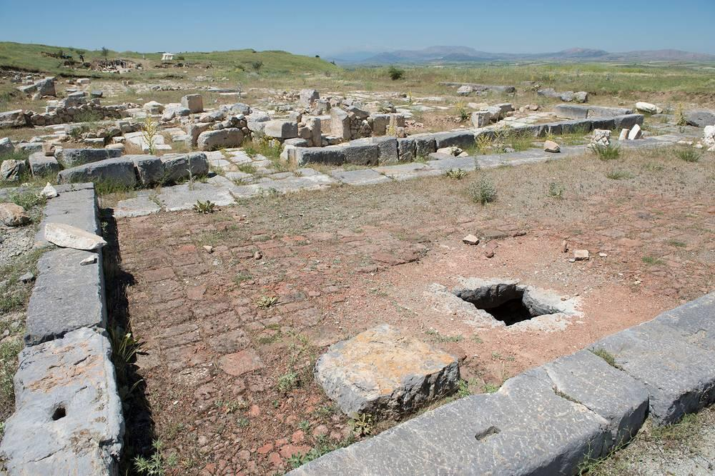
link

Ruínas da Antioquia antiga

Image Content

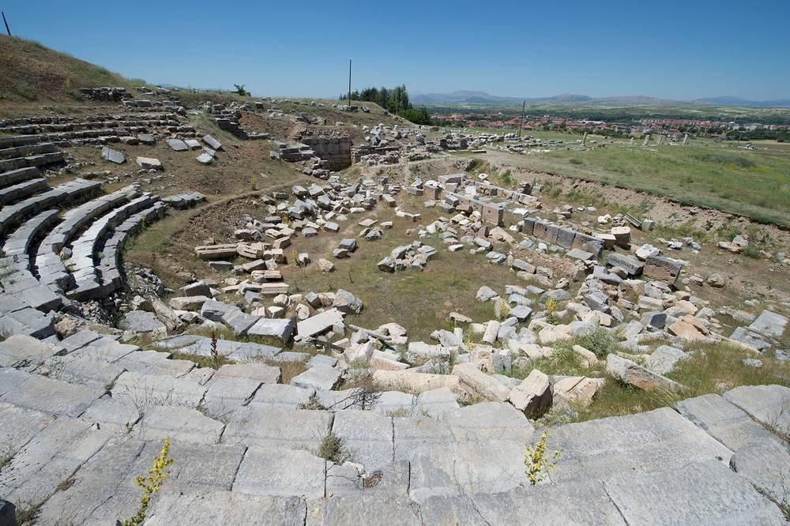
link

