Resource: Familiarization, Internalization, Articulation (Fia) Images
Familiarization, Internalization, Articulation (FIA) Images © 2023 SRV Partners Released under CC BY-SA 4.0 license. Familiarization, Internalization, Articulation (FIA) Images has been adapted in the following languages Tok Pisin, عربي, Français, हिंदी, Bahasa Indonesia, Português, Русский, Español, Kiswahili, 简体中文 from Familiarization, Internalization, Articulation (FIA) © 2023 SRV Partners. Released under CC BY-SA 4.0 license by Mission Mutual

Familiarization, Internalization, Articulation (Fia) Images

S

Sala de reunião judaica

Image Content

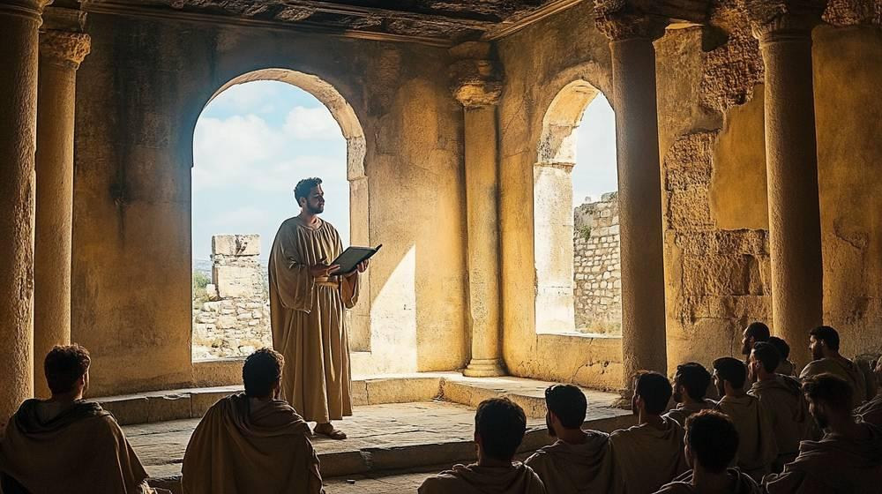
link

Sala de reunião judaica

Image Content

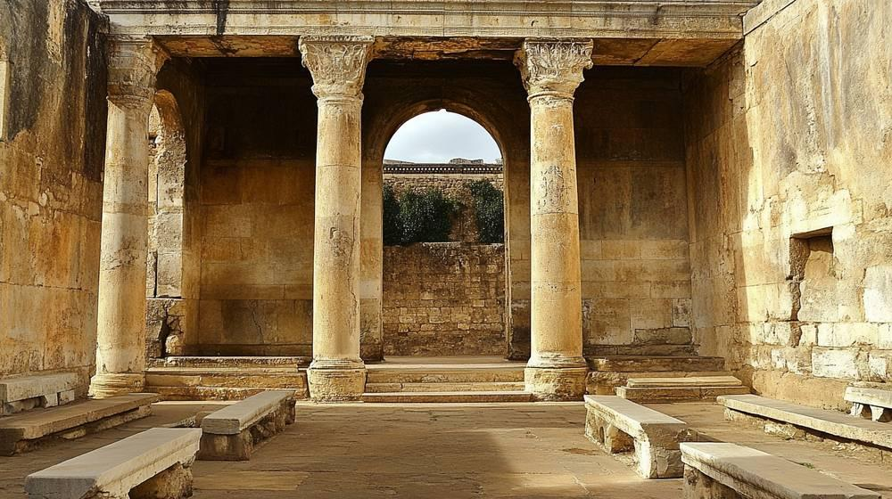
link

Sala de reunião judaica

Image Content

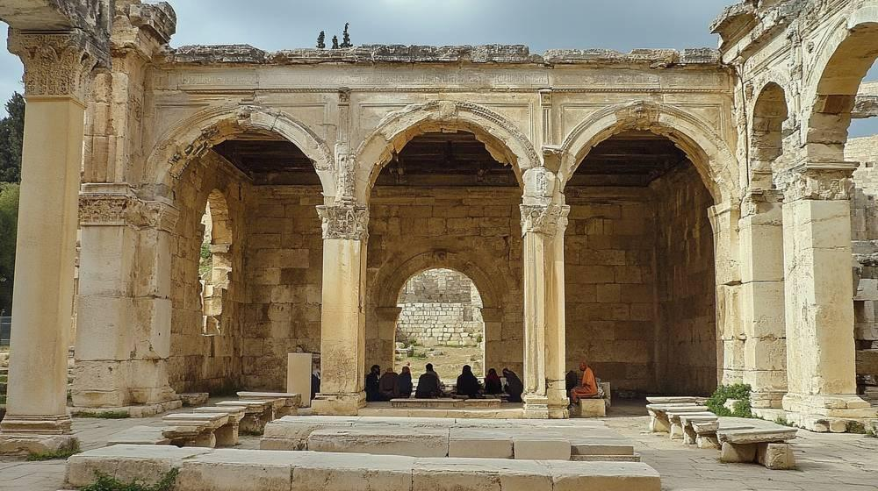
link

Sala superior

Image Content

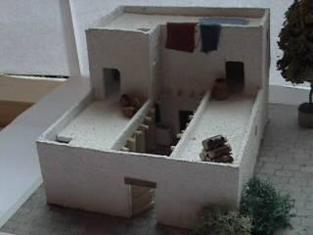
link

Sala superior

Image Content

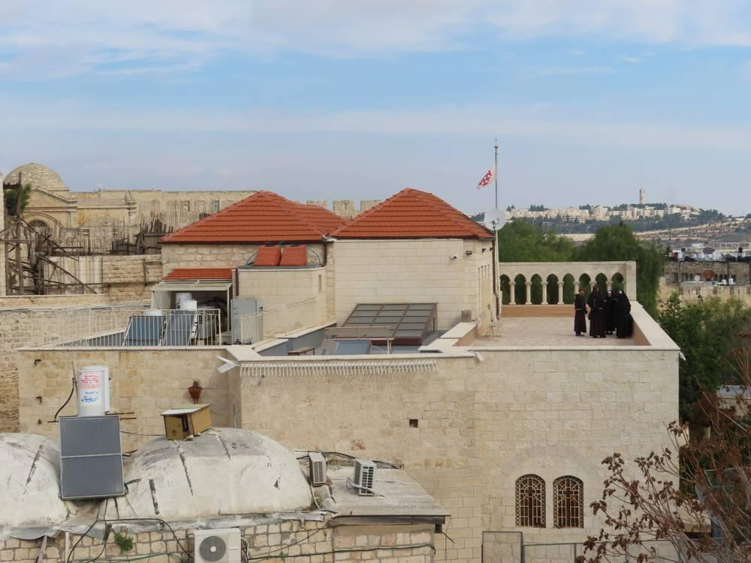
link

Sala superior

Image Content

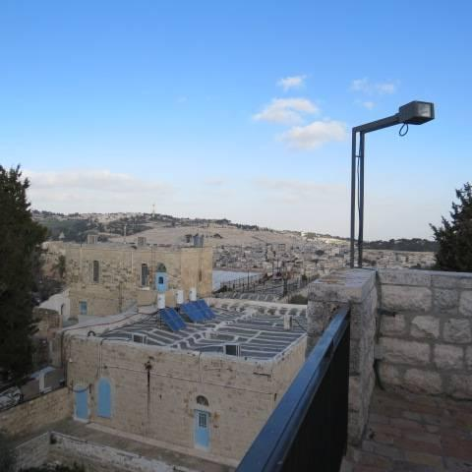
link

Sandálias

Image Content

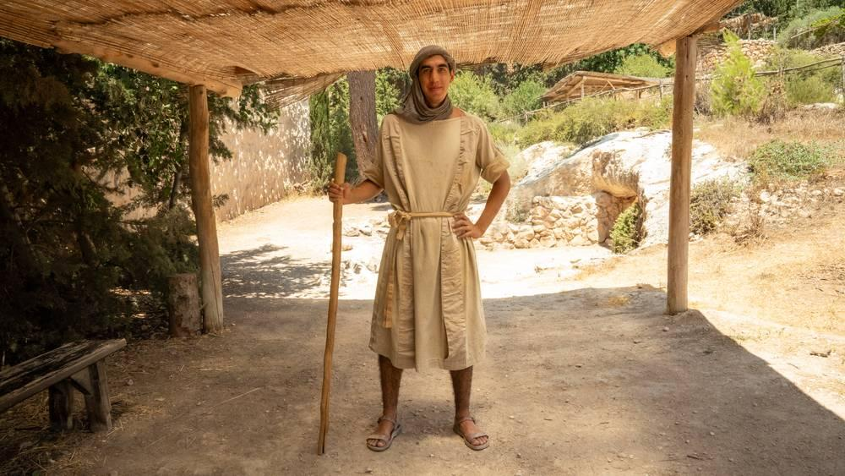
link

Sandálias

Image Content

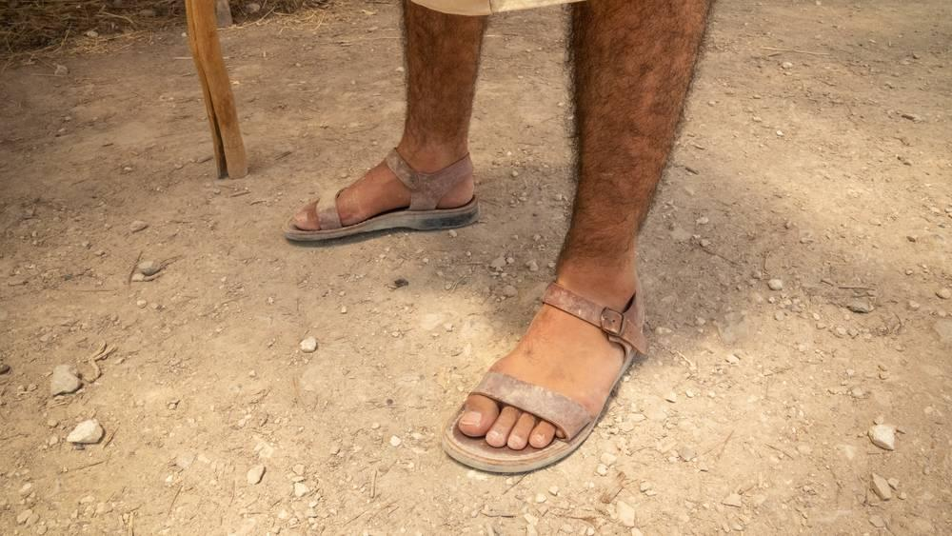
link

Santuário do Templo de Herodes

Image Content

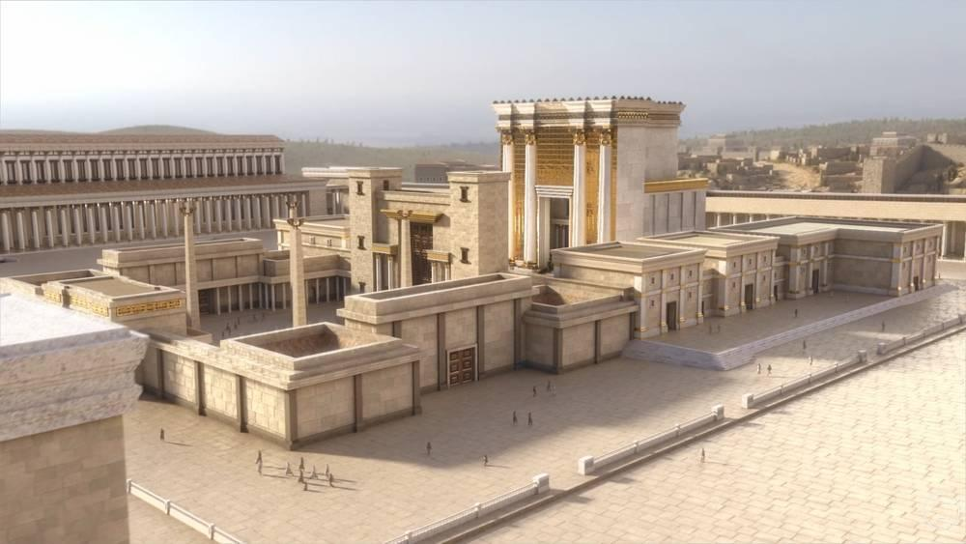
link

Semeador

Image Content

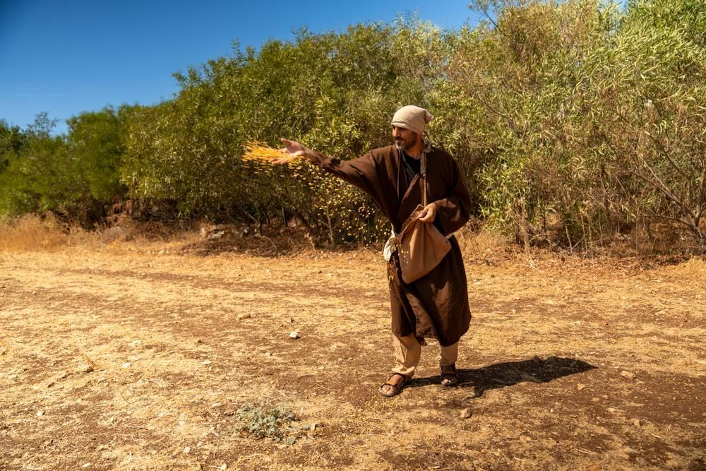
link

Semeador

Image Content

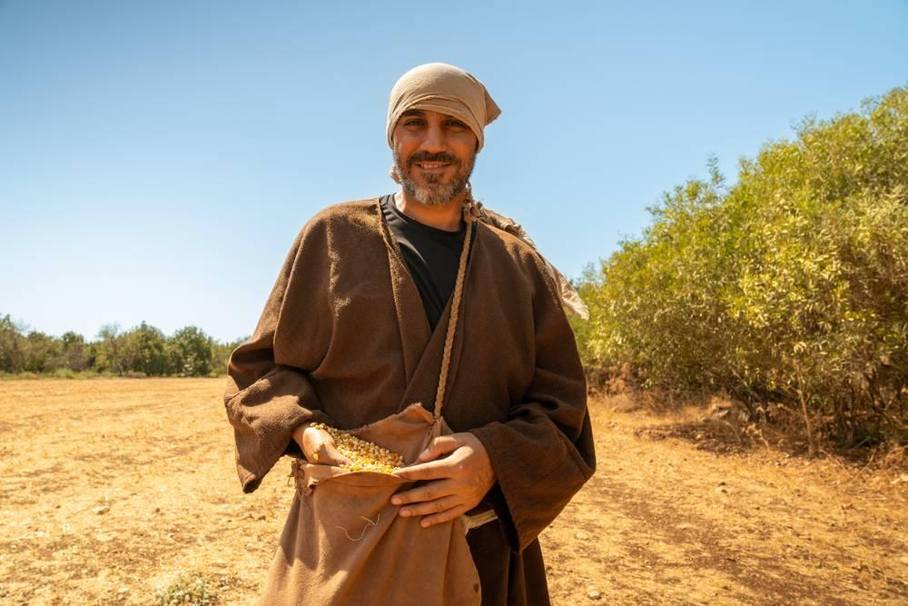
link

Semente de mostarda

Image Content

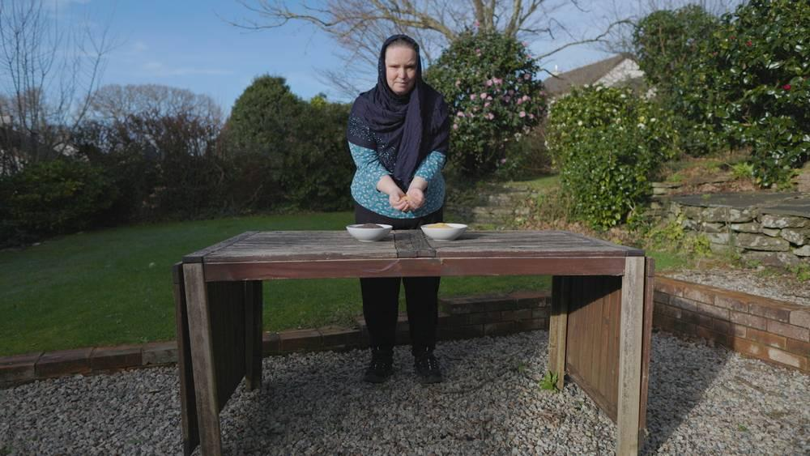
link

Semente de mostarda

Image Content

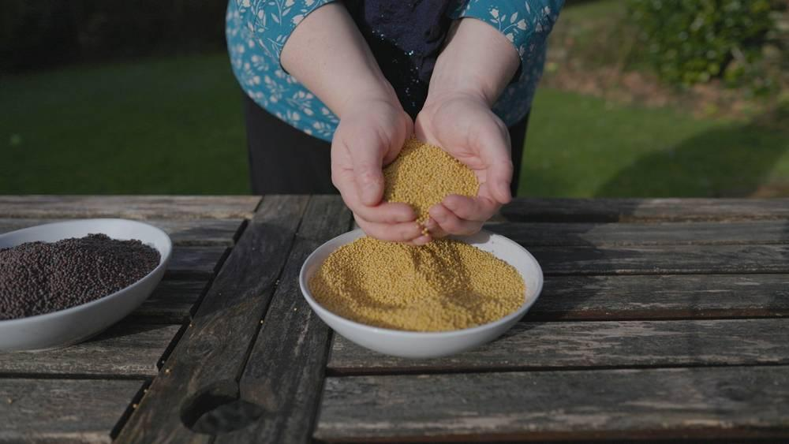
link

Semente de mostarda

Image Content

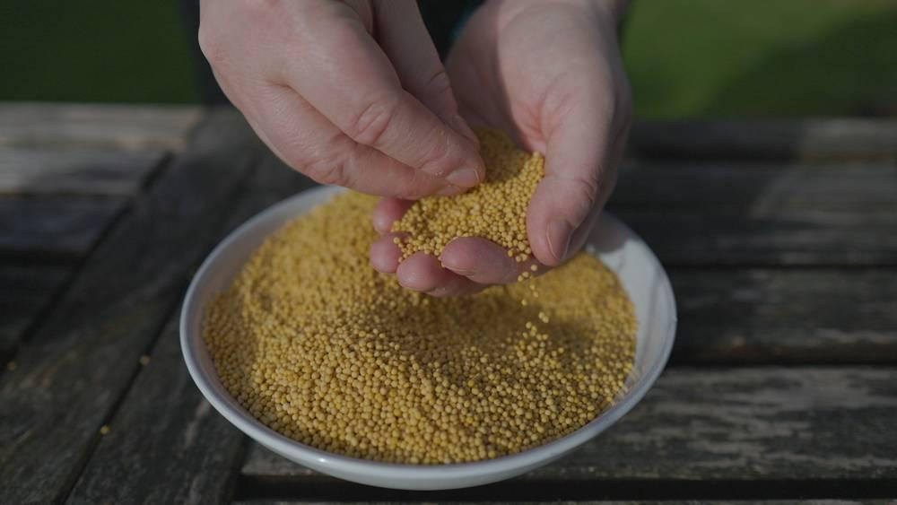
link

Semente de mostarda

Image Content

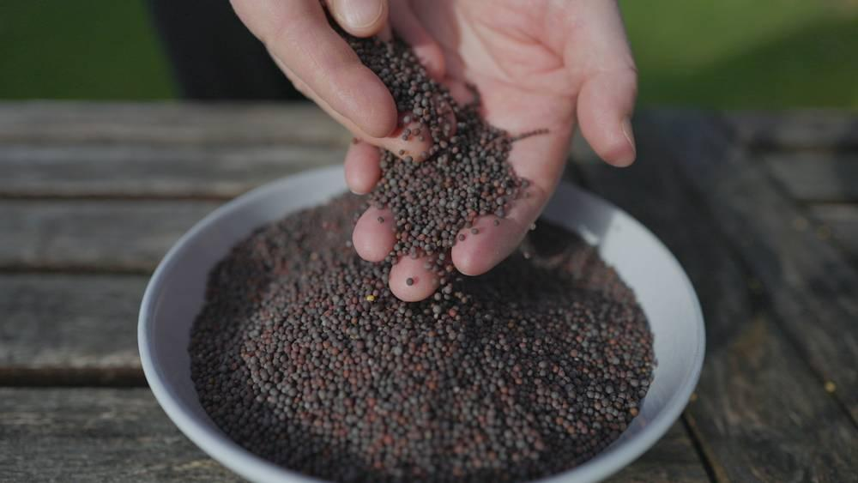
link

Serpente

Image Content

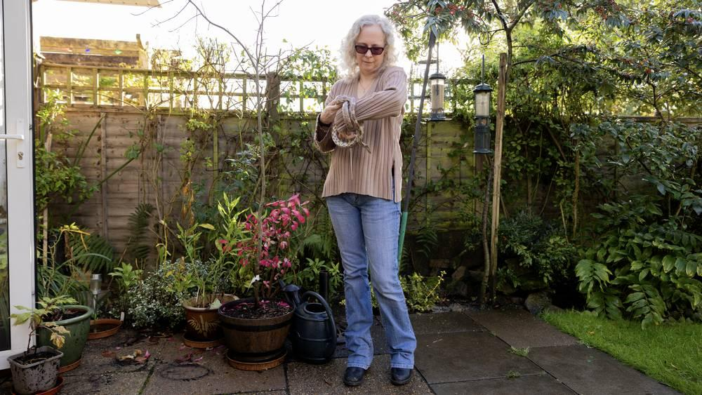
link

Serpente

Image Content

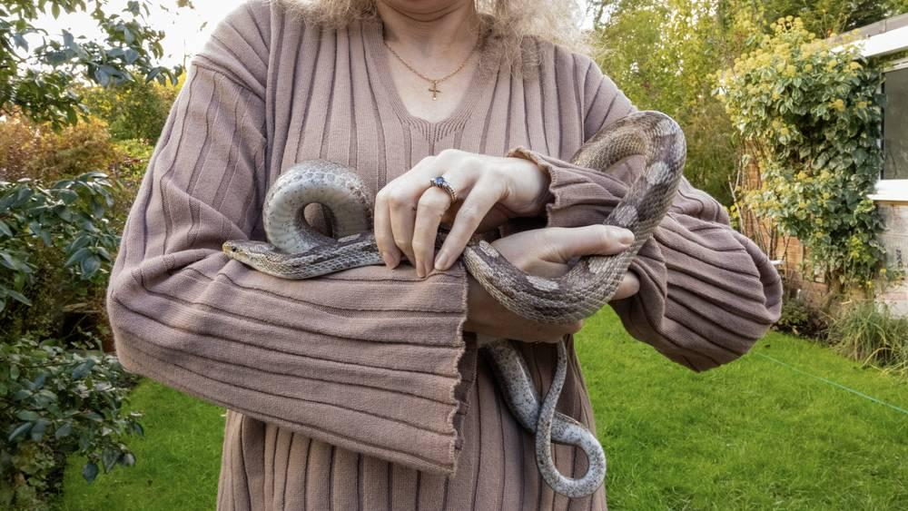
link

Serpente

Image Content

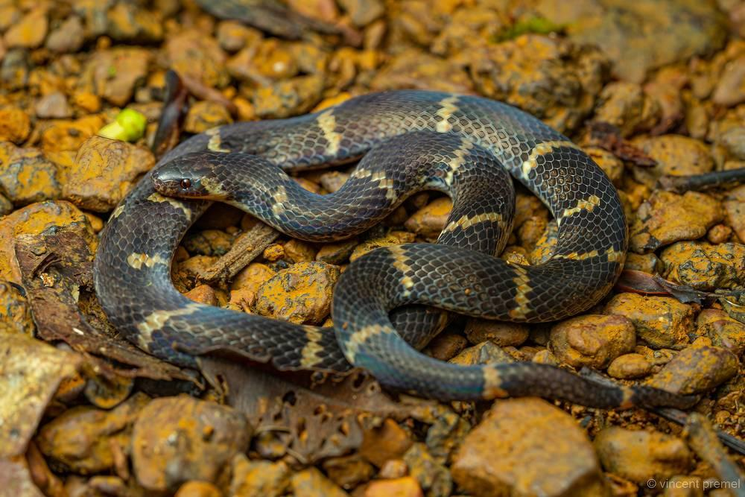
link

Serpente

Image Content

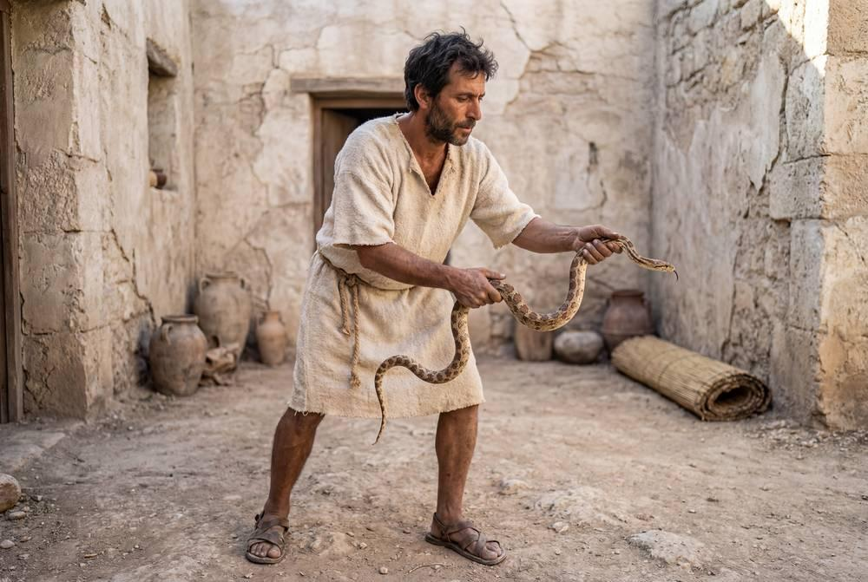
link

Serpente

Image Content

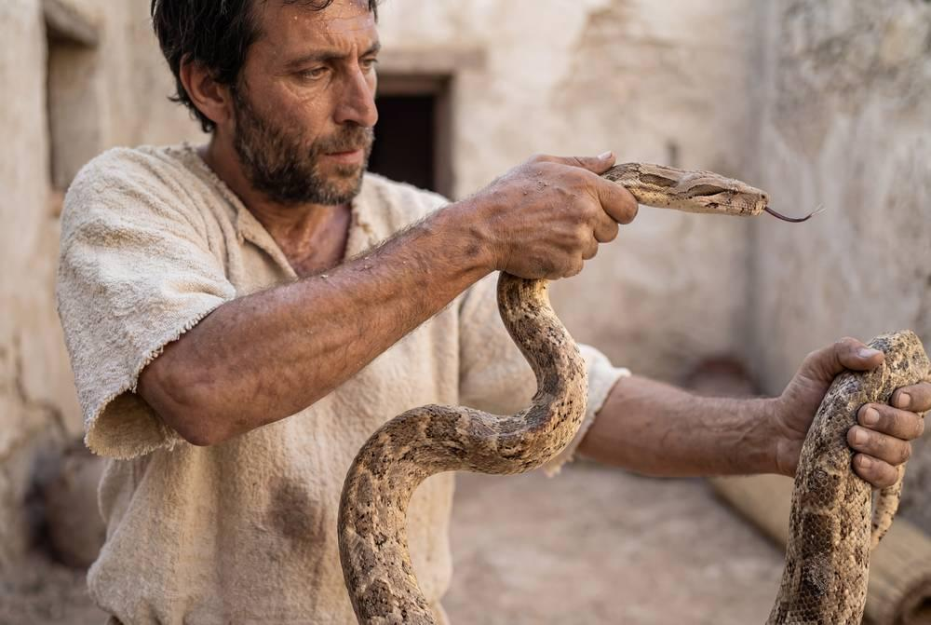
link

Serpente

Image Content

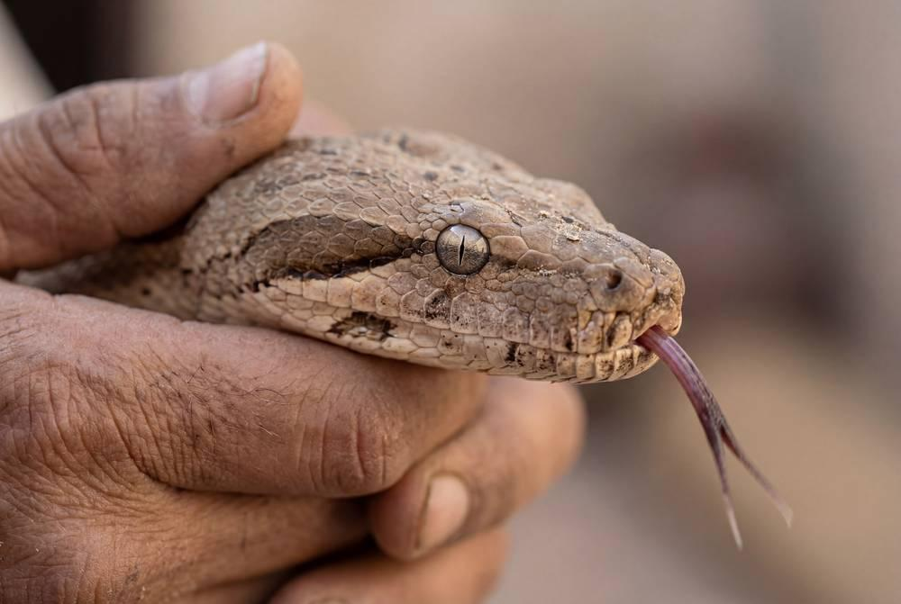
link

Sinagoga

Image Content

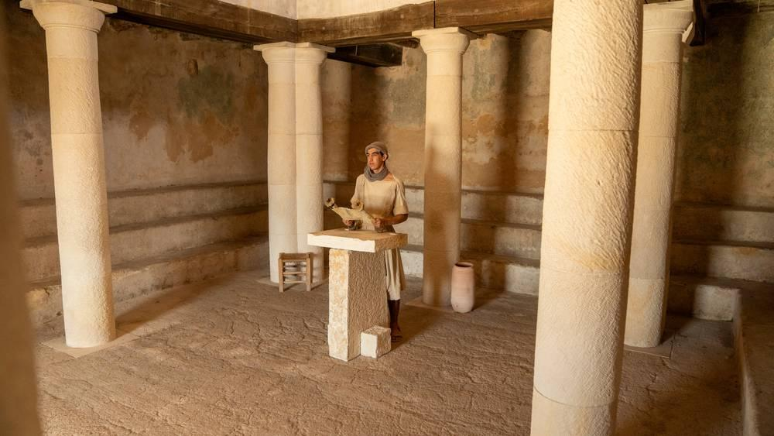
link

Sinagoga

Image Content

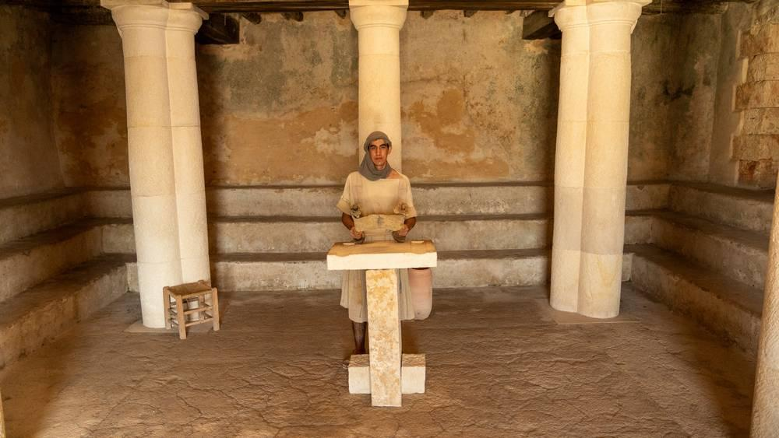
link

Sinagoga

Image Content

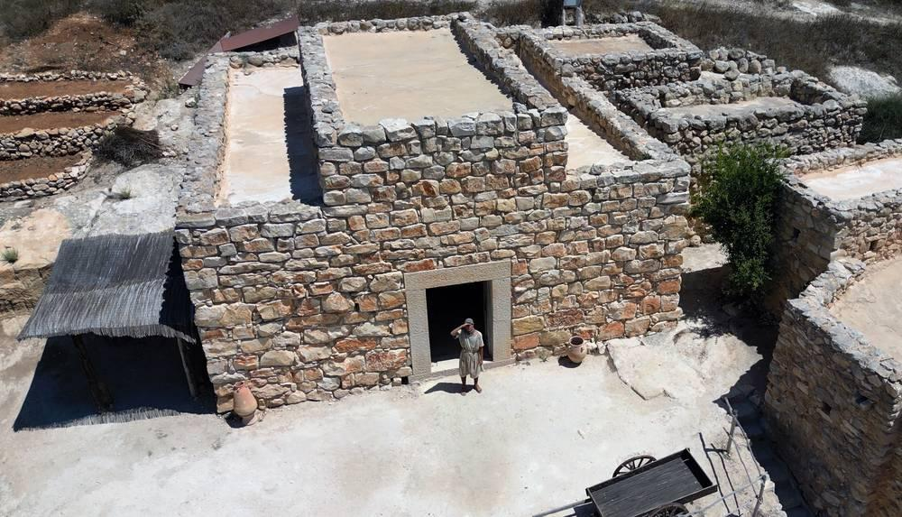
link

Sinagoga de Cafarnaum

Image Content

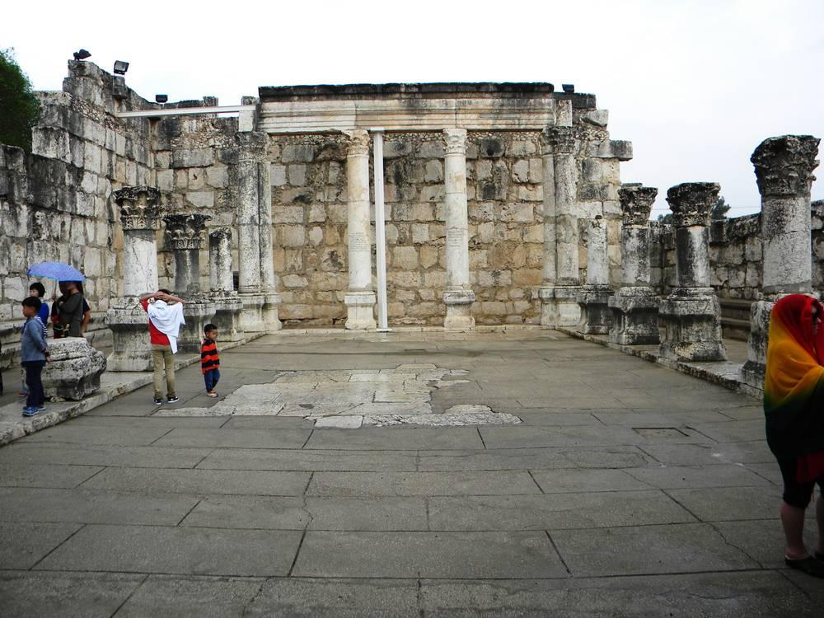
link

Sinagoga de Cafarnaum

Image Content

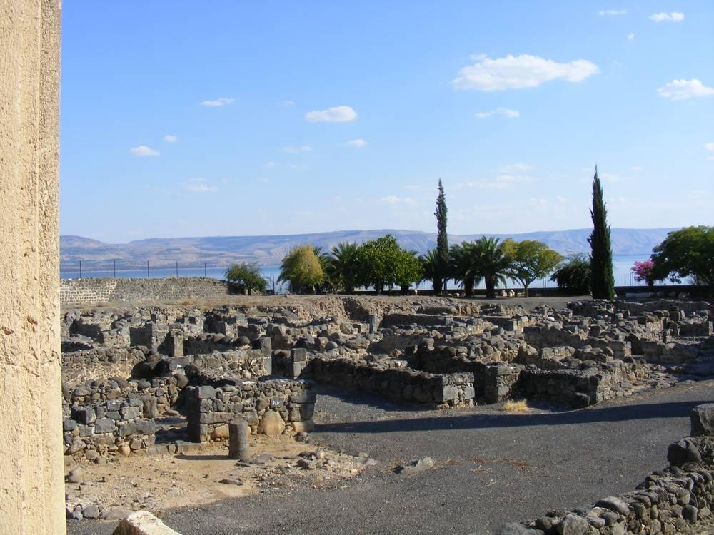
link

Soldado romano com armadura completa

Image Content

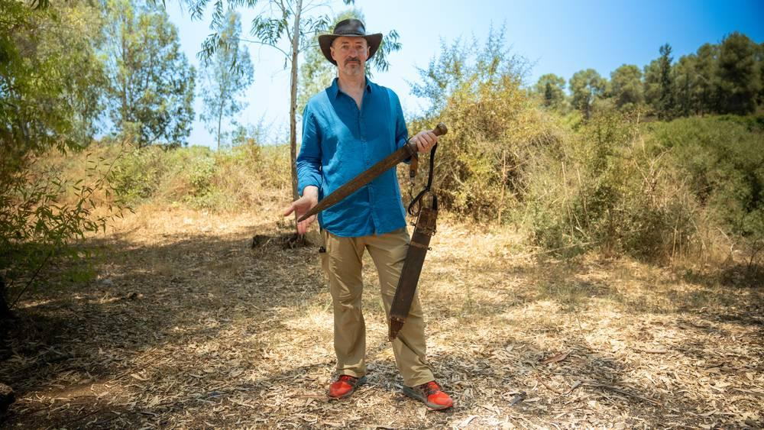
link

Soldado romano com armadura completa

Image Content

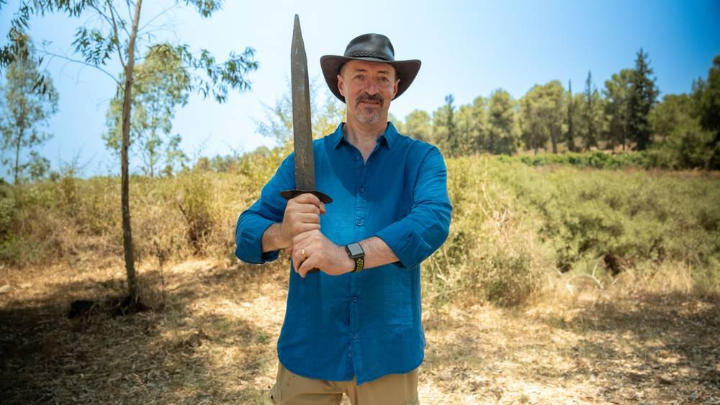
link

Soldado romano com armadura completa

Image Content

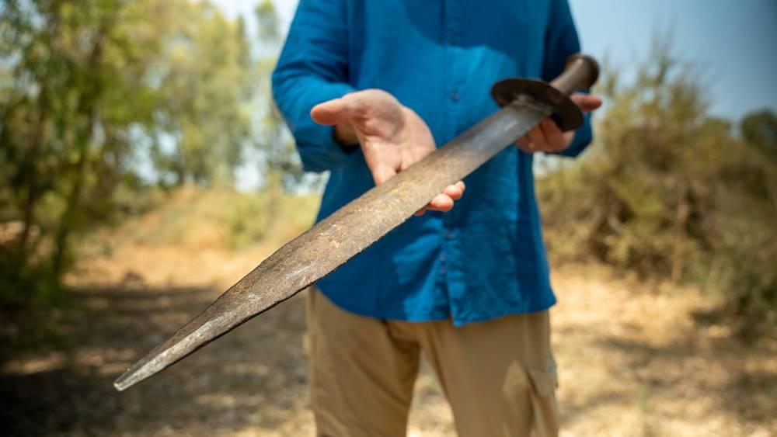
link

Soldado romano com armadura completa

Image Content

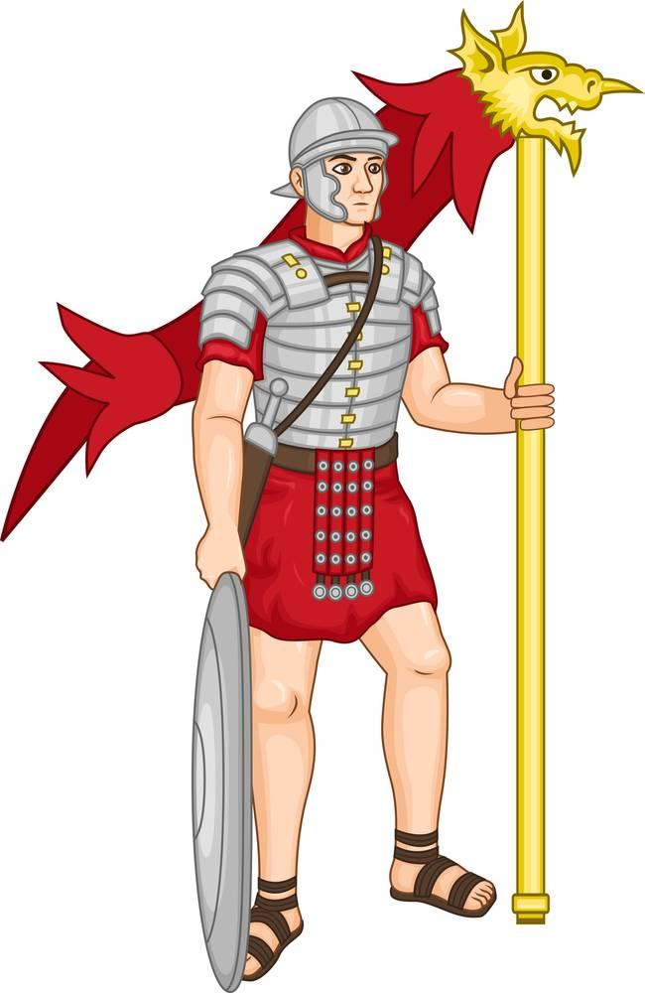
link

Soldado romano com armadura completa

Image Content

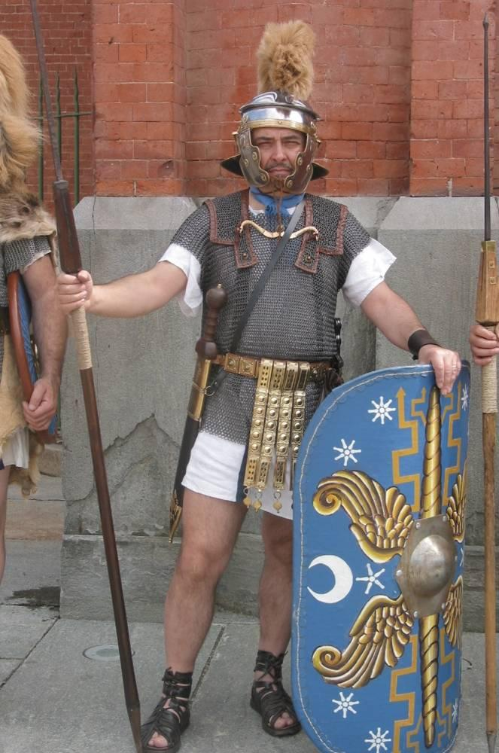
link

Soldado romano com armadura completa

Image Content

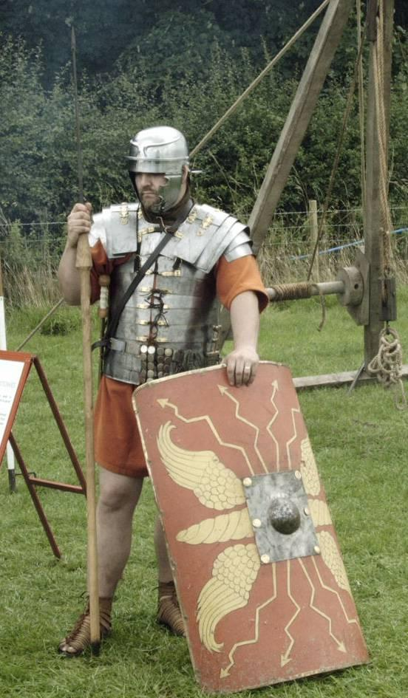
link

Sortes

Image Content

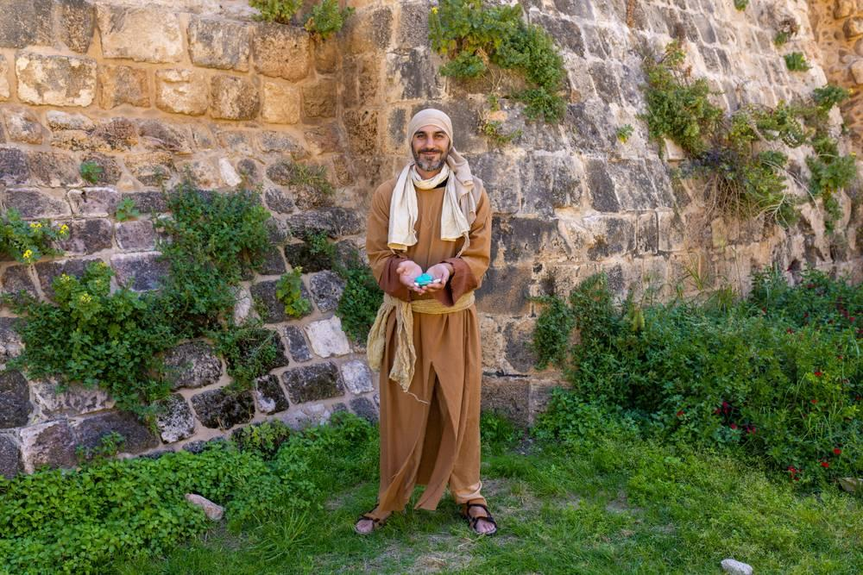
link

Sortes

Image Content

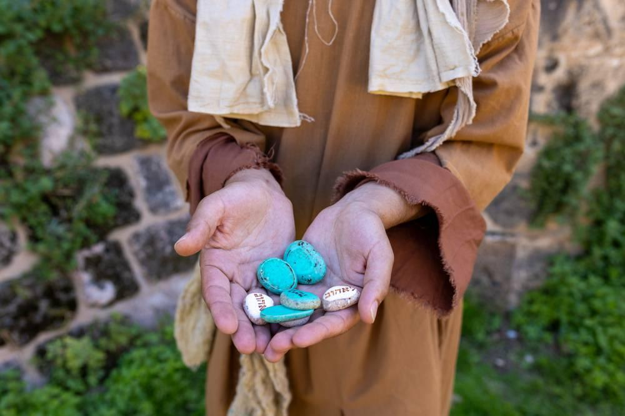
link

Suporte de candeeiro

Image Content

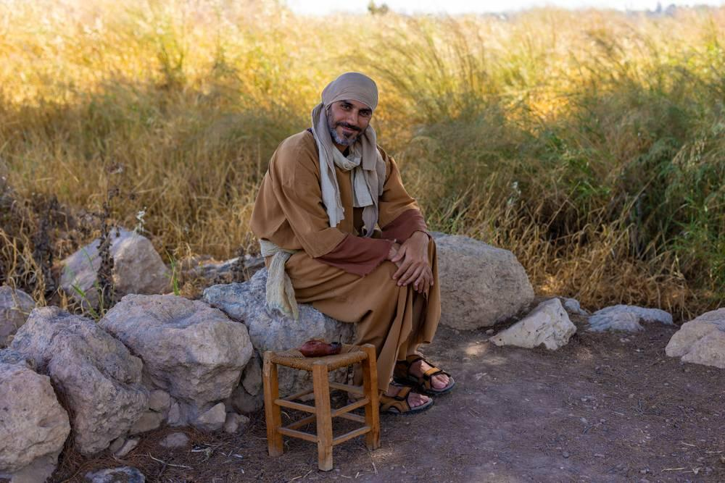
link

Suporte de candeeiro

Image Content

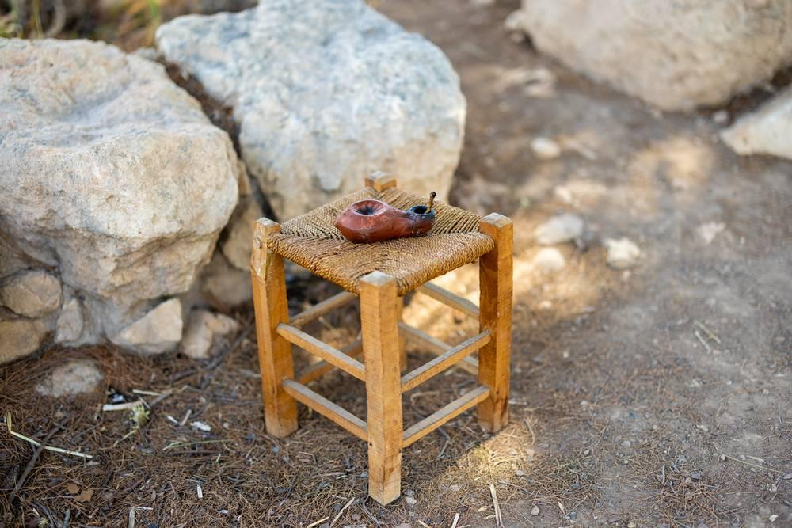
link

