Resource: Familiarization, Internalization, Articulation (Fia) Images
Familiarization, Internalization, Articulation (FIA) Images © 2023 SRV Partners Released under CC BY-SA 4.0 license. Familiarization, Internalization, Articulation (FIA) Images has been adapted in the following languages Tok Pisin, عربي, Français, हिंदी, Bahasa Indonesia, Português, Русский, Español, Kiswahili, 简体中文 from Familiarization, Internalization, Articulation (FIA) © 2023 SRV Partners. Released under CC BY-SA 4.0 license by Mission Mutual

Familiarization, Internalization, Articulation (Fia) Images

B

Banco de comedor

Image Content

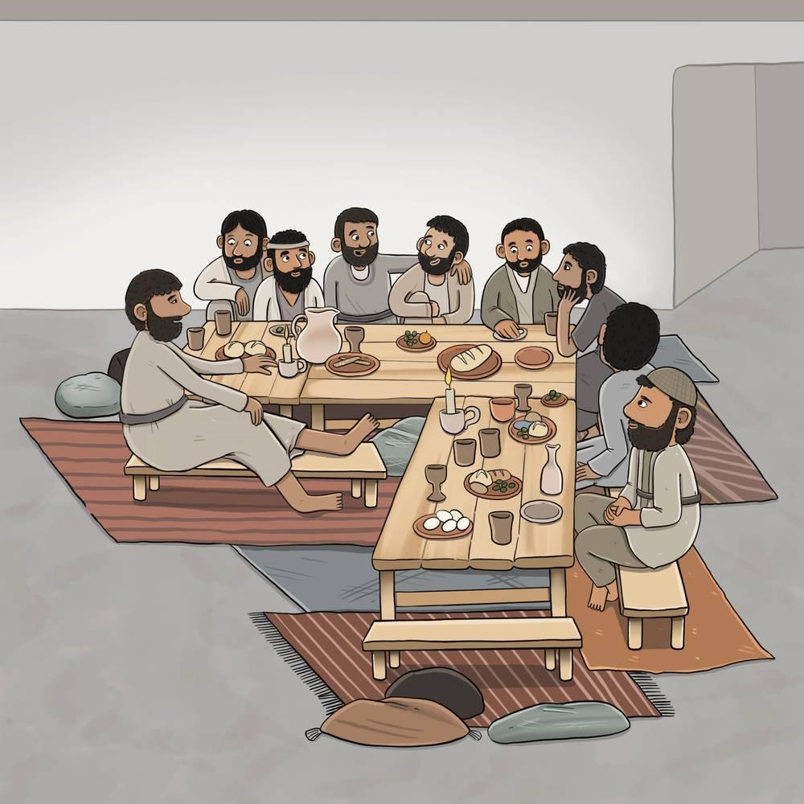
link

Banco de comedor

Image Content

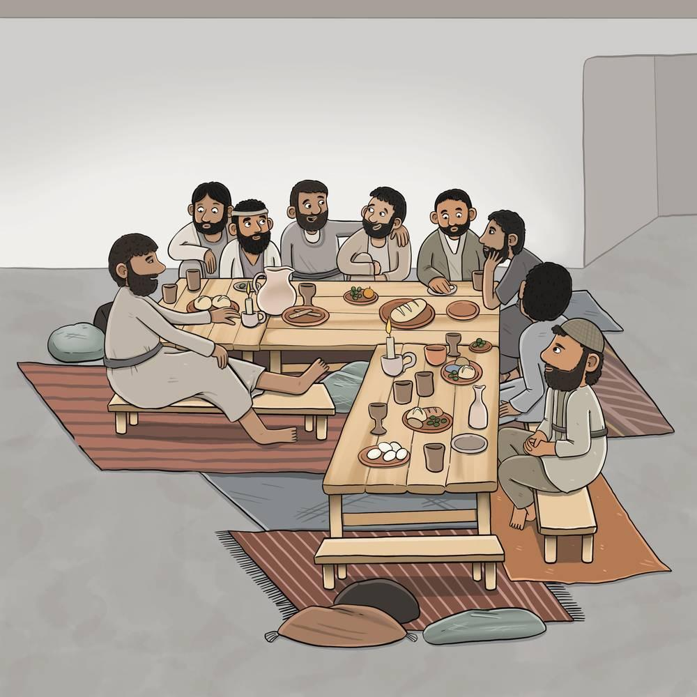
link

Bandeja

Image Content

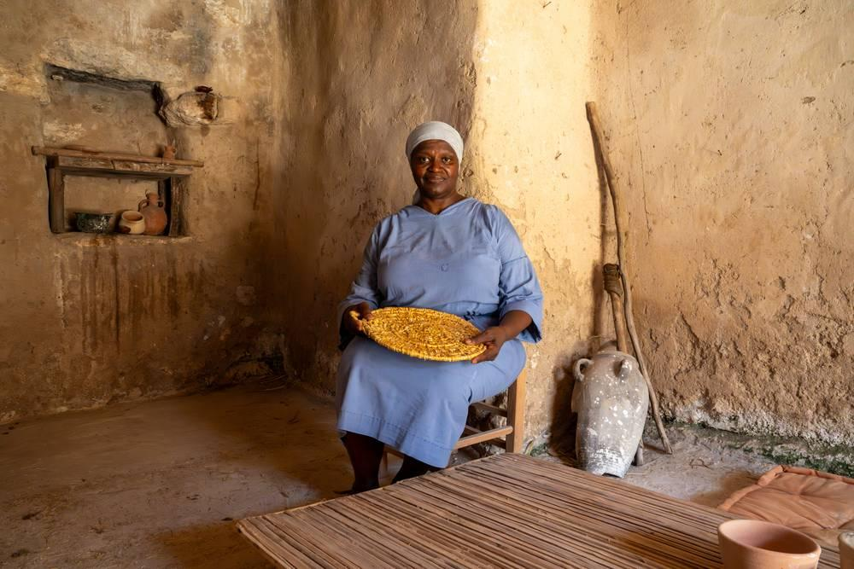
link

Bandeja

Image Content

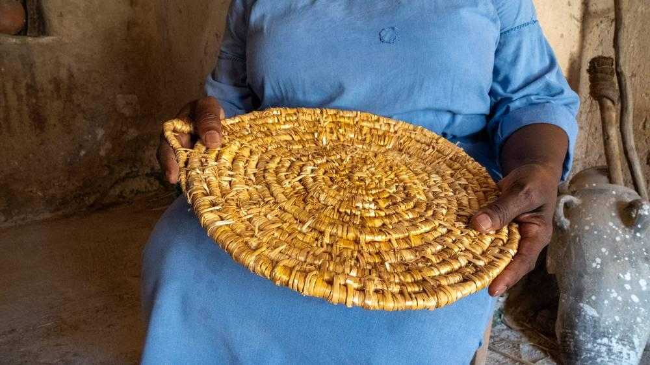
link

Barco

Image Content

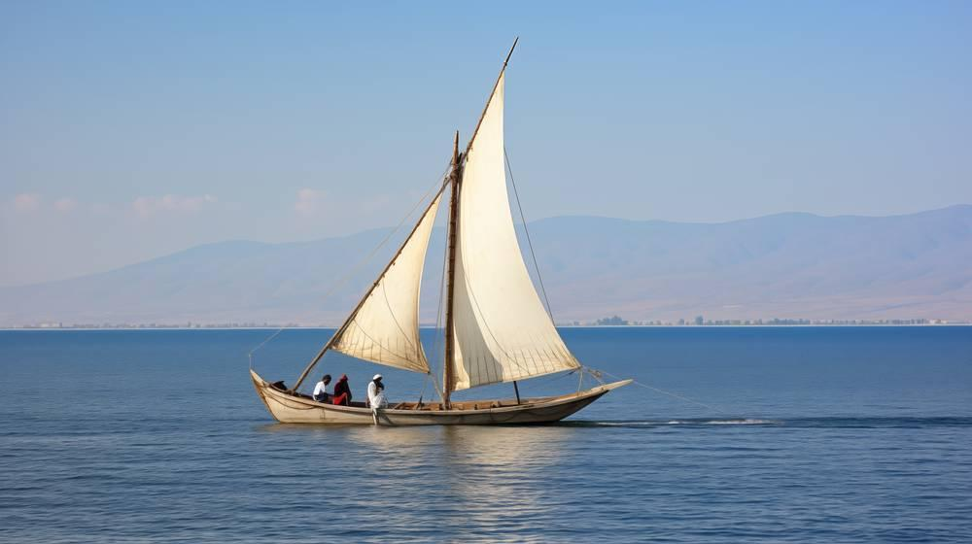
link

Bastón

Image Content

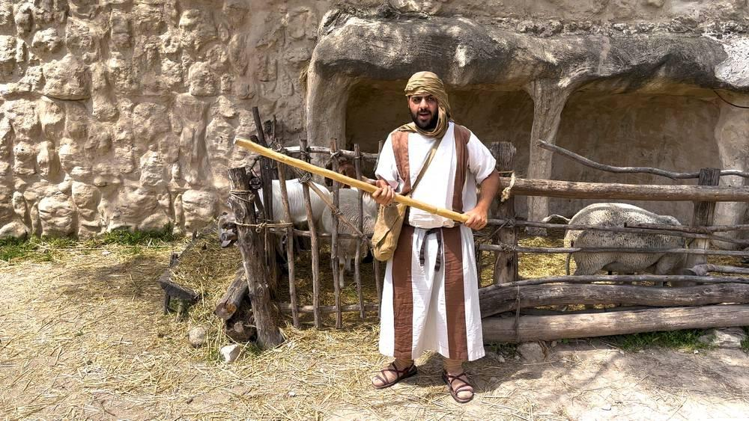
link

Bolsa de semillas del sembrador

Image Content

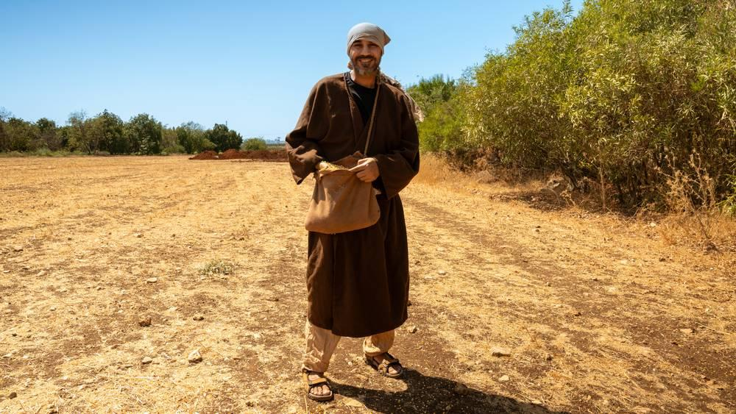
link

Bolsa de semillas del sembrador

Image Content

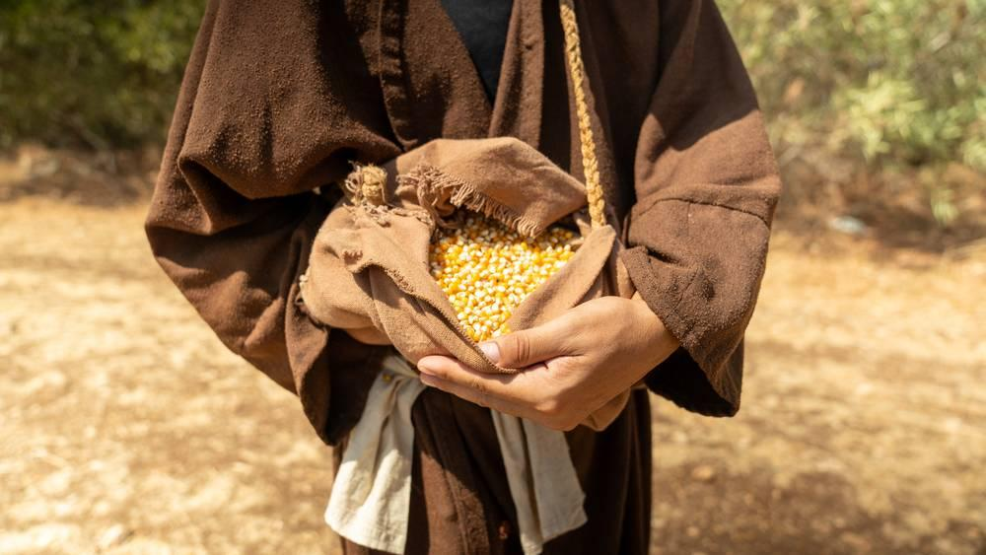
link

Bolsa de viajero

Image Content

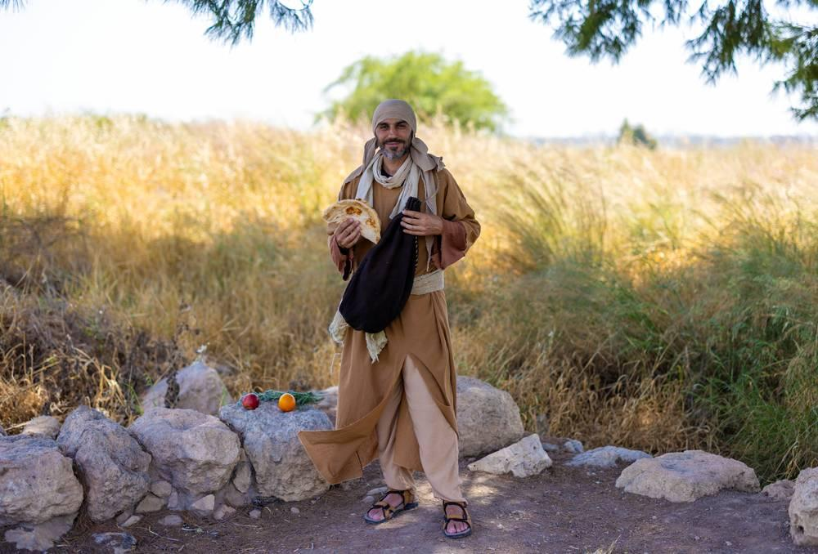
link

Bolsa de viajero

Image Content

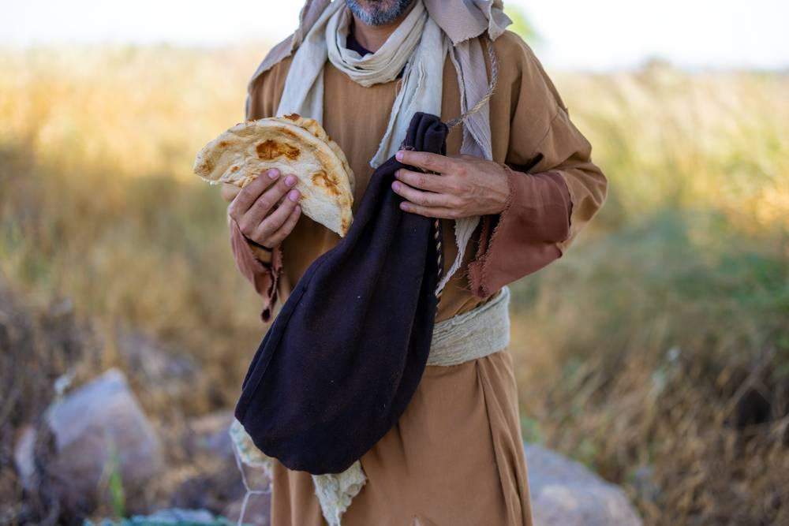
link

Borde del manto con borlas

Image Content


link

Burro joven

Image Content

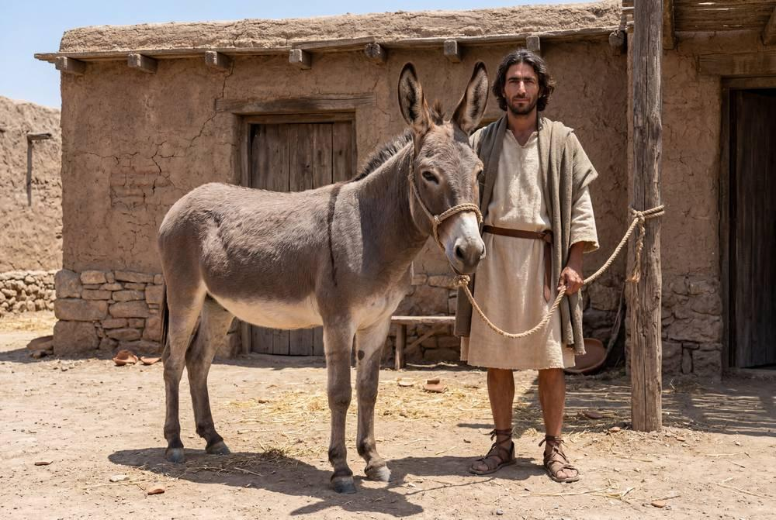
link

Burro joven

Image Content

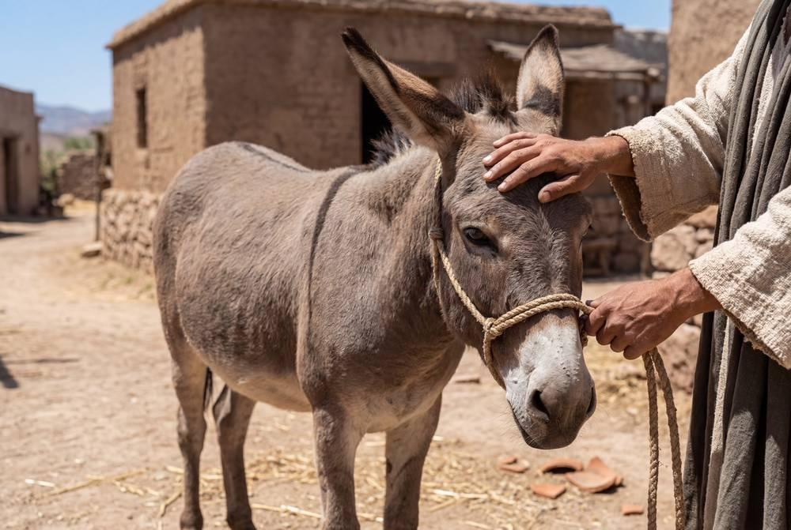
link

Burro joven

Image Content

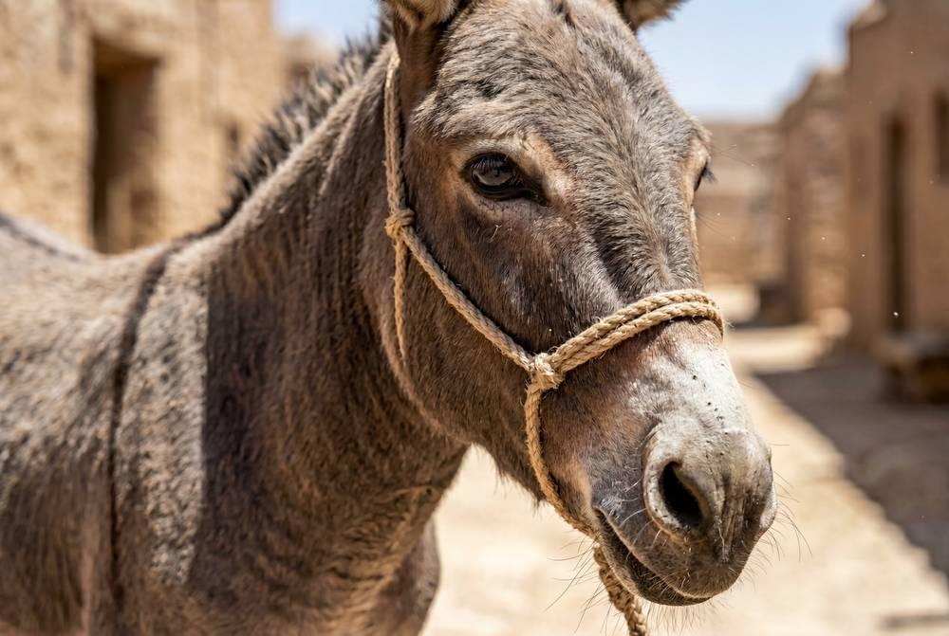
link

