Resource: Familiarization, Internalization, Articulation (Fia) Images
Familiarization, Internalization, Articulation (FIA) Images © 2023 SRV Partners Released under CC BY-SA 4.0 license. Familiarization, Internalization, Articulation (FIA) Images has been adapted in the following languages Tok Pisin, عربي, Français, हिंदी, Bahasa Indonesia, Português, Русский, Español, Kiswahili, 简体中文 from Familiarization, Internalization, Articulation (FIA) © 2023 SRV Partners. Released under CC BY-SA 4.0 license by Mission Mutual

Familiarization, Internalization, Articulation (Fia) Images

C

Cadenas

Image Content

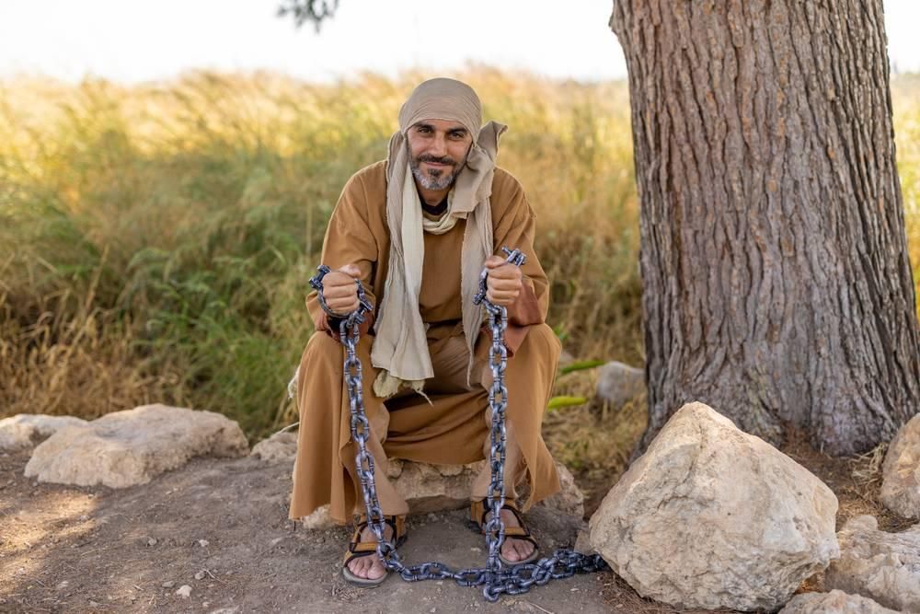
link

Cadenas

Image Content

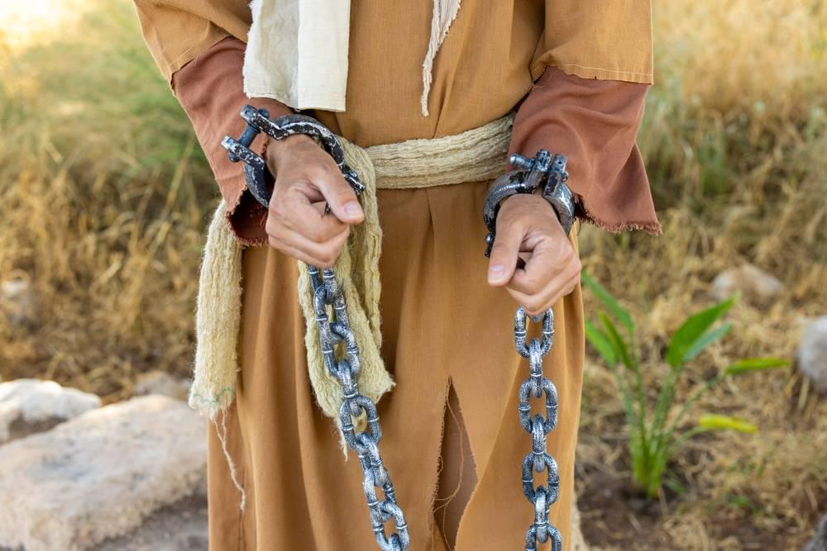
link

Caja de colecta del templo

Image Content

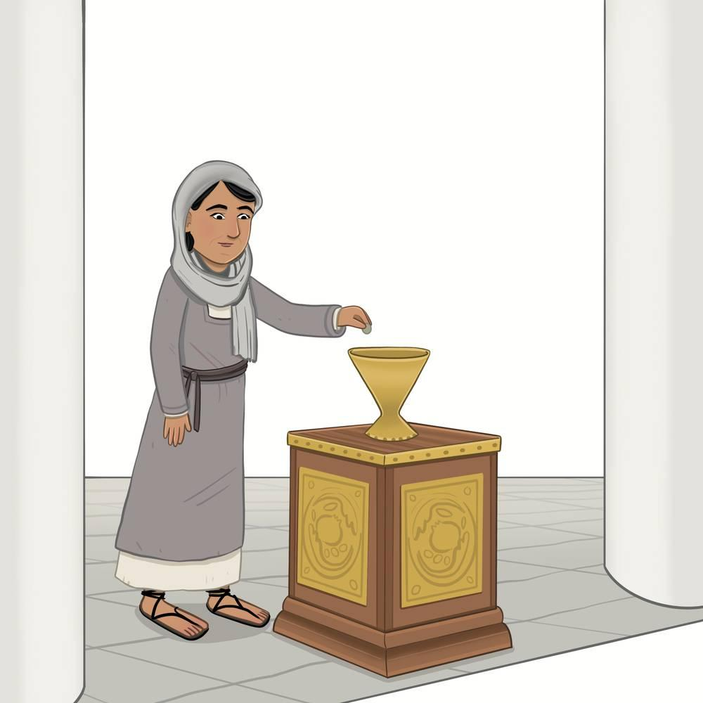
link

Calle estrecha

Image Content

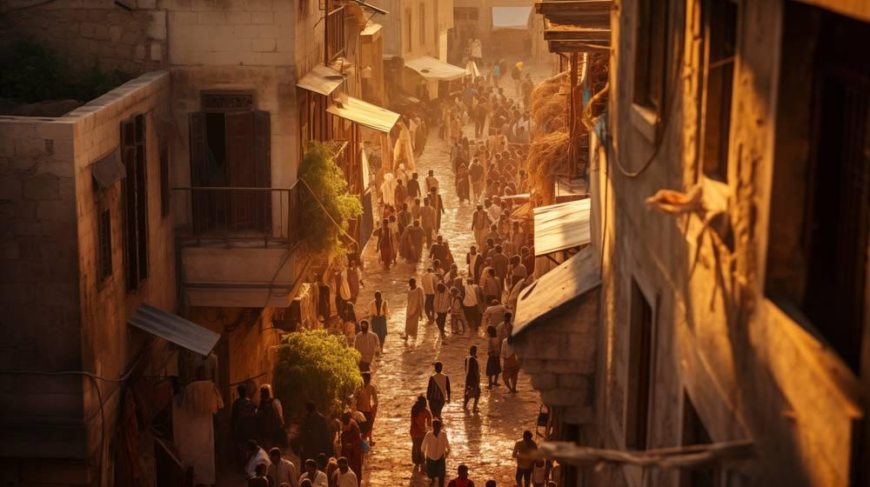
link

Calle estrecha

Image Content

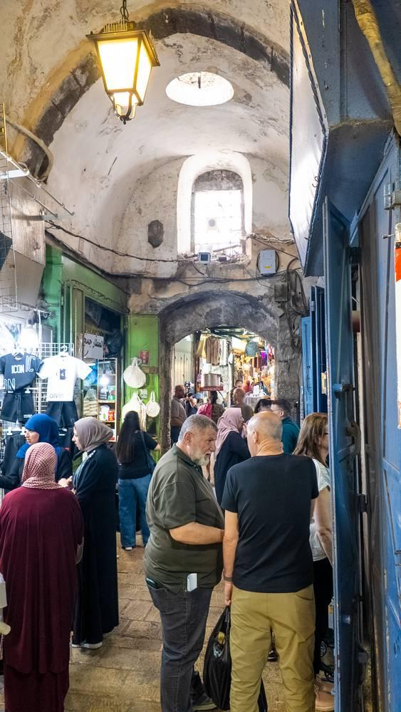
link

Cama de madera

Image Content

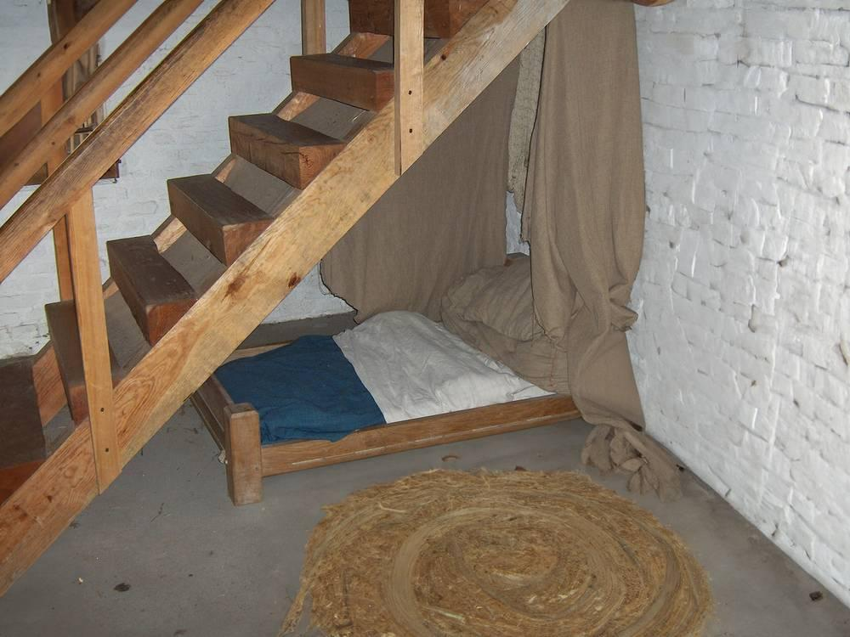
link

Camello

Image Content

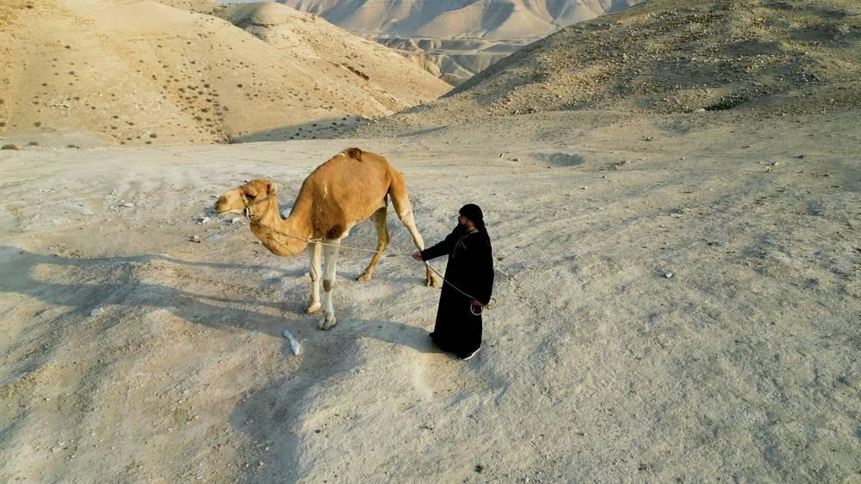
link

Candelero

Image Content

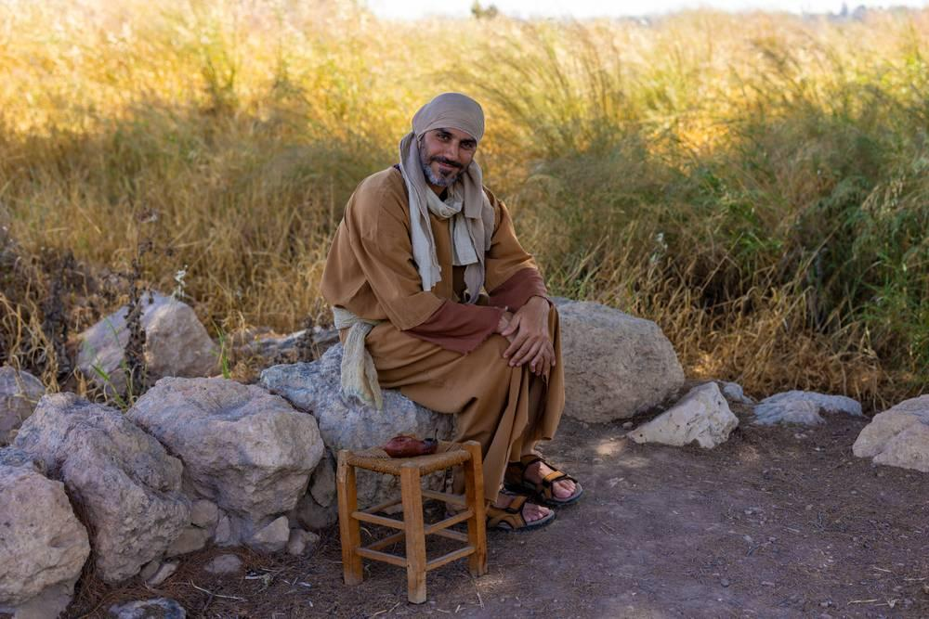
link

Candelero

Image Content

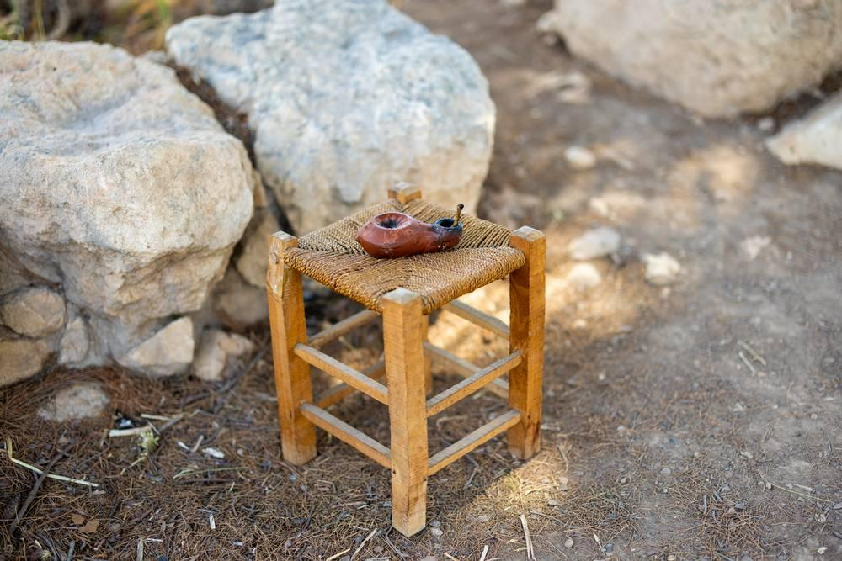
link

Casa en el tiempo de Jesús

Image Content

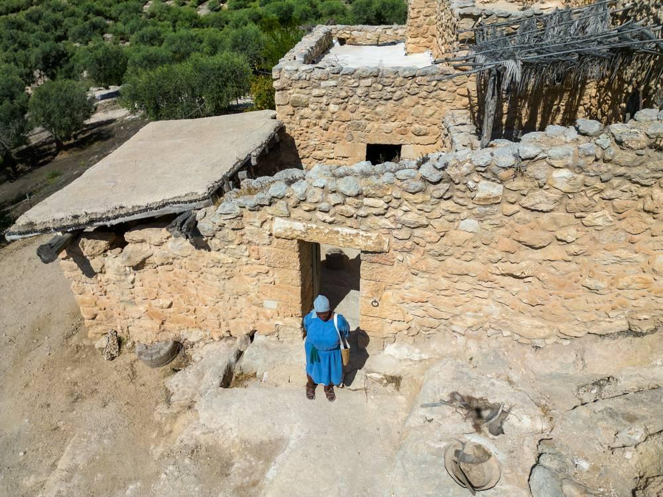
link

Casa en el tiempo de Jesús

Image Content

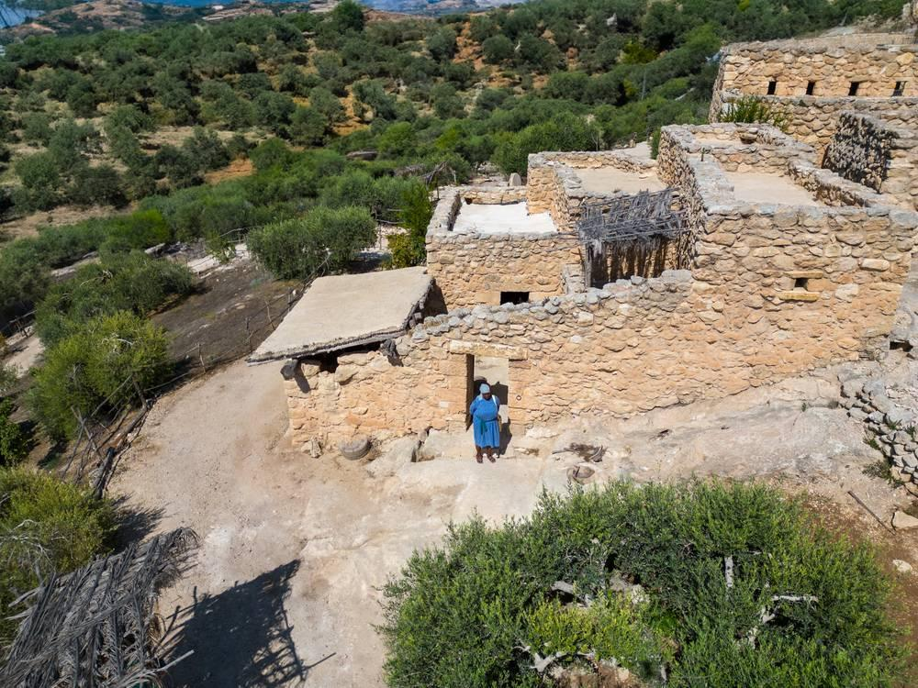
link

Casa en el tiempo de Jesús

Image Content

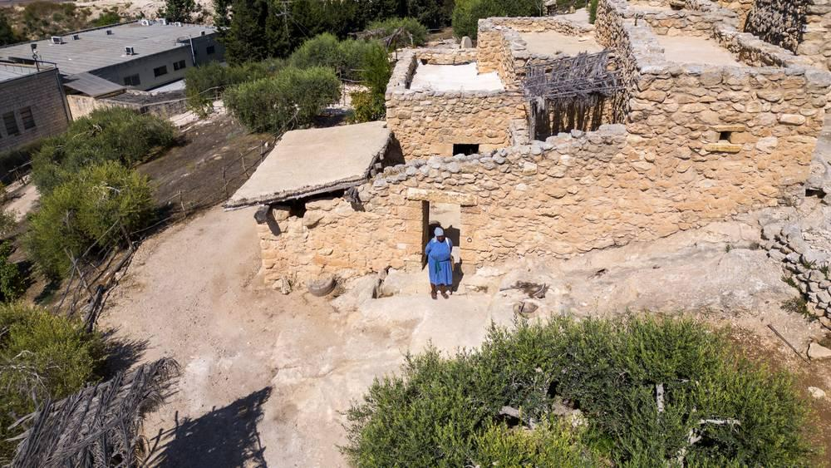
link

Casa en el tiempo de Jesús

Image Content

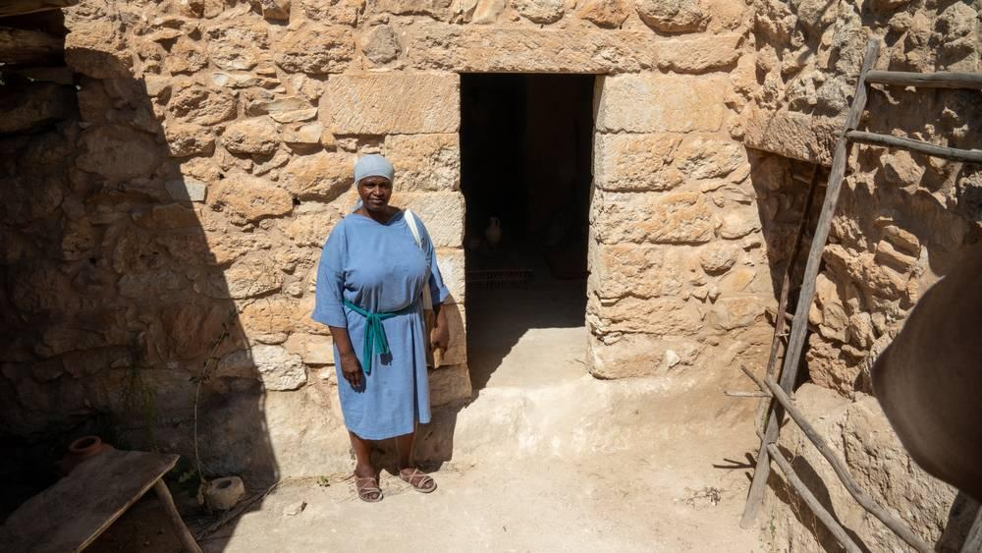
link

Cebada

Image Content

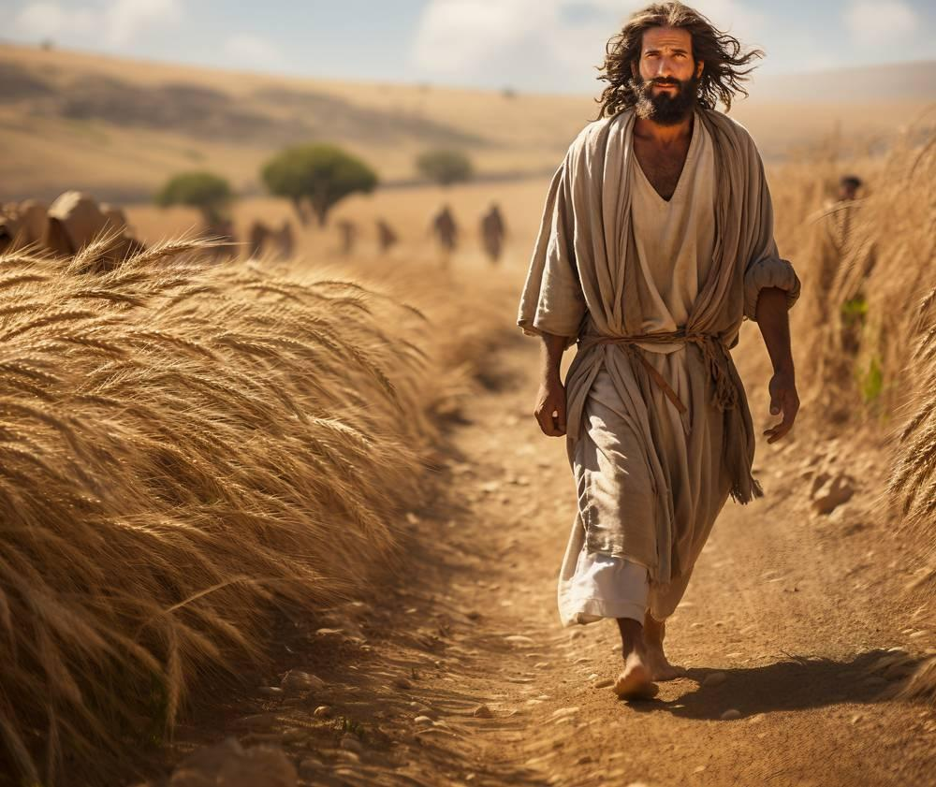
link

Cebada

Image Content

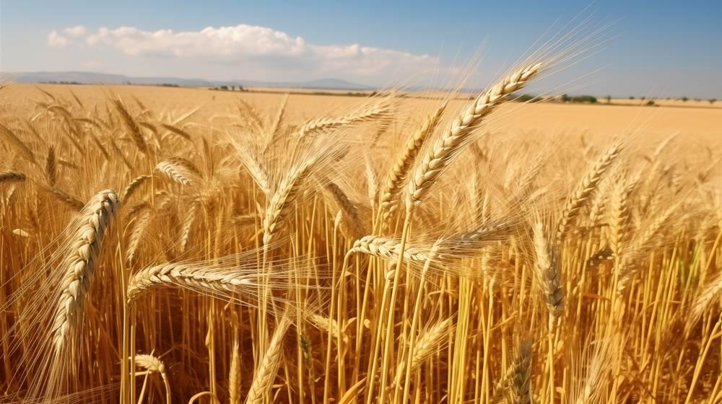
link

Cebada

Image Content

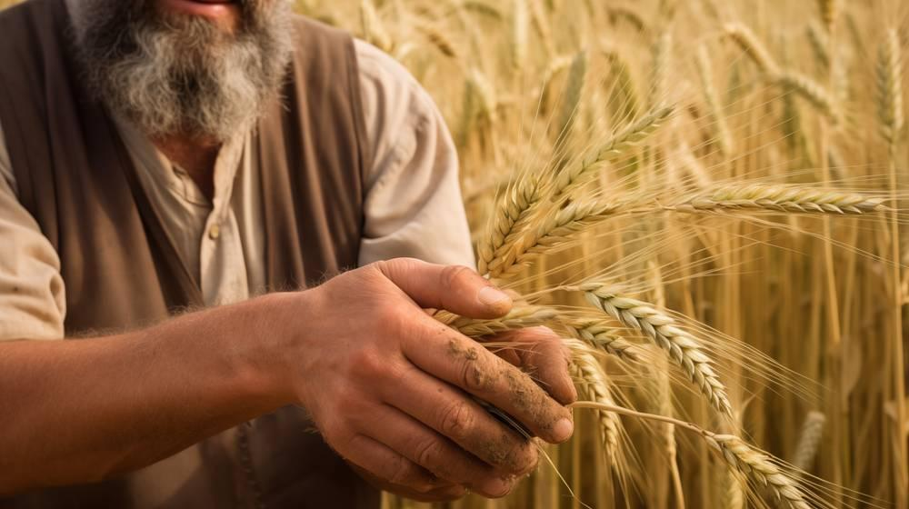
link

Cerdos

Image Content

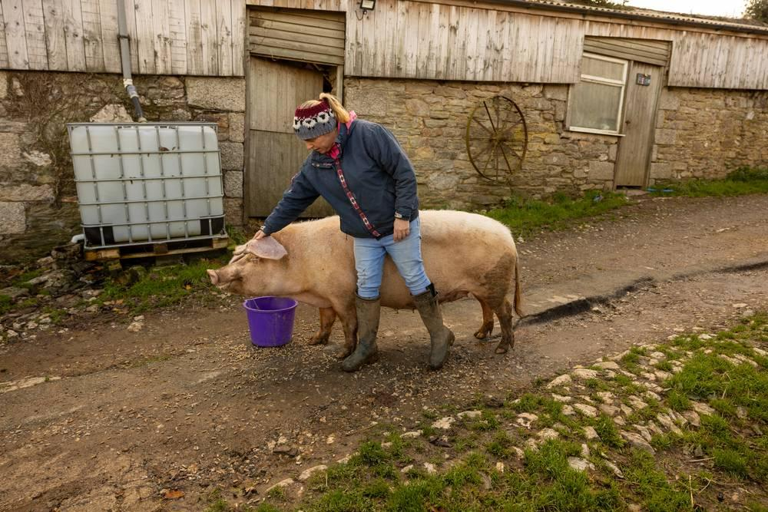
link

Cerdos

Image Content

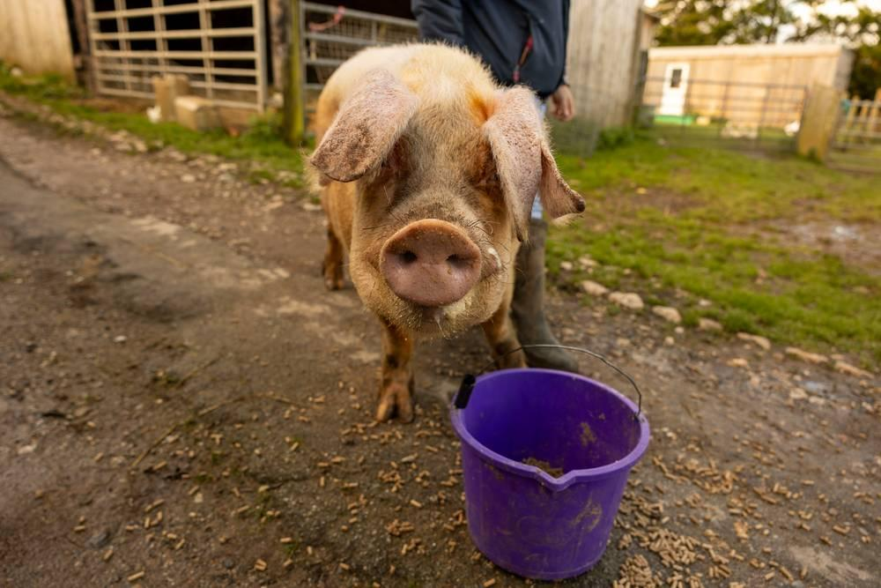
link

Cesta como celemín

Image Content

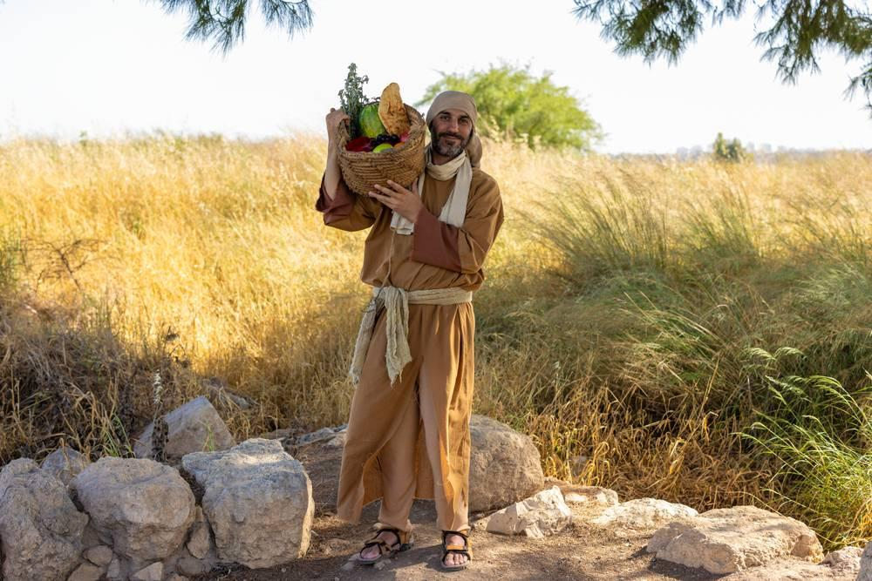
link

Cesta como celemín

Image Content

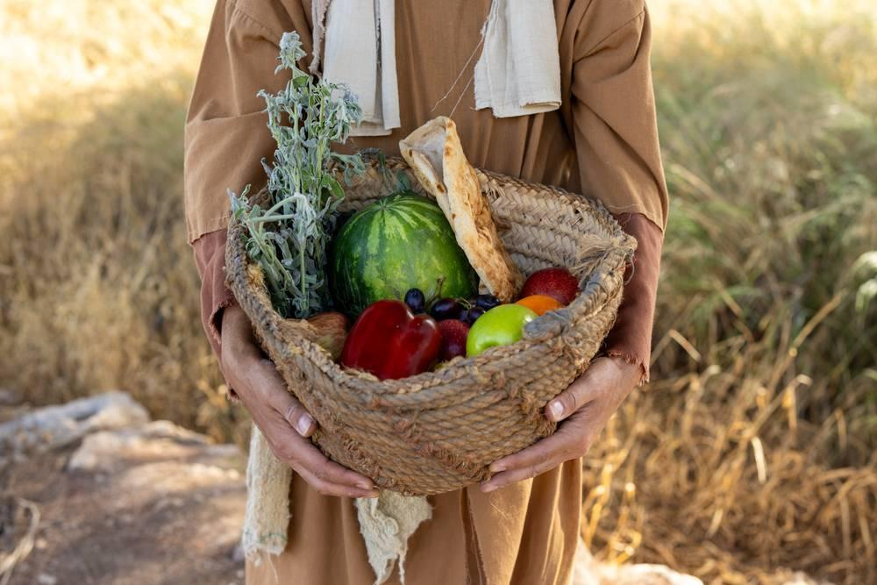
link

Cesta grande

Image Content

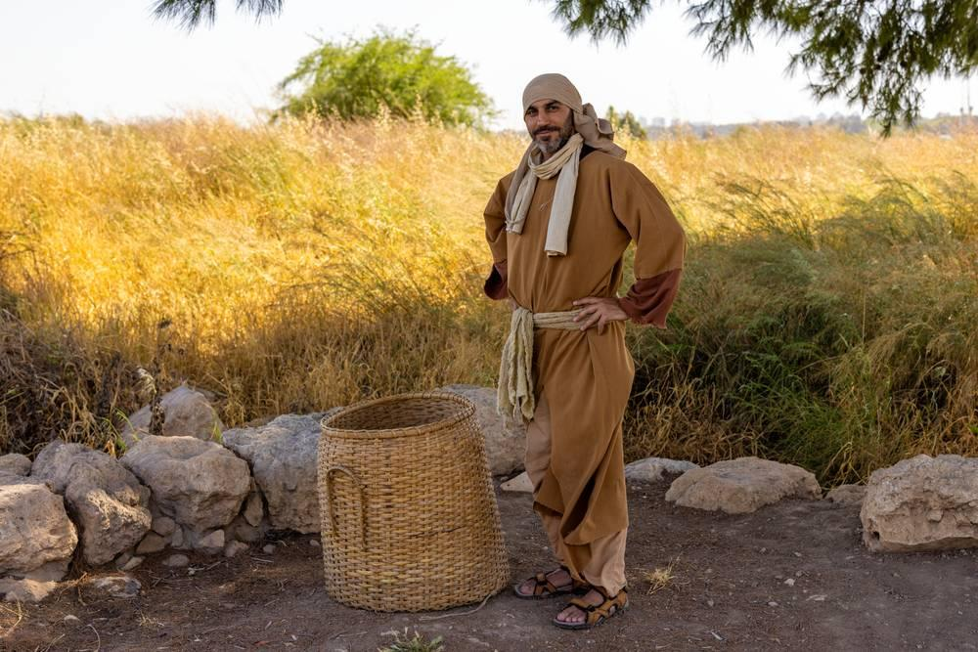
link

Cesta grande

Image Content

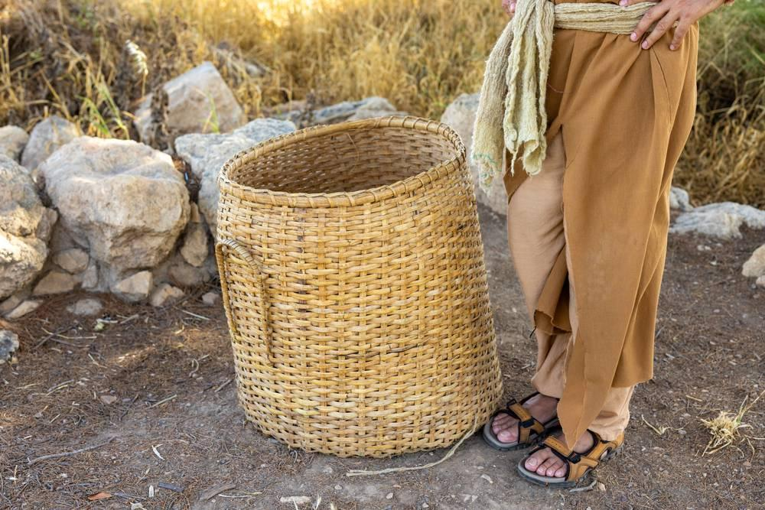
link

Cesta para provisiones

Image Content

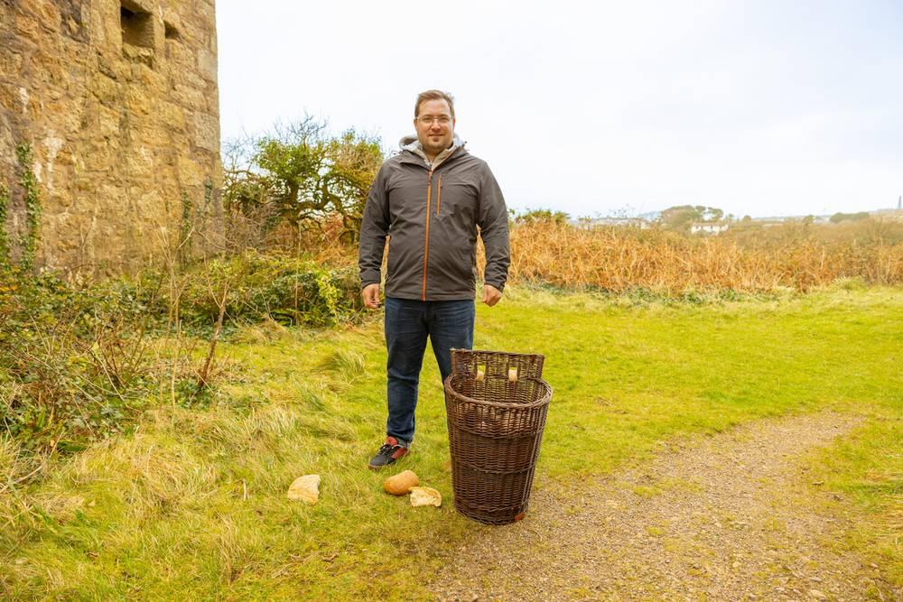
link

Cesta para provisiones

Image Content

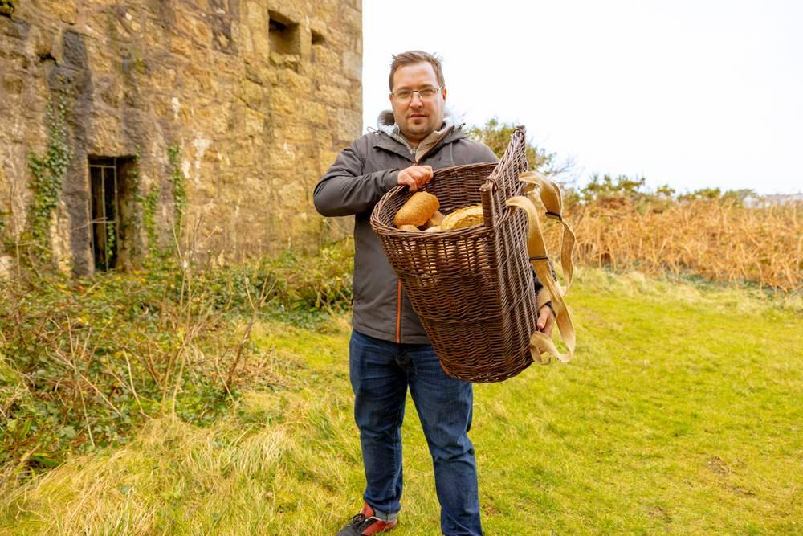
link

Cesta para provisiones

Image Content

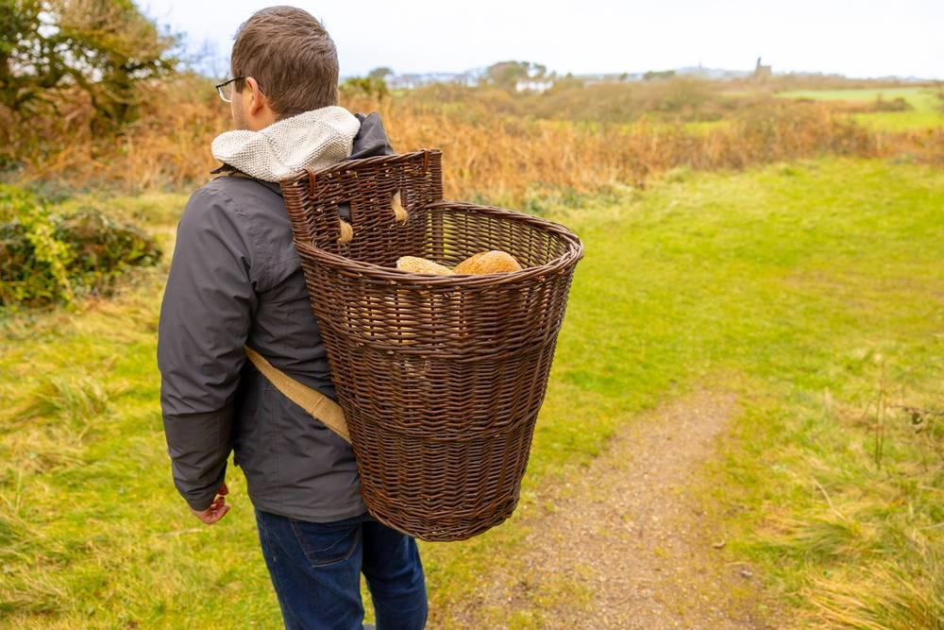
link

Colinas en el Mar de Galilea

Image Content

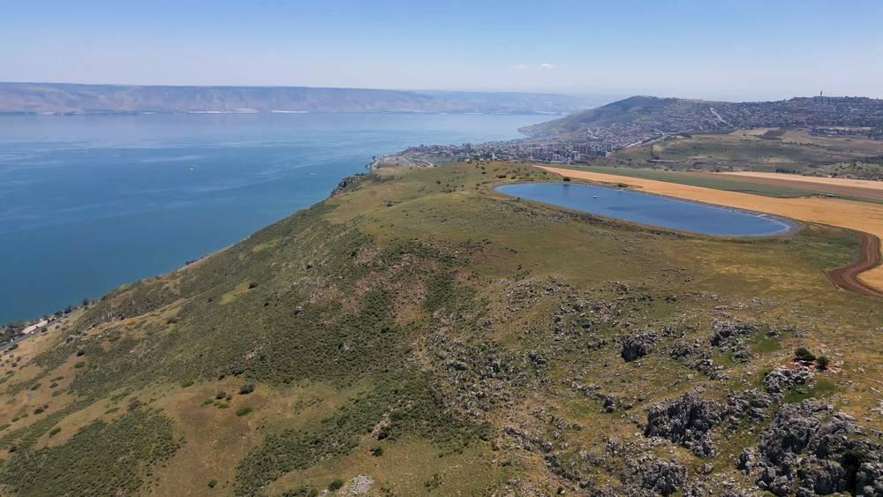
link

Colinas en el Mar de Galilea

Image Content

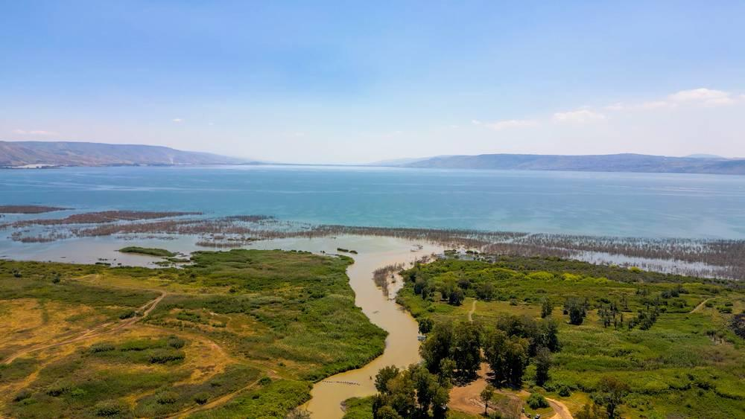
link

Colinas en el Mar de Galilea

Image Content

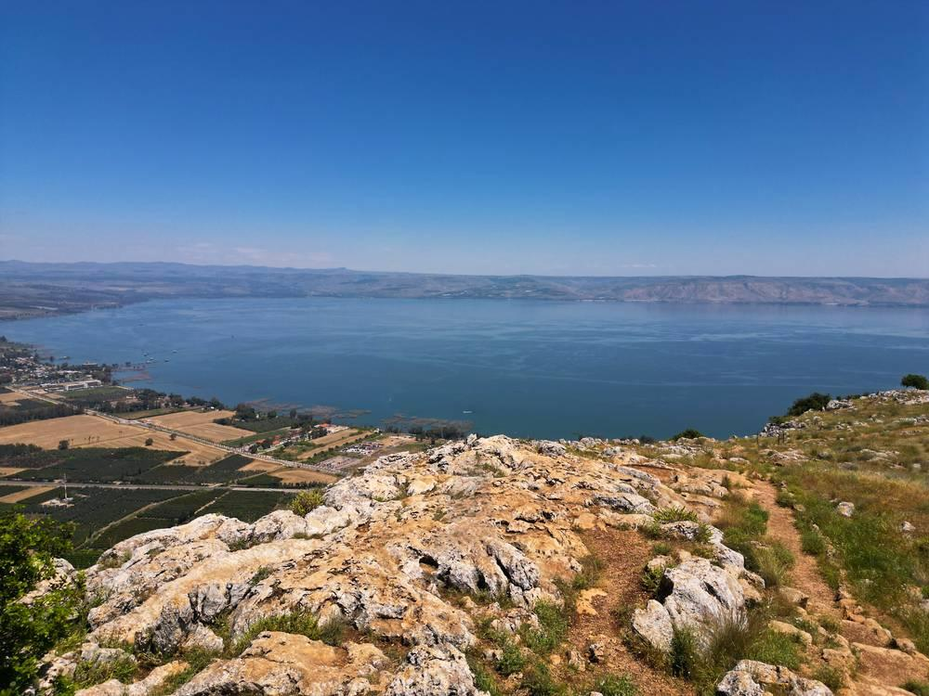
link

Colinas en el Mar de Galilea

Image Content

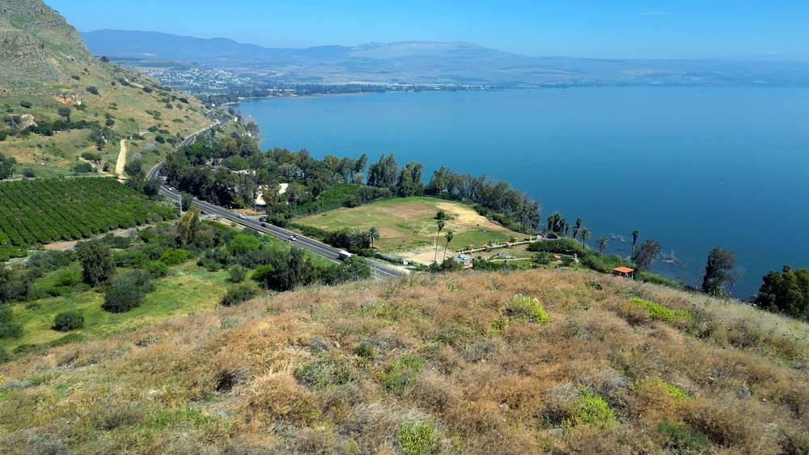
link

Cortina en el Templo de Herodes

Image Content

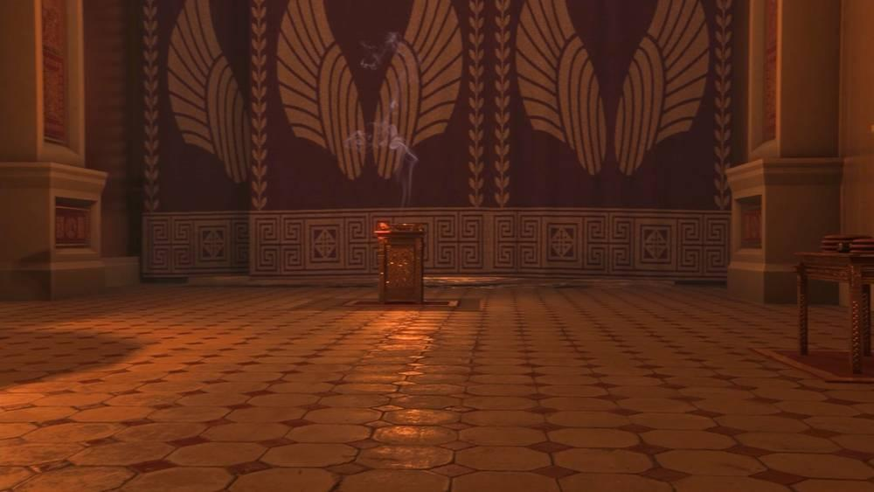
link

Cortina en el Templo de Herodes

Image Content

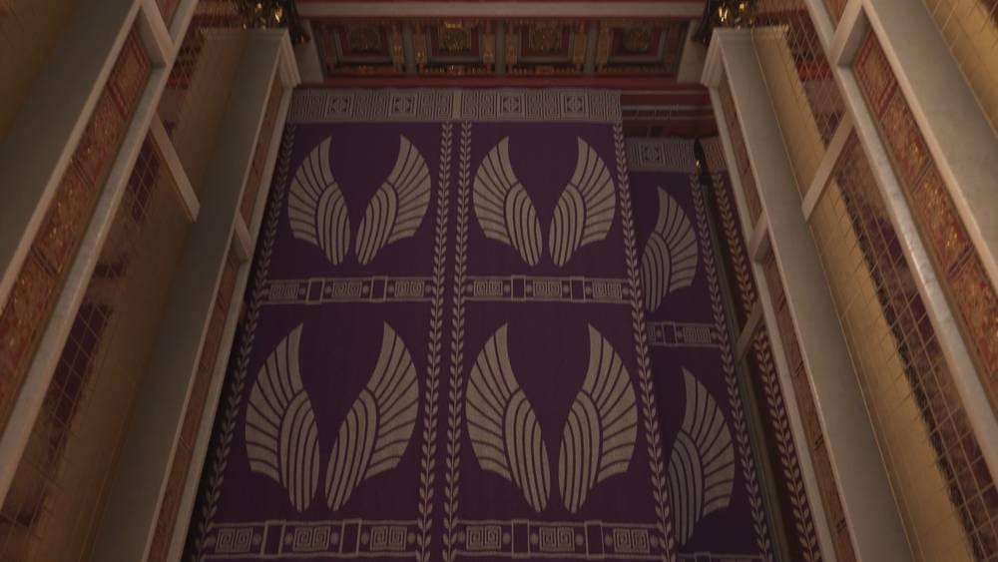
link

Crucifixión

Image Content

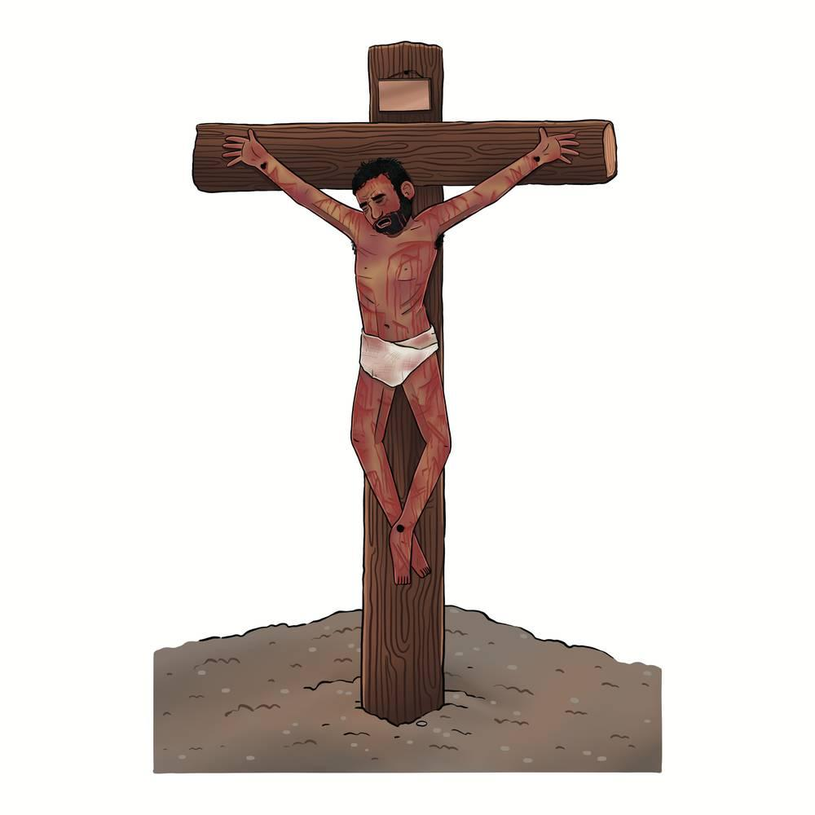
link

Cuatro suelos

Image Content

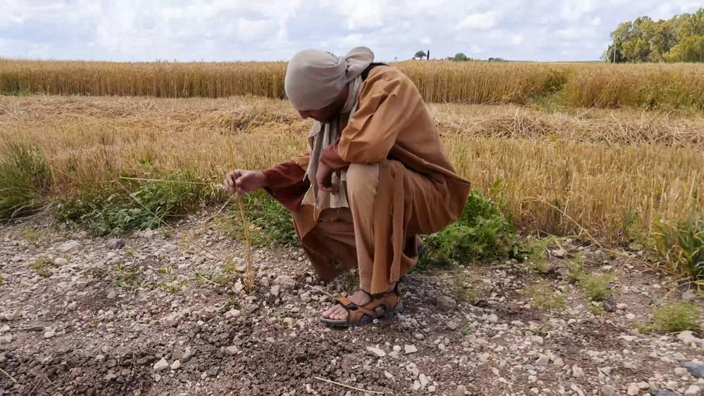
link

Cuatro suelos

Image Content

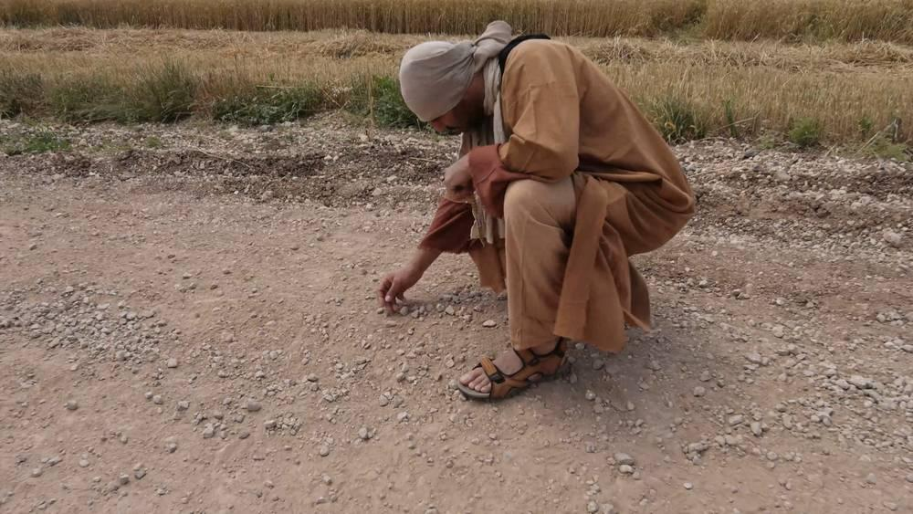
link

Cuatro suelos

Image Content

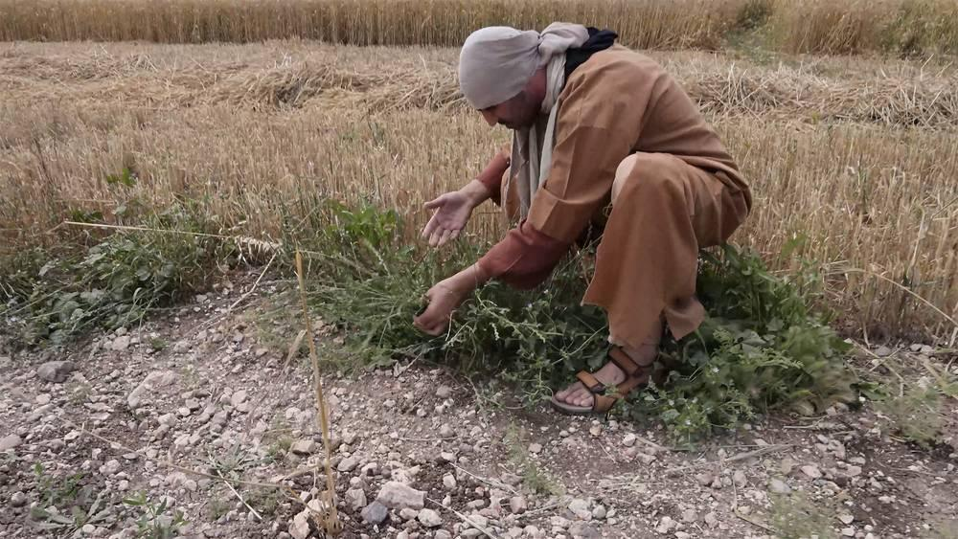
link

Cuatro suelos

Image Content

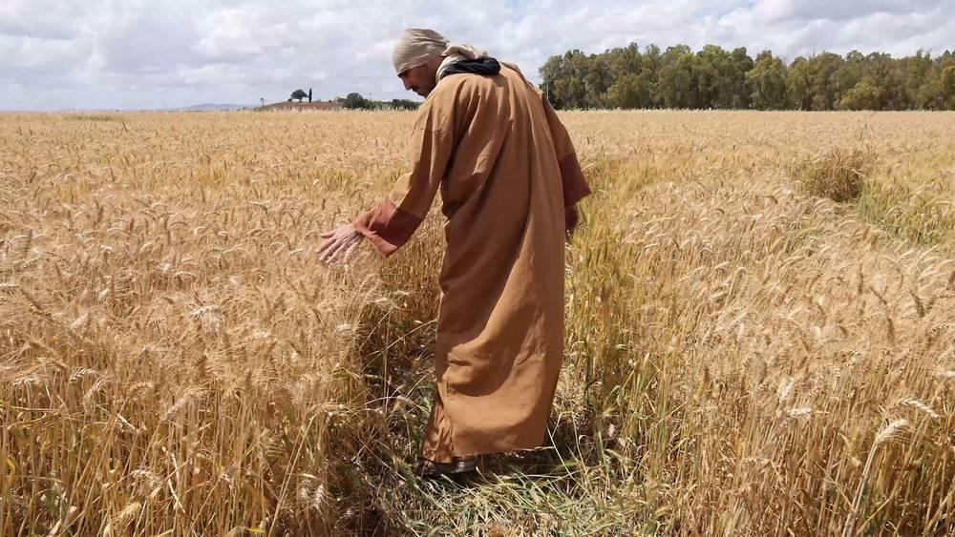
link

Cuatro suelos

Image Content

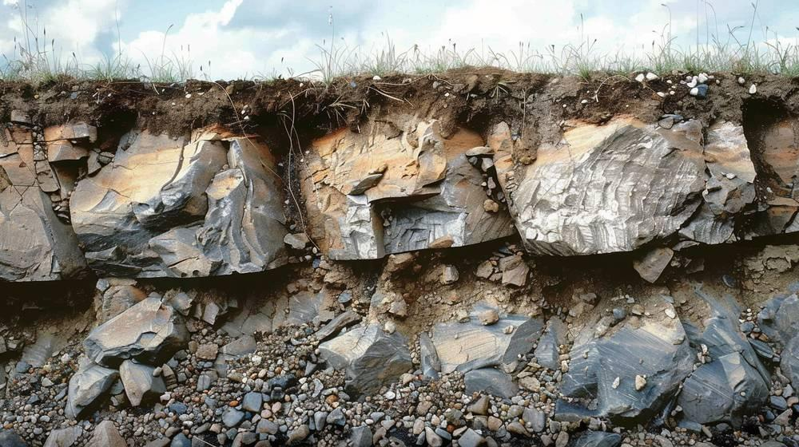
link

