Resource: Familiarization, Internalization, Articulation (Fia) Images
Familiarization, Internalization, Articulation (FIA) Images © 2023 SRV Partners Released under CC BY-SA 4.0 license. Familiarization, Internalization, Articulation (FIA) Images has been adapted in the following languages Tok Pisin, عربي, Français, हिंदी, Bahasa Indonesia, Português, Русский, Español, Kiswahili, 简体中文 from Familiarization, Internalization, Articulation (FIA) © 2023 SRV Partners. Released under CC BY-SA 4.0 license by Mission Mutual

Familiarization, Internalization, Articulation (Fia) Images

E

Espada

Image Content

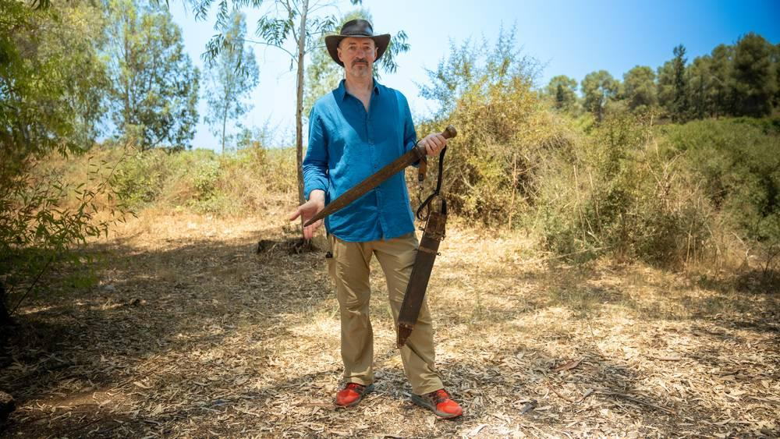
link

Espada

Image Content

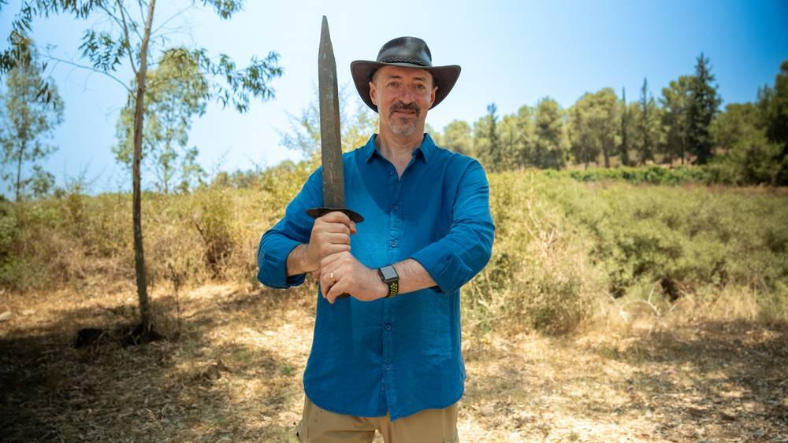
link

Espada

Image Content

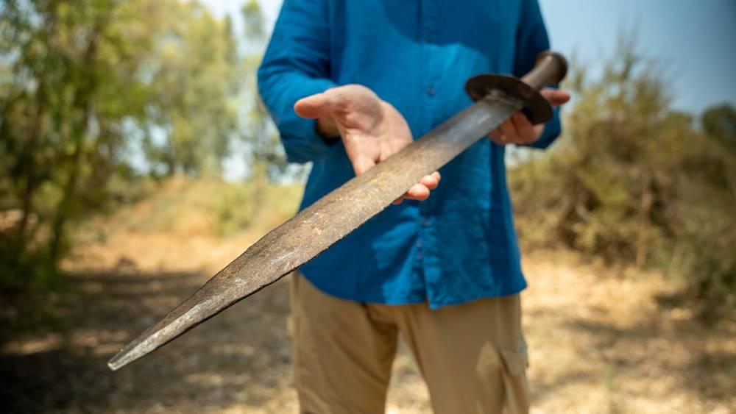
link

Espada

Image Content


link

Espada

Image Content

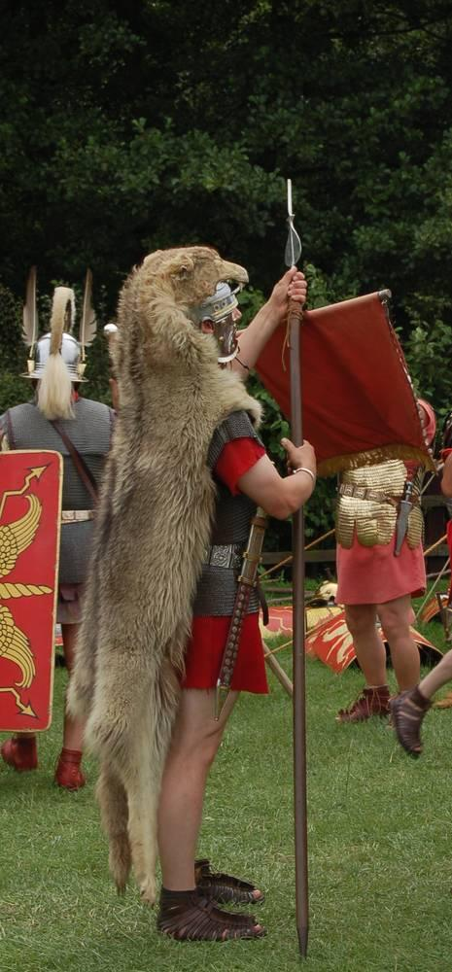
link

Especias

Image Content

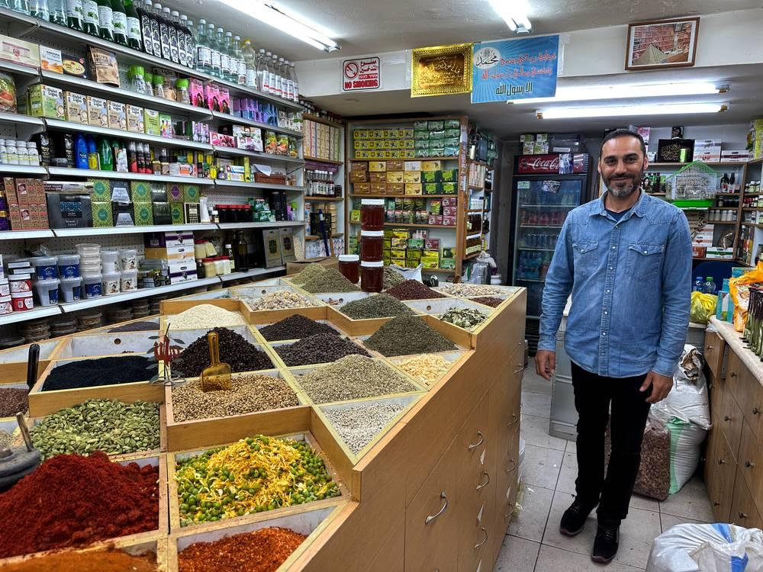
link

Especias

Image Content

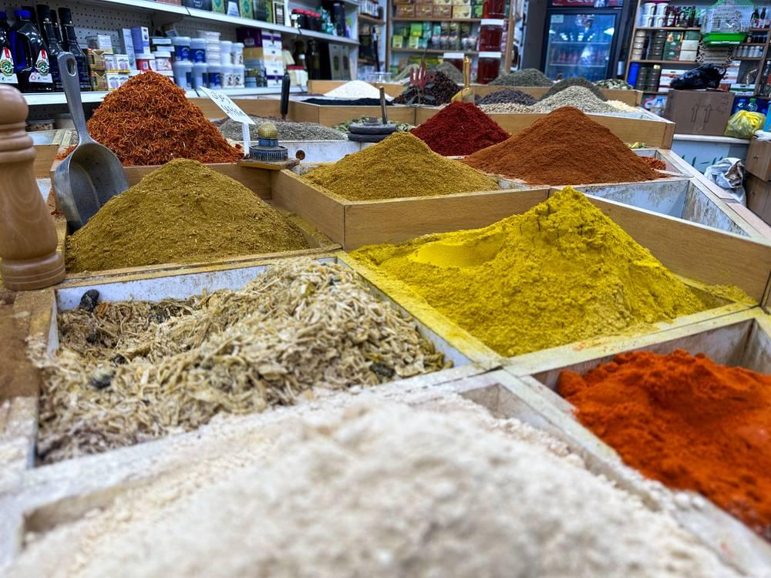
link

Especias

Image Content

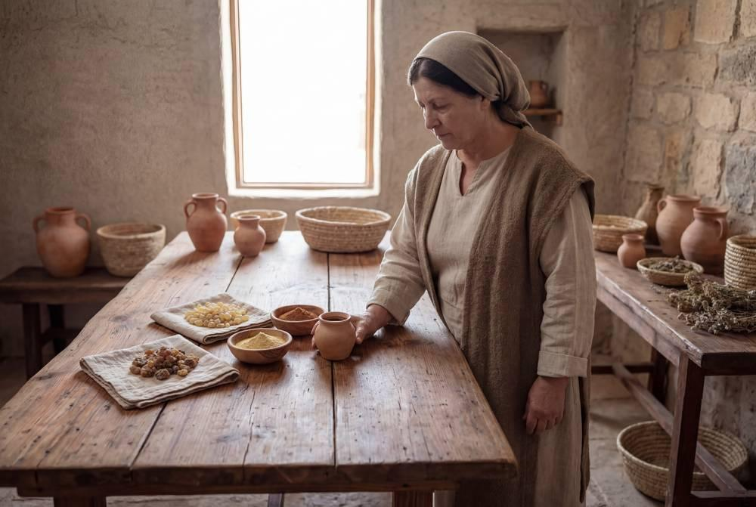
link

Especias

Image Content

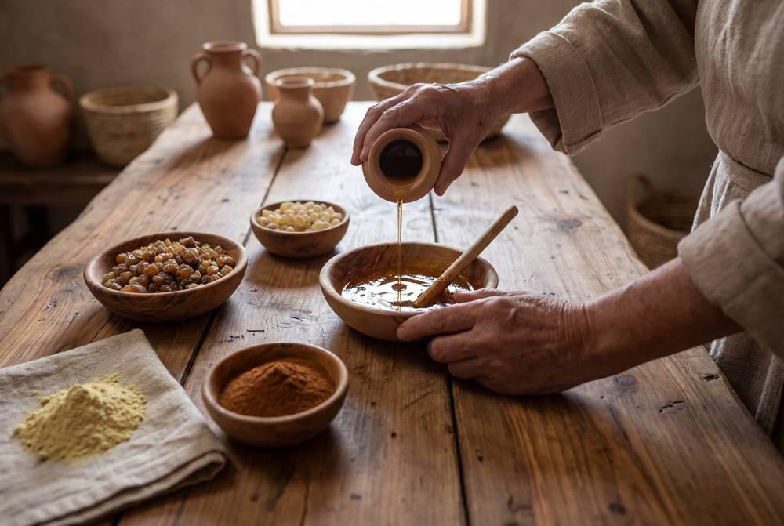
link

Especias

Image Content

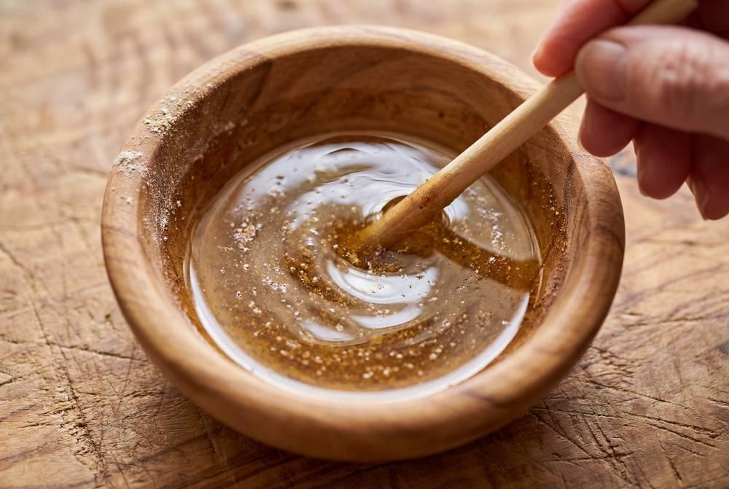
link

Esponja con vino en un palo

Image Content

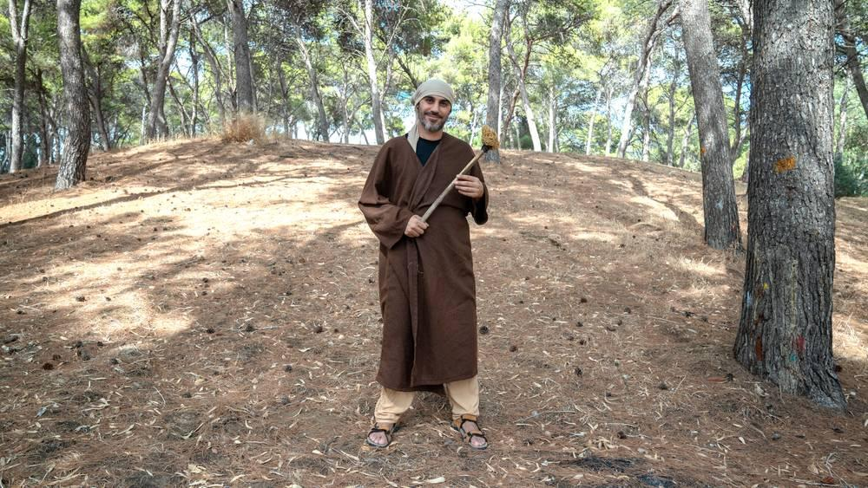
link

Esponja con vino en un palo

Image Content

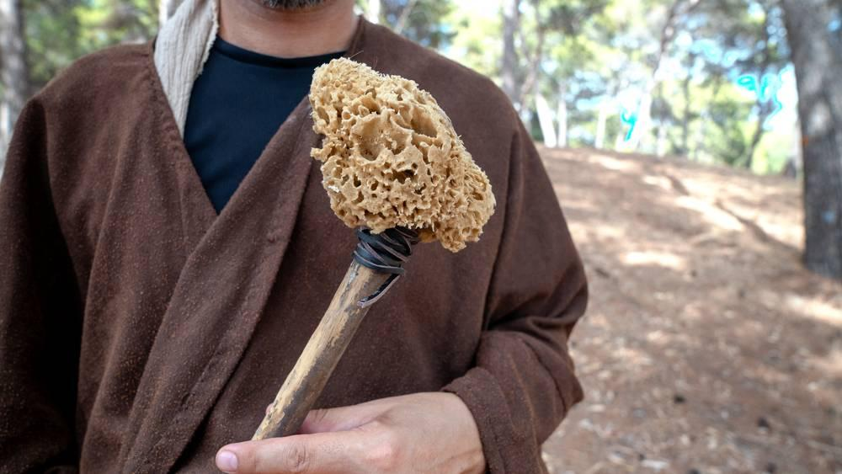
link

Esterilla para dormir

Image Content


link

Esterilla para dormir

Image Content

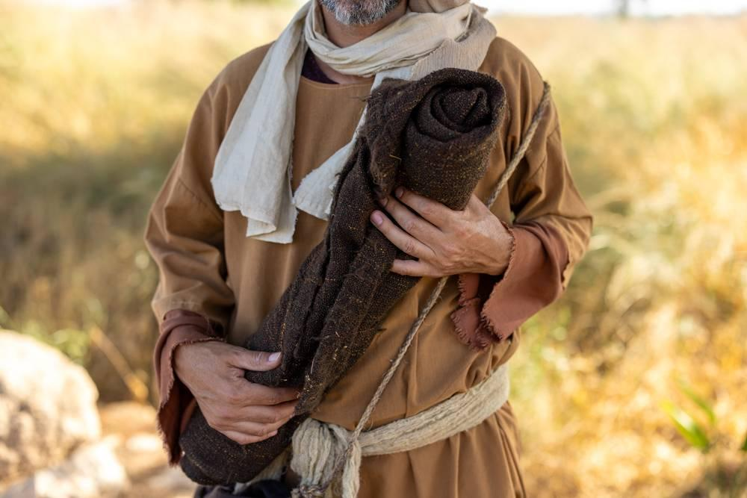
link

Etapas del crecimiento del trigo

Image Content

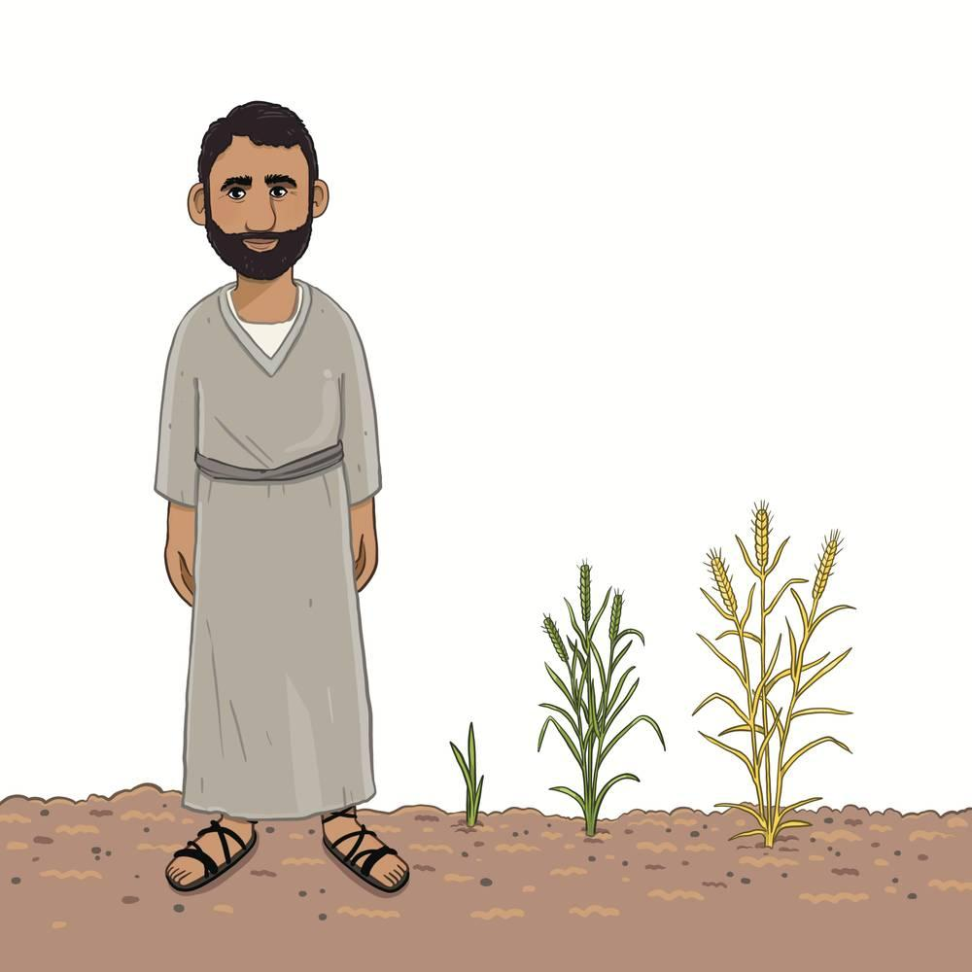
link

