Resource: Familiarization, Internalization, Articulation (Fia) Images
Familiarization, Internalization, Articulation (FIA) Images © 2023 SRV Partners Released under CC BY-SA 4.0 license. Familiarization, Internalization, Articulation (FIA) Images has been adapted in the following languages Tok Pisin, عربي, Français, हिंदी, Bahasa Indonesia, Português, Русский, Español, Kiswahili, 简体中文 from Familiarization, Internalization, Articulation (FIA) © 2023 SRV Partners. Released under CC BY-SA 4.0 license by Mission Mutual

Familiarization, Internalization, Articulation (Fia) Images

H

Hierbas amargas

Image Content

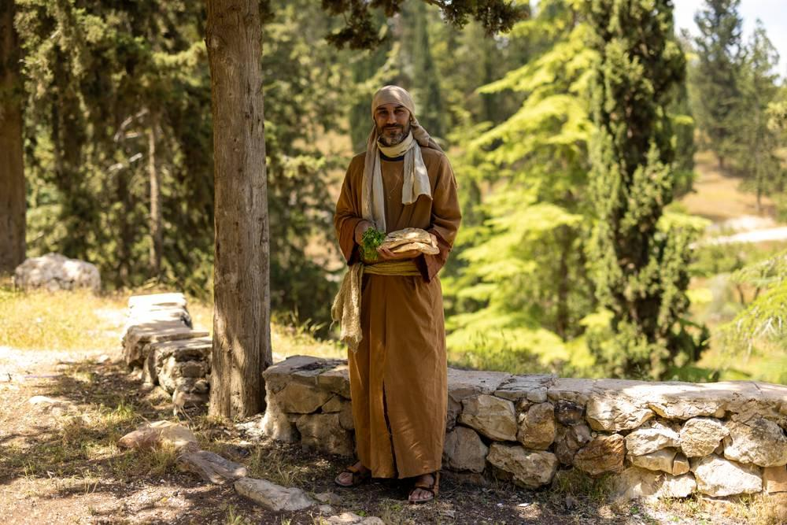
link

Hierbas amargas

Image Content

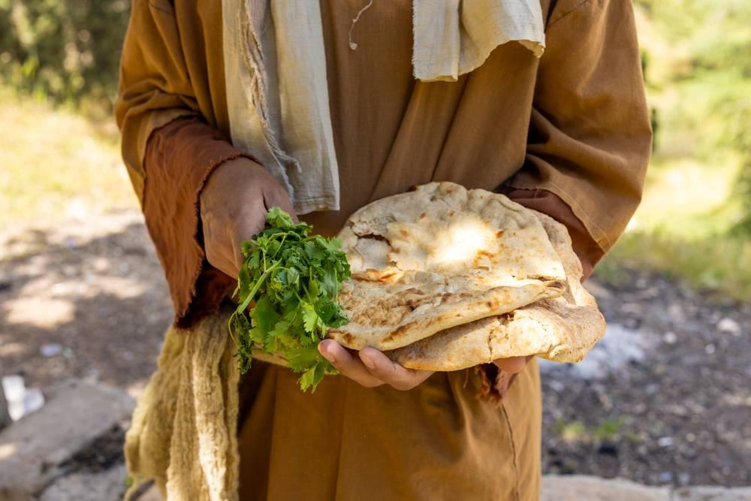
link

Higuera

Image Content

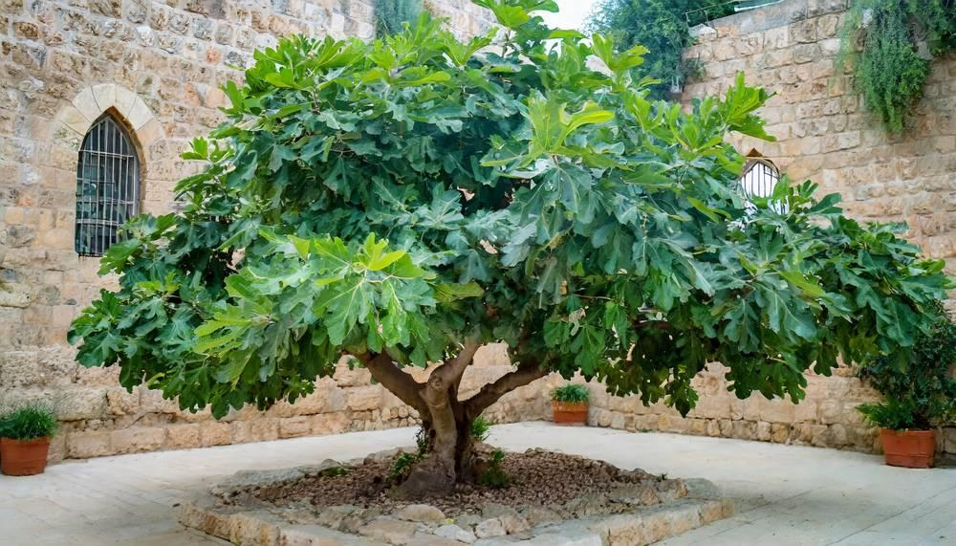
link

Higuera

Image Content

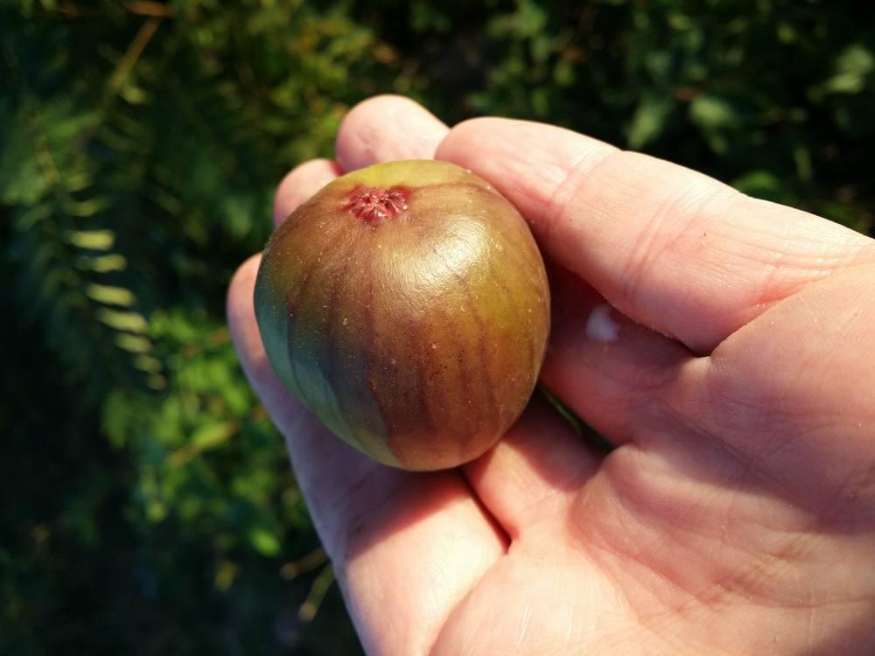
link

Hombre llevando una cruz

Image Content

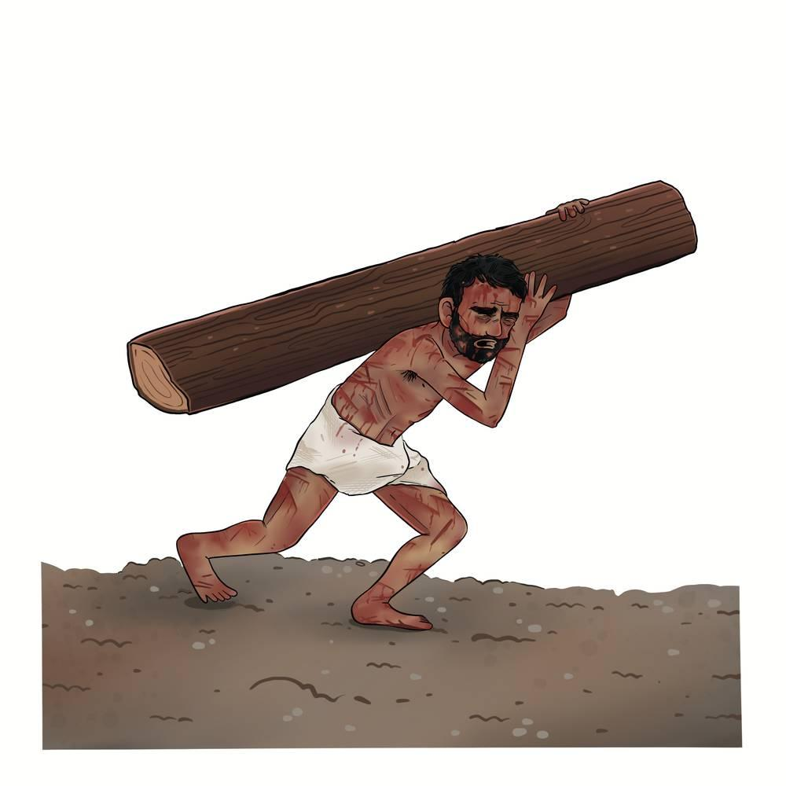
link

Hoz

Image Content

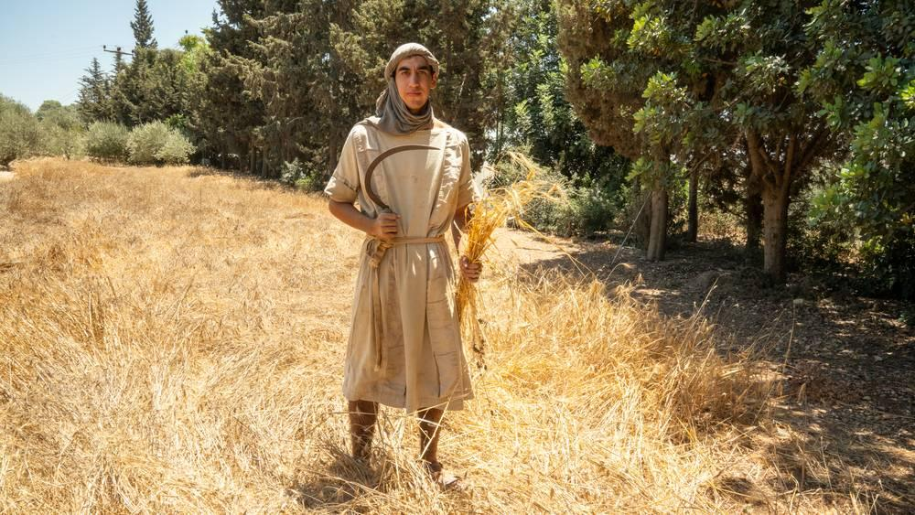
link

Hoz

Image Content

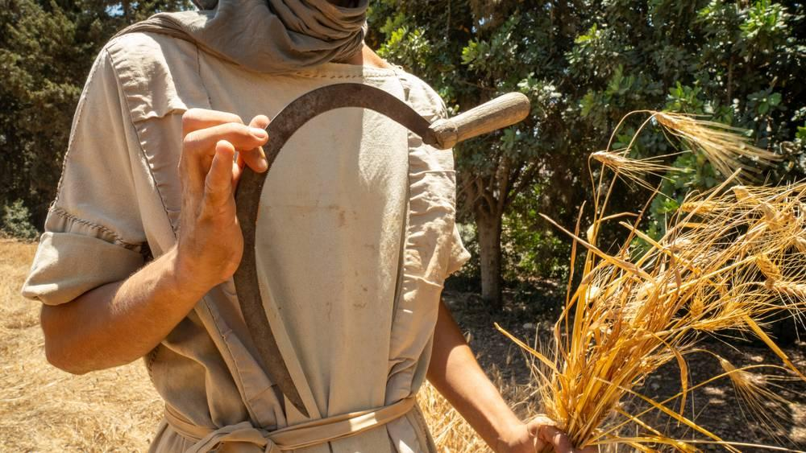
link

Hoz

Image Content

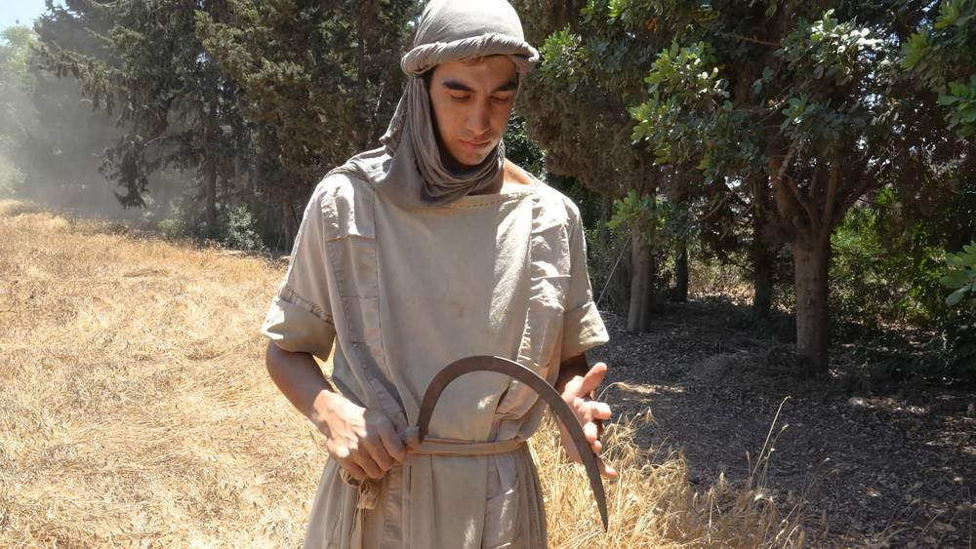
link

Hoz

Image Content

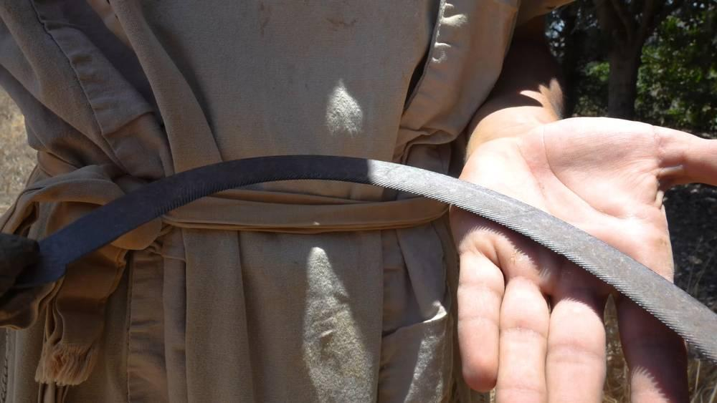
link

