Resource: Familiarization, Internalization, Articulation (Fia) Images
Familiarization, Internalization, Articulation (FIA) Images © 2023 SRV Partners Released under CC BY-SA 4.0 license. Familiarization, Internalization, Articulation (FIA) Images has been adapted in the following languages Tok Pisin, عربي, Français, हिंदी, Bahasa Indonesia, Português, Русский, Español, Kiswahili, 简体中文 from Familiarization, Internalization, Articulation (FIA) © 2023 SRV Partners. Released under CC BY-SA 4.0 license by Mission Mutual

Familiarization, Internalization, Articulation (Fia) Images

J

Jardín de Getsemaní

Image Content

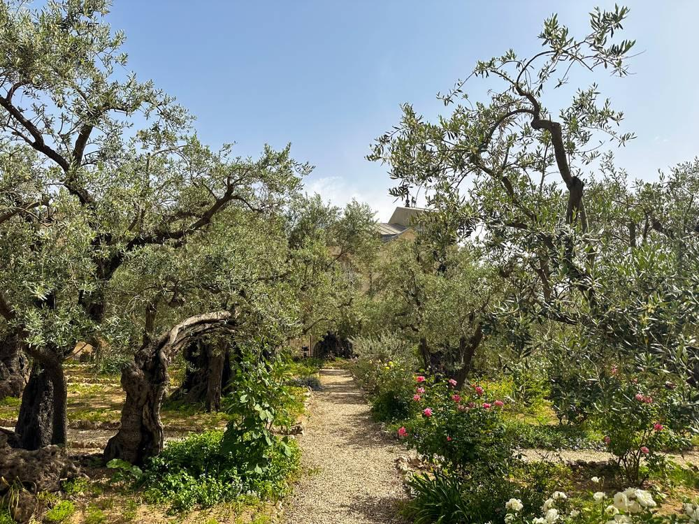
link

Jardín de Getsemaní

Image Content

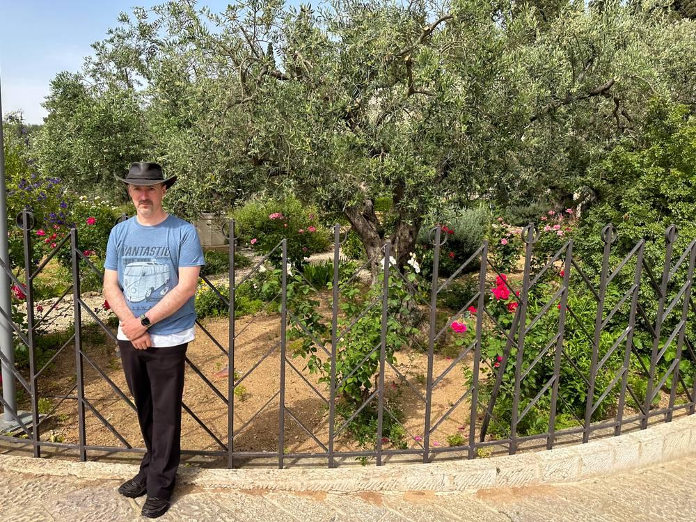
link

Jarra de agua

Image Content

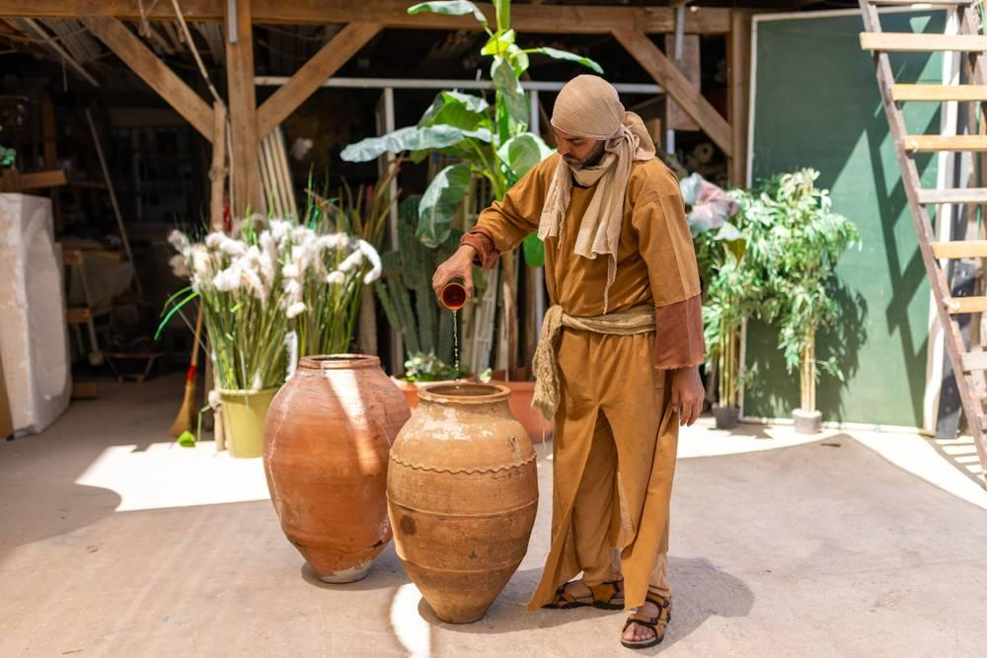
link

Jarra de agua

Image Content

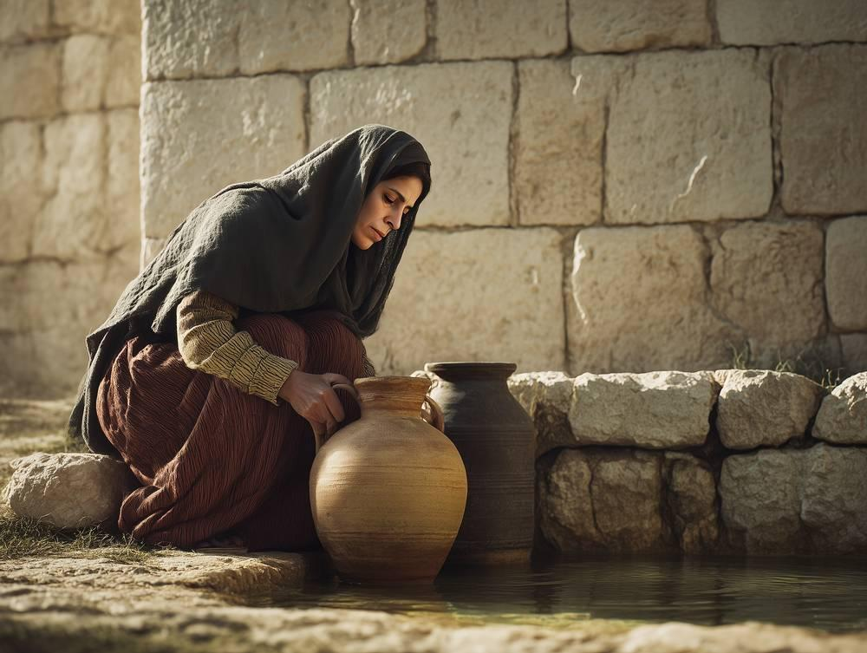
link

Jarra de agua

Image Content

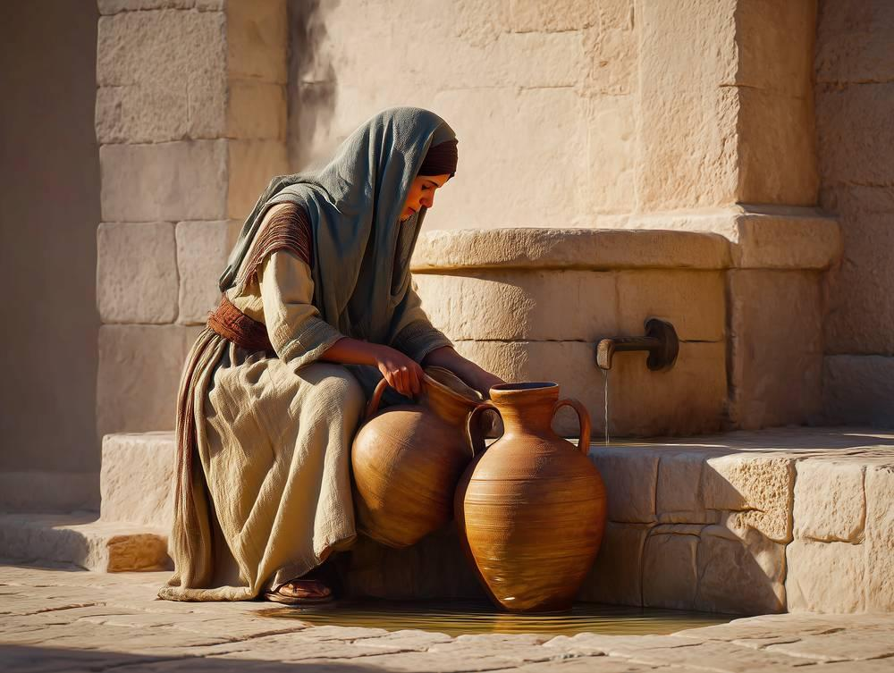
link

Jarra de agua

Image Content

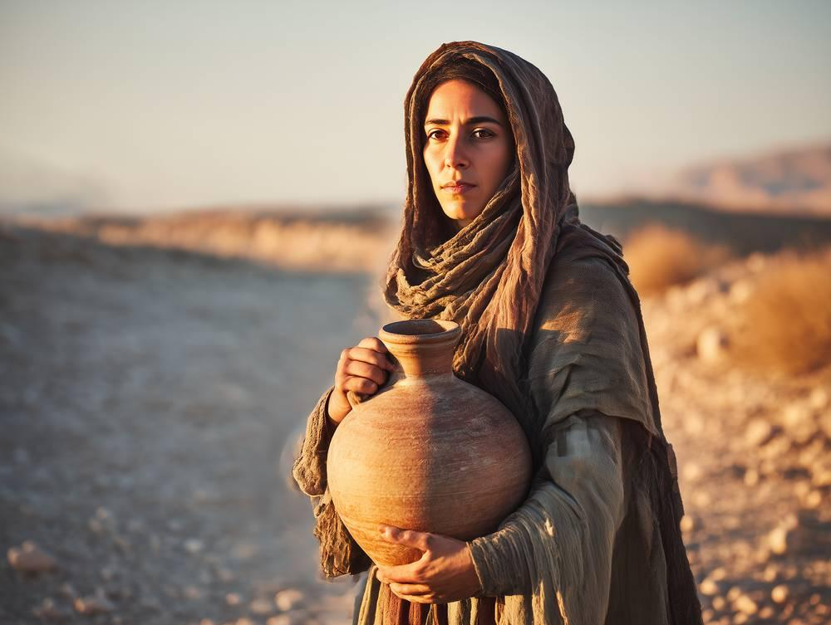
link

Jarra de alabastro

Image Content

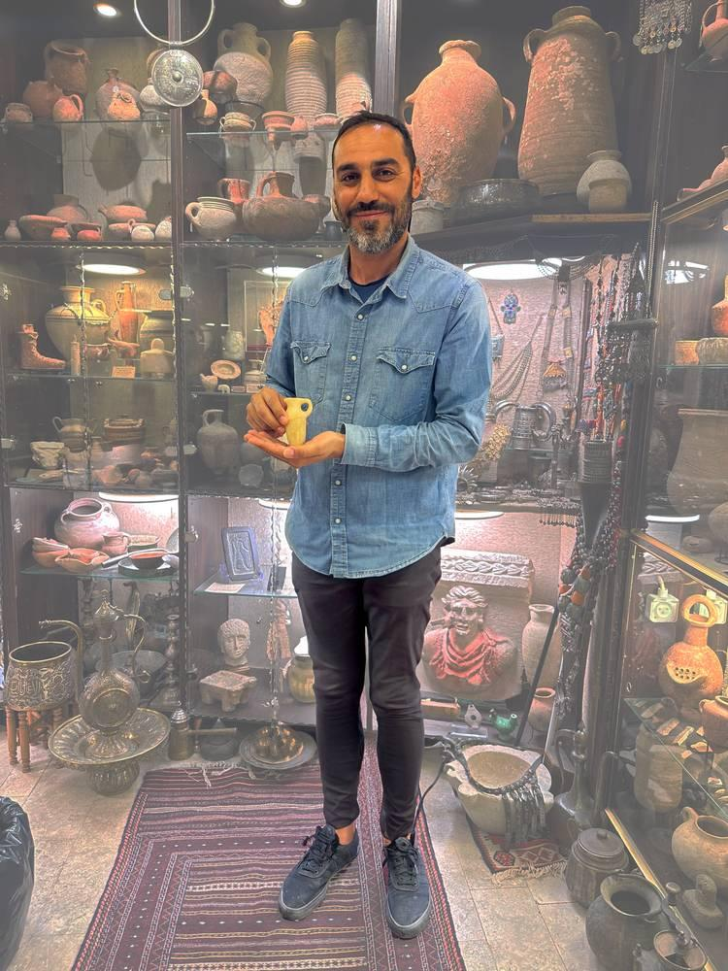
link

Jarra de alabastro

Image Content

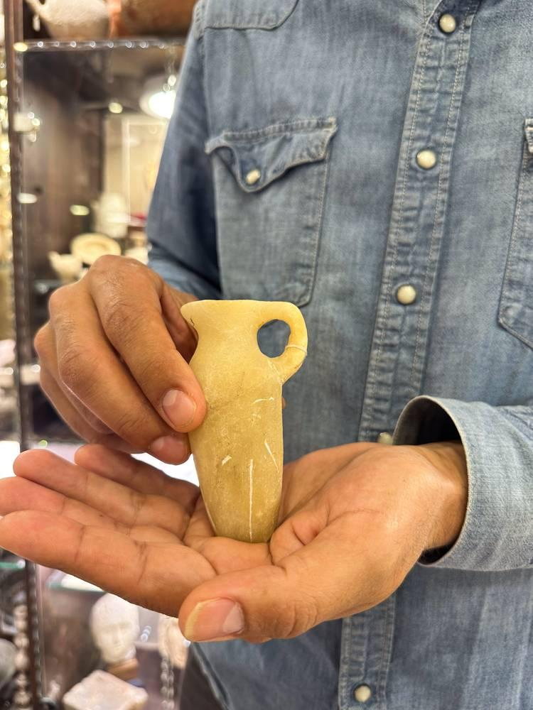
link

Jarra de alabastro

Image Content

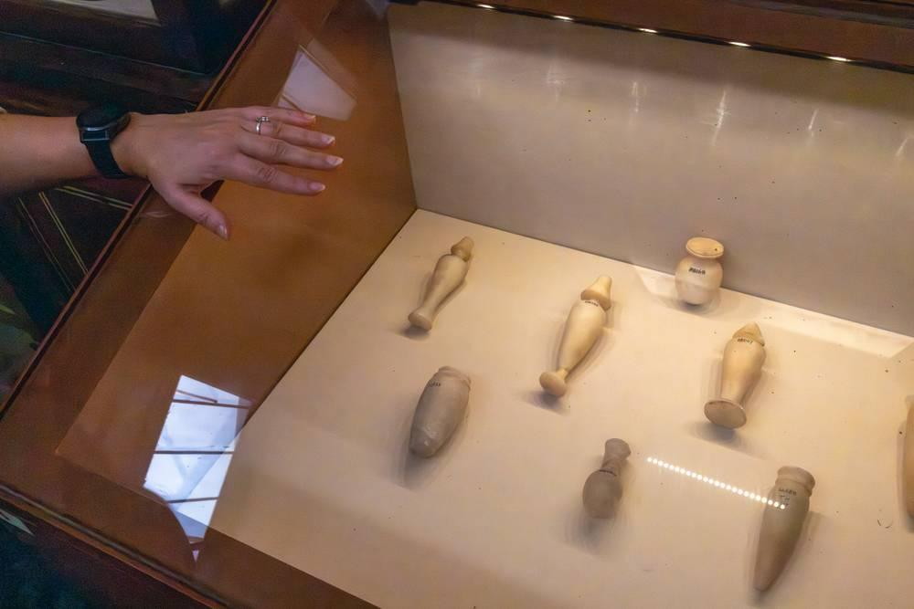
link

Jarra de alabastro

Image Content

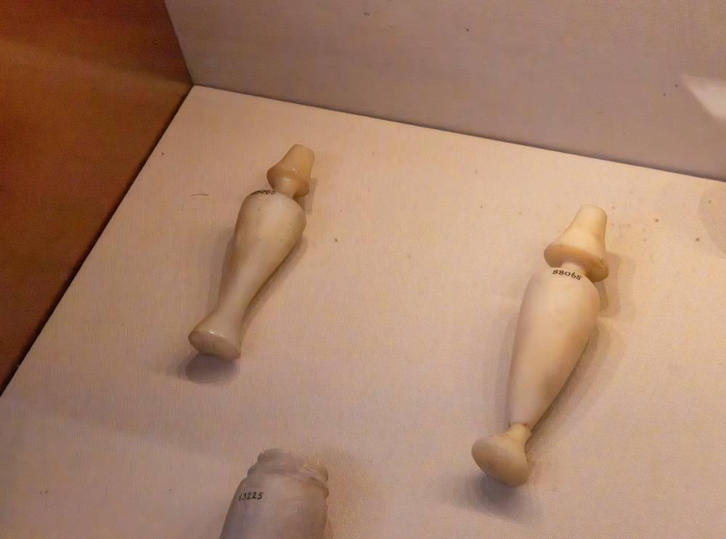
link

Jarro

Image Content

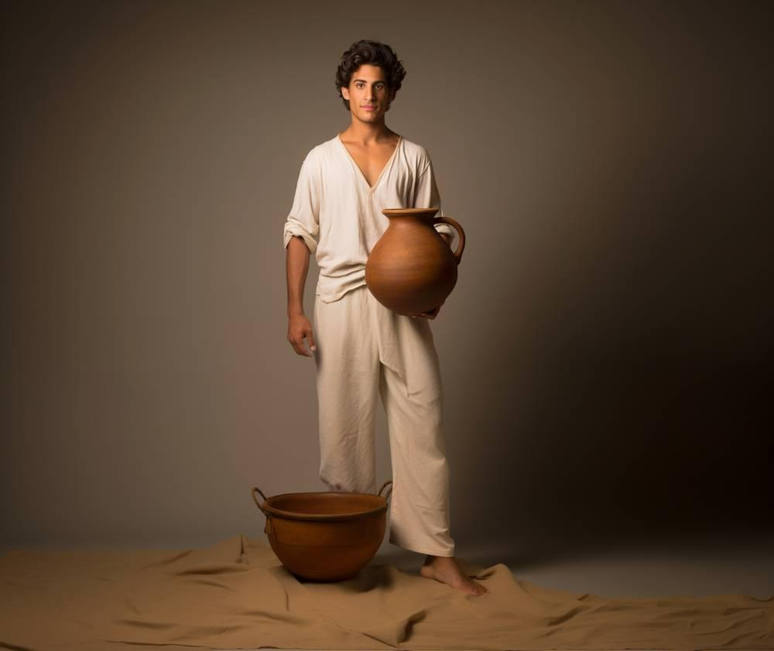
link

