Resource: Familiarization, Internalization, Articulation (Fia) Images
Familiarization, Internalization, Articulation (FIA) Images © 2023 SRV Partners Released under CC BY-SA 4.0 license. Familiarization, Internalization, Articulation (FIA) Images has been adapted in the following languages Tok Pisin, عربي, Français, हिंदी, Bahasa Indonesia, Português, Русский, Español, Kiswahili, 简体中文 from Familiarization, Internalization, Articulation (FIA) © 2023 SRV Partners. Released under CC BY-SA 4.0 license by Mission Mutual

Familiarization, Internalization, Articulation (Fia) Images

M

Manto

Image Content

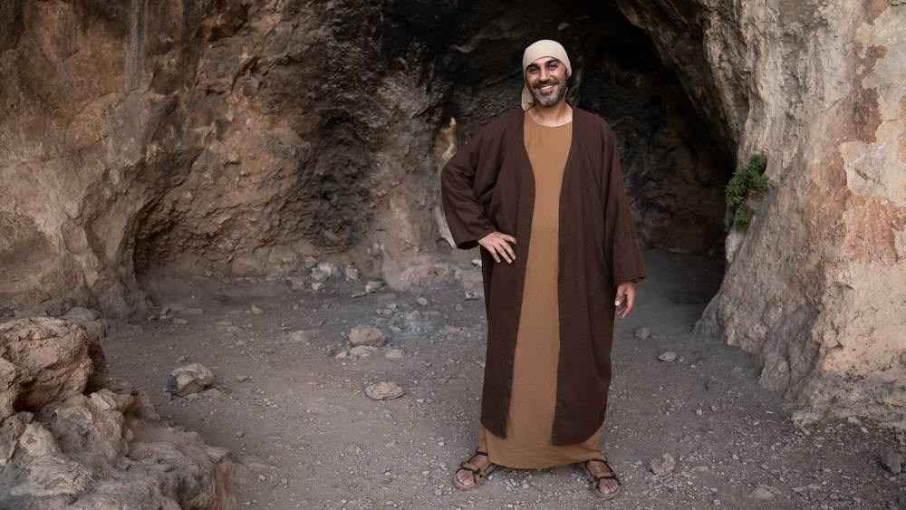
link

Mar de Galilea

Image Content

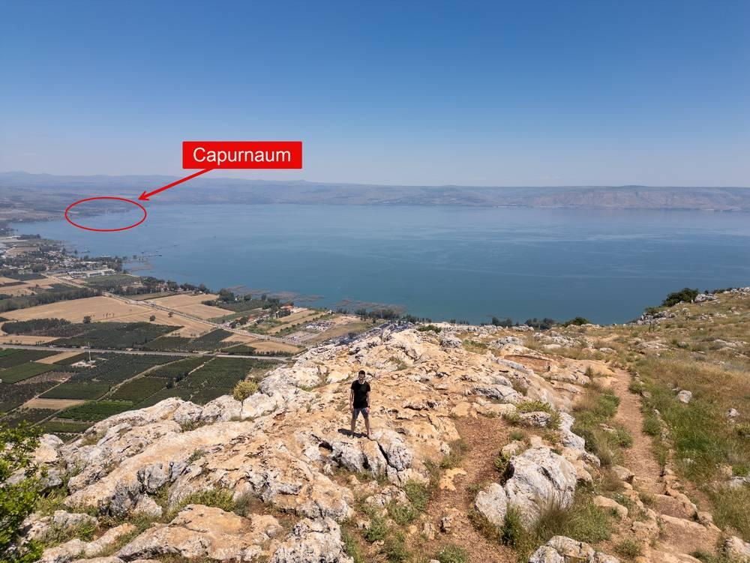
link

Mar de Galilea

Image Content

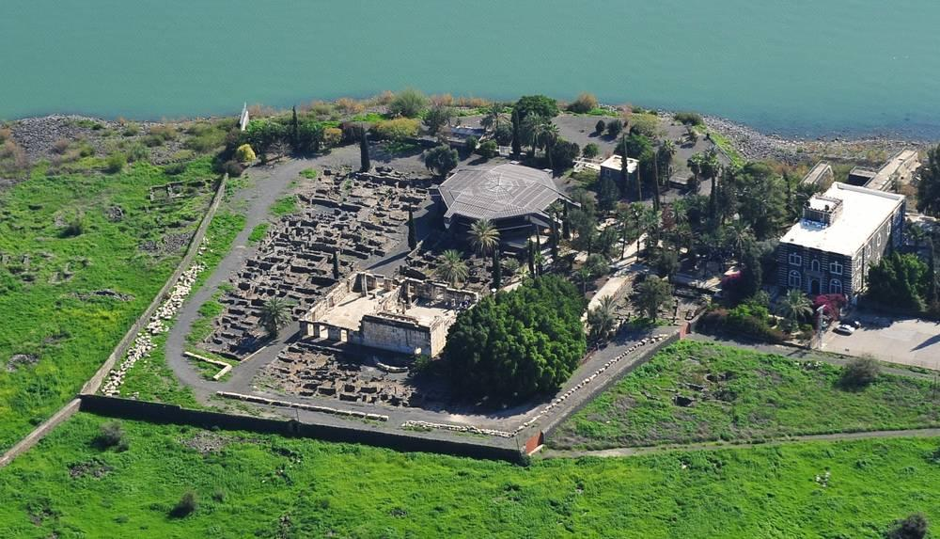
link

Mesa de comedor

Image Content

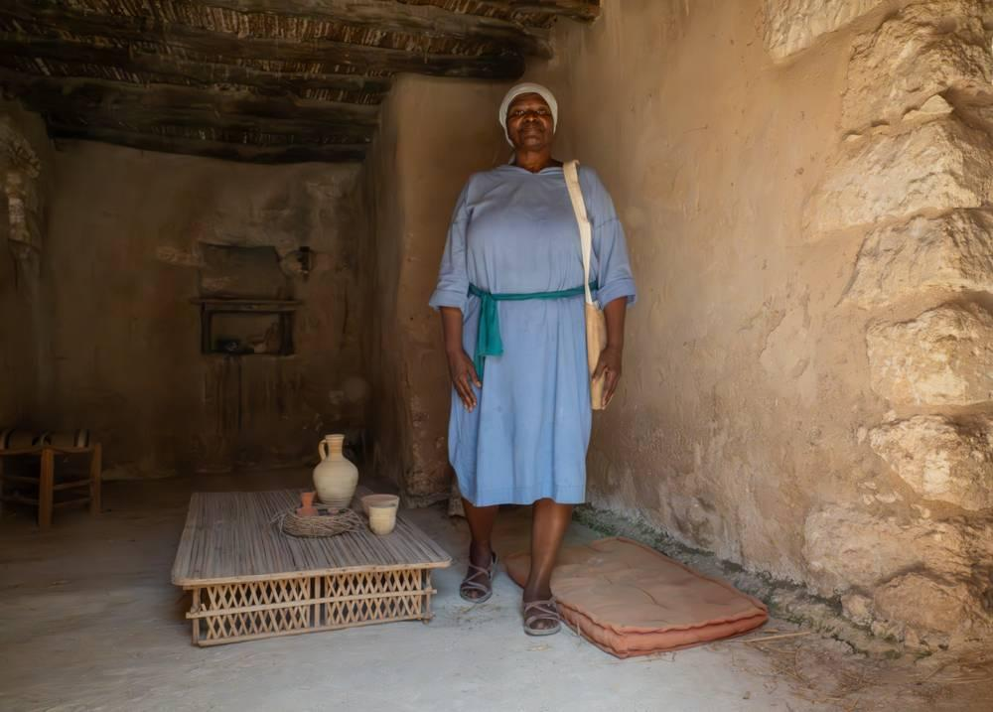
link

Mesa de comedor

Image Content

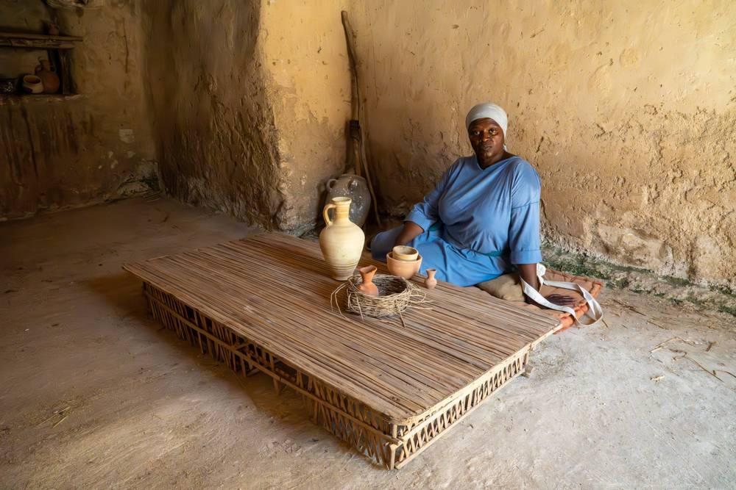
link

Monedas

Image Content

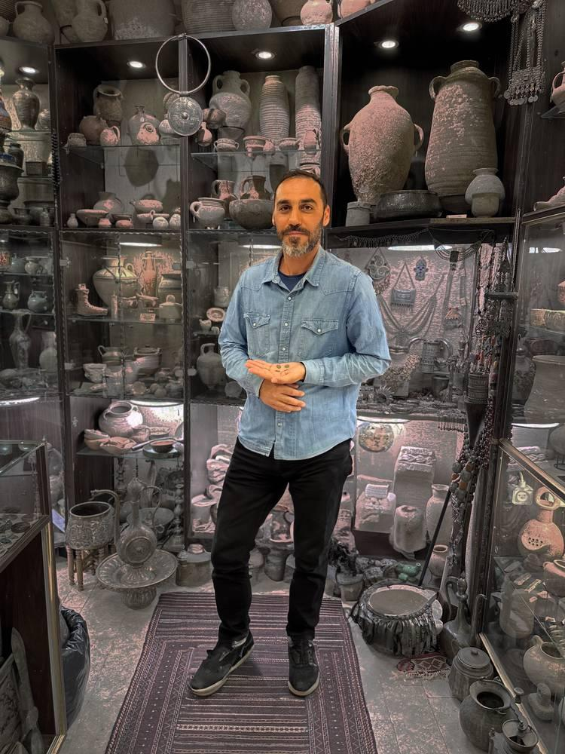
link

Monedas

Image Content

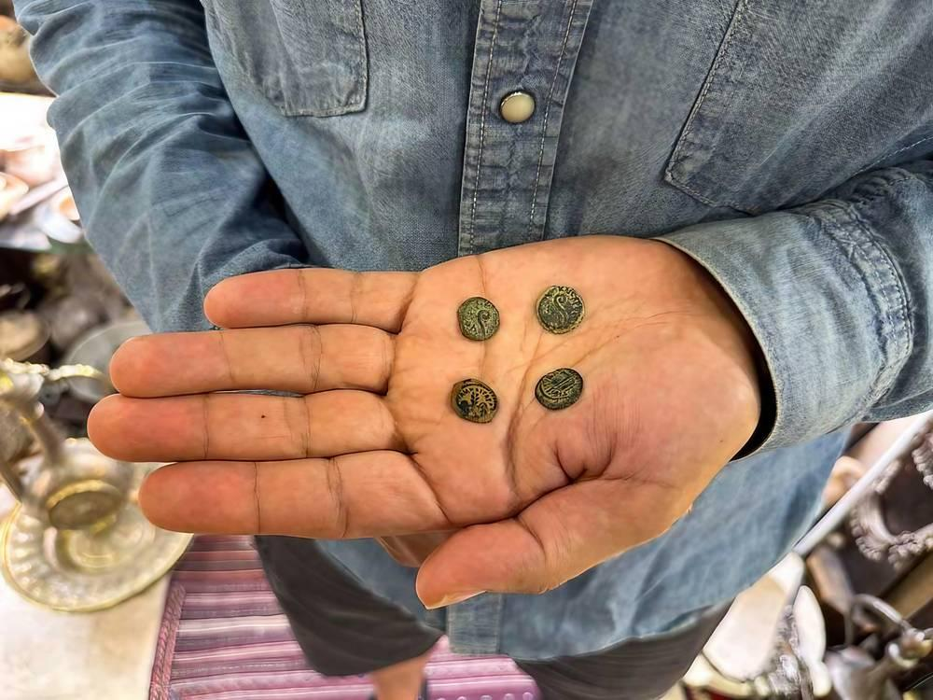
link

Monedas de cobre

Image Content

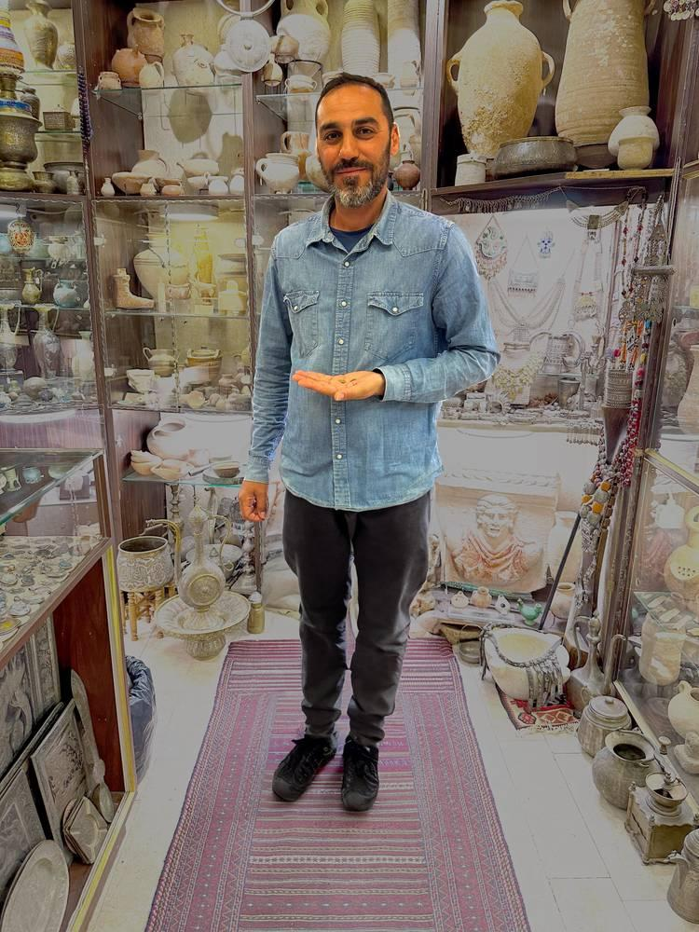
link

Monedas de cobre

Image Content

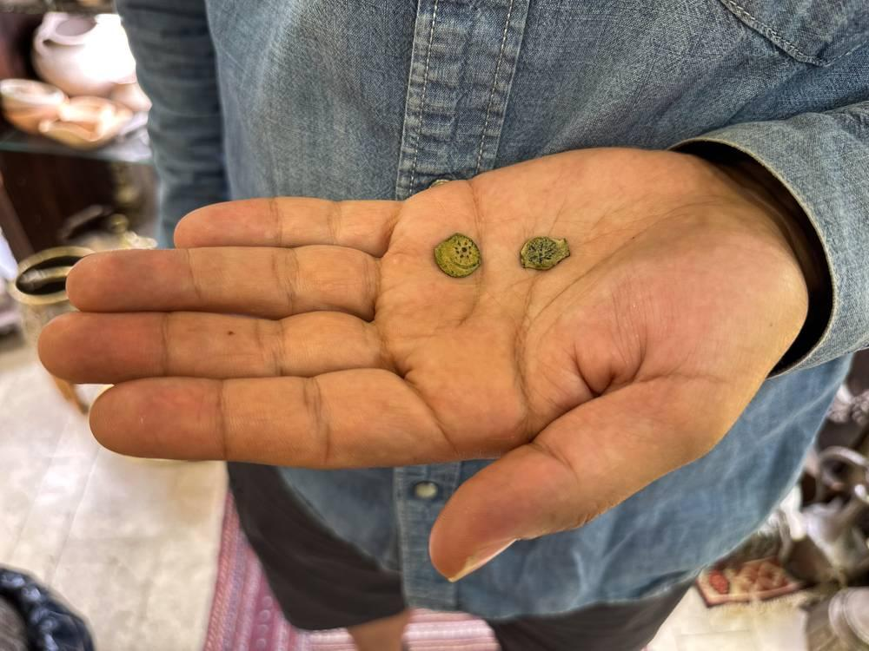
link

Monte de los Olivos

Image Content

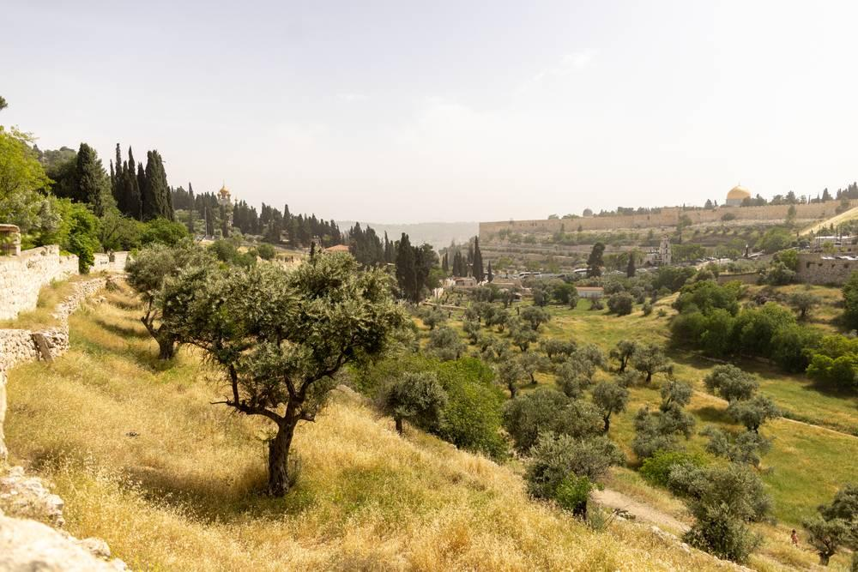
link

Muro de piedra alrededor de un viñedo

Image Content

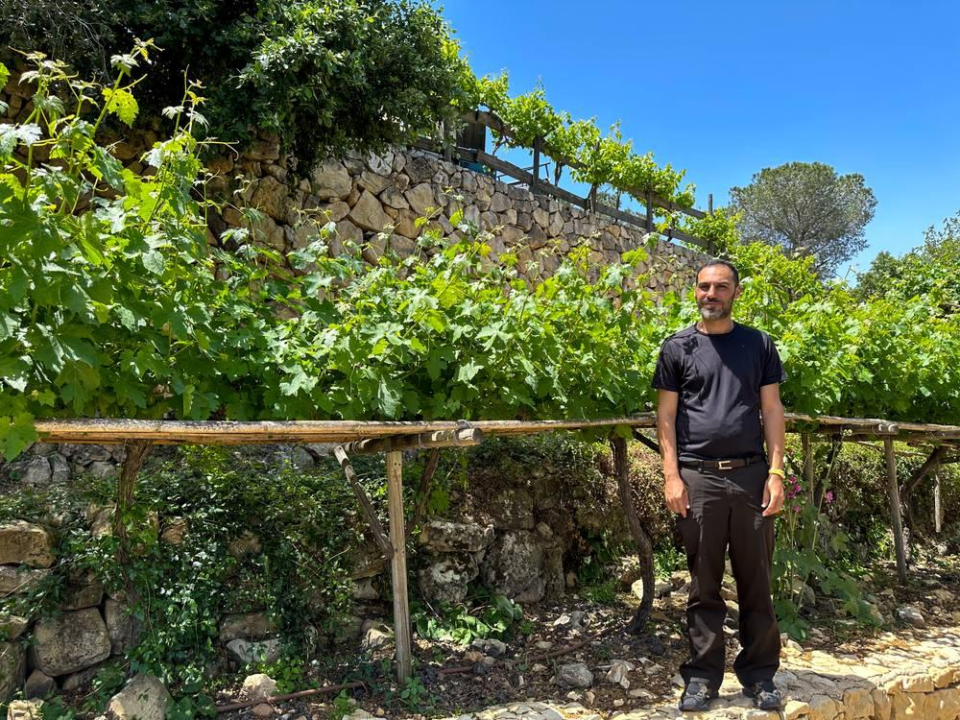
link

